实验八 规则集和映射

学号： 32001298 姓名： 杨晨露 班级： 计算2001
【实验目的和要求】
- 能够使用HashSet、LinkedHashSet或TreeSet来存储元素；
- 区分Collection与Map，能够理由合适的类来存储带键值的值。
【实验内容】
【实验内容】
1、按升序显示不重复的单词，编写一个程序，从控制台读取英文段落，以新的一行****作为结束行，将所有不重复的单词按升序显示。

代码：（不要截图，直接源代码）

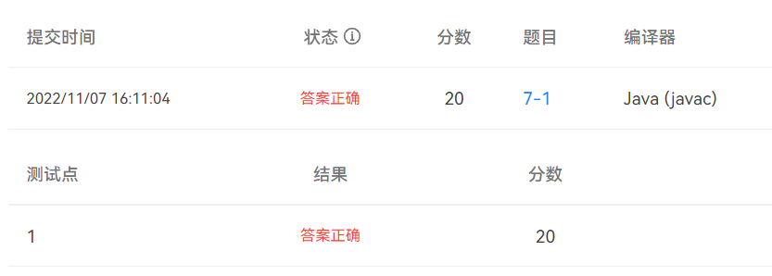

import java.util.ArrayList;

import java.util.Collections;

import java.util.HashSet;

import java.util.List;

import java.util.Scanner;

import java.util.Set;

public class Task1 {

public static void main(String[] args) {

Scanner scanner=new Scanner(System.in);

String word;

List<String> list=new ArrayList<String>();

while(!"****".equals(word=scanner.nextLine())) {

list.add(word);

}

Set<String> set=new HashSet<String>();

List<String> res=new ArrayList<String>();

for(int i=0;i<list.size();i++) {

String tmp=list.get(i);

char[] eng=tmp.toCharArray();

String English="";

for(char e:eng) {

if((e>=0x41 && e<=0x5A) || (e>=0x61 && e<=0x7A)) { //若读到的是英文字母

English+=e+"";

}else if(!"".equals(English)){ //不是英文字母就把单词放到集合里

set.add(English);

English="";

}

}

if(!"".equals(English)){ //最后一个单词放到集合里

set.add(English);

}

}

set.forEach(e->res.add(e.toString()));

Collections.sort(res);

System.out.println("排序后的单词为： ");

for(String e:res) {

System.out.print(e+" ");

}

}

}

2、读取个数不定的整数，查找其中出现频率最高的数字，当输入为0时，表示输入结束。如果输入的频率最高的数字不是一个，而是多个，则把多个数字都显示出来。

代码：（不要截图，直接源代码）

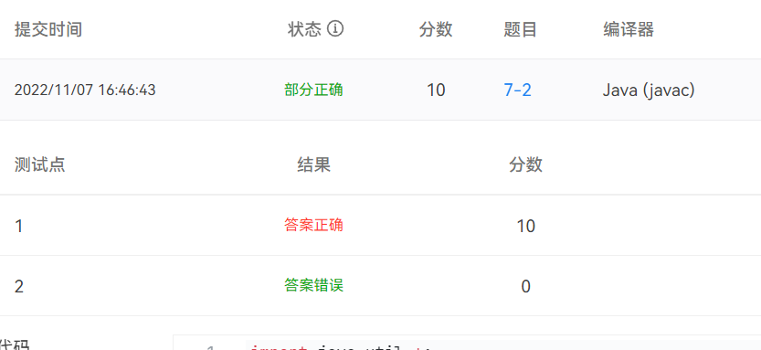
import java.util.Arrays;
import java.util.Collection;
import java.util.HashMap;
import java.util.Iterator;
import java.util.Map;
import java.util.Scanner;
import java.util.Set;

public class Task2 {
public static void main(String[] args) {
Scanner scanner=new Scanner(System.in);
Map<Integer, Integer> map=new HashMap<Integer, Integer>();
int num;
while(true) {
num=scanner.nextInt();
if(num==0) {
break;
}
if(!map.containsKey(num)) {
map.put(num, 1);
}else {
int v=map.get(num);
map.put(num, ++v);
}
}

Collection<Integer> col=map.values();
Object[] o=col.toArray();
Arrays.sort(o);

Set<Integer> keySet=map.keySet();
Iterator<Integer> it=keySet.iterator();
while(it.hasNext()) {
Object key=it.next();
Object value=map.get(key);
if(value==o[map.size()-1]) {
System.out.println("Number "+key+" occurred most:"+value);
}
}
}
}

3、统计java源代码中的关键字。如果关键字在注释或者字符串中，则不统计。将java源代码从控制台输入，以新的一行****作为结束行。

代码：（不要截图，直接源代码）

String[] keywordString = {"abstract", "finally", "public",

"boolean", "float", "return", "break", "for", "short", "byte",

"goto", "static", "case", "if", "super", "catch", "implements",

"switch", "char", "import", "synchronized", "class",

"instanceof", "this", "const", "int", "throw", "continue",

"interface", "throws", "default", "long", "transient", "do",

"native", "try", "double", "new", "void", "else", "package",

"volatile", "extends", "private", "while", "final",

"protected", "true", "null"};
import java.util.ArrayList;
import java.util.Arrays;
import java.util.HashSet;
import java.util.List;
import java.util.Map;
import java.util.Scanner;
import java.util.Set;
import java.util.TreeMap;
import java.util.regex.Matcher;
import java.util.regex.Pattern;

public class Task3 {
public static void main(String[] args) throws Exception{
Scanner scanner=new Scanner(System.in);
String word;
String string="";
while(!"****".equals(word=scanner.nextLine())) {
string+=word+"\n";
}
count(string);
}
public static void count(String string) throws Exception{
String[] keywordString = {"abstract", "finally", "public",
"boolean", "float", "return", "break", "for", "short", "byte",
"goto", "static", "case", "if", "super", "catch", "implements",
"switch", "char", "import", "synchronized", "class",
"instanceof", "this", "const", "int", "throw", "continue",
"interface", "throws", "default", "long", "transient", "do",
"native", "try", "double", "new", "void", "else", "package",
"volatile", "extends", "private", "while", "final",
"protected", "true", "null"};
Set<String> keywordSet=new HashSet<>(Arrays.asList(keywordString));
int res=0;

Pattern p1=Pattern.compile("//.+");
Matcher m1=p1.matcher(string);
string=m1.replaceAll(" ");

Pattern p2=Pattern.compile("/\\*.*\\*/", Pattern.DOTALL);
Matcher m2=p2.matcher(string);
string=m2.replaceAll(" ");

Pattern p3=Pattern.compile("\\s+");
Matcher m3=p3.matcher(string);
string=m3.replaceAll(" ");

Pattern p4=Pattern.compile("\".+\"");
Matcher m4=p4.matcher(string);
string=m4.replaceAll(" ");

String[] resstr=string.split("[\\s+.,;:?!(){}]");
for(String e:resstr) {
if(keywordSet.contains(e)){
res++;
}
}
System.out.println("keywords:"+res);
}
}

