实验十 实现一个红五的发牌程序

学号： 32001298 姓名： 杨晨露 班级： 计算机2001
【实验目的和要求】
- 理解多线程技术；
- 了解红五游戏的规则。
- 了解敏捷开发过程
【实验内容】

实现一个红五的发牌程序，给四位玩家排序时候采用多线程的方式进行，排序结束再统一输出每一位玩家排好序的结果。

1）游戏由两副牌构成

2）4个玩家

3）系统能随机洗牌后模拟真实情况分别向4个玩家发牌，并剩下8张底牌

4）程序能符合人性的方式输出四个玩家手上的牌和底牌（按照人类合理的理牌顺序输出）*合理的理牌顺序是分花色，分大小归类排序，每次都按照打2，并且黑心是主牌进行整理主牌大小顺序：

1、黑色：红心5，大王，小王，黑桃3，梅花3，黑桃2，梅花2，红色2，方色2， A,K,Q,J,10,9,8,7,6, 5,4

2、红色副牌：A,K,Q,J,10,9,8,7,6, 4,3

3、梅花色副牌：A,K,Q,J,10,9,8,7,6,5,4

4、方色副牌：A,K,Q,J,10,9,8,7,6,5, 4,3

输出结果截图：

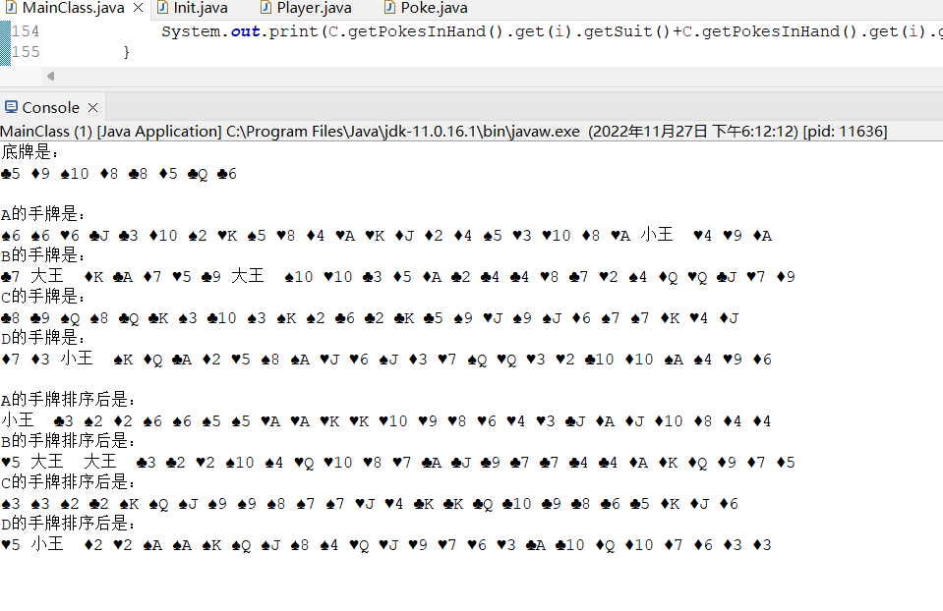

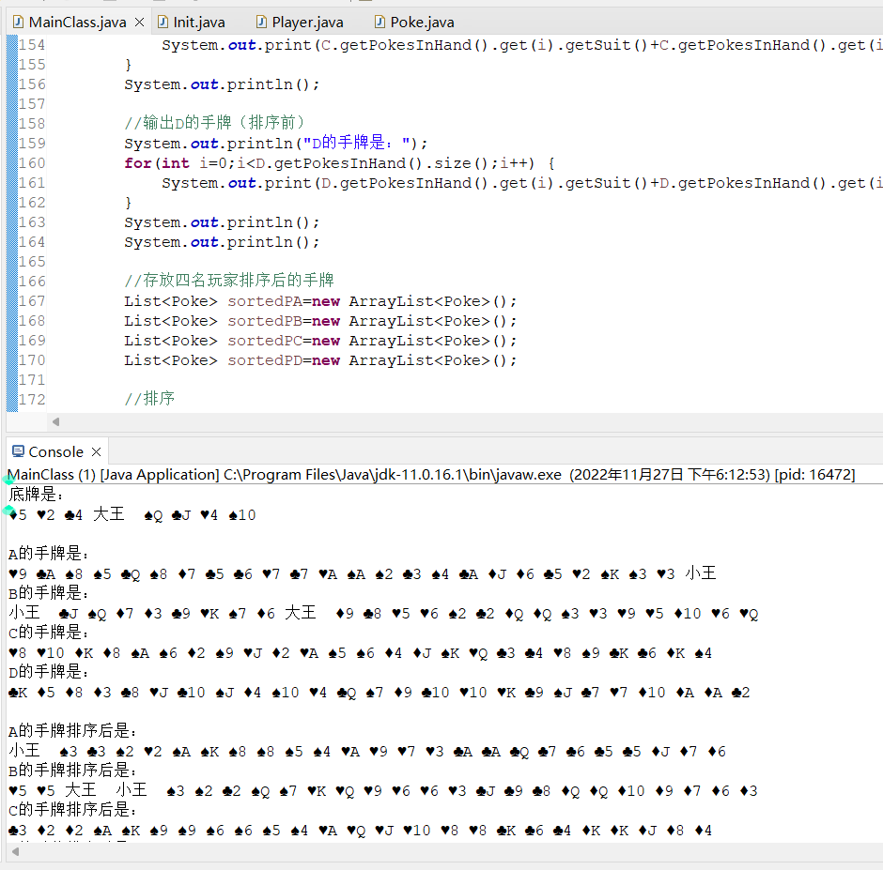
实现代码：
package week11;

import java.util.ArrayList;
import java.util.Collections;
import java.util.Comparator;
import java.util.List;
import java.util.concurrent.locks.*;

public class MainClass{
private static int cnt=0;
private static Lock lock=new ReentrantLock();//处理线程同步

public static void main(String[] args) throws InterruptedException{
//初始化牌
Init pokes=new Init();
pokes.create();//创建牌
pokes.shuffle();//随机打乱

//创建Condition接口，保证4名玩家正常摸牌
Condition condition1=lock.newCondition();
Condition condition2=lock.newCondition();
Condition condition3=lock.newCondition();
Condition condition4=lock.newCondition();

//初始化玩家
Player A=new Player(pokes.getPokes(), "A");
Player B=new Player(pokes.getPokes(), "B");
Player C=new Player(pokes.getPokes(), "C");
Player D=new Player(pokes.getPokes(), "D");
//向第一个玩家发牌
new Thread(()->{
while(true) {
lock.lock();//上锁
try {
while(cnt%4!=0) {//cnt为0或4的倍数，表示先向第一个人发牌，
//执行后唤醒线程condition2，condition1等待
condition1.await();
}
if(cnt>=100) {//表示牌已发完（要留8张底牌）
break;
}
A.getPokesInHand().add(pokes.getPokes().get(cnt));//更新A目前拥有的手牌
A.getIndex().add(pokes.getIndex().get(cnt));//记录这张牌的初始下标
cnt++;
condition2.signal();//唤醒线程2
} catch (InterruptedException e) {
e.printStackTrace();
} finally {
lock.unlock();
}
}
},"A").start();

//向第二个玩家发牌
new Thread(()->{
while(true) {
lock.lock();//上锁
try {
while(cnt%4!=1) {//表示向第二个人发牌，
//执行后唤醒线程condition3，condition2等待
condition2.await();
}
if(cnt>=100) {//表示牌已发完（要留8张底牌）
break;
}
B.getPokesInHand().add(pokes.getPokes().get(cnt));//更新B目前拥有的手牌
B.getIndex().add(pokes.getIndex().get(cnt));//记录这张牌的初始下标
cnt++;
condition3.signal();//唤醒线程3
} catch (InterruptedException e) {
e.printStackTrace();
} finally {
lock.unlock();
}
}
},"B").start();

//向第三个玩家发牌
new Thread(()->{
while(true) {
lock.lock();//上锁
try {
while(cnt%4!=2) {//表示向第三个人发牌，
//执行后唤醒线程condition4，condition3等待
condition3.await();
}
if(cnt>=100) {//表示牌已发完（要留8张底牌）
break;
}
C.getPokesInHand().add(pokes.getPokes().get(cnt));//更新C目前拥有的手牌
C.getIndex().add(pokes.getIndex().get(cnt));//记录这张牌的初始下标
cnt++;
condition4.signal();//唤醒线程4
} catch (InterruptedException e) {
e.printStackTrace();
} finally {
lock.unlock();
}
}
},"C").start();

//向第四个玩家发牌
new Thread(()->{
while(true) {
lock.lock();//上锁
try {
while(cnt%4!=3) {//表示向第四个人发牌，
//执行后唤醒线程condition1，condition4等待
condition4.await();
}
if(cnt>=100) {//表示牌已发完（要留8张底牌）
break;
}
D.getPokesInHand().add(pokes.getPokes().get(cnt));//更新D目前拥有的手牌
D.getIndex().add(pokes.getIndex().get(cnt));//记录这张牌的初始下标
cnt++;
condition1.signal();//唤醒线程1
} catch (InterruptedException e) {
e.printStackTrace();
} finally {
lock.unlock();
}
}
},"D").start();

Thread.sleep(1000);//主线程休眠1s

//输出底牌
System.out.println("底牌是：");
for(int i=cnt;i<pokes.getPokes().size();i++) {//遍历底牌
System.out.print(pokes.getPokes().get(i).getSuit()+pokes.getPokes().get(i).getSize()+" ");
}
System.out.println();
System.out.println();

//输出A的手牌（排序前）
System.out.println("A的手牌是：");
for(int i=0;i<A.getPokesInHand().size();i++) {
System.out.print(A.getPokesInHand().get(i).getSuit()+A.getPokesInHand().get(i).getSize()+" ");
}
System.out.println();

//输出B的手牌（排序前）
System.out.println("B的手牌是：");
for(int i=0;i<B.getPokesInHand().size();i++) {
System.out.print(B.getPokesInHand().get(i).getSuit()+B.getPokesInHand().get(i).getSize()+" ");
}
System.out.println();

//输出C的手牌（排序前）
System.out.println("C的手牌是：");
for(int i=0;i<C.getPokesInHand().size();i++) {
System.out.print(C.getPokesInHand().get(i).getSuit()+C.getPokesInHand().get(i).getSize()+" ");
}
System.out.println();

//输出D的手牌（排序前）
System.out.println("D的手牌是：");
for(int i=0;i<D.getPokesInHand().size();i++) {
System.out.print(D.getPokesInHand().get(i).getSuit()+D.getPokesInHand().get(i).getSize()+" ");
}
System.out.println();
System.out.println();

//存放四名玩家排序后的手牌
List<Poke> sortedPA=new ArrayList<Poke>();
List<Poke> sortedPB=new ArrayList<Poke>();
List<Poke> sortedPC=new ArrayList<Poke>();
List<Poke> sortedPD=new ArrayList<Poke>();

//排序
sortedPA=sort(A.getPokesInHand());
sortedPB=sort(B.getPokesInHand());
sortedPC=sort(C.getPokesInHand());
sortedPD=sort(D.getPokesInHand());

//输出四名玩家排序后的手牌
//输出A的手牌（排序后）
System.out.println("A的手牌排序后是：");
for(int i=0;i<sortedPA.size();i++) {
System.out.print(sortedPA.get(i).getSuit()+sortedPA.get(i).getSize()+" ");
}
System.out.println();

//输出B的手牌（排序前）
System.out.println("B的手牌排序后是：");
for(int i=0;i<sortedPB.size();i++) {
System.out.print(sortedPB.get(i).getSuit()+sortedPB.get(i).getSize()+" ");
}
System.out.println();
//输出C的手牌（排序前）
System.out.println("C的手牌排序后是：");
for(int i=0;i<sortedPC.size();i++) {
System.out.print(sortedPC.get(i).getSuit()+sortedPC.get(i).getSize()+" ");
}
System.out.println();
//输出D的手牌（排序前）
System.out.println("D的手牌排序后是：");
for(int i=0;i<sortedPD.size();i++) {
System.out.print(sortedPD.get(i).getSuit()+sortedPD.get(i).getSize()+" ");
}
System.out.println();
}
//排序方法
public static List<Poke> sort(List<Poke> pokes){
List<Poke> res=new ArrayList<Poke>();//存放排序后的结果

//首先对红心5进行排序
for(int i=0;i<pokes.size();i++) {
if("♥".equals(pokes.get(i).getSuit()) && "5".equals(pokes.get(i).getSize())) {
res.add(pokes.get(i));//加入到结果中
pokes.remove(i);//从原牌组中移除
}
}

//然后对大王进行排序
for(int i=0;i<pokes.size();i++) {
if("大王".equals(pokes.get(i).getSuit())) {
res.add(pokes.get(i));//加入到结果中
pokes.remove(i);//从原牌组中移除
}
}

//然后对小王进行排序
for(int i=0;i<pokes.size();i++) {
if("小王".equals(pokes.get(i).getSuit())) {
res.add(pokes.get(i));//加入到结果中
pokes.remove(i);//从原牌组中移除
}
}

//然后对黑桃3进行排序
for(int i=0;i<pokes.size();i++) {
if("♠".equals(pokes.get(i).getSuit()) && "3".equals(pokes.get(i).getSize())) {
res.add(pokes.get(i));//加入到结果中
pokes.remove(i);//从原牌组中移除
}
}
//然后对梅花3进行排序
for(int i=0;i<pokes.size();i++) {
if("♣".equals(pokes.get(i).getSuit()) && "3".equals(pokes.get(i).getSize())) {
res.add(pokes.get(i));//加入到结果中
pokes.remove(i);//从原牌组中移除
}
}
//然后对黑桃2进行排序
for(int i=0;i<pokes.size();i++) {
if("♠".equals(pokes.get(i).getSuit()) && "2".equals(pokes.get(i).getSize())) {
res.add(pokes.get(i));//加入到结果中
pokes.remove(i);//从原牌组中移除
}
}

//然后对其他2进行排序
for(int i=0;i<pokes.size();i++) {
if("2".equals(pokes.get(i).getSize())) {
res.add(pokes.get(i));//加入到结果中
pokes.remove(i);//从原牌组中移除
}
}

//然后对剩余牌按花色进行排序
Collections.sort(pokes,new Comparator<Poke>() {
@Override
public int compare(Poke o1, Poke o2) {
return o1.getIndex()-o2.getIndex();
}
});

//剩下的牌按花色排序后按序加入玩家手牌中即可
for(int i=0;i<pokes.size();i++) {
res.add(pokes.get(i));
}

return res;
}
}
package week11;

import java.util.ArrayList;
import java.util.Collections;
import java.util.List;

public class Init {
private static int pokenum=108; //牌数
private String[] suits={"♠","♥","♣","♦"};//花色
private String[] sizes={"2","A","K","Q","J","10","9","8","7","6","5","4","3"};//排的大小
List<Poke> pokes=new ArrayList<Poke>();//存放牌的列表
List<Integer> index=new ArrayList<Integer>();//存放牌的下标
public static int count=0;//计数，用与把牌加到存放牌的列表中

public static int getPokenum() {
return pokenum;
}

public static void setPokenum(int pokenum) {
Init.pokenum = pokenum;
}

public String[] getSuits() {
return suits;
}
public void setSuits(String[] suits) {
this.suits = suits;
}

public String[] getSizes() {
return sizes;
}

public void setSizes(String[] sizes) {
this.sizes = sizes;
}

public List<Poke> getPokes() {
return pokes;
}

public void setPokes(List<Poke> pokes) {
this.pokes = pokes;
}
public List<Integer> getIndex() {
return index;
}

public void setIndex(List<Integer> index) {
this.index = index;
}

//创建新的牌
public void create() {
//除大小王外的牌
for(String suit:suits) {
for(String size:sizes) {
for(int i=0;i<2;i++) {
pokes.add(new Poke(suit, size, count));
index.add(count);
count=count+1;
}
}
}
//大小王
for(int i=0;i<2;i++) {
pokes.add(new Poke("大王", " ", count));
index.add(count);
count=count+1;
pokes.add(new Poke("小王", " ", count));
index.add(count);
count=count+1;
}
}
//随机打乱牌组
public void shuffle() {
Collections.shuffle(pokes);
}
}

package week11;

import java.util.ArrayList;
import java.util.List;

public class Player {
private static List<Poke> pokes=new ArrayList<Poke>();//牌组
private List<Poke> pokesInHand=new ArrayList<Poke>();//手牌
private List<Integer> index=new ArrayList<Integer>();//下标
private String username;//用户名

public Player(List<Poke> pokes,String username) {
this.pokes=pokes;
this.username=username;
}

public static List<Poke> getPokes() {
return pokes;
}

public static void setPokes(List<Poke> pokes) {
Player.pokes = pokes;
}

public List<Poke> getPokesInHand() {
return pokesInHand;
}

public void setPokesInHand(List<Poke> pokesInHand) {
this.pokesInHand = pokesInHand;
}

public String getUsername() {
return username;
}public void setUsername(String username) {
this.username = username;
}

public List<Integer> getIndex() {
return index;
}

public void setIndex(List<Integer> index) {
this.index = index;
}
}

package week11;

public class Poke {
public String suit;//花色
public String size;//大小
public int index;//初始下标

public Poke(String suit, String size, int index) {
this.suit = suit;
this.size = size;
this.index = index;
}

public String getSuit() {
return suit;
}

public void setSuit(String suit) {
this.suit = suit;
}

public String getSize() {
return size;
}

public void setSize(String size) {
this.size = size;
}

public int getIndex() {
return index;
}

public void setIndex(int index) {
this.index = index;
}

@Override
public String toString() {
return "Poke [suit=" + suit + ", size=" + size + ", index=" + index + "]";
}
}

