## 波士顿房价预测线性回归实践

32001298 杨晨露

1. 第一次测试

迭代次数=50 学习率=0.001

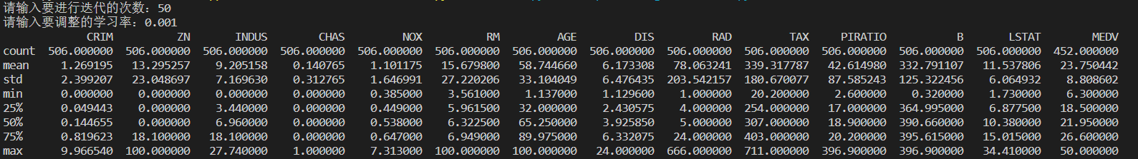

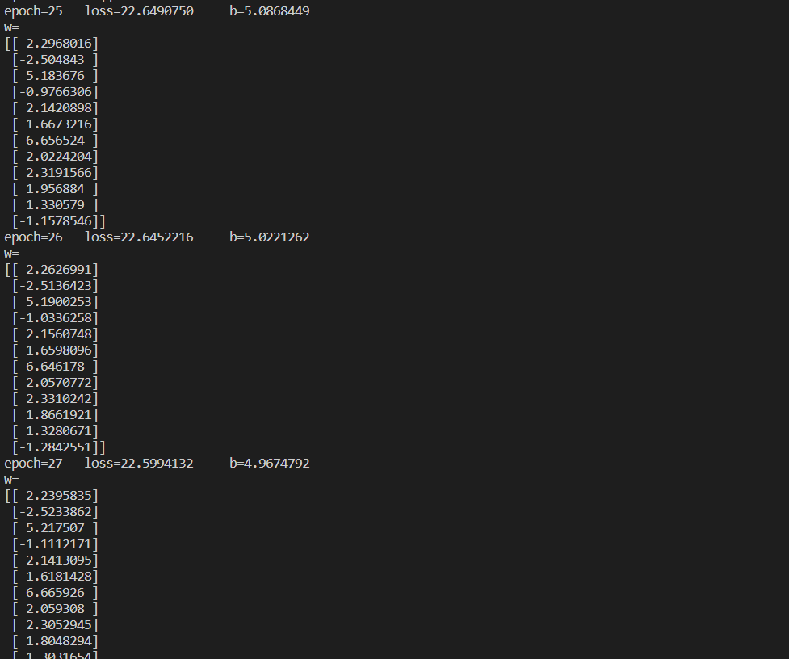

epoch=2

loss=30.5112099

b=5.1143146

w=

[[ 1.001943 ]

[-0.24120946]

[ 2.101802 ]

[ 0.6470674 ]

[ 0.87784344]

[ 0.9612782 ]

[ 3.2826595 ]

[ 1.1118214 ]

[ 1.0080767 ]

[ 2.0167704 ]

[ 0.753774 ]

[ 2.5166743 ]]

epoch=1

loss=54.3143130

b=5.0504131

w=

[[0.6824327 ]

[0.11005452]

[1.7058963 ]

[0.5530682 ]

[0.5927884 ]

[0.6856487 ]

[2.8898277 ]

[0.93947804]

[0.66966397]

[1.8725815 ]

[0.55356926]

[3.0120633 ]]

中间省略一些数据……

epoch=49

loss=22.2893673

b=5.3041387

w=

[[ 1.9386548]

[-2.3725874]

[ 5.9269896]

[-1.8044213]

[ 2.2348151]

[ 1.234432 ]

[ 7.3496904]

[ 2.8295944]

[ 2.2849753]

[ 1.0334749]

[ 1.1417118]

[-1.9888573]]

epoch=50

loss=22.2661930

b=5.4078708

w=

[[ 1.9435929]

[-2.351702 ]

[ 5.983279 ]

[-1.8073215]

[ 2.2434485]

[ 1.2232243]

[ 7.4237804]

[ 2.8796778]

[ 2.288915 ]

[ 1.0475652]

[ 1.1424716]

[-1.9300591]]

三次抽取测试集

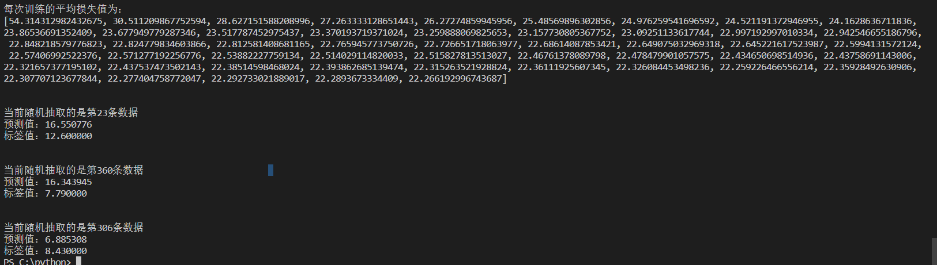

1. 第二次测试

迭代次数=25 学习率=0.001

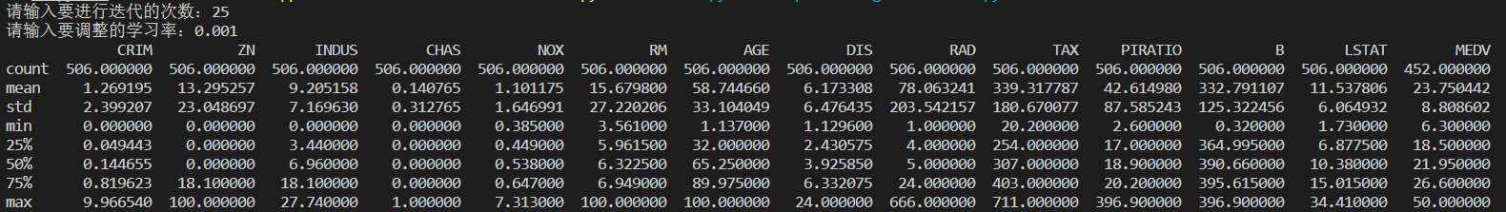

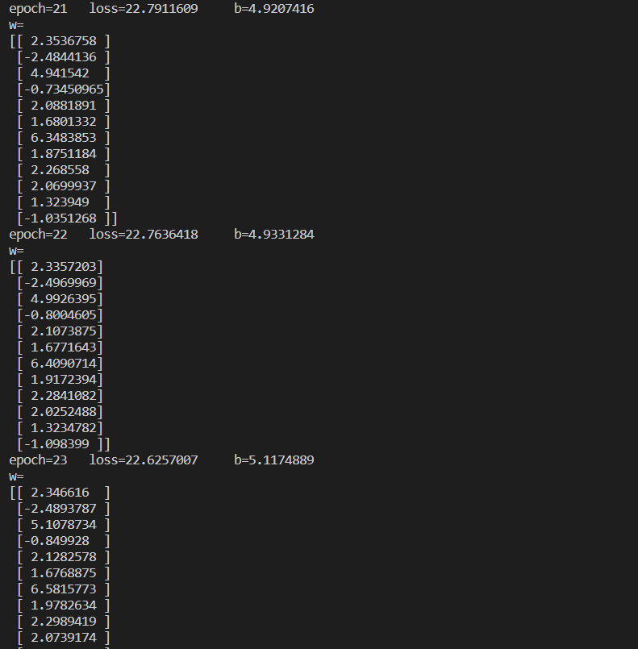

epoch=1

loss=54.2964656 b=5.0478749

w=

[[0.7079106 ]

[0.10309166]

[1.7057917 ]

[0.56985736]

[0.6076239 ]

[0.6805096 ]

[2.8725615 ]

[0.96847963]

[0.6730952 ]

[1.8831608 ]

[0.551639 ]

[3.0018933 ]]

epoch=2

loss=30.5214909 b=5.1019573

w=

[[ 1.0339872 ]

[-0.25436035]

[ 2.108702 ]

[ 0.64628685]

[ 0.8784377 ]

[ 0.93902576]

[ 3.2799685 ]

[ 1.120869 ]

[ 0.9926921 ]

[ 2.0343237 ]

[ 0.7402286 ]

[ 2.5093963 ]]

中间省略一些数据……

epoch=24

loss=22.7375812 b=5.0288429

w=

[[ 2.317805 ]

[-2.5096896]

[ 5.118195 ]

[-0.9228837]

[ 2.1346104]

[ 1.6593267]

[ 6.5721693]

[ 1.9986049]

[ 2.3008504]

[ 1.9824252]

[ 1.3162795]

[-1.1395376]]

epoch=25

loss=22.6461360 b=4.9415164

w=

[[ 2.2880456]

[-2.527719 ]

[ 5.129814 ]

[-0.9951971]

[ 2.1355574]

[ 1.635557 ]

[ 6.564925 ]

[ 2.0133696]

[ 2.295337 ]

[ 1.894335 ]

[ 1.3007692]

[-1.2755102]]

三次抽取测试集

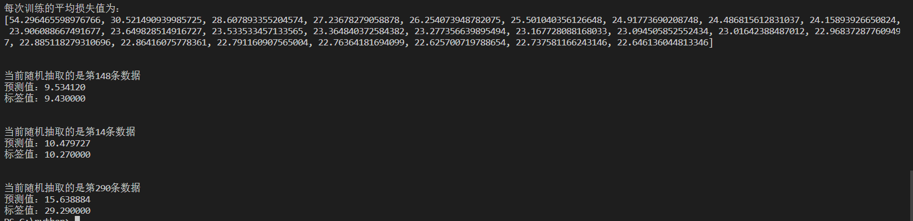

1. 第三次测试

迭代次数=15 学习率=0.001

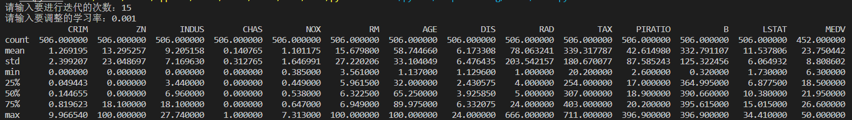

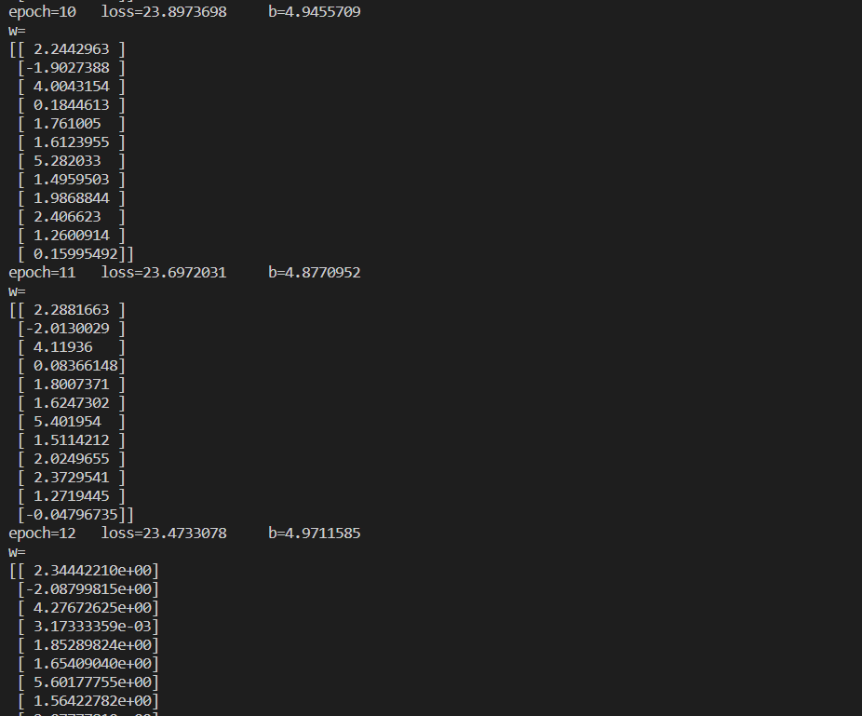

epoch=1

loss=54.2260118 b=5.0437989

w=

[[0.68781656]

[0.10913657]

[1.7194526 ]

[0.5655645 ]

[0.6005318 ]

[0.669632 ]

[2.8910375 ]

[0.95996255]

[0.6813135 ]

[1.8658471 ]

[0.5609814 ]

[3.0077944 ]]

epoch=2

loss=30.4879691 b=5.0575585

w=

[[ 1.0050149 ]

[-0.25120023]

[ 2.0964963 ]

[ 0.6459434 ]

[ 0.8818685 ]

[ 0.9390494 ]

[ 3.2588909 ]

[ 1.120059 ]

[ 1.0143405 ]

[ 1.9829551 ]

[ 0.7521057 ]

[ 2.4671452 ]]

中间省略……

epoch=14

loss=23.2292710 b=4.9508352

w=

[[ 2.3858202 ]

[-2.2290175 ]

[ 4.472506 ]

[-0.16796704]

[ 1.9338151 ]

[ 1.6874739 ]

[ 5.821796 ]

[ 1.6401725 ]

[ 2.1580946 ]

[ 2.3484828 ]

[ 1.3269618 ]

[-0.38577905]]

epoch=15 l

oss=23.1546672 b=4.9262180

w=

[[ 2.390079 ]

[-2.2895808]

[ 4.552917 ]

[-0.2609277]

[ 1.9600698]

[ 1.6892775]

[ 5.9096847]

[ 1.6678587]

[ 2.1812024]

[ 2.3053465]

[ 1.3319933]

[-0.5123837]]

三次抽取测试集

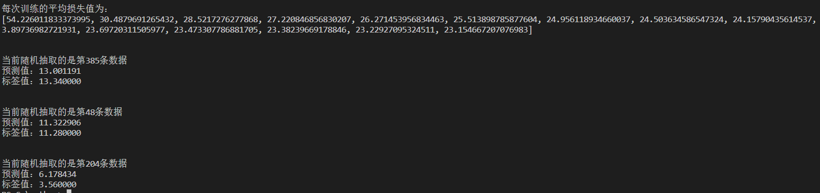

1. 第四次测试

迭代次数=15 学习率=0.002

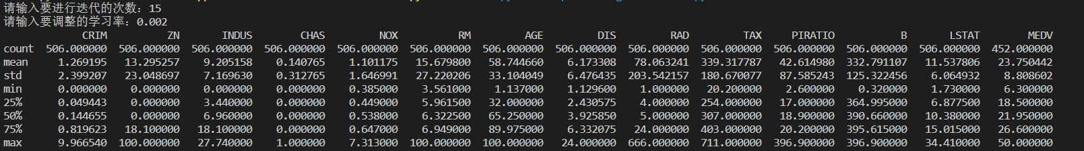

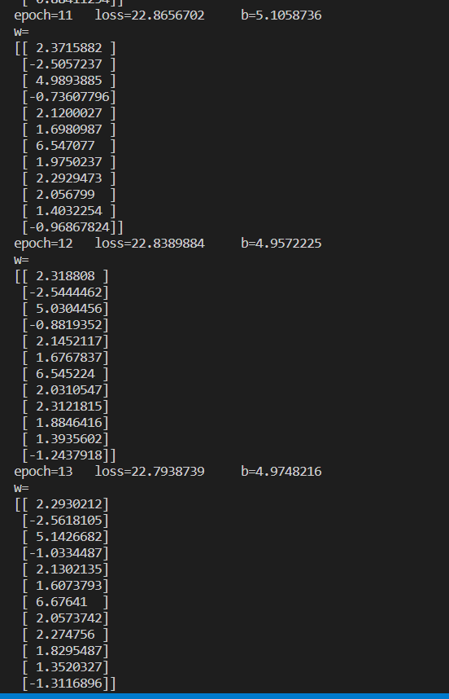

epoch=1

loss=42.0740390 b=5.6317253

w=

[[ 0.91475505]

[-0.11726685]

[ 2.0282855 ]

[ 0.6704608 ]

[ 0.88951933]

[ 0.9812296 ]

[ 3.4661598 ]

[ 1.2974887 ]

[ 1.0074962 ]

[ 2.0681462 ]

[ 0.83907485]

[ 3.0567229 ]]

epoch=2

loss=28.6419658 b=5.2140913

w=

[[ 1.4392835 ]

[-0.79257125]

[ 2.5994816 ]

[ 0.63358665]

[ 1.2388108 ]

[ 1.2768646 ]

[ 3.9404948 ]

[ 1.3808941 ]

[ 1.4116142 ]

[ 2.1307235 ]

[ 1.0490543 ]

[ 1.8312964 ]]

中间省略……

epoch=14

loss=22.7510923 b=5.0471601

w=

[[ 2.263686 ]

[-2.5599828]

[ 5.2475243]

[-1.12974 ]

[ 2.1558697]

[ 1.5872986]

[ 6.7966113]

[ 2.140969 ]

[ 2.2901566]

[ 1.774774 ]

[ 1.3481722]

[-1.3619422]]

epoch=15

loss=22.6520424

b=4.9726801

w=

[[ 2.209303 ]

[-2.5659177]

[ 5.3045154]

[-1.2785957]

[ 2.1314445]

[ 1.5107464]

[ 6.8385115]

[ 2.1602538]

[ 2.2443376]

[ 1.6608795]

[ 1.3019792]

[-1.4886839]]

三次抽取测试集

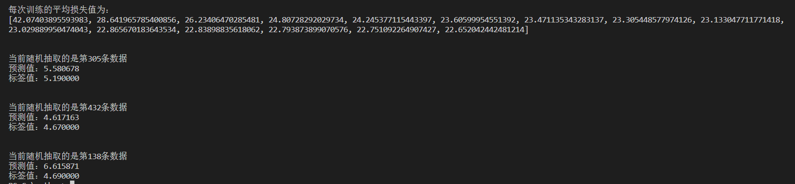

1. 第五次测试

迭代次数=20 学习率=0.002

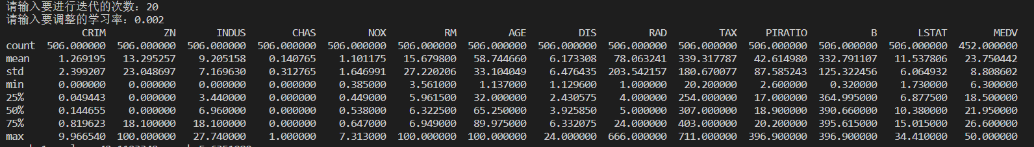

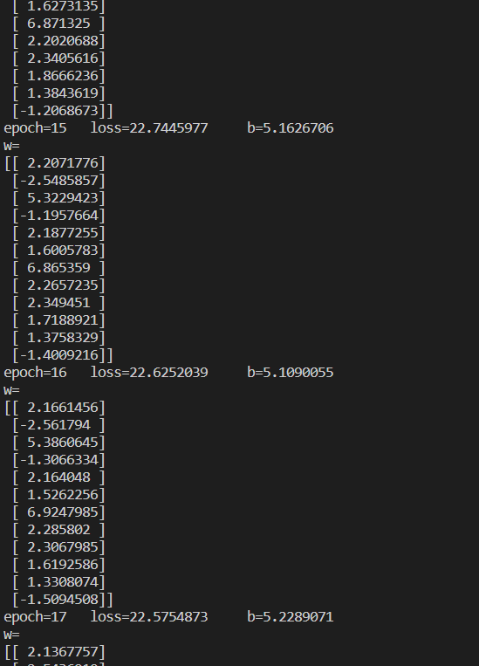

epoch=1

loss=42.1123342 b=5.6351080

w=

[[ 0.91505027]

[-0.10278232]

[ 2.0267122 ]

[ 0.67246324]

[ 0.8719777 ]

[ 0.97282404]

[ 3.4616623 ]

[ 1.2924577 ]

[ 1.0116805 ]

[ 2.062078 ]

[ 0.84192884]

[ 3.0657282 ]]

epoch=2

loss=28.7296527 b=5.1513982

w=

[[ 1.4090657 ]

[-0.81503916]

[ 2.600356 ]

[ 0.58937824]

[ 1.1610736 ]

[ 1.1971549 ]

[ 3.9398499 ]

[ 1.2977306 ]

[ 1.3389182 ]

[ 2.1195235 ]

[ 1.0066698 ]

[ 1.864147 ]]

中间省略……

epoch=19

loss=22.5577119 b=5.2156839

w=

[[ 2.0820467]

[-2.5103314]

[ 5.585222 ]

[-1.5413992]

[ 2.188793 ]

[ 1.4189248]

[ 7.134326 ]

[ 2.4975429]

[ 2.2970896]

[ 1.4076995]

[ 1.279025 ]

[-1.6756556]]

epoch=20 loss=22.4423848 b=5.1935201

w=

[[ 2.0687506]

[-2.5034258]

[ 5.6426797]

[-1.6199752]

[ 2.1780083]

[ 1.359503 ]

[ 7.199689 ]

[ 2.536012 ]

[ 2.2696645]

[ 1.3333868]

[ 1.2466348]

[-1.7666259]]

三次抽取测试集

