作业说明：

因为tensorflow版本问题采用

import tensorflow as tf

tf.compat.v1.disable_eager_execution()

实验展示结果：

finished loading CIFAR_10 data

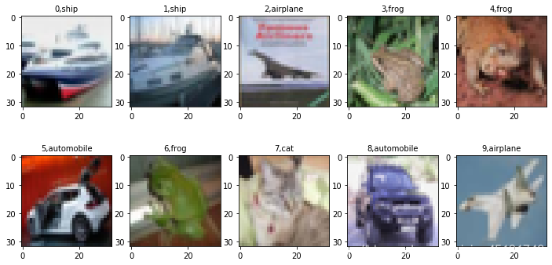

Training from scratch

Training starts from 1 epoch

Step 0 finished

Step100 finished

Step200 finished

Step300 finished

Step400 finished

Step500 finished

Step600 finished

Step700 finished

Step800 finished

Step900 finished

Step1000 finished

Step1100 finished

Step1200 finished

Train epoch:1 loss=2.159069 Accuracy=0.30000001192092896

Step 0 finished

Step100 finished

Step200 finished

Step300 finished

Step400 finished

Step500 finished

Step600 finished

Step700 finished

Step800 finished

Step900 finished

Step1000 finished

Step1100 finished

Step1200 finished

Train epoch:2 loss=2.138892 Accuracy=0.3000000119209289

Step 0 finished

Step100 finished

Step200 finished

Step300 finished

Step400 finished

Step500 finished

Step600 finished

Step700 finished

Step800 finished

Step900 finished

Step1000 finished

Step1100 finished

Step1200 finished

Train epoch:3 loss=2.143780 Accuracy=0.30000001192092896

………………

………………

………………

Step 0 finished

Step100 finished

Step200 finished

Step300 finished

Step400 finished

Step500 finished

Step600 finished

Step700 finished

Step800 finished

Step900 finished

Step1000 finished

Step1100 finished

Step1200 finished

Train epoch:30 loss=1.933603 Accuracy=0.5249999761581421

Step 0 finished

Step100 finished

Step200 finished

Step300 finished

Step400 finished

Step500 finished

Step600 finished

Step700 finished

Step800 finished

Step900 finished

Step1000 finished

Step1100 finished

Step1200 finished

Train epoch:31 loss=1.905577 Accuracy=0.5249999761581421

Step 0 finished

Step100 finished

Step200 finished

Step300 finished

Step400 finished

Step500 finished

Step600 finished

Step700 finished

Step800 finished

Step900 finished

Step1000 finished

Step1100 finished

Step1200 finished

Train epoch:32 loss=1.907997 Accuracy=0.5249999761581421

………………

………………

………………

Step 0 finished

Step100 finished

Step200 finished

Step300 finished

Step400 finished

Step500 finished

Step600 finished

Step700 finished

Step800 finished

Step900 finished

Step1000 finished

Step1100 finished

Step1200 finished

Train epoch:78 loss=1.765176 Accuracy=0.75

Step 0 finished

Step100 finished

Step200 finished

Step300 finished

Step400 finished

Step500 finished

Step600 finished

Step700 finished

Step800 finished

Step900 finished

Step1000 finished

Step1100 finished

Step1200 finished

Train epoch:79 loss=1.746915 Accuracy=0.7250000238418579

Step 0 finished

Step100 finished

Step200 finished

Step300 finished

Step400 finished

Step500 finished

Step600 finished

Step700 finished

Step800 finished

Step900 finished

Step1000 finished

Step1100 finished

Step1200 finished

Train epoch:80 loss=1.763659 Accuracy=0.699999988079071

Train finished takes: 8067.50168466568

Test accuracy0.673400

