生成数据的散点图：

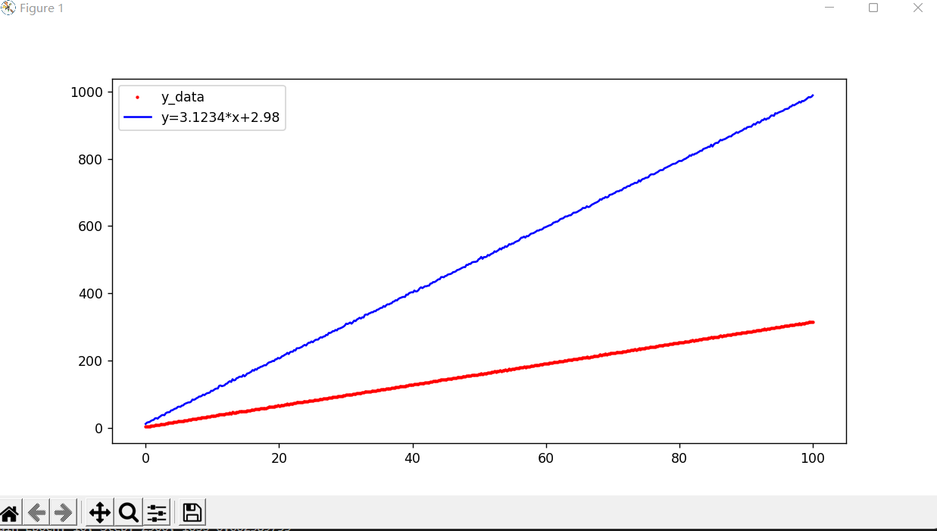

代码源码：

import numpy as np

import tensorflow as tf

tf.compat.v1.disable_eager_execution()

import matplotlib.pyplot as plt

x_data = np.linspace(0,100,500)

y_data = 3.1234* x_data + 2.98 + np.random.randn(500) * 0.5

plt.figure(figsize=[10,5])

plt.plot(x_data,y_data,'r.',markersize=3)

plt.plot(x_data,y_data *3.1234 + 2.98 ,'b-')

plt.legend(['y_data','y=3.1234*x+2.98'])

# plt.show()

x = tf.compat.v1.placeholder('float',name='x')

y = tf.compat.v1.placeholder('float',name='y')

w = tf.compat.v1.Variable(1.0,name='w0')

b = tf.compat.v1.Variable(1.0,name='b0')

def model(x,w,b):

return x*w+b

pred = model(x,w,b)

#训练模型

train_epochs = 10

learning_rate = 0.0001

display_step = 20

loss_function = tf.reduce_mean(tf.square(y - pred))

optimizer = tf.compat.v1.train.GradientDescentOptimizer(learning_rate).minimize(loss_function)

sess = tf.compat.v1.Session()

init = tf.compat.v1.global_variables_initializer()

loss_list = []

step = 0

sess.run(init)

for epoch in range(train_epochs):

for xs, ys in zip(x_data, y_data):

_, loss = sess.run([optimizer, loss_function], feed_dict={x: xs, y: ys})

loss_list.append(loss)

step += 1

if step % display_step == 0:

print(f'Train Epoch: {epoch+1:02d}, Step: {step:03d}, loss={loss:.9f}')

x_test = 5.79

y_hat = sess.run(model(x_test, w, b))

y_target = 3.1234 * x_test + 2.98

print(f'当x=5.79时，目标值为{y_target}，模型预测值为{y_hat}')

logdir =r'C:/Users/19085/my_log_dir'

tf.compat.v1.summary.FileWriter(logdir, tf.compat.v1.get_default_graph()).close()

通过Tensorboard显示构建的计算图：

