
AMERICAN INTERNATIONAL UNIVERSITY-BANGLADESH
Faculty of Science and Technology
Department of Computer Science
CSC 3215: Web Technologies

Semester: Summer 2025-26 | Group No:10 |  | Section: | I

Group Members:
SL. | Student ID | Name | Role | Signature
 | 24-56805-1 | Md. Abu Hurayra Arafat | Group Leader
 | 23-55027-3 | Tahomina Era | Member
 | 24-57978-2 | Syed Shahriar Mustafa | Member
 | 23-54990-3 | Sumiya Rahman Hadir | Member
Project Title
Pet Shop and Veterinary Service Management System

1. Project Title
PawCare - Pet Shop and Veterinary Service Management System

2. Short Description
PawCare is a web-based management system for a pet shop that also provides veterinary appointment services. The system brings pet and product browsing, shopping-cart management, order processing, delivery tracking, veterinary appointments, doctor appointment management, and medical-record access into one application.
The application is implemented with PHP, MySQL/MariaDB, HTML5, CSS3, JavaScript, and PHP sessions. It is a server-rendered, role-based monolithic web application intended to run locally through XAMPP.

3. Introduction
Pet owners commonly need to purchase pets or pet-care products and arrange veterinary services. When these activities are handled manually or through unrelated systems, customers may have difficulty finding products, tracking orders, booking appointments, and retaining treatment information. Shop administrators also need a central system to maintain inventory, observe sales, moderate reviews, and coordinate deliveries.
PawCare addresses this problem through four role-based portals:
- Customer portal - shopping, ordering, profile management, and appointment booking.
- Administrator portal - inventory, sales, delivery tracking, and review management.
- Doctor portal - appointment status management and medical-record viewing.
- Delivery portal - assigned-order processing and delivery-status updates.
The public pages provide access to the home page, specialist-doctor directory, doctor profiles, and appointment entry points. Authenticated pages use PHP sessions and role checks to restrict access to the appropriate portal.

4. Background Study

4.1 Problem context
A pet shop may manage several types of information simultaneously:
- Pet categories, breeds, health information, vaccination status, price, and stock.
- Pet-care products, categories, brands, prices, and stock.
- Customer accounts, carts, orders, payment methods, and delivery addresses.
- Doctors, specializations, availability, consultation fees, and appointments.
- Diagnoses, prescriptions, treatment notes, and future visit dates.
- Delivery agents, delivery status, and customer reviews.
Without a centralized database, the same information may be entered repeatedly, inventory may become inaccurate, and customers may not receive clear order or appointment updates.

4.2 Proposed solution
PawCare uses a relational MySQL/MariaDB database and role-specific PHP pages. The relational design connects users to doctors, customers to orders and appointments, orders to line items and deliveries, and appointments to medical records. Prepared statements, session-based authorization, input validation, password hashing, and escaped output are used in the implemented code where applicable.

4.3 Project objectives
The objectives of PawCare are to:
- Provide a single web interface for pet and product shopping.
- Maintain product, pet, category, and stock information.
- Allow customers to place and review orders.
- Provide online veterinary appointment booking.
- Allow doctors to update appointment status and view treatment records.
- Support delivery-status processing for assigned orders.
- Provide administrators with operational summaries and review controls.
- Apply role-based access to protect portal-specific operations.

5. Technology and Development Environment
Area | Technology used
Frontend markup | HTML5
Styling | CSS3
Client-side behavior | JavaScript
Server-side programming | PHP
Database | MySQL/MariaDB
Database API | PHP MySQLi
Authentication state | PHP sessions and a remember-login identifier cookie
Local server environment | XAMPP Apache and MySQL
Design assets | CSS files, image assets, and uploaded sample media

No Composer configuration, Node package manifest, separate API server, or automated test suite was identified in the project files.

6. System Architecture
PawCare follows a server-rendered client-server architecture. The PHP files combine request handling, database operations, and HTML presentation. Shared database and session initialization is provided by config/database.php and includes/session.php.
User browser
|
v
Public or role-specific PHP page
|
v
Session check and input validation
|
v
PHP business/request logic
|
v
MySQLi prepared statements and queries
|
v
MySQL/MariaDB database
|
v
HTML response, CSS styling, and JavaScript behavior

6.1 Main application areas
Area | Main files/directories
Public pages | index.php, specialist_doctors.php, doctor_profile.php, pet_reviews.php
Authentication | login.php, register.php, logout.php
Customer portal | customer/
Administrator portal | admin/
Doctor portal | doctor/
Delivery portal | delivery/
Shared infrastructure | config/, includes/
Database | database/
Presentation assets | assets/css/, assets/js/, assets/images/, uploads/

7. Project Folder Structure
PawCare/
├── index.php
├── login.php
├── register.php
├── logout.php
├── specialist_doctors.php
├── doctor_profile.php
├── book_appointment.php
├── confirm_appointment.php
├── appointment_token.php
├── pet_reviews.php
├── test_connection.php
├── config/
│ └── database.php
├── includes/
│ └── session.php
├── admin/
│ ├── dashboard.php
│ ├── dashboard_overview.php
│ ├── inventory.php
│ ├── manage_inventory.php
│ ├── sales_analytics.php
│ ├── delivery_tracking.php
│ └── customer_reviews.php
├── customer/
│ ├── dashboard.php
│ ├── billing.php
│ ├── orders.php
│ ├── order_details.php
│ ├── order_success.php
│ ├── profile.php
│ ├── edit_profile.php
│ └── change_password.php
├── doctor/
│ ├── login.php
│ ├── dashboard.php
│ ├── appointments.php
│ └── medical_records.php
├── delivery/
│ ├── index.php
│ ├── login.php
│ ├── dashboard.php
│ ├── assigned_orders.php
│ ├── order_details.php
│ ├── history.php
│ └── profile.php
├── database/
│ ├── schema.sql
│ ├── sample_data.sql
│ ├── pawcare_db.sql
│ ├── pawcare_schema_drop_and_create.sql
│ ├── pawcare_sample_data.sql
│ └── database_guide.md
├── assets/
│ ├── css/
│ ├── js/
│ └── images/
├── uploads/
│ ├── pets/
│ ├── products/
│ └── profiles/
└── Project_Report/
├── ER_Diagram.jpg
├── Use_CASE_Diagram.jpg
├── G_08_Project_Proposal_Paw_Care _Pet_Shop_and_Veterinary_Service_Management_System.docx
└── FINAL_PROJECT_REPORT.md

8. Types of Users
The system contains the four user types required by the project proposal:
- Administrator
- Customer
- Doctor
- Delivery agent
The users.role field stores these values as admin, customer, doctor, and delivery. The login process redirects each role to a separate dashboard.

9. Common Features

9.1 Authentication
- Login using username or email and password.
- Logout through logout.php.
- Session initialization through includes/session.php.
- Session regeneration after successful login.
- Role-based redirection to the correct dashboard.
- Account status check before login completion.

9.2 User registration
Public registration is implemented in register.php. Newly registered accounts are assigned the customer role. The form validates required values, email format, username format and length, Bangladeshi phone-number format, and minimum password length.

9.3 Account management
Customer and delivery profile pages provide profile viewing and editing. Customers can change their password through customer/change_password.php; the implementation verifies the current password before updating it. The source code does not provide a general account-deletion workflow or a separate password-reset-by-email workflow.

9.4 Dashboard
After login, each role receives a role-specific dashboard:
User type | Dashboard
Administrator | admin/dashboard.php
Customer | customer/dashboard.php
Doctor | doctor/dashboard.php
Delivery agent | delivery/dashboard.php

10. Specific Features by User Type
The following features are distinct by user type and are supported by the corresponding implementation files.

10.1 User 1: Administrator
- Inventory and stock administration - View and manage pets, products, categories, prices, availability, and stock through admin/inventory.php and admin/manage_inventory.php.
- Sales analytics - View order and sales information through admin/sales_analytics.php.
- Delivery monitoring - Monitor delivery and order statuses through admin/delivery_tracking.php.
- Customer-review moderation - Review customer feedback through admin/customer_reviews.php.
- Administrative overview - Access the administrator landing dashboard and overview page.

10.2 User 2: Customer
- Pet and product shopping - Browse available pets and products from customer/dashboard.php.
- Cart and checkout - Add or remove items, clear the cart, choose payment and delivery information, and create orders through customer/dashboard.php and customer/billing.php.
- Order history and receipts - View orders, line items, details, and successful-order receipts through customer/orders.php, customer/order_details.php, and customer/order_success.php.
- Veterinary appointment booking - Select a doctor, enter pet and appointment details, confirm the booking, and view the appointment token.
- Profile and password management - Edit profile data and change the account password.

10.3 User 3: Doctor
- Doctor-specific login and dashboard - Access the doctor portal using the doctor role.
- Appointment filtering - View appointments by all, pending, confirmed, completed, or cancelled status in doctor/appointments.php.
- Appointment status management - Confirm, complete, or cancel appointments belonging to the authenticated doctor.
- Medical-record viewing - View diagnosis, prescriptions, treatment notes, and next-visit dates in doctor/medical_records.php.
- Professional profile presentation - Doctor specialization, qualification, availability, fee, and biography are displayed through the public doctor pages.

10.4 User 4: Delivery Agent
- Assigned-order processing - View orders assigned to the authenticated delivery user through delivery/assigned_orders.php.
- Start delivery - Change an assigned delivery to Out for Delivery and update the related order to Shipped.
- Complete delivery - Mark an order as Delivered, save the delivery time, and update the related order status.
- Delivery history - Review previously processed deliveries through delivery/history.php.
- Delivery profile management - View and update delivery-user profile information through delivery/profile.php.
Implementation note: Delivery PHP files query a delivery_agents table, but that table is not defined in the supplied SQL schema files. The delivery portal therefore requires a schema correction or an update to the delivery queries before it can be considered fully deployable.

11. Detailed Functional Workflows

11.1 Customer shopping workflow
Customer logs in
↓
Available pets and products are loaded
↓
Customer adds an item to the cart
↓
Stock is checked
↓
Cart quantity is updated
↓
Customer opens billing
↓
Order and order items are inserted
↓
Customer views confirmation and order history

11.2 Appointment workflow
Visitor opens specialist_doctors.php
↓
Selects a doctor profile
↓
Submits book_appointment.php
↓
Login is required if the visitor is not authenticated
↓
Appointment details are stored in the session
↓
confirm_appointment.php inserts the appointment
↓
appointment_token.php displays the appointment information

11.3 Doctor workflow
Doctor logs in
↓
System verifies doctor role and doctor record
↓
Doctor filters appointments
↓
Doctor confirms, completes, or cancels an appointment
↓
Doctor views related medical records

11.4 Delivery workflow
Delivery agent logs in
↓
Assigned orders are loaded
↓
Start delivery
↓
Delivery status becomes Out for Delivery
↓
Mark delivered
↓
Delivery and order statuses become Delivered

12. Database Design
The application database is named pawcare_db. The principal tables are:
Table | Description
users | Names, usernames, email, password hash, role, profile, and status
doctors | Doctor specialization, qualification, availability, fee, and biography
pet_categories | Pet category definitions
pets | Pet catalogue, health and vaccination status, price, and stock
product_categories | Product category definitions
products | Product catalogue, brand, price, and stock
carts | Customer cart item type, item ID, and quantity
orders | Customer order totals, address, delivery, payment, and order status
order_items | Item-level order details and subtotals
appointments | Customer, doctor, pet, schedule, reason, and appointment status
medical_records | Diagnosis, prescription, treatment notes, and next visit
deliveries | Delivery assignment and delivery status
reviews | Customer rating, comment, and visibility status

12.1 Key relationships
users 1 ─── 1 doctors
users 1 ─── * carts
users 1 ─── * orders
users 1 ─── * appointments
doctors 1 ─── * appointments
orders 1 ─── * order_items
appointments 1 ─── 0..1 medical_records
orders 1 ─── 0..1 deliveries
The complete schema and foreign-key definitions are in database/schema.sql; the full import file is database/pawcare_db.sql.

13. ER Diagram
The project repository contains the ER diagram at:
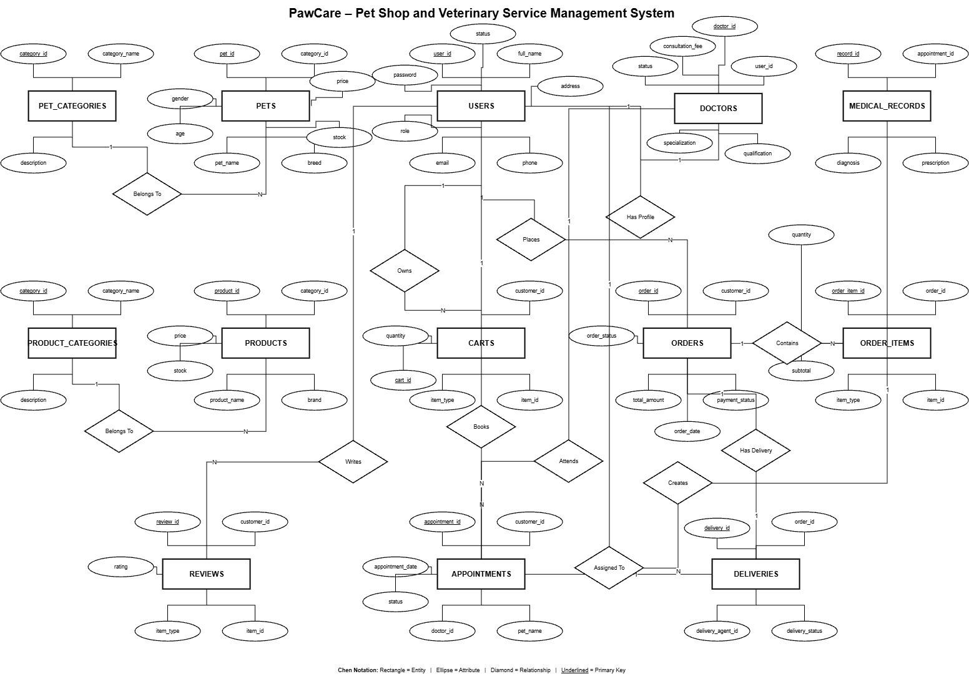
PawCare ER Diagram
File: Project_Report/ER_Diagram.jpg
The diagram should be reviewed against the current schema before final submission, particularly because the delivery PHP code references delivery_agents while the supplied schema defines delivery assignment through deliveries.delivery_agent_id.

14. Use Case Diagram
The project repository contains the use-case diagram at:
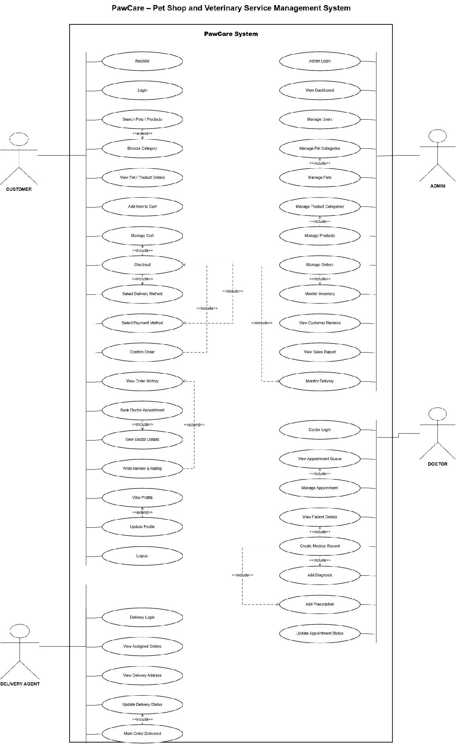
PawCare Use Case Diagram
File: Project_Report/Use_CASE_Diagram.jpg
The principal actors are Administrator, Customer, Doctor, and Delivery Agent. Public visitors also interact with the doctor directory and registration/login entry points.

15. UI Design
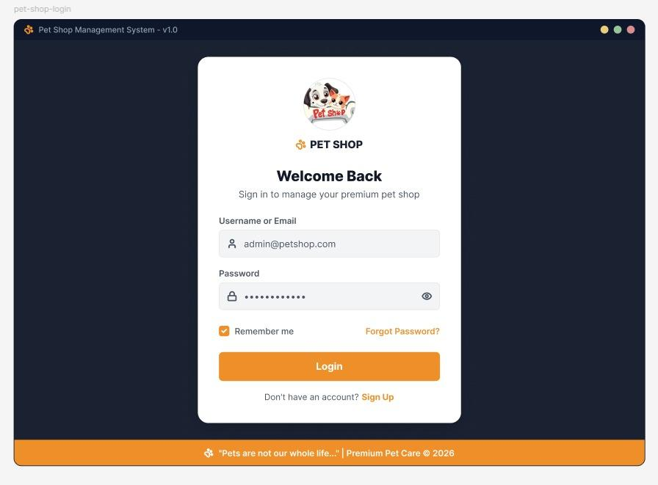
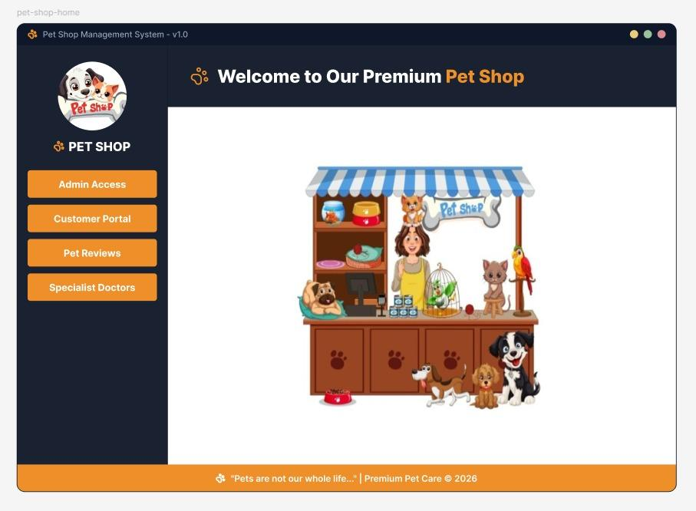
UI (Figma/Sketch)

15.1 Main UI areas
UI area | Relevant files
Public home page | index.php, assets/css/home.css
Login and registration | login.php, register.php, assets/css/login.css, assets/css/register.css
Customer dashboard | customer/dashboard.php, assets/css/customer-dashboard.css
Customer orders and billing | customer/orders.php, customer/billing.php, assets/css/customer-orders.css, assets/css/billing.css
Administrator dashboard | admin/dashboard.php, assets/css/admin-dashboard.css
Doctor dashboard | doctor/dashboard.php, assets/css/doctor-dashboard.css
Delivery portal | delivery/*.php, assets/css/delivery_*.css
Doctor directory and profiles | specialist_doctors.php, doctor_profile.php, assets/css/specialist-doctors.css, assets/css/doctor-profile-public.css

15.2 Proposed screen navigation
Home
├── Customer Login / Registration
│ └── Customer Dashboard
│ ├── Shop and Cart
│ ├── Billing and Orders
│ ├── Profile
│ └── Veterinary Appointment
├── Administrator Login
│ └── Admin Dashboard
│ ├── Inventory
│ ├── Sales Analytics
│ ├── Delivery Tracking
│ └── Customer Reviews
├── Doctor Login
│ └── Doctor Dashboard
│ ├── Appointments
│ └── Medical Records
└── Delivery Login
└── Delivery Dashboard
├── Assigned Orders
├── Delivery History
└── Profile

16. Security and Validation
Security area | Implementation evidence
Password hashing | register.php uses password_hash()
Password verification | login.php and customer/change_password.php use password_verify()
Session protection | login.php calls session_regenerate_id(true) after successful login
Role authorization | Role checks are present at the beginning of role-specific pages
SQL injection reduction | Most user-controlled operations use MySQLi prepared statements
Input validation | Registration, appointment status, item type, and identifier values are validated
Output escaping | Dynamic output commonly uses htmlspecialchars()
Transactional delivery update | Delivery and order updates use a MySQL transaction

No CSRF-token implementation, rate limiter, or environment-variable secret manager was identified. Database credentials are currently stored in config/database.php, so the local credentials must not be reused in a production deployment.

17. Installation and Demonstration

Requirements
- XAMPP
- Apache
- MySQL/MariaDB
- phpMyAdmin
- A modern web browser

Steps
- Copy the project folder to C:\xampp\htdocs\.
- Start Apache and MySQL in XAMPP.
- Visit http://localhost/phpmyadmin.
- Import database/pawcare_db.sql.
- Verify the connection values in config/database.php.
- Visit:
`text
http://localhost/WT_Summer_2025-26_G_08_Paw_Care-_Pet_Shop_and_Veterinary_Service_Management_System/

Demonstration accounts
The sample SQL includes these account identifiers:
Role | Username | Email
Administrator | pawcare_admin | admin@pawcare.com
Customer | rahim_ahmed | customer1@pawcare.com
Customer | sadia_islam | customer2@pawcare.com
Doctor | dr_hasan | doctor1@pawcare.com
Doctor | dr_nusrat | doctor2@pawcare.com
Delivery | karim_delivery | delivery1@pawcare.com
Delivery | rafi_delivery | delivery2@pawcare.com

The SQL contains password hashes rather than plaintext passwords. The plaintext sample passwords were not documented in the repository; they should be set separately in a controlled local demonstration database.

18. Requirement Checklist
Requirement | Status | Evidence
Project title | Implemented | PawCare project files and documentation
Short description | Completed | Section 2
Introduction | Completed | Section 3
Background study | Completed | Section 4
ER diagram | Available | ER_Diagram.jpg
Use-case diagram | Available | Use_CASE_Diagram.jpg
UI design | Implemented UI documented | Section 15; page-specific CSS and PHP files
Four user types | Implemented | Admin, customer, doctor, delivery
Login | Implemented | login.php and role-specific login entry points
Logout | Implemented | logout.php
Registration | Implemented for customers | register.php
Password change | Implemented for customers | customer/change_password.php
Profile management | Implemented for customer and delivery pages | customer/edit_profile.php, delivery/profile.php
Personalized dashboards | Implemented | admin/, customer/, doctor/, and delivery/
At least three distinct features per user type | Documented | Section 10

19. Limitations and Future Improvements
- Add or reconcile the missing delivery_agents table so the delivery portal matches the database schema.
- Move database credentials to environment variables or a protected configuration outside the public web root.
- Add CSRF tokens to state-changing forms.
- Add a controlled password-reset process.
- Add automated functional and integration tests.
- Add a dedicated Figma/Sketch design file if a separate design artifact is required.
- Add server-side upload validation if user-upload workflows are expanded.
- Add pagination and stronger reporting filters for large catalogues and order histories.

20. Conclusion
PawCare provides an integrated foundation for pet-shop and veterinary-service management. Its role-based structure separates the responsibilities of administrators, customers, doctors, and delivery agents, while the relational database connects catalogue, commerce, appointment, medical, delivery, and review data. The implementation satisfies the principal CSC 3215 project requirements and provides a practical base for further improvements in deployment security, automated testing, and delivery-schema consistency.

References to Project Artifacts
- database/schema.sql - relational database schema
- database/sample_data.sql - sample records
- Project_Report/ER_Diagram.jpg - entity-relationship diagram
- Project_Report/Use_CASE_Diagram.jpg - use-case diagram
- Project_Report/G_08_Project_Proposal_Paw_Care _Pet_Shop_and_Veterinary_Service_Management_System.docx - original proposal

