DFT Example : Hand Calculation:

Calculate the Discrete Fourier Transformation (DFT) of a single sine function with f0 = 1Hz , N=4, Ts = ¼ seconds , Fs = 4 Hz .  
In this example the observation window (N*Ts) is equal to one period of the periodic time function. The definition of the normalised DFT is given below:

$$X\left[k\right]=\left(\frac{1}{N}\right)∙\sum_{n=0}^{N-1}{x\left[n\right]∙e^{-j\frac{2π}{N}kn} }n and k ϵ \left[0 ;N-1\right]$$

x(t)

x[n]

| X[k] |

t (s)

║

n*Ts = n*tstep

0 1*fstep 2*fstep 3*fstep 4*fstep

║ ║

Fs/2 Fs

f (Hz)

║

k*(Fs /N) = k*fstep

X[0] =

X[1] =

X[2] =

X[3] =

The concept of the DFT is summarised in the figure below[1]:

DFT

N-Points

time

domain

N-Points

frequency

domain

Ts

N.Ts

t (s)

fstep

N.fstep

f (Hz)

Fs

Fs/2

Fs (N-1)/N

t (s)

fmin= fstep=1/(N.Ts) = Fs /N

fstep

The upper half of the X[k] coefficients actually corresponds to the spectrum range [-Fs/2 ; 0)

Figure 1 FFT basic idea: converting N points in time to N points in frequency domain

Fill out the table below for the example which you calculated in the previous page:

x(t)

x[n]

| X[k] |

0,5

t (s)

║

n*Ts = n*tstep

0 1*fstep 2*fstep 3*fstep 4*fstep

║ ║

Fs/2 Fs

f (Hz)

║

k*(Fs /N) = k*fstep

**Exercise 1** function with f0 = 1 Hz , N=4, Fs = 4 Hz

|  |  |  |  |  |  |  |  |  |
| --- | --- | --- | --- | --- | --- | --- | --- | --- |
|  | ***Parameters of the DFT*** | | | | |  | ***Characteristics of the Signal*** | |
| Exercise Nr. | Number of points | Sampling Frequency | Frequency Resolution | Time Step = Time resolution | Observation Window |  | Fundamental Frequency | Period |
| & Time Fct | **N** | **Fs**  [Hz] | **Fs/N = fstep**  [Hz] | **Ts = tstep**  [s] | **N*Ts = N/Fs**  [s] |  | **f0** [Hz]  and in [k*fstep] | **T0** [s]  and in [n*Ts] |
| (1) Single Sinus |  |  |  |  |  |  |  |  |

You can calculate the DFT numerically using the FFT (Fast Fourier Transform) function. An example code is shown below.

It is important to notice that, when you calculate the DFT numerically, you code needs to:

* define the parameters of the DFT
* define time and frequency vectors, based on a common index vector.

clear all, close all, clc;

% PARAMETERS

N = 4;

Fs = 4; %100;

aux = 0:1:N-1;

tstep = 1/Fs;

fstep = Fs/N;

t = aux*tstep;

f = aux*fstep;

% FUNCTIONS

x_t = sin(2*pi*1*t);

X_k = (1/N)*fft(x_t);

% PLOTS

….

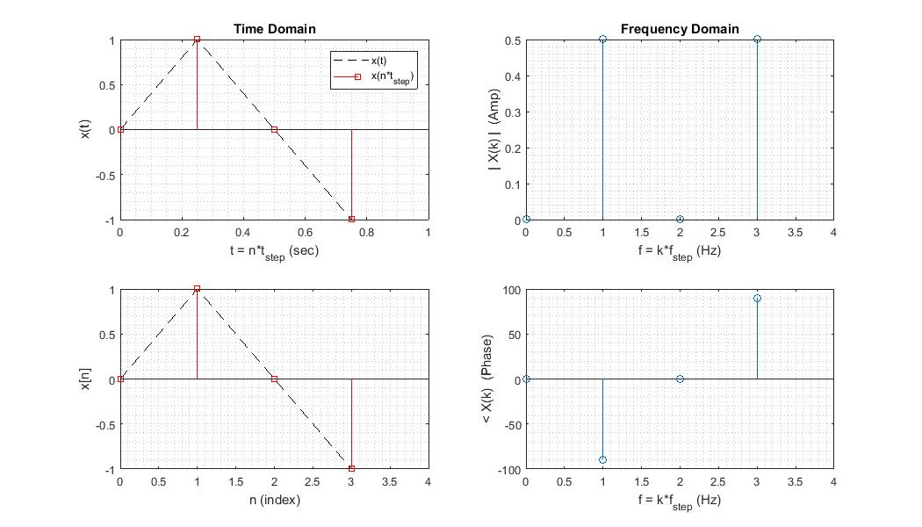

The complete Matlab script is uploaded as *DFT_example_basic.m*

Read and understand the code lines describing the plot commands and the “goodies for a clearer plot”.

Then change the parameters to match the request of the following exercises. You can add for each exercise the corresponding plot as a jpg figure, to document your work.

**Exercise 2** function with f0 = 25 Hz , N=4, Fs = 100 Hz

|  |  |  |  |  |  |  |  |  |
| --- | --- | --- | --- | --- | --- | --- | --- | --- |
|  | ***Parameters of the DFT*** | | | | |  | ***Characteristics of the Signal*** | |
| Exercise Nr. | Number of points | Sampling Frequency | Frequency Resolution | Time Step = Time resolution | Observation Window |  | Fundamental Frequency | Period |
| & Time Fct | **N** | **Fs**  [Hz] | **Fs/N = fstep**  [Hz] | **Ts = tstep**  [s] | **N*Ts = N/Fs**  [s] |  | **f0** [Hz]  and in [k*fstep] | **T0** [s]  and in [n*Ts] |
| (2) Single Sinus |  |  |  |  |  |  |  |  |

**Exercise 3** function with f0 = 25 Hz , N=16, Fs = 100 Hz

|  |  |  |  |  |  |  |  |  |
| --- | --- | --- | --- | --- | --- | --- | --- | --- |
|  | ***Parameters of the DFT*** | | | | |  | ***Characteristics of the Signal*** | |
| Exercise Nr. | Number of points | Sampling Frequency | Frequency Resolution | Time Step = Time resolution | Observation Window |  | Fundamental Frequency | Period |
| & Time Fct | **N** | **Fs**  [Hz] | **Fs/N = fstep**  [Hz] | **Ts = tstep**  [s] | **N*Ts = N/Fs**  [s] |  | **f0** [Hz]  and in [k*fstep] | **T0** [s]  and in [n*Ts] |
| (3) Single Sinus |  |  |  |  |  |  |  |  |

**Exercise 4** function with f0 = 25 Hz , N=16, Fs = 400 Hz

|  |  |  |  |  |  |  |  |  |
| --- | --- | --- | --- | --- | --- | --- | --- | --- |
|  | ***Parameters of the DFT*** | | | | |  | ***Characteristics of the Signal*** | |
| Exercise Nr. | Number of points | Sampling Frequency | Frequency Resolution | Time Step = Time resolution | Observation Window |  | Fundamental Frequency | Period |
| & Time Fct | **N** | **Fs**  [Hz] | **Fs/N = fstep**  [Hz] | **Ts = tstep**  [s] | **N*Ts = N/Fs**  [s] |  | **f0** [Hz]  and in [k*fstep] | **T0** [s]  and in [n*Ts] |
| (4) Single Sinus |  |  |  |  |  |  |  |  |

Try now changing the time function for a cosinus, a triangle, a sawtooth and a square function, and check the corresponding spectra.

1. The concept of the DFT is discussed in chapter 2 of the script.