Application is collection of components that work with each other and with the android framework

There are 4 types of components

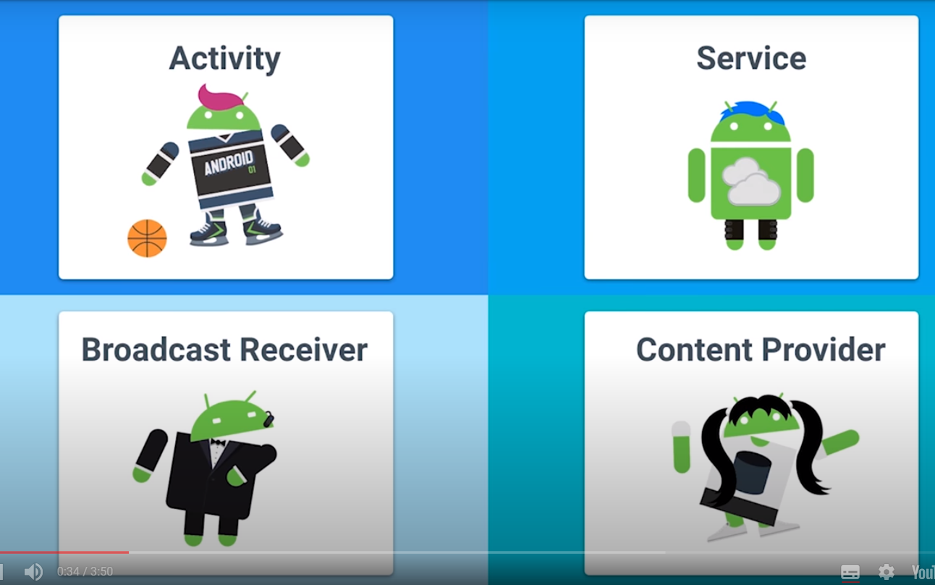

Activity is a single focused thing that the user can do



An activity creates **views** to show the user information, and to let the user interact with the activity. Views are a class in the Android UI framework. They occupy a rectangular area on the screen and are responsible for drawing and handling events. An activity determines what views to create (and where to put them), by reading an XML layout file. These XML files, as Dan mentioned, are stored in the **res** folder inside the folder labeled **layout**.

Android

* It is a software stack with linux kernel as its base which handles low level task like hardware,power management
* Above that we have c/c++ libraries like Sqlite + Android runtime along with core android libraries
* Above that Application framework
* Above Application layer which includes our app and any other app
* When we click on run then the first thing which happens is compilation of code into byte code which can be run at runtime In android studio this is done using gradle –a build tool kit that manages dependencies

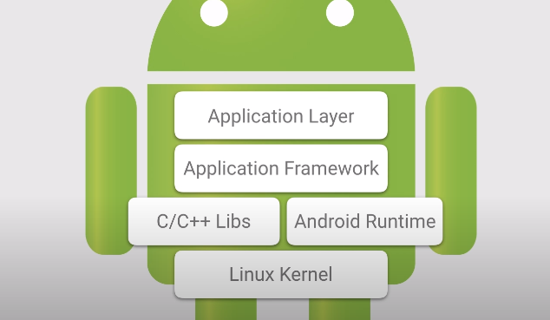

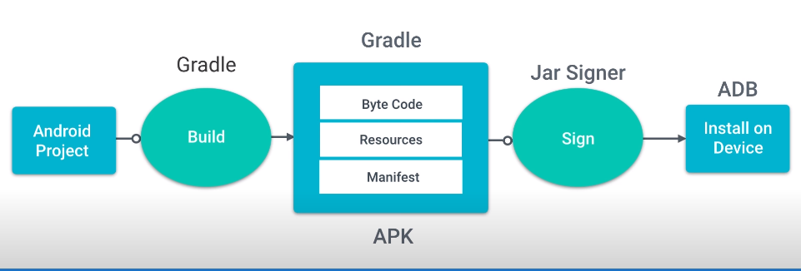

## Android Debug Bridge

The other tool that Dan mentioned is **adb** which is short for Android Debug Bridge. ADB is a command line utility included with Android's SDK.

TabLayout

* Tabs are created using newTab() method of TabLayout class.
* Tabs of layout are attached over TabLayout using the method addTab(Tab) method.

FRAGMENTS

* You create fragments by extending **Fragment** class and You can insert a fragment into your activity layout by declaring the fragment in the activity's layout file, as a **<fragment>** element.
* Prior to fragment introduction, we had a limitation because we can show only a single activity on the screen at one given point in time. So we were not able to divide device screen and control different parts separately. But with the introduction of fragment we got more flexibility and removed the limitation of having a single activity on the screen at a time. Now we can have a single activity but each activity can comprise of multiple fragments which will have their own layout, events and complete life cycle.
* 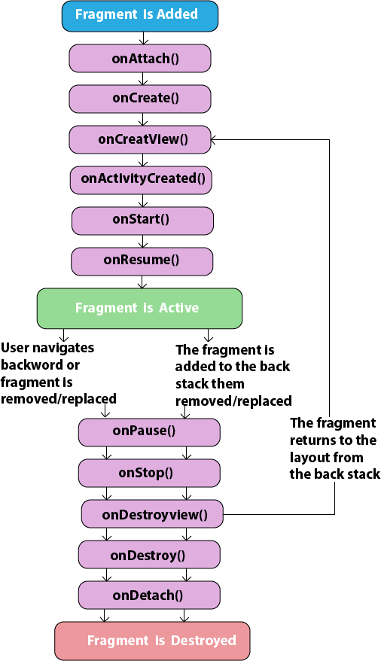
* onCreateView(LayoutInflater, ViewGroup, Bundle) –main method

### Output:

in making

#paneer

in making

#paneer

#onion

#tomato

in making

#paneer

#onion

#tomato

#chilli sauce

Name-Apoorva Gupta

Enroll No-0901CS181018

[Report Bug](https://ide.geeksforgeeks.org/report.php)



FrameLayout is the simplest implementation of ViewGroup. Child views are drawn are in a stack, where the latest added view is drawn at the top. Usually you can use one of the next approaches or combine them:

1. Add a single view hierarchy into FrameLayout
2. Add multiple children and use android:layout_gravity to navigate them

[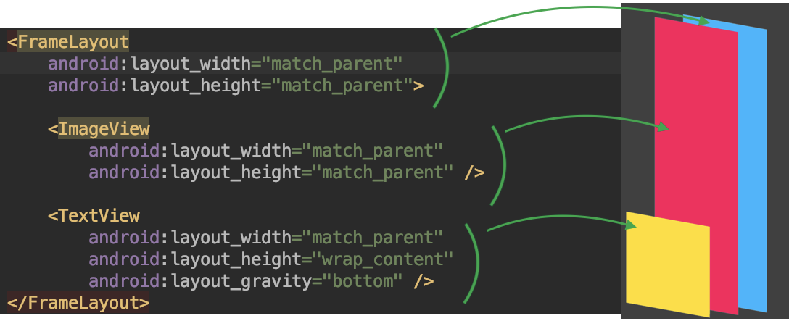](https://i.stack.imgur.com/8AU83.png)

Another popular approaches of using FrameLayout:

* as a Fragment container
* as an ancestor of your custom ViewGroup

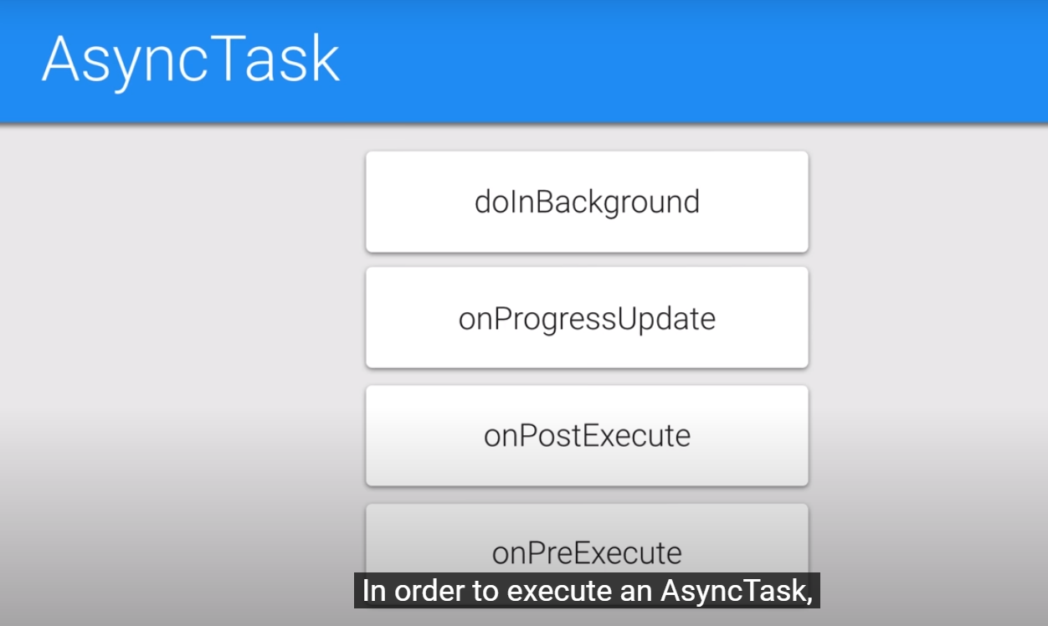

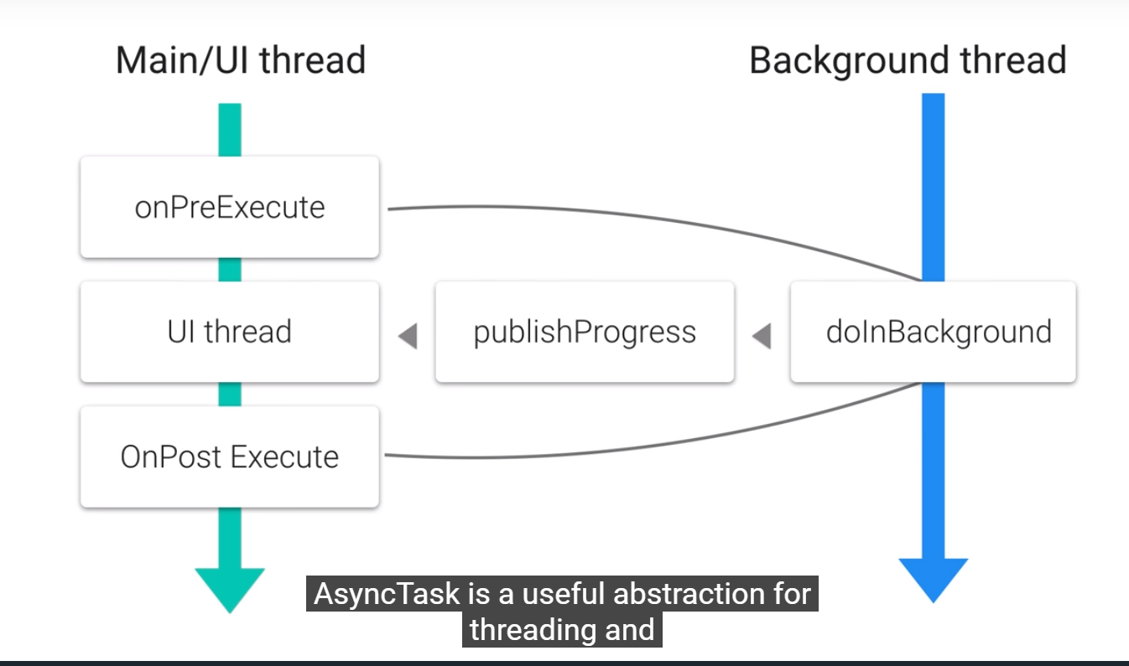

Fragments

