Computer Networks

**A computer network is a system in which multiple computers are connected to each other to share information and resources.**In other words, it is a network of various communicating devices or elements connected by communication links. The communication elements can be a computer, mobile, router, switch, etc., and communication links can be an optical fibre cable, coaxial fibre cable, wireless LAN, etc.

In a computer network, one process in one device is able to send/receive data to/from at least one process residing in a remote device. The internet is a network of networks. It is not managed by a single organization.

#### Node

**In a computer network, a node is either a connection point, a redistribution point, or a communication point.**In other words, a node refers to a point or joint where a connection takes place.

A physical network node is an active electronic device that is attached to a network. It is capable of sending, receiving, or forwarding information over a communication channel.

**Each device on a network that has a unique logical or IP (Internet Protocol) address can also be termed as a node.** When connected in a network, every node in a network must have a MAC address. MAC address is a unique identifier assigned by device manufacturers to a network interface controller (NIC) for communications in a network. NIC is a computer hardware component that connects a computer to a computer network. When connected to the internet or intranet, the nodes are referred to as internet nodes. These nodes are identified by their IP addresses.

Some Data Link layer devices(switches, bridges, WLAN access points, etc.) do not have an IP address. Thus, they are physical but not internet node

The degree of connectivity of a node is the measure of the number of connections a node has with other nodes.

**Goals of a Computer Network**

The main goal of a computer network is mainly related to interconnection and information interchange. Some major goals of a computer network are as follows :

* **Resource Sharing:**All the devices present in a computer network can share their resources with each other.
* **Reliability:**A computer network makes the system reliable. If one node fails, the working of all nodes will not be affected.
* **Money Efficiency:** In a computer network, nodes can share hardware and software components with each other, thus making it money efficient.
* **Scalability:**A computer network makes the system scalable. We can add or remove the nodes from the network with our convenience.

**Classification of Computer Network**

A computer network can be classified on the basis of communication media, functional relationships, topology, and scale of the network.

Now have a look at all these classifications one by one.

* **Classification based on communication media:**

Computer Networks can be broadly classified in the following two categories based on communication media:

1. **Wired Network:** It can be implemented using coaxial cable, optical fibre cable, etc.
2. **Wireless Network:** It can be implemented using Terrestrial Microwave, Communication Satellites, Wireless LANs.

* **Classification according to scale:**

Computer Networks can be broadly classified in the following three categories according to scale or the area of a network:

1. **LAN:** It is the acronym for Local Area Network. It is confined to a small geographical area such as a library, college building, etc.
2. **MAN:** It is the acronym for Metropolitan Area Network. It is confined to a large geographical area such as a city or town.
3. **WAN:** It is the acronym for Wide Area Network. It is confined to a very large geographical area such as a country or even the whole world.

* **Classification based on Network topology:**

Computer Networks can be broadly classified in the following five categories based on network topology i.e based on how the nodes are connected in a network:

1. **Bus:** In this network topology, every node is connected to a single cable, also called a bus.
2. **Star:** In this network topology, all the devices are connected to a single hub through a cable. This hub is the central node. The hub can be active or passive in nature.
3. **Ring:** In this network topology, a ring is formed between various nodes that connect a device with its exactly two neighbour devices.
4. **Mesh:** In this network topology, every node is connected to another node via a particular channel.
5. **Hybrid:** This network topology is a combination of two or more topologies.

* **Classification based on Functional Relationship:**

Computer Networks can be broadly classified in the following three categories based on functional relationship:

1. **Active Networking:** It allows the packets flowing through a telecommunications network to dynamically modify the operations of a network.
2. **Client-Server Networking:** It is a network in which a client runs the program and access data that are stored on the server.
3. **Peer-to-Peer Networking:** This network facilitates the flow of information from one peer to another without any central server.

**A computer network is a system in which multiple computers are connected to share information and resources.**Computer network varies with each other based on their functionality, geography, ownership, and communication media used.

So, in this blog, we are going to learn about various types of computer networks based on geographical areas they cover, functionality, ownership, and communication media used.

Types of Computer Networks

***A computer network can be divided into the following types, based on the geographical area that they cover, they are:***

1. **LAN(Local Area Network)**
2. **MAN(Metropolitan Area Network)**
3. **WAN(Wide Area Network)**

Now, let us study these networks one by one:

#### LAN(Local Area Network)

A local area network is a network, which is designed to operate over a very small geographical or physical area such as an office, building, a group of buildings, etc.

Generally, it is used to connect two or more personal computers through a communication medium such as coaxial, twisted-pair cables, etc. A LAN can use either wired or wireless mode of communication. The LAN which entirely uses wireless media for communication can be termed as **WLAN(Wireless Local Area Network)**.

Local Area Networks came under existence in around 1970s. IEEE developed the specifications for LAN. The speed of this network varies from 10mbps(Ethernet network) to 1gbps(FDDI or Gigabit Ethernet).

In other words, a LAN connects a relatively small number of machines in a relatively close geographical area. Bus, Ring, and Star topology are generally used in a local area network. In LAN, one computer can become a server in a star topology, serving all other computers called clients. Two different buildings can be connected very easily in LAN using a 'Bridge'.

Ethernet LAN is the most commonly used LAN. The speed of a Local Area Network also depends on the topology used. ***For example,*** a LAN using bus topology has a speed of 10mbps to 100mbps, while in ring topology it is around 4mbps to 16mbps. LAN's are generally privately owned networks.

**Following are the functionalities of a Local Area Network:**

1. **File Serving:** In LAN, a large storage disk acts as a central storage repository.
2. **Print Serving:** Printers can be shared very easily in a LAN by various computers.
3. **Academic Support:** A LAN can be used in the classroom, labs, etc. for educational purposes.
4. **Manufacturing Support:** LAN can support the manufacturing and industrial environment.
5. **High Reliability:** Individual workstations might survive the network in case of failures.

**Following are the advantages of a LAN:**

1. File transfer and file access
2. Resource or peripherals sharing
3. Personal computing
4. Document distribution
5. Easy to design and troubleshoot
6. Minimum propagation delay
7. High data rate transfer
8. Low error rate
9. Easily scalable(devices can be added or removed very easily)

**Following are the disadvantages of a LAN:**

1. Equipment and support may be costly
2. Some hardware devices may not inter-operate properly

#### MAN(Metropolitan Area Network)

A Metropolitan Area Network is a bigger version of LAN that uses similar technology as LAN. It spans over a larger geographical area such as a town or an entire city.

It can be connected using an optical fiber cable as a communication medium. Two or more LAN's can also be connected using routers to create a MAN. When this type of network is created for a specific campus, then it is termed as CAN(Campus Area Network).

The MAN spans over a geographical area of about 50km. The best example of MAN is the cable television network that spans over the whole city.

A MAN can be either a public or privately owned network. Generally, a telephone exchange line is most commonly used as a communication medium in MAN. The protocols that are used in MAN are RS-232, Frame Relay, ISDN, etc.

**Uses of MAN are as follows:**

1. MAN can be used for connecting the various offices of the same organization, spread over the whole city.
2. It can be used for communication in various governmental departments.

**Following are the advantages of using MAN:**

1. Large geographical area cover as compared to LAN
2. High-speed data connectivity
3. The Propagation delay of MAN is moderate

**Following are the disadvantages of MAN:**

1. It is hard to design and maintain a MAN
2. MAN is less fault-tolerant
3. It is costlier to implement
4. Congestions are more in a MAN

WAN(Wide Area Network)

A Wide Area Network is the largest spread network. It spans over very large-distances such as a country, continent or even the whole globe. Two widely separated computers can be connected very easily using WAN. For Example, the Internet.

A WAN may include various Local and Metropolitan Area Network. The mode of communication in a WAN can either be wired or wireless. Telephone lines for wired and satellite links for wireless communication can be used in a wide area network.

In other words, WAN provides long distance transmission of data, voice, image, and video, over a large geographical area. A WAN may span beyond 100km range. It may be privately or publicly owned.

The protocols used in WAN are ISDN(Integrated Service Digital Network), SMDS(Switched Multi-Megabit Data Service), SONET(Synchronous Optical Network), HDLC(High Data Link Control), SDLC(Synchronous Data Link Control), etc.

The advantage of WAN is that it spans over a very large geographical area, and connects a huge mass of people.

**Following are the disadvantages of WAN:**

1. The propagation delay is more in a WAN
2. The data rate is low
3. The error rate is high
4. It is very complex to design a WAN

These are the types of network according to geographical area.

***Following are the types of network, based on functionality:***

* **Client-Server Network:** Client-Server network is a network in which a client runs the program and access data that are stored on the server. In this kind of network, one computer becomes the server, serving all other computers called clients.
* **Peer-to-Peer Network:** Peer-to-Peer network facilitates the flow of information from one peer to another without any central server. In other words, each node on a server acts as both client and server.

***Following are the types of network, based on Ownership:***

* **Private Network:** A private network is a network in which various restrictions are imposed to secure the network, to restrict unauthorized access. This type of network is privately owned by a single or group of people for their personal use. Local Area Network(LAN) can be used as a private network.
* **Public Network:** A public network is a network that has the least or no restrictions on it. It can be freely accessed by anyone, without any restrictions. This type of network is publicly owned by the government or NGOs. Metropolitan Area Network(MAN) and Wide Area Network(WAN) can be used as a public network.

***Following are the types of network, based on Transmission Media:***

* **Bound/Guided Media Network:** Bounded/Guided media can also be referred to as wired media. This kind of networks provides a physical link between two nodes connected in a network. The physical links are directed towards a particular direction in the network. Co-axial, twisted pair, optical fiber cable, etc. can be used in such networks for connectivity. Local Area Network(LAN) and Metropolitan Area Network(MAN) can be used as a Bound/Guided media network.
* **Unbound/Unguided Media Network:** Unbounded/Unguided media can also be referred to as wireless media. This kind of network does not need any physical link for electromagnetic transmission. Radio waves, Microwaves, Infrared, etc. can be used in such networks for connectivity. Metropolitan Area Network(MAN) and Wide Area Network(WAN) can be used as an Unbound/Unguided media network.

#### Peer-to-Peer Network

**The Peer-to-Peer network is also called P2P or computer-to-computer network.** 'Peers' are the nodes or computer system which are connected to each other. In this kind of network, each node is connected to each other node in the network.

The nodes can share printers or CDROM drives, and allow other devices to read or write to its hard disk, allowing sharing of files, access to its internet connection, and other resources. Files or resources can be shared directly between the system on the network, without the need of any central server. Such kind of network, where we allow nodes to become a server and share things in this manner, can be referred to as a peer-to-peer network.

In a peer-to-peer network, each node can work as either a server as well as a client. This network does not distinguish between the client or server.

***Following are the advantages of using a peer-to-peer network:***

1. Easy to implement and manage.
2. Nodes or workstations are independent of one another. Also, no access permissions are needed.
3. The network is reliable in nature. If a peer fails, it will not affect the working of others.
4. There is no need for any professional software in such kind of networks.
5. The cost of implementation of such networks is very less.

***Following are the disadvantages of using a peer-to-peer network:***

1. Storage is decentralized, and also not so efficiently managed.
2. No data backup options are available in peer-to-peer networks.
3. These kinds of networks are not so secure.

#### Server-Based Networks

**A Server-Based network can also be termed as a Client-Server network.**A server is a node that acts as a service provider for clients. They wait for client requests and then respond to them. The server is located elsewhere on the network, usually on a more powerful machine. Here, the server is the central location where users share and access network resources. It controls the level of access that users have to share resources. In other words, a server provides functionality and serve other programs called clients.

There is various kind of servers depending upon their use, they can be a web server(which servers HTTP requests), Database servers(which runs DBMS), File server(which provides files to clients), Mail server, print server, Game server, Application server, and so on. A server can contain web resources, host web applications, store user and program data, etc.

## What are the Data Transmission Modes in a network?

***The data transmission modes can be characterized in the following three types based on the direction of exchange of information:***

1. Simplex
2. Half-Duplex
3. Full Duplex

***The data transmission modes can be characterized in the following two types based on the synchronization between the transmitter and the receiver:***

1. Synchronous
2. Asynchronous

***The data transmission modes can be characterized in the following two types based on the number of bits sent simultaneously in the network:***

1. Serial
2. Parallel

**Simplex**

**Simplex is the data transmission mode in which the data can flow only in one direction, i.e., the communication is unidirectional.** In this mode, a sender can only send data but can not receive it. Similarly, a receiver can only receive data but can not send it.

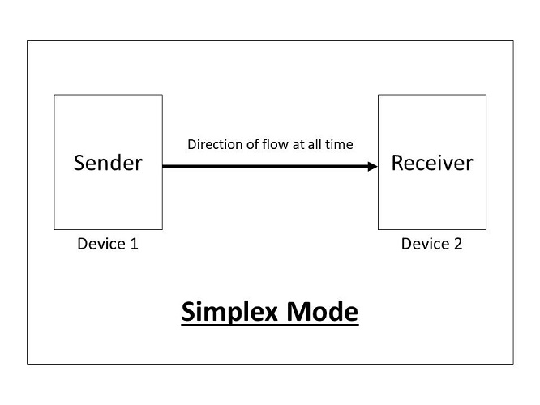

For Example, Radio and TV transmission, keyboard, mouse, etc.

**Following are the advantages of using a Simplex transmission mode:**

1. It utilizes the full capacity of the communication channel during data transmission.
2. It has the least or no data traffic issues as data flows only in one direction.

**Following are the disadvantages of using a Simplex transmission mode:**

1. It is unidirectional in nature having no inter-communication between devices.
2. There is no mechanism for information to be transmitted back to the sender(No mechanism for acknowledgement).

**2. Half-Duplex**

**Half-Duplex is the data transmission mode in which the data can flow in both directions but in one direction at a time. It is also referred to as Semi-Duplex.** In other words, each station can both transmit and receive the data but not at the same time. When one device is sending the other can only receive and vice-versa.

**3. Full-Duplex**

**Full-Duplex is the data transmission mode in which the data can flow in both directions at the same time. It is bi-directional in nature.**It is two-way communication in which both the stations can transmit and receive the data simultaneously.

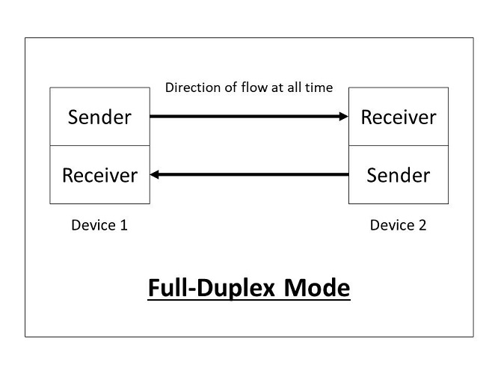

Full-Duplex mode has double bandwidth as compared to the half-duplex. The capacity of the channel is divided between the two directions of communication. This mode is used when communication in both directions is required simultaneously.

For Example, a Telephone Network, in which both the persons can talk and listen to each other simultaneously.

**Following are the advantages of using a full-duplex transmission mode:**

1. The two-way communication can be carried out simultaneously in both directions.
2. It is the fastest mode of communication between devices.

**Following are the disadvantages of using a half-duplex transmission mode:**

1. The capacity of the communication channel is divided into two parts. Also, no dedicated path exists for data transfer.
2. It has improper channel bandwidth utilization as there exist two separate paths for two communicating devices.

**1. Synchronous**

**The Synchronous transmission mode is a mode of communication in which the bits are sent one after another without any start/stop bits or gaps between them.** Actually, both the sender and receiver are paced by the same system clock. In this way, synchronization is achieved.

In a Synchronous mode of data transmission, bytes are transmitted as blocks in a continuous stream of bits. Since there is no start and stop bits in the message block. It is the responsibility of the receiver to group the bits correctly. The receiver counts the bits as they arrive and groups them in eight bits unit. The receiver continuously receives the information at the same rate that the transmitter has sent it. It also listens to the messages even if no bits are transmitted.

In synchronous mode, the bits are sent successively with no separation between each character, so it becomes necessary to insert some synchronization elements with the message, this is called "**Character-Level Synchronization**".

For Example, if there are two bytes of data, say(10001101, 11001011) then it will be transmitted in the synchronous mode as follows:

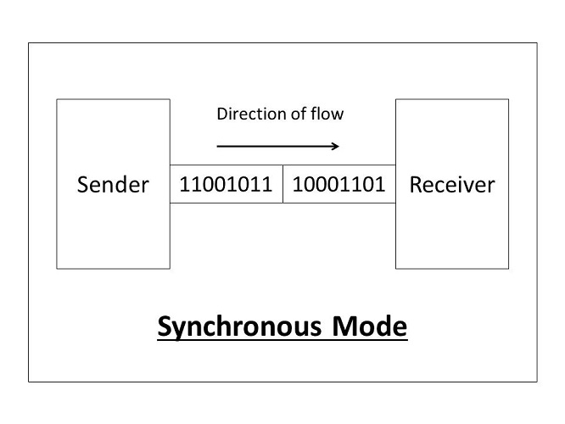

For Example, communication in CPU, RAM, etc.

**Following are the advantages of using a Synchronous transmission mode:**

1. Transmission speed is fast as there is no gap between the data bits.

**Following are the disadvantages of using a Synchronous transmission mode:**

1. It is very expensive.

**2. Asynchronous**

**The Asynchronous transmission mode is a mode of communication in which a start and the stop bit is introduced in the message during transmission.**The start and stop bits ensure that the data is transmitted correctly from the sender to the receiver.

Generally, the start bit is '0' and the end bit is '1'.Asynchronous here means 'asynchronous at the byte level', but the bits are still synchronized. The time duration between each character is the same and synchronized.

In an asynchronous mode of communication, data bits can be sent at any point in time. The messages are sent at irregular intervals and only one data byte can be sent at a time. This type of transmission mode is best suited for short-distance data transfer.

For Example, if there are two bytes of data, say(10001101, 11001011) then it will be transmitted in the asynchronous mode as follows:

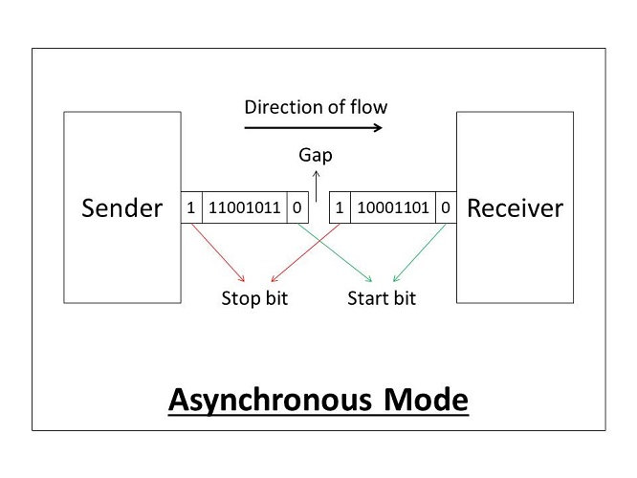

For Example, Data input from a keyboard to the computer.

**Following are the advantages of using an Asynchronous transmission mode:**

1. It is a cheap and effective mode of transmission.
2. Data transmission accuracy is high due to the presence of start and stop bits.

**Following are the disadvantages of using an Asynchronous transmission mode:**

1. The data transmission can be slower due to the gaps present between different blocks of data.

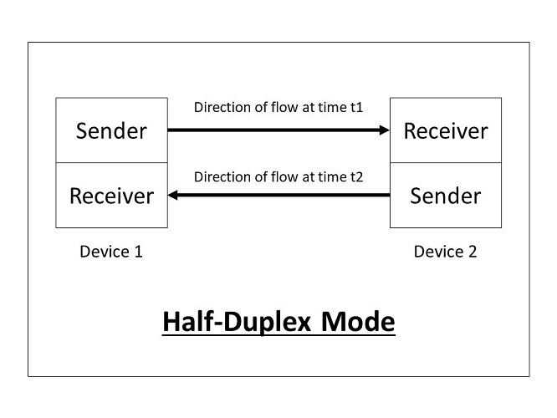

In this type of transmission mode, the entire capacity of the channel can be utilized for each direction. Transmission lines can carry data in both directions, but the data can be sent only in one direction at a time.

This type of data transmission mode can be used in cases where there is no need for communication in both directions at the same time. It can be used for error detection when the sender does not send or the receiver does not receive the data properly. In such cases, the data needs to be transmitted again by the receiver.

For Example, Walkie-Talkie, Internet Browsers, etc.

**Following are the advantages of using a half-duplex transmission mode:**

1. It facilitates the optimum use of the communication channel.
2. It provides two-way communication.

**Following are the disadvantages of using a half-duplex transmission mode:**

1. The two-way communication can not be established simultaneously at the same time.
2. Delay in transmission may occur as only one way communication can be possible at a time.

***According to the number of bits sent simultaneously in the network:***

**1. Serial**

**The Serial data transmission mode is a mode in which the data bits are sent serially one after the other at a time over the transmission channel.**

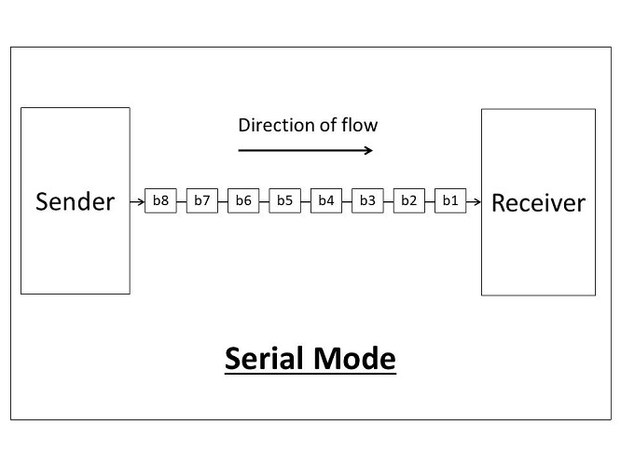

It needs a single transmission line for communication. The data bits are received in synchronization with one another. So, there is a challenge of synchronizing the transmitter and receiver.

In serial data transmission, the system takes several clock cycles to transmit the data stream. In this mode, the data integrity is maintained, as it transmits the data bits in a specific order, one after the other.

This type of transmission mode is best suited for long-distance data transfer, or the amount of data being sent is relatively small.

For Example, Data transmission between two computers using serial ports.

**Following are the advantages of using a serial transmission mode:**

1. It can be used for long-distance data transmission as it is reliable.
2. The number of wires and complexity is less.
3. It is cost-effective.

**Following are the disadvantages of using a serial transmission mode:**

1. The Data transmission rate is slow due to a single transmission channel.

**2. Parallel**

**The Parallel data transmission mode is a mode in which the data bits are sent parallelly at a time.**In other words, there is a transmission of n-bits at the same time simultaneously.

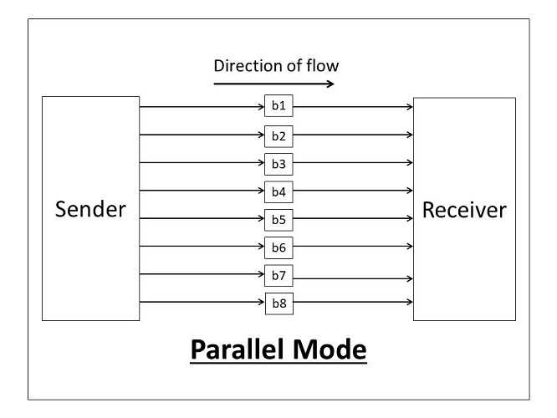

Multiple transmission lines are used in such modes of transmission. So, multiple data bytes can be transmitted in a single system clock. This mode of transmission is used when a large amount of data has to be sent in a shorter duration of time. It is mostly used for short-distance communication.

For n-bits, we need n-transmission lines. So, the complexity of the network increases but the transmission speed is high. If two or more transmission lines are too close to each other, then there may be a chance of interference in the data, degrading the signal quality.

For Example, Data transmission between computer and printer.

**Following are the advantages of using a parallel transmission mode:**

1. It is easy to program or implement.
2. Data transmission speed is high due to the n-transmission channel.

**Following are the disadvantages of using a parallel transmission mode:**

1. It requires more transmission channels, and hence cost-ineffective.
2. Interference in data bits, likewise in video conferencing.

***Hence, after learning the various transmission modes, we can conclude that some points need to be considered when selecting a data transmission mode:***

* **Transmission Rate.**
* **The Distance that it covers.**
* **Cost and Ease of Installation.**
* **The resistance of environmental conditions.**

## What is network topology and types of network topology?

**Topology is derived from two Greek words topo and logy, where topo means 'place' and logy means 'study'. In computer networks, a topology is used to explain how a network is physically connected and the logical flow of information in the network.**A topology mainly describes how devices are connected and interact with each other using communication links.

***In computer networks, there are mainly two types of topologies, they are:***

1. **Physical Topology:**A physical topology describes the way in which the computers or nodes are connected with each other in a computer network. It is the arrangement of various elements(link, nodes, etc.), including the device location and code installation of a computer network. In other words, we can say that it is the physical layout of nodes, workstations, and cables in the network.
2. **Logical Topology:**A logical topology describes the way, data flow from one computer to another. It is bound to a network protocol and defines how data is moved throughout the network and which path it takes. In other words, it is the way in which the devices communicate internally.

**Network topology defines the layout, virtual shape, or structure of the network, not only physically but also logically. A network can have one physical topology and multiple logical topologies at the same time.**

In this blog, we will mainly concentrate on physical topologies. We'll learn about different types of physical topologies, their advantages, and disadvantages.

***In a computer network, there are mainly six types of physical topology, they are:***

1. Bus Topology
2. Ring Topology
3. Star Topology
4. Mesh Topology
5. Tree Topology
6. Hybrid Topology

Now let us learn these topologies one by one:

#### Bus Topology

**Bus topology is the simplest kind of topology in which a common bus or channel is used for communication in the network. The bus is connected to various taps and droplines.** Taps are the connectors, while droplines are the cables connecting the bus with the computer. In other words, there is only a single transmission line for all nodes.

When a sender sends a message, all other computers can hear it, but only the receiver accepts it(verifying the mac address attached with the data frame) and others reject it. Bus technology is mainly suited for small networks like LAN, etc.

In this topology, the bus acts as the backbone of the network, which joins every computer and peripherals in the network. Both ends of the shared channel have line terminators. The data is sent only in one direction and as soon as it reaches the end, the terminator removes the data from the communication line(to prevent signal bounce and data flow disruption).

In a bus topology, each computer communicates to another computer on the network independently. Every computer can share the network's total bus capabilities. The devices share the responsibility for the flow of data from one point to the other in the network.

For Example Ethernet cable, etc.

***Following are the advantages of Bus topology:***

1. Simple to use and install.
2. If a node fails, it will not affect other nodes.
3. Less cabling is required.
4. Cost-efficient to implement.

***Following are the disadvantages of Bus topology:***

1. Efficiency is less when nodes are more(strength of signal decreases).
2. If the bus fails, the network will fail.
3. A limited number of nodes can connect to the bus due to limited bus length.
4. Security issues and risks are more as messages are broadcasted to all nodes.
5. Congestion and traffic on the bus as it is the only source of communication.

#### Ring Topology

**Ring topology is a topology in which each computer is connected to exactly two other computers to form the ring.**The message passing is unidirectional and circular in nature.

This network topology is deterministic in nature, i.e., each computer is given access for transmission at a fixed time interval. All the nodes are connected in a closed-loop. This topology mainly works on a token-based system and the token travels in a loop in one specific direction.

In a ring topology, if a token is free then the node can capture the token and attach the data and destination address to the token, and then leaves the token for communication. When this token reaches the destination node, the data is removed by the receiver and the token is made free to carry the next data.

For Example, Token Ring, etc.

***Following are the advantages of Ring topology:***

1. Easy Installation.
2. Less Cabling Required.
3. Reduces chances of data collision(unidirectional).
4. Easy to troubleshoot(the faulty node does not pass the token).
5. Each node gets the same access time.

***Following are the disadvantages of Ring topology:***

1. If a node fails, the whole network will fail.
2. Slow data transmission speed(each message has to go through the ring path).
3. Difficult to reconfigure(we have to break the ring).

#### Star Topology

**Star topology is a computer network topology in which all the nodes are connected to a centralized hub.**The hub or switch acts as a middleware between the nodes. Any node requesting for service or providing service, first contact the hub for communication.

The central device(hub or switch) has point to point communication link(the dedicated link between the devices which can not be accessed by some other computer) with the devices. The central device then broadcast or unicast the message based on the central device used. The hub broadcasts the message, while the switch unicasts the messages by maintaining a switch table. Broadcasting increases unnecessary data traffic in the network.

In a star topology, hub and switch act as a server, and the other connected devices act as clients. Only one input-output port and one cable are required to connect a node to the central device. This topology is better in terms of security because the data does not pass through every node.

For Example High-Speed LAN, etc.

***Following are the advantages of Star topology:***

1. Centralized control.
2. Less Expensive.
3. Easy to troubleshoot(the faulty node does not give response).
4. Good fault tolerance due to centralized control on nodes.
5. Easy to scale(nodes can be added or removed to the network easily).
6. If a node fails, it will not affect other nodes.
7. Easy to reconfigure and upgrade(configured using a central device).

***Following are the disadvantages of Star topology:***

1. If the central device fails, the network will fail.
2. The number of devices in the network is limited(due to limited input-output port in a central device).

#### Mesh Topology

**Mesh topology is a computer network topology in which nodes are interconnected with each other.**In other words, direct communication takes place between the nodes in the network.

**There are mainly two types of Mesh:**

1. **Full Mesh:** In which each node is connected to every other node in the network.
2. **Partial Mesh:** In which, some nodes are not connected to every node in the network.

In a fully connected mesh topology, each device has a point to point link with every other device in the network. If there are **'n'** devices in the network, then each device has exactly **'(n-1)'** input-output ports and communication links. These links are simplex links, i.e., the data moves only in one direction. A duplex link(in which data can travel in both the directions simultaneously) can replace two simplex links.

If we are using simplex links, then the number of communication links will be **'n(n-1)'** for **'n'** devices, while it is **'n(n-1)/2'** if we are using duplex links in the mesh topology.

For Example, the Internet(WAN), etc.

***Following are the advantages of Mesh topology:***

1. Dedicated links facilitate direct communication.
2. No congestion or traffic problems on the channels.
3. Good Fault tolerance due to the dedicated path for each node.
4. Very fast communication.
5. Maintains privacy and security due to a separate channel for communication.
6. If a node fails, other alternatives are present in the network.

***Following are the disadvantages of Mesh topology:***

1. Very high cabling required.
2. Cost inefficient to implement.
3. Complex to implement and takes large space to install the network.
4. Installation and maintenance are very difficult.

#### 5. Tree Topology:

**Tree topology is a computer network topology in which all the nodes are directly or indirectly connected to the main bus cable.**Tree topology is a combination of Bus and Star topology.

In a tree topology, the whole network is divided into segments, which can be easily managed and maintained. There is a main hub and all the other sub-hubs are connected to each other in this topology.

***Following are the advantages of Tree topology:***

1. Large distance network coverage.
2. Fault finding is easy by checking each hierarchy.
3. Least or no data loss.
4. A Large number of nodes can be connected directly or indirectly.
5. Other hierarchical networks are not affected if one of them fails.

***Following are the disadvantages of Tree topology:***

1. Cabling and hardware cost is high.
2. Complex to implement.
3. Hub cabling is also required.
4. A large network using tree topology is hard to manage.
5. It requires very high maintenance.
6. If the main bus fails, the network will fail.

#### Hybrid Topology:

**A Hybrid topology is a computer topology which is a combination of two or more topologies.**In practical use, they are the most widely used.

In this topology, all topologies are interconnected according to the needs to form a hybrid. All the good features of each topology can be used to make an efficient hybrid topology.

***Following are the advantages of Hybrid topology:***

1. It can handle a large volume of nodes.
2. It provides flexibility to modify the network according to our needs.
3. Very Reliable(if one node fails it will not affect the whole network).

***Following are the disadvantages of Hybrid topology:***

1. Complex design.
2. Expensive to implement.
3. Multi-Station Access Unit(MSAL) required.

***Hence, after learning the various computer network topologies, we can conclude that some points need to be considered when selecting a physical topology:***

* **Ease of Installation.**
* **Fault Tolerance.**
* **Implementation Cost.**
* **Cabling Required.**
* **Maintenance Required.**
* **Reliable Nature.**
* **Ease of Reconfiguration and upgradation.**

## What are Routers, Hubs, Switches, Bridges?

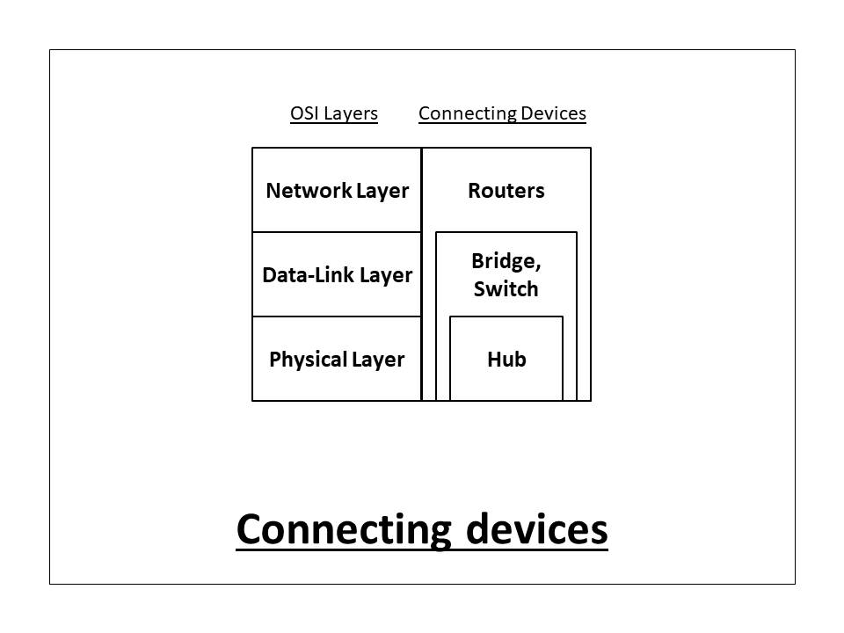

* 1. **Hub**

A **hub** is a physical layer networking device which is **used** to connect multiple devices in a network. They are generally **used** to connect computers in a LAN. A **hub** has many ports in it. A computer which intends to be connected to the network is plugged in to one of these ports.05

Hub is a very simple network connecting device . In Star/hierarchical topology, a Repeater is called Hub. It is also known as a **Multiport Repeater Device**.

**A Hub is a layer-1 device and operates only in the physical network of the OSI Model.** Since it works in the physical layer, it mainly deals with the data in the form of bits or electrical signals. A Hub is mainly used to create a network and connect devices on the same network only.

A Hub is not an intelligent device, it forwards the incoming messages to other devices without checking for any errors or processing it. It does not maintain any address table for connected devices.

When a data packet arrives at one of the ports of a Hub, it simply copies the data to every port. In other words, a hub broadcasts the incoming data packets in the network. Due to this, there are various security issues in the hub. Broadcasting also leads to unnecessary data traffic on the channel.

***There are mainly two types of Hub, they are:***

1. **Active Hub:** An Active hub is also known as Concentrator. It requires a power supply and can work as a repeater. Thus, it can analyze the data packets and can amplify the transmission signals, if needed.
2. **Passive Hub:** A passive hub does not need any power supply to operate. It only provides communication between the networking devices and does not amplify the transmission signals. In other words, it just forwards the data as it is.

**OSI Model**

**n other words, the OSI model defines and is used to understand how two computers connect with each other in a computer network.**

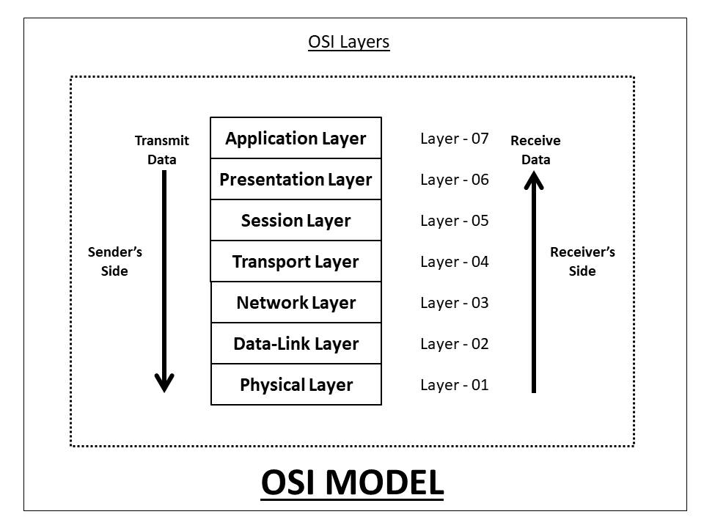

#### 1. Physical Layer

**The Physical Layer is the lowest layer of the OSI model and it deals with data in the form of bits or signals.** The type of signal being generated depends upon the transmission medium. For example, if we are using copper wire or LAN cable, the output signal will be an electrical signal. Likewise, the output signal will be a light signal for optical fibre cable, and radio signal for air as a transmission medium.

At the sender's side, the physical layer will get the data from the upper layer and convert it into bitstreams(0's and 1's) and send it through a physical channel. At the receiver's side, it will convert the bitstreams into frames to be passed to the data-link layer.

***Following are the functionalities of a physical layer:***

1. It defines the transmission media between two connecting devices.
2. It also specifies the data rate(number of bits sent each second) over the defined media.
3. It defines the [topology of the network](https://afteracademy.com/blog/what-is-network-topology-and-types-of-network-topology). The topology may be Bus, Ring, Star, Mesh, Tree, or Hybrid.
4. It defines a [data transmission mode](https://afteracademy.com/blog/what-are-the-data-transmission-modes-in-a-network). It can be Simplex, Half-Duplex, or Duplex.
5. It defines the type of data encoding used in the transmission.
6. It defines the line configuration of the network. It can be point-to-point or multiport.

#### 2. Data-Link Layer

**The Data-Link Layer is the second layer of the OSI model. It performs the physical addressing of data.**Physical addressing is the process of adding the physical(MAC) address to the data. MAC(Media Access Control) Address is a 48-bit alpha-numeric number that is embedded in NIC(Network Interface Card) by the manufacturer. In other words, the data-link layer is embedded as software in the NIC which provides a means for data transfer from one computer to another via a local media. Thus, the data-link layer facilitates the transmission of data within the same network only.

The source and destination MAC addresses are included in the data header file by the data-link layer. At the sender's side, it receives the data in the form of packets from the network layer and converts it into smaller forms, called the data frame. At the receiver's side, it converts the data frame into packets for the network layer.

***Following are the main functionalities of a data-link layer:***

1. **Allows media access using framing:** It allows the upper layers to access the media using framing, as it performs physical addressing of the data.
2. **Controls data:** It performs flow, error, and access control of the data. It controls the data rate of the transmission to control the data flow. It uses the header information or checksum bits to control the error. Most importantly, it performs access control of the data using the MAC address.

#### 3. Network Layer

**The Network layer is the third layer of the OSI model. It mainly performs the transmission of data from one computer to another in different networks.** This layer may not be so beneficial if we are transmitting the data in the same network. **The network layer performs logical addressing(IP addressing) of the data.** The source and destination IP addresses are included in the data header file by the network layer. The data is in the form of packets in this layer.

At the sender side, the network layer breaks the data segments received from the upper layer into smaller units, called data packets. Similarly, at the receiver's side, it reassembles the data packets into segments for the upper layer, i.e., the transport layer. [Routers](https://afteracademy.com/blog/what-are-routers-hubs-switches-bridges) are mainly used in the network layer for routing purposes. Some of the protocols that are mostly used in this layer are OSPF(Open Shortest Path First), BGP(Border Gateway Protocol), IS-IS(Intermediate System to Intermediate System), etc.

***Following are the main functionalities of a network layer:***

1. **Logical Addressing:**Every computer in a network has a unique IP(Internet Protocol) address. The network layer attaches the source and destination IP address to the data so that it can be transmitted even in different networks. Internet Protocol Version 4(IPv4) and Internet Protocol Version 6(IPv6) addressing are used by the network layer for logical addressing.
2. **Routing:**Routing is a process through which the data packets can travel from one node to another in a computer network. In the network layer, the routing decisions are mainly based on IP addresses or logical addressing.
3. **Path Determination:**Path determination is the process of selecting a path from various available paths based on the routing information. Path determination is done by the network layer for finding the most optimum path for data transmission.

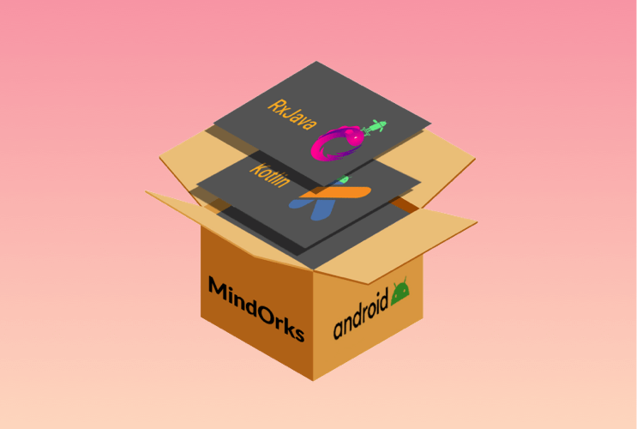

NEW

##### **Android App Development Online Course by MindOrks**

Start your career in Android Development. Learn by doing real projects.

[**CHECK NOW**](https://mindorks.com/android-app-development-online-course)

#### 4. Transport Layer

**The Transport layer is the fourth layer of the OSI model. It is mainly responsible for the process-to-process delivery of the data.** **It performs flow and error control in the data for its proper transmission.** The transport layer controls the reliability of communication through various functionalities.

At the sender's side, the transport layer receives the data from the upper layer and performs segmentation.The source and destination port numbers are also included in the header file of the data before forwarding it to the network layer. At the receiver's side, the transport layer performs the reassembly and sequencing of data. It reads the port number of the data from the header file, and then direct it towards the proper application.

***Following are the main functionalities of a network layer:***

1. **Segmentation:**Dividing the data received into multiple data segments can be termed as segmentation. The transport layer performs the assembly as well as reassembly of data at the sender's and receiver's side respectively. Each segment has the source and destination 'port' and 'sequence' number. The port number helps to direct each data segment to the correct application, while the sequence number keeps them in a correct sequence when the segmented data is received at the receiver's side.
2. **Flow Control:**The transport layer controls the flow of the data being transmitted. It is mainly done to avoid any data loss and enhance data transmission efficiency.
3. **Error Control:**The transport layer checks for any kind of errors in the data using the checksum bits that are present in the data header. It can also request for retransmission of some data if it is not received at the receiver's end.
4. **Connection Control:**The transport layer also maintains the connection between the devices in a proper way. For connection-oriented transmission, TCP(Transmission Control Protocol) is used. TCP is quite slow but is reliable in nature. It can be used for long-distance transmissions. For connection-less transmission, UDP(User Datagram Protocol) is used. UDP is fast but not reliable in nature. It is mainly preferred for short-distance transmissions.

#### 5. Session Layer

**The Session layer is the fifth layer of the OSI model. It mainly helps in setting up, closing and managing the connection in the network.**Actually, whenever two devices get connected, a session is created, which is terminated as soon the connection is no longer required. The termination of the session is important to avoid the unnecessary wastage of resources. In other words, the session layer performs session management.

The session layer enables the devices to send and receive the data by establishing connections and also terminates the connection after the data transfer. It mainly performs authentication and authorization for establishing a secure connection in the network.

***Following are the main functionalities of a session layer:***

1. **Authentication:**Authentication is a process of verifying the user. The session layer may ask the devices to enter valid login credentials, so as to maintain a secure data connection.
2. **Authorization:**Authorization is the process of determining the user's authority to access the data. The session layer determines whether the device has permission to access those data elements or not.
3. **Synchronization:**The session layer synchronizes the sender and receiver. It adds various checkpoints with the data to synchronize data at the sender's and receiver's side. In case of any crash or transfer failure, the data transmission can be resumed from the last checkpoint. There is no need to retransfer the whole data.

#### 6. Presentation Layer

**The Presentation layer is the sixth layer of the OSI model. It mainly performs data translation, encryption & decryption, and compression in the network.** The presentation layer deals with the syntax and semantics of the information exchanged between two systems.

At the sender's side, it receives the data from the application layer and performs data encryption and compression to it. At the receiver's side, it receives the data from the transport layer and performs data translation, decryption, and uncompresses data.

***Following are the main functionalities of a presentation layer:***

1. **Data Translation:**Data translation refers to transforming data from one form to the other. The presentation layer transforms the high-level user language data to the equivalent low-level machine-level language, and vice versa. Some of the standards used by this layer for translation are ASCII, EBCDIC, etc.
2. **Data Encryption and Decryption:**Data encryption is the process of converting a plain text into cypher text for security. Encryption is applied to the data at the sender's side. Data decryption is the process of converting a ciphertext into plain text. It is applied to the data at the receiver's side. The presentation layer uses the SSL(Secure Socket Layer) for data encryption and decryption.
3. **Data Compression:**Data compression is the process of reducing the number of bits in the data. It can either be lossy or lossless in nature. Lossless compression is mostly preferred for some important data items.

#### 7. Application Layer

**The Application layer is the topmost layer of the OSI model. This layer is mostly used by the network applications, that use the network.** It mainly acts as an interface between the user and the network services. The Application layer provides services for network applications with the help of protocols. Some of the most widely used application layer protocols are HTTP, HTTPS, FTP, NFS, DHCP, FMTP, SNMP, SMTP, Telnet, etc.

***Following are the main functionalities of an application layer:***

1. **File Transfer:**The Application layer mainly facilitates the file transfer between two network devices with the help of FTP(File Transfer Protocol).
2. **Web Surfing:**Web surfing is possible only in the application layer. Some protocols like HTTP(Hypertext Transfer Protocol), HTTPs(Hypertext Transfer Protocol Secure), etc. enables web surfing.
3. **Emails:**Electronic-mails can be sent from one device to another on the network only through the application layer. Some protocols like SMTP(Simple Mail Transfer Protocol), etc. are used for sending emails over the network.
4. **Network Virtual Terminal:**The Application layer facilitates the remote host login in the network with the help of protocols like Telnet, etc. It can also be referred to as the software version of the physical terminal in the network.