WEEK 2 TASK
Advanced Data Visualization
and Storytelling with Python
“The Anatomy of Online Toxicity” — A Data Story
Built on the Wikipedia Toxic Comment Classification dataset (Week 1 cleaned data)
Prepared by Apoorv
Data Science Internship — Week 2 Deliverable

Table of Contents
1. Introduction 3
1.1 Objective 3
1.2 Why This Dataset & Audience 3
2. Methodology 3
2.1 Tools & Approach 3
2.2 Chart Selection Philosophy 4
3. The Data Story: The Anatomy of Online Toxicity 4
Chapter 1 — The Scale of the Problem 4
Chapter 2 — Not All Toxicity Is Equal 5
Chapter 3 — Toxicity Rarely Travels Alone 6
Chapter 4 — What Does Toxic Language Look Like? 7
Chapter 5 — Short, Sharp, and Shareable 8
Chapter 6 — The Anatomy of a Toxic Comment 9
4. Business & Scientific Implications 10
5. Conclusion 11

1. Introduction

1.1 Objective
This report moves beyond exploratory data analysis (the focus of Week 1) into advanced data visualization and storytelling. Rather than presenting isolated charts, the goal this week is to build a coherent visual narrative — a sequence of six visualizations, each chosen deliberately for what it can show that a simpler chart cannot, that together walk a non-technical reader through a complete story: how big the problem is, what shape it takes, how its parts relate to one another, and what it would take to act on it.
The dataset is the same cleaned Wikipedia Toxic Comment Classification data produced in Week 1 (157,379 comments, zero missing values, zero duplicates) — reused deliberately so that this week's effort goes entirely into visualization and narrative craft rather than repeating data preparation.

1.2 Why This Dataset & Audience
The intended reader for this report is a non-technical stakeholder — for example, a platform trust & safety lead or a product manager — who needs to understand the shape of the toxicity problem well enough to make resourcing and policy decisions, without needing to read a confusion matrix or a regression table. Every visualization in Section 3 is built and captioned with that reader in mind: plain-language titles, one clear takeaway per chart, and minimal jargon.

2. Methodology

2.1 Tools & Approach
All visualizations were built in Python using Matplotlib and Seaborn as the core plotting engines, with NumPy/SciPy for the statistical computations (kernel density estimation) behind the ridgeline chart. Several chart types below are not available as a single off-the-shelf function — the treemap, the co-occurrence “UpSet” plot, and the comparative word cloud were each built from lower-level drawing primitives (rectangles, scatter points, and positioned text) to get a layout well-suited to this specific story, rather than a generic default.
Library | Role in this report
pandas / NumPy | Data loading, aggregation, and the numeric transforms behind each chart
Matplotlib | Core rendering engine for every figure, including custom chart types
Seaborn | Base styling (gridlines, palette foundations)
SciPy (gaussian_kde) | Density estimation for the ridgeline plot (Chapter 5)

2.2 Chart Selection Philosophy
Every chart type below was chosen to answer one specific narrative question, not simply to show variety. The guiding rule: a reader should be able to glance at a chart's title and caption and know exactly what it claims, before studying the chart itself.
Narrative Question | Chart Type | Why This Type
How big is the problem, in one glance? | Donut chart + callout | A single proportion is best read as a part-of-whole shape with one dominant number
How is the problem composed? | Treemap | Area encodes magnitude more intuitively than bar length when comparing a few nested categories at once
Do these categories overlap? | UpSet-style combination plot | Purpose-built for visualizing set intersections — something a pie or bar chart cannot show
What does it look like, qualitatively? | Comparative word layout | Puts the most human-readable signal (actual language) directly in front of a non-technical reader
How does a key metric vary by group? | Ridgeline (joy) plot | Stacks many distributions for easy visual comparison without the overlap clutter of a single histogram
How do many metrics compare at once? | Radar chart | Captures a multi-metric “profile” or “shape” in one view, ideal for a two-group comparison

3. The Data Story: The Anatomy of Online Toxicity
The six chapters below are designed to be read in sequence — each one answers the question the previous one raises, building from “how big is this?” down to “what, specifically, does it look like, and where does it concentrate?”

Chapter 1 — The Scale of the Problem
How much of what people say on Wikipedia talk pages actually crosses the line?
Why a donut chart?
When the first thing a reader needs is a single, memorable proportion, a donut chart centered on one big number outperforms a bar or table — the eye reads the dominant wedge and the callout number simultaneously, with no axis to decode.

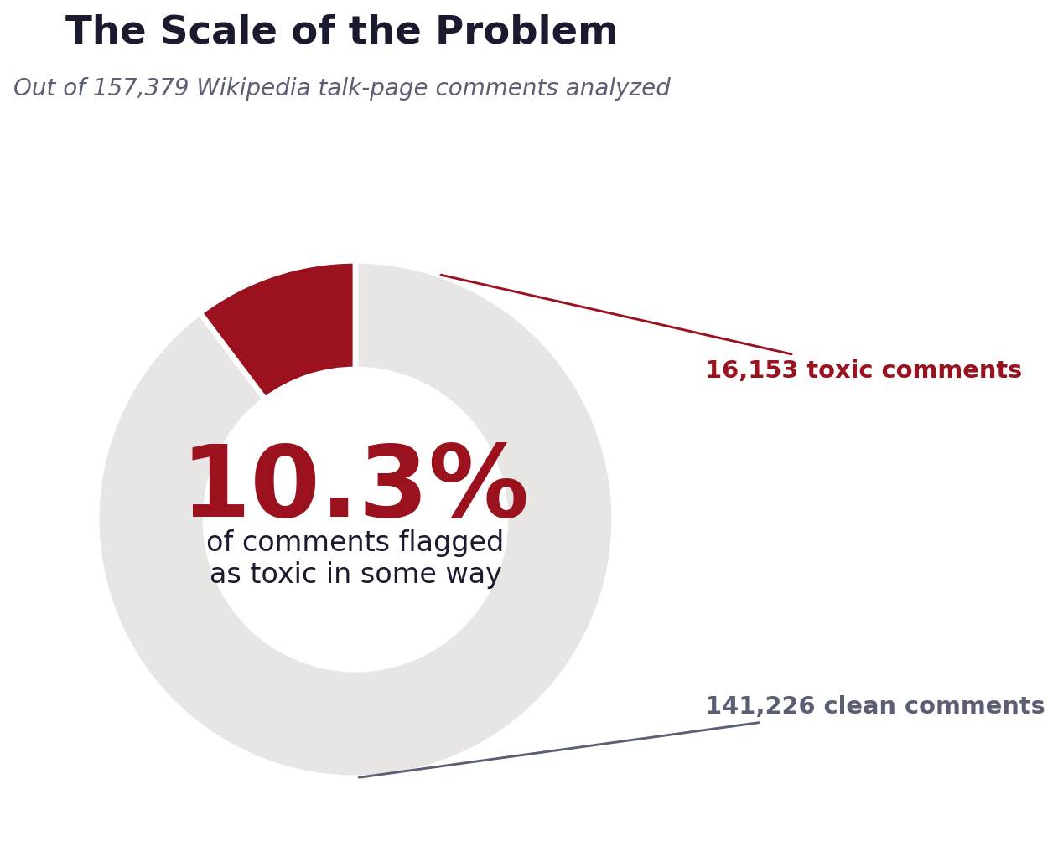
Figure 1 — Share of comments flagged as toxic in some way, out of 157,379 analyzed.
Just over 1 in 10 comments (10.3%) was flagged as toxic in at least one of the six categories. On the surface, that may sound like a manageable minority — but at Wikipedia's scale, 16,153 toxic comments in this sample alone translates to a very large absolute volume when extrapolated across the full platform and its millions of daily edits and discussions.
This number sets the stage for the rest of the story: the question is no longer “is this a problem?” but “what shape does this problem take, and where should moderation effort be concentrated?” — which the next chapters address directly.

Chapter 2 — Not All Toxicity Is Equal
Toxicity is not one thing — it is a mix of very different behaviors, in very different proportions.
Why a treemap?
A treemap encodes magnitude as area, which lets a reader compare six categories at a glance without reading axis values — and naturally draws the eye to the one or two categories that dominate, exactly as this story needs.

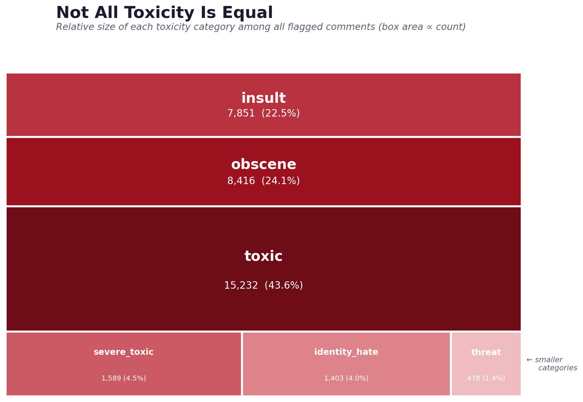
Figure 2 — Relative size of each toxicity category among all flagged comments (box area ∝ count).
General “toxic”, “obscene”, and “insult” together account for roughly 90% of all flagged content — ordinary rudeness and profanity, not extreme behavior, is the bulk of the problem. The three smaller categories — severe_toxic, identity_hate, and threat — make up a combined 10%, with threat alone at just 1.4%.
This has a direct resourcing implication, developed further in Section 4: a moderation system tuned only to catch the rare, extreme cases (threats, severe toxicity) would miss the vast majority of the actual problem volume, which is everyday obscenity and insults.

Chapter 3 — Toxicity Rarely Travels Alone
When a comment is toxic, is it usually toxic in exactly one way — or several at once?
Why a combination (“UpSet”) plot?
A Venn diagram stops being readable past three sets; with six overlapping categories, a combination matrix — a bar chart of the most common combinations paired with a dot-matrix showing exactly which labels make up each one — is the standard, purpose-built way to visualize set intersections at this scale.

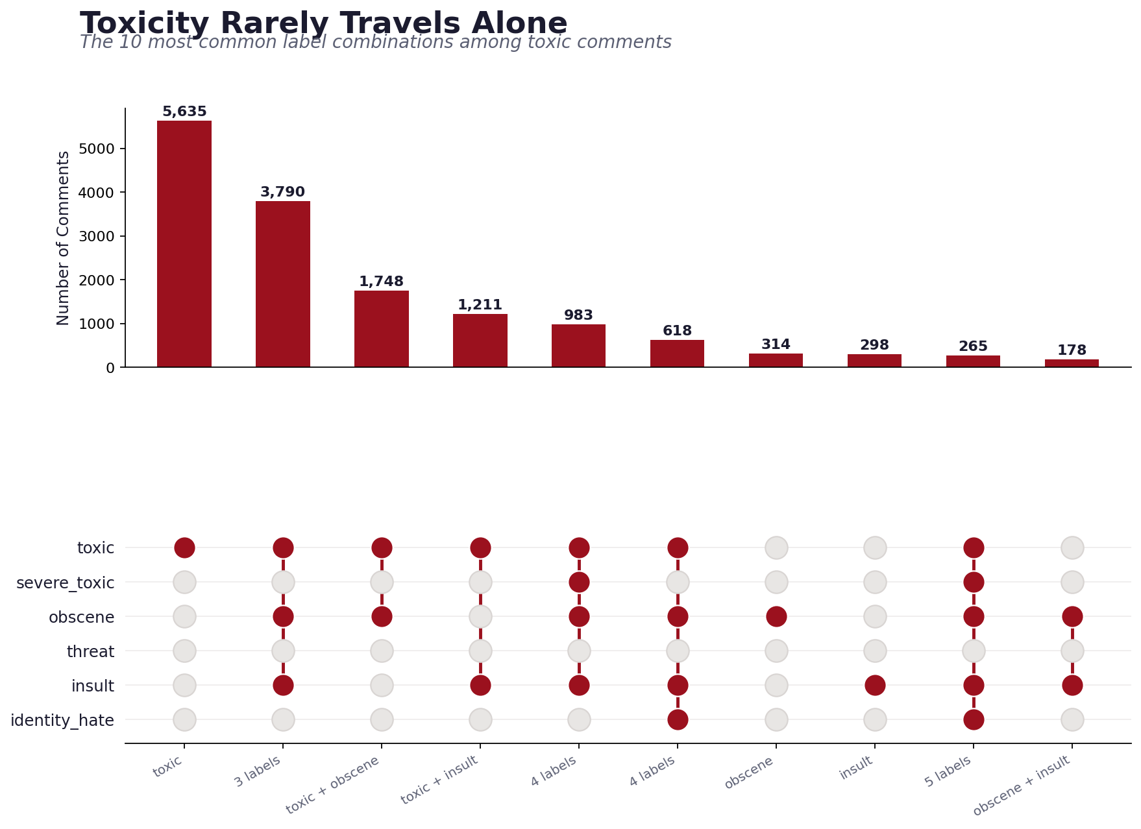
Figure 3 — The 10 most common label combinations among toxic comments, with connected dots showing which labels co-occur.
The single most common pattern (5,635 comments) is “toxic” alone, with no other label — simple rudeness with no further qualifier. But the second and third most common patterns are multi-label: “toxic + obscene + insult” (3,790 comments) and “toxic + obscene” (1,748) show that when a comment escalates, it tends to escalate on several dimensions simultaneously rather than one.
Notice how rarely “threat” appears paired with anything in this top-10 view — reinforcing Chapter 2's finding that threats behave as a distinct, less-correlated category. This matters for moderation design: a classifier or review queue built around the dominant “toxic + obscene + insult” cluster may need a separate, dedicated path for the rarer but more severe threat category, since it won't reliably be caught as a side effect of catching the common cluster.

Chapter 4 — What Does Toxic Language Look Like?
Numbers and labels are abstract — actual words are not.
Why a comparative word layout?
For a non-technical audience, nothing communicates “what is actually being said” faster than the words themselves, sized by how often they appear. Placing the toxic and non-toxic vocabularies side by side, in the same visual language, makes the contrast immediate.

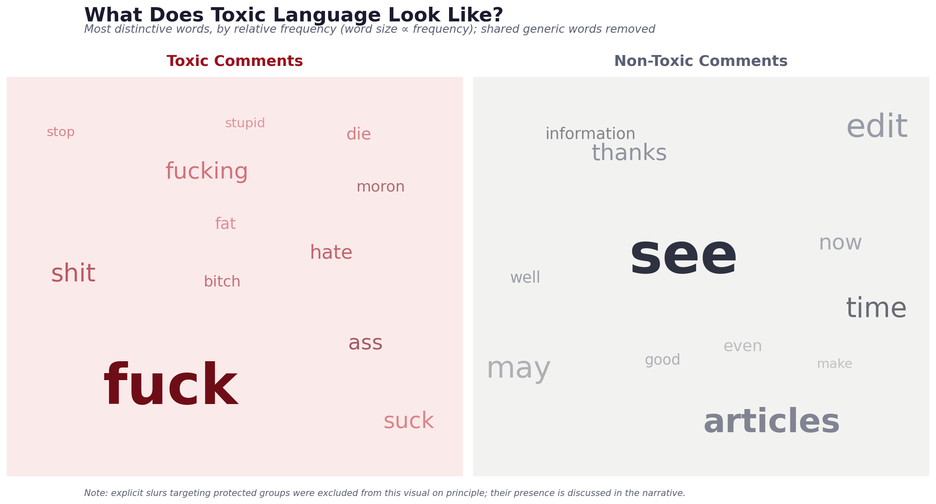
Figure 4 — Most distinctive words in toxic vs. non-toxic comments (word size ∝ frequency; words common to both sides removed).
Non-toxic comments are dominated by ordinary editorial vocabulary — “see”, “articles”, “edit”, “information”, “thanks” — the language of people doing collaborative reference work. Toxic comments are dominated by explicit profanity and aggressive language (“fuck”, “shit”, “hate”, “stupid”, “die”) rather than subtle jabs, suggesting most toxicity on this platform is blunt and overt rather than passive-aggressive or coded.
One pattern is deliberately not shown in this chart: a meaningful share of comments in the identity_hate category use explicit slurs targeting race, religion, or sexual orientation. Those terms were excluded from this visualization on principle — reproducing slurs at large size in a shareable report is not necessary to make the point, and risks causing harm on its own. Their presence is, however, real and already reflected quantitatively in the identity_hate counts in Chapters 2 and 3 (1,403 comments, 4.0% of toxic content).

Chapter 5 — Short, Sharp, and Shareable
Does a toxic comment read differently in length, not just in word choice?
Why a ridgeline plot?
Overlaying seven histograms directly would be an unreadable mess of overlapping bars. A ridgeline (joy) plot staggers each distribution vertically so all seven stay visually distinct while remaining directly comparable on the same horizontal scale.

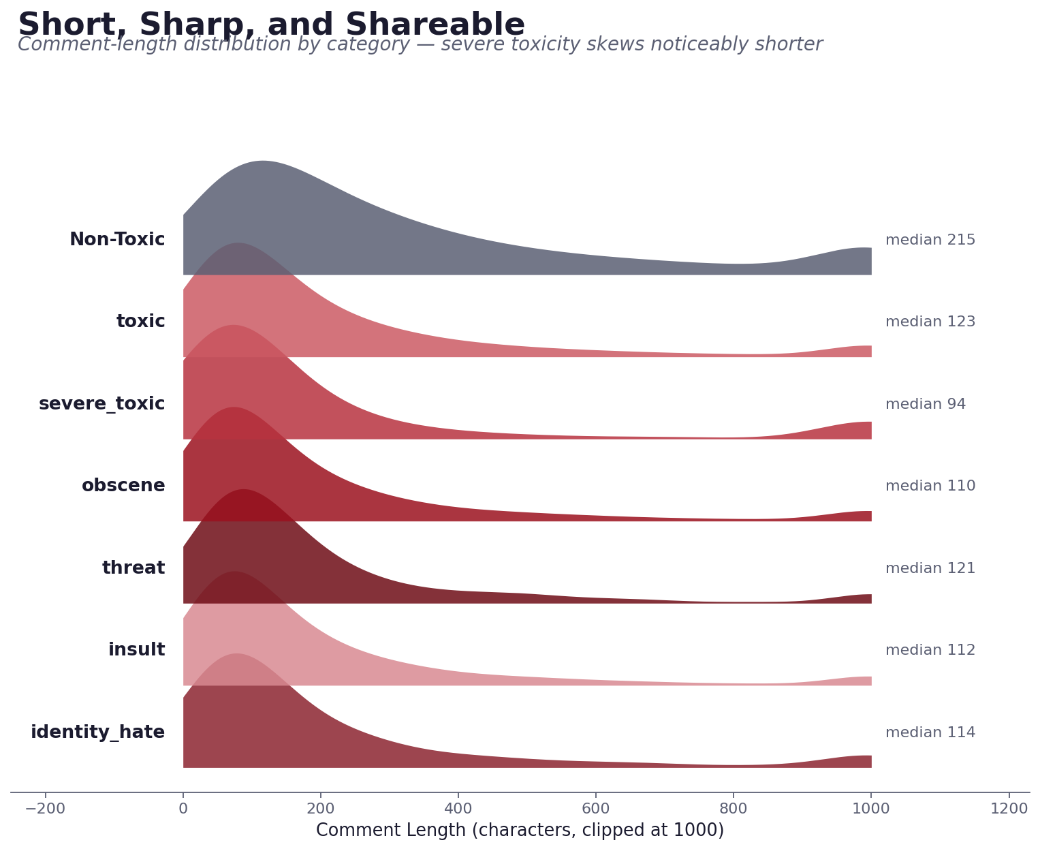
Figure 5 — Comment-length distribution by category; each curve is a smoothed density, median length labeled on the right.
Non-toxic comments have a clearly longer, flatter distribution (median 215 characters) — consistent with substantive, discussion-style editing. Every toxic category clusters much further left, with severe_toxic the shortest of all (median 94 characters). Toxic comments, in other words, tend to be quick outbursts rather than developed arguments.
This is a genuinely useful, low-cost signal: comment length alone — available instantly, with no NLP model required — already separates toxic from non-toxic comments to a meaningful degree, making it a strong candidate engineered feature for any future triage or classification system.

Chapter 6 — The Anatomy of a Toxic Comment
If you could only look at five signals at once, what would distinguish a toxic comment from a clean one?
Why a radar chart?
A radar chart turns several normalized metrics into a single recognizable shape, making a multi-dimensional comparison between two groups intuitive — the reader doesn't need to study five separate numbers, just compare two silhouettes.

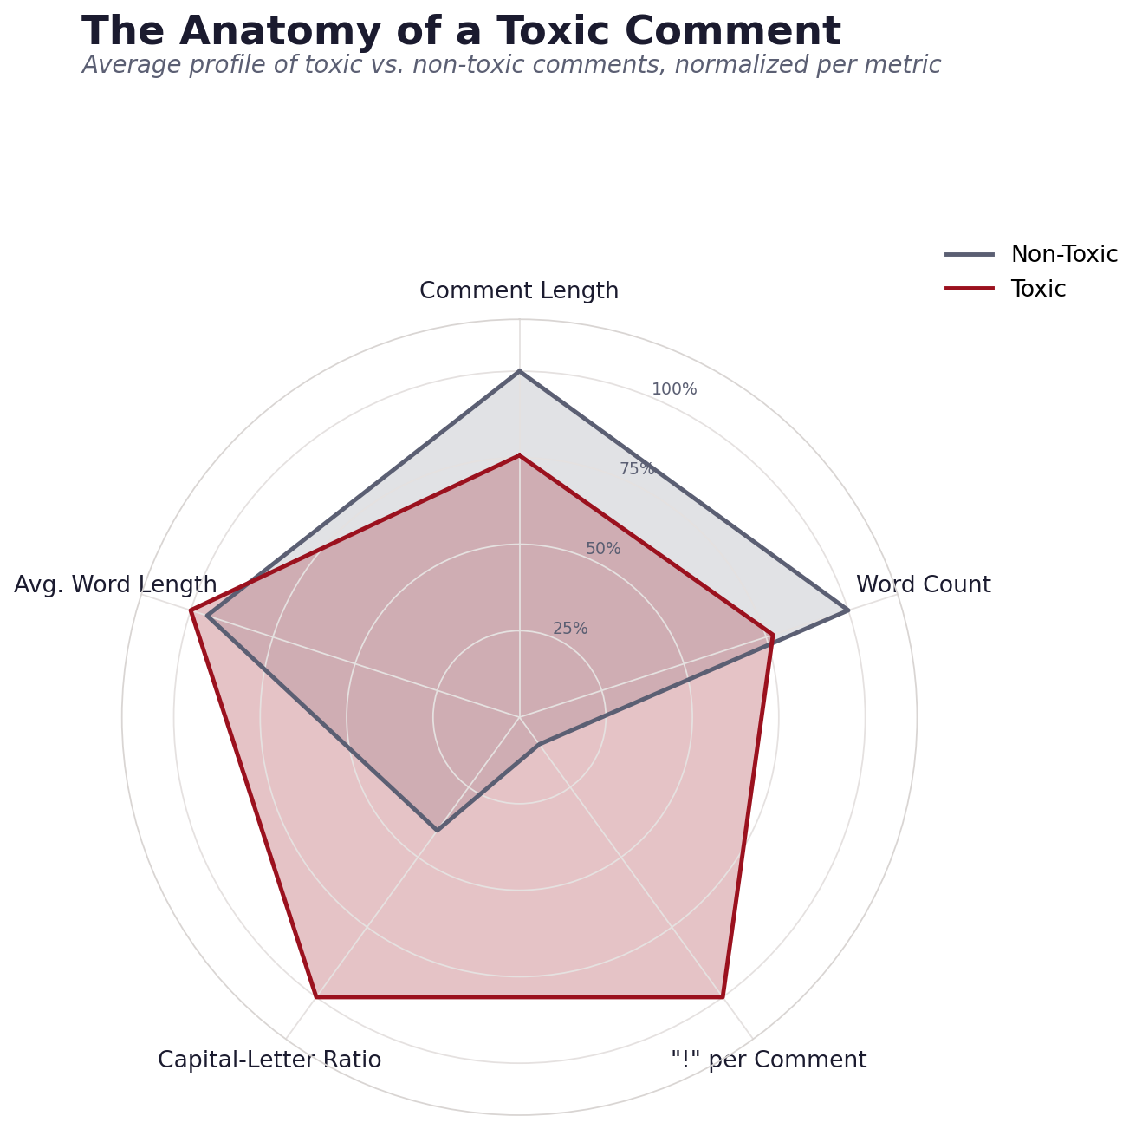
Figure 6 — Average profile of toxic vs. non-toxic comments across five metrics, each normalized to the larger of the two group means.
The two shapes diverge sharply on two metrics: toxic comments average roughly 10x more exclamation marks per comment (3.48 vs. 0.34) and more than double the ratio of capital letters (11.1% vs. 4.5%) — the written equivalent of raised volume. They are shorter on length and word count (consistent with Chapter 5), but use marginally longer individual words on average.
Put together, the profile that emerges is not “complex, coded hostility” but “short, loud, and blunt” — a finding that is consistent across every chapter in this report and has a direct, practical implication explored next.

4. Business & Scientific Implications
Taken together, the six chapters above point toward a small number of concrete, actionable conclusions for a platform trust & safety team or a research group studying online toxicity.

4.1 Business Implications
- Prioritize volume, not just severity. With toxic/obscene/insult making up ~90% of flagged content (Chapter 2), a moderation system should be resourced primarily for high-volume, moderate-severity content — not solely tuned for rare extreme cases.
- Build a separate path for threats. Because threat behaves almost independently of the other categories (Chapter 3), it needs its own detection logic and review queue rather than relying on being caught incidentally by a general toxicity filter.
- Use cheap signals for first-pass triage. Comment length, exclamation-mark count, and capital-letter ratio (Chapters 5–6) are all computable without any machine learning model and already carry real separating power — well suited to a fast, low-cost first-pass filter ahead of a heavier NLP model.
- Design review UIs around multi-label reality. Since toxic comments frequently carry 2–5 labels at once (Chapter 3), a moderator-facing review tool should surface the full label set together, not force a single primary-category decision.

4.2 Scientific / Research Implications
- Treat this as a genuine multi-label problem. The co-occurrence structure (Chapter 3) and label correlation patterns confirm that collapsing the six categories into one binary “toxic/not” target would discard real structure in the data.
- Length and “shouting” features are promising engineered features. Both show consistent, sizable separation between classes (Chapters 5–6) and are worth including explicitly alongside text-embedding-based features in a future classification model, rather than relying on the text content alone.
- Vocabulary differs mainly in bluntness, not just topic. The word-level contrast (Chapter 4) suggests a lexicon-based or profanity-list feature could already provide a strong baseline, before investing in more complex contextual language models.

5. Conclusion
This report set out to turn a cleaned dataset into a coherent, non-technical visual narrative — not just a set of charts, but a story with a beginning (how big is the problem), a middle (how is it structured, and what does it look like), and an end (what should be done about it). Six purpose-built visualizations — a donut, a treemap, a combination plot, a comparative word layout, a ridgeline plot, and a radar chart — were each selected because they were the right tool for a specific narrative question, not simply to demonstrate variety.
The throughline across all six chapters is consistent: online toxicity on this platform is high-volume but low-complexity — predominantly short, blunt, loud, profanity-driven outbursts rather than rare, sophisticated hostility. That single, memorable insight, and the concrete recommendations it supports in Section 4, is the kind of conclusion a non-technical stakeholder can act on directly — which was the central goal of this week's task.

