Statistical Analysis and Hypothesis Testing in Python
Week 3 Task | Student Performance Analysis
Topic: Does studying more hours per week relate to higher examination scores?

1. Introduction and Problem Statement
This study investigates whether students who study more hours per week achieve higher examination scores. The question has educational and practical relevance because institutions can use evidence about study behaviour to design academic-support programmes. The analysis uses a reproducible, self-generated dataset of 120 hypothetical students. Because the data are simulated, the findings demonstrate the statistical method and must not be interpreted as evidence about a real institution.

2. Hypotheses
Research hypothesis (H₁): Students in the high-study group have a different mean examination score from students in the low-study group. The expected direction is that the high-study group will score higher.
Null hypothesis (H₀): The two groups have equal population mean examination scores. Significance level: α = 0.05. The test is two-sided, so the analysis checks for any difference rather than assuming one in advance.

3. Data and Methodology
The dataset contains student ID, weekly study hours, attendance percentage, and examination score. Study hours were divided at the sample median into High study and Low study groups, producing two independent groups of 60 students each. The dependent variable is exam score, measured from 0 to 100.
A Welch independent-samples t-test was selected to compare the two group means because it does not require equal population variances. SciPy documents this as a test for the means of two independent samples; setting equal_var=False performs Welch’s version. [1] A 95% confidence interval was calculated for the mean difference (High study − Low study). Pearson correlation was also calculated as a supplementary measure of the linear association between study hours and score.

4. Exploratory Visualisations
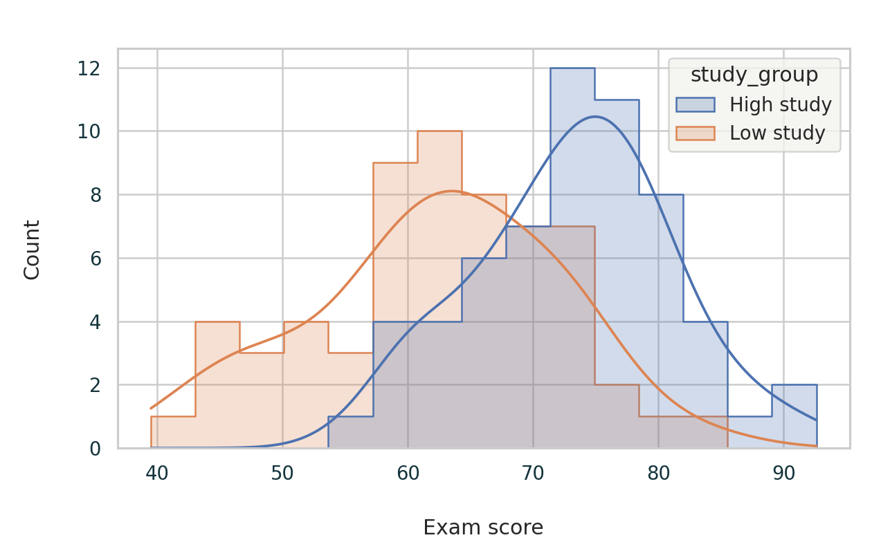
Figure 1. Distribution of examination scores by study group.
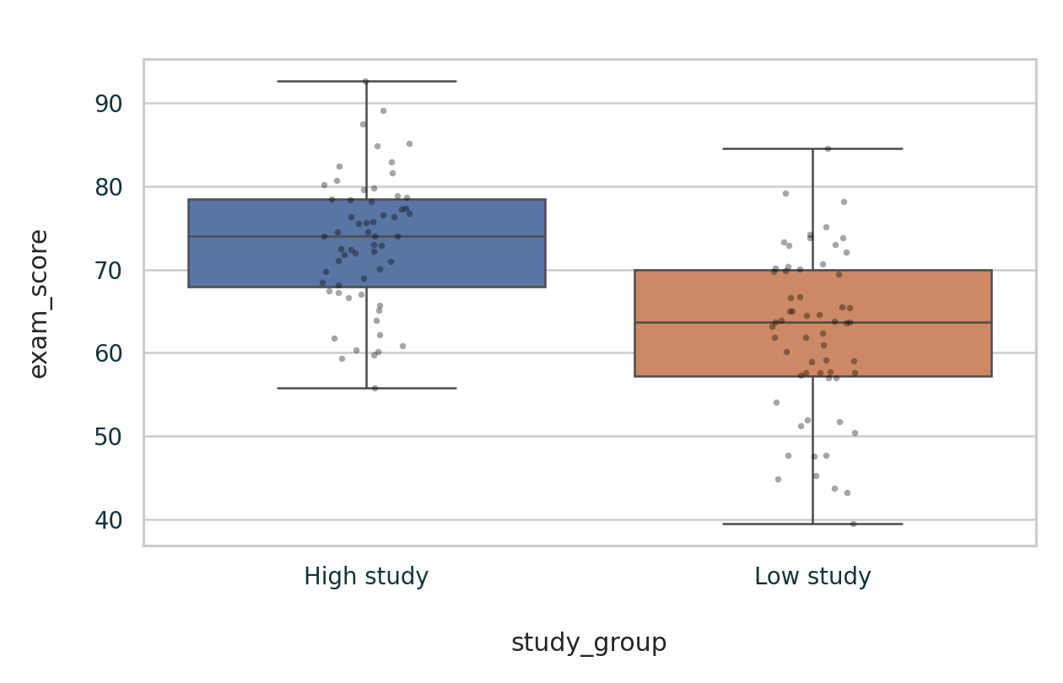
Figure 2. Group comparison using boxplots and individual observations.
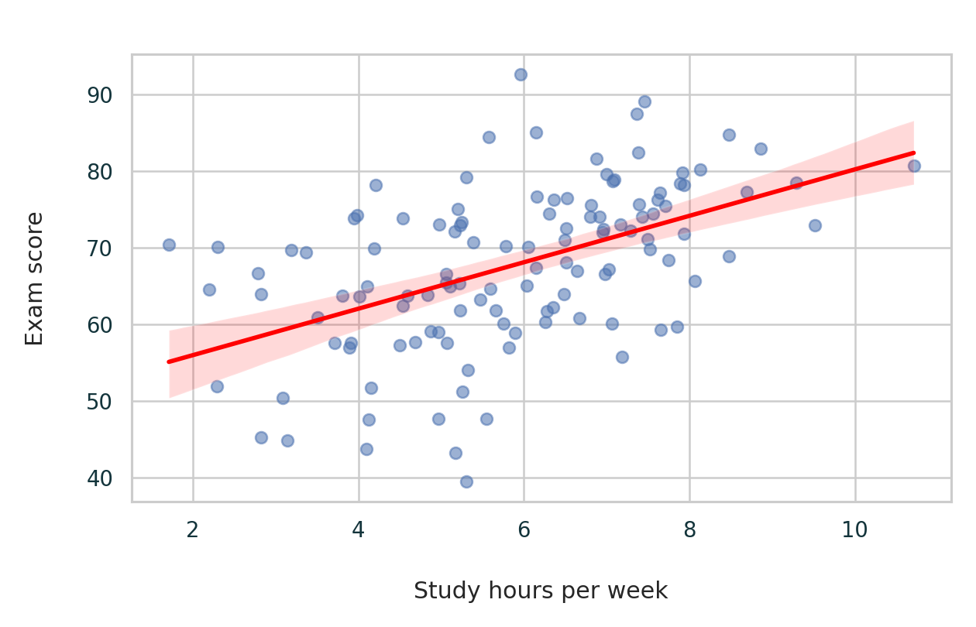
Figure 3. Relationship between weekly study hours and exam score.

5. Statistical Results
Measure | High study | Low study
Sample size | 60 | 60
Mean score | 73.23 | 62.17
Standard deviation | 7.89 | 9.91
Welch t-test: t = 6.766, degrees of freedom = 112.38, p = 0.000000. Mean difference = 11.07 points, with a 95% confidence interval from 7.83 to 14.31. Cohen’s d = 1.24.
Supplementary Pearson correlation between study hours and exam score: r = 0.498, p = 0.000000.

6. Assumption Checks
Shapiro–Wilk normality tests gave p = 0.8795 for the high-study scores and p = 0.4626 for the low-study scores. Levene’s test for equal variances gave p = 0.1210. Welch’s test was retained because it is robust to unequal variances. Visual inspection of the histogram and boxplot should also be used; formal tests should not be treated as the only evidence.

7. Interpretation and Conclusion
The p-value is below 0.05, so H₀ is rejected. The sample provides statistically significant evidence that the mean exam scores differ between the two study groups. The positive mean difference indicates that the high-study group scored higher by approximately 11.07 points. Because the confidence interval does not include zero, it supports the same conclusion.
The result should not be interpreted as proof that studying alone causes higher scores. Attendance, prior ability, teaching quality, motivation, and assessment conditions may also influence performance. The self-generated dataset limits external validity. A real study should use anonymised institutional data, pre-register the analysis where possible, report missing-data handling, and consider multiple regression to adjust for relevant confounding variables.

8. Python Code
import pandas as pd
from scipy import stats

df = pd.read_csv("student_performance_dataset.csv")
median_hours = df["study_hours"].median()
df["study_group"] = df["study_hours"].apply(
lambda x: "High study" if x >= median_hours else "Low study"
)
high = df.loc[df["study_group"] == "High study", "exam_score"]
low = df.loc[df["study_group"] == "Low study", "exam_score"]

# Welch independent-samples t-test
result = stats.ttest_ind(high, low, equal_var=False)
ci = result.confidence_interval(confidence_level=0.95)
print(result)
print("Mean difference:", high.mean() - low.mean())
print("95% CI:", ci)

# Assumption checks and association
print(stats.shapiro(high))
print(stats.shapiro(low))
print(stats.levene(high, low))
print(stats.pearsonr(df["study_hours"], df["exam_score"]))

9. Work Plan (30–35 Hours)
- Topic selection, research question, and hypothesis: 3 hours
- Dataset design or collection and data dictionary: 5 hours
- Data cleaning and exploratory analysis: 6 hours
- Statistical-test selection and assumption checks: 6 hours
- Python implementation and visualisations: 6 hours
- Interpretation, limitations, and academic writing: 5 hours
- Proofreading, formatting, and reproducibility checks: 2 hours

References
[1] SciPy documentation. “ttest_ind: Calculate the T-test for the means of two independent samples.” https://docs.scipy.org/doc/scipy/reference/generated/scipy.stats.ttest_ind.html
[2] python-docx documentation. “Working with Documents.” https://python-docx.readthedocs.io/en/latest/user/documents.html
Note: The DOCX-generation approach uses python-docx, which supports creating and saving Word documents. [2]

