SECURE SOCKETS LAYER PROTOCOL SIMULATION A Minor Project Report
Submitted for the partial fulfillment of the
Requirement for the
Award of Degree for

BACHELOR OF TECHNOLOGY
IN
COMPUTER SCIENCE AND ENGINEERING
by

Under guidance of

DEPARTMENT OF COMPUTER SCIENCE AND ENGINEERING

(Affiliated to RGPV,B HOPAL)
DEPARTMENT OF COMPUTER SCIENCE AND ENGINEERING

(Affiliated to RGPV,B HOPAL)

CERTIFICATE

This is to certify that have submitted the minor project report on SECURE SOCKETS LAYER PROTOCOL SIMULATION has the part of their B.Tech III year curriculum for the partial fulfillment for the award of the Degree.

INTERNAL GUIDE HEAD OF DEPARTMENT
Prof. Abha Suryavanshi Prof. Sanjeev Jain

CONTENTS

ABSTRACT v
LIST OF FIGURES vi
LIST OF TABLES vii
LIST OF SCREENSHOTS viii
1. INTRODUCTION
  - SSL Basics 11
  - Internet Security Issues 13
    - Web Security 14
  - Technical Overview Of The SSL Protocol 26
  - SSL Objectives And Architecture 27
  - The SSL Goals 35
1. p = a prime modulus, where 2^{L-1} <p < 2^{L} for 512 = < L = <1024 and L a multiple of 64
2. q = a prime divisor of p - 1, where 2¹⁵⁹ < q < 2¹⁶⁰
3. g = h ^{(p-1)/q} mod p, where h is any integer with 1 < h < p - 1 such that h ^{(p-1)/q} mod p > 1
(g has order q mod p)

  - Software And Hardware Requirement Specification 36
- SYSTEM ANALYSIS
  - Problem Definition 37
  - Requirement Analysis 38
  - Previous System 39
  - Proposed System 40
  - Feasibility Study 40
    - Technical Feasibility 42
    - Economical Feasibility 42
    - Operational Feasibility 42
    - Scheduled Feasibility 43
- SYSTEM DESIGN
  - Flow Charts 44

3.2. Software Modules And Algorithms 47
  - 3.2.1 Modules 47
    - Algorithms used 48
3.3. Data Flow Diagrams 1
3.4 UML Diagrams 4. TESTING AND VALIDATION
  - Testing 74
4.2 Test cases 76
5. SCREEN SHOTS 6. CONCLUSION
6.1Conclusion 101
6.2 Future Work 103
7. BIBILOGRAPHY 104

ABSTRACT

This project deals with the Secure Sockets Layer Protocol. Today, we rely heavily on the Internet for electronic data transfer, financial transactions, communication, and information retrieval and so on. Be it the success and smooth operation of a business enterprise or the convenience of the general public, the Internet has become the answer for many of our needs. But any breach in the confidentiality and integrity of the data transferred over the Internet can nullify the advantages offered and cause great loss and inconvenience to the user. Thus, the growing use of Internet necessitates the development of a protocol that would make ‘secure and reliable transfer of data’ possible and at the same time, would be flexible enough to incorporate changes as the need arises.
Secure Sockets Layer (SSL) is one such protocol that has gained widespread popularity because of its various attractions like efficiency, cryptographic security, interoperability, and extensibility.
This project deals with the implementation of the Secure Sockets Layer protocol. Here we are mainly concerned with the implementation of the client and server entities and the SSL transaction between them. This transaction comprises of the authentication, key exchange and bulk data transfer. Our implementation guarantees secure and reliable communication (message exchange) and data transfer (files) between the two entities.

LIST OF FIGURES

Fig 1.1 SSL runs above TCP/IP and below high-level application protocols 11

Fig 1.2 Network level 17

Fig 1.3 Transport Level 17
Fig 1.4 Application level 18
Fig 1.5 Symmetric-key encryption 20
Fig 1.6 Public-key encryption 21

Fig 1.7 Using a digital signature to validate data integrity 22

Fig 1.8 Using a certificate to authenticate a client to a server 25
Fig 1.9 Diagram of relation between SSL, Applications and the Network 26
Fig 1.10 The SSL Protocol stack 28
Fig 1.11 Creating a packet under SSL record protocol 30
Fig 1.12 SSL Handshake Protocol Action 34
Fig 3.1 System Flow Diagram 45
Fig 3.2 Data Flow Diagrams 51
Fig 3.3 UML Diagrams 53

LIST OF TABLES
Table 1.1 comparison of the threats on the web 15
Table 1.2 Encryption Algorithms 18
Table 5.2 Test Cases 83

LIST OF SCREEN SHOTS

  - Client frame 76
  - Server frame 77
  - Server entered 78
  - Client Intitates Handshake 79
  - Handshake successful on client side 80
  - Handshake successful on client side 81
  - Client sending a message 82
  - Server viewing the received message 83
  - Server viewing the received cipher 84
  - Server sending a message 85
  - Client viewing the received message 86
  - Client viewing the received cipher 87
  - Client sending a file 88
  - Server opening the received file 89
  - Server viewing the received file cipher 90
  - Server sending a file 91
  - Client opening the received file 92
  - Client viewing the file cipher 93

SECURE SOCKETS LAYER PROTOCOL SIMULATION

- INTRODUCTION

INTRODUCTION
1.1 SSL BASICS
The Transmission Control Protocol/Internet Protocol (TCP/IP) governs the transport and routing of data over the Internet. Other protocols such as the Hypertext Transport Protocol (HTTP), Lightweight Directory Access Protocol (LDAP), or Internet Messaging Access Protocol (IMAP), run “on top of” TCP/IP in the sense that they all use TCP/IP to support typical application tasks such as displaying web pages or running email servers.

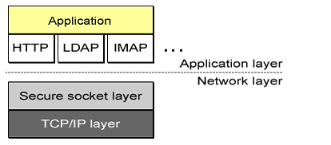

Figure 1.1: SSL runs above TCP/IP and below high-level application protocols
The SSL protocol runs above TCP/IP and below higher-level protocols such as HTTP or IMAP. It uses TCP/IP on behalf of the higher-level protocols and in the process allows an SSL-enabled server to authenticate itself to an SSL-enabled client, allows the client to authenticate itself to the server, and allows both machines to establish an encrypted connection

These capabilities address fundamental concerns about communication over the Internet and other TCP/IP networks:

SSL SERVER AUTHENTICATION: allows a user to confirm a server’s identity. SSL-enabled client software can use standard techniques of public-key cryptography to check that a server’s certificate and public ID are valid and have been issued by a certificate authority (CA) listed in the client’s list of trusted CA’s. This conformation might be important if the user, For example, is sending a credit card number over the network and wants to check the receiving server’s identity.

- SSL CLIENT AUTHENTICATION: allows a server to confirm a user’s identity. Using the same techniques as those used for server authentication, SSL-enabled server software can check that a client’s certificate and public ID are valid and have been issued by a certificate authority (CA) listed in the server’s list of trusted CA’s. This confirmation might be important if the server, for example, is a bank sending confidential financial information to a customer and wants to check the recipient’s identity.

- AN ENCRYPTED SSL CONNECTION: requires all information sent between a client and a server to be encrypted by the sending software and decrypted by the receiving software, thus providing a high degree of confidentiality. Confidentiality is important for both parties to any private transaction. In addition, all data sent over an encrypted SSL connection is protected with a mechanism for detecting tampering--- that is, for automatically determining whether the data has been altered in transit.

The SSL Protocol is composed of two layers. At the lowest level, layered on top of some reliable transport protocol (e.g., TCP), is the SSL Record Protocol. The SSL Record Protocol is used for encapsulation of various higher-level protocols. One such encapsulated protocol, the SSL Handshake Protocol, allows the server and client to authenticate each other and to negotiate an encryption algorithm and cryptographic keys before the application protocol transmits or receives its first byte of data.

1.2 INTERNET SECURITY ISSUES

All communication over the Internet uses the Transmission Control Protocol
Internet Protocol (TCP/IP). TCP/IP allows information to be sent from one computer to another through a variety of intermediate computers and separate networks before it reaches its destination.

The great flexibility of TCP/IP has led to its worldwide acceptance as the basic Internet and intranet communications protocol. At the same time, the fact that TCP/IP allows information to pass through intermediate computers makes it possible for a third party to interface with communications in the following ways:

- EAVESDROPPING: Information remains intact, but its privacy is compromised. For example, some one could learn your credit card number, record a sensitive conversation, or interact classified information.
- TAMPERING: Information in transit is changed or replaced and then sent to the recipient. For example, some one could alter an order for goods or change a person’s resume.
- IMPRESONATION: Information passes to a person who poses as the intended recipient. Impersonation can take two forms:
  - SPOOFING: A person can pretend to be some one else. For example, a person can pretend to have the email address jdoe@xyz.com or a computer can identify itself as a site called www.xyz.comwhen it is not. This type of impersonation is known as spoofing.
  - MISREPRESENTATION: A person or organization can misrepresent itself. For example, suppose the site www.xyz.com pretends to be a furniture store when it is really just a site that takes credit-card payments but never sends any goods..

PUBLIC-KEY CRYPTOGRAPHY FACILATATES THE FOLLOWING TASKS

- ENCRYPTION AND DECRYPTION allow two communicating parties to disguise information they send to each other. The sender encrypts, or scrambles, information before sending it. The receiver decrypts, or unscrambles, the information after receiving it. While in transit the encrypted information is unintelligible to an intruder.
- TAMPER DETECTION: allows the recipient of information to verify that it has not been modified in transit. Any attempt to modify data or substitute a false message for a legitimate one will be detected.
- AUTHENTICATION: allows the recipient of information to determine its origin--- that is, to confirm the sender’s identity.
- NON-REPUDIATION: prevents the sender of information from claiming at a later date that the information was never sent.
The sections that follow introduce the concepts of public-key cryptography that underlie these capabilities.
1.2.1 WEB SECURITY
These general requirements for web security then focus on standardized schemes known as SSL/TLS and SET.

• WEB SECURITY CONSIDERATION: The World Wide Web is fundamentally a client server application running over the Internet and TCP/IP intranets.

• WEB SECURITY THREATS: Given table provides a summary of the types of security threats faced in using the web. One way to group these threats is in terms of passive & active attacks. Passive attacks include eaves dropping on network traffic between browser and server and gaining access to information on a website. Active attacks include impersonating another user, attacking messages in transit between client and server and altering information on a website.

Table1.1: - comparison of the threats on the web
 | Threats | Consequences | Countermeasures
Integrity  Confidentiality  Denial of service  Authentication | - Modification of user data  - Trojan horse browser  - Modification of memory  - Modification of message traffic in transit  - Eavesdropping on the Net  - Theft of info from server  - Theft of data from client  - Info about n/w configuration  - Info about which client talks to server  - Killing of user threads  - Flooding m/c with bogus threats  - Filling up disk or memory  - Isolating m/c by DNS attacks  - Impersonation of legitimate users  - Data forgery | - Loss of information  - Compromise of machine  - Vulnerability to all other users  - Loss of information  - Loss of privacy  - Disruptive  - Annoying  - Prevent user from work done  - Misrepresentation of user  - Belief that false information is valid | Cryptographic checksums  Encryption, web proxies  Difficult to prevent  Cryptographic techniques

- WEB TRAFFIC SECURITY APPROACHES: - There are number of approaches to providing web security. The various approaches that have been considered are similar in the services, but they differ with respect to their scope of applicability and their relative location within the TCP/IP protocol stack.

- One way to provide web security is by using IP security Figure1.2. The advantage of using IPSEC is, it is transparent to end users and applications

HTTP | FTP | SMTP

TCP
IP/IPsec

Figure 1.2: Network level

- Another way is to implement security just above TCP Figure 1.3. The foremost example of this approach is the security sockets layer (SSL) and the follow-on Internet standard of SSL known as Transport layer security (TLS)

HTTP | FTP | SMTP

SSL or TLS

TCP
IP

Figure 1.3: Transport Level

- Application specific security services are embedded within the particular application. Fig 1.4. shows examples of this architecture. The advantage of this approach is that the service can be tailored to the specific needs of a given application.
S/MIME |  | PGP | SET
Kerberos | SMTP |  |  |  | HTTP
UDP | TCP
IP

Figure 1.4: Application level

ENCRYPTION AND DECRYPTION
Encryption is the process of converting a plaintext message into cipher text, which can be decoded back into the original message. An encryption algorithm along with a key is used in the encryption and decryption of data. There are several types of data encryptions, which form the basis of network security.
- ENCRYPTION ALGORITHMS

Block Cipher |  |  | Stream Cipher
Algorithm | Key Size |  | Algorithm |  | Key Size
Idea  RC2-40  DES-40  DES  3DES  Fortezza |  | 128  40  40  56  168  80 |  | RC4-40  RC4-128 |  | 40  128
Table 1.2: Encryption Algorithms
Encryption schemes are based on block or stream ciphers. The type and length of the keys utilized depend upon the encryption algorithm and the amount of security needed. In conventional symmetric encryption a single key is used. With this key, the sender can encrypt a message and a recipient can decrypt the message but the security of the key becomes problematic. In asymmetric encryption, the encryption key and the decryption key are different. One is a public key by which the sender can encrypt the message and the other is a private key by which a recipient can decrypt the message.
A cryptographic algorithm, also called a cipher, is a mathematical function used for encryption or decryption. In most cases, two related functions are employed, one for encryption and the other for decryption.
With most modern cryptography, the ability to keep encrypted information secret is based not on the cryptographic algorithm, which is widely known, but on a number called a key that must be used with the algorithm to produce an encrypted result or to decrypt previously encrypted information. Decryption with the correct key is simple. Decryption with out the correct key is very difficult, and in some cases impossible for all practical purposes.

The sections that follow introduce the use of keys for encryption and decryption.

SYMMETRIC-KEY ENCRYPTION

With symmetric-key encryption, the encryption key can be calculated from the decryption key and vice versa. With most symmetric algorithms, the same key is used for both encryption and decryption, as shown in Figure 1.5.

Encryption Decryption
Dear A: I have received the news….
 
Dear A: I have received the news…

Original Symmetric Scrambled Symmetric Original
Data key data key data

Figure 1.5: Symmetric-key encryption

Implementation of symmetric-key encryption can be highly efficient, so that users do not experience any significant time delay as a result of the encryption and decryption. Symmetric-key encryption also provides a degree of authentication, since information encrypted with one symmetric key cannot be decrypted with any other symmetric key. Thus, as long as the symmetric key is kept secret by the two parties using it to encrypt communications, each party can be sure that it is communicating with the other as long as the decrypted messages continue to make sense.

Symmetric-key encryption is effective only if the two parties involved keep the symmetric key secret. If anyone else discovers the key, it affects both confidentiality and authentication. A person with an unauthorized symmetric key not only can decrypt messages sent with that key but can encrypt new messages and send them as if they came from one of two parties who were originally using the key.

PUBLIC-KEY ENCRYPTION
Public-key encryption (also called asymmetric encryption) involves a pair of keys--- a public key and a private key – associated with an entity that needs to authenticate its identity electronically or to sign or encrypt data. Each public key is published, and the corresponding private key is kept secret. Data encrypted with your public key can be decrypted only with your private key. Figure 1.6 shows a simplified view of the way public-key encryption works.
 
Encryption Decryption
Dear A: I have received the news….
Dear A: I have received the news…

Original Public Scrambled Private Original
Data key data key data

Figure 1.6: Public-key encryption

DIGITAL SIGNATURES
Encryption and decryption address the problem of eavesdropping, one of the three Internet security issues mentioned at the beginning of this document. But encryption and decryption, by themselves, do not address the other two problems mentioned in Internet Security Issues: tampering and impersonation.

Tamper detection and related authentication techniques rely on a mathematical function called a one-way hash (also called a message digest). A one-way hash is a number of fixed length with the following characteristics:

- The value of the hash is unique for the hashed data. Any change in the data, even deleting or altering a single character, results in a different value.
- The content of the hashed data cannot, for all practical purposes, be deduced from the hash--which is why it is called “one-way.”

Figure 1.7 shows a simplified view of the way a digital signature can be used to validate the integrity of signed data.

Dear A: I have received the news….
Hashing algorithm
Dear A: I have received the news….
Original data

Network
One-way
hash

Hashing algorithm

One-way private key Digital Digital Public One-way
Hash encryption signature Signature decryption hash

Figure 1.7: Using a digital signature to validate data integrity

Figure 1.7 shows two items transferred to the recipient of some signed data: the original data and the digital signature, which is basically a one-way hash (of the original data) that has been encrypted with the signer’s private key. To validate the integrity of the data, the receiving software first uses the signer’s public key to decrypt the hash. It then uses the same hashing algorithm that generated the original hash to generate a new one-way hash of the same data.

CERTIFICATES AND AUTHENTICATION

A CERTIFICATE IDENTIFIES SOMEONE OR SOMETHING

A certificate is an electronic document used to identify an individual, a server, a company, or some other entity and to associate that identity with a public key. Like a driver’s license, a passport, or other commonly used personal Ids, a certificate provides generally recognized proof of a person’s identity. Public-key cryptography uses certificates to address the problem of impersonation.

Certificate authorities (CAs) are entities that validate identities and issue certificates. They can be either independent third parties or organizations running their own certificate-issuing server software. Before issuing the certificate the CA must use its published verification procedures for that type of certificate to ensure that an entity requesting a certificate is in fact who it claims to be. The certificate issued by the CA binds a particular public key to the name of the entity the certificate identifies (such as the name of an employee or a server). Certificates help prevent the use of fake public keys for impersonation. Only the public key certified by the certificate will work with the corresponding private key possesses by the entity identified by the certificate.

AUTHENTICATION CONFIRMS AN IDENTITY

Authentication is the process of confirming an identity. In the content of network interactions, authentication involves the confident identification of one party by another party. Authentication over networks can take many forms. Certificates are one way of supporting authentication.

Network interactions typically take place between a client, such as browser software running on a personal computer, and a server, such as the software and hardware used to host a Web site. Client authentication refers to the confident identification of a client by a server (that is, identification of the person assumed to be using the client software). Server authentication refers to the confident identification of a server by a client (that is, identification of the organization for a server at a particular network address).

- PASSWORD-BASED AUTHENTICATION: Almost all server software permits client authentication by means of a name and password. For example, a server might require a user to type a name and password before granting access to the server. The server maintains a list of names and passwords; if a particular name is on the list, and the user types the correct password, the server grants access.
- CERTIFICATE BASED AUTHENTICATION: Client authentication based on certificates is part of the SSL protocol. The client digitally signs a randomly generated piece of data and sends both the certificate and the signed data across the network. The server uses techniques of public-key cryptography to validate the signature and confirm the validity of the certificate.

Figure 1.8 shows how client authentication works using certificates and the SSL protocol. To a user to a server, a client digitally signs a randomly generated piece of data and sends both certificate and the signed data across the network. For the purposes of this discussion the digital signature associated with some data can be thought of as evidence provided by the client to the server.

User enters server enters
11121121
2121121

Private-key
Client retrieves private key and uses it to create” evidence”
(Digital signature)

SSL connection
Client sends certificate and evidence across network
33
Server uses certificate and evidence to authenticate the user’s identity.
44
55
Figure 1.8: Using a certificate to authenticate a client to a server

The process shown in Figure 1.8 requires the use of SSL. Certificate based authentication is generally considered preferable to password authentication because it is based on what the user has (the private key) as well as what the user knows (the password that protects the private key).

1.3 TECHNICAL OVERVIEW OF THE SSL PROTOCOL
The SSL Protocol is designed to provide privacy between two communicating application (a client and a server). Second, the protocol is designed to authenticate the server, and optionally the client.
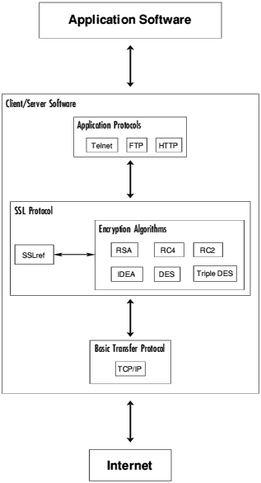
Figure 1.9: Diagram of relation between SSL, Applications and the Network

SSL uses X.509 certificates for authentication, RS as its public key cipher and one of RC4 -128, RC2-128, DES, Triple DES or IDEA as its bulk symmetric cipher.

1.4 SSL OBJECTIVES AND ARCHITECTURE
- THE MAIN OBJECTIVE OF SSL ARE
- Authenticating the client and server to each other: the SSL protocol supports the use of standard key cryptographic techniques (public key encryption) to authenticate the communicating parties to each other. Though the most frequent application consists in authenticating the service client on the basis of a certificate, SSL may also use the same methods to authenticate the client.
- Ensuring data integrity: during a session, data cannot be either intentionally or unintentionally tampered with.
- Securing data privacy: data in transport between the client and the server must be protected from interception and be readable only by the intended recipient. This prerequisite is necessary for both the data associated with the protocol itself (securing traffic during negotiations) and the application data that is sent during the session itself.

- SSL ARCHITECTURE
SSL is in fact not a single protocol but rather a set of protocols that can additionally be further divided in two layers:

1. The protocol to ensure data security and integrity: this layer is composed of the SSL Record Protocol,
2. The protocols that are designed to establish an SSL connection: three protocols are used in this layer: the SSL Handshake Protocol, the SSL Change Cipher Spec Protocol and the SSL Alert Protocol.
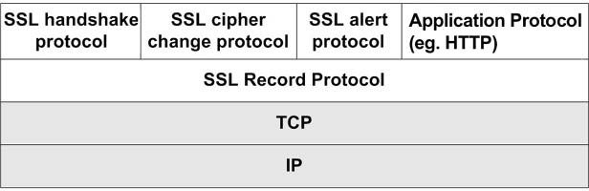
Figure 1.10: The SSL Protocol stack
SSL uses these protocols to address the tasks as described above. The SSL record protocol is responsible for data encryption and integrity. As can be seen in Figure, it is also used to encapsulate data sent by other SSL protocols, and therefore, it is also involved in the tasks associated with the SSL check data. The other three protocols cover the areas of session management, cryptographic parameter management and transfer of SSL messages between the client and the server. Prior to going into a more detailed discussion of the role of individual protocols and their functions let us describe two fundamental concepts related to the use of SSL.
- SSL SESSION AND CONNECTION
The concepts as mentioned above are fundamental for a connection between the client and the server, and they also encompass a series of attributes. Let’s try to give some more details:
- Connection: this is a logical client/server link, associated with the provision of a suitable type of service. In SSL terms, it must be a peer-to-peer connection with two network nodes.
- Session: this is an association between a client and a server that defines a set of parameters such as algorithms used session number etc.:
- Session identifier: this is an identifier generated by the server to identify a session with a chosen client,
- Peer certificate: X.509 certificate of the peer,
- Compression method: a method used to compress data prior to encryption,
- Algorithm specification termed Cipher Spec: specifies the bulk data encryption algorithm (for example DES) and the hash algorithm (for example MD5) used during the session,
- Master secret: 48-byte data being a secret shared between the client and server,
- “Is resumable”: this is a flag indicating whether the session can be used to initiate new connections.
According to the specification, the SSL connection state is defined by the following parameters:
- Server and client random: random data generated by both the client and server for each connection,

The abbreviation MAC used in the above definitions means Message Authentication Code that is used for transmission of data during the SSL session. The role of MAC will be explained further when discussing the record protocols. A brief description of the terms was necessary to be able to explain the next issues connected with the functioning of the SSL protocol, namely the SSL record protocol.
The SSL Record Protocol
The SSL record protocol involves using SSL in a secure manner and with message integrity ensured. To this end it is used by upper layer SSL protocols. The purpose of the SSL record protocol is to take an application message to be transmitted, fragment the data which needs to be sent, encapsulate it with appropriate headers and create an object just called a record, which is encrypted and can be forwarded for sending under the TCP protocol.
The first step in the preparation of transmission of the application data consists in its fragmentation i.e. breaking up the data stream to be transmitted into 16Kb (or smaller) data fragments followed by the process of their conversion in a record.

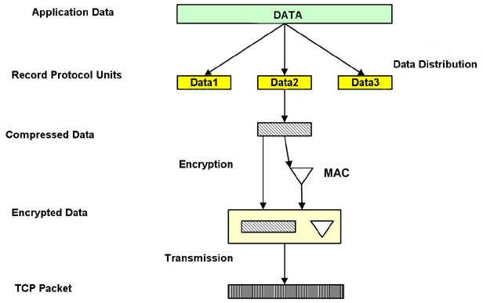

Figure 1.11: Creating a packet under SSL record protocol
The SSL record protocol is used to transfer any data within a session - both messages and other SSL protocols (for example the handshake protocol), as well as for any application data.

The SSL Record Protocol provides two services for SSL connections:

- Confidentiality: The handshake Protocol defines a shared secret key that is used for conventional encryption of SSL payloads.
- Message Integrity: The Handshake protocol also defines a shared secret key that is used to form a message authentication code.

Figure1.11. indicates the overall operation of the SSL Record Protocol. The Record Protocol takes an application message to be transmitted, fragments the data into manageable blocks, compresses the data, applies a MAC, encrypts, adds a header, and transmits the resulting unit in a TCP segment. Received data are decrypted, verified, decompressed, and reassembled and then delivered to higher-level users.

The first step is Fragmentation. Each upper layer message is fragmented into blocks of 2^14 bytes or less.

Next Compression is optionally applied. Compression must be loss less and may not increase the content length by more than 1024 bytes. In SSLv3 no compression algorithm is specified, so the default compression algorithm is null. The next step is to compute a message authentication code over the compressed data. For this purpose, a shared secret key is used. The calculation is defined as follows:

Hash (MAC_write_secret || pad_2 ||
Hash (MAC_write_secret || pad_1 || seq_num || SSLCompressed.type ||
SSLCompressed.length || SSLCompressed.fragment))

Where
|| = Concatenation
MAC_write_secret = shared secret key
Hash = cryptographic hash algorithm SHA-1
Pad_1 = the byte 0x36 repeated 40 times for SHA-1
Pad_2 = the byte 0x5c repeated 40 times for SHA-1
Seq_num = the sequence number for this message
SSLCompressed.type = the higher level protocol used to process this
Fragment
SSLCompressed.length = the length of compressed fragment
SSLCompressed.fragment = the compressed fragment

The compressed message plus the MAC are encrypted using symmetric encryption. Encryption may not increase the content length by more than 1024 bytes, so the total length may not exceed 2^14+2048.

THE ALERT PROTOCOL

Parties to convey session messages associated with data exchange and functioning of the protocol use the Alert Protocol. Each message in the alert protocol consists of two bytes. The first byte always takes a value, “warning” (1) or “fatal” (2), that determines the severity of the message sent. Sending a message having a „fatal” status by either party will result in an immediate termination of the SSL session. The next byte of the message contains one of the defined error codes, which may occur during an SSL communication session.

THE CHANGE CIPHER SPEC PROTOCOL
This protocol is the simplest SSL protocol. It consists of a single message that carries the value of 1. The sole purpose of this message is to cause the pending session state to be established as a fixed state, which results, for example, in defining the used set of protocols. The client must send this type of message to the server and vice versa. After exchange of messages, the session state is considered agreed. This message and any other SSL messages are transferred using the SSL record protocol.
THE SSL HANDSHAKE PROTOCOL
The Handshake protocol constitutes the most complex part of the SSL protocol. It is used to initiate a session between the server and the client. Within the message of this protocol, various components such as algorithms and keys used for data encryption are negotiated. Due to this protocol, it is possible to authenticate the parties to each other and negotiate appropriate parameters of the session between them.
The process of negotiations between the client and the server is illustrated in Figure 1.12. It can be divided into 4 phases separated with horizontal broken lines. During the first phase, a logical connection must be initiated between the client and the server followed by the negotiation on the connection parameters.
The client sends the server a client _hello message containing data such as:
- Version: The highest SSL version supported by the client,
- Random: data consisting of a 32-bit time stamp and 28 bytes of randomly generated data. This data is used to protect the key exchange session between the parties of the connection.
- Session ID: a number that defines the session identifier. A nonzero value of this field indicates that the client wishes to update the parameters of an existing connection or establish a new connection on this session.
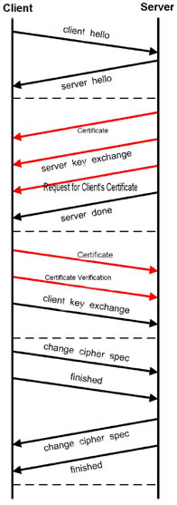
Figure 1.12: SSL Handshake Protocol Action

THE SSL GOALS
The goals of SSL Protocol v3.0, in order of their priority, are:
- CRYPTOGRAPHIC SECURITY
SSL should be used to establish a secure connection between two parties.

- INTEROPERABILITY
Independent programmers should be able to develop applications utilizing SSL 3.0 that will then be able to successfully exchange cryptographic parameters without knowledge of one another's code.
Note: It is not the case that all instances of SSL (even in the same application domain) will be able to successfully connect. For instance, if the server supports a particular hardware token, and the client does not have access to such a token, then the connection will not succeed.

- EXTENSIBILITY
SSL seeks to provide a framework into which new public key and bulk encryption methods can be incorporated as necessary. This will also accomplish two sub-goals: to prevent the need to create a new protocol (and risking the introduction of possible new weaknesses) and to avoid the need to implement an entire new security library.

- RELATIVE EFFICIENCY
Cryptographic operations tend to be highly CPU intensive, particularly public key operations. For this reason, the SSL protocol has incorporated an optional session caching scheme to reduce the number of connections that need to be established from scratch. Additionally, care has been taken to reduce network activity.

1.6 S/W & H/W REQUIREMENT SPECIFICATION

SOFTWARE REQUIREMENT SPECIFICATION

OPERATING SYSTEM: WINDOWS XP

LANGUAGE: JAVA2SDK 1.5.0. VERSION

DOCUMENTATION TOOL: MS-WORD

HARDWARE REQUIREMENT SPECIFICATION

PROCESSOR: PENTIUM

SPEED: 250 MHZ TO 833MHZ

RAM: 512 MB

HARD DISK: 40 GB

NETWORK: LAN

LAN SPEED: 100Mbps

- SYSTEM ANALYSIS

SYSTEM ANALYSIS

  - PROBLEM DEFNITION
The primary goal of the SSL Protocol is to provide privacy and data integrity between two communicating applications. The protocol is composed of two layers: the SSL Record Protocol and the SSL Handshake Protocol. At the lowest level, layered on top of some reliable transport protocol (e.g., TCP), is the SSL Record Protocol. The SSL Record Protocol provides connection security that has two basic properties.

- THE CONNECTION IS PRIVATE: Symmetric cryptography is used for data encryption (e.g., DES, RC4, etc.) The keys for this symmetric encryption are generated uniquely for each connection and are based on a secret negotiated by another protocol (such as the TLS Handshake Protocol). The record Protocol can also be used without encryption.
- THE CONNECTION IS RELABLE: Message transport includes a message integrity check using a keyed MAC. Secure hash functions (e.g., SHA, MD5, etc.) are used for MAC computations. The Record Protocol can operate without a MAC, but is generally only used in this mod while another protocol is using the Record Protocol as a transport for negotiating security parameters.

Systems need to be represented as separate functional and physical models.
  - System functions change slowly with time while physical elements may change.
  - Dramatically
- The model provides evidence of how well the target is understood.
- The model is reverse-engineered from multi-source, sampled data.
- Total analysis is never completed

System Analysis is a process of examining the current system in order to develop the software design tool through better procedures and methods. It is the process of gathering and interpreting facts, diagnosing the problems and using the information to recommend approaches in the system.
System analysis is done to understand the problem, which the new system is going to solve. Such analysis typically requires a thorough understanding of existing system, and the part, which must be automated. Understanding the existing system is usually the starting activity in problem analysis. The goal of this activity is to understand the requirement of the new system that is to be developed.

The major steps followed in System Analysis are:
- Problem evaluation and synthesis.
- Proposed System.
- Software Requirements Specification.
- Feasibility study

  - REQUIREMENT ANALYSIS
Requirement analysis is to understand the problem and collect the requirements to solve the problem. It results in a system description and a set of requirements to solve the problem. Requirement analysis is a communication intensive activity. If the communication fails, even the rest technical approach will fail short.

Analysis is used to gain an understanding of an existing system and what is acquired of it. It is very important in the development of project life cycle. It helps us to develop a new package, which satisfies all the necessary goals. The fundamental activities of the system analysis phases are:-

  - Understanding the system clearly.
  - Analysis the needs and creating a design for the new system.
  - Difficulties in the existing system.
  - Propose new system.

System analysis is an important activity that takes place when we are building new information or changing the existing one. It is therefore necessary to spend considerable time to properly understand the system and its problems.

  - PREVIOUS SYSTEM

The first version of SSL was never released because of problems regarding protection of credit card transactions on the Web.

In 1994, Netscape created SSLv2, which made it possible to keep credit card numbers confidential and also authenticate the Web server with the use of encryption and digital certificates. The first public version of SSL, version 2, suffered from a number of security flaws, which have been fixed in SSLv3. As browsers nowadays still support SSLv2, and as it is still in use in some systems, we briefly sum up its security problems:
- SSLv2 has a weak MAC construction and relies solely on the MD5 hash function;
- SSLv2 does not have any protection for the handshake, so that a person-in-the-middle attack cannot be detected;
- finally, a truncation attack is possible, as SSLv2 simply uses the TCP connection close to indicate the end of data, so that the attacker can simply forge the TCP FINs and the recipient cannot tell that it is not a legitimate end of data
  - PROPOSED SYSTEM

Netscape strengthened the cryptographic algorithms and resolved many of the security problems in SSLv2 with the release of SSLv3. SSLv3 now supports more security algorithms than SSLv2.

Some minor modifications were made to increase security:

- The way cryptographic keys are expanded from the initially exchanged secret was improved;

- The MAC construction was slightly modified into an HMAC;

- And, implementations were required to include support for the Diffie-Hellman key agreement, the Digital Signature Standard, and Triple-DES encryption.

  - FEASIBILITY STUDY
Once the problem is clearly understood, the next step is to conduct the feasibility study, which is a high level capsule version of the entire system analysis and design process. The objective is to determine whether the proposed system is feasible.
The feasibility study documents the analysis of a business problem, including the determination of whether it can be solved effectively. The operational (will it work?), economical (costs and benefits) and technical (can it be built?) aspects are part of the study. Results of the study determine whether the solution should be implemented.
The purpose of the feasibility study was two fold. Its first objective was to develop a verification methodology that bridged the gap between formal verification and simulation in a way that would integrate into an existing design flow. The second objective was to gather some quantitative evidence to support the idea that such a methodology would offer advantages over our existing simulation based verification techniques. This selection reflected the importance we place on the functional verification of leading edge processors; however the methodology is applicable to most designs. The choice of the decoder made it possible to investigate the problems of modeling and test specification while simplifying other tasks, in particular the translation from abstract to concrete tests.
The Four tests of feasibility have been carried out
- TECHNICAL FEASIBILITY: Can the work for the project be done with current equipment, existing software technology, and available personnel? If new technology is required, what is the likelihood that it can be developed?
- ECONOMIC FEASIBILITY: Are there sufficient benefits in creating the system to make the costs acceptable: Or, are the costs of not creating the system so great that the project must be undertaken?
- OPERATIONAL FEASIBILITY: Will the system be used if it is developed and implemented? Will there be resistance from users that will undermine the possible application benefits?
- SCHEDULED FEASIBILITY: The time schedule required for the development of the project is important, since more development time affects machine time and cost of delay in development of other systems

TECHNICAL FEASIBILITY

The technical issues usually raised during the feasibility stage of the investigation include these
- Does the necessary technology exist to do what is suggested (and Can it be Acquired)?
- Does the proposed equipment have the technical capacity to hold the data required using the new system?
- Will the propose system provide adequate responses to inquiries, regardless of the number or location of users?
- Can the system be expanded if developed?
- Are there technical guarantees of accuracy, reliability, ease of access, and data security?

    - ECONOMICAL FEASIBILITY

A system that can be developed technically and that will be used if installed must still be a good investment for the organization. Financial benefits must equal or exceed the costs. The financial and economic questions rose by analysts during the preliminary investigation a for the purpose of estimating the following:

1. The cost to conduct a full systems investigation
2. The cost of hardware and software for the class of application being considered
3. The benefits in the form of reduced costs or fewer costly errors
4. The cost if nothing changes (i.e., the proposed system is not developed)
    - OPERATIONAL FEASIBILITY

Proposed projects are beneficial only if they can be turned into information systems that will mettle organization’s operation requirements.

- Is their sufficient support for the project from management? From users? If the current system is well liked and used to the extent that persons will not be able to see reasons for a change, there may be resistance.
- Are current business methods acceptable to the users? If they are not users may welcome a change that will bring about a more operational and useful system.
- Have the users been involved in the planning and development of the project? Early involvement reduced the chances of resistance to the system and change in general and increases the likelihood of successful projects.
- Will the proposed system cause harm? Will it produce poorer results in any respect or area? Will loss of control result in any area will accessibility of information be lost? Will individual customers be affected in an undesirable way will the system slow performance in any areas?
- Issues that appear to be relatively minor in the beginning have way of growing into major problems after implementation therefore all-operational aspects must be considered carefully.

    - SCHEDULED FEASIBILITY

The time schedule required for the development of the project is important, since more development time affects machine time and cost of delay in development of other systems. As our goals, the requirements also change with time and technology; one should be first in incorporating them in the allocated schedule.

3. SYSTEM DESIGN

SYSTEM DESIGN
Design is first and foremost an intellectual process. Contrary to popular belief, designers are not artists. They employ artistic methods to visualize thinking and process, but, unlike artists, they work to solve a client’s problem, not present their own view of the world. If a design project, however, is to be considered successful – and that would be the true measure of quality – it will not only solve the problem at hand, but also add an aesthetic dimension beyond the pragmatic issues.
Design could be viewed as an activity that translates an idea into a blueprint for something useful, whether it's a car, a building, a graphic, a service or a process. The important part is the translation of the idea, though design's ability to spark the idea in the first place shouldn't be overlooked.
The types of design techniques that are used in designing the present system are of the following:
Flow Chart
System Design Process and
Objet Oriented Process.

3.1 FLOW CHARTS
A flow chart is a graphical or symbolic representation of a process. Each step in the process flow is represented by a different symbol and contains a short text description of the process step in the flow chart symbol. The flow chart symbols are linked together with arrow connectors (also known as flow lines).

The step by step procedure for successfully accessing this system is represented by the system flow diagram in the following way:
FIG 3.1: SYSTEM FLOW DIAGRAM

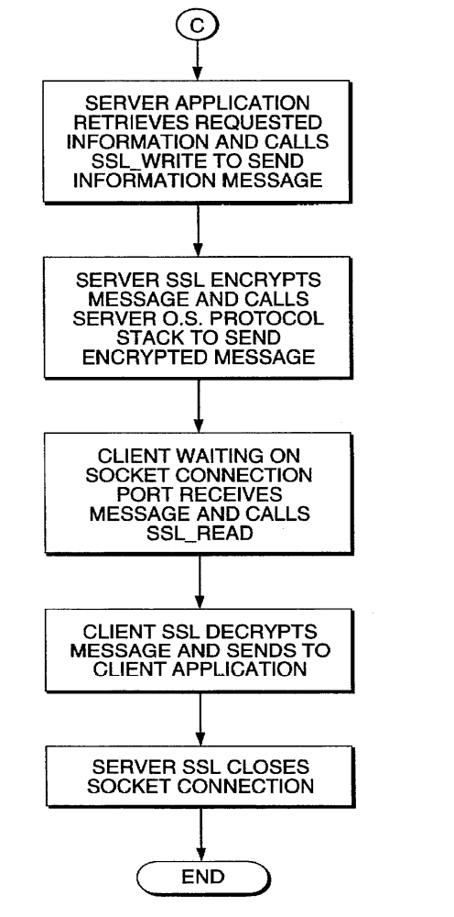
FIG 3.1: SYSTEM FLOW DIAGRAM
  - SOFTWARE MODULES AND ALGORITHMS

3.2.1 MODULES
There are 5 modules in this project:

- CLIENT MODULE: This module contains the code for the client frame. This module also includes the code for sending and receiving and storing the applications on client side.

- SERVER MODULE: This module contains the code for the server frame. This module also includes the code for sending and receiving and storing the applications on server side.

- HANDSHAKE MODULE: This module contains the code for the implementation of the ssl handshake protocol on both client and server side. This module implements RSA key exchange algorithm.

- RECORD PROTOCOL MODULE: This module implements ssl record protocol. For this, it implements SHA1, MD5 and DES encryption-decryption algorithms.

- ALERT PROTOCOL MODULE: This module contains the code for implementing ssl alert protocol.

3.2.2 ALGORITHMS USED

- SHA-1 ALGORITHM

The SHA-1 (Secure Hash Algorithm) may be used with the DSA (Digital Signature Algorithm) in electronic mail, electronic funds transfer, software distribution, data storage, and other applications which require data integrity assurance and data origin authentication [10]. SHA-1 may also be used whenever it is necessary to generate a condensed version of a message. The algorithm for SHA-1 which is used in this project is explained in detail below.

A hash function H is a transformation that takes an input m and returns a fixed-size string, which is called the hash value h (that is, h = H (m)). Hash functions with just this property have a variety of general computational uses, but when employed in cryptography, the hash functions are usually chosen to have some additional properties.

The basic requirements for a cryptographic hash function are as follows.
- The input can be of any length.
- The output has a fixed length.
- H(x) is relatively easy to compute for any given x.
- H(x) is one-way.
- H(x) is collision-free.

A hash function H is said to be one-way if it is hard to invert, where ``hard to invert'' means that given a hash value h, it is computationally infeasible to find some input x such that H(x) = h. If, given a message x, it is computationally infeasible to find a message y not equal to x such that H(x) = H(y), then H is said to be a weakly collision-free hash function. A strongly collision-free hash function H is one for which it is computationally infeasible to find any two messages x and y such that H(x) = H(y).

IMPLEMENTATIONS: The SHA-1 may be implemented in software, firmware, hardware, or any combination thereof. Only implementations of the SHA-1 that are validated by NIST will be considered as complying with this standard. Information about the requirements for validating implementations of this standard can be obtained from the National Institute of Standards and Technology, Computer Systems Laboratory.

APPLICATIONS: The SHA-1 may be used with the DSA in electronic mail, electronic funds transfer, software distribution, data storage, and other applications which require data integrity assurance and data origin authentication. The SHA-1 may also be used whenever it is necessary to generate a condensed version of a message.
- RSA ALGORITHM
[Rivest, Shamir and Adleman 1978] invented an asymmetric cryptosystem named MIT cryptosystem. However, the name RSA is usually used today instead of MIT cryptosystem. In contrast to DES, RSA's security relies on a solid mathematical background. Although current RSA implementations are much slower than symmetric cryptosystems, RSA is not only used for key exchange. Increasing performance of computers could make RSA to a real alternative to symmetric cryptosystems for numerous applications.

An "RSA operation," whether encrypting, decrypting, signing, or verifying is essentially a modular exponentiation. This computation is performed by a series of modular multiplications.

A Simple explanation of RSA Algorithm in view to computer:

Let p and q be distinct large primes and let n be their product. Assume that we also computed two integers, d (for decryption) and e (for encryption) such that d * e 1 (mod ø (n)) where ø (n) is the number of positive integers smaller than n that have no factor except 1 in common with n.

The integers n and e are made public, while p, q, and d are kept secret. Let m be the message to be sent, where m is a positive integer less than and relatively prime to n. A plaintext message is easily converted to a number by using either the alphabet position of each letter (a=01, b=02, ..., z=26) or using the standard ASCII table. If necessary (so that m<n), the message can be broken into several blocks. The encoder computes and sends the number m' = m^e mod n. To decode, we simply compute e^d mod n. The security of RSA depends on the fact that it takes an impractical amount of time to factor large numbers

- DES ALGORITHM

DES, an acronym for the Data Encryption Standard, is the name of the Federal Information Processing Standard (FIPS) 46-3, which describes the data encryption algorithm (DEA). The DEA is also defined in the ANSI standard X3.92.

The DEA has a 64-bit block size and uses a 56-bit key during execution (8 parity bits are stripped off from the full 64-bit key). The DEA is a symmetric cryptosystem, specifically a 16-round Feistel cipher and was originally designed for implementation in hardware. When used for communication, both sender and receiver must know the same secret key, which can be used to encrypt and decrypt the message, or to generate and verify a message authentication code (MAC). The DEA can also be used for single-user encryption, such as to store files on a hard disk in encrypted form environment, secure
DES Block Diagram
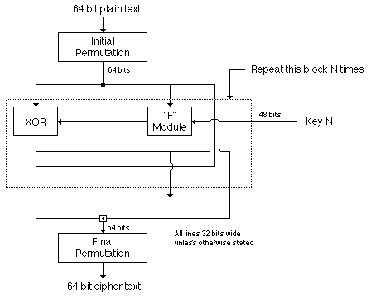

3.3 DATA FLOW DIAGRAMS

1-DFD

SSL
SYSTEM
Encrypted Data Decrypted Data

KEY KEY

2-DFD

SSL
SYSTEM

REQUEST REQUEST

SSL
Client

SSL
Server

RESPONSE
RESPONSE

3-DFD

REQUEST Client_Hello

SSL
Client
SSL
RECORD
PROTOCOL

SSL
Server
SSL
HANDSHAKE
PROTOCOL

Server_Hello
Server
Certificate

3-DFD

SSL SYSTEM
SSL
RECORD
PROTOCOL
CLIENT REQUEST Client_Hello

SSL
Client

SSL
Server
SSL
HANDSHAKE
PROTOCOL
Server Hello
Server
Certificate

Finish Finish
Verify

Certificate
Certificate Authority

3.4 UML DIAGRAMS

The UML is the language for:
• Visualizing
• Specifying
• Constructing
• Documentation
These are the artifacts of a software-intensive system.

A CONCEPTUAL MODEL OF UML

Basic building blocks of the UML Things - Things are the abstractions that are first-class citizens in a model. Relationships - Relationships tie these things together Diagrams - Diagrams group the interesting collections of things.

Things in UML: these are four kinds of things in the UML

• Structural Things
• Behavior Diagrams
• Grouping Things
• Annotational Things

USE CASE DIAGRAMS
CLIENT USECASE DIAGRAM

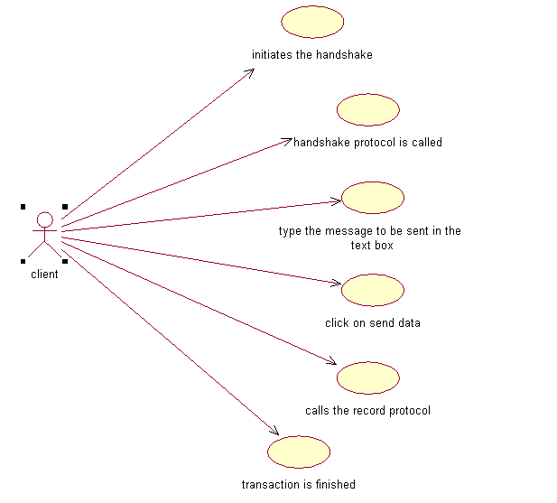

The client configuration i.e. the cryptographic parameters such as the SSL version, cryptographic algorithms available with the client is taken. Then the handshake protocol is initiated by the client to authenticate the server, negotiate the parameters, and to establish the security parameters. After successful completion of the handshake the client is secure enough to enter its secret data which is transmitted using the record protocol.

SERVER USECASE DIAGRAM

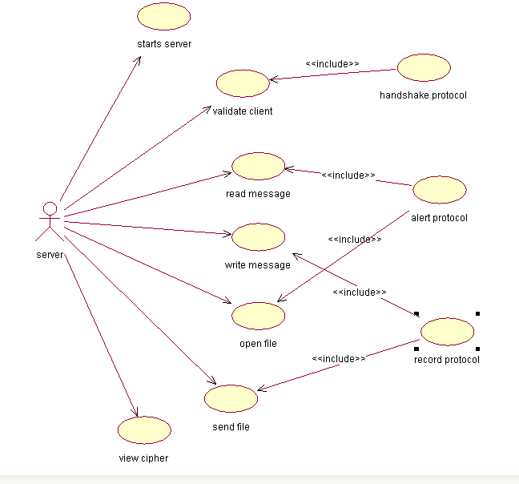

ENTIRE SYSTEM USECASE DIAGRAM

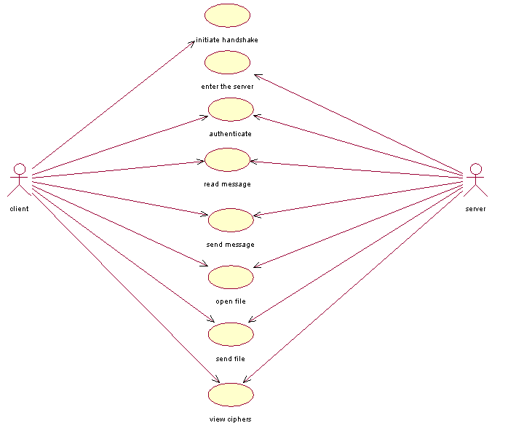

HANDSHAKE PROTOCOL

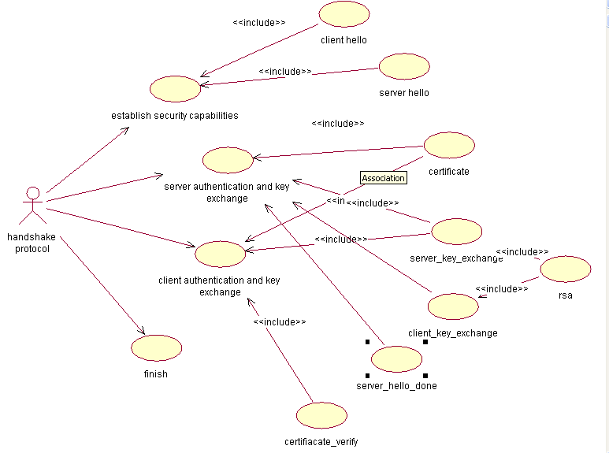

SSL RECORD PROTOCOL

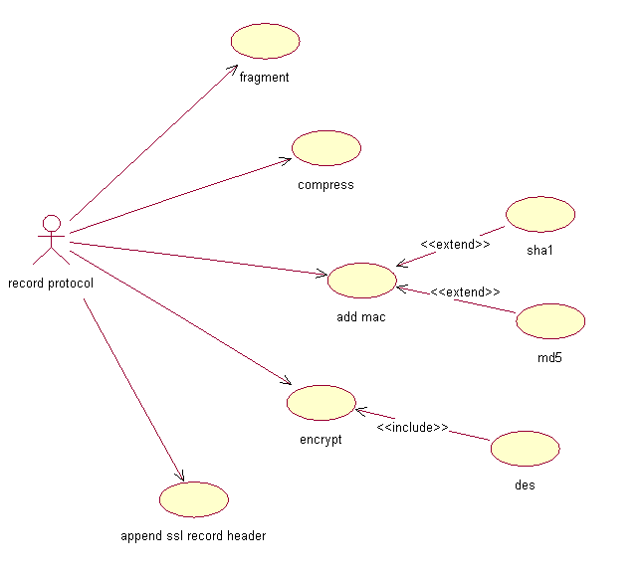

SEQUENCE DIAGRAMS
A Sequence diagram is graphical view of a scenario that shows object interaction in a time based sequence what happens first, what happens next. Sequence diagrams establish the roles of objects and help provide essential information to determine class responsibilities and interface. This type of diagram is best used during early analysis phases in design because they are simple and easy to comprehend. Sequence diagrams are normally associated with use cases.
Sequence diagrams are closely related to collaboration diagrams and both are alternate representations of an interaction. There are two main differences between sequence and collaboration diagrams: sequence diagrams show time based object interaction while collaboration diagrams show how objects associate with each other.
A sequence diagram has two dimensions: typically, vertical placement represents time and horizontal placement represents different objects.
The following tools located on the sequence diagram toolbox enable you to model sequence diagrams:
- Object
- Message icons
- Focus of control
- Message to self
- Note
.

HANDSHAKE PROTOCOL

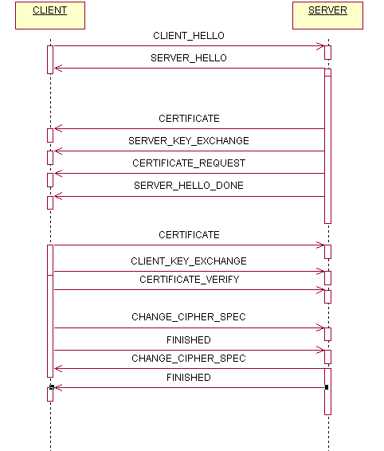

CLIENT- SERVER INTERACTION

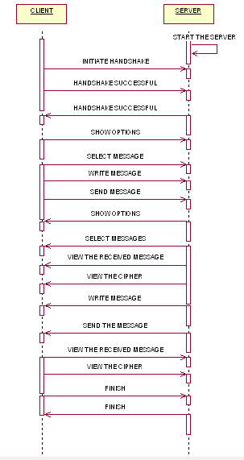

4. TESTING AND VALIDATION

TESTING AND VALIDATION
4.1 TESTING
Software testing is the process used to measure the quality of developed computer software. Usually, quality is constrained to correctness completeness, security, but can also include more technical requirements such as capability, reliability, efficiency, portability, maintainability, compatibility, and usability. Testing is a technical investigation that is intended to reveal quality-related information about the product with respect to the context in which it is intended to operate.
Any engineered product can be tested in one of two ways.
- Black-box testing
- White-box testing

BLACK - BOX TESTING
Black-box testing, also called Behavioral testing, focuses on the functional requirements of the software. It enables the software engineer to derive sets of input conditions that will fully exercise all functional requirements for a problem.
Black box testing attempts to find errors in the following categories.
- Incorrect or missing functions.
- Interface errors.
- Errors in data structures or external data base access.
- Behavior or performance errors.
- Initialization and termination errors.

WHITE - BOX TESTING

White box testing, also called Glass-box testing is a test case design philosophy that uses the control structure described as part of component-level design to derive test cases.
Using white box testing test cases can be derived that

- Guarantee that all independent parts within a module have been exercised at least once.
- Exercise all logical decisions on their true and false sides.
- Execute all loops at their boundaries and within their operational bounds
- Exercise internal data structures to ensure their validity.

4.2 TEST CASES

S.No. | Server side | Client side | Message/file | Handshake status | Result
1. | Starts the server | Initiates Handshake | Types the message  In the text box. | Not yet connected | Warning (which shows that Handshake is not yet established)
2. | Starts the Server | Initiates the handshake | Types the message in the text box | Connection has been established | Message is successfully sent.
3. | Starts the message | Initiates the handshake | Types the file path of a file(eg: for .jpg, .bmp) | Connection has been established | Data will not be sent.
4. | Starts the message | Initiates the handshake | Types the file path( eg: for .txt, .doc) | Connection has been established | File is sent successfully

5.SCREEN SHOTS

SCREEN SHOTS

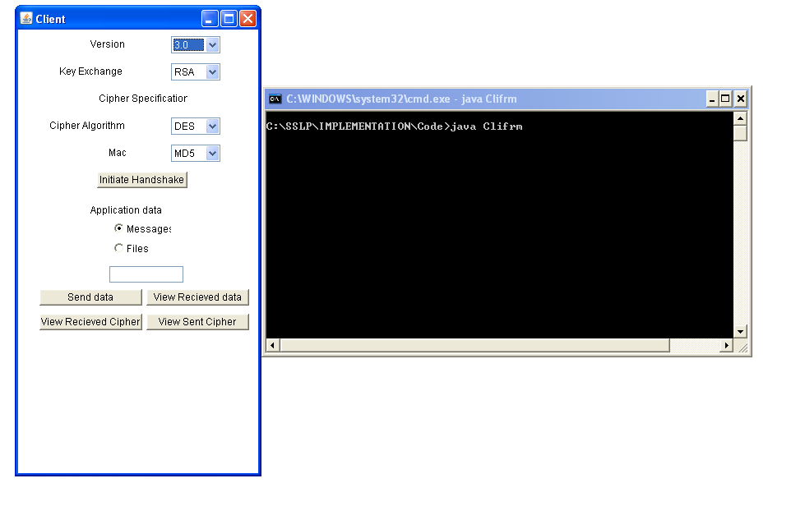

5.1 CLIENT FRAME

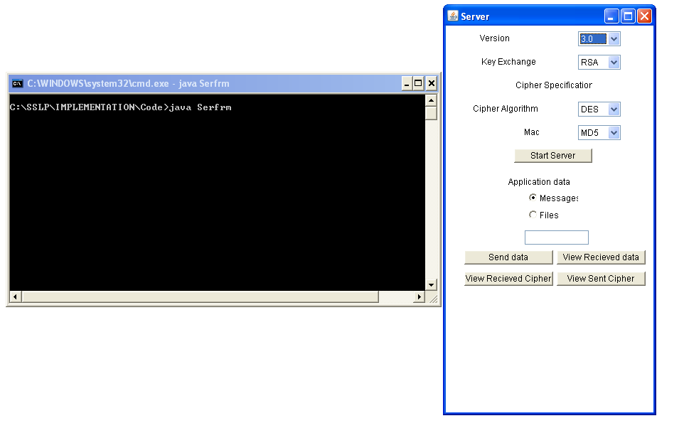

5.2 SERVER FRAME

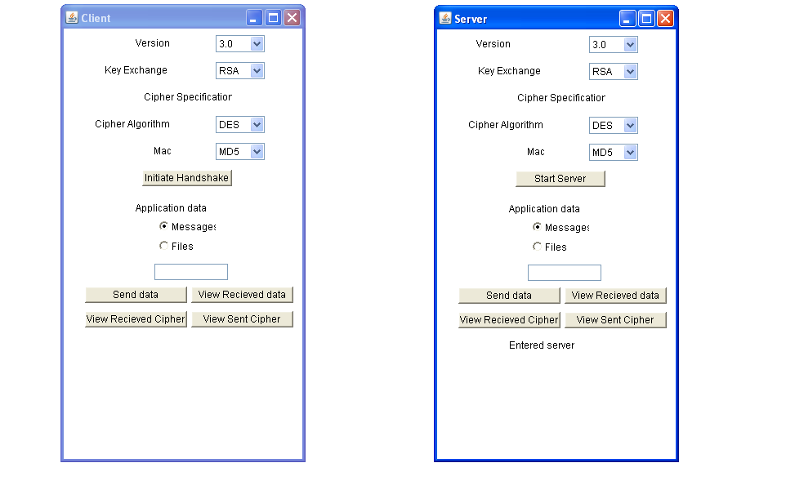
  - SERVER ENTERED

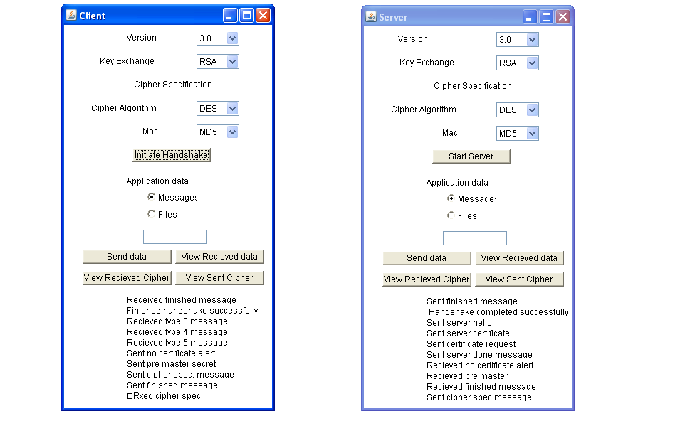

5.4 CLIENT INITIATES HANDSHAKE

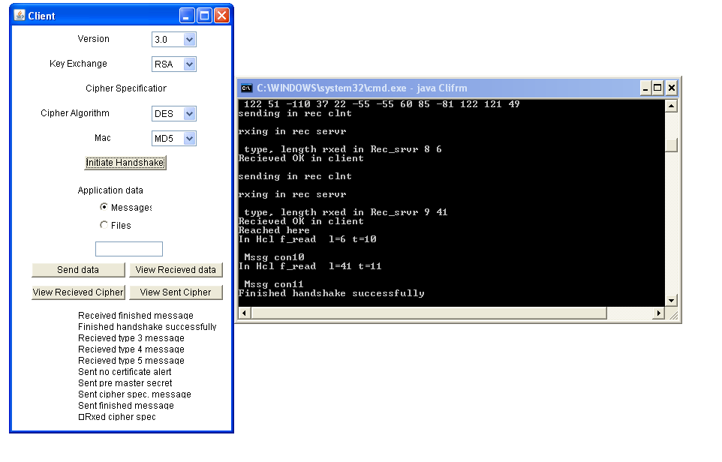

5.5 HANDSHAKE SUCCESSFUL ON CLIENT SIDE

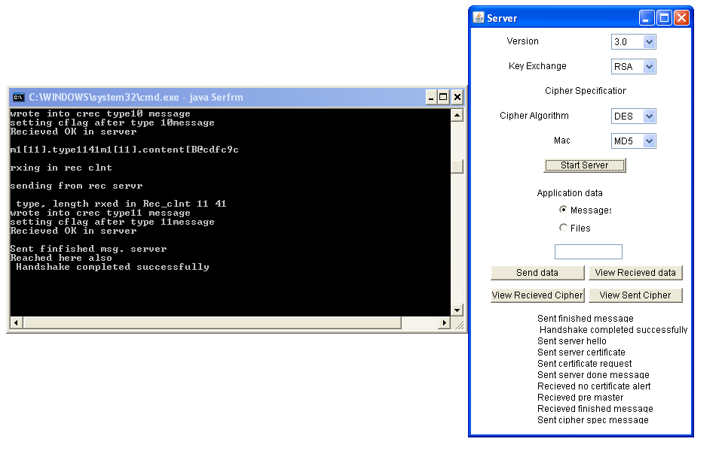
  - HANDSHAKE SUCCESSFUL ON SERVER SIDE

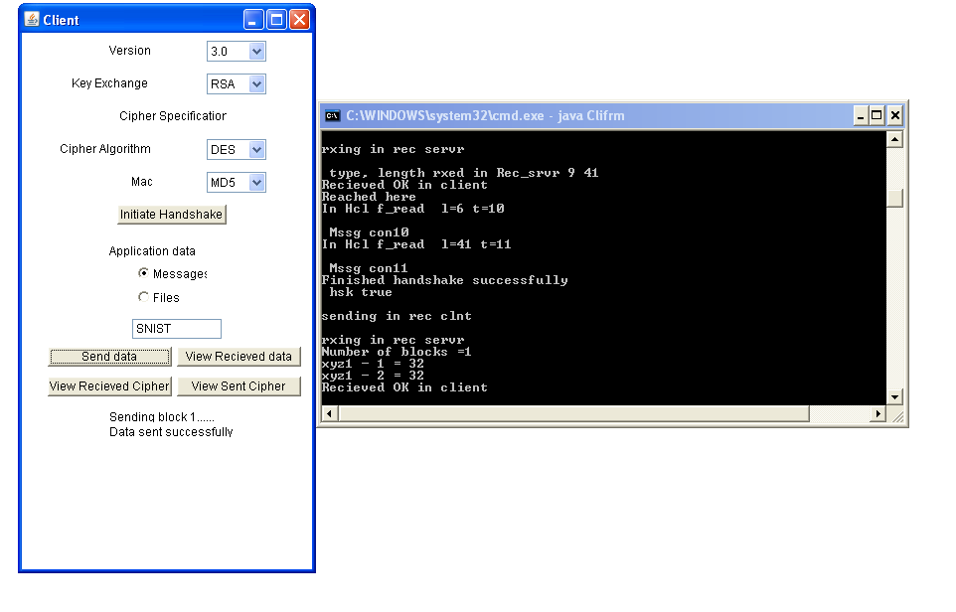

  - CLIENT SENDING A MESSAGE

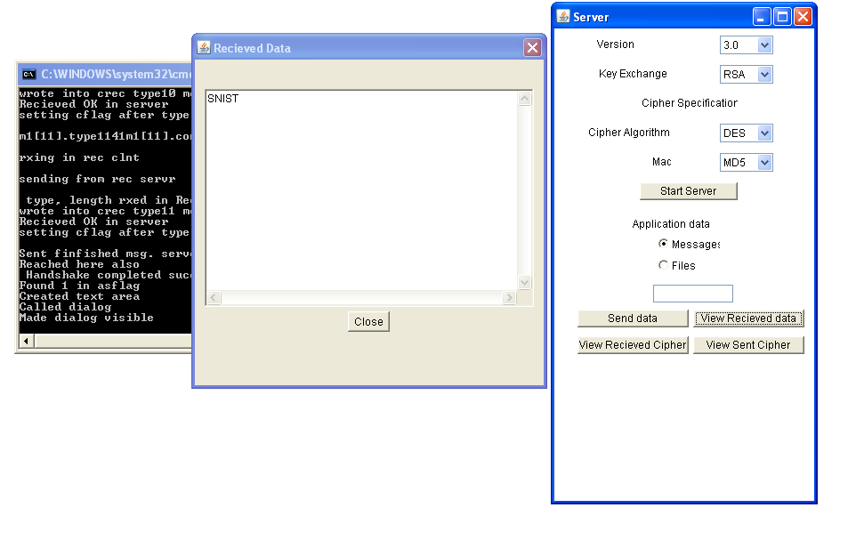

  - SERVER VIEWING THE RECEIVED MESSAGE

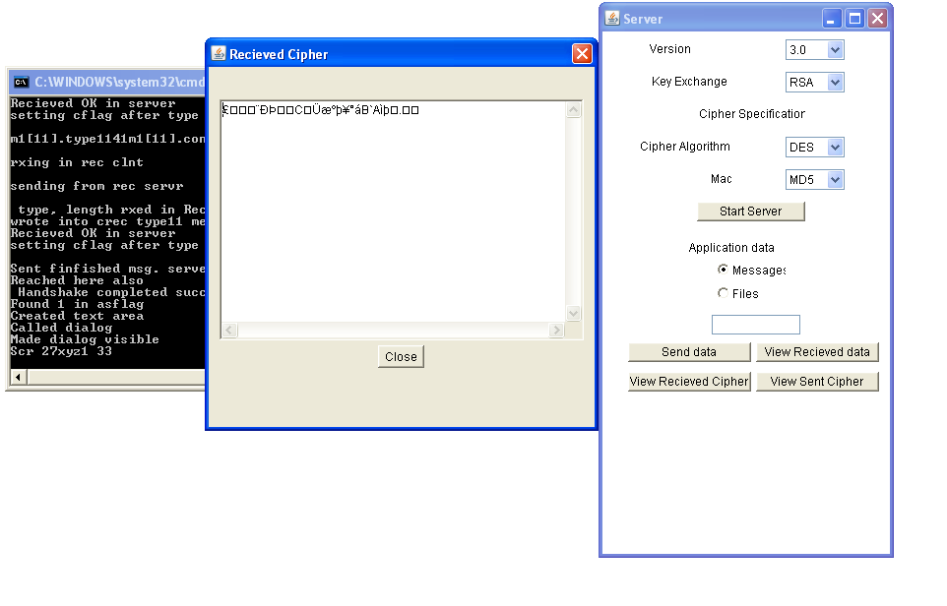

5.9 SERVER VIEWING THE RECEIVED CIPHER

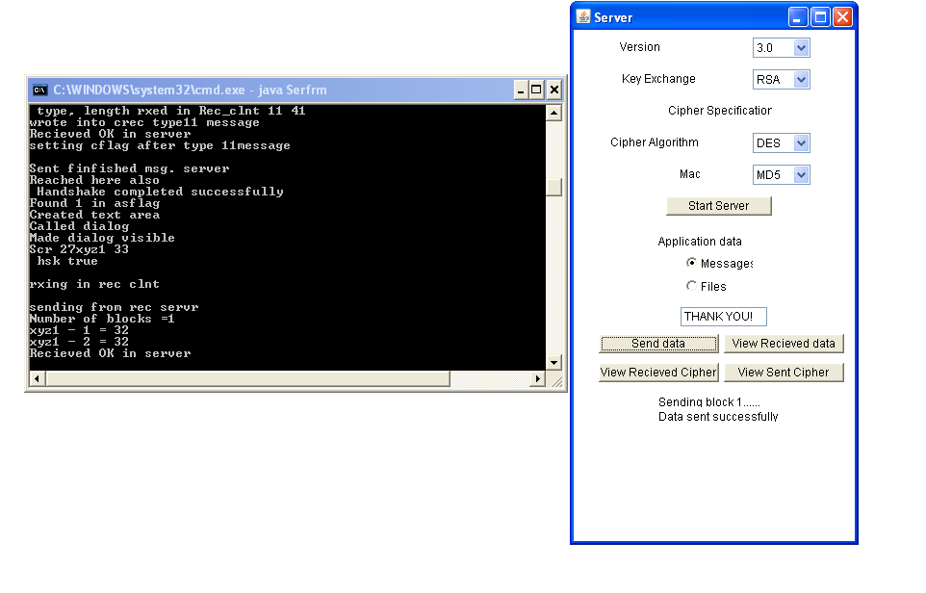

5.10 SERVER SENDING A MESSAGE

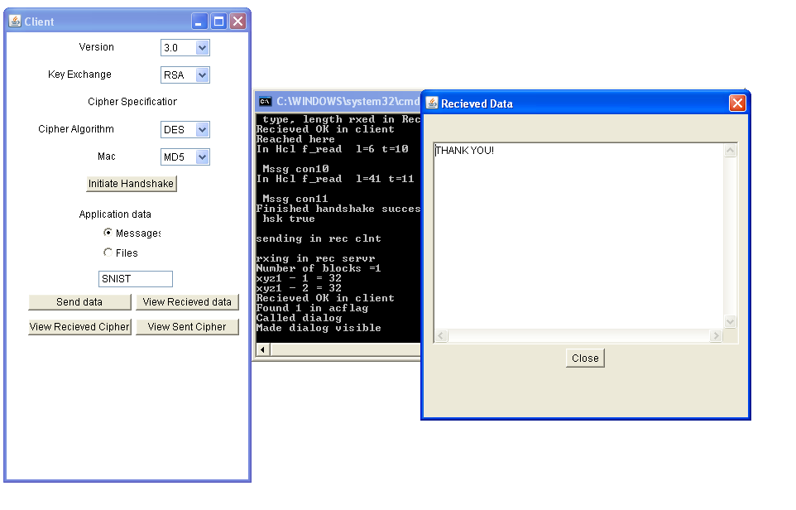

5.11 CLIENT VIEWING THE RECEIVED MESSAGE

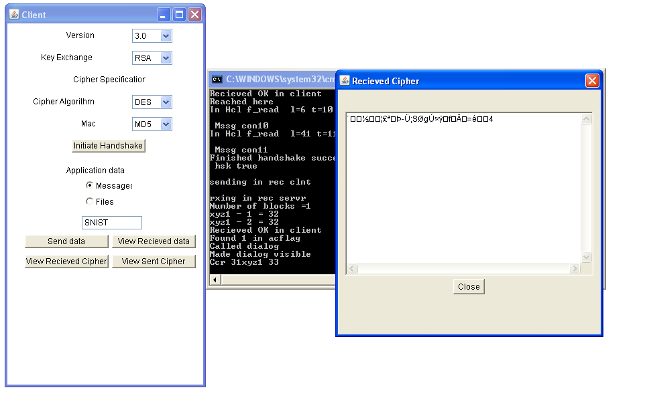

5.12 CLIENT VIEWING THE RECEIVED MESSAGE

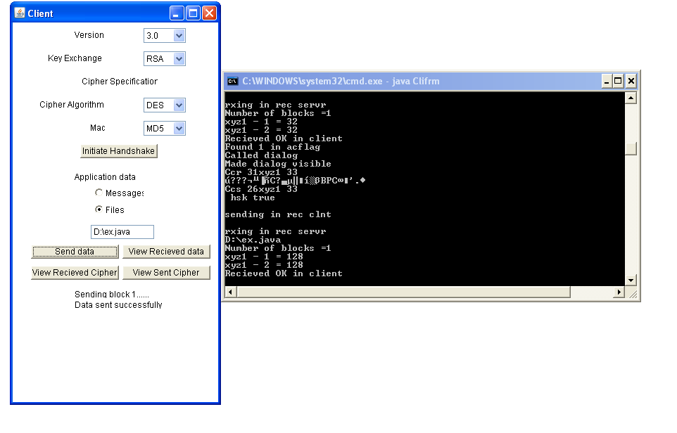

5.13 CLIENT SENDING A FILE

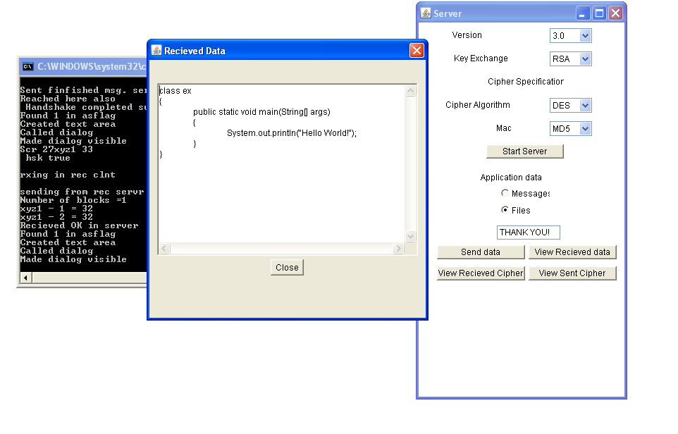

5.14 SERVER OPENING THE RECEIVED FILE

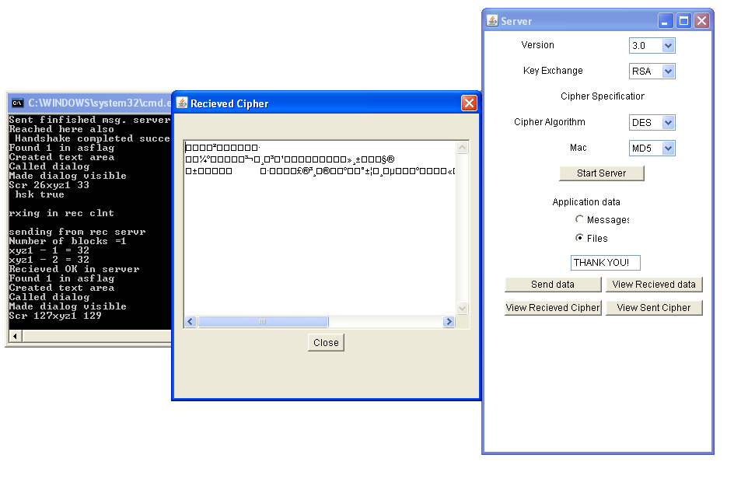

5.15 SERVER VIEWING THE RECEIVED FILE CIPHER

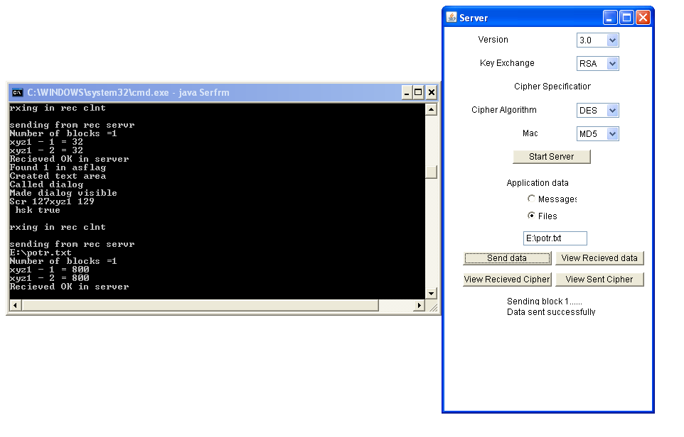

5.16 SERVER SENDING A FILE

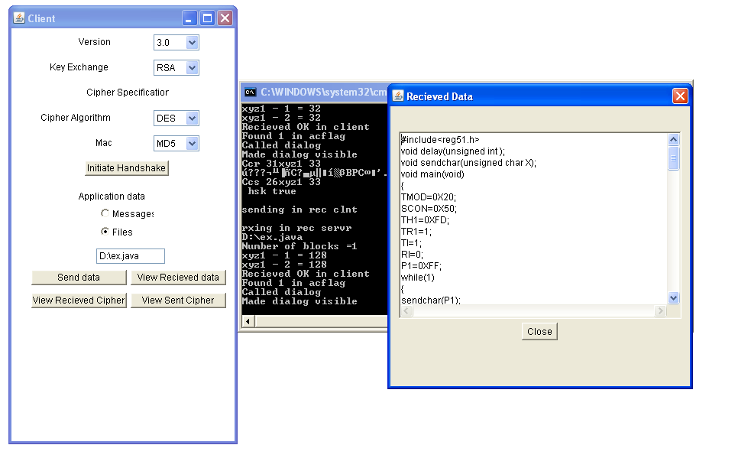

5.17 CLIENT OPENIG THE RECEIVED FILE

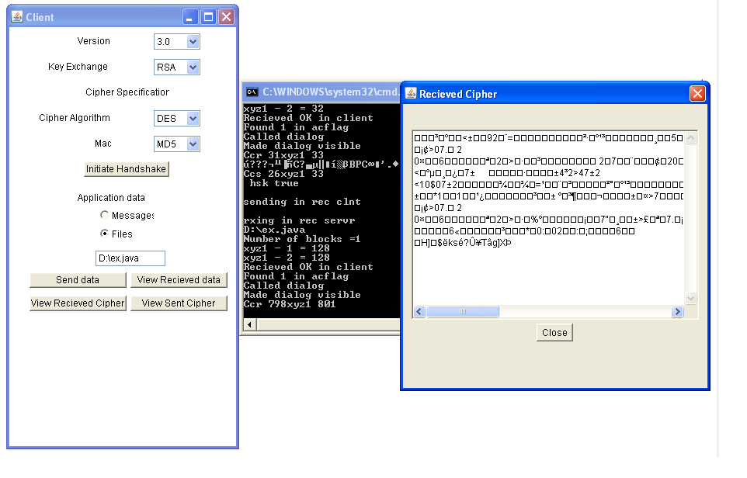

5.18 CLIENT VIEWING THE FILE CIPHER

- CONCLUSION

CONCLUSION
  - CONCLUSION
SSL is a very effective way of providing secure and reliable communication. The advantage offered by the establishment of a secure connection more than justifies the cost of encryption incurred at the server side and saves us from various kinds of attacks, which can result in loss and inconvenience.
The whole process can be viewed as – three SSL specific protocols (handshake, alert, change_cipher_spec) calling the SSL record protocol, which is responsible for passing the application data / messages after placing them in an encrypted payload. After successful completion of the handshake, both the client and the server become secure enough to pass their secret data to the record layer for fragmentation, encryption and transmission. The alert protocol is responsible for raising alerts (mentioning the severity of the failure) which when occur; decide the future of the connection (whether to be resumed or terminated) and any other necessary actions. The change_cipher_spec protocol updates the cipher-suite being used on the current connection. Thus, through an interleaved operation of these protocols, we achieve the overall intended effect of a ‘secure tunnel’ for communication, which is protected from attacks done for interception and alteration.
In this implementation, a secure file-transfer between the client and server is successfully achieved by performing: authentication of the parties, negotiation of cryptographic parameters, generation of session keys, establishment of sessions and finally encryption of all the communication between the entities. Here, we also provide the flexibility of transferring either a pre-existing file or a block taken as input from the user through a graphical, easy-to-understand interface. The end-user interface also shows the cipher-suite (set of cryptographic algorithms) and the exact sequence of events, leading to a clear insight into the working of the protocol. Thus, the final product is able to provide an effective and user-friendly means of making a transmission truly secure.

  - FUTURE WORK

In future the rate of the number of transactions that are handled by this system will be increased, with the same amount of authentication and security that which it provides now. Hence it can be successfully applied in the advanced levels.

The present work done in this system is only supported to a level of LAN and this can be further extended to the MAN and WAN levels.

- BIBILOGRAPHY

BIBILOGRAPHY
- CRYPTOGRAPHY AND NETWORK SECURITY
Author: WILLIAM STALLINGS
Publisher: PRESSMAN
- JAVA-2 COMPLETE REFERENCE
Author: PATRICK NORTON AND HERBERT SCHILD
Publisher: TATA McGRAW HILL
- OBJECT ORIENTED SYSTEM ANALYSIS AND DESIGN
Author: ALI BAHRAMI
Publisher: TATA McGRAW HILL
- IEEE Paper: A NETWORK PRIMETER WITH SECURE EXTERNAL ACCESS
Author: FREDERICK M. AVOLIO AND MARCUS J. RANUM
- COMPUTER NETWORKS
Author: ANDREW S. TANENBAUM
Publisher: PRESSMAN

