

Detecting Scale Free Network using Networkx Python Library
Submitted as part of mandate requirement of T1-21-22- AI 608
Network Science for the Web

Submitted by : MT2020013 Apoorv Panse

Guided by : Prof. Srinath Srinivasa

Abstract

The most common phenomena occuring in universe is the normal distribution of various random events. Where most of the data values cluster around mean. Many continuous data in nature follows normal distribution. Now when it comes to social networks, we see that the distribution of connections is not normal, but it follows power law distribution. Which is crucial in determining if the network is scale free or not. Knowing if a network is scale free is useful to further analyse it for finding influencers, information spreaders, controlling epidemics and so on. In this paper I will explain few terminologies about Scale Free Networks and then move on to show how we can use NetworkX library available in Python to prove that a social network is scale free using SNAP Facebook dataset example.

Scale Free Networks
The network is said to be scale-free if the properties or attributes of the network are independent of the enormity or its size. Overall when the network grows or scales up, its underlying structure remains the same. Now this is very useful in observing social phenomenon because as population grows, and network increases, the underlying characteristics of that network may remain the same. Which can be use to model various social strategies.

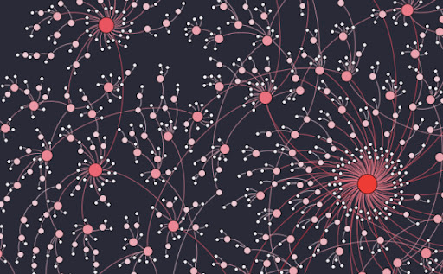
Fig Source : http://social-dynamics.org/scale-free-network/

Power Law
This kind of distribution is based on the relationship in which relative change in one quantity gives rise to a proportional relative change in other quantity. This is useful because it helps in identifying the regularities in the network especially in large complex systems. Because large network may have characteristics that is independent of its scale. Social networks tends to follow power law as it has preferential attachment. That means it is far more attractive to connect with people who already have more connections. This is also based on the idea of rich getting richer. LinkedIn, Twitter, Facebook and all major social network tends to follow power law distribution when it comes to connectivity of people.

In larger network, small world principle holds, that says if a node is connected to other nodes in small number of steps, then it may act as a hub between all other nodes connecting to it.

Normal Distribution Vs Power Law Distribution
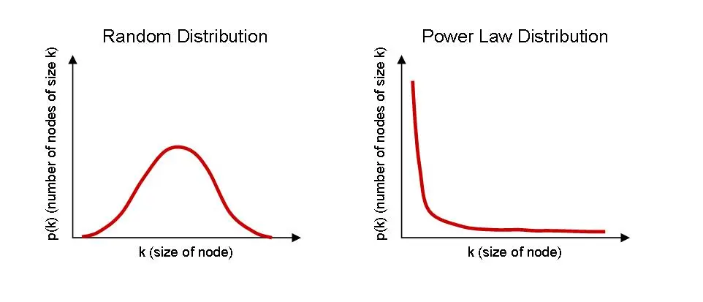
Fig Source: https://thewisdomoflife.wordpress.com/2017/02/19/the-power-law-and-the-nature-of-systems/

Social Network Analysis
We have computing power to study networks and analyse it on a large scale. Social networks like Facebook have billions of node (people) and the connectivity between them can be studied using social network analysis techniques. If we try to define it, SAN is basically the process of investigating different social structures using mathematical techniques, network principles and graph theory.

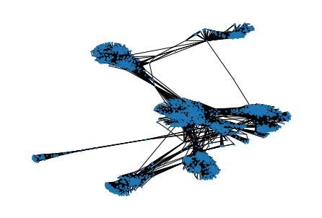
Fig Source : Graph Visualization of Facebook Network. Code is attached along with this document.

For an undirected network, we can just write the degree distribution as
Pdeg(k)∝k−γ,
where γ is some exponent. This form of Pdeg(k) decays slowly as the degree k
increases, increasing the likelihood of finding a node with a very large degree.
Networks with power-law distributions a called scale-free1 because power laws have the same functional form at all scales. The power law Pdeg(k)
remains unchanged (other than a multiplicative factor) when rescaling the independent variable k, as it satisfies Pdeg(ak)=a−γPdeg(k).

References
- https://www.futurelearn.com/info/courses/complexity-and-uncertainty/0/steps/1855
- https://necsi.edu/power-law
- https://en.wikipedia.org/wiki/Social_network_analysis
- https://snap.stanford.edu/data/egonets-Facebook.html

