

Data Flow Testing for Hotel Reservation System
Submitted as part of project requirement of T1-21-22-CS731
Software Testing

Submitted by :
MT202050 Deepti Chawda
MT2020092 Meghna Pai
MT2020013 Apoorv Panse

Guided by : Prof. Meenakshi D’Souza

Abstract

Data flow testing is one of the strategies that is based on choosing paths through the program’s control flow to explore more sequence of events related to status of variables being used or the data objects being used. Focus is mainly on where these variables and objects are defined and where they are used.

Benefits of Data flow testing involves :
- A variable that is never used in the program but was declared.
- A variable that is defined multiple times before it is used.
- Deallocating a variable before it is used.

Software Code to be tested
We have used github repository to find a suitable code for our project. The github link for the code is cited in reference section. Project basically involves a console based java application for a hotel management system with simple functionality.
The hotel has three categories of rooms: Luxury, Delux and Super Delux. Only the Delux and Super Delux have wi-fi facility in the rooms. Delux and Luxury rooms may have either single or double occupancy. Each rooms has a a default room rate that is adjustable. The system changes the status of room to “occupied” when it is reserved. There is a facility to cancel the reservation also. The booking is done for some number of days. When a room is reserved, the room charge is displayed. The system also shows the status of rooms in each category.

The program displays a menu of alternatives to:
- Indicate the room type that needs to be booked
- Indicate the occpancy (single/double) in that category.
If the rooms in a particular category are full, your program asks the person if it is acceptable to be placed in the other category. If yes, appropriate room is assigned.
Process of Data flow testing that we used

This involved following steps :
- Build a control flow diagram and write definitions and usage of variables for each node in the CFG. The corresponding graph is known as a DFG (Data flow graph).
- Prepare a Def Use chart.
- Feed the graph and variable def-use data to the online Web App to find DU Pairs, DU Paths and All DU Path Coverages.
- Design test cases so that program traverses those paths.

Building Data Flow graph
First we started of with program structure analysis and prepare a hand drawn data flow graph of the code.
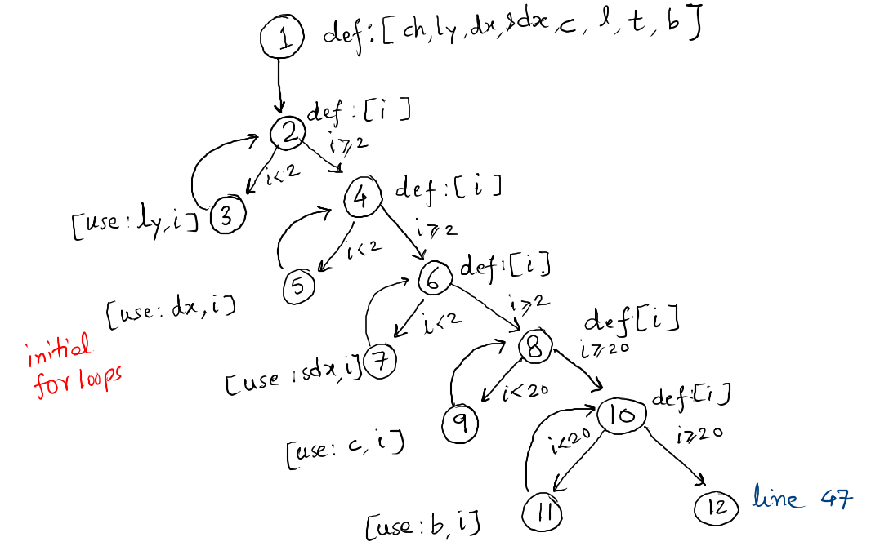
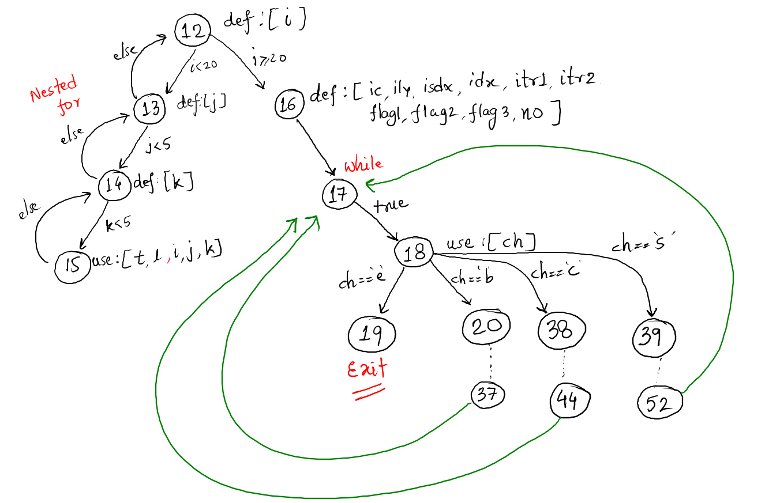
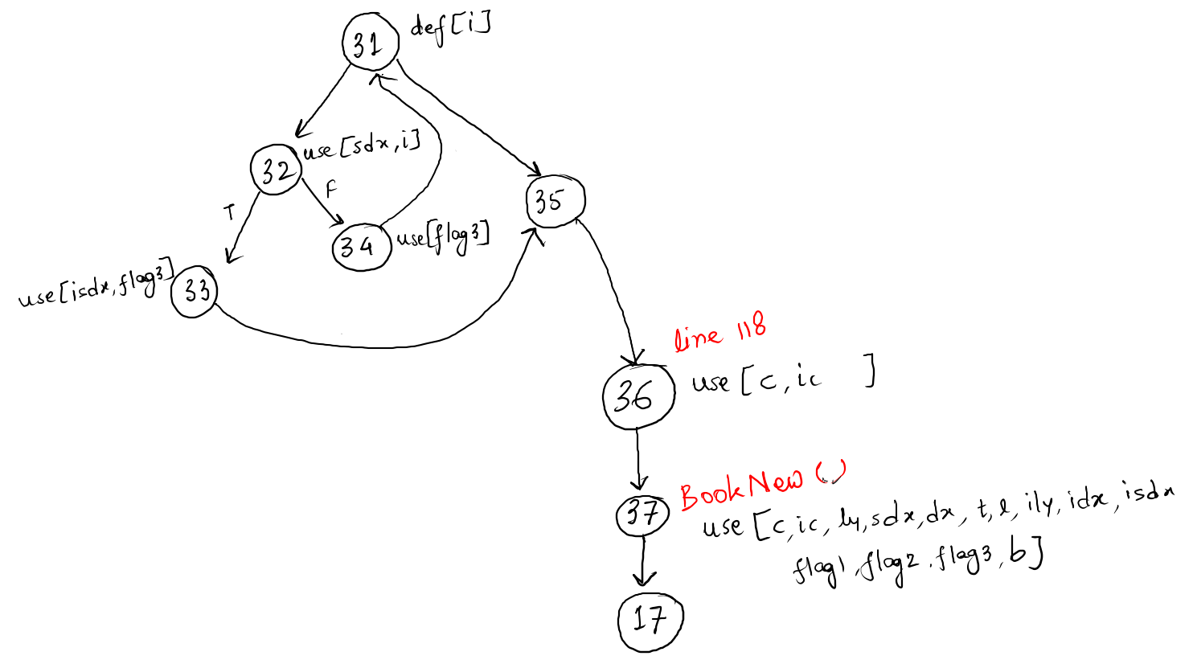
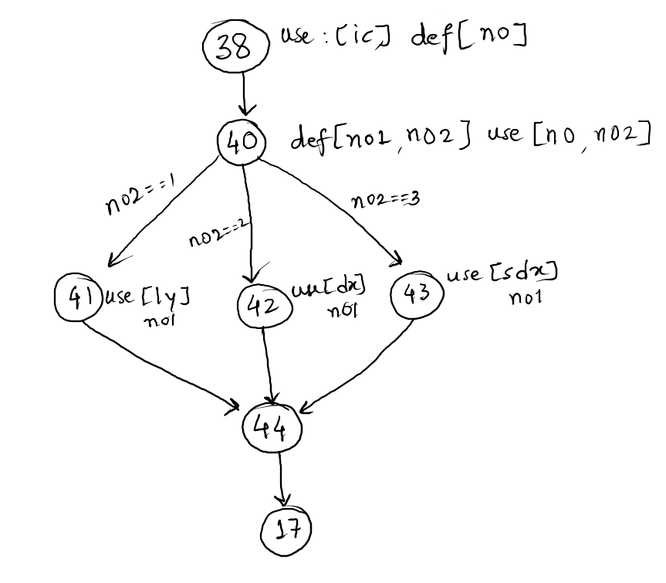
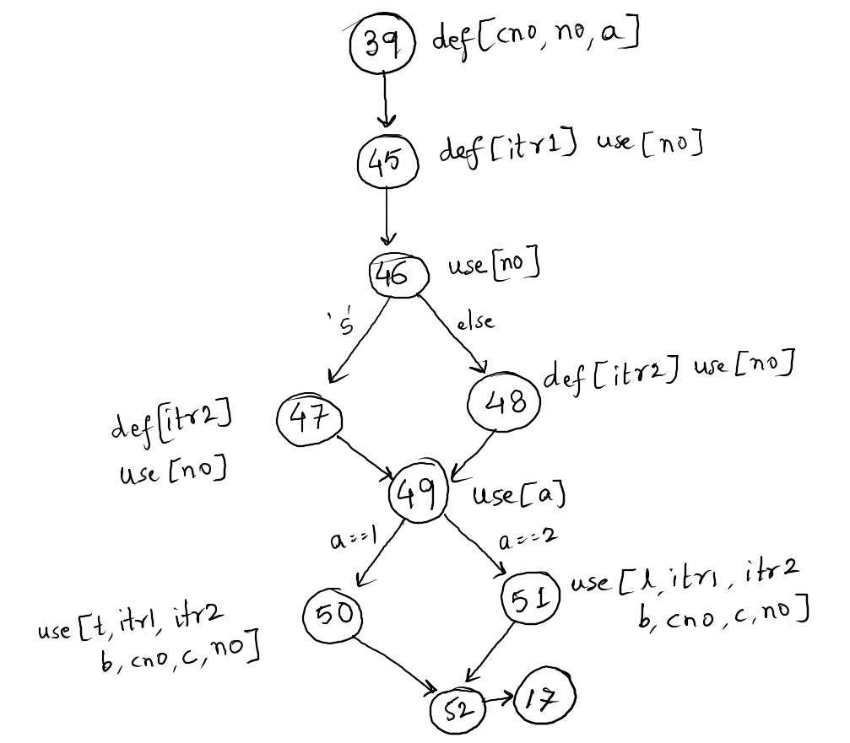
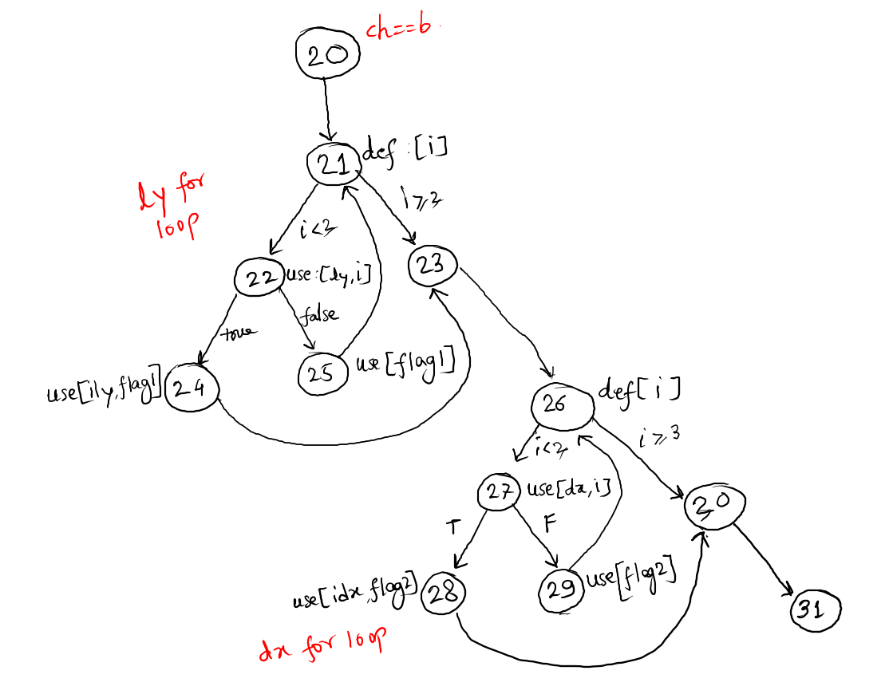
Data Flow Chart
Below are the variables used in the program with their defs and uses. Refer below CFG for node numbers.
Variable | Defs | Uses
ch | 1 | 18
ly | 1 | 3 22 37 41
dx | 1 | 5 27 37 42
sdx | 1 | 7 32 37 43
c | 1 | 9 36 37 50 51
l | 1 | 15 37 51
t | 1 | 15 37 50
b | 1 | 11 37 50 51
i | 2 4 6 8 10 12 21 22 26 31 | 3 5 7 9 11 15 22 27 32
ic | 16 | 36 37 38
j | 13 | 15
k | 14 | 15
ily | 16 | 24 37
isdx | 16 | 37 33
idx | 16 | 28 37
itr1 | 16 45 | 50 51
itr2 | 16 47 48 | 50 51
flag1 | 16 | 23 25 37
flag2 | 16 | 28 29 37
flag3 | 16 | 33 34 37
no | 16 38 39 | 40 45 46 47 48 50 51
cno | 39 | 50 51
no1 | 40 | 41 42 43
no2 | 40 | 40
a | 39 | 49

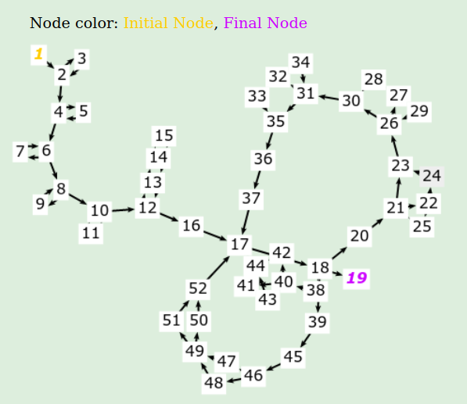

DU Pairs, DU Paths and All DU Path Coverages
DU Pairs : A definition-use pair (DU pair) is a pairing of definition and use of a variable, with at least one def-clear path between them.
DU Path : A du-path is a simple path where the initial node of the path is the only defining node of x in the path.
All DU Path : All definition-clear subpaths that are cycle-free or simple-cycles from each definition to each use reached by that definition and each successor node of the use.

Designing Test Cases
Now we can test few cases manually and see the result of execution if it is expected or not.

Test Case 1 :
Variable : ily
All DU Path Coverage : [1,2,4,6,8,10,12,16,17,18,20,21,22,24,23,26,30,31,35,36,37,17,18,19]
Inputs and conditions to be used for traversing this path (in sequence of their usage):
ch=’b’ (at node 18), i<3 (At node 21) , ly[i].status = false (At node 22)
Result Expected : Luxury Room is booked

Test Case 2 :
Variable : ily
All DU Path Coverage : [1,2,4,6,8,10,12,16,17,18,20,21,23,26,30,31,35,36,37,17,18,19]
Inputs and conditions to be used for traversing this path (in sequence of their usage):
ch=’b’ (at node 18), i>=3 (At node 21)
Result Expected : No Luxury Rooms Available
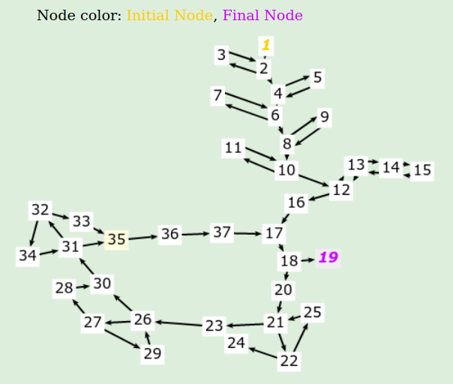

References
- https://www.tutorialspoint.com/software_testing_dictionary/data_flow_testing.htm
- https://www.geeksforgeeks.org/data-flow-testing/
- https://github.com/Dvik/Hotel-Reservation-System

