Compute Versus Accuracy of LSTM and Transformer Temporal Models for Pediatric Ear Video Classification on a CPU
Apoorv Gadiya, Anagha M Nair, Adhithi M, Satyam Goyal, Abdul Muqtadeer Ahmed, Deepak Krishna Murthy
School of Computer Science and Engineering, RV University, Bengaluru, Karnataka, India

apoorvg.btech23@rvu.edu.in

Abstract: Medical video classifiers usually turn each frame into numbers with an image network and then combine the frames with a temporal model, most often an LSTM or a Transformer. Transformers lead on large video benchmarks, but it is unclear whether they help on small medical video sets, or what they cost on the ordinary CPUs found in clinics. We compared both, under the same conditions, on 874 pediatric ear screening videos (643 Normal, 231 Abnormal). From each video, 20 frames were turned into features once by a frozen ImageNet MobileNetV2, and seven temporal models were trained on these same features: an LSTM, a Transformer of similar size, three LSTM-attention hybrids and two simple frame-averaging controls. We used 3-fold cross-validation repeated with two seeds (42 runs), a corrected t-test with a 0.03 AUROC equivalence margin, and repeated CPU timing. The LSTM and the Transformer reached AUROC 0.907 and 0.905, which is statistically equivalent, while the Transformer took 1.36 ms per clip against 3.54 ms for the LSTM (2.6 times faster). No model differed significantly from the LSTM, and even a plain average of the frame features reached 0.900. Video decoding and MobileNetV2 took over 99% of the roughly 465 ms needed per clip. On this task there is no trade-off: the Transformer is cheaper and just as accurate, and real time savings must come from decoding and the frame encoder.
Index Terms: Computational cost, CPU inference, long short-term memory, medical video classification, otoscopy, transformer
I. Introduction
A. Background and Problem
A handheld otoscope records a few seconds of video of a child's ear canal, and a trained reader decides whether the view is Normal or Abnormal. Automatic classification of such videos could help screening programmes that see many children and have few specialists.
Most video classifiers work in two steps. An image network turns each frame into a feature vector, and a temporal model combines the frames into one decision. The two common temporal models are the LSTM [1], which reads the frames one after another, and the Transformer [2], which compares every frame with every other frame at once. Transformers lead on large video benchmarks [3]. But medical video sets are small, and screening tools often run on a laptop without a graphics card. For that setting we do not know whether the Transformer is more accurate, or whether it is slower, as is often assumed.
B. Research Gap
CNN-LSTM models do well on small medical video sets [4], [5], Transformers help on long surgical videos [6], and one direct comparison on fixed frame features found the LSTM ahead on small non-medical video sets [7]. None of these keeps the features, classifier, data splits and training rules identical while comparing the two models on small medical video, and none measures CPU time per clip next to accuracy.
C. Aim, Objectives and Research Questions
Aim: to measure accuracy and CPU cost of LSTM and Transformer temporal models on short pediatric ear videos. Objectives: build a pipeline where every model gets the same input, train seven models, measure accuracy and CPU time, and test pre-registered hypotheses.
1) RQ1: Does a Transformer perform more accurately than an LSTM on the same frame features?
2) RQ2: What is the cost of each model on a CPU, and how large is this cost relative to the whole pipeline cost?
3) RQ3: What are the most accurate models for a given cost?
D. Contributions
Four contributions have been made by our study into this context. The seven temporal models process the same inputs, and thus the difference between them can only come from the temporal model itself. Each temporal model was tested for its performance separately and within the entire pipeline from the video file to predictions on a laptop CPU. An equivalence test shows that the LSTM and the Transformer provide equivalent accuracy. The hybrid model hybrid_attn scored the highest AUROC, matching the LSTM in accuracy in less than one-third of the LSTM’s execution time.
II. Literature Review and Related Work
A. Search and Selection
We started from the ten papers named in the project proposal and looked each one up by title (Google Scholar, PubMed Central, arXiv, publisher sites; October to November 2026). Papers that could not be found, or whose findings could not be checked, were left out. Seven studies remained; the five closest to our question are in Table I.

TABLE I
Comparative literature matrix of the included studies.
Study | Objective | Method | Data | Key finding | Limit for our question
Owais et al., 2019 [4] | GI disease, endoscopy | ResNet + LSTM | About 52,000 frames | AUC about 97% | Other task
Barros et al., 2021 [5] | Lung ultrasound video | Xception + LSTM | 185 videos | About 93% accuracy | Small set
Soeleman et al., 2022 [7] | Violence detection | InceptionV3 + LSTM / Transformer | 3 small video sets | LSTM beat Transformer | Not medical video
Czempiel et al., 2021 [6] | Surgical phase | CNN + Transformer | 2 surgery video sets | Beat earlier models | Long videos
Gao et al., 2021 [8] | Surgical phase | CNN + Transformer | Cholec80, M2CAI16 | Transformer fusion works | Long videos

B. What the Literature Says and the Gap
Taken together, these studies suggest a pattern. With large data and long videos, attention helps [3], [6], [8]. With small data, short clips and fixed frame features, the LSTM matches or beats the Transformer [7], [5]. Our setting (874 clips, 20 frames, frozen features) is clearly of the second kind, so we expected the two to tie on accuracy. What we could not find in any of them was a measured CPU time per clip; when cost is reported at all, it is given as a parameter count or an operation count. We report both accuracy and measured time.
III. Research Problem, Objectives and Hypotheses
A. Hypotheses
We wrote down both hypotheses before training any model.
1) H₀-acc: the Transformer's mean AUROC equals the LSTM's. H₁-acc: they differ. A non-significant p-value would not show that the two are the same, so we added an equivalence test and call the models equal only if the AUROC difference stays within ± 0.03.
2) H₀-cpu: with one clip at a time, the Transformer runs at least as fast as the LSTM. H₁-cpu: the Transformer is slower.
IV. Research Methodology
A. Research Design
This is a comparison experiment. Only the temporal model changes, everything else stays fixed, and every model is tested on the same six data splits, so the scores can be compared split by split. Fig. 1 shows the steps.
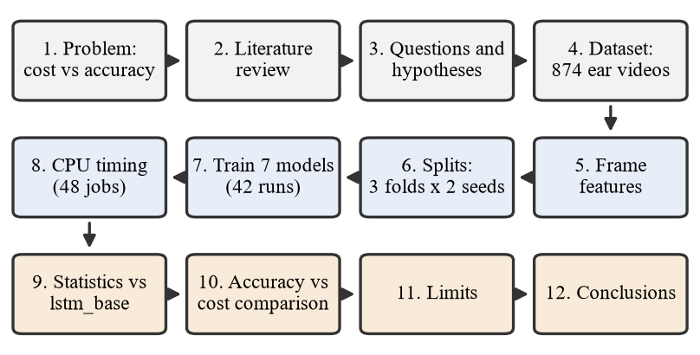
Fig. 1. Research procedure.
B. Dataset
We used all 874 pediatric ear screening videos from an earlier project (643 Normal, 231 Abnormal, 26.4% Abnormal; ages 3 to 18; 0.9 to 71 s long; 480 x 640 pixels). Every single video was retained, and there were no lost or excluded videos at all. The labels file provides information only about three attributes for each video: its unique identifier, label and child’s age. Initially, we used an oral cavity videos dataset, but the models were unable to learn anything from those videos (AUROC on test near 0.5). Thus, we turned to the ear videos dataset.
C. Pipeline and Models
For each video, we extracted 20 equally spaced images, converting them from BGR to RGB format, and then resizing them to 224 × 224 and processing them once using MobileNetV2 [9] with frozen weights trained on ImageNet dataset. These images are represented by vectors of 1280 numbers, giving us 20 × 1280 matrix for one clip. All seven architectures begin with this matrix and end with the same small classifier (Fig. 2). Table II lists them.
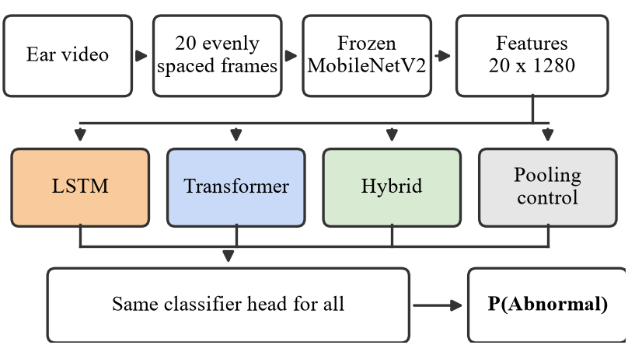
Fig. 2. Pipeline. Only the temporal block differs between models.
1) lstm_base: two LSTM layers (256 and 128 units). It reads the 20 frames one at a time, so each step must wait for the one before.
2) transformer_base: projects each frame to 256 numbers, adds position information and runs two self-attention blocks [2], [10]. Sized to roughly match the LSTM (1.40 M against 1.78 M parameters).
3) Hybrids: an LSTM followed by one attention block, hybrid_attn and hybrid_lite networks apply the learned importance to the frames, in addition to retaining the most important individual frame signal, because it could appear in only some of the frames.
4) Controls (pool_mean, pool_max): these bypass frame order entirely and just use the average or maximum over the 20 frames. A temporal model which cannot outperform these does not get anything from the order of the frames.
TABLE II
The seven models (T = 20 frames). MACs: multiply-add operations per clip for the temporal block and head.
Model | Temporal block | Params | MACs
lstm_base | LSTM(256), LSTM(128) | 1.78 M | 35.4 M
transformer_base | 2 attention blocks, d = 256 | 1.40 M | 28.0 M
hybrid_base | LSTM(128), 1 block | 0.86 M | 17.2 M
hybrid_attn | LSTM(128), 1 block, attn + max pool | 0.44 M | 8.6 M
hybrid_lite | Same as hybrid_attn, d = 64 | 0.16 M | 3.0 M
pool_mean | Average of frames | 0.08 M | 0.08 M
pool_max | Maximum of frames | 0.08 M | 0.08 M

D. Training and Timing Setup
Splits: stratified 3-fold cross-validation, repeated with two seeds, gives 6 test sets of 291 to 292 clips (77 Abnormal each). From each training part we set aside 15% as validation data. It told us when to stop training and where to put the decision cut-offs; the test clips played no part in either choice.
Training: every model had the same loss, class weights, batch size (32) and stopping rule. With the class weights, a mistake on an Abnormal clip cost about 2.8 times as much as one on a Normal clip, and training stopped once validation AUROC had not improved for 15 epochs. We trained the LSTM and the controls with Adam [11] and the attention models with AdamW [12] plus a short warm-up, since that is how each family is normally trained. The whole set of 42 runs finished in about 18 minutes on the laptop CPU.
Timing: Intel Core i5-12450H laptop, 15.7 GB RAM, no GPU; Python 3.11, TensorFlow 2.17, Keras 3.6. We started a new process for every measurement, made 50 warm-up calls and then timed 300 calls. This was done for one clip (batch 1) and for 32 clips, on 1 and on 8 CPU threads. We repeated the whole grid in three separate sessions and report the median. Video decoding and MobileNetV2 were timed on their own.
E. Metrics and Statistics
AUROC is our main metric. It is the probability that the model gives a randomly chosen Abnormal clip a higher score than a randomly chosen Normal clip, so 0.5 means guessing and 1.0 means perfect ranking. We do not use plain accuracy for decisions: a model that always says "Normal" would already get 73.6%. In screening, a missed Abnormal clip is worse than a false alarm, so we also report sensitivity at 90% specificity, which is the fraction of Abnormal clips caught when the cut-off is set so that only one Normal clip in ten is flagged.
We compare every model with lstm_base on the same 6 splits, one split at a time. A plain paired t-test would overstate the evidence here, because the training sets of different folds share most of their clips. For that reason we used the corrected resampled t-test [13], [14]:
t = d̄ / √[s_{d}² (1/n + n_{test}/n_{train})] (1)
Here d̄ and s_{d}² are the mean and variance of the 6 paired AUROC differences, n = 6, and n_{test}/n_{train} = 0.5, which gives 5 degrees of freedom (α = 0.05). For equivalence we used two one-sided tests [15]; a model counts as equivalent when the 90% confidence interval of its difference lies entirely inside ± 0.03.
V. Results
A. Accuracy
All seven models ended up close together (Table III), with AUROC between 0.893 and 0.909. That spread of 0.016 is no larger than how much a single model moved from one test set to another (standard deviation 0.009 to 0.022). The LSTM scored 0.907 and the Transformer 0.905.
TABLE III
Accuracy on the test sets (mean over 6, ± standard deviation). Sens@90: sensitivity at 90% specificity. Missed: Abnormal clips missed per test set (of 77) at the high-sensitivity cut-off.
Model | AUROC | Sens@90 | Missed
hybrid_attn | 0.909 ± 0.016 | 0.760 | 10.2
lstm_base | 0.907 ± 0.013 | 0.749 | 9.3
transformer_base | 0.905 ± 0.011 | 0.699 | 8.7
hybrid_base | 0.905 ± 0.010 | 0.701 | 8.8
hybrid_lite | 0.900 ± 0.022 | 0.684 | 10.0
pool_mean | 0.900 ± 0.009 | 0.665 | 7.0
pool_max | 0.893 ± 0.017 | 0.639 | 6.0

B. Hypothesis Tests
Fig. 3 and Table IV set each model against the LSTM. None of the differences was significant; the smallest p-value was 0.26.
TABLE IV
AUROC of each model compared with lstm_base: corrected t-test (5 degrees of freedom) and equivalence test with a ± 0.03 margin.
Model | Diff. | t | p | 90% CI | Equal?
transformer_base | -0.001 | -0.17 | 0.87 | -0.019, +0.016 | Yes
hybrid_attn | +0.002 | 0.18 | 0.86 | -0.018, +0.022 | Yes
pool_mean | -0.007 | -0.85 | 0.43 | -0.024, +0.010 | Yes
hybrid_base | -0.002 | -0.09 | 0.93 | -0.035, +0.032 | Not shown
hybrid_lite | -0.007 | -0.40 | 0.70 | -0.040, +0.027 | Not shown
pool_max | -0.013 | -1.26 | 0.26 | -0.035, +0.008 | Not shown

H₀-acc is supported. The Transformer's AUROC was 0.001 lower than the LSTM's (t(5) = -0.17, p = 0.87, Cohen's d_{z} = -0.14). Its 90% interval, -0.019 to +0.016, sits inside the ± 0.03 band, so we treat the two as equivalent. Where Table IV says "Not shown", the interval was simply too wide to fit in the band; it does not mean that model did worse.
H₀-cpu is supported. In every one of the 3 timing sessions the Transformer beat the LSTM (Section V-C). We did not run a formal test on the timings, because the gap was large and hardly changed between sessions.
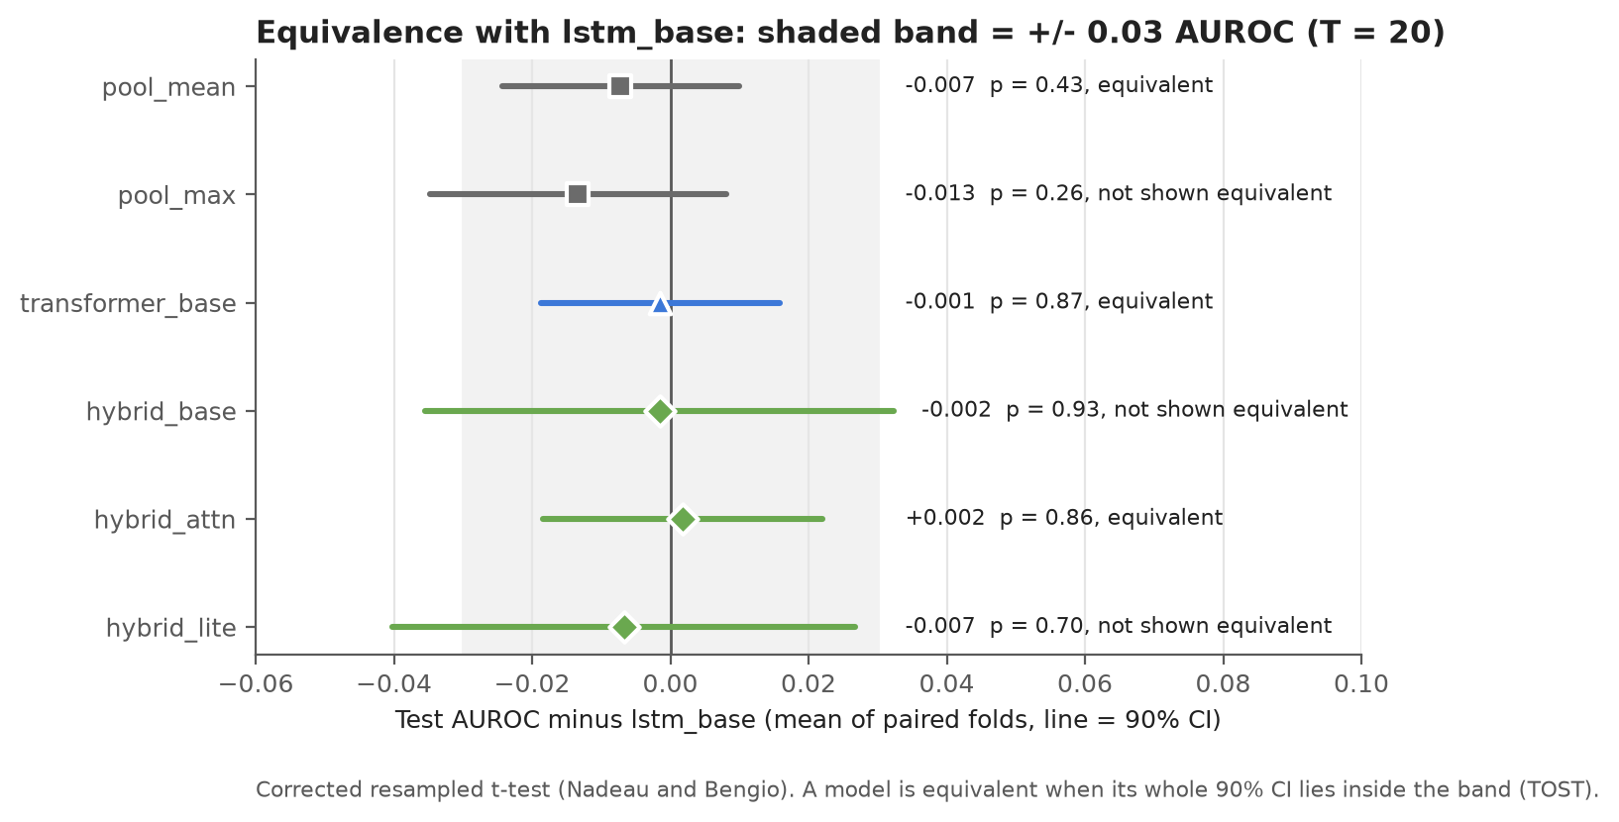
Fig. 3. Difference in AUROC from lstm_base, with 90% confidence intervals. A model whose interval stays inside the ± 0.03 band is counted as equivalent.
C. CPU Cost
Table V lists the time per clip for the temporal model plus classifier, without decoding or MobileNetV2. For one clip on one thread, the Transformer needed 1.36 ms and the LSTM 3.54 ms, a 2.6-fold difference (session medians 1.34 to 1.46 ms and 3.52 to 3.56 ms). The LSTM must run its 20 steps in order, while the Transformer handles all frames in a few large calculations. With 32 clips on 8 threads the two tied (19.1 against 18.9 ms). More threads made single clips slower for every temporal model (1.4 to 1.8 times), because the work is too small to share. Memory was below 410 MB for all models.
TABLE V
CPU time of the temporal model and classifier (ms, median of 3 sessions).
Model | 1 clip, 1 thread | 1 clip, 8 threads | 32 clips, 8 threads | vs LSTM
lstm_base | 3.54 | 5.82 | 18.9 | 1.0x
transformer_base | 1.36 | 2.02 | 19.1 | 2.6x faster
hybrid_base | 2.12 | 3.83 | 11.6 | 1.7x faster
hybrid_attn | 1.11 | 1.50 | 8.5 | 3.2x faster
hybrid_lite | 0.92 | 1.31 | 4.8 | 3.9x faster
pool_mean | 0.22 | 0.23 | 0.4 | 16x faster
pool_max | 0.25 | 0.21 | 0.4 | 14x faster

Full pipeline. Before any temporal model runs, each clip needs about 145 ms of video decoding, 4 ms of preparation and 312 ms of MobileNetV2 on one thread. A clip took about 465 ms in total with the LSTM and 462 ms with the Transformer, so the temporal model was under 1% of the time (Fig. 5).
D. Accuracy Against Cost
Fig. 4 puts both together. Since all models are close in AUROC, cost decides. hybrid_attn has the highest AUROC (0.909) and sensitivity at 90% specificity (0.760) at 1.11 ms, 3.2 times faster than the LSTM. pool_mean is equivalent to the LSTM in AUROC at 0.22 ms (16 times faster), but catches fewer Abnormal clips at 90% specificity (0.665 against 0.749; not significant, p = 0.11). Between the two classic models, the Transformer has 21% fewer parameters and operations and is 2.6 times faster at the same accuracy.
E. Screening View
At a cut-off chosen on validation data to catch 95% of Abnormal clips, the models caught 87% to 92% on test, missing 6 to 10 of 77 Abnormal clips per test set. The cost was more false alarms: about half of the flagged clips were Normal. A clip the models cleared was Normal about 95% of the time. Predicted probabilities for Abnormal clips were low (mean 0.62 to 0.70), so the default 0.5 cut-off should not be used.

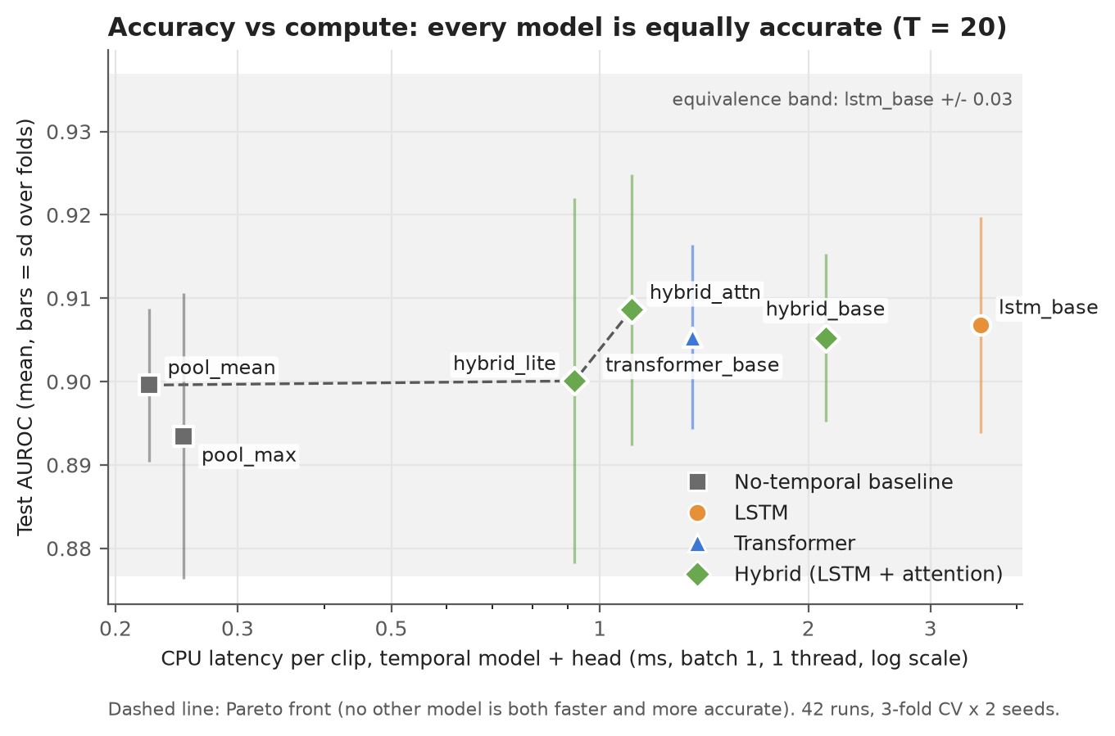
Fig. 4. AUROC against CPU time per clip (log scale). Grey band: lstm_base ± 0.03. Dashed line: models that no other model beats on both accuracy and speed.

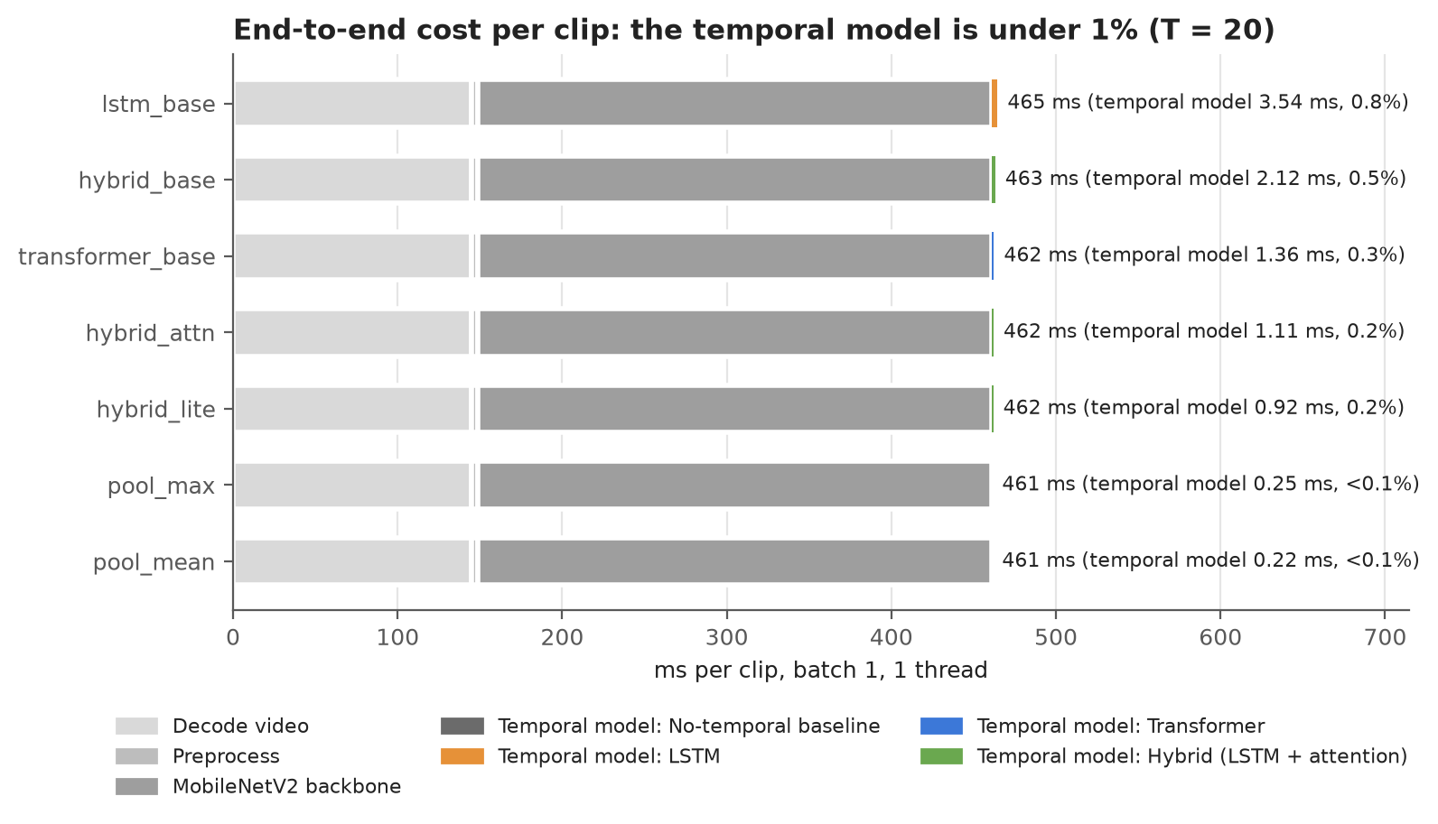
Fig. 5. Time per clip, from video file to prediction (one clip, one thread). Almost all of it goes to decoding and MobileNetV2; the temporal model takes less than 1%.

VI. Discussion
A. What the Results Mean
1) RQ1: no. On these features the Transformer is not more accurate than the LSTM; the equivalence test puts them level.
2) RQ2: for one clip at a time the Transformer costs less than the LSTM, but the gap hardly matters next to the roughly 460 ms spent on video decoding and MobileNetV2.
3) RQ3: between the LSTM and the Transformer there is no trade-off to make, since the faster one is also as accurate. hybrid_attn should be used when maximizing accuracy per millisecond is the aim, while pool_mean should be chosen in case only the cost of model matters since it is the most inexpensive model that has an equal AUROC.

The most surprising observation for us is pool_mean. It disregards the frame order and still manages to achieve an AUROC that is within 0.01 of all the other temporal models. We think that the classification may be based not on motion but on the condition of the ear canal in a few key frames, although we did not check this hypothesis. The accuracy limit seems to be set by the frame feature space and not by the temporal model.
B. Comparison with Previous Studies
According to Soeleman et al. [7], however, the LSTM was superior to the Transformer for small-sized videos with fixed features where we had found a tie. These two studies coincide in their conclusions on the general idea that attention does not provide any benefit in terms of accuracy when working with limited amounts of data and fixed features. This is consistent with Barros et al. [5], who found success with the LSTM over 20 frames of a pre-trained ImageNet network on 185 videos of a lung ultrasound. In contrast, those studies where the Transformers were useful [6], [8] utilized surgical videos consisting of thousands of frames.

C. Limitations
1) With only 6 test sets the confidence intervals are wide, which is why three of the models could not be shown to be equivalent.
2) We tested a single frame count (20), one data set, one image network and one laptop.
3) The data have no patient ID, so retakes of one child may be split across folds. All models share this problem, so the comparison holds, but the absolute scores could be too high.
4) Timing was not tested formally, and the DeLong, McNemar and Holm tests we had planned were not carried out.
5) We compared models as an engineering question; none of them has been validated as a diagnostic tool.
VII. Conclusion and Future Work
A. Conclusion
The LSTM (AUROC 0.907) and Transformer (0.905) performed equally well on the 874 pediatric ear videos, but the latter was 2.6 times faster on a CPU per clip. The other models did not surpass the LSTM significantly, while an average of the features extracted from the frames worked almost as well. Over 99% of time per clip was used for video decoding and the image network processing. In summary, selecting the more economical temporal network does not result in loss of performance, and the interested person should concentrate on video decoding and frame encoder instead.
B. Recommendations
1) For CPU use, pick the Transformer over the LSTM; use hybrid_attn for the best screening sensitivity and pool_mean for the lowest cost.
2) Run the temporal model on one thread when scoring one clip at a time.
3) Choose the decision cut-off on validation data (for example for 95% sensitivity), not 0.5.
4) To save time, use fewer frames or a lighter image network.
C. Future Work
Test 10 and 40 frames and a third seed; run DeLong and McNemar tests; fine-tune the image network or use a medical one to miss fewer Abnormal clips; recover patient grouping; and test on an external ear video set.
References
[1] S. Hochreiter and J. Schmidhuber, "Long short-term memory," Neural Comput., vol. 9, no. 8, pp. 1735–1780, 1997.
[2] A. Vaswani et al., "Attention is all you need," in Proc. Adv. Neural Inf. Process. Syst. (NeurIPS), 2017, pp. 5998–6008.
[3] A. Arnab, M. Dehghani, G. Heigold, C. Sun, M. Lučić, and C. Schmid, "ViViT: A video vision transformer," in Proc. IEEE/CVF Int. Conf. Comput. Vis. (ICCV), 2021, pp. 6836–6846.
[4] M. Owais, M. Arsalan, J. Choi, T. Mahmood, and K. R. Park, "Artificial intelligence-based classification of multiple gastrointestinal diseases using endoscopy videos for clinical diagnosis," J. Clin. Med., vol. 8, no. 7, Art. no. 986, 2019, doi: 10.3390/jcm8070986.
[5] B. Barros, P. Lacerda, C. Albuquerque, and A. Conci, "Pulmonary COVID-19: Learning spatiotemporal features combining CNN and LSTM networks for lung ultrasound video classification," Sensors, vol. 21, no. 16, Art. no. 5486, 2021, doi: 10.3390/s21165486.
[6] T. Czempiel, M. Paschali, D. Ostler, S. T. Kim, B. Busam, and N. Navab, "OperA: Attention-regularized transformers for surgical phase recognition," in Proc. MICCAI, LNCS, vol. 12904, 2021, pp. 604–614, doi: 10.1007/978-3-030-87202-1_58.
[7] M. A. Soeleman, C. Supriyanto, D. P. Prabowo, and P. N. Andono, "Video violence detection using LSTM and transformer networks through grid search-based hyperparameters optimization," Int. J. Saf. Secur. Eng., vol. 12, no. 5, pp. 615–622, 2022, doi: 10.18280/ijsse.120510.
[8] X. Gao, Y. Jin, Y. Long, Q. Dou, and P.-A. Heng, "Trans-SVNet: Accurate phase recognition from surgical videos via hybrid embedding aggregation transformer," in Proc. MICCAI, LNCS, vol. 12904, 2021, doi: 10.1007/978-3-030-87202-1_57.
[9] M. Sandler, A. Howard, M. Zhu, A. Zhmoginov, and L.-C. Chen, "MobileNetV2: Inverted residuals and linear bottlenecks," in Proc. IEEE/CVF Conf. Comput. Vis. Pattern Recognit. (CVPR), 2018, pp. 4510–4520.
[10] R. Xiong et al., "On layer normalization in the transformer architecture," in Proc. Int. Conf. Mach. Learn. (ICML), 2020, pp. 10524–10533.
[11] D. P. Kingma and J. Ba, "Adam: A method for stochastic optimization," in Proc. Int. Conf. Learn. Represent. (ICLR), 2015.
[12] I. Loshchilov and F. Hutter, "Decoupled weight decay regularization," in Proc. Int. Conf. Learn. Represent. (ICLR), 2019.
[13] C. Nadeau and Y. Bengio, "Inference for the generalization error," Mach. Learn., vol. 52, no. 3, pp. 239–281, 2003.
[14] R. R. Bouckaert and E. Frank, "Evaluating the replicability of significance tests for comparing learning algorithms," in Proc. Pacific-Asia Conf. Knowl. Discov. Data Min. (PAKDD), LNCS, vol. 3056, 2004, pp. 3–12.
[15] D. J. Schuirmann, "A comparison of the two one-sided tests procedure and the power approach for assessing the equivalence of average bioavailability," J. Pharmacokinet. Biopharm., vol. 15, no. 6, pp. 657–680, 1987.

