**PRACTICAL - 6**

**Name** : Apoorva Dudhe

**Roll No**: A3_B1_15

**Aim**: Smart Library Search Optimization

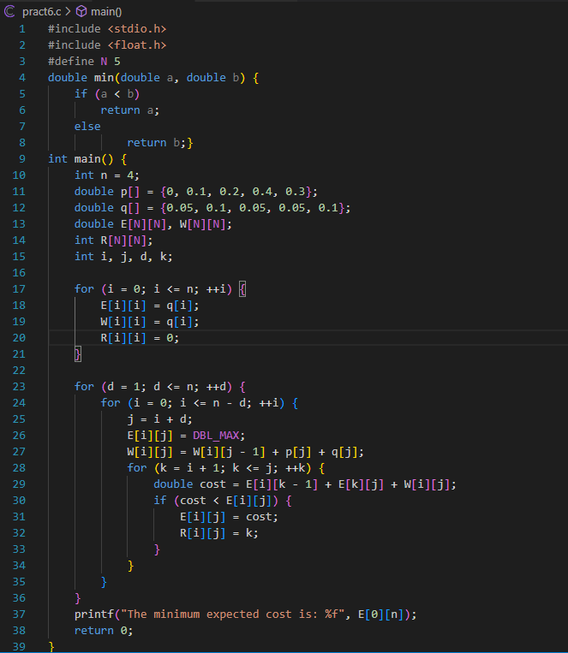

Output:

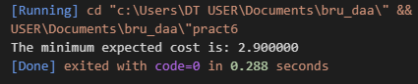

Task 2:

