**PRACTICAL - 7**

NAME: Apoorva Dudhe

SECTION: A3 - B1

ROLL NO.: 15

Problem Statement:

The Smart City Transportation Department is designing a night-patrol route for

security vehicles. Each area of the city is represented as a vertex in a graph, and a road between two areas is represented as an edge.

The goal is to find a route that starts from the main headquarters (Area A), visits

each area exactly once, and returns back to the headquarters — forming a

Hamiltonian Cycle.

If such a route is not possible, display a suitable message.

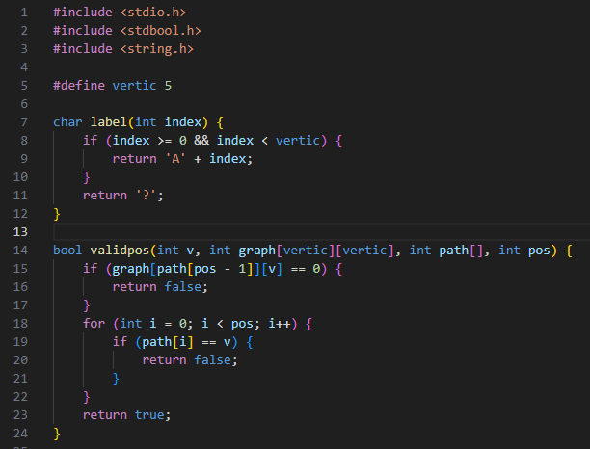

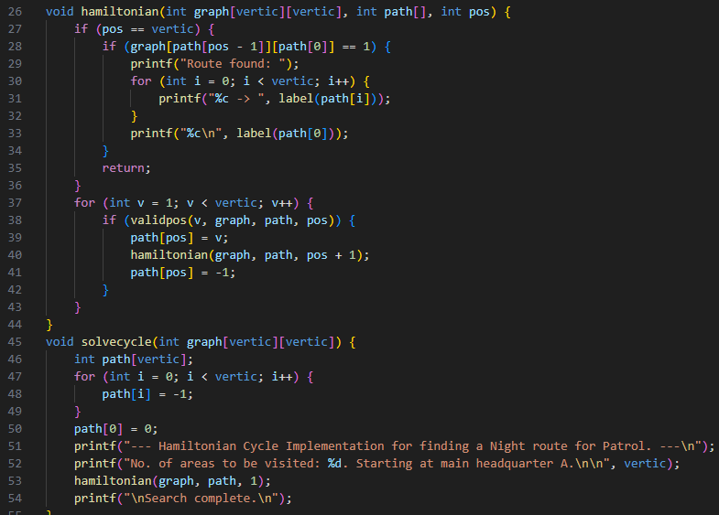

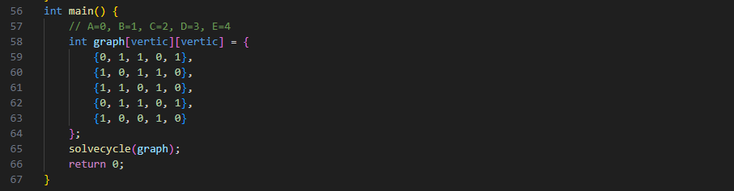

OUTPUT

