**PRACTICAL - 7**

NAME: Apoorva Dudhe

SECTION: A3 - B1

ROLL NO.: 15

Competitive Programming Code

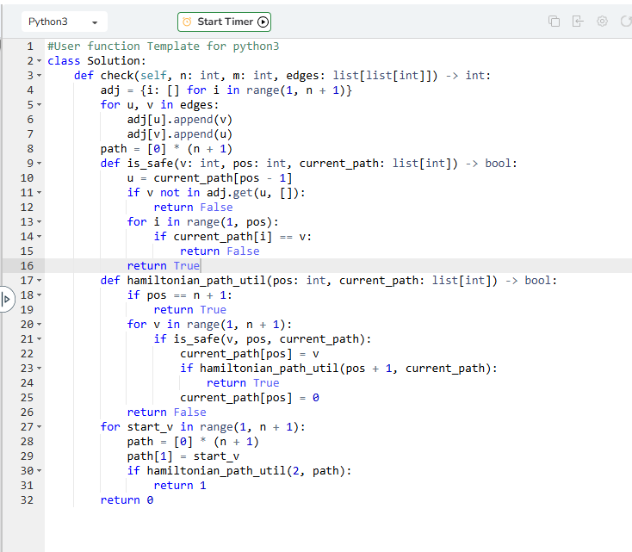

OUTPUT

