**PRACTICAL 5(leetcode):**

**Name :Apoorva Dudhe**

**Section : A3-B1**

**Roll no : 15**

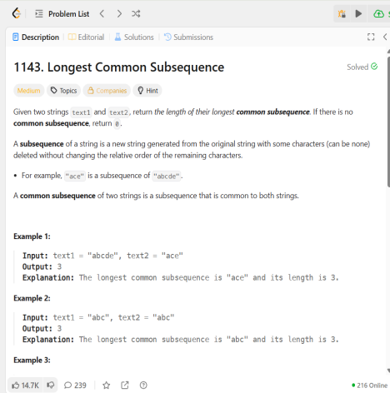

**Code**

#include <stdio.h>

#include <string.h>

#include <stdlib.h>

int longestCommonSubsequence(char * text1, char * text2){ int m = strlen(text1);

int n = strlen(text2);

int **dp = (int **)malloc((m + 1) * sizeof(int *));

for (int i = 0; i <= m; i++) {

dp[i] = (int *)calloc(n + 1, sizeof(int));

}

for (int i = 1; i <= m; i++) {

for (int j = 1; j <= n; j++) {

if (text1[i - 1] == text2[j - 1]) {

dp[i][j] = 1 + dp[i - 1][j - 1];

} else {

dp[i][j] = (dp[i - 1][j] > dp[i][j - 1]) ? dp[i - 1][j] : dp[i][j - 1];

}

}

}

int result = dp[m][n];

for (int i = 0; i <= m; i++) {

free(dp[i]);

}

free(dp);

return result;

}

**OUTPUT:**

