D.A.A. PRACTICAL - 8

NAME: Apoorva Dudhe
SECTION: A3-B1
ROLL No.: 15

#include <stdio.h>
#include <stdbool.h>
#define N 6 //no. of vertices
#define M 3 // no. of colours

int graph[N][N];
int color[N];

void initialize_graph_1() {
for (int i = 0; i < N; i++) {
color[i] = 0;
for (int j = 0; j < N; j++) {
graph[i][j] = 0;
}
}
graph[0][1] = graph[1][0] = 1;
graph[0][2] = graph[2][0] = 1;
graph[0][4] = graph[4][0] = 1;
graph[0][5] = graph[5][0] = 1;

graph[3][2] = graph[2][3] = 1;
graph[3][4] = graph[4][3] = 1;
graph[3][5] = graph[5][3] = 1;

graph[1][2] = graph[2][1] = 1;
graph[1][5] = graph[5][1] = 1;
graph[2][4] = graph[4][2] = 1;
graph[4][5] = graph[5][4] = 1;
}

bool is_safe(int k, int c) {
for (int i = 0; i < N; i++) {
if (graph[k][i] && c == color[i]) {
return false;
}
}
return true;
}
void print_solution() {
printf("Vertex | Color\n");
printf("-------|------\n");
for (int i = 0; i < N; i++) {
printf(" %d | %d\n", i, color[i]);
}
printf("\n");
}
void color_graph(int k) {
if (k == N) {
printf(" Solution found using %d colors (1 to %d) for Graph 1:\n", M, M);
print_solution();
return;
}
for (int c = 1; c <= M; c++) {
if (is_safe(k, c)) {
color[k] = c;
color_graph(k + 1);
color[k] = 0;
}
}
}

int main() {
printf("Graph Coloring Problem (Backtracking) for Graph 1 (N=%d, M=%d)\n", N, M);
printf("-----------------------------------------------------------\n");
initialize_graph_1();
color_graph(0);
bool solution_found = false;
for(int i = 0; i < N; i++) {
if(color[i] != 0) {
solution_found = true;
break;
}
}
if (!solution_found) {
printf("No solution found using M=%d colors for this graph.\n", M);
printf("Suggestion: Try increasing M (the number of available colors).\n");
}

return 0;
}

OUTPUT
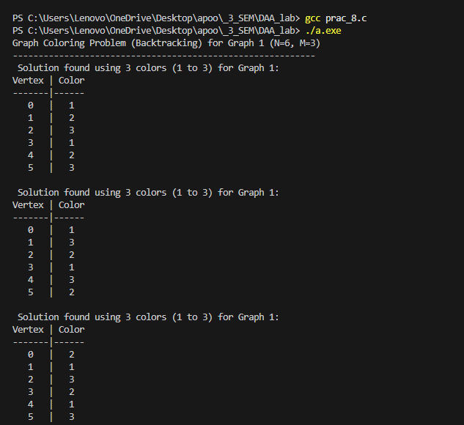

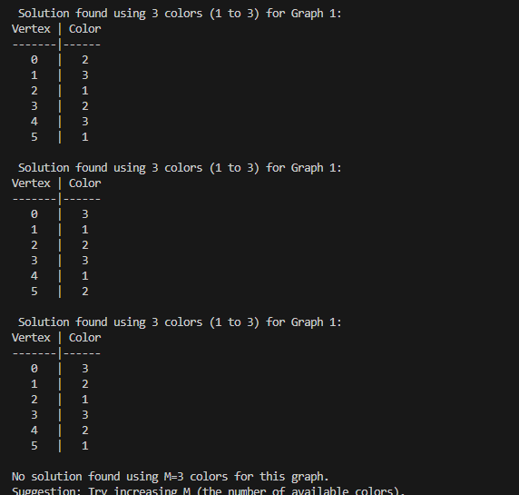

CP PROBLEM
