Task 1:

Time: ***3:00 pm*** *to* ***4:30 pm***

*Monthly entropy vs Cases*

Entropy (y -axis -- right hand) (entropy folder)

Cases (y-axis -- left) (cases)

* ENTROPY: Create a combined file with country information for monthly entropy
* CASES: Use the cases information available in the data folder

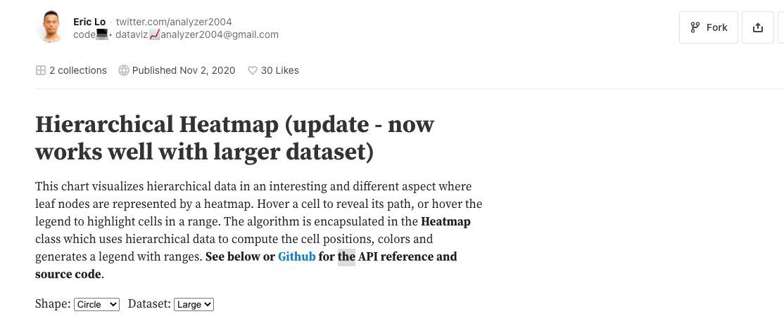

<https://observablehq.com/@analyzer2004/hierarchical-heatmap>

Task to be completed: Implement *Country* menu as above