Database of BFC project.

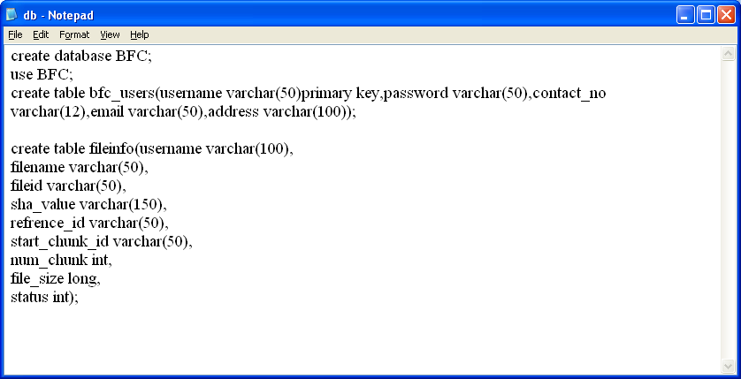

This db.txt file is available inside BFC/LogicalLayer folder. You need to install mysql (mysql used as persistent layer) and give mysql password as ‘root’. After mysql installation copy content from db.txt file and paste it in mysql console to create BFC database and its tables. All files chunks will store inside fileinfo mysql table. New user details who register will store inside bfc_users table.

Java HashMap key/value pair class and file system acts like storage layer.

Inside BFC folder you will find two folders

1. LogicalLayer: This folder contains code of logical layer and it’s responsible to accept all files chunks from ApplicationLayer and store inside key/value pair and mysql database. This layer use SHA technique to create hash code for each chunk and used AES technique to encrypt file data.
2. ApplicationLayer. This layer runs by user. First user has to register and then login, after login user can upload file and this file will be divided into chunks and send to logical layer for storage. Logical layer is responsible to check duplicates by comparing hash code of each chunk with one and other. If duplicate found then only reference will be save not entire chunk.

Each file uploaded by user will saved in inside BFC/LogicalLayer/DummyCloud folder and all metadata of all files will save inside BFC/LogicalLayer/ metadata folder

To run logical layer simple double click on ‘run.bat’ file BFC/LogicalLayer and after running logical layer double click on run.bat file from BFC/ApplicationLayer folder.

Screen Shots

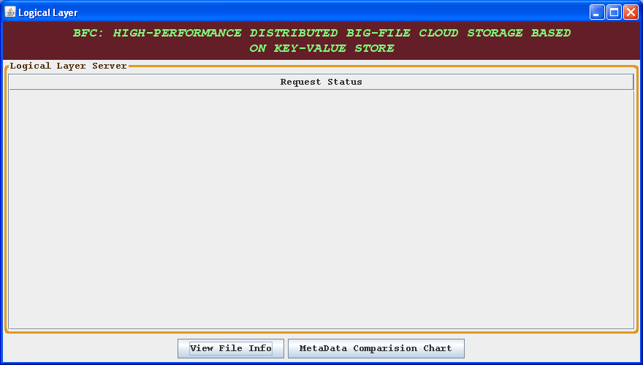

In above screen Logical Layer server started. Now run batch file from application layer

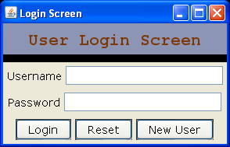

In above screen click on ‘New User’ button to add one user

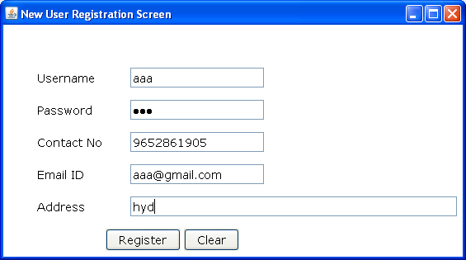

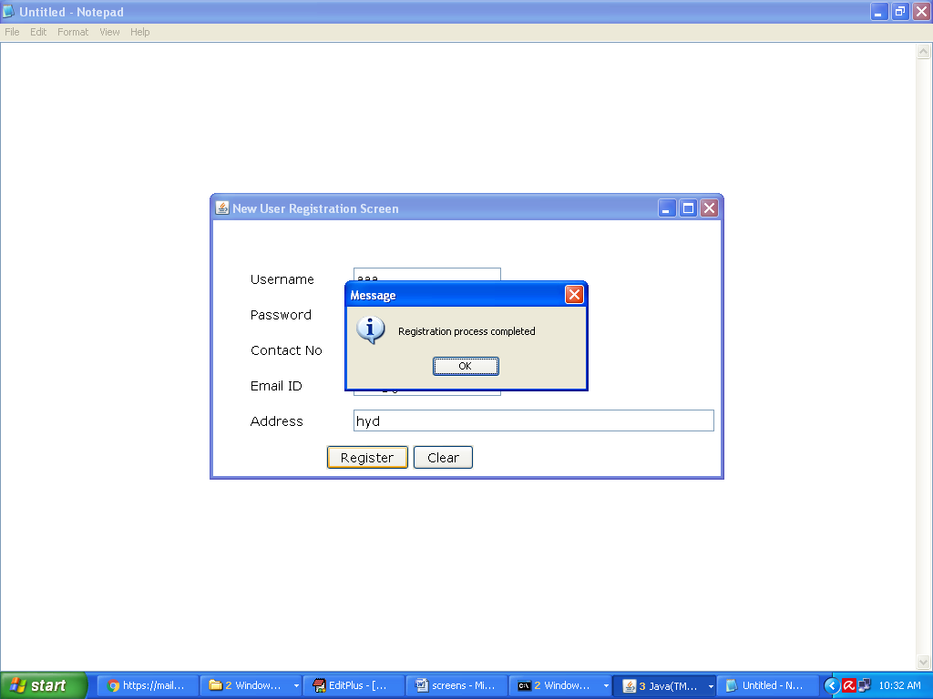

After registration user can login

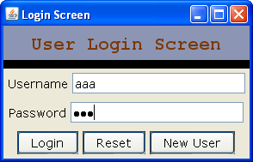

After successful login we will get user screen

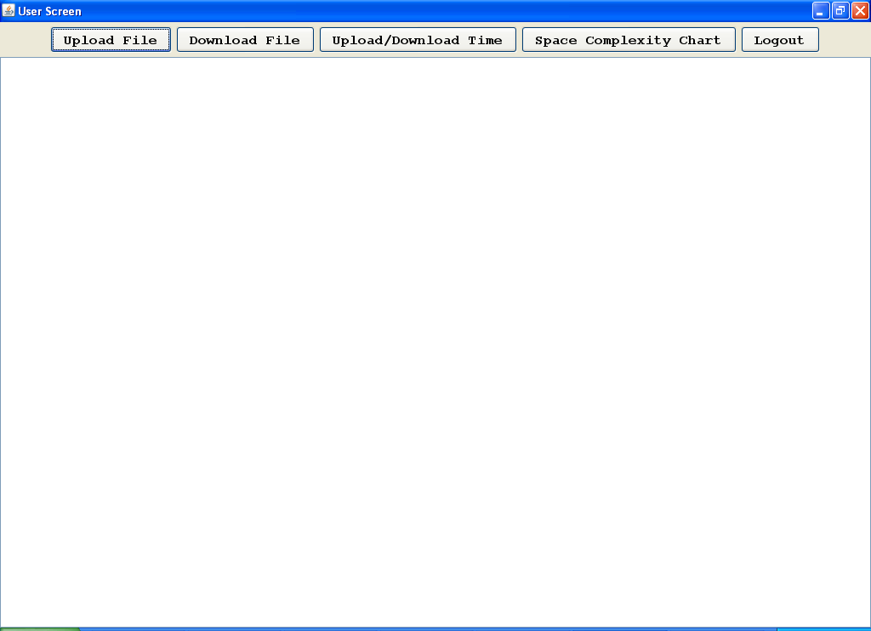

Click on upload file button to upload file

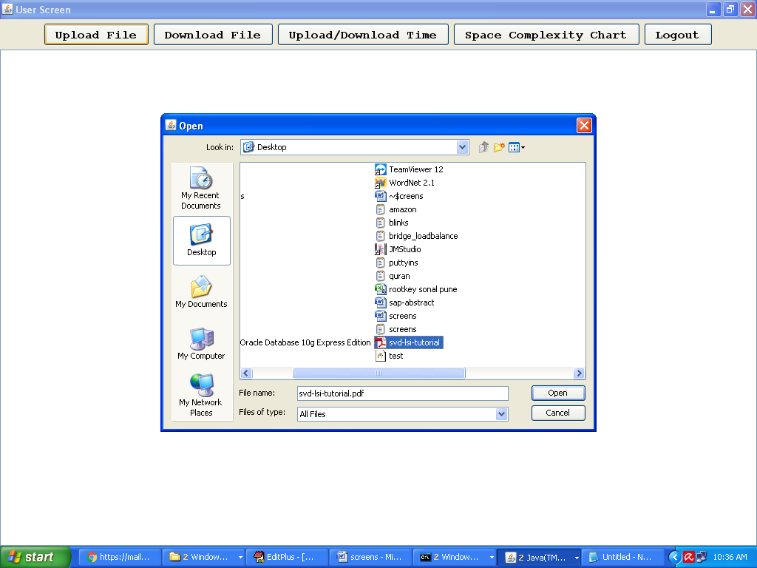

In above screen I am uploading on pdf file. After upload all chunks will be created and send to logical layer for storage. After uploading we will get below message

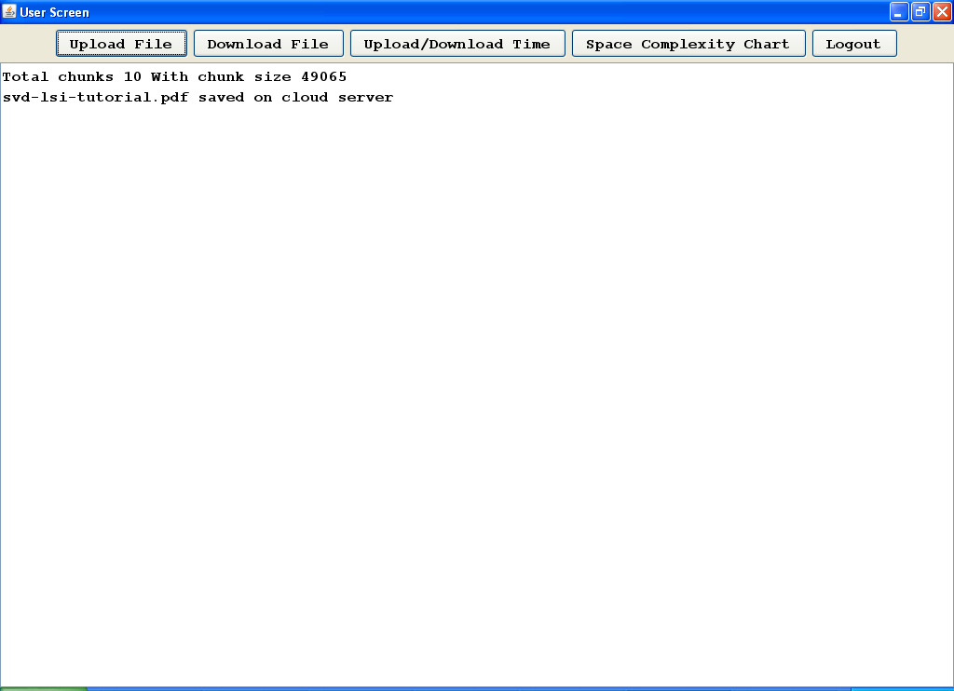

Now we can see Logical Layer screen

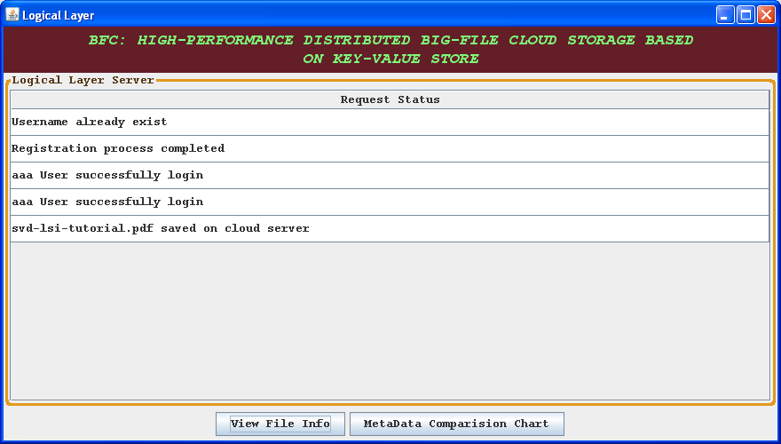

Above screen will record all operations done by all users. We can see inside DummyCloud folder for chunks storage



Now click on ‘View File Info’ from logical layer screen to get file details

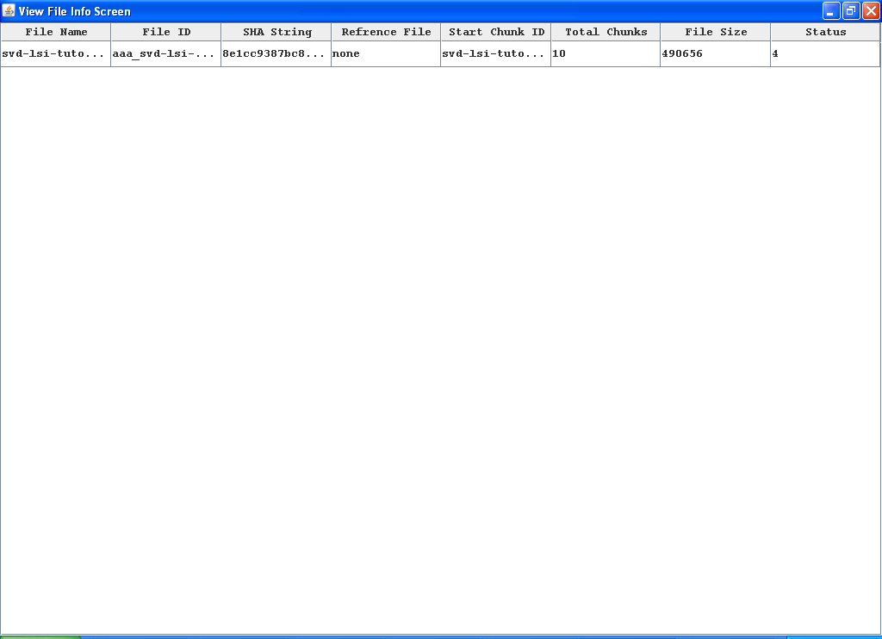

If we upload any duplicate file then refrence file column will display name of refrence file. Now from application layer you can download same file. You can upload and download as many as you want or your system can store

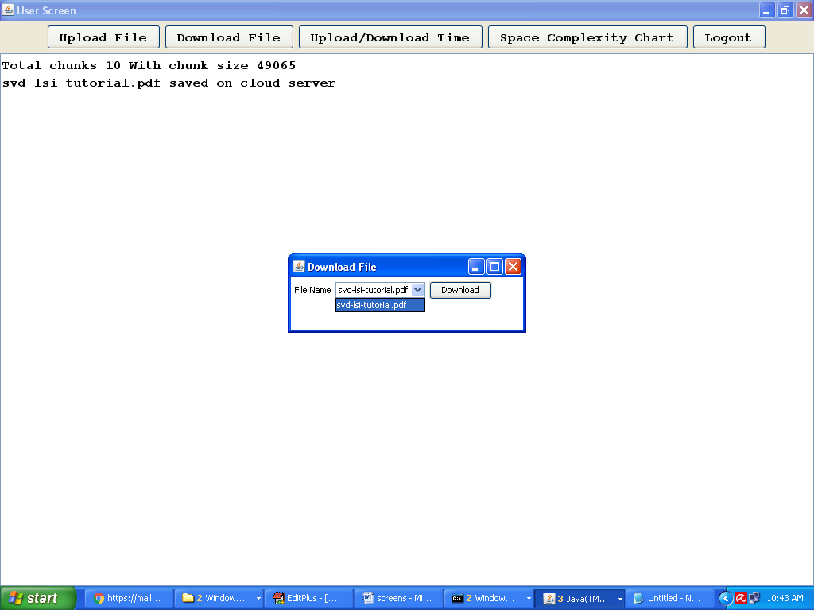

Select file name from drop down and click on ‘Download’ button

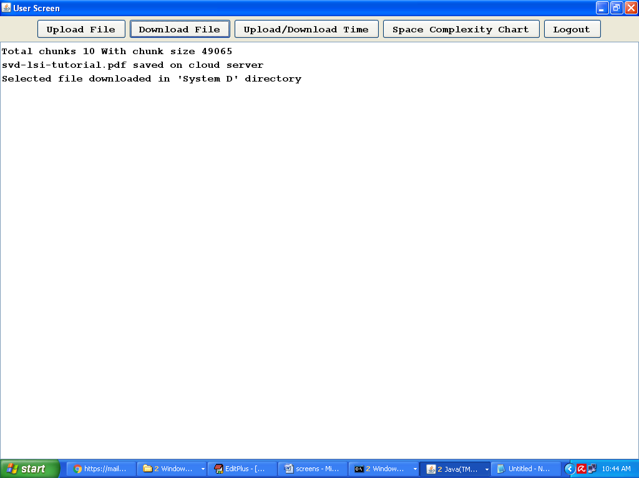

In above screen we can get the message as file downloaded to system D directory. You can calculate upload and download time in the form of chart

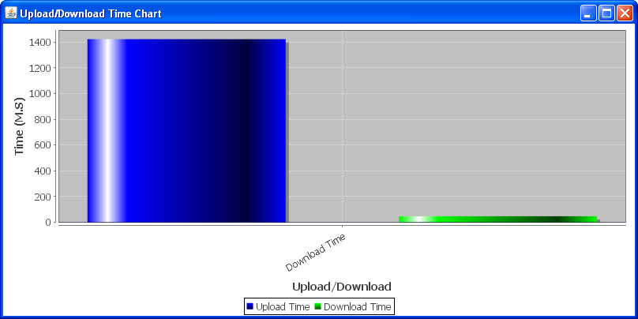

Space complexity chart will display size of each file storage

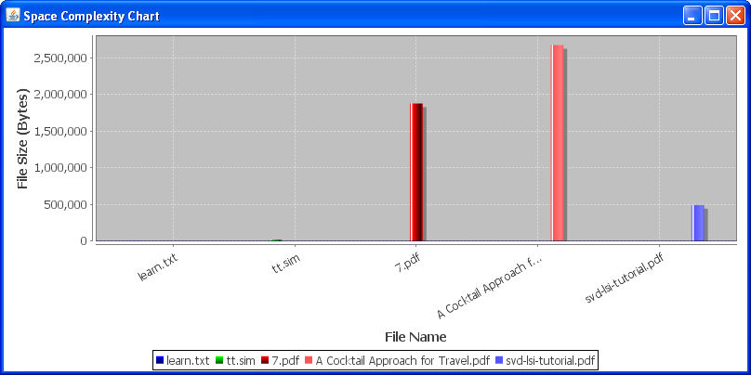

Note:

This application we are giving as native desktop where user can upload and download by using desktop application.