Git Assessment Practice

Git Commands Practiced:

- git clone: Clone an existing repository from remote.
- git status: Show current changes and staged files.
- git add . :Stage all changed files.

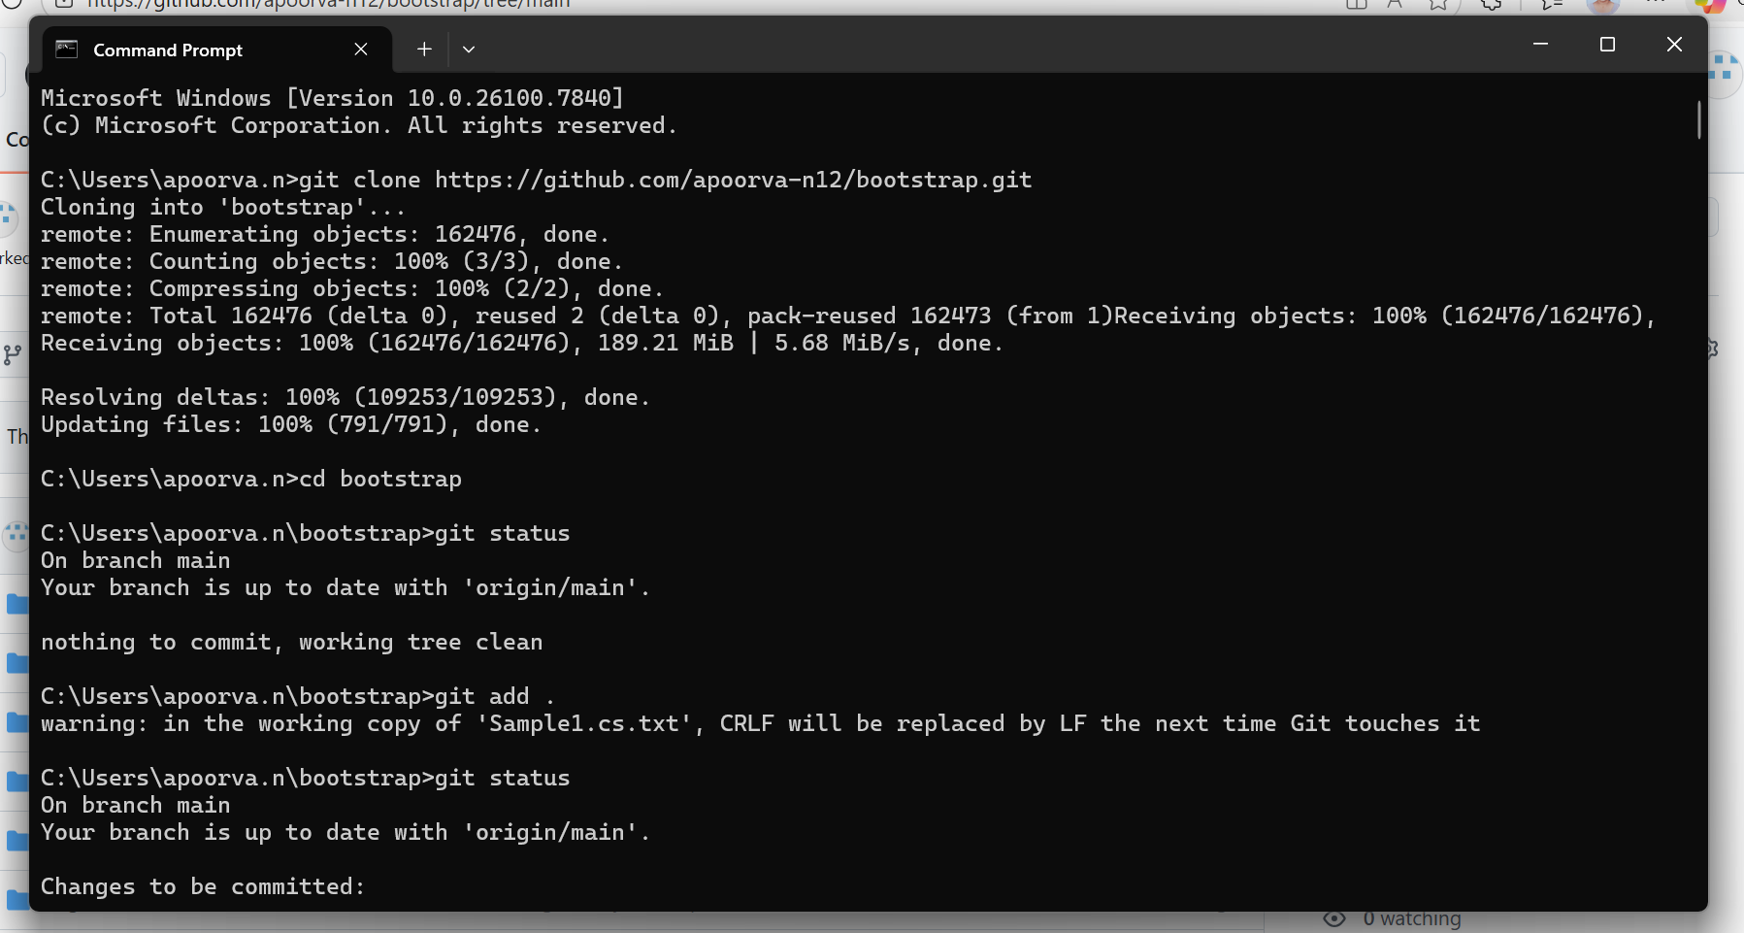

- git push: Push a tag to the remote.
- git head: Show the latest commit pointed to by HEAD.

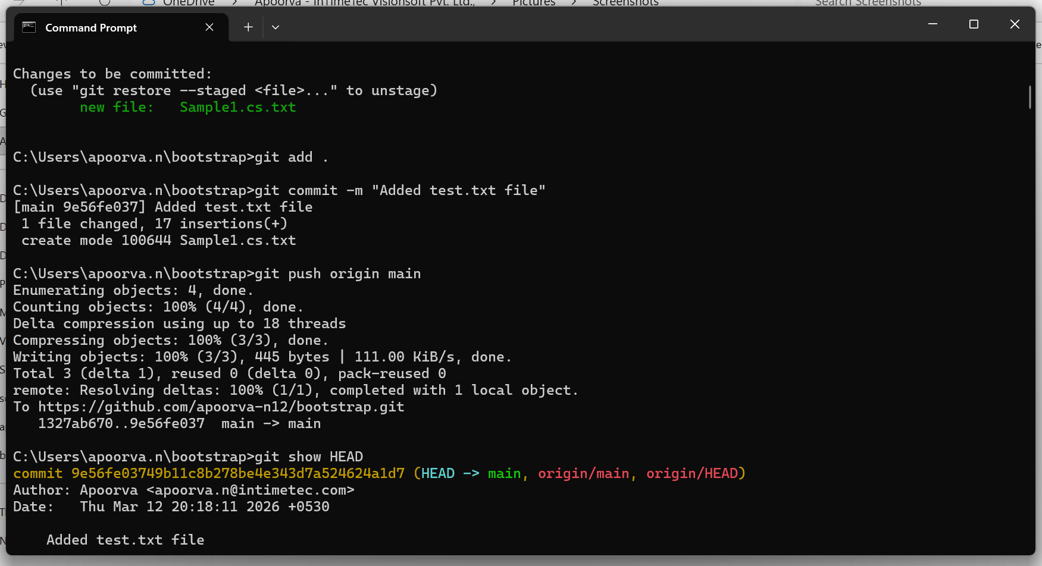

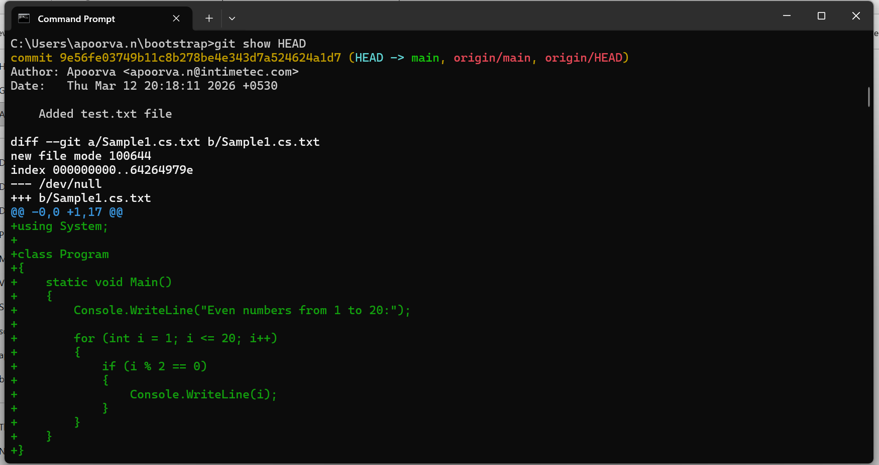

- git log: Shows commits; HEAD is the current commit

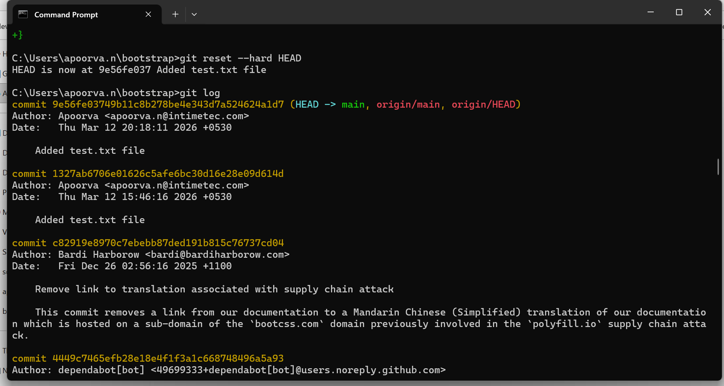

- git rm –cached used to remove the document.

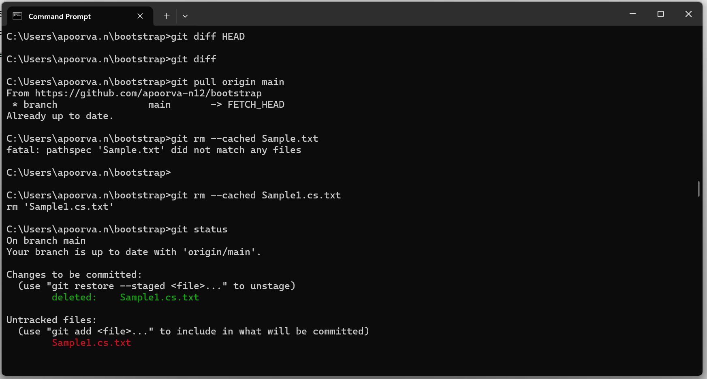

- git commit: It records changes to tracked files.
- git push: Git push used to push the data to local repository to remote repository.

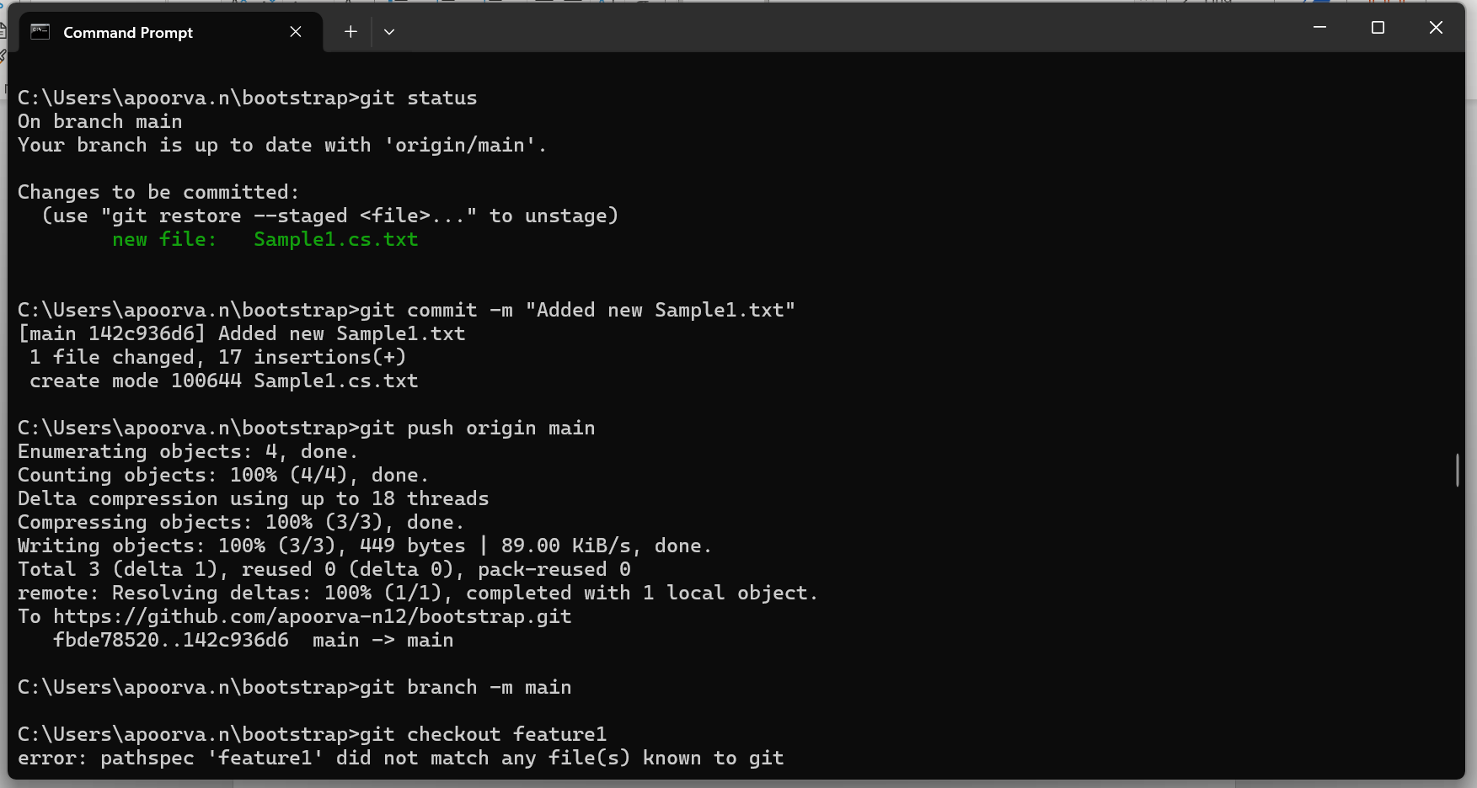

- git checkout: Create a new branch.

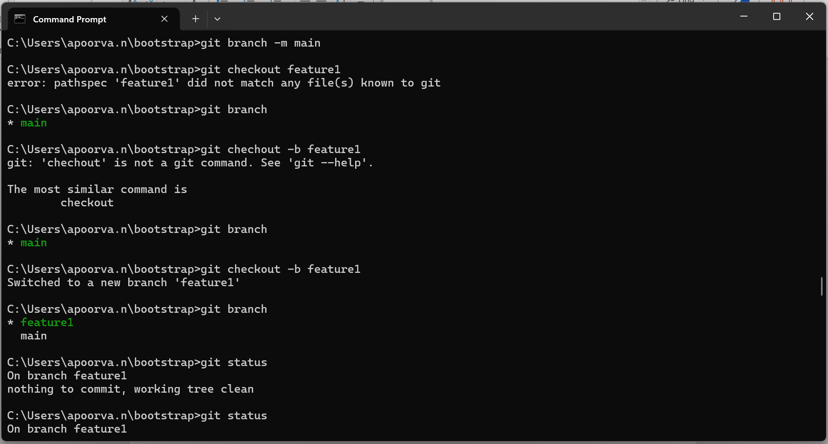

- git status: shows the current state of your working directory and staging area.

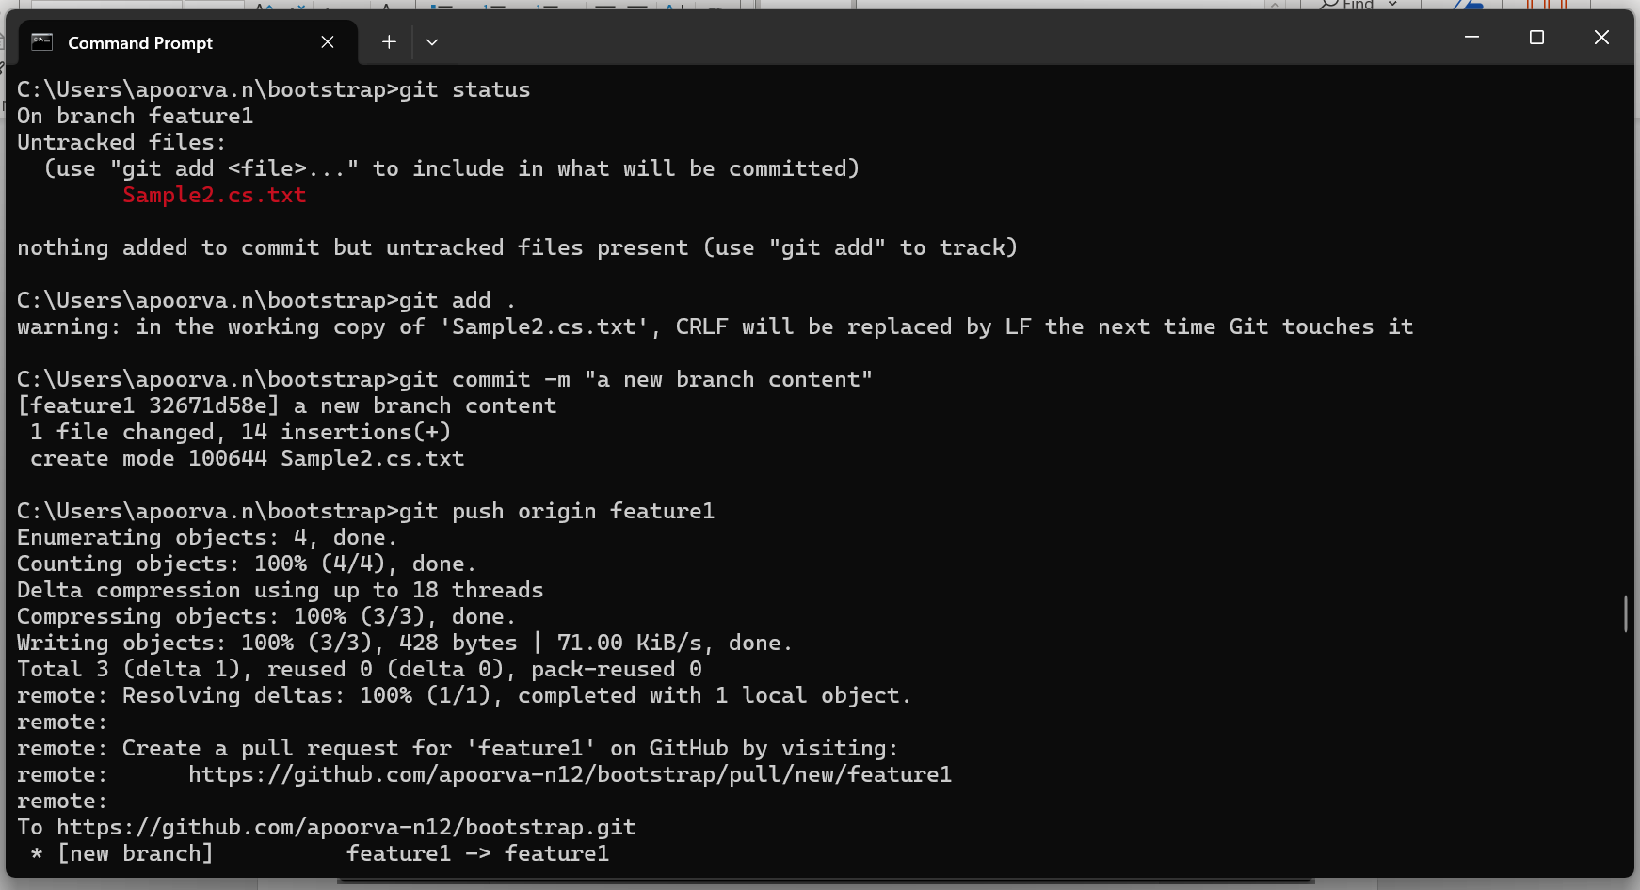

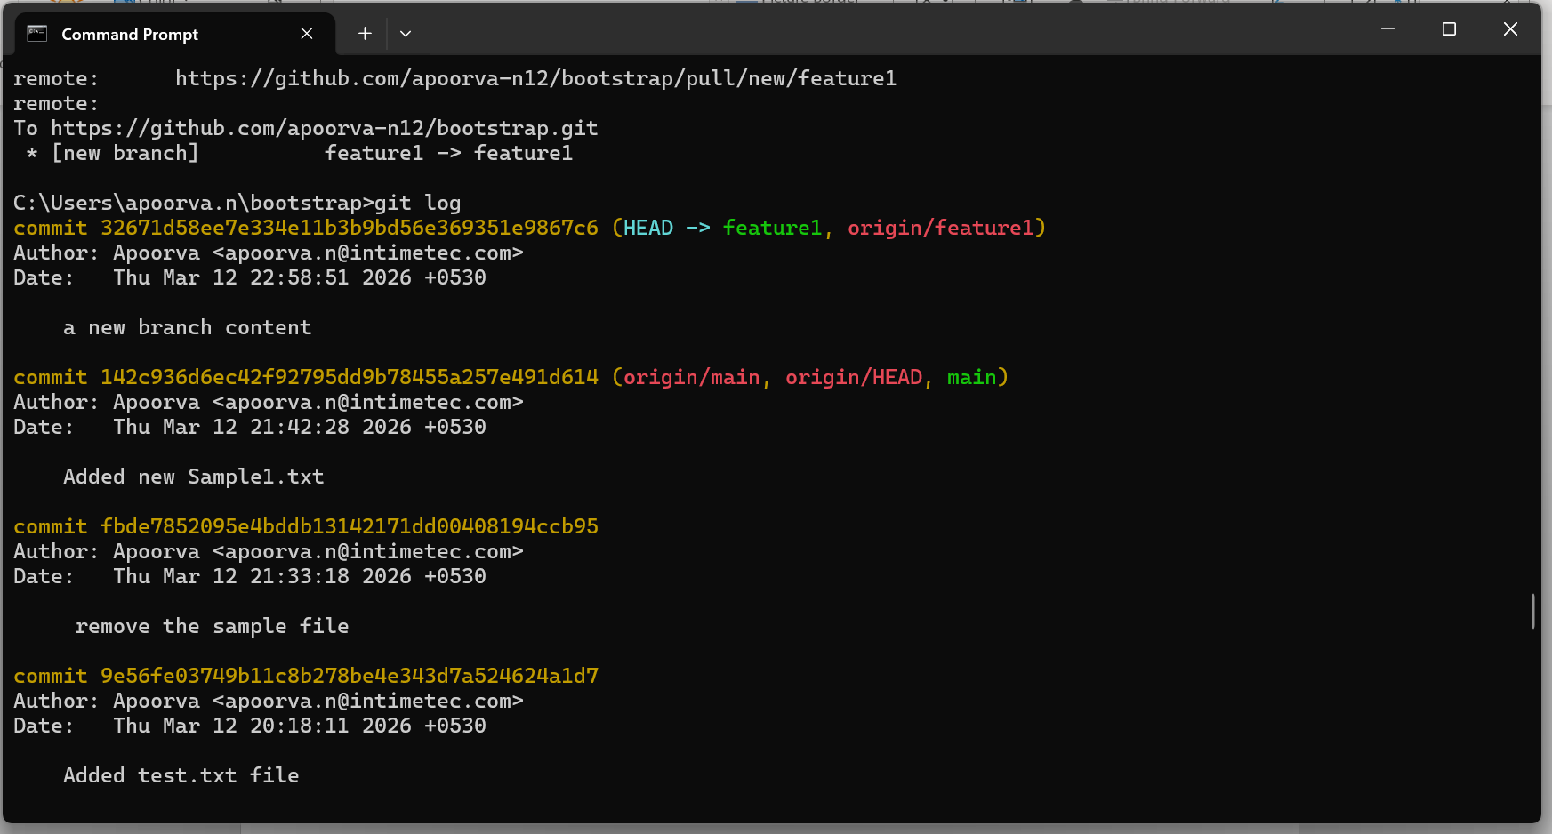

- git switch: is used to change branches or create & switch to a new branch.
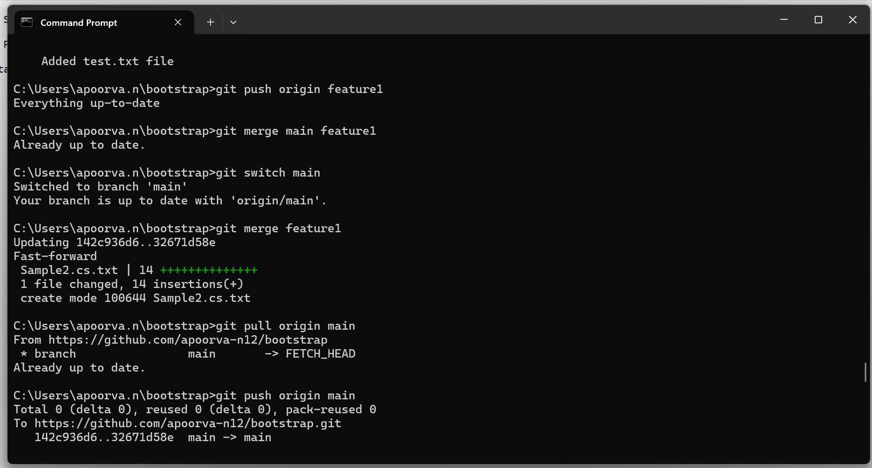

- git stash: temporarily save the uncommitted changes.
- git stash save: Save the current stash changes.

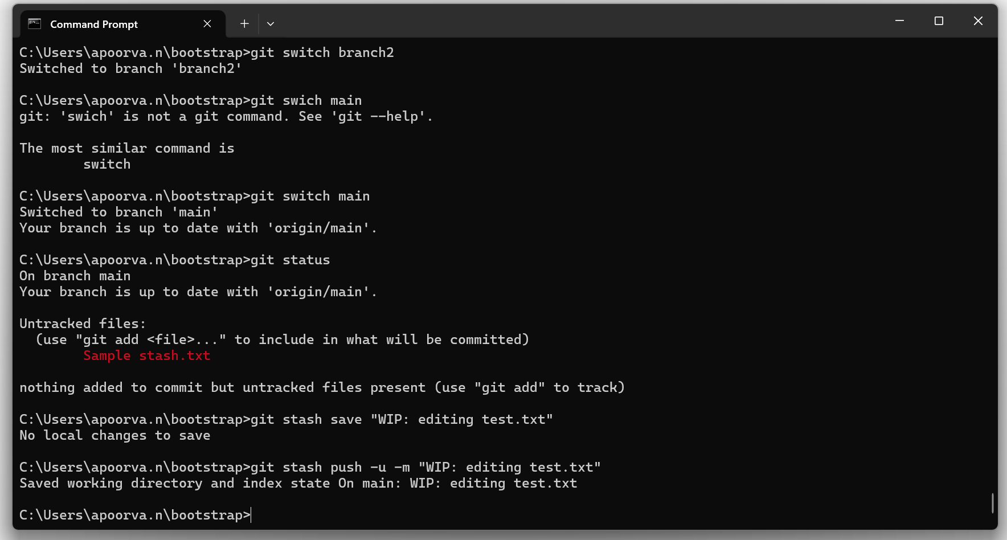

- git stash list: View stashed changes.
- git Stash apply: Apply the latest stash (without removing it from the stash list):

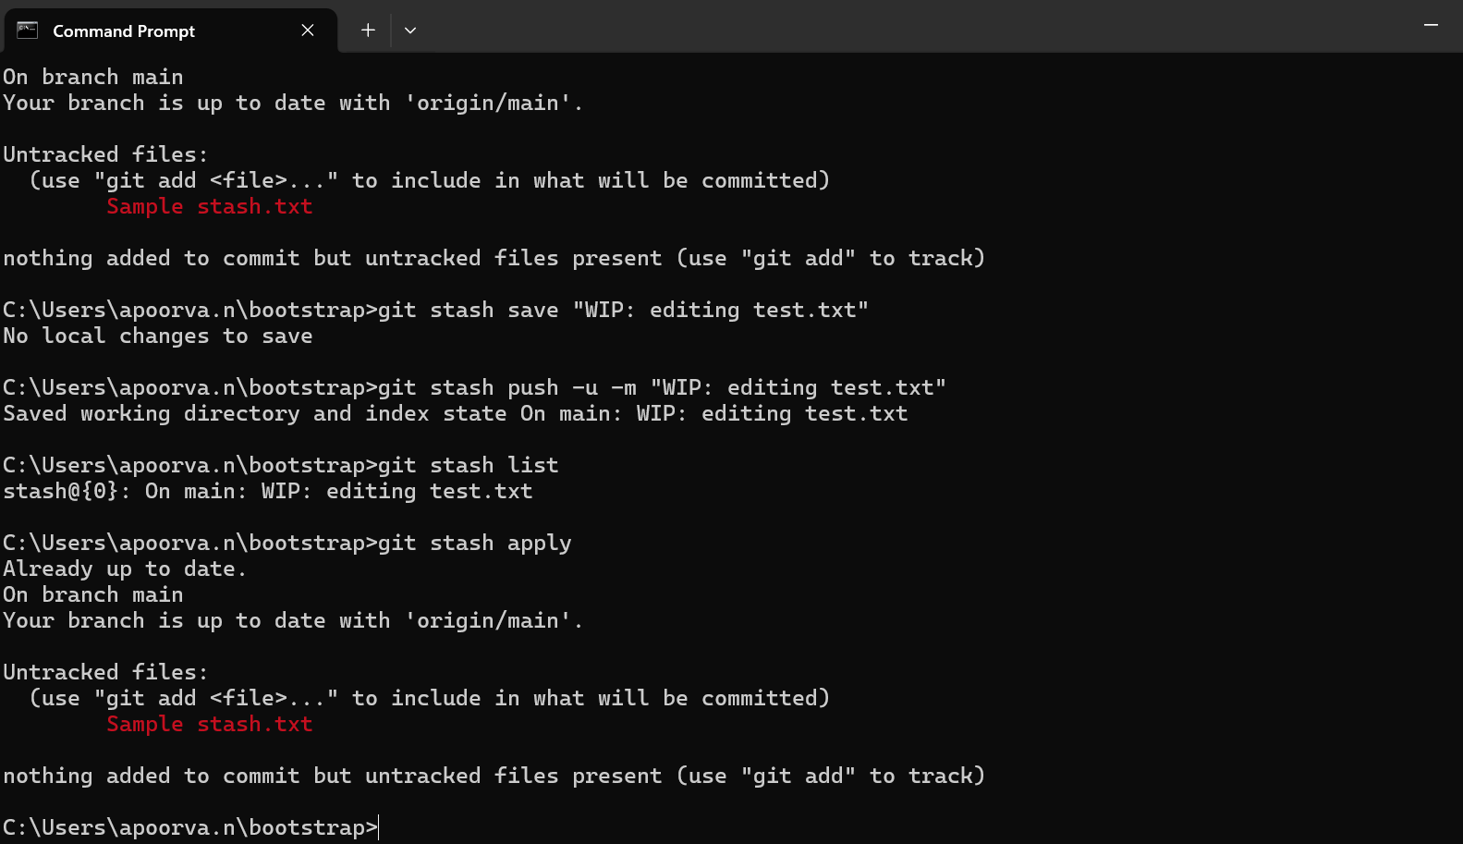

- git pull: used to fetch the latest changes from the remote repository and merge them into the local branch.

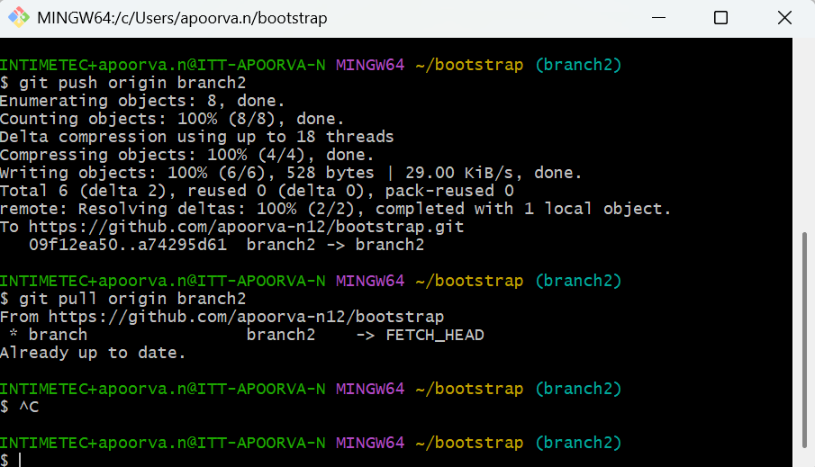

- git merging

three way merge: integrates changes from another branch into the current branch.

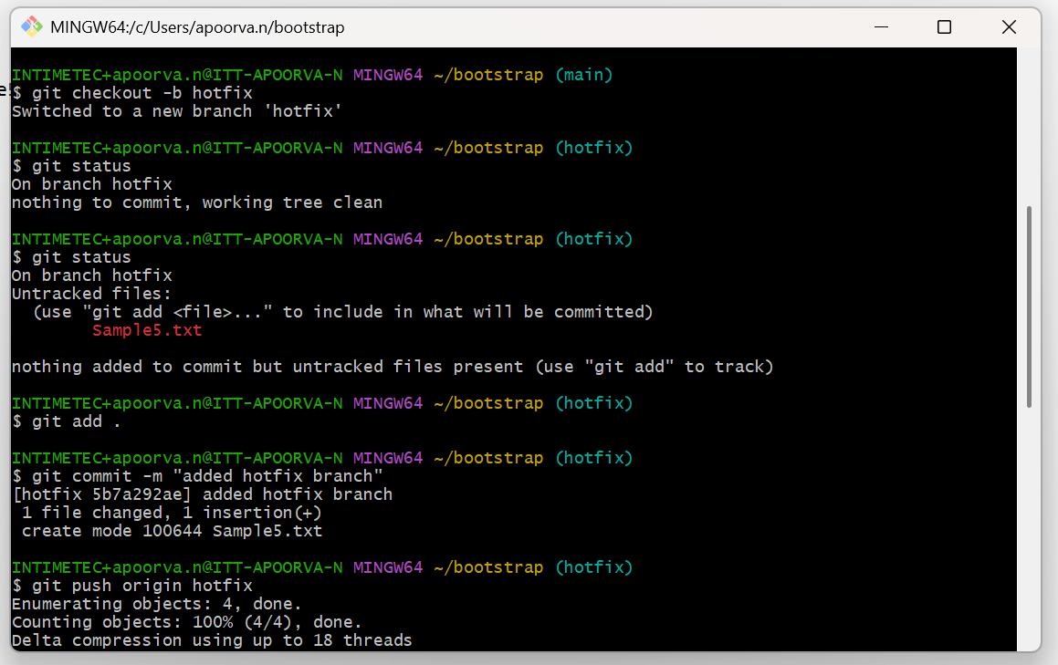

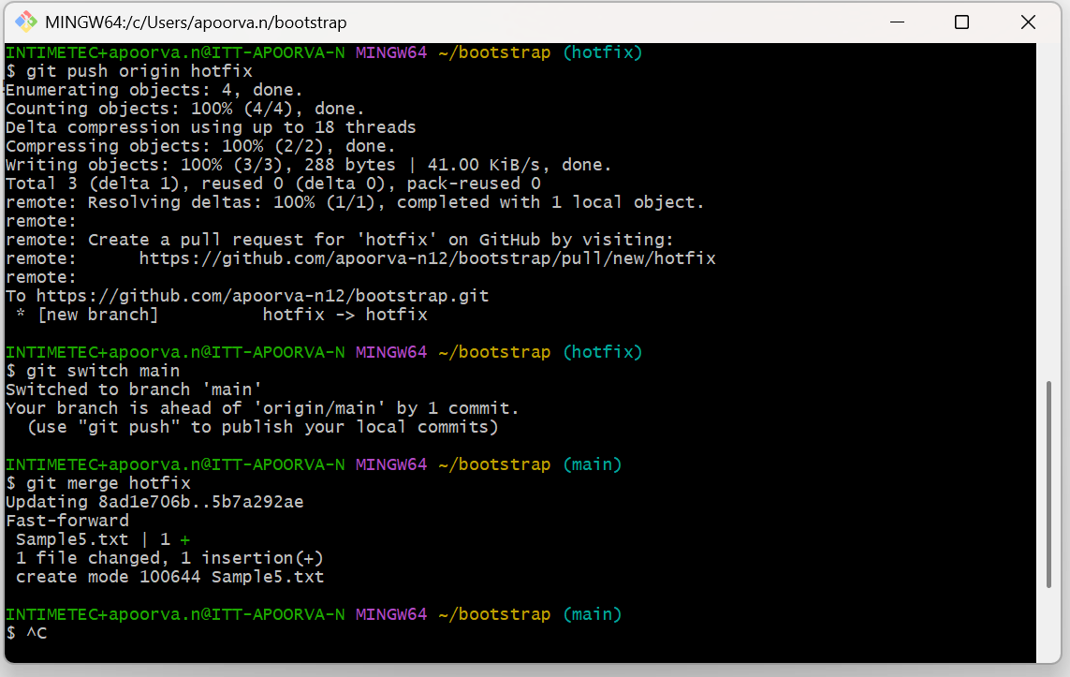
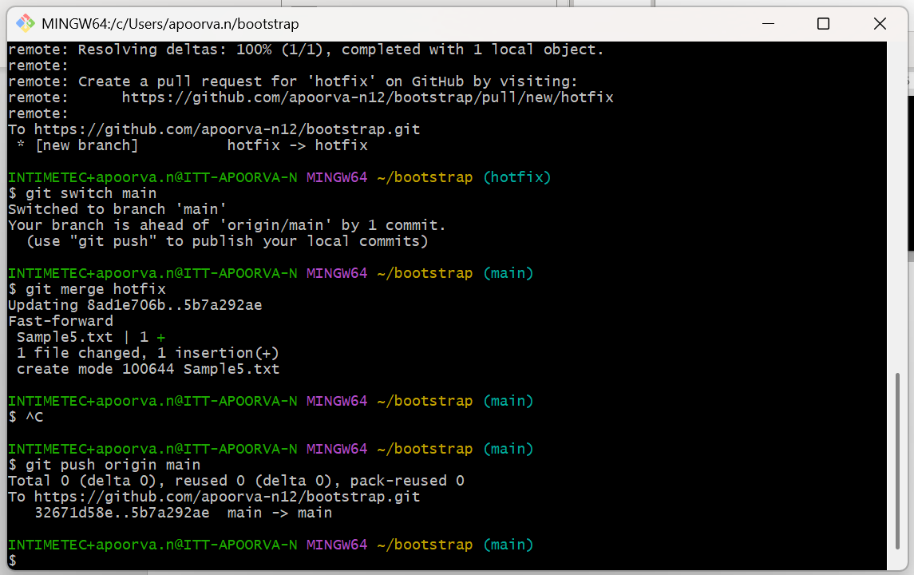

Fast Forword merge: Main branch has not changed since you created another branch.

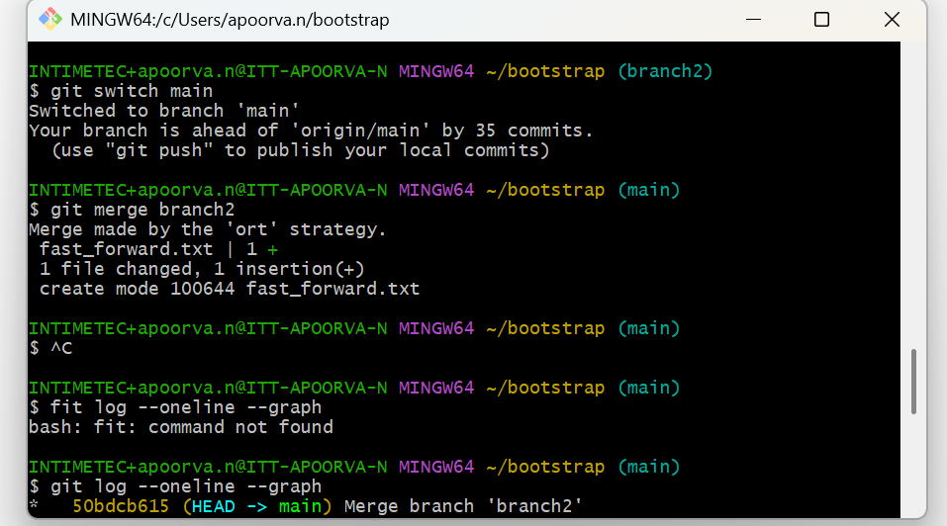

Merge conflict: Git happens when two branches change the same part of a file, and Git cannot automatically decide which change to keep.

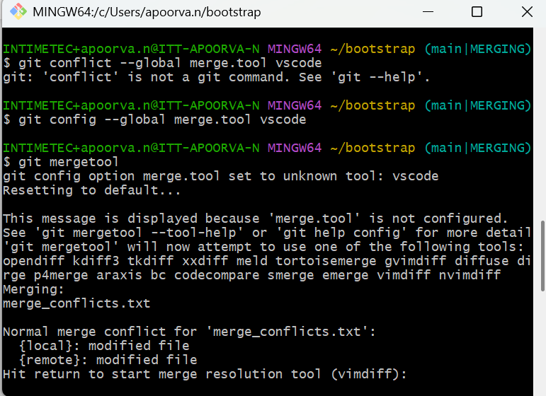

git reset: is used to undo commits or remove files from the staging area.

3 ways:

- Get mixed: Undo commits and unstage changes. Changes remain in working directory.

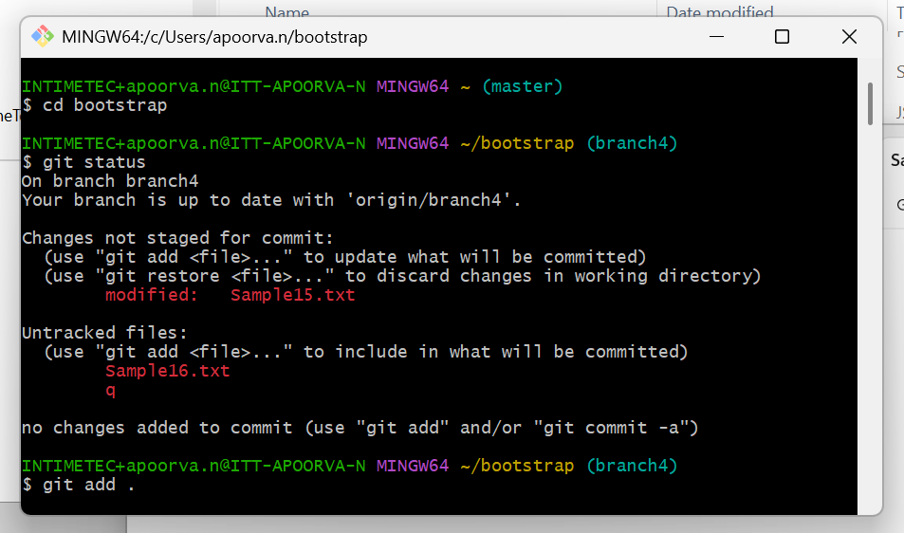

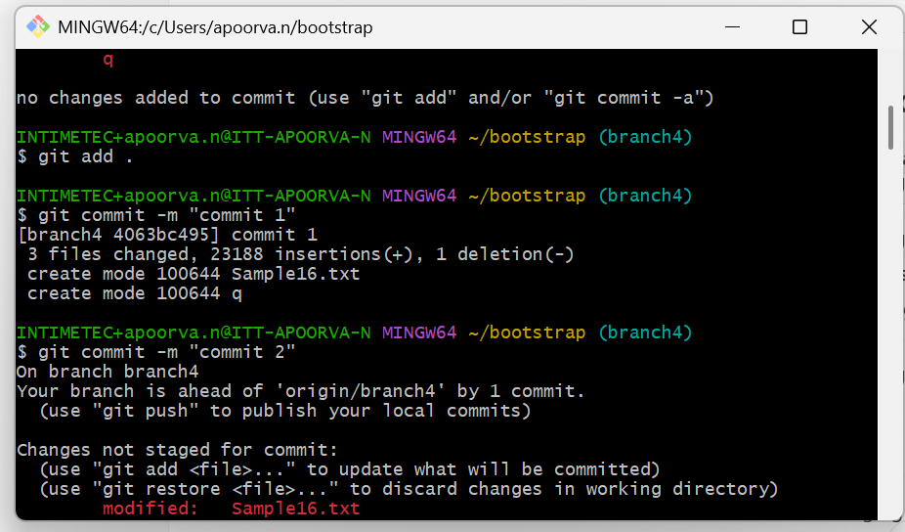

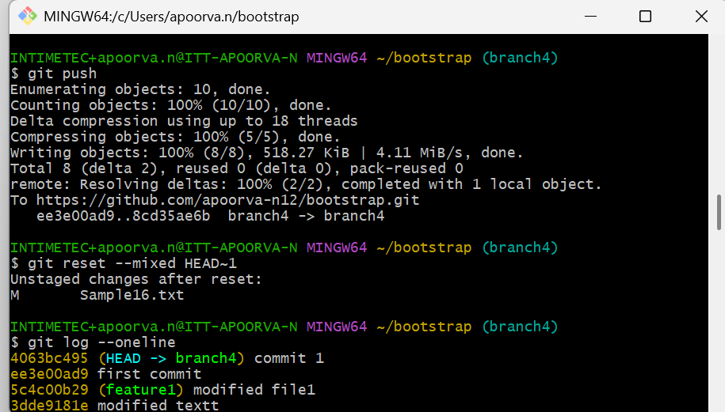

- git soft : Undo commits only, keep all changes staged for a new commit

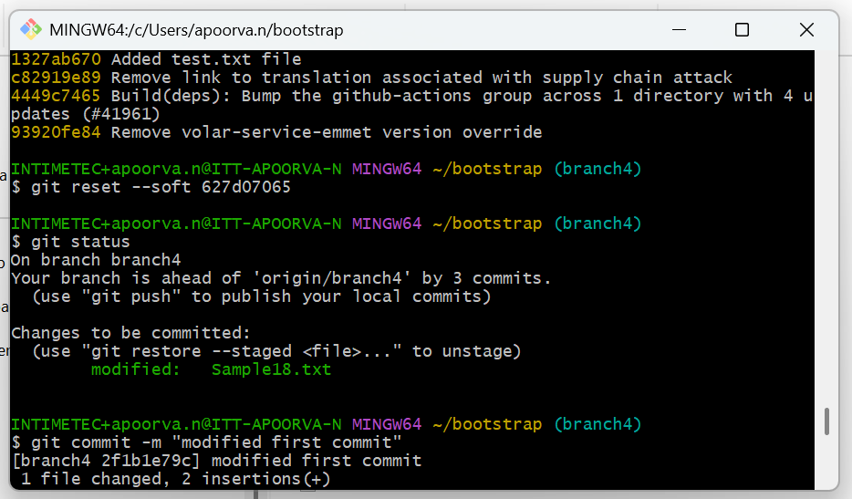

- git hard: Undo commits and delete all changes permanently.

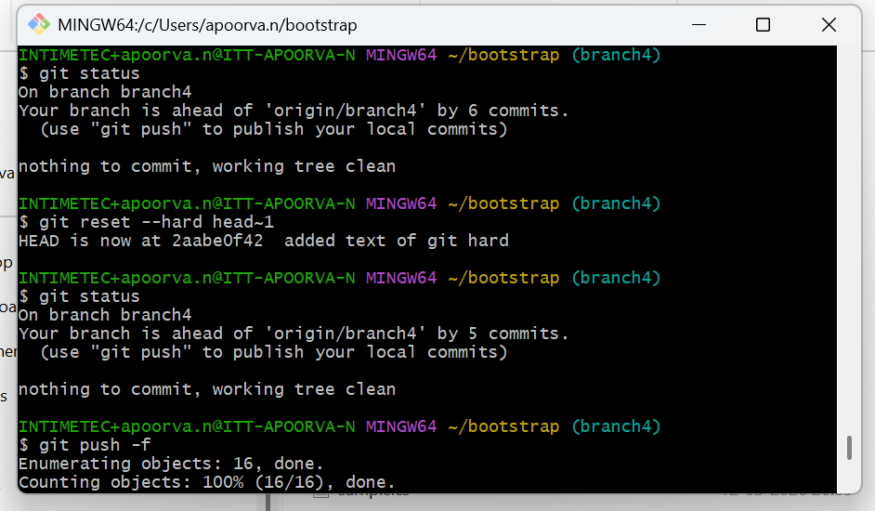

git restore: used to restore files to their previous state.

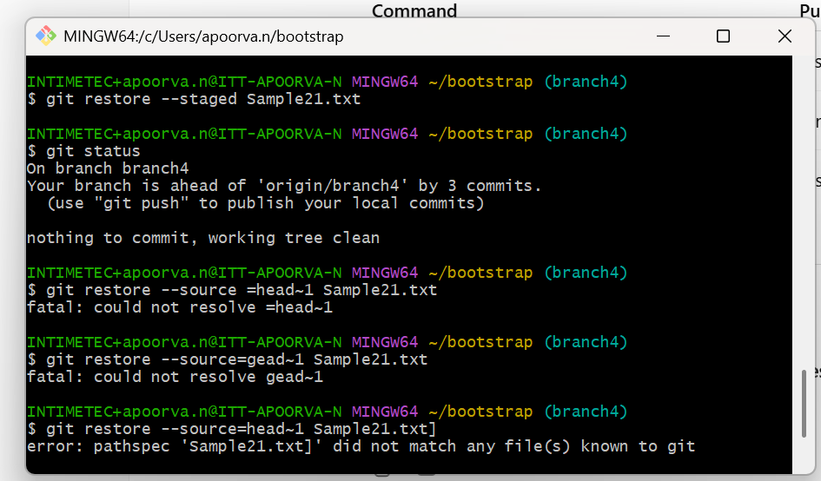

git diff: shows what changes were made in files.

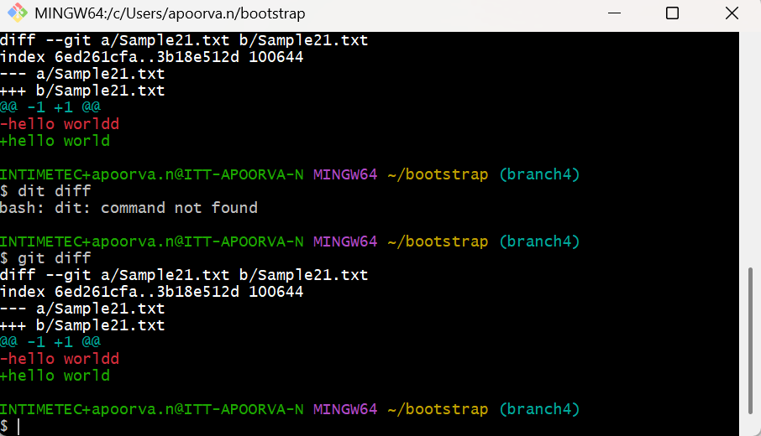

git amend: is used to modify the last commit.

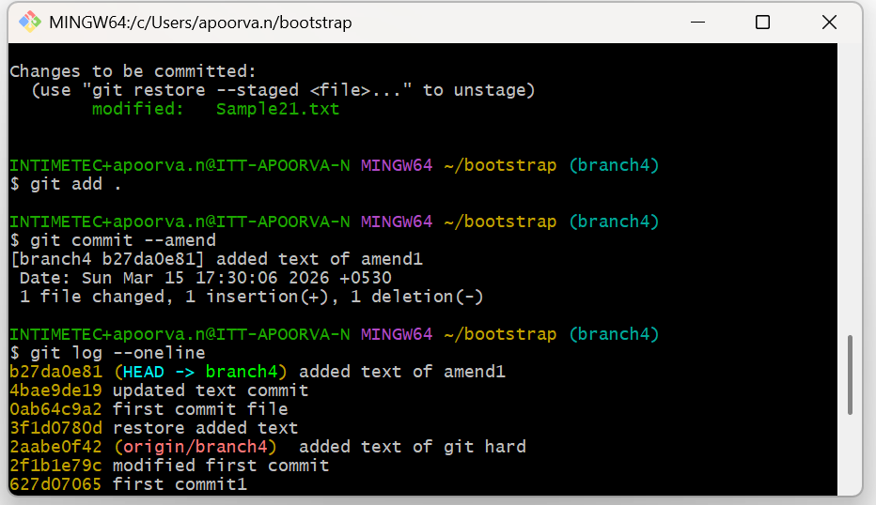

git cherry-pick: commit copy between branches (local).

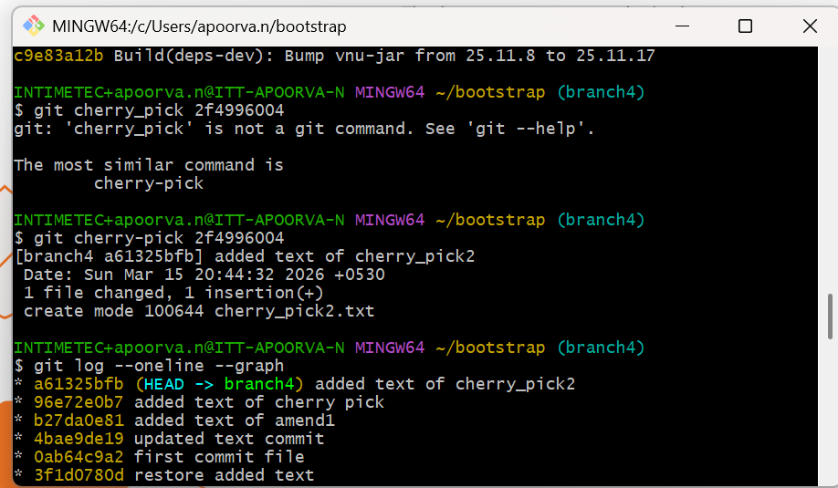

rebasing: means moving your branch commits on top of another branch to maintain a clean commit history.

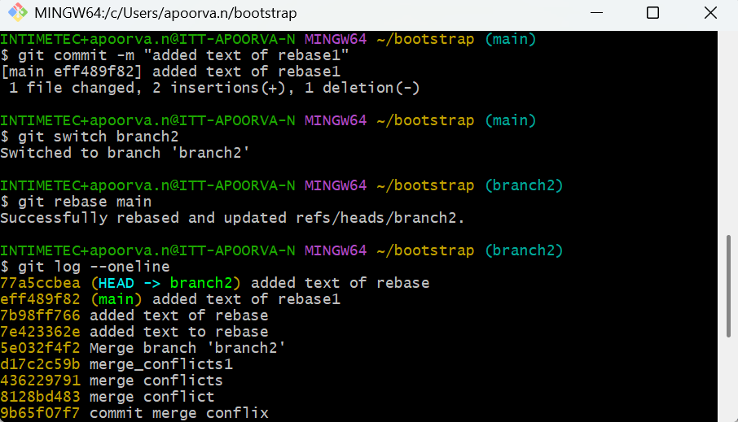

git tag: marking a specific commit with a label (tag) so it’s easy to find later.

