Git Assessment Practice:

Git commands:

git fork: is a copy of someone else’s repository that lives under your own account.

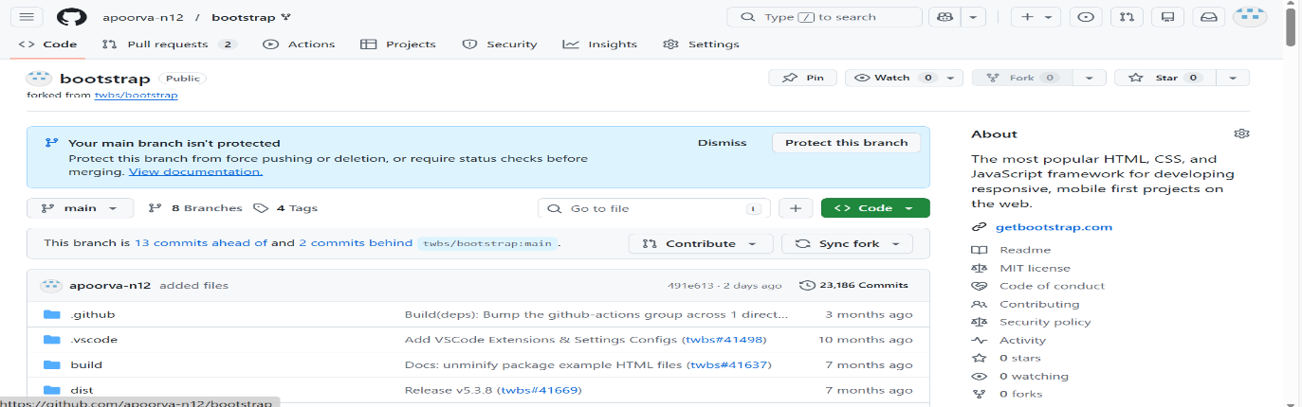

git clone: is a command used to download a repository from a remote server

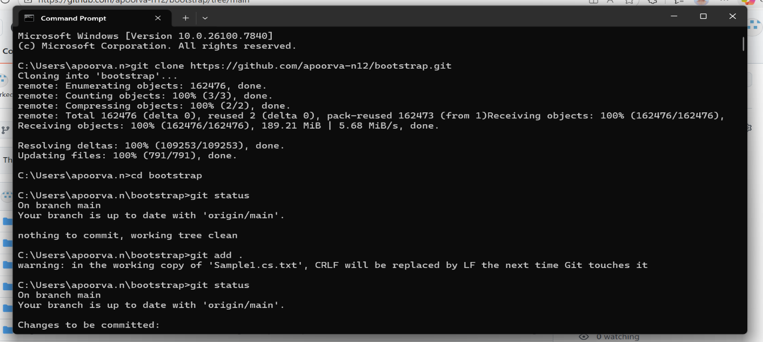

Branch Creation and check out to different branch: Branch creation in Git means creating a separate line of development from the main codebase. This lets you work on features or fixes without affecting the main branch.

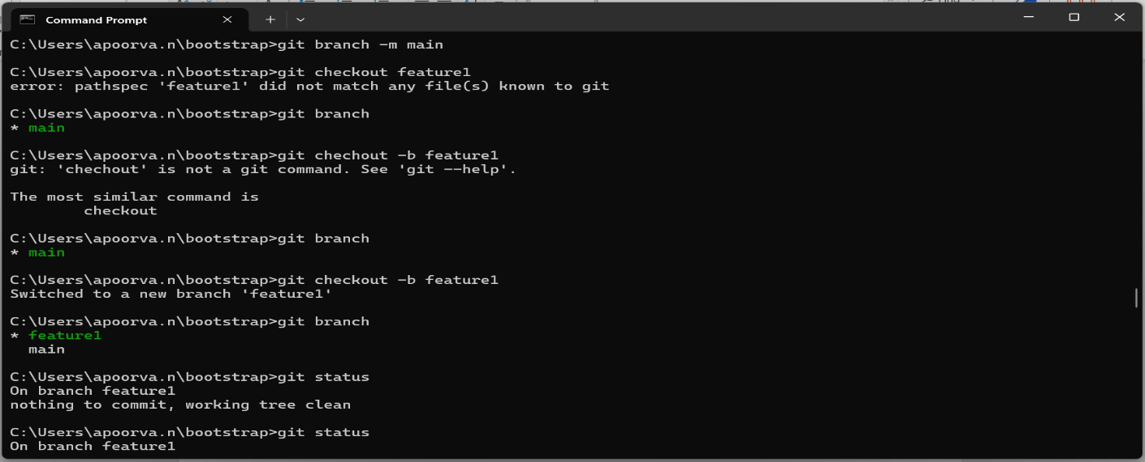

git add . :Stage all changed files.

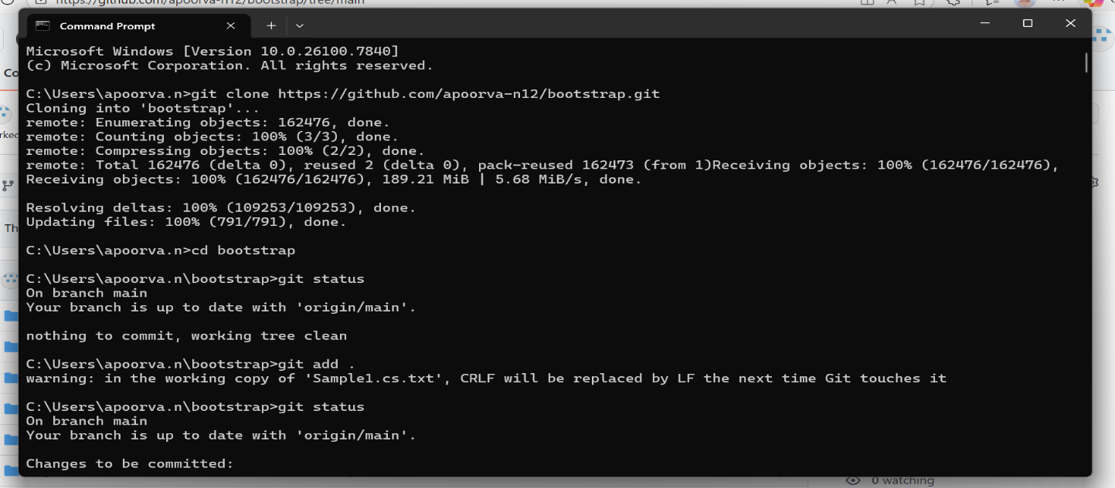

git commit: It records changes to tracked files.

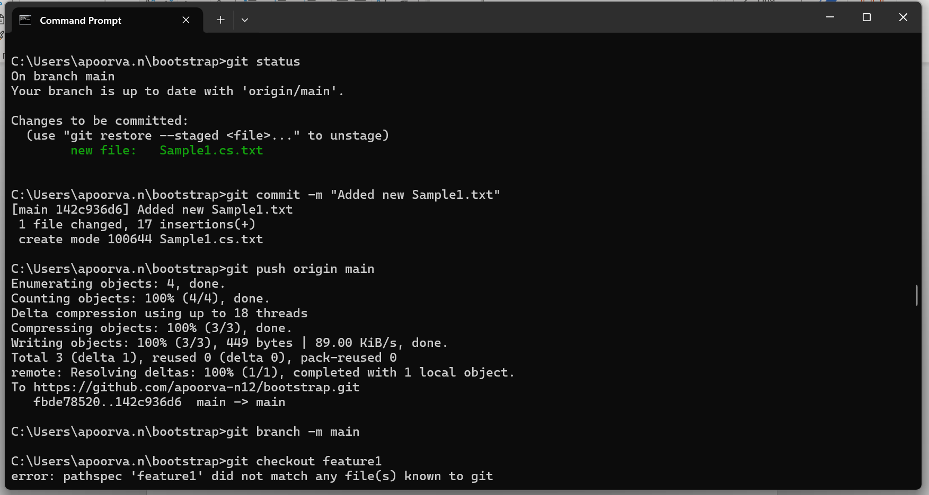

git pull: used to fetch the latest changes from the remote repository and merge them into the local branch.

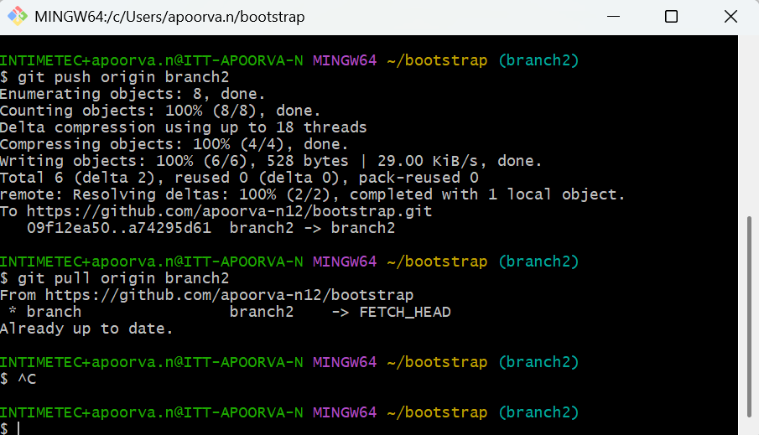

git stash: temporarily save the uncommitted changes.

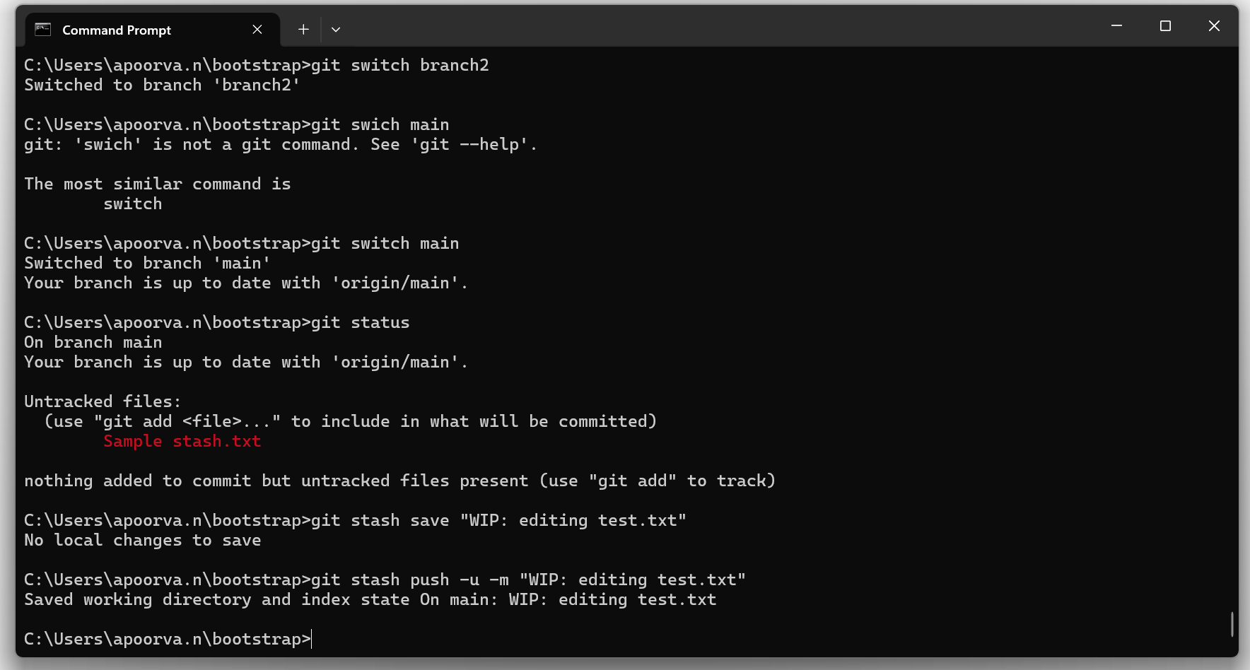

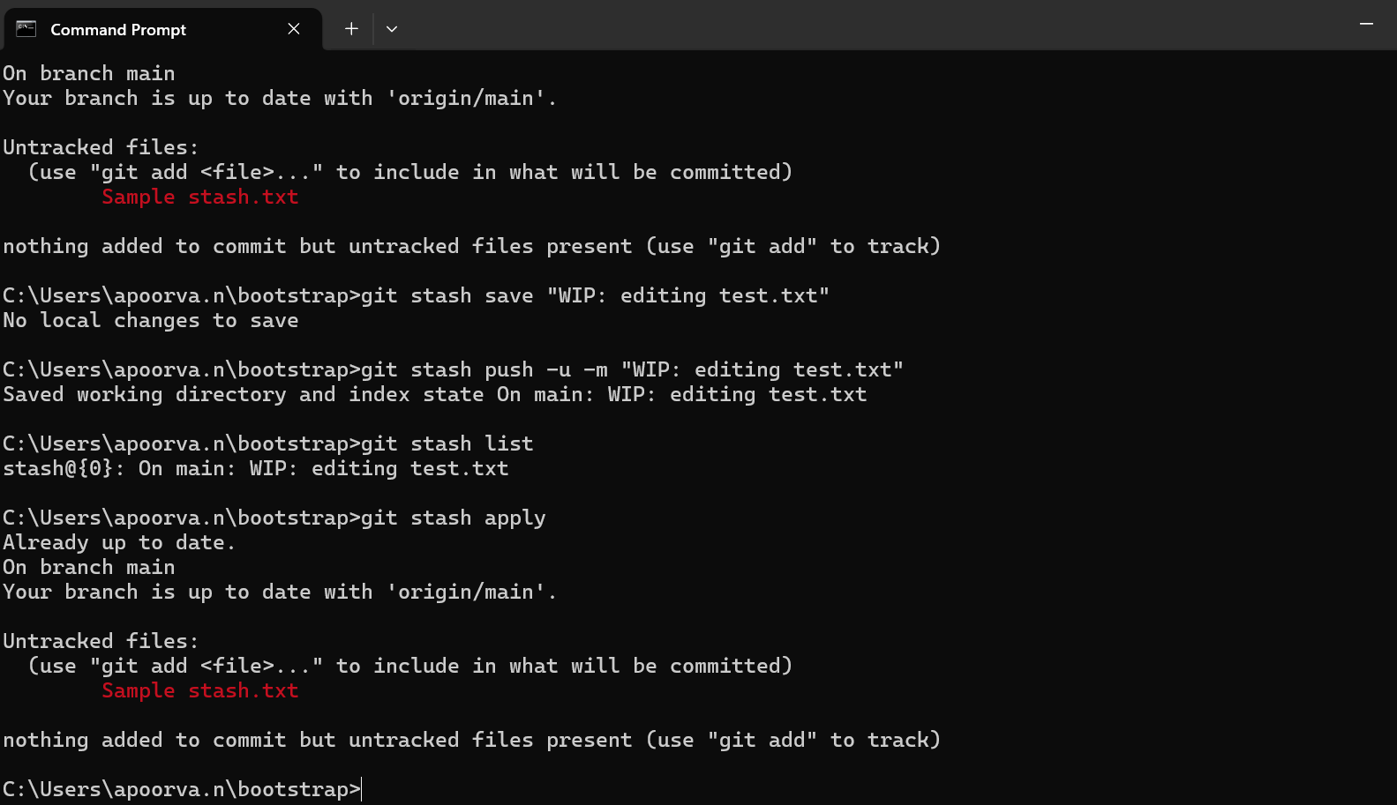

git merging:

three way merge: integrates changes from another branch into the current branch.

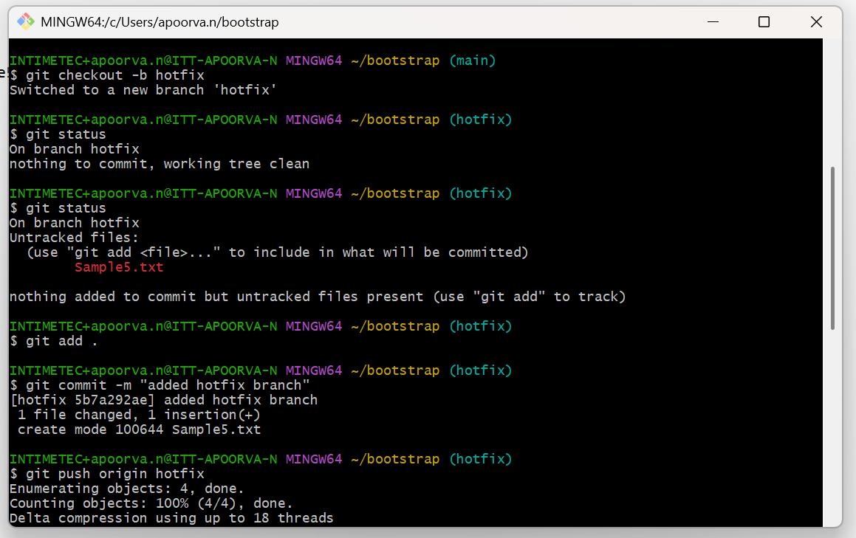

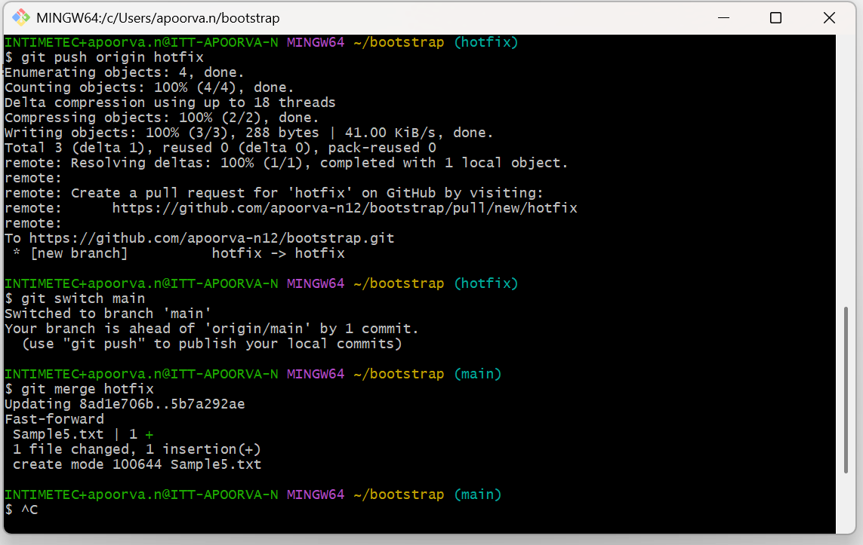

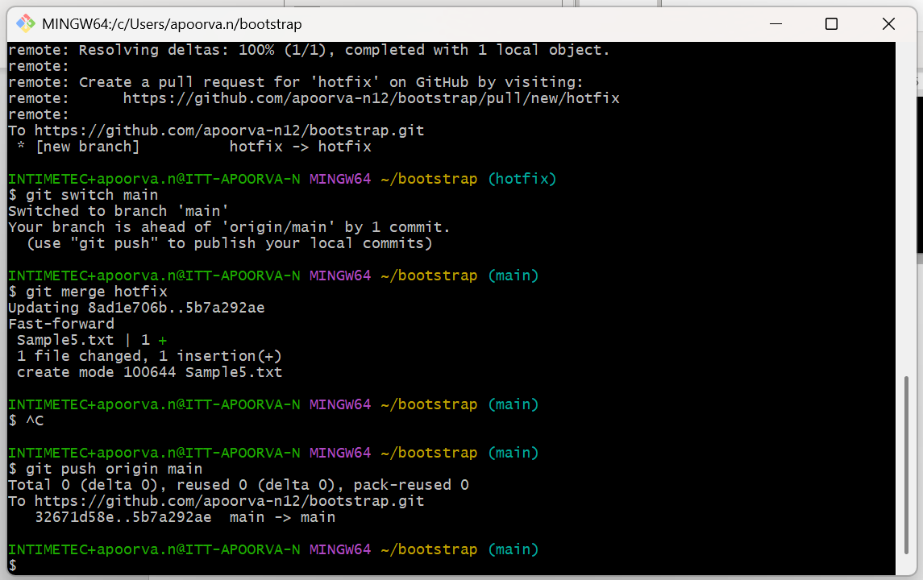

Fast Forword merge: Main branch has not changed since you created another branch.

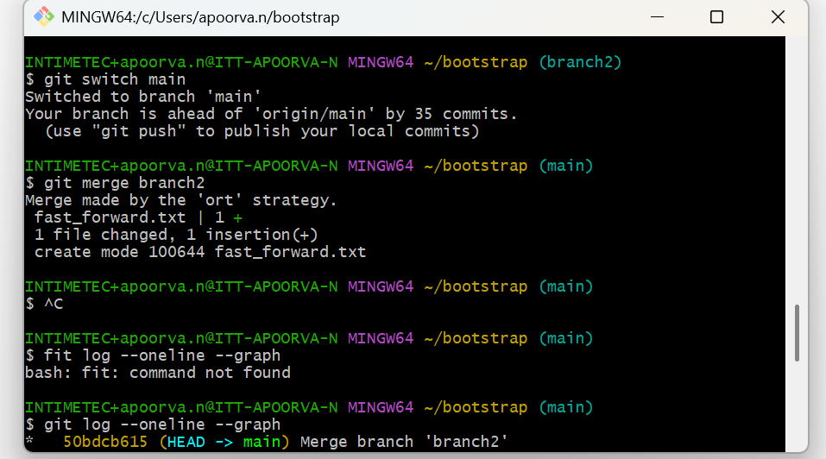

Merge conflict: Git happens when two branches change the same part of a file, and Git cannot automatically decide which change to keep.

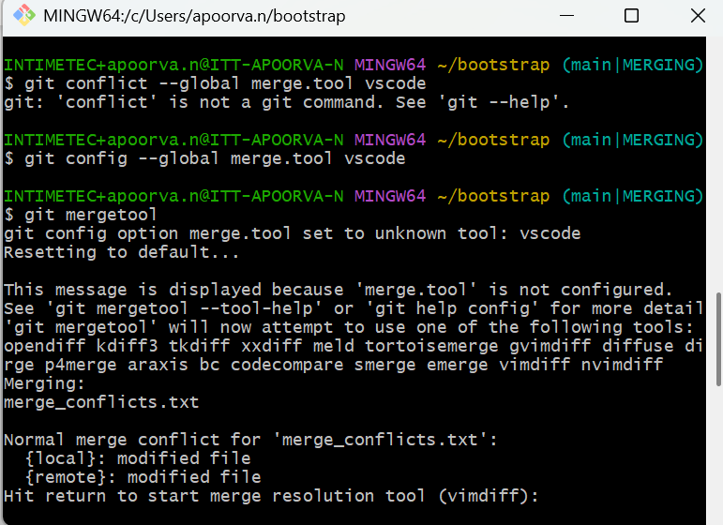

git cherry-pick: commit copy between branches (local).

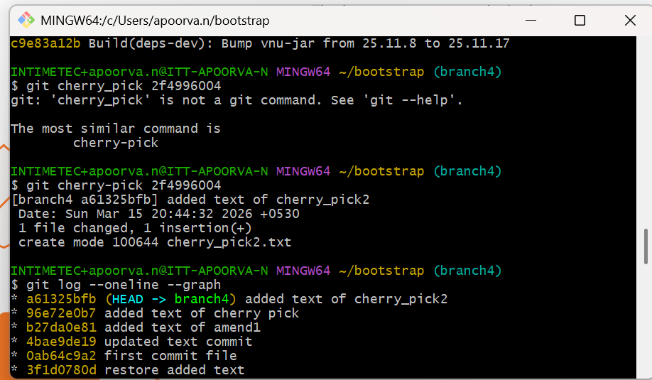

rebasing: means moving your branch commits on top of another branch to maintain a clean commit history.

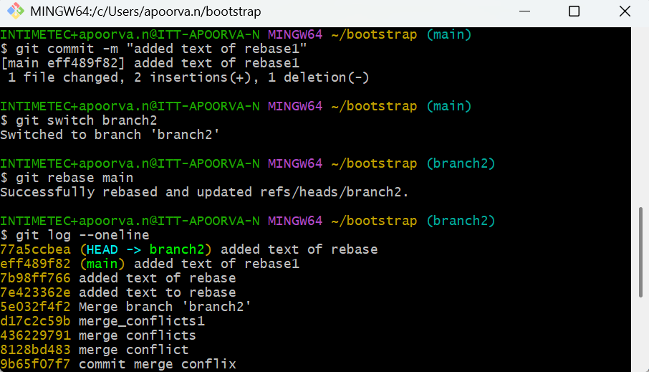

git tag: marking a specific commit with a label (tag) so it’s easy to find later.

