Netflix Movies and TV Shows Analysis

1. Project Overview
This project analyzes the Netflix Movies and TV Shows dataset to identify patterns and trends in content type, release year, genres, countries, ratings, movie duration, TV show seasons, and content added to Netflix.
The project includes data cleaning, exploratory data analysis, data visualization, sentiment analysis, key insights, recommendations, and an interactive dashboard.

1.1 Problem Statement
Netflix contains a large collection of movies and TV shows from different countries, genres, and release years. Analyzing this data can help identify content trends, popular categories, ratings, and other useful patterns.

1.2 Objectives
- Analyze Netflix movies and TV shows.
- Clean and prepare the dataset.
- Identify important content trends and patterns.
- Create meaningful visualizations.
- Perform sentiment analysis on content descriptions.
- Develop an interactive dashboard directly inside Google Colab.
- Provide data-based insights and recommendations.

2. Dataset Description
The project uses the Netflix Movies and TV Shows dataset.
- Dataset Name: Netflix Movies and TV Shows
- Number of Records: 8,807
- Number of Columns: 12
- File Name: netflix_titles.csv
- Dataset Source: https://zenodo.org/records/13925131
Main Columns: show_id, type, title, director, cast, country, date_added, release_year, rating, duration, listed_in, description.

3. Technologies Used
- Python
- Google Colab
- Pandas
- NumPy
- Matplotlib
- Seaborn
- Plotly
- IPywidgets
- TextBlob
These tools were used for data loading, cleaning, analysis, visualization, sentiment analysis, and interactive dashboard development.

4. Methodology
- Dataset loading
- Data understanding
- Missing-value analysis
- Duplicate-value analysis
- Data cleaning
- Data type conversion
- Exploratory data analysis
- Data visualization
- Sentiment analysis
- Interactive dashboard development
- Insight generation
- Recommendations
- Conclusion

5. Data Loading and Understanding
The Netflix dataset was loaded into a Pandas DataFrame using Python. The initial dataset contains 8,807 rows and 12 columns. The dataset was examined using head(), shape, info(), isnull().sum(), and duplicated().sum().
The dataset contains information about content type, title, director, cast, country, date added, release year, rating, duration, genre, and description.
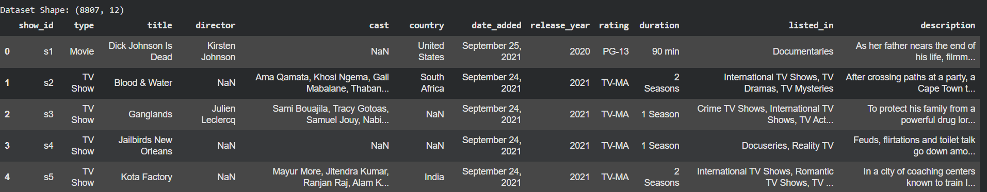
Figure 1: Dataset Preview

6. Data Cleaning

6.1 Missing Values
Missing values were identified in the director, cast, country, date_added, rating, and duration columns. Missing categorical values were replaced with meaningful labels such as Not Available and Not Rated.

6.2 Duplicate Records
Duplicate records were checked and removed where necessary. The final dataset contained 0 missing values and 0 duplicate records.

6.3 Date Conversion
The date_added column was converted into a datetime format for analysis. Invalid or unavailable dates were handled appropriately during the conversion process.

6.4 Final Dataset
After cleaning, the dataset retained 8,807 rows and 12 columns.
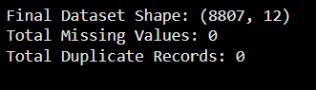
Figure 2: Final Data Cleaning Check

7. Exploratory Data Analysis

7.1 Movies vs TV Shows
The dataset contains 6,131 Movies and 2,676 TV Shows. Movies form the larger portion of the Netflix dataset.
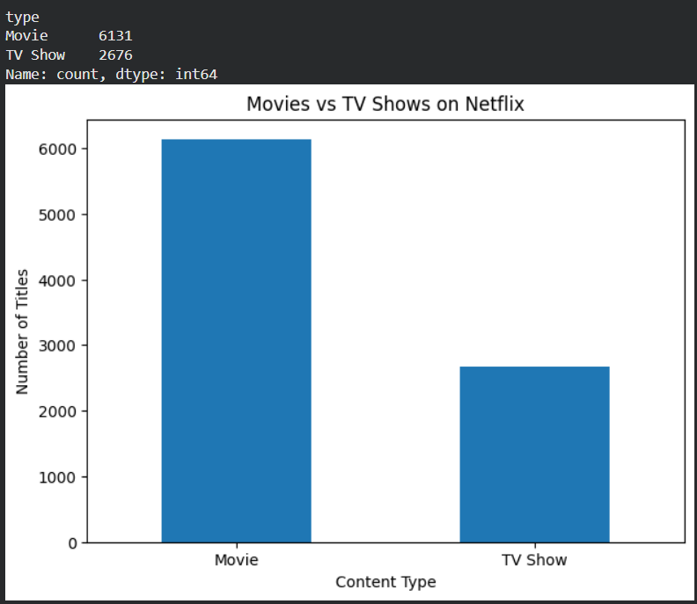
Figure 3: Movies vs TV Shows

7.2 Content by Release Year
The release year distribution was analyzed to understand how Netflix content is distributed across different years. Visualization was created to identify changes and trends in the number of movies and TV shows released over time.
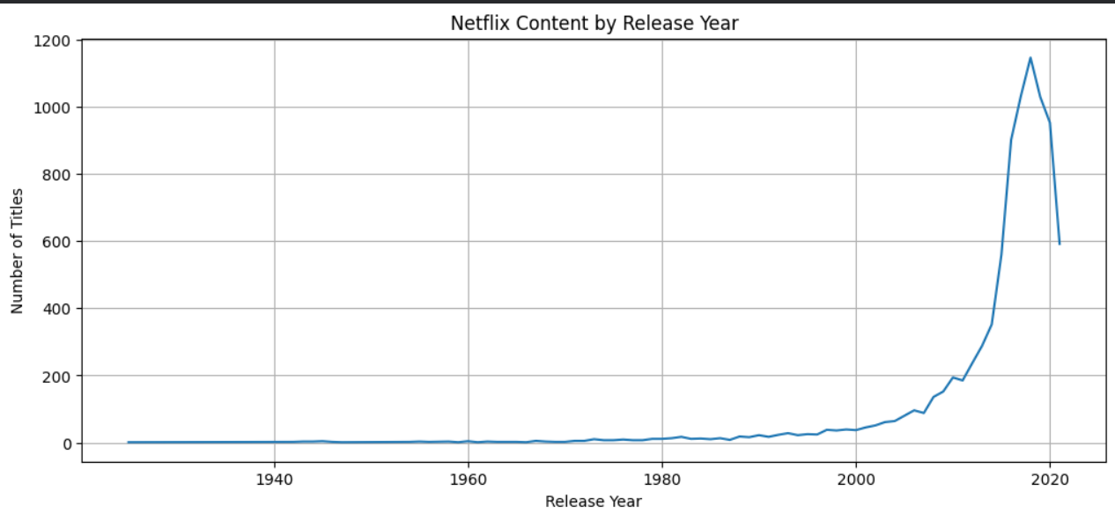
Figure 4: Content by Release Year

7.3 Content Added to Netflix Over Time
The date_added column was analyzed to understand how content was added to Netflix across different periods.
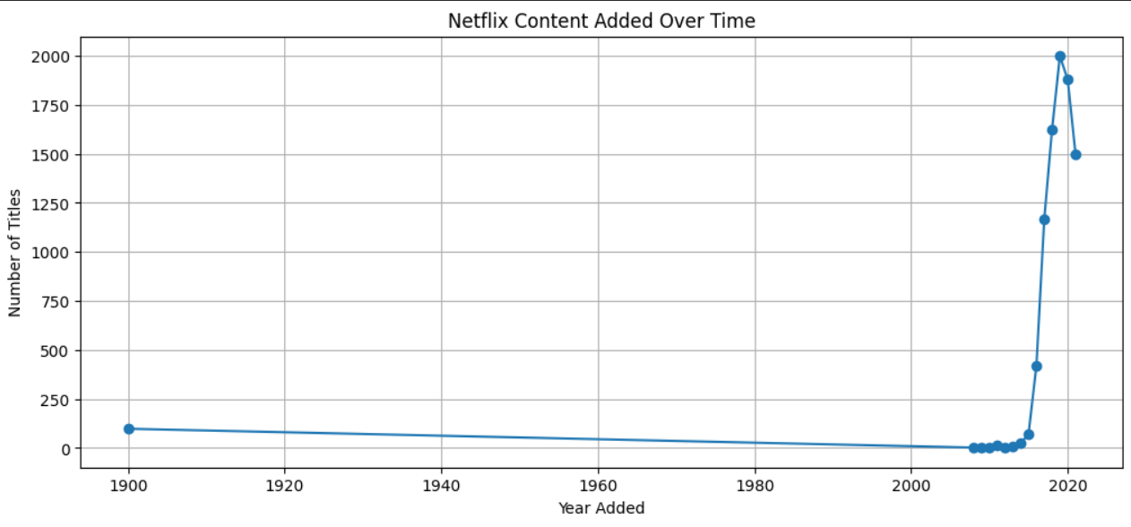
Figure 5: Content Added to Netflix Over Time

7.4 Top Countries
The leading identified countries by number of titles include: United States (3,690), India (1,046), United Kingdom (806), Canada (445), France (393), Japan (318), Spain (232), South Korea (231), and Germany (226). Not Available entries were treated separately.
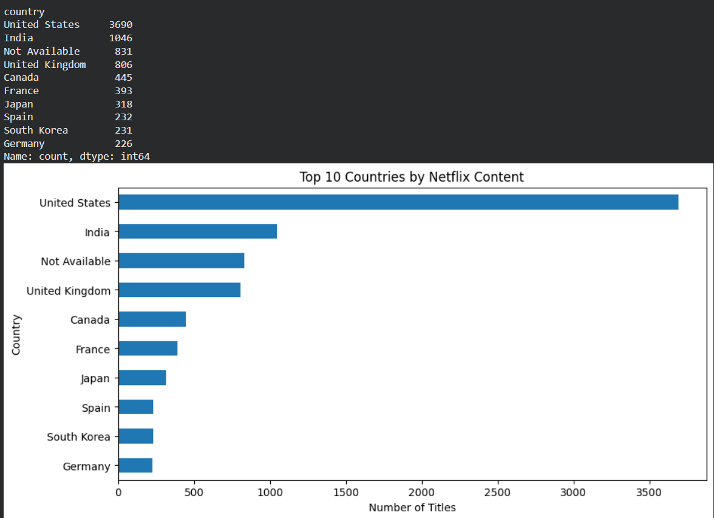
Figure 6: Top Countries

7.5 Top Genres
The most common genres/categories include International Movies (2,752), Dramas (2,427), Comedies (1,674), International TV Shows (1,351), Documentaries (869), Action & Adventure (859), TV Dramas (763), Independent Movies (756), Children & Family Movies (641), and Romantic Movies (616).
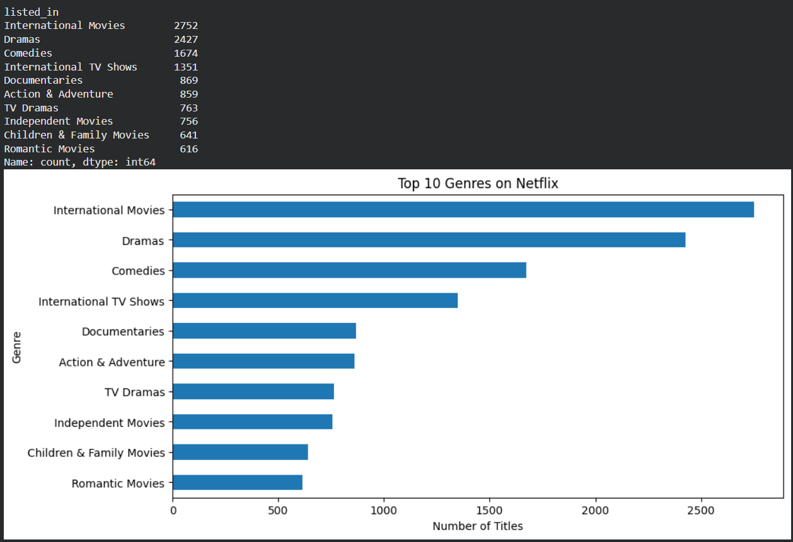
Figure 7: Top Genres

7.6 Ratings Distribution
The most common ratings include TV-MA (3,207), TV-14 (2,160), TV-PG (863), R (799), PG-13 (490), TV-Y7 (334), TV-Y (307), PG (287), TV-G (220), and NR (80).
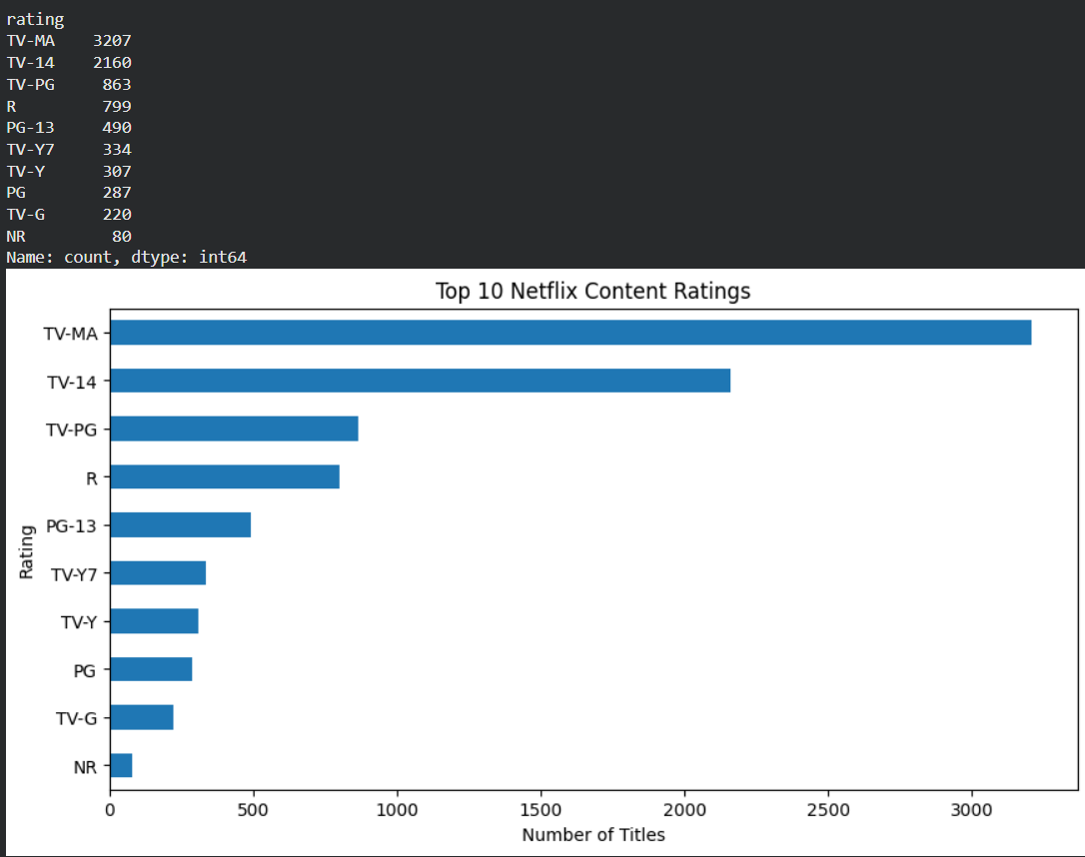
Figure 8: Ratings Distribution

7.7 Movie Duration
The average movie duration is approximately 99.58 minutes, with a median of 98 minutes. The minimum duration is 3 minutes and the maximum is 312 minutes.
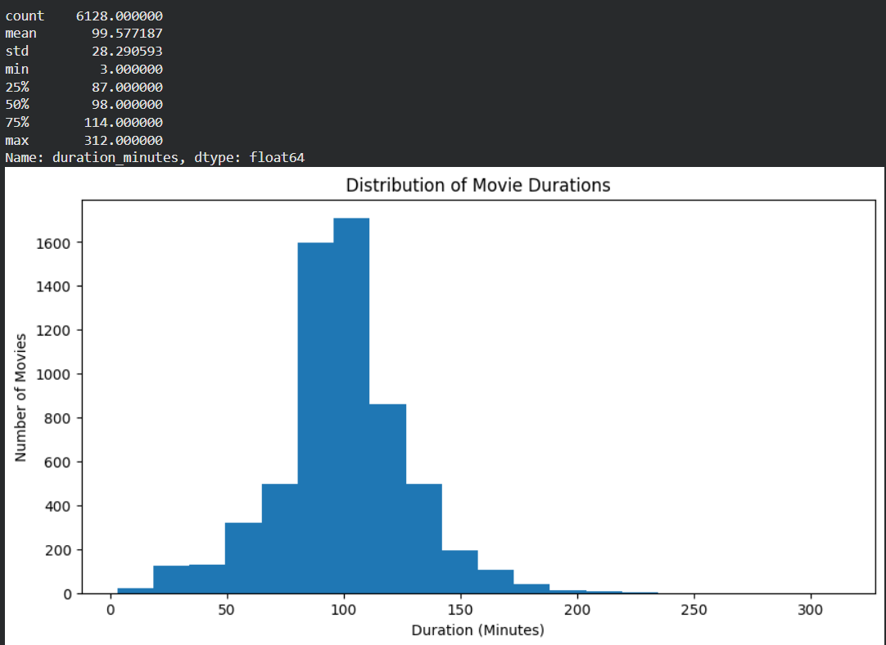
Figure 9: Movie Duration

7.8 TV Show Seasons
The average number of TV show seasons is approximately 1.76. The median is 1 season, with a minimum of 1 and a maximum of 17 seasons.
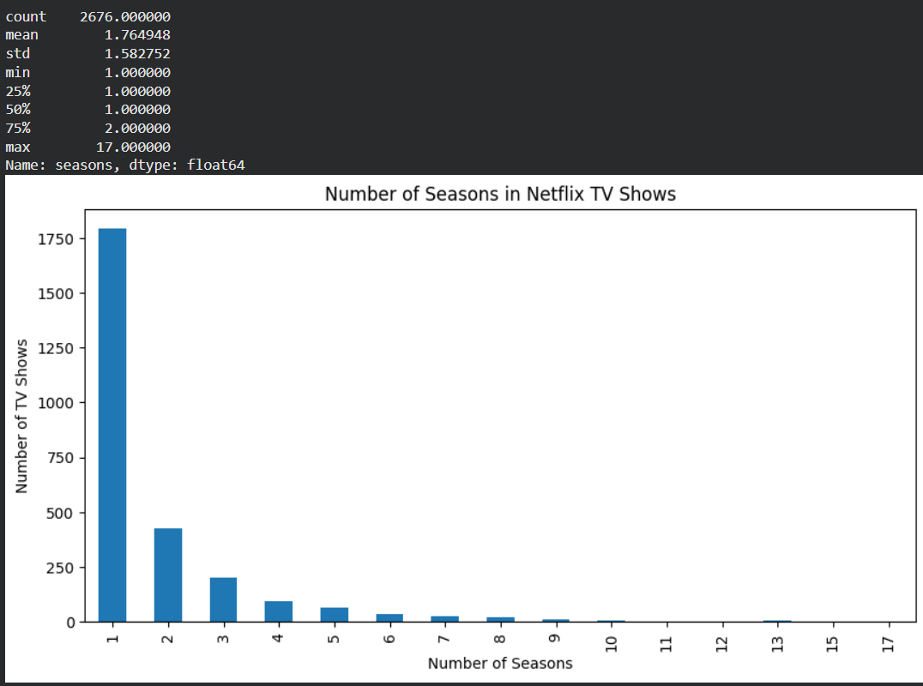
Figure 10: TV Show Seasons

8. Sentiment Analysis
Sentiment analysis was performed on Netflix title descriptions using the TextBlob library.

8.1 Sentiment Classification
Each description was assigned a polarity score. Polarity greater than 0 was classified as Positive, polarity less than 0 as Negative, and polarity equal to 0 as Neutral.

8.2 Sentiment Results
Positive: 4,547 titles. Negative: 2,662 titles. Neutral: 1,598 titles.
This sentiment analysis reflects the wording and tone of the descriptions, not audience satisfaction or viewer ratings.
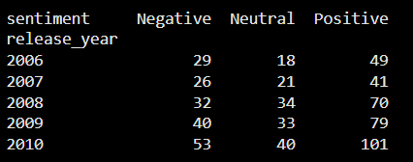
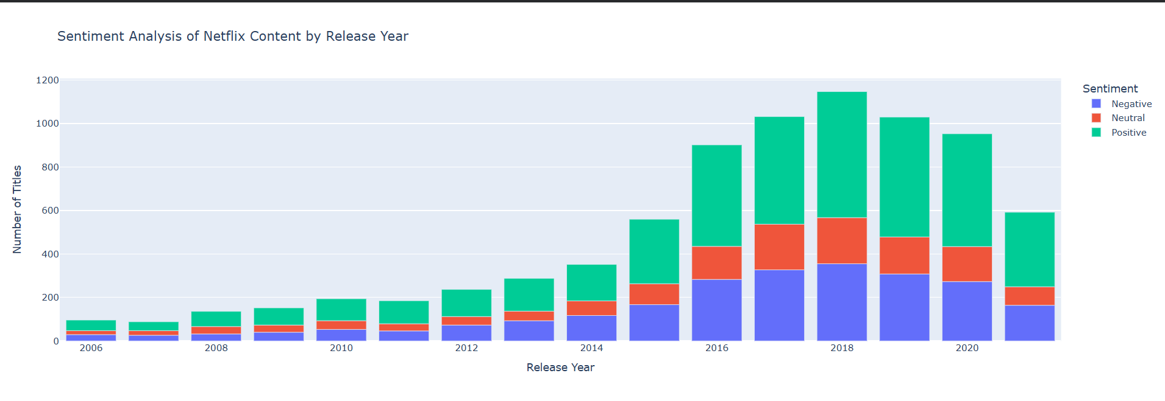
Figure 11: Sentiment Analysis

9. Interactive Dashboard
An interactive dashboard was developed directly inside Google Colab using Python, Matplotlib, and IPywidgets. The dashboard allows users to filter Netflix content and explore key statistics and visualizations.

9.1 Interactive Filters
The dashboard provides filters for Content Type, Release Year, and Rating.

9.2 KPI Summary
The dashboard displays Total Titles, Movies, and TV Shows, and calculates the average movie duration based on the selected filters.

9.3 Interactive Charts
The dashboard contains visualizations for Movies vs TV Shows, Content by Release Year, and Top Ratings. The charts update according to the selected filters.

9.4 Dashboard Testing
The dashboard was tested by changing filter values and checking whether the displayed statistics and charts updated according to the selected conditions. The dashboard runs directly inside Google Colab without requiring an external server or deployment platform.
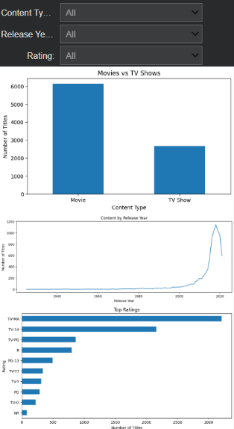
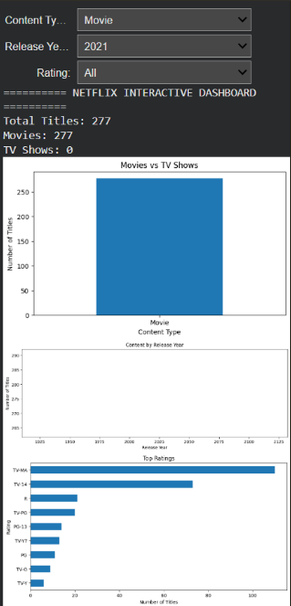
Figure 12: Interactive Netflix Dashboard

10. Key Insights

10.1 Content Insights
- The dataset contains 8,807 Netflix titles.
- Movies account for 6,131 titles.
- TV Shows account for 2,676 titles.
- Movies represent the larger content category in the dataset.

10.2 Genre Insights
- International Movies are the most frequently represented category.
- Dramas and Comedies are also highly represented.
- International TV Shows form another major category.

10.3 Country Insights
- The United States has the largest number of identified titles.
- India is the second-largest identified country in the dataset.
- The United Kingdom and Canada are also strongly represented.

10.4 Rating Insights
- TV-MA is the most common rating.
- TV-14 is the second most common rating.
- The dataset contains content covering several different audience rating categories.

10.5 Sentiment Insights
- Positive descriptions are the largest sentiment category.
- Negative and neutral descriptions also form significant portions of the dataset.
- Sentiment analysis provides information about the wording of descriptions rather than actual audience reactions.

11. Recommendations

11.1 Content Strategy Recommendations
Netflix content analysis can be used to monitor the balance between movies and TV shows and identify categories with high representation.

11.2 Genre and Market Recommendations
Frequently occurring genres and countries can be monitored to understand the distribution of content across different markets and categories.

11.3 Data-Based Recommendations
Interactive dashboards can be used to explore content trends using filters such as content type, release year, and rating. Sentiment analysis can also be used as an additional descriptive feature when studying the language used in content descriptions.

12. Conclusion
This project analyzed the Netflix Movies and TV Shows dataset using Python-based data analytics techniques. The project covered data loading, data understanding, data cleaning, exploratory data analysis, visualization, sentiment analysis, and interactive dashboard development.
The analysis identified important patterns related to content type, genres, countries, ratings, movie duration, TV show seasons, and description sentiment.
An interactive dashboard was also developed inside Google Colab, allowing users to filter the dataset and explore the results dynamically.
Overall, the project demonstrates the application of Python, Pandas, NumPy, Matplotlib, Seaborn, Plotly, IPywidgets, and TextBlob for practical data analytics.

13. Project Files and Submission
The final project submission includes the Jupyter Notebook (.ipynb), Python requirements file (requirements.txt), README file (README.md), Project Report (.docx), dataset (netflix_titles.csv), and GitHub Repository.
The Jupyter Notebook contains the complete analysis, visualizations, sentiment analysis, and interactive dashboard.

14. References
- Netflix Movies and TV Shows Dataset — https://zenodo.org/records/13925131
- Pandas Documentation — https://pandas.pydata.org/docs/
- NumPy Documentation — https://numpy.org/doc/
- Matplotlib Documentation — https://matplotlib.org/stable/
- Seaborn Documentation — https://seaborn.pydata.org/
- Plotly Documentation — https://plotly.com/python/
- IPywidgets Documentation — https://ipywidgets.readthedocs.io/
- TextBlob Documentation — https://textblob.readthedocs.io/

