**A PROJECT REPORT**

**ON**

**RESUME BUILDER APPLICATION**



A Project Report

Submitted to the Rajasthan Technical University,Kota

In partial fulfillment of the requirement for the degree of B.TECH

Submitted to: Submitted By:

Mr. Pankaj Dhadeech Aditi Gupta(12ESKCS006) Apoorva Jain(12ESKCS019)

Kanika Bakshi(12ESKCS059)

Kratika Jain(12ESKCS061)

Department of Computer Science

Swami Keshavanand Institute of Technology,

Management &Gramothan,Jaipur

**ACKNOWLEDGMENT**

The ability to help and patience to exercise diligence and provide support is a quality admonished by very few. Any job in this would however trivial or tough can not be accomplished without the assistance of the others. We would thereby take the opportunity to express our indebtedness to people who have helped us to accomplish this task. The present line of accomplishment is not a formality but an honest word of appreciation that has exactly been felt by during our training.

We would like to thanks **Mr. Pankaj Dhadeech** and **Mr.Saurabh Ranjan Srivastava** for providing support and the opportunity to work in this organization.Last but not least we would like to thanks all “SKIT” faculty who have directly or indirectly helped and cooperated in accomplishing this project.

**PREFACE**

The project report is submitted for the partial fulfillment of **Bachelor Of Technology** degree from **Rajasthan Technical University**, Kota Rajasthan.

This project report has been prepared as per the requirement of the syllabus of B.Tech VII semester course structure under which the students are required to undertake the training.

It was a great experience for us because we were exposed to the software sector and facing the Software Development strategies.

Now we take the opportunity to present the project report and sincerely hope that it will be as much knowledge enhancing to the readers as it was to use during the development work and the compilation of the report.

**TABLE OF CONTENTS**

|  |  |  |
| --- | --- | --- |
| **S No.** | **Topic** | **Page No.** |
| 1. | Introduction | 6 |
| 2. | Tools and technologies used  2.1 Java Server Pages  2.2 Java  2.3 MYSQL  2.4 Apache server  2.5 Eclipse  2.6 Java Script  2.7 Creately Tool | 6-8 |
| 3. | System Requirements | 9 |
| 4. | Project Description | 10 |
| 5. | System Analysis | 11 |
| 6. | System Design  6.1 Design goals  6.2 Use case model  6.3 ER Diagram  6.4 Class Diagram | 12-15 |
| 7. | Snapshots | 16-19 |
| 8. | Bibliography and References | 20 |

1. **Introduction**

This application is used for automating the process or resume writing. This would be facilitating the employees to make and print their resumes in a proper format. In addition , it will be facilitating the higher management to search the employees depending upon their skills sets and other attributes. The basic requirement is to have a centralized repository of all the skill holders in the organization so that an employee with a particular skill set can be immediately found in case of urgent requirement.

**2. Tools and technologies Used**

* FRONT END-Java
* BACK END-My SQL
* SERVER-Apache Server
* BROWSER-Google Chrome
* OS-Windows 7/8

**2.1 JSP**

* Java Server Pages (JSP) is a server-side programming technology that enables the creation of dynamic, platform-independent method for building Web-based applications.
* The JSP pages are easier to maintain than servlet because we can separate designing and development.
* A JSP container works with the Web server to provide the runtime environment and other services a JSP needs.

**2.3 Java**

* Java is a general purpose, [high-level programming language](http://www.webopedia.com/TERM/H/high_level_language.html) developed by [Sun Microsystems](http://www.webopedia.com/TERM/S/Sun_Microsystems.html)

* Java was originally called OAK, and was designed for handheld devices and set-top boxes.

**2.3 MySQL**

* MySQL handles a large subset of the functionality of the most expensive and powerful database packages.
* MySQL is customizable. The open-source GPL license allows programmers to modify the MySQL software to fit their own specific environments.

**2.4 Apache Server**

* It is an open source web server developed by apache group
* Apache is the servlet container that is used in implementation for the java servlet and java server pages technologies
* Web servers like Apache tomcat support only web components
* To develop a web application with jsp/servlet installs any web server like JRun, Tomcat etc. to run your application.

**2.5 Eclipse**

* **Java Eclipse is an open source project that brings together programmers of many different languages**
* Via a Java plugin system, it allows programmers in various languages such as Java, C, C + +, Perl, Python, PHP to collaborate with the minimum of difficulty.
* **Eclipse is a powerful cross platform development tool based on Java.**
  1. **Creately**
* **Creatly is a tool which is used to develop UML diagrams.**

**3. System Requirements**

3.1 **Hardware Requirements:**

* Intel i3 processor
* 1 GB RAM or higher
* 100 GB HDD or higher

3**.**2 **Software Requirements**:

* Microsoft Windows-8/7
* Database-MySQL
* Backend-Apache Tomcat Server
* Browser-Mozilla/Chrome

1. **Project Description**

|  |
| --- |
| It is an application that simplifies the task of creating a resume for individuals. The system is flexible to be used and reduces the need of thinking and designing an appropriate resume according to qualifications. The system is developed to provide an easy means for creating a professional looking resume. Individuals just have to fill up a form that specifies questions from all required fields such as personal questions, educational, qualities, interest, skills and so on. The answers provided by the users are stored and the system automatically generates a well structured resume. Users have option to create resume in any format and file. |
|  |

**ADVANTAGES**

* Provides instant resume to individuals.
* There are choices available for resume format for users as per their qualification and requirements.
* Reduces tedious work in thinking and creating resume and is convenient for users.
* Provides quick access and is affordable.
* The system saves time and reduces human efforts.

**DISADVANTAGES**

* Sometime user wants customized resume that is not possible in the system.

**5. System Analysis**

Before we begin a new system it is important to study the present system that will be improved or replaced. We need to analyze how this system uses hardware, software etc. In this present age of competition our resume need to be prepared and updated according to the changing requirements of industry. The present system for resume building just provides wizard through which one can prepare resume only in given format.

**Disadvantages of Present System**

* Inability of modification of data · Provides fixed format of resume ·
* Lack of immediate retrieval
* Inability of sharing the resume data ·
* Lack of expert guidance at every step of building resume

**Characteristics of Proposed System**

* Easy to edit and update resume
* Free Resume hosting
* Wide range of resume formats
* Expert guidance at every step of resume building

**6. System Design**

**6.1 Design Goals**

The following goals were kept in mind while designing the system:

* **Make system more secure**: This was necessary so that system could be used more secure and system could act as a catalyst in achieving objectives.
* **Make system more user-friendly**:This was necessary so that system could be used esily by the end users.
* **Make system compatible**:It should fit in every system.Future maintainence and enhancement must be less.It could integrate other modules of system into itself.

**6.2 Use Case Model**

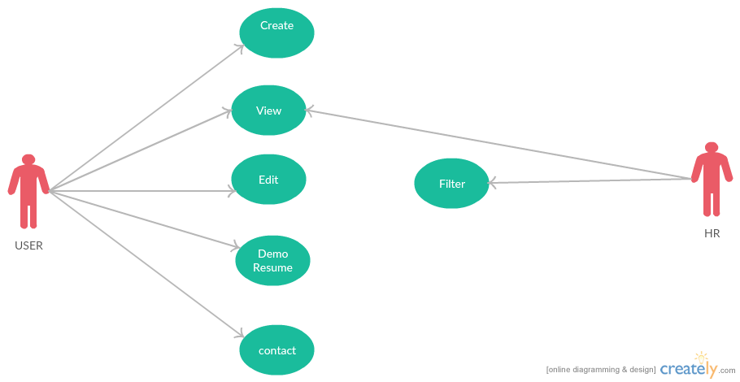

**6.3 ER Diagrams**

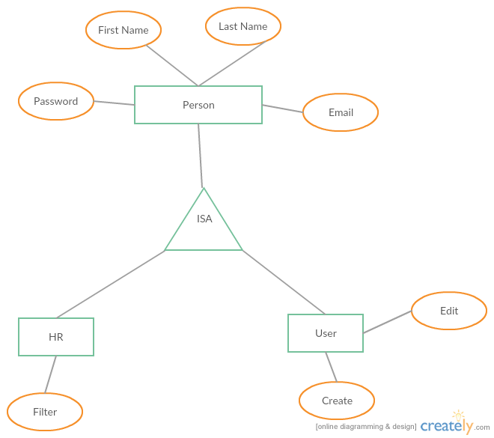

**6.4 Class Diagram**

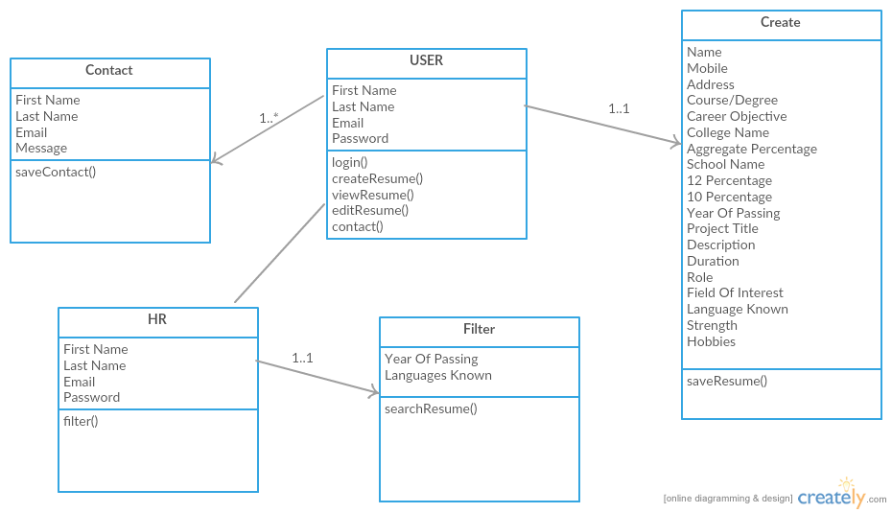

**7. Snapshots**

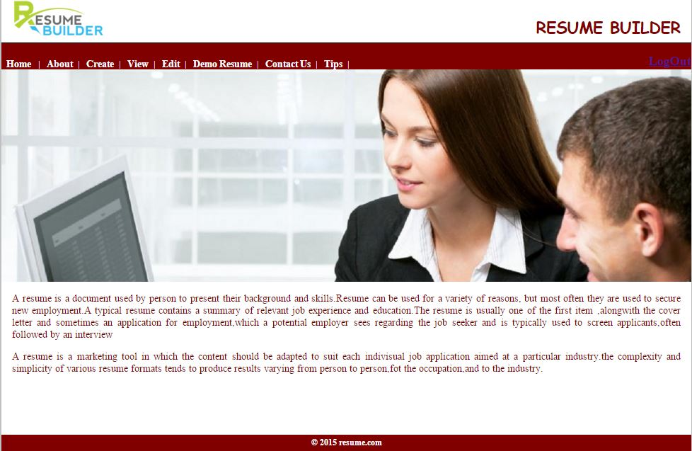

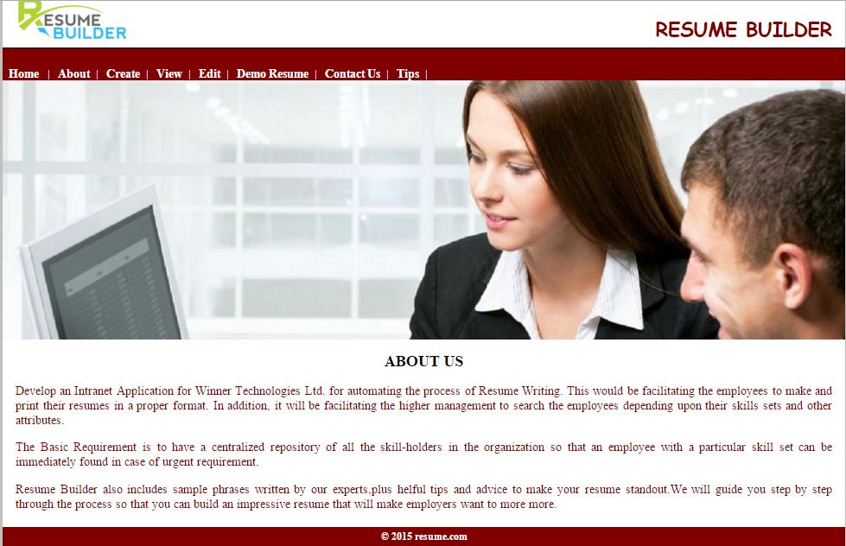

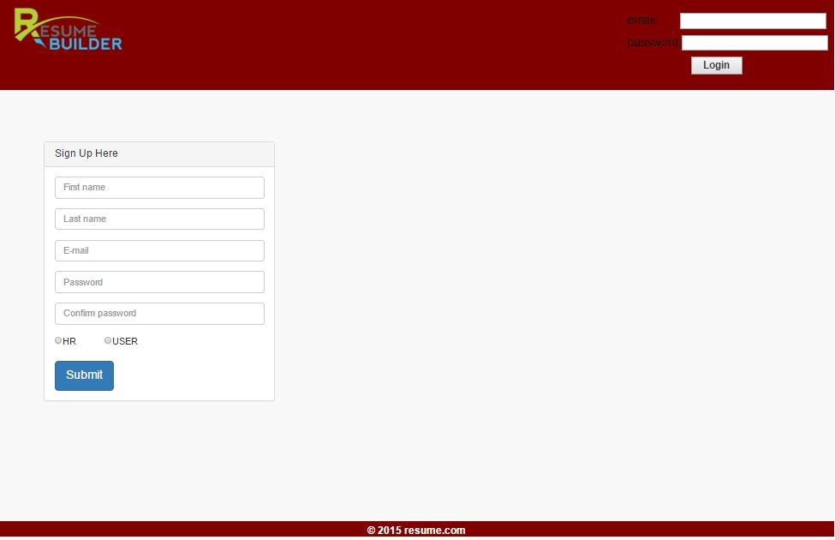

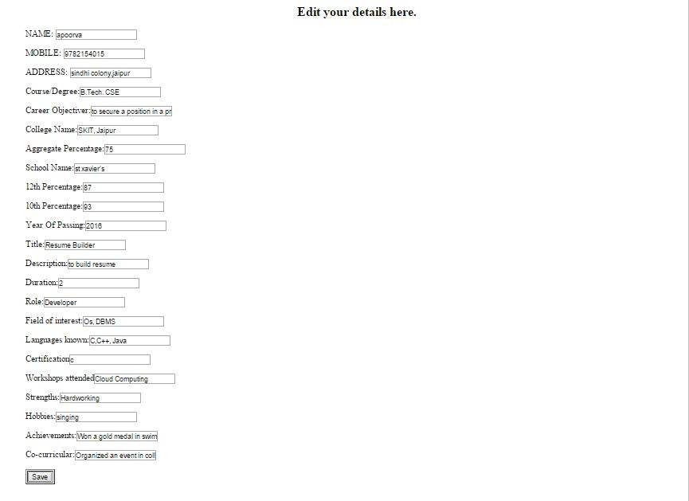

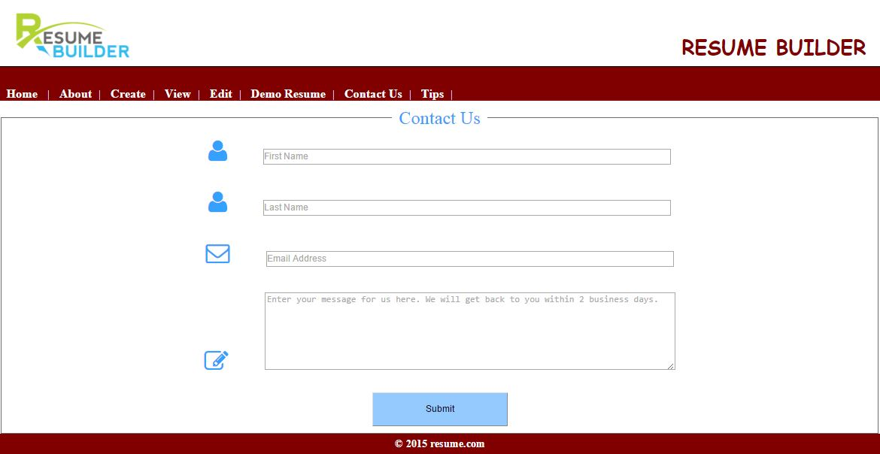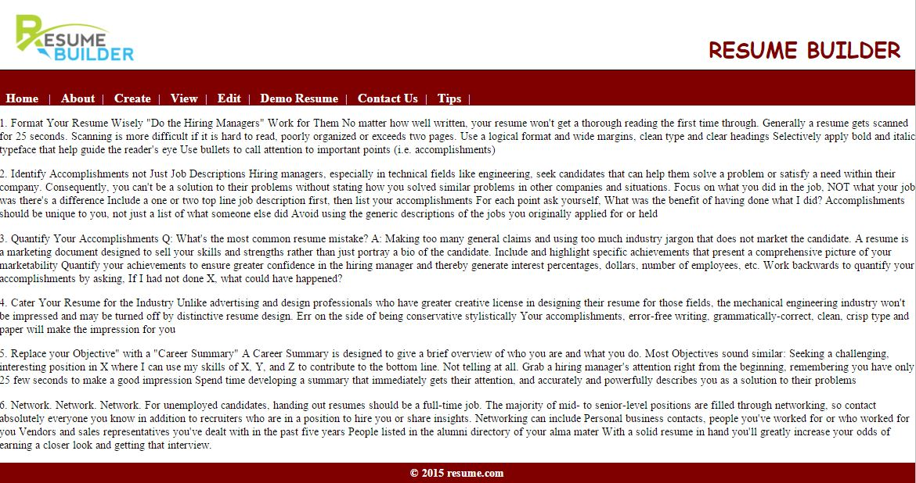

**8 . Bibliography and References**

1. <http://www.functionx.com/sqlserver/> (SQL-server tutorial)
2. http://www.w3schools.com (Many Tutorials Available)

1. <http://www.javatpoint.com>
2. <http://www.vbworld.com>
3. Java server pages, Oreily Publications
4. Database design: Korth