**DAILY ONLINE ACTIVITIES SUMMARY**

|  |  |  |  |  |  |  |  |  |
| --- | --- | --- | --- | --- | --- | --- | --- | --- |
| **Date:** | **16-07-2020** | | | | | **Name:** | **Apoorva H P** | |
| **Sem & Sec** | **6th Sem & A Sec** | | | | | **USN:** | **4AL17CS011** | |
| **Online Test Summary** | | | | | | | | |
| **Subject** | | **-** | | | | | | |
| **Max. Marks** | | **-** | | **Score** | | | **-** | |
| **Certification Course Summary** | | | | | | | | |
| **Course** | **Python data structure** | | | | | | | |
| **Certificate Provider** | | | **Coursera** | | **Duration** | | | **19 hrs** |
| **Coding Challenges** | | | | | | | | |
| **Problem Statement:**  Python Program to Check if binary representation is palindrome. | | | | | | | | |
| **Status: Completed** | | | | | | | | |
| **Uploaded the report in GitHub** | | | | | **yes** | | | |
| **If yes Repository name** | | | | | <https://github.com/ashaapoorva/Online-course-2-July-> | | | |
| **Uploaded the report in slack** | | | | | **yes** | | | |

**Online Certification:**

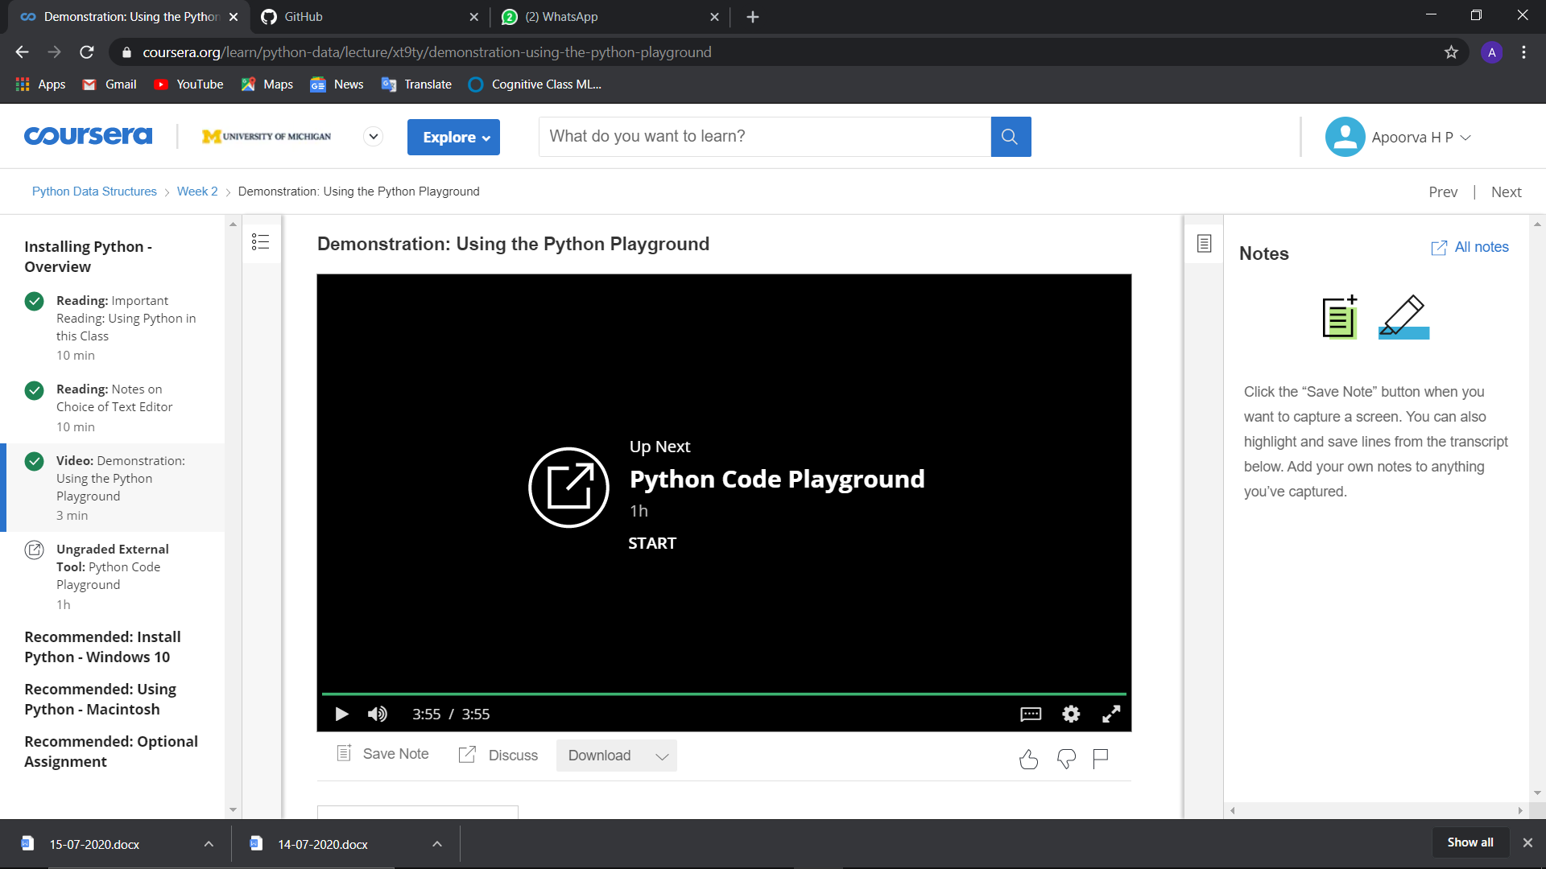

**Online Coding:**

Python Program to Check if binary representation is palindrome.

