**BAN_630_02: OPTIMIZATION METHODS FOR ANALYTICS**

**Project Report**

|  |  |  |  |
| --- | --- | --- | --- |
| **Sr. No.** | **Group Member Name** | **Net ID** | **Email ID** |
| 1 | Apoorva Nerkar | pd7644 | [anerkar@horizon.csueastbay.edu](mailto:anerkar@horizon.csueastbay.edu) |
| 2 | Mansi Mrugen Shah | ws2865 | [mshah41@horizon.csueastbay.edu](mailto:mshah41@horizon.csueastbay.edu) |
| 3 | Shruti Bhalotiya | eg7732 | [sbhalotiya@horizon.csueastbay.edu](mailto:sbhalotiya@horizon.csueastbay.edu) |
| 4 | Shweta Arande | mq3395 | [sarande@horizon.csueastbay.edu](mailto:sarande@horizon.csueastbay.edu) |
| 5 | Vibhuti Vajde | ti6557 | [vvadje@horizon.csueastbay.edu](mailto:vvadje@horizon.csueastbay.edu) |

**Turnaround time & Agents Optimization**

**at California Call Center**

# 

Table of Contents

1. Summary 4
2. Introduction 6
3. Company 6
4. Problem 6
5. Proposed solution 7
6. Main Chapter 8
7. Data Collection 8
8. Data Cleaning 8
9. Data Analysis 9
10. Requirement Gathering 13
11. Optimization Model 1 14
12. Solution Results and Analysis 18
13. Sensitivity Analysis 22
14. *One Way Analysis 22*
15. *Two Way Analysis 25*
16. Optimization Model 2 25
17. Solution Results and Analysis 31
18. Sensitivity Analysis 33
19. *One Way Analysis 33*
20. *Two Way Analysis 34*
21. Conclusion 36
22. APPENDIX 38

# Summary

What is the biggest turn-off when you call the customer service center for seeking support on any issue? For many of us, it is the time required getting to connect to the agents/representative. The line: “Your call is important to us” really does not do any consolation to the customer who is waiting in the line. Customer support is supremely important for any company whether it is a Telecom company, Internet Service Provider, Bank, Insurance company or an E-Commerce Firm.

In this case study, the optimization models represented are for minimizing call turnaround time and minimizing the number of agents in California Call Center and which helps to optimize costs. Accurately forecasting the demand for workforce is a critical issue for California call center success. Understaffing increases customer attrition and over-staffing increases costs. By predicting the number of agents required at any point of time, call centers can optimize workforce and cost. The challenge is to identify peaks and troughs of inbound call volume and to assign agents accordingly. While optimizing the agents we also need to keep in mind Customer satisfaction.

The team successfully analyzed call type patterns in data using Tableau. Clustered the agents into groups according to their skills in handling call types & then based on their shifts, scheduling is performed to get optimal number of agents by assigning respective call type to their groups in each shift.

The team did extensive research to find the average call turnaround time per call type. Microsoft Excel and the Solver add-in are used to complete the optimization for the chosen item. After this, the team used sensitivity analysis to learn more about the model’s constraints and relationships.

We finished with thinking about how this model would be implemented in a production environment at a massive scale. Ultimately this can be done, but not practically using excel. If California Call Center really wants to reduce the call turnaround time by assigning agents in right shifts according to their call types, it needs to spend the resources to develop this solution based on our findings.

# Introduction

## **Company**

California Call Center is an inbound call center to handle customer complaints and grievances. They receive approximately 1000 calls per day. The California Call Center provides several different services:

* Information on and transactions of checking and saving, to bank-customers
* Computer generated voice information (through VRU = Voice Response Unit)
* Information for prospective customers
* Support for the customers (internet customers)

The call center constitutes of:

* 26 agents
* 3 shifts per day (8hours shift)
  + 7am – 3pm
  + 12pm – 8pm
  + 4pm – 12am

## **Problem**

Things get more complex when a customer needs to wait so long till the call center customer representative arrives on the call to attend him/her. The lower the call turnaround time, the more efficient a call center tends to be operating. The same problem California call center was facing i.e. They are experiencing high call turnaround time which results into high call abandon rate (callers hanging up before call reaching the server/agents). Calls were randomly assigned to agents, which led to the problem of high call turnaround time between agents and callers.

Another problem was to schedule group agents in the respective shifts so that no shifts gets too full or remains empty (gets overlapped). Number of agents in each shift needs to be optimized to reduce the cost. If an excess number of agents are employed in a shift, it will eventually lead to higher cost of operation.

## **Proposed solution**

With proper guidance, the potential for a call center is high as they have enough resources. Performance of the call center can be improved by reducing its call turnaround time. This can be achieved by segregating servers(agents) based on the call types (NE, NW, PE, PS, TT) they handle. By grouping the agents and calculating the average turnaround time for each call type by each group, this will help us to implement a solver model to minimize call turnaround time.

Group1 will handle NE, PS, TT. Group 2 will handle NE, PE, PS, TT and Group 3 will handle NE, PE, PS, NW, TT type of calls. Groups that we formed earlier would be useful for scheduling agents in shifts. Number of agents can be optimized by assigning them in the required shifts based on call type they handle. Our intent is to show that the performance of call centers can be improved by employing an optimization approach for this scheduling problem, and at the same time designing efficient solution algorithms for the problem.

# 

# Main Chapter

## **Data Collection**

The California Call Center’s data is available in the company’s data warehouse and can be extracted using Data Extraction Tools. The company also made the data available using direct APIs which allow users to download the data in a .csv format. The raw data from this API has 31599 call records for 1 month. Before data analysis, we wanted to clean the data to have a subset on which Data Analysis can be performed. The steps used for Data Cleaning is explained in the next section.

## **Data Cleaning**

Data cleaning steps are listed below-

**Step 1: Remove all the logs which were not received by the Server (agent)**

* These are those calls where customer called the call center, the call was received by the VRU and entered the queue, but before an agent could answer this call, the call got disconnected (no service was provided)
* After this, we had 26571 logs remaining

**Step 2: Remove all the logs where Customer ID is 0 (Spam calls)**

* These are those calls where customer id cannot be identified. Call Center has marked these calls as Spam Calls
* After this, we had 11289 logs remaining

**Step 3: Remove all the logs where server time is 0**

* These are the calls where as soon as a customer was connected to the server (agent), the call ended. Hence, the total server time is 0 which we cannot use for our analysis
* After this, we had 9735 records

**Step 4: Remove all the logs where VRU time is negative**

* VRU Time is time (in seconds) spent in the VRU (calculated by vru_exit – vru_entry)
* This time cannot be negative hence we assume these are bad records
* After this, we had 9717 records

**Step 5: Remove all the logs where outcome is “Phantom”**

* There are 3 possible outcomes for each phone call:
* AGENT – service
* HANG - hung up
* PHANTOM - a virtual call to be ignored (unclear to us – fortunately, there are only a few of these.)
* After this, we had 9566 records

Performing the 5 steps of data cleaning above, we have narrowed our dataset from ~32K records to ~9.5K records. Next step was to do some Data Analysis on our final dataset.

## **Data Analysis**

Analyzing the data is one of the most important steps in data optimization. Research for data analysis began with identifying some facts using one month of data. First, we calculated the Total time (Calculated field) for each call as

***Total Time = vru_time + q_time + ser_time***

**Analysis 1: Find the Average turnaround time for each Call Type**

Now, we know that California Call Center supports 5 types (NE, NW, PE, PS, TT) of calls. Using the Excel “Pivot Table” function, we identified the Average turnaround time foreach call type.Below **Table 1** illustrates the findings-

*Table 1-*

***Average Call Turnaround time per call type = Sum of Total Time / Count of Calls***

They are experiencing high call turnaround time which results into high call abandon rate. i.e. callers hanging up before call reaching the server. turnaround time for each type of call is given in the last column and itsaggregation at the bottom i.e. 1191.27 seconds is basically average turnaround time totake 5 calls (one call per call type).

**Analysis 2: Group all Servers (agents) based on the skills**

Our goal was to find a logical way to group all our servers (agents) into specific Groups/Categories based on the skills. Analyzing the data based on Call types and different servers who handled these calls, we plotted the data using Tableau shown in Figure 1.

*Figure 1-*

**GROUP 3**

**GROUP 2**

**GROUP 1**

Using this representation, we can see that the 26 servers (agents) are split in 3 groups based on the call types they handle. For e.g. Agents in the group 1 take only 3 types of calls, agents in the group 2 take 4 types of calls and group 3 agents are trained to take all the 5 types of calls. The output of our analysis can be summarized as below **Table 2**.

*Table 2-*

|  |  |  |
| --- | --- | --- |
| Group Number | Number of Agents | Call Type |
| Group1 | 6 | NE, PS, TT |
| Group 2 | 12 | NE, PS, TT, PE |
| Group 3 | 8 | NE, PS, TT, PE, NW |

**Analysis 3: Find the Average turnaround time for each Call Type for each group**

We now want to calculate the average turnaround time for each Call Type by each Group.There are some call types which are handled by all 3 Groups of agents. Breaking downthe turnaround time of each group will explain which group is taking more time to closethe call. We achieved this by feeding the data in Tableau and plotting the graph as shownbelow **Figure 2**.

*Figure 2-*

Using this representation, we can see that Group 2 has the best turnaround time for calls of type “NE” (367.2 seconds) while Group 1 has fastest turnaround time for call type “TT” (64.8 seconds). The output of our analysis can be summarized as shown in **Table 3**.

*Table 3-*

## **Requirement Gathering**

Building out the two models was not as straightforward as we had initially thought. First, we used some constraints that we already knew were going to be asked to use. Our first requirement is to minimize call turnaround time & second is to identify optimal number of agents to reduce the cost of the call center. Existing average turnaround time is 1191.27 seconds for 5 calls, one for each call type and 26 agents from 3 groups in the 3 different shifts. Digging into the data, we discovered some additional constraints that would also be needed to optimize these numbers. For example,

* Group 1 agents cannot be more than 6
* Group 2 agents cannot be more than 12
* Group 3 agents cannot be more than 8

All other constraints are mentioned in the Table 6 & Table 11. According to this data, agents are randomly assigned into the shifts and are not grouped into categories according to their call type.

# Optimization Model 1

Having completed our data retrieval, we were ready to build our model. Below you will see our model’s decision variables, objective function, and constraints. To complete this model, we had the following decision variables:

Xij = Assignment of call type i to group j (i = NE, NW, PE, PS and TT; j = 1, 2 and 3)

Xij = 1, if type i calls are assigned to group j, and

Xij = 0, if not assigned

Total of 15 variables, all binary variables

*Table 4: Decision Variables and Definition*

|  |  |  |  |
| --- | --- | --- | --- |
| Sr. No. | Decision Variables | | Definition |
| 1 | Assignment of Type NE to G1 | XNE1 | Assignment of Call Type NE to Group 1 Agents |
| 2 | Assignment of Type NE to G2 | XNE2 | Assignment of Call Type NE to Group 2 Agents |
| 3 | Assignment of Type NE to G3 | XNE3 | Assignment of Call Type NE to Group 3 Agents |
| 4 | Assignment of Type NW to G1 | XNW1 | Assignment of Call Type NW to Group 1 Agents |
| 5 | Assignment of Type NW to G2 | XNW2 | Assignment of Call Type NW to Group 2 Agents |
| 6 | Assignment of Type NW to G3 | XNW3 | Assignment of Call Type NW to Group 3 Agents |
| 7 | Assignment of Type PE to G1 | XPE1 | Assignment of Call Type PE to Group 1 Agents |
| 8 | Assignment of Type PE to G2 | XPE2 | Assignment of Call Type PE to Group 2 Agents |
| 9 | Assignment of Type PE to G3 | XPE3 | Assignment of Call Type PE to Group 3 Agents |
| 10 | Assignment of Type PS to G1 | XPS1 | Assignment of Call Type PS to Group 1 Agents |
| 11 | Assignment of Type PS to G2 | XPS2 | Assignment of Call Type PS to Group 2 Agents |
| 12 | Assignment of Type PS to G3 | XPS3 | Assignment of Call Type PS to Group 3 Agents |
| 13 | Assignment of Type TT to G1 | XTT1 | Assignment of Call Type TT to Group 1 Agents |
| 14 | Assignment of Type TT to G2 | XTT2 | Assignment of Call Type TT to Group 2 Agents |
| 15 | Assignment of Type TT to G3 | XTT3 | Assignment of Call Type TT to Group 3 Agents |

Our objective in this study, as stated earlier, is to minimize the Average Call Turnaround Time. Here is the formulation of objective function:

Min

where, Tij = Time taken for Call Type i by Group j agents

*Table 5: Objective function and definition*

|  |  |
| --- | --- |
| Objective Function | Definition |
| Minimize average call time:  where, Tij = Time taken for Call Type i by Group j agents | We will minimize the average turnaround time by assigning different call types to specific group agents according to their proficiency in handling different types of calls. |

For this model, we will have the following constraints:

*Table 6: Constraints, Equation and Explanation*

|  |  |  |
| --- | --- | --- |
| Constraint | Equation | Explanation |
| Assignment of type NE calls to agents | XNE1 + XNE2 + XNE3 <= 3  XNE1 + XNE2 + XNE3 >= 1 | We will ensure that Sum of type NE calls assigned to agent group 1, group 2, or group 3 should be greater than or equal to 1 and less than or equal to 3 calls. |
| Assignment of type NW calls to agents | XNW1 + XNW2 + XNW3 = 1 | We will target Sum of type NW calls assigned to agent groups 1, group 2 or group 3 to be equal to 1. |
| Assignment of type PE calls to agents | XPE1 + XPE2 + XPE3 <= 2  XPE1 + XPE2 + XPE3 >= 1 | We will ensure that Sum of type PE calls assigned to agent group 1, group 2 or group 3 should be greater than or equal to 1 and less than or equal to 2 calls. |
| Assignment of type PS calls to agents | XPS1 + XPS2 + XPS3 <= 3  XPS1 + XPS2 + XPS3 >=1 | We will ensure that Sum of type PS calls assigned to agent group 1, group 2 or group 3 should be greater than or equal to 1 and less than or equal to 3 calls. |
| Assignment of type TT calls to agents | XTT1 + XTT2 + XTT3 <= 3  XTT1 + XTT2 + XTT3 >=1 | We will ensure that Sum of type TT calls assigned to agent group 1, group 2 or group 3 should be greater than or equal to 1 and less than or equal to 3 calls. |
| Assignment of calls to Group 1 agents | XNE1 + XPS1 + XTT1 <= 3 | As group 1 agents can take only 3 types of calls (NE, PS and TT), the sum of calls taken by group 1 agents are restricted to 3 or less. |
| Assignment of calls to Group 2 agents | XNE2 +XPE2 + XPS2 + XTT2 <= 4 | As group 2 agents can take 4 types of calls (NE, PE, PS and TT), the sum of calls taken by group 2 agents are restricted to 4 or less. |
| Assignment of calls to Group 3 agents | XNE3 + XNW3 + XPE3 + XPS3 + XTT3 <= 5 | As group 3 agents can take all 5 types of calls (NE, PE, PS, NW, and TT), the sum of calls taken by group 3 agents are restricted to 5 or less. |
| Assignment of call to Group 1 agents | XNW1 + XPE1 = 0 | As Group 1 does not take call types NW and PE, these call types should not be assigned to Group 1. |
| Assignment of call to Group 2 agents | XNW2 = 0 | As Group 2 does not take call type NW, this call type should not be assigned to Group 2. |

With our model constructed, we are now set out to solve the model with Excel’s Solver. We used the Simplex LP function to get our optimized solution. See the output below:

## **Solution Results and Analysis**

Before running the Solver, we decided to see what the total average turnaround time is. It came out to be 1191.27 seconds if we stayed at the original call time figures. This analysis resulted in the below assignment model (Table 7) showing average turnaround time for each call type (NE, NW, PE, PS and TT) taken by each group. As discussed, in the above section, Group 1 agents are proficient in taking NE, PS and TT call types, Group 2 agents are proficient in taking NE, PS, TT and PE call types whereas Group 3 agents are proficient in taking NE, PS, TT, PE and NW call types. Moreover, as group 1 and group 2 agents are not proficient in taking call type NW and group 1 agents are not proficient in taking call type PE, we kept these cells as blank to solve the model.

*Table 7: Assignment Model*

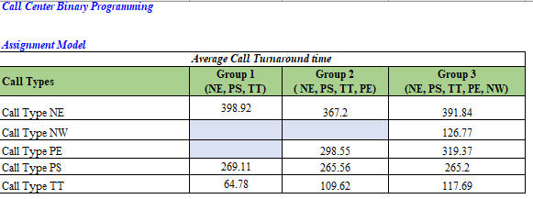Running the model using Simplex LP in Solver gave the following result:

*Table 8: shows the optimized values of the decision variables*

|  |  |  |  |
| --- | --- | --- | --- |
| Sr. No. | Decision Variables | | Values |
| 1 | Assignment of Type NE to G1 | XNE1 | 0 |
| 2 | Assignment of Type NE to G2 | XNE2 | 1 |
| 3 | Assignment of Type NE to G3 | XNE3 | 0 |
| 4 | Assignment of Type NW to G1 | XNW1 | 0 |
| 5 | Assignment of Type NW to G2 | XNW2 | 0 |
| 6 | Assignment of Type NW to G3 | XNW3 | 1 |
| 7 | Assignment of Type PE to G1 | XPE1 | 0 |
| 8 | Assignment of Type PE to G2 | XPE2 | 1 |
| 9 | Assignment of Type PE to G3 | XPE3 | 0 |
| 10 | Assignment of Type PS to G1 | XPS1 | 0 |
| 11 | Assignment of Type PS to G2 | XPS2 | 0 |
| 12 | Assignment of Type PS to G3 | XPS3 | 1 |
| 13 | Assignment of Type TT to G1 | XTT1 | 1 |
| 14 | Assignment of Type TT to G2 | XTT2 | 0 |
| 15 | Assignment of Type TT to G3 | XTT3 | 0 |

*Figure 3: shows the optimal solution after running Solver*

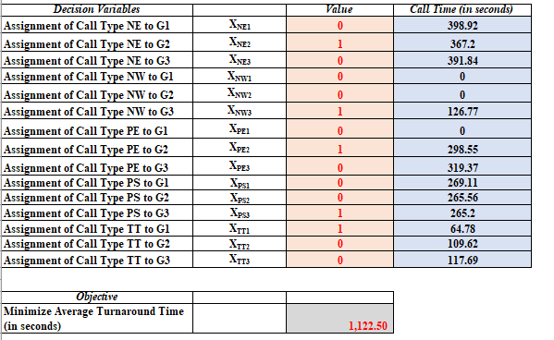

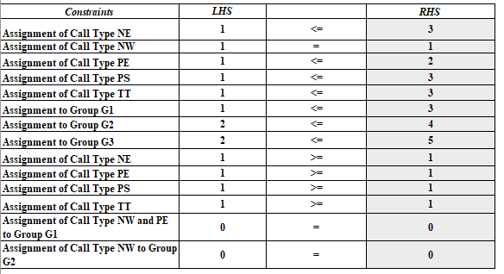

**Figure 3** shows us the optimal solution of the binary optimization model that meets all constraints with minimized average turnaround time of 1122.50 seconds which is 68.77 seconds less than the average turnaround time which was 1191.27 seconds before optimizing the solution.

Another crucial point here to make from the analysis is, we are saving 13.75 seconds per call which can be calculated as 68.77 / 5 = 13.75 seconds where, 5 is number of different call types (NE, NW, PE, PS, TT) and 68.77 seconds is the optimized average turnaround time from the solved model.

As we know, we have 9566 call records for 30 days. To get a holistic picture of the optimized model, when we calculated the total time saved per month on each call, we came to the inference that 131532.5 seconds (9566 * 13.75) which approximates to 2192 minutes (~ 37 hours) were saved in a time span of 30 days. Thus, 37 hours approximates to 4-ManDays of saving per month, by conserving the amount of time, we have helped California Call Center to optimize their time and resource utilization in a very advantageous way.

## **Sensitivity Analysis**

### One Way Analysis

Using a solver table for the binary programming model, we will now see how the optimal function to minimize average turnaround time varies with changes in the assignment of number of different call types (NE, NW, PE, PS, TT) to Group1, Group2 and Group3 agents using sensitivity analysis.

1. Sensitivity of optimal average call time to the assignment of calls to Group 1

Specifically, in order to perform one-way sensitivity analysis using solver table, first we ran one-way sensitivity analysis for assignment of calls to Group G1 and varied the number of different call types (NE, NW, PE, PS, TT) from 1 to 5 with an increment of 1 call to see its effect on the optimal solution of minimizing the average turnaround time.

*Figure 3.1: Sensitivity of optimal solution (average turnaround time) to the assignment of different call types to Group 1*

After running the one-way solver table to see the effect of a change in “number of different call types (NE, NW, PE, PS, TT)  assigned to Group1” on the optimal solution, we can see in **Figure 3.1** that average call time remains constant at 1,122.50 seconds as the call types varies between 1 and 5. Here, on x-axis numbers 1 to 5 represents different types of calls (NE, NW, PE, PS, PT) assigned to group 1.

1. Sensitivity of optimal average call time to the assignment of number of different call types (NE, NW, PE, PS, TT) to Group 2

To see the effect of "Assignment of number of different call types (NE, NW, PE, PS, TT) to group 2" (**Figure 3.2**) on the optimization function to minimize the average turnaround time, we ran the solver table and saw that average call time for 1 call type is more as compared to number of call types 2, 3, 4 and 5.

*Figure 3.2: Sensitivity of optimal solution (average turnaround time) to the assignment of different call types to Group 2*

The average turnaround time when only one call is assigned to Group 2 is 1143.32 seconds which is 20.82 seconds more than the average turnaround time taken for number call types between 2 and 5. Moreover, the optimal solution remains constant i.e. 1,122.50 seconds for any number of calls between 2 and 5.

1. Sensitivity of optimal average call time to the assignment of calls to Group 3

To see the effect of "Assignment of number of call types to group 3" (**Figure 3.3**) on the optimization function to minimize the average turnaround time, we ran the solver table analysis and saw that average turnaround time when 1 call type assigned to group 3 is a little more as compared to number of calls types between 2 and 5, which is 0.36 seconds more than average call time taken for the same number of call types. Moreover, for any number of calls from 2 – 5, the optimal solution remains the same i.e. 1122.50.

*Figure 3.3: Sensitivity of optimal solution (average turnaround time) to the assignment of call types to Group 3*

### Two Way Analysis

*Figure 4: Two-way sensitivity analysis*

**Figure 4** shows two-way sensitivity analysis which indicates effect of change in optimal solution by varying number of call types to group 2 with respect to effect of change in assignment of call type NE to varying number of groups. Both the charts are varied from 1 to 5 number of call types with an increment of 1.

For every change in the number of call types between 2-5, there is no change in the feasible solution i.e. the average turnaround time (1122.50 seconds) remains unchanged. Whereas, if only 1 call type is assigned to group 1 agent then, the average turnaround time is more (1143.32 seconds) as compared to average turnaround time for number of call types between 2-5 (1122.50 seconds).

# Optimization Model 2:

After completing the data analysis and optimization model 1, we are ready to build our 2nd optimization model. The objective of this model is to minimize the number of agents in the call center. Model’s decision variables, objective function, and constraints are as follows:

**Legends:**

* S1 = Shift from 7 am to 3 pm
* S2 = Shift from 12 pm to 8 pm
* S3 = Shift from 4 pm to 12 am
* G1 = Group 1
* G2 = Group 2
* G3 = Group 3

*Figure 5: Visualize call center shift timings*

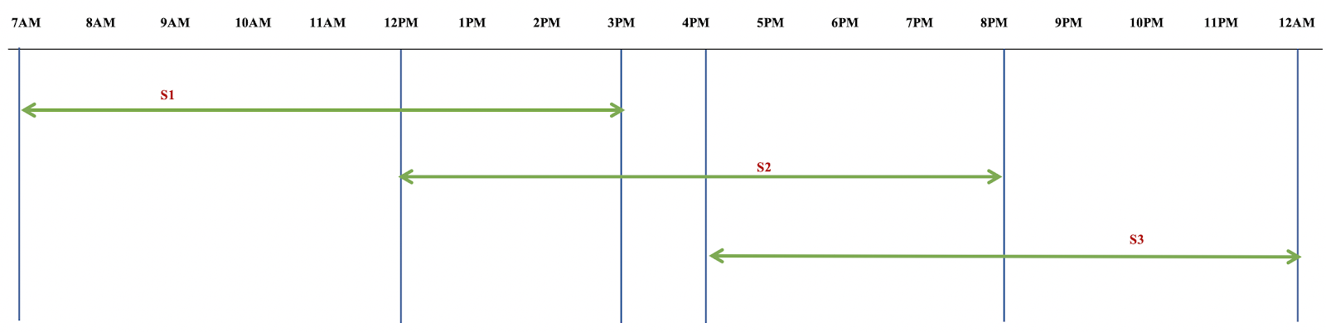

*Table 9: Decision Variables and Definition*

|  |  |  |
| --- | --- | --- |
| Sr. No. | Decision variables | Definition |
| 1 | G11 | Number of G1 agents in S1 |
| 2 | G21 | Number of G2 agents in S1 |
| 3 | G31 | Number of G3 agents in S1 |
| 4 | G12 | Number of G1 agents in S2 |
| 5 | G22 | Number of G2 agents in S2 |
| 6 | G32 | Number of G3 agents in S2 |
| 7 | G13 | Number of G1 agents in S3 |
| 8 | G23 | Number of G2 agents in S3 |
| 9 | G33 | Number of G3 agents in S3 |

Our objective is to minimize the total number of agents:

*Table 10: Objective function and definition*

|  |  |
| --- | --- |
| Objective Function | Definition |
| Minimize number of agents:  Min  where,  i represents Groups, i=1,2,3  j represents Shifts, j=1,2,3  Or  Min [G11 + G21 + G31 + G12 + G22 + G32 + G13 + G23 + G33] | We will minimize the number of agents per day by taking the sum of agents for each group in each shift. |

For this model, Constraints are derived based on following analysis and assumptions: -

* **Assumption:** A typical call center agent takes approximately 40 calls per day. i.e. ~ 5 calls per hour.
* **Analysis:** Analyzing the data set to calculate call volumes in various time frames & dividing it by typical number of calls per hour that one agent call handle (5 calls per hour). We calculated the minimum number of agents required in each time slot.

*Table 11: Constraints, Equation and Explanation*

|  |  |  |
| --- | --- | --- |
| Constraint | Equation | Explanation |
| Agents from 7 am to 12 pm | G11 + G21 + G31 >= 6 | Number of agents from 7 am – 12 pm should be at least 6. |
| Agents from 12 pm to 3 pm. | G11 + G21 + G31 + G12 + G22 + G32  >= 11 | Number of agents from 12 pm to 3 pm should be at least 11. |
| Agents from 3 pm to 4 pm | G12 + G22 + G32 >= 5 | Number of agents from 3 pm to 4 pm should be at least 5. |
| Agents from 4 pm to 8 pm | G12 + G22 + G32 + G13 + G23 + G33  >= 8 | Number of agents from 4pm to 8pm should be at least 8. |
| Agents from 8 pm to 12 am | G13 + G23 + G33 >= 3 | Number of agents from 8 pm to 12 am should be at least 3. |
| Minimum number of agents of G1 in S1 | G11 >= 1 | At least, 1 agent of Group 1 should be present in Shift 1. |
| Minimum number of agents of G1 in S2 | G12 >= 1 | At least, 1 agent of Group 1 should be present in Shift 2. |
| Minimum number of agents of G1 in S3 | G13 >= 1 | At least, 1 agent of Group 1 should be present in Shift 3. |
| Minimum number of agents of G2 in S1 | G21 >= 3 | We have the highest number of agents in group 2. We need at least 3 agents of Group 2 to be present in Shift 1. |
| Minimum number of agents of G2 in S2 | G22 >= 3 | We have the highest number of agents in group 2. We need at least 3 agents of Group 2 to be present in Shift 2. |
| Minimum number of agents of G2 in S3 | G23 >= 2 | At least, 2 agents of Group 3 should be present in Shift 3. |
| Minimum number of agents of G3 in S1 | G31 >= 2 | At least, 2 agents of Group 3 should be present in Shift 1 |
| Minimum number of agents of G3 in S2 | G32 >= 2 | At least, 2 agents of Group 3 should be present in Shift 2 |
| Minimum number of agents of G3 in S3 | G33 >= 2 | At least, 2 agents of Group 3 should be present in Shift 3. |
| Maximum number of agents in G1 | G11+G12+G13 <= 6 | We have at most 6 agents in group 1. |
| Maximum number of agents in G2 | G21+G22+G23 <= 12 | We have at most12 agents in group 2. |
| Maximum number of agents in G3 | G31+G32+G33 <= 8 | We have at most 8 agents in group 3. |
| Total in Shift 1 | G11+G21+G31 >= 6 | Shift 1 should have at least 6 agents. |
| Total in Shift 2 | G12+G22+G32 >= 5 | Shift 2 should have at least 5 agents. |
| Total in Shift 3 | G13+G23+G33 >= 3 | Shift 3 should have at least 3 agents. |
| Integer and non-negativity constraint | G11, G12, G13, G21, G22, G23, G31, G32, G33 >= 0 and Integer | To keep the values integer and non-negative, since number of agents cannot be negative. |

With our model constructed, we set out to solve the model with Excel’s Solver. We used Simplex LP function to get our optimized solution.

## **Solution Results and Analysis**

Currently the call center employs 26 agents to cover 3 shifts. We grouped these agents based on their skill set and optimized the call routing to minimize the average call turnaround time. Now we will perform integer programming to optimize the number of agents in each shift from each group and thereby minimize the operating cost of the call center. The optimized model is shown below:

*Figure 6: shows the optimal solution after running the solver*

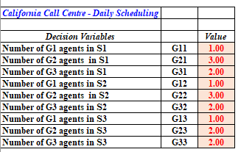 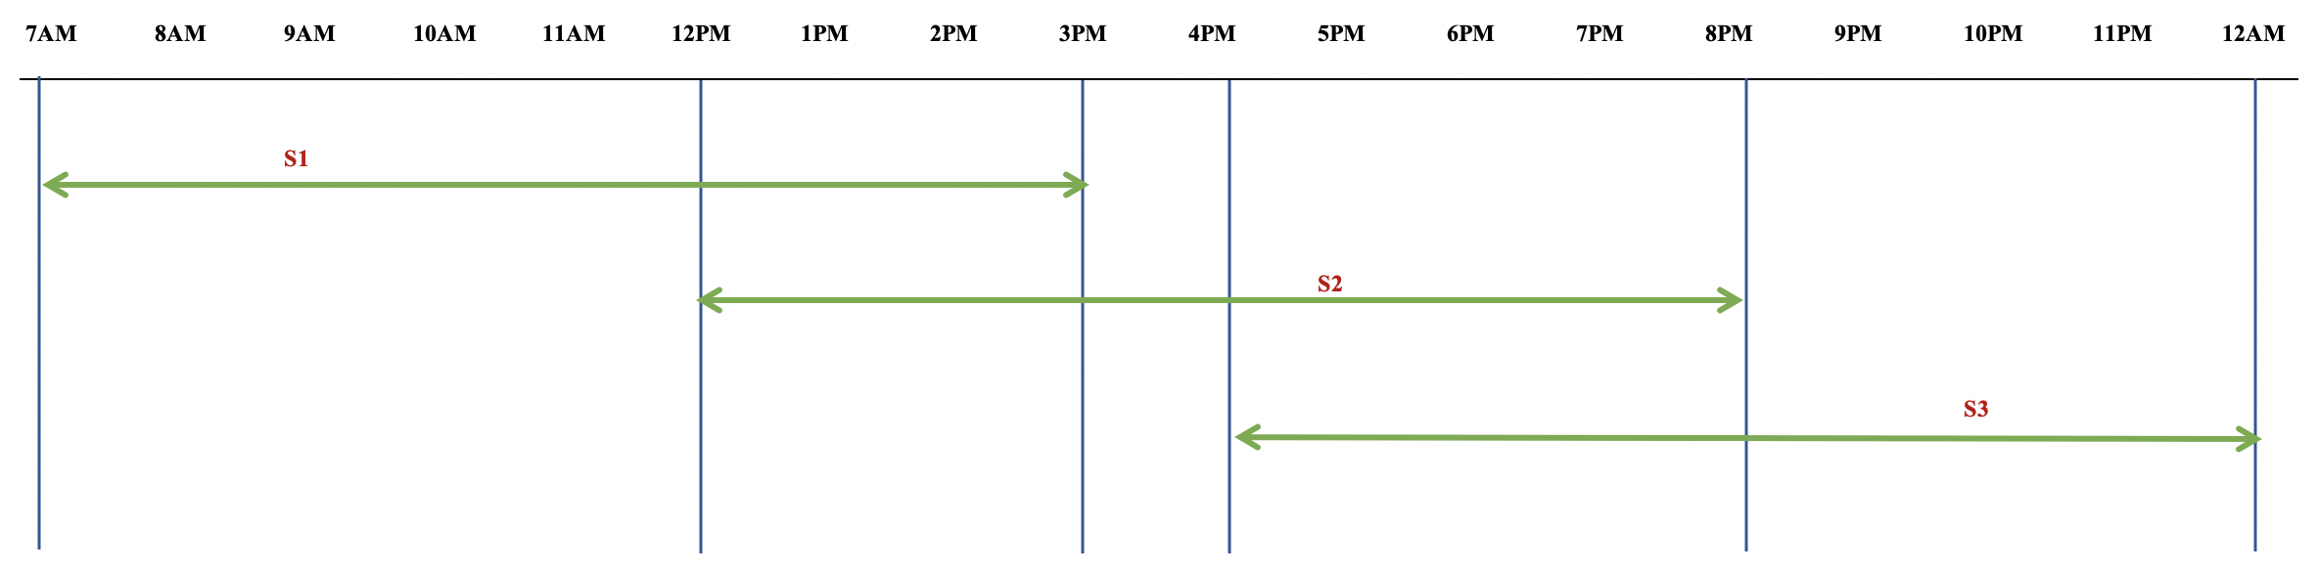

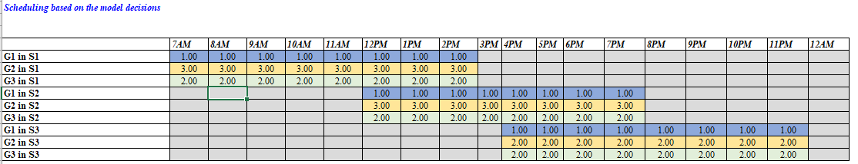

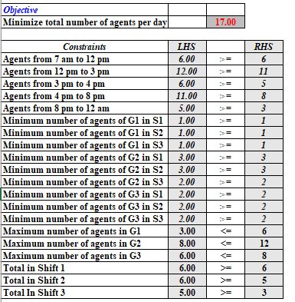

**Figure 6** shows the minimum number of agents required per day is now reduced to 17. This helps in substantially minimizing the cost to the call center by reducing the number of agents from 26 to 17. Please have a look on the below Table12.

*Table 12:*

|  |  |  |
| --- | --- | --- |
| **Group Number** | **Number of agents before optimization** | **Number of agents after optimization** |
| Group 1 | 6 | 3 |
| Group 2 | 12 | 8 |
| Group 3 | 8 | 6 |
| ***Total*** | ***26*** | ***17*** |

## **Sensitivity Analysis**

### One Way Analysis

Using a solver table for the integer programming model, we ran a one-way sensitivity analysis for the maximum number of agents in group 2 (G21+G22+G23) to see its effect on the total number of agents. One-way Sensitivity of total agents to the maximum number of agents in group 2(G2) is as below:

Figure 7: Sensitivity of total agents to the maximum number of agents in group 2

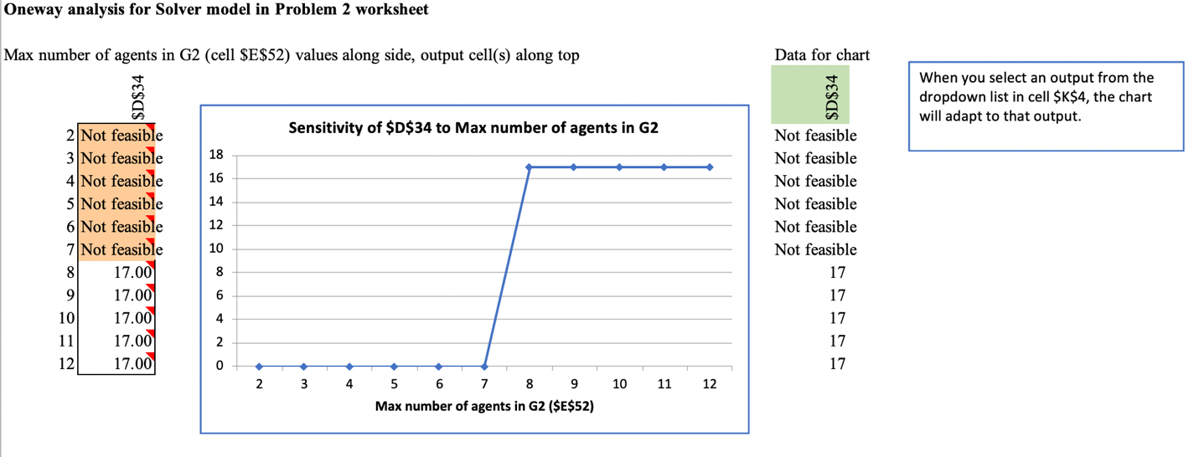

**Figure 7** is a one-way analysis for displaying how the decision variables (number of agents per) vary with changes in the constraint (maximum number of agents in Group 2). The value for the input is varied from 2 to 12 in increments of 1. Below are the observations:

* When we increase the maximum number of agents in Group 2 from 2 to 7, we do not have a feasible solution. This is because there are 3 other constraints affecting the number of agents from group 2. The minimum number of agents from Group 2 in shifts 1, 2 and 3 need to be at least 3, 3, and 2 respectively. That means there needs to be at least 8 agents from group 2.
* When we vary the maximum number of agents in Group 2 from 8 to 12, the total number of agents obtained is 17. This is the same as the optimal solution we had obtained using the constraints given. This basically indicates that any increase in the maximum number of agents in group 2 from 9 to 12 has no effect on the total number of agents. It remains constant at 17.

### Two Way Analysis

Using solver table for the integer programming model, we ran two-way sensitivity analysis on Total agents in shift 1 and total agents in shift 3. The two-way sensitivity analysis is as below:

Figure 8: Two-way sensitivity analysis

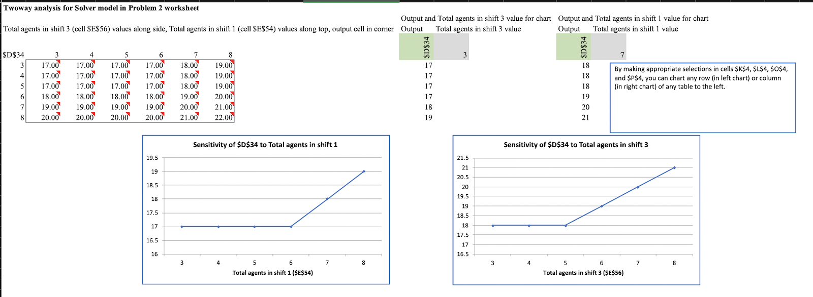

**Figure 8** is a two-way analysis where we vary the below 2 parameters: -

1. Total number of agents in shift 1
2. Total number of agents in shift 3

We have couple of observations given below:

* The minimum number of agents per day by varying these constraints is 17
* The maximum number of agents per day by varying these constraints is 22

Analyzing the effect of total agents in shift 1 on total number of agents and keeping the count in shift 3 constant, we observed:

1. Our optimum model for total number of agents remains insensitive to any changes in number of agents in shift 1 up to 6 agents. It changes to 18 agents when total shift 1 agents are 7 and 19 when total agents in shift 1 is 8.
2. The outputs basically follow the same pattern for different values of total agents in shift 3. It remains constant for when the total number of agents in shift 1 are varied from 3 to 6 and the increases by 1 for every increase in the total number of agents in shift1.

Now, keeping total agents in shift 1 constant, and changing the agents in shift 3 to see the impact on total number of agents, we observed:

1. The pattern followed by the output value when we vary the total number of agents in shift 3 is the same for all values of the other input (total number of agents in shift 1).
2. The output value variations are exactly the same when we keep the total number of agents in group 1 as 3, 4, 5 or 6. The output variations based on varying total number of agents in shift 3 show the exact same values for the 4 input values for the total number of agents in shift.
3. When total agents in shift 1 are kept constant at 7, the output is 18 for varying inputs from 3 to 5 but linearly increases by 1 agent for every increment in the input value.
4. When total agents in shift 1 are kept constant at 8, the output is 19 for varying input from 3 to 5 but linearly increases by 1 agent for every increment in the input value.

# Conclusion

In this project, using Excel Solver and Excel Solver Table add-in, we, as a team demonstrated the optimal solution for the California Call Center problem. We achieved 2 objectives in this project:

1. **Reduce the average call turnaround time**

We were able to achieve our goal of reducing the call time from 1191.27 seconds to 1122.50 seconds thus saving ~14 seconds per call. This is achieved by routing the right call types to right agent groups. Furthermore, we also learned additional results by running One-way and Two- way sensitivity analysis using Excel Solver Table tool for the models. Our prime objective of this study was to see how the optimal function to minimize average turnaround time varies with changes in the assignment of number of different call types (NE, NW, PE, PS, TT) to Group1, Group2 and Group3 agents using sensitivity analysis.

From this analysis we concluded that group 3 is best to take any type of call as they are proficient in answering all call types and their average turnaround time is the least among other groups. Given a situation wherein, Group 1 or Group 2 call center agents are falling short in answering the calls or in case of their absence/emergency, Group 3 agents can take over to suffice the need of the hour due to their proficiency in answering all types of calls considering the optimal turnaround time.

1. **Minimize the operating cost of the call center by optimizing the number of agents**

We were able to achieve our goal to minimize the number of agents from 26 to 17 and thus optimizing the cost. Similarly, for scheduling integer programming model we saw how the optimal function to minimize the number of agents varies for maximum number of agents in group 2 (G21+G22+G23). We concluded that the minimum number of agents from Group 2 in shifts 1, 2 and 3 need to be at least 3, 3, and 2 respectively. That means there needs to be at least 8 agents from group 2. Another finding using two-way sensitivity was the minimum number of agents should be 17 so that the call center operating cost is optimized.

It is recommended that California Call Center adopt this binary optimization model for minimizing the call time and scheduling model across all shifts to make proper utilization of the workforce. The best approach to implement these models is to provide an automated dashboard to pre- calculate the average call turnaround time per call, based on call types schedule agents in each shift and use that dashboard to suggest appropriate routing of calls for each agent group based on the above model.

# APPENDIX

1. Data Description-

|  |  |  |
| --- | --- | --- |
| **Sr No** | **Column Name** | **Data Description** |
| 1 | vru+line - 6 digits | Each entering phone-call is first routed through a VRU: There are 6 VRUs labeled AA01 to AA06. Each VRU has several lines labeled 1-16. There is a total of 65 lines. Each call is assigned a VRU number and a line number. |
| 2 | Call_id - 5 digits | Each entering call is assigned a call id. Although they are different, the ids are not necessarily consecutive due to being assigned to different VRUs. |
| 3 | Customer_id - 0 to 12 digits | This is the identification number of the caller, which identifies the customer uniquely; the ID is zero if the caller is not identified by the system (as is the case for prospective customers, for example). |
| 4 | Priority - 1 digit | There are 3 types of customers: - - 0 indicate unidentified customers  - 1 indicates Regular customers  - 2 indicates priority customers |
| 5 | Type - 2 digits | There are 5 different types of services:  1. PS - regular activity (coded 'PS' for 'Peilut Shotefet')  2. PE - regular activity in English (coded 'PE' for 'Peilut English')  3. NE -stock exchange activity (coded 'NE' for 'Niarot Erech')  4. NW - potential customer getting information  5. TT – customers who left a message asking the bank to return their call but, while the system returned their call, the calling-agent became busy hence the customers were put on hold in the queue. |
| 6 | Date - 6 digits | year-month-day |
| 7 | vru_entry - 6 digits | Time that the phone-call enters the call-center. More specifically, each calling customer must first be identified, which is done by providing the VRU with the customer-id. Hence this is the time the call enters the VRU. |
| 8 | vru_exit - 6 digits | Time of exit from the VRU: either to the queue, or directly to receive service, or to leave the system (abandonment). |
| 9 | vru_time - 1 to 3 digits | Time (in seconds) spent in the VRU (calculated by exit_time – entry_time). |
| 10 | q_start - 6 digits | Time of joining the queue (being put on “hold”). This entry is 00:00:00, for customers who have not reached the queue (abandoned from the VRU). |
| 11 | q_exit - 6 digits | Time (in seconds) of exiting the queue: either to receive service or due to abandonment. |
| 12 | q_time - 1 to 3 digits | Time spent in queue (calculated by q_exit – q_start) |
| 13 | Outcome - 4,5 or 7 digits | There are 3 possible outcomes for each phone call:  1. AGENT - service 2. HANG - hung up  3. PHANTOM - a virtual call to be ignored (unclear to us – fortunately, there are only few of these.) |
| 14 | ser_start - 6 digits | Time of beginning of service by agent. |
| 15 | ser_exit - 6 digits | Time of end of service by agent. |
| 16 | ser_time - 1 to 3 digits | Service duration in seconds (calculated by ser_exit – ser_start) |
| 17 | Server - text | Name of the agent who served the call. This field is NO_SERVER, if no service was provided. |

1. Snapshot of the data –

