Introducing about myself: Keep it concise: Try to keep your answer to two minutes or less. You don't want to ramble on and lose the interviewer's attention.  
  
➡ Highlight your relevant experience: Talk about your strengths and accomplishments that demonstrate your qualifications for the job.  
  
➡ Provide a brief personal background: It's okay to briefly mention where you're from or your education, but keep it relevant and focused on how it has prepared you for the role you're interviewing for.  
  
➡ Demonstrate your enthusiasm: Convey your enthusiasm for the position and the company. Show the interviewer that you're excited about the opportunity to work for them.  
  
Here's an example answer:  
  
"I have been working in the marketing industry for the past five years, with a focus on social media and content marketing. I have experience in developing and executing successful campaigns that have led to an increase of, almost 33% in engagement and conversions for my clients. I am particularly proud of the campaign I worked on for XYZ company, which led to a 20% increase in sales. In addition, I have a bachelor's degree in marketing from ABC University, which provided me with a strong foundation in this field. I'm excited about the opportunity to join your team and apply my skills and experience to help drive growth for the company."

Talking about resume: Be Prepared: Ensure you've thoroughly reviewed your resume before the interview. You should be able to speak to each position you've held, including your responsibilities, accomplishments, and how each role has prepared you for the current position you're applying for.  
  
🎯 Keep it concise: Your interviewer doesn't need to hear every detail about every job you've ever had. Stick to the highlights, and be sure to tie your experience back to the current position you're applying for.  
  
🎯 Highlight your achievements: Talk about specific achievements you've had in each position. This will give your interviewer a better understanding of your capabilities and how you can contribute to the organization.

ure, I'd be happy to. I started my career as a marketing assistant at XYZ Company, where I gained experience in event planning and social media marketing. After two years, I moved to ABC Company, where I was promoted as a marketing coordinator. In this role, I managed multiple social media campaigns, which led to a 30% increase in engagement. I also developed and executed several successful email marketing campaigns that led to a 25% increase in sales.  
  
➡ After three years at ABC Company, I joined LMN Company as a marketing manager. In this position, I led a team of five marketing professionals and developed and implemented a new marketing strategy that resulted in a 40% increase in website traffic. I also worked closely with the sales team to create and implement lead generation campaigns that led to a 20% increase in qualified leads.  
  
➡ Overall, my experience has allowed me to develop a strong set of marketing skills, including event planning, social media marketing, email marketing, and team management. I'm excited about the opportunity to bring these skills to your organization and continue to grow as a marketing professional."  
  
⭐ Remember, your resume is your ticket to an interview, and the "walk me through your resume" question is your chance to expand on your experience and demonstrate why you're the best candidate for the job.  
  
With these tips in mind, you're sure to impress your interviewer and land the position you're after.

"Where do you see yourself five years from now?"  
  
One of the most common questions that often comes up in interviews. This question is designed to assess your long-term career goals and ambitions, as well as your commitment to the company and the role you are applying for.  
  
Follow these tips to answer this question effectively in an interview:  
  
✅ Start with your current position: Start by acknowledging your current position and how it has prepared you for future growth. You can mention the skills and experiences you have gained and how they will contribute to your future success.  
  
✅ Be specific: Employers want to know that you have a clear idea of where you want to be in the future. Be specific about the position or role you hope to have in five years and how it matches the company's goals and objectives.  
  
✅ Focus on professional development: Employers are interested in candidates who are committed to ongoing learning and professional development. Highlight any additional training, certifications, or education you plan to pursue to achieve your career goals.  
  
✅ Demonstrate a commitment to the company: Employers want to know that you are committed to the company and the role you are applying for. You can demonstrate this by discussing how your long-term career goals align with the company's mission and values.  
  
✅ Keep it realistic: While it's important to be ambitious, it's also important to keep your career goals realistic. Avoid making unrealistic or vague statements that could raise red flags for the interviewer. Focus on achievable goals that are synced with your skills and experience.  
  
✅ Show enthusiasm: Demonstrate your passion for the work you do and your commitment to achieving your long-term career goals.  
  
Example: In five years, I see myself as a more experienced and skilled professional, having honed my abilities and gained valuable knowledge through my work. This will enable me to become a part of the management team. I am eager to take on new challenges and responsibilities, and I hope to have made a significant impact in my field. I will work towards building strong relationships with my colleagues and mentors and have built a solid reputation for myself in this industry. Ultimately, I believe that my hard work and dedication will lead to continued success and growth for myself and this organization.

“Share about the biggest challenge in your previous role”.  
  
A tricky interview question, this one!  
  
When answering this question, it is important, to be honest, and authentic while also demonstrating your problem-solving skills and ability to overcome challenges.  
  
Here are some steps you can follow to answer this question effectively:  
  
🗝️Identify the challenge: Start by identifying the biggest challenge in your previous job. This could be a specific project, a difficult client, or a complex task that you had to complete.  
  
🗝️Describe the challenge: Give some context about the challenge, including the specific circumstances and any obstacles or difficulties you faced. Be sure to focus on the specific challenge and avoid blaming others or making excuses.  
  
🗝️Explain how you approached this challenge: Share the steps you took to overcome the challenge. Did you seek guidance from a colleague or manager? Did you research and gather more information? Did you break the challenge down into smaller, more manageable tasks?  
  
🗝️Share the outcome: Explain how you ultimately resolved the challenge and the results you achieved. Did you successfully complete the project or task? Did you improve the relationship with the difficult client?  
  
🗝️Highlight what you learned: Lastly, share what you learned from the experience and how you have applied that knowledge in your subsequent work. This shows that you are reflective, adaptable, and always seeking to improve.  
  
🗝️Be honest and authentic in your answer while highlighting your problem-solving skills and ability to overcome challenges. Remember to stay positive and focused on the solution rather than dwelling on the challenge itself.  
  
Here's an example answer:  
In my previous job, the biggest challenge I faced was managing a high volume of tasks within a tight deadline. The nature of the job required me to constantly prioritize and re-prioritize tasks based on their urgency and importance.  
  
To tackle this challenge, I implemented a time-management system that helped me stay organized and focused. I would start each day by reviewing my to-do list and identifying the most urgent tasks that needed my immediate attention. I also made sure to communicate with my colleagues and supervisors about my workload and any potential roadblocks that could impact the timely completion of tasks.  
  
Additionally, I constantly looked for ways to streamline processes and eliminate inefficiencies to make the most of my time. This included delegating tasks to other team members and using technology tools to automate repetitive tasks.  
Although it was a tough challenge, I learned a lot from this experience and developed valuable skills to apply to future roles.

 “How does a typical day at work in your previous role looks like?"  
  
When answering this interview question, focus on providing a concise and specific description of your typical tasks and responsibilities.  
It is also a great opportunity to slide in some of your top skills and strengths into this answer!  
  
➡ Here are some steps you can follow to answer this question effectively:  
  
🎯 Start by providing an overview of your previous role and your position within the organization.  
  
🎯 Mention the specific job duties and responsibilities that you had on a daily basis. Be sure to emphasize the tasks that are most important and relevant to the job you are applying for.  
  
🎯 Use specific examples to illustrate the type of work you did on a daily basis. This can help to provide a clear picture of your work experience and skills.  
  
🎯 Highlight any challenges you faced in your previous role and how you overcame them. Show them your problem-solving skills, analytical skills, and team-working skills.  
  
🎯 If applicable, mention any achievements or accomplishments that you achieved in your previous role, and how they contributed to the success of the organization.  
  
➡ Example answer:  
"In my current role as a marketing coordinator, my day-to-day activities involves managing social media accounts, creating and sending email campaigns, analyzing market research data, and coordinating events. I am also responsible for collaborating with the design team to create new marketing materials and managing relationships with external vendors. One of the biggest challenges I have faced in this role was managing tight deadlines, but I was able to overcome this by implementing more efficient project management techniques. Through my efforts, I am able to increase social media engagement by 25% and drive a 15% increase in event attendance."

What are your strengths?  
  
This common interview question is actually a bit tricky to answer, as you want to showcase your skills and abilities without coming across as boastful.  
  
Here are a few tips on how to approach this question:  
  
🎯 Identify your strengths:  
Be aware of what are your actual strengths. Take a Free Strengths Test at high5test or 16personalities - select five/ten strengths that align with the role you are applying for and then pick the best two while answering this question.  
  
🎯 Be honest:  
Just saying something because it sounds good or is easy, is a common mistake that many make. It's important to be truthful when answering this question. Think about what you genuinely excel at and try to relate those strengths to the job you're applying for.  
  
🎯 Use specific examples:  
Backup your answer with specific examples from your work history. This will help demonstrate your abilities and show the interviewer that you have experience in the areas you're discussing.  
  
🎯 Tie your strengths to the job:  
When discussing your strengths, try to relate them to the job you're interviewing for. This will help the interviewer see how you would be a good fit for the position.  
  
⭐ Here's an example of how you might answer this question:  
  
"One of my strengths is my ability to communicate effectively with both clients and colleagues. In my previous role as a customer service representative, I was often praised for my ability to de-escalate difficult situations and turn unhappy customers into satisfied ones. I also received positive feedback from my colleagues on my clear and concise communication style, which helped streamline our team's workflows. I believe that these communication skills would be valuable in this role, as I would be working closely with both clients and internal teams to ensure that projects are completed efficiently and to everyone's satisfaction."  
  
⭐ Remember, when answering this question, try to focus on a few key strengths that are relevant to the job you're applying for. Be specific and use examples to back up your claims. With a little preparation, you can confidently showcase your strengths and make a strong impression on your interviewer.

“What are your weaknesses?"  
  
One of the most common interview questions that candidates often dread is, "What are your weaknesses?"  
  
🌟 It's a tough question because it requires you to be honest about your shortcomings while still positioning yourself as a strong candidate for the job.  
  
But fear not! There are ways to answer this question that can actually work in your favor.  
  
🎯 Firstly, it's important to remember that the interviewer is not trying to catch you out or make you feel bad. They simply want to know how self-aware you are and whether you have the ability to recognize areas where you could improve.  
So, be honest and don't try to dodge the question.  
  
🎯 However, you also don't want to mention a weakness that could be detrimental to the job you are applying for. For example, if you're applying for a job as a project manager, you wouldn't want to mention that you struggle with time management.  
Instead, choose a weakness that is unrelated to the core competencies of the job, but that you have taken steps to improve on.  
  
🎯 Example Answer:  
"One weakness I've had in the past is public speaking. I used to get nervous and stumble over my words when presenting in front of large groups. However, I recognized this as an area for improvement and have since taken a public speaking course and joined a local Toastmasters group. I'm proud to say that I've made significant progress and am much more confident when presenting now."  
  
🌟 In this example, the weakness mentioned is not directly related to the job, but it still shows that the candidate is self-aware, proactive, and committed to personal development.  
  
🌟 Remember, the key to answering this question is to be honest, demonstrate self-awareness, and show that you are taking steps to improve.

What is your greatest failure, and what did you learn from it?"  
  
This question is an opportunity to show self-awareness and demonstrate how you've grown from past mistakes.  
  
Follow these steps and get this answer on point:  
  
🎯 Briefly describe the situation and what went wrong.  
  
🎯 Explain what you learned from the experience.  
  
🎯 Share how you've applied that lesson in your work since then.  
  
🎯 Remember, the interviewer is interested in how you handle failures and setbacks, not just your successes.  
  
🎯 Showing humility, reflection, and a willingness to learn from mistakes can demonstrate your potential to grow and improve in the role.  
  
Example answer:  
  
⭐ "My greatest failure happened during my first job as a project manager. I was assigned to manage a team of five people on a critical project. I was confident in my abilities and underestimated the complexity of the project. As a result, I failed to communicate effectively with my team members and didn't provide them with the necessary resources to complete the project successfully. The project ended up being delayed, and my team's morale was low.  
  
⭐ From this experience, I learned the importance of effective communication and teamwork. I realized that as a project manager, it's crucial to not only provide clear direction but also to listen to my team members' feedback and concerns. I also learned the importance of being transparent and honest with my team about project challenges and limitations. Since then, I've made a conscious effort to prioritize communication and collaboration in my work, and I'm proud to say that I've successfully managed multiple projects with positive outcomes."

Why do you want to work here?’  
  
This a rather simple interview question but tends to catch many interviewees off guard!  
  
Of course, you can say - Because I need a job and you guys are hiring!  
  
💡 But we know this answer is not what the interviewer is looking for. They want to know if you've thought about where you want to work and that you're not just sending your resume to any company with a job opening. Demonstrate your knowledge and inclination about the company and its mission.  
  
Here are some tips for crafting an effective answer:  
  
🎯 Research the company: Read through the company's history, values, and recent initiatives (on their website). This will allow you to speak specifically about why you're excited to work for the company.  
  
🎯 Identify your alignment: Show how your own values and goals align with the company's mission and culture. This will help the interviewer understand why you're a good fit for the company.  
  
🎯 Connect to the position: Talk about how the specific role you're applying for fits into your career goals and interests. This will demonstrate that you've thought about how this job can help you grow professionally.  
  
🎯 Highlight the company's strengths: Highlight what specifically draws you to the company, whether it be their reputation, products or services, or the team culture.  
  
⭐ Example answer:  
  
"I'm really excited about the opportunity to work here because I'm passionate about [domain]. I've been following ‘ABC’ for a while now and I'm impressed with the way you [specific example of recent company initiative or accomplishment]. As someone who values [company's core value], I believe this is a company where I can thrive and contribute to meaningful work.  
  
Specifically, the [position you are applying for] role aligns with my strengths in [specific skill or experience] and I believe it will help me grow as a professional. I'm excited about the prospect of working with a team that's committed to [specific value or goal] and making a difference in the [industry or community].

'Was there a time when your work was criticized, can you describe it?'  
  
This question is intimidating, but it's important to remember that constructive criticism is a natural part of any job and can help us grow and improve.  
  
When answering this question, it's important to remember that the interviewer is likely trying to gauge your ability to handle criticism and respond professionally.  
  
Here are some tips on how to answer this interview question effectively:  
  
🎯 Be honest and specific:  
Choose a specific example of a time when your work was criticized, and be honest about what happened. Explain the situation, who was involved, and what the criticism was. It's important to be as specific as possible so that the interviewer can get a clear understanding of the situation.  
  
🎯 Focus on the resolution:  
While it's important to explain what went wrong, it's even more important to focus on how you responded to the criticism. Talk about the steps you took to address the issue and how you worked to improve your work. This will demonstrate that you are proactive and willing to take responsibility for your mistakes.  
  
🎯 Emphasize what you learned:  
It's important to emphasize what you learned from the experience. Talk about how the criticism helped you grow as a professional and how you have used the feedback to improve your work moving forward. This will demonstrate that you are open to feedback and willing to learn from your mistakes.  
  
🎯 Stay positive:  
Finally, it's important to stay positive when answering this question. Avoid placing blame or getting defensive, and instead focus on the positive aspects of the experience. Emphasize how you were able to turn the criticism into a positive learning experience and how you are now a stronger and more capable professional as a result.  
  
⭐ Example Answer:  
  
"Yes, I can certainly describe a time when my work was criticized. At my previous job, I was responsible for organizing a company-wide event, and one of my colleagues pointed out that I hadn't provided enough information about the event's schedule. While it was difficult to hear at first, I knew that my colleague was trying to help me improve the event, so I took their criticism as a constructive opportunity to make adjustments. I thanked them for their feedback and worked to provide more detailed information about the schedule. As a result, the event went off without a hitch and received positive feedback from attendees."  
  
In your answer, make sure to show that you are open to constructive criticism and have the ability to take feedback in a positive way. Highlight how you turned the criticism into an opportunity for growth and improvement.

Why do you want to work here?  
  
This question is designed to gauge your level of interest in the company and how well you would fit in with the organization's culture.  
  
It's an opportunity for you to showcase your research on the company and articulate how you see yourself contributing to its success.  
  
To answer this question effectively, there are a few key things you should keep in mind:  
  
👉 Research the company: Do your due diligence by researching the company's history, mission  
statement, and recent news. Look for information on its company culture, core values, and any  
notable projects or initiatives.  
  
👉 Focus on the company's needs: Consider the job description and the company's needs. Highlight how your skills and experience align with the job requirements and how you can add value to the  
organization.  
  
👉 Personalize your answer: While it's important to highlight the company's strengths and accomplishments, make sure to also share why you're personally excited about the opportunity to  
work there.  
  
Example answer:  
"I'm excited about the opportunity to work for this company because of the innovative work you're  
doing in the field of sustainability. Your commitment to reducing your environmental impact and finding sustainable solutions is something that aligns with my own values and career goals.  
  
I was particularly impressed by your recent project to reduce plastic waste in your packaging, which is an issue I'm also passionate about.  
  
In addition, I believe my skills and experience make me an ideal fit for the company. With my  
background in project management and my ability to work collaboratively with cross-functional teams, I'm confident I could contribute to the success of your sustainability initiatives.  
  
Overall, I'm excited about the possibility of joining a team that is making a real impact and creating positive change."  
  
Remember to make your answer personal and specific to the company you're interviewing with.  
  
By showing your enthusiasm for the company and demonstrating how you can contribute to its success, you'll make a strong impression on your interviewer.

Why is there a gap in your resume?  
  
This one’s a tricky one to answer, but with the right approach, you can turn it into an opportunity to showcase your skills and experiences.  
  
Here are some tips on how to answer this question effectively.  
  
🎇 Be honest: It's essential to be truthful when answering this question. If you took time off to travel, take care of a sick family member, or handle personal issues, state that honestly. Employers appreciate honesty and transparency.  
  
🎇 Explain how you spent your time: If you had a gap in your resume, it's essential to explain what you were doing during that time. Were you freelancing, volunteering, or pursuing additional education? Mentioning these activities can show that you were still active and making the most of your time.  
  
🎇 Show what you learned: If you were out of work for an extended period, you may have learned valuable skills or gained new experiences. Mention those experiences and what you learned from them. Highlighting your self-development can make you an attractive candidate.  
  
🎇 Emphasize your readiness to work: Employers want to know that you are ready to work and committed to the job. Explain why you are excited about this opportunity and how you are prepared to work hard and contribute to the company.  
  
Example answer:  
  
"During the time gap on my resume, I took a break to care for my aging mother, who was diagnosed with cancer. Although it was a difficult time, it allowed me to spend quality time with my mother and take care of her during her treatment. During this time, I also volunteered at a local cancer center, which allowed me to gain new skills in patient care and support. I learned a lot about compassion, empathy, and working with people in challenging situations. Now that my mother's health has improved, I'm ready to get back to work, and I'm excited about the opportunity to bring my skills and experience to this company."  
  
This example response is honest, and straightforward, and shows how the gap in the resume allowed the candidate to develop new skills and gain valuable experiences. The candidate also emphasizes their readiness to work and how they are excited about the opportunity to contribute to the company.

What is your ideal company?  
  
This a common interview question that can catch many job candidates off guard!  
  
However, it's an important question because it helps the interviewer understand your values and what you are looking for in a workplace.  
  
Here are some tips on how to answer the question and an example answer to help guide you:  
  
👉 Do your research: Before the interview, do some research on the company you're interviewing with. Look at their mission statement, company culture, and values. This will give you an idea of what the company stands for and what they prioritize.  
  
👉 Focus on your values: Think about what's important to you in the workplace. Do you value work-life balance? A collaborative team environment? Opportunities for growth and advancement? Make a list of your top priorities.  
  
👉 Be specific: When answering the question, be specific about what you're looking for. Instead of saying "I want to work for a company that values teamwork," give an example of what that looks like for you.  
For example, "My ideal company is one that encourages collaboration by having regular team-building activities and an open-door policy that allows for easy communication between team members."  
  
👉 Tie it back to the company: Make sure your answer aligns with the company you're interviewing with. If the company is known for its innovation, talk about how you value a company that encourages creativity and new ideas.  
  
🌟 Example answer:  
"My ideal company is one that values work-life balance and encourages personal and professional growth. I want to work for a company that provides its employees with opportunities for development and advancement. I'm also looking for a collaborative team environment where everyone's ideas are heard and valued.  
  
From what I've researched about your company, I see that you prioritize these things as well. For example, I was impressed by your company culture and the emphasis you place on employee well-being. Your commitment to innovation also aligns with my own values, and I'm excited about the potential for growth and learning at your company."

 How do you handle conflicts at work?  
  
This question is asked to gauge how a candidate approaches and resolves conflicts, as conflict resolution is an essential skill in any workplace.  
  
Here are some tips for answering this question effectively:  
  
🗝️ Start with an acknowledgment: Begin your answer by acknowledging that conflicts can arise in any workplace and that it's essential to address them constructively.  
This shows that you understand the importance of conflict resolution and are not afraid to confront difficult situations.  
  
🗝️ Emphasize communication: Communication is key to resolving conflicts effectively. In your answer, stress the importance of listening to both sides of the conflict, understanding their perspectives, and finding common ground.  
It's also essential to communicate your own thoughts and feelings respectfully and clearly.  
  
🗝️ Highlight problem-solving skills: Problem-solving skills are crucial when it comes to conflict resolution. You should demonstrate that you can approach conflicts analytically and creatively, taking into account the needs and interests of all parties involved.  
Explain how you would gather information, evaluate options, and work towards a mutually beneficial solution.  
  
🗝️ Show emotional intelligence: Emotional intelligence involves the ability to recognize and manage one's emotions and the emotions of others. When answering this question, emphasize your ability to stay calm and composed in the face of conflict, and your willingness to empathize with others and show understanding.  
This shows that you are a mature, responsible team player who can handle difficult situations with grace.  
  
🎯 Example answer:  
  
"In my experience, conflicts are bound to happen in any workplace. When faced with a conflict, my first step is always to acknowledge the issue and communicate openly with both sides.  
  
I listen carefully to everyone's perspective, making sure to ask clarifying questions and show that I understand their concerns. Once I have a good understanding of the situation, I work towards finding a mutually beneficial solution that addresses everyone's needs.  
  
I approach conflict resolution analytically and creatively, weighing all options and brainstorming ideas until we find a solution that works for everyone. Above all, I try to stay calm and composed in the face of conflict, showing empathy and understanding for all parties involved."

What has been your greatest professional achievement?  
  
While answering this, you want to showcase your strengths and highlight the accomplishments that make you a standout candidate. On the other hand, you don't want to come across as arrogant or overconfident.  
  
To answer this question effectively, you need to strike a balance between highlighting your accomplishments and demonstrating your humility.  
  
Here are a few tips to help you craft an effective response:  
  
🗝️ Choose an achievement that aligns with the job: Think about the job you're interviewing for and choose an achievement that demonstrates your ability to excel in that role. This will show the interviewer that you understand the job requirements and have the skills and experience necessary to succeed in the role.  
  
🗝️ Be specific: Rather than giving a vague answer, provide specific details about your achievement. For example, mention the project you completed, the results you achieved, and any challenges you overcame.  
  
🗝️ Highlight your contribution: When discussing your achievement, be sure to highlight the role you played in its success. This will show the interviewer that you're a team player and can work collaboratively to achieve a common goal.  
  
🗝️ Finally, be sure to emphasize the impact of your achievement. Explain how it benefited the company, your team, or your clients.  
  
Here's an example answer that incorporates these tips:  
  
"One of my greatest professional achievements was leading a team that developed a new software application for a client in the healthcare industry. The project involved working closely with the client to understand their needs and developing a customized solution that met their requirements.  
  
Despite some initial challenges, we were able to deliver the project on time and within budget, and the client was extremely satisfied with the end result. As a result of our work, the client was able to streamline their operations and improve patient care, which was incredibly rewarding for our team."

Why did you decide to change the domain?  
  
This interview question can be tricky to answer, especially if you are making a significant domain change in your career.  
  
Try to give the interviewer some insight into your motivations and thought processes via your answer.  
  
Here are a few tips to answer this question effectively:  
  
🔑 Be honest and straightforward: Be upfront about why you decided to change your domain.  
This will show that you are a self-aware and reflective individual who has put great thought into your career path.  
  
🔑 Highlight your skills: Share how your transferable skills can benefit the new domain.  
This will show the interviewer that you have a valuable skill set that can be applied in different contexts.  
  
🔑 Show your enthusiasm: If you are making a significant shift, it is highly because you are enthusiastic about the new domain. Show your enthusiasm by sharing what steps you took to learn more about it.  
This will show the interviewer that you are committed to the new domain and eager to learn more.  
  
🔑 Emphasize your personal growth: Changing domains can be a challenging decision, but it is also an opportunity for personal growth. Talk about how the change has helped you develop new skills, gain new experiences, and broaden your overall perspective.  
This shows that you are adaptable and open to new challenges.  
  
🎯 Example answer:  
"I decided to change domains because I was looking for new opportunities to gain experience and grow. While I enjoyed my previous role, I felt that I had reached a point where I was no longer learning new things. As I realized that my skills and experience can transfer to a new domain, I decided to learn new things and expand my horizons.  
  
Through research and talking to a few experts in the new domain, I found, that my project management and analytical skills would be very valuable here, I also did a certificate course/diploma/online course/workshop to dive deep. Additionally, I have always been passionate about the new domain, and I am enjoying working on it.  
  
While the decision to change domains was not easy, I believe it was the right decision for my growth. I am excited about what lies ahead and look forward to contributing my skills and experience here”.

How would your manager and co-workers describe you?  
  
This question aims at assessing your professional qualities and how well you work with others.  
  
The interviewer wants an insight into your interpersonal skills, work ethic, and overall compatibility with a team.  
  
Here are a few tips to answer this question effectively:  
  
🔑 Be self-aware: Reflect on your work experiences to get an understanding of how others perceive you. Think about the feedback you would have received from managers and co-workers in the past. This self-awareness will help you provide a precise and realistic response.  
  
🔑 Bring out your positive qualities: Focus on positive attributes that align with the current role and the company's values. Think about qualities such as reliability, teamwork, leadership, adaptability, communication, and problem-solving skills.  
  
🔑 Provide examples: Support your description with specific examples that demonstrate the qualities you mention this offers concrete evidence of your abilities and the credibility of your answer.  
  
🔑 Avoid clichés: If you feel tempted to use generic phrases like "hardworking" or "team player," avoid them. Be more specific and provide insights about you as a person. Show the interviewer that you have a deeper understanding of your strengths and contributions.  
  
🎯 Example Answer:  
  
"When it comes to how my manager and co-workers would describe me, I believe they would mention my strong work ethic and my dedication to achieving excellent results. In my previous role as a project coordinator, I consistently went the extra mile to meet deadlines and deliver high-quality work.  
  
My co-workers would call me supportive and encouraging. I provided guidance on tasks I was hands-on with, and they struggled with. For instance, during a particularly busy period, I noticed a colleague struggling with their workload, so I stepped in and offered my assistance in writing client emails. This not only helped ease their stress but also ensured that we met our project deadline successfully.  
  
My manager has also appreciated my problem-solving skills. One specific example was when our team faced unexpected obstacles that threatened the completion of a crucial client presentation. I quickly brainstormed alternative approaches, rallied the team, and we successfully delivered an impressive presentation that ultimately won the client's trust."

Have you ever received feedback that you didn't agree with? How did you handle it?  
  
Feedback is an important part of personal and professional growth.  
Interviewers ask this question to assess your ability to handle criticism, demonstrate self-awareness, and show your adaptability to different perspectives.  
  
Here are a few tips to answer this question effectively:  
  
🔑 Don’t hesitate: Everyone gets feedback and especially those who show a sign of growth and openness. So do not feel awkward about this question.  
  
🔑 Be aware of your response: We often reminisce about the feedback and display signs of non-acceptance or offense. Choose your words mindfully.  
  
🔑 Be humble but not naïve: If you share feedback that was very critical or where the client/company had to pay a huge price, it won’t reflect too well on your profile.  
  
🎯 Example Answer:  
  
"Yes, I have encountered situations where I received feedback I initially didn't agree with. While working on a group project in my current job, a colleague provided feedback suggesting that I was not contributing enough to the team effort. Although I respected their viewpoint, I didn't entirely agree, as I felt I had actively participated and made valuable contributions.  
  
To address this, I scheduled a meeting with my colleague to gain a deeper understanding of their concerns. During the discussion, I actively listened to understand their perspective.  
  
I also shared my viewpoint, explaining the tasks I had completed and how I perceived my involvement in the project. I provided examples of my contributions to the team's success.  
  
Instead of focusing solely on our disagreement, I shifted the conversation toward finding common ground and a solution.  
  
We concluded that our expectations of individual contributions differed.  
  
We discussed ways to clarify expectations and improve communication within the team to prevent similar misunderstandings in the future.  
  
This experience taught me the importance of effective communication and understanding differing perspectives. I always recognize the value of constructive feedback, even if I don’t fully agree.  
  
I believe in collaboration and finding resolutions that benefit the team as a whole."

How would you tell your clients you goofed up, if ever?  
  
This question is asked to assess the candidate’s problem-solving skills and ability to handle difficult situations. It evaluates your communication skills, honesty, and accountability.  
  
Here are some tips to answer this question effectively:  
  
🗝️Stay Calm and Take Responsibility:  
When addressing a mistake to clients, it's crucial to remain calm and composed. Accepting responsibility is the first step toward building trust and credibility. Assure the interviewer that you understand the importance of owning up to errors and emphasize your commitment to delivering exceptional client service.  
  
🗝️Be Honest and Transparent:  
While communicating with clients about a mistake, it's important, to be honest and transparent about what went wrong. Provide a clear and concise explanation without making excuses or shifting blame. Honesty builds credibility and demonstrates your commitment to resolving the issue as best as possible.  
  
🗝️Offer a Solution:  
While discussing the mistake, providing a viable solution or action plan is crucial to rectify the situation. By offering a clear path forward, you demonstrate your commitment to resolving the issue and regaining the client's trust. Highlight your problem-solving skills and ability to take proactive measures to prevent similar errors in the future.  
  
☀️ Example Answer:  
"I firmly believe that open and transparent communication is essential, especially when it comes to admitting mistakes to clients. If I ever find myself in a situation where I've made an error, my approach would be to address the issue promptly and directly. Firstly, I would take a moment to gather all the facts and understand the impact of the mistake before reaching out to the client. I would then schedule a meeting or phone call to discuss the matter, ensuring that it takes place as soon as possible.  
  
During the conversation with the client, I would openly acknowledge the mistake I made, taking full responsibility for my actions. I would explain the details of what went wrong, ensuring I comprehensively understand the situation. It's essential to avoid making excuses or blaming others, as that undermines trust. Instead, I would focus on finding a solution and mitigating any negative impact caused by the mistake.  
  
Once I've explained the mistake, I would immediately propose a solution or an action plan to rectify the situation. This could involve outlining steps to correct the error, providing any necessary compensations or alternative solutions, and implementing measures to prevent similar mistakes from happening in the future. By taking decisive action and offering a solution, I aim to show my commitment to the client's satisfaction and rebuild their trust in me and the organization."

Which skill as per you is the most important for professional growth?  
  
This question provides an excellent opportunity to showcase your understanding of the job market and your own capabilities.  
  
🗝 Understand the Question: Before formulating your response, it's essential to grasp the intent behind the question. The interviewer wants to gauge your perspective on the skills that drive professional growth and assess your self-awareness regarding your own strengths. They are also interested in your ability to align your answer with the requirements of the position you are applying for.  
  
🗝 Identifying the Key Skill: When considering the most important skill for professional growth, it is crucial to balance general competencies with broad applicability and specific skills related to your role. Some skills that are often valued in the professional realm include:  
  
1. Communication: Effective communication allows individuals to convey ideas, collaborate with others, and build relationships, which are crucial for career advancement.  
  
2. Adaptability: In today's rapidly evolving workplace, the ability to adapt to change, learn new technologies, and embrace new approaches is highly valuable.  
  
3. Leadership: Strong leadership skills enable individuals to guide teams, inspire others, and take on increased responsibilities, paving the way for growth.  
  
4. Critical Thinking: The capacity to analyze complex situations, make informed decisions, and solve problems is an asset in any professional setting.  
  
☀️ Example Answer:  
  
"When it comes to professional growth, I believe that adaptability is the most important skill. It has helped me to thrive and embrace new challenges.  
  
For instance, in my previous role as a marketing coordinator, I encountered several instances where adaptability played a vital role. Our industry experienced a significant shift due to the rise of social media marketing. To stay ahead of the curve, I proactively sought relevant courses and workshops to expand my knowledge. By adapting to the changing times, I was able to implement innovative strategies and achieve remarkable results for my team.  
  
It has also helped me to effectively collaborate with diverse teams and navigate different work environments. By embracing new perspectives and remaining open to change, I am able to foster a culture of creativity, problem-solving, and growth within myself and the team/company I work with.  
  
So, while many skills contribute to professional growth, I firmly believe adaptability stands out as the most crucial one. Its ability to facilitate continuous learning, navigate uncertainty, and seize new opportunities ensures long-term success in any professional field."

To whom would you attribute your career success?  
  
This is my fav question for leaders, it allows me to understand their ability to acknowledge and appreciate the support, guidance, and resources that have shaped their professional journey.  
  
Here are some tips to answer this question effectively:  
  
🗝️Acknowledge External Influences:  
Begin by recognizing the external influences that have played a significant role in your career success. These can include mentors, supervisors, colleagues, or organizations that have provided guidance, opportunities, and resources that contributed to your growth. Be specific about the impact they had on your professional development by sharing examples.  
  
🗝️Highlight Personal Attributes:  
Next, discuss the personal attributes that have driven your career achievements. This could involve your work ethic, determination, adaptability, or a willingness to continuously learn and grow. Emphasize how these qualities have enabled you to make the most of the opportunities that came your way.  
  
🗝️Connect It to Future Goals:  
Conclude your response by tying it to your future goals and aspirations. Explain how the support and attributes you mentioned earlier will continue to shape your trajectory and enable you to achieve even greater success in your career.  
  
☀️Example Answer:  
"I have been fortunate to work with exceptional mentors and supervisors who have provided invaluable guidance throughout my journey. One person who stands out is my former manager, Shreya. She recognized my potential early on and constantly challenged me to step out of my comfort zone. Her belief in my abilities and her guidance in navigating complex projects helped me develop both professionally and personally.  
  
Moreover, I attribute my success to my proactive nature and strong work ethic. I am someone who thrives on taking ownership of my responsibilities and constantly pushing myself to deliver exceptional results. This drive, coupled with a thirst for learning, has allowed me to seize opportunities and contribute effectively to my and organization's objectives.  
  
Looking ahead, I am committed to further developing my skills and knowledge to make a broader impact. I am grateful for the guidance I have received thus far, and the people I have worked with. I am excited about the possibility of collaborating with future mentors who can challenge me to grow in new ways. With their support and my determination, I am confident in my ability to achieve my long-term goals and continue to make significant contributions in my field."

Have you given feedback to someone senior at work, how did you manage that?  
  
This question is asked to demonstrate your communication skills, professionalism, and ability to handle difficult conversations.  
  
Here are some tips to answer this question effectively:  
  
🗝️Emphasize the Importance of Feedback: Highlight how feedback is crucial for professional growth, fostering a culture of continuous improvement, and achieving organizational goals. Express your belief that constructive feedback should be provided irrespective of hierarchical positions.  
  
🗝️Choose a Relevant Example: Share an experience where you provided feedback to a senior colleague. Ensure it showcases your ability to handle such situations effectively, without causing conflicts or undermining relationships.  
  
🗝️Follow the STAR Method: Structure your answer using the Situation, Task, Action, and Result (STAR) method. It is a clear and concise framework for sharing your experience and highlighting your accomplishments.  
  
☀️Example Answer:  
  
"During my role as a project manager, I needed to provide feedback to a senior executive who was responsible for overseeing our project. The project had experienced delays and quality issues, which were impacting all of us and the client. I realized that addressing these concerns was crucial for the project's success and maintaining a strong relationship with the client.  
  
S: Our project was facing significant challenges, including missed deadlines and quality concerns.  
  
T: As the project manager, I felt it was my responsibility to address these issues and provide constructive feedback to the senior executive overseeing the project.  
  
A: I approached the situation with a solution-oriented mindset. Before discussing it, I did an analysis to gather relevant data, identify specific problem areas, and propose potential solutions. I scheduled a meeting with the executive, ensuring it was in a private and comfortable setting to foster open communication.  
  
During the meeting, I began by expressing my appreciation for their guidance and support throughout the project. I then shared the specific concerns, presenting the data and evidence to support my points. I focused on the impact these issues were having on our client's satisfaction and the importance of addressing them promptly.  
  
To ensure a constructive conversation, I maintained a respectful and professional tone, highlighting that my intention was to find solutions and improve the project's outcomes. I actively listened to the executive's perspective and welcomed their input and suggestions.  
  
Result: I was appreciated for my proactive approach and dedication to the project's success. We discussed solutions and agreed on a revised plan to address the delays and quality issues. This resulted in improved project performance, increased client satisfaction, and a stronger working relationship with the senior executive.”

How well do you handle work pressure?  
  
This question is asked to assess your ability to handle stress and remain productive in demanding situations.  
  
Here are some tips to answer this question effectively:  
  
🗝️ Understand the question: It’s important to comprehend the underlying meaning of the question. The interviewer wants to gauge your response to pressure, stress, and coping mechanisms. They aim to determine if you can maintain composure and perform well under challenging circumstances.  
  
🗝️ Emphasize your strengths: When answering this question, highlight specific qualities that demonstrate your ability to handle work pressure effectively. Here are a few qualities to consider:  
  
👉 Adaptability: Show that you can quickly adjust to changing priorities, tight deadlines, and unexpected challenges.  
  
👉 Time management: Discuss your ability to prioritize tasks, manage your workload efficiently, and meet deadlines without compromising quality.  
  
👉 Problem-solving skills: Illustrate your capacity to analyze complex situations, identify solutions, and make well-informed decisions under pressure.  
  
👉 Communication: Highlight your strong communication skills, which enable you to collaborate effectively, delegate tasks, and seek support when necessary.  
  
👉 Resilience: Showcase your ability to bounce back from setbacks, stay motivated, and maintain a positive attitude in demanding situations.  
  
☀️ Example Answer:  
  
“I’ve had many opportunities to work in high-pressure environments that demanded exceptional performance. I thrive under such circumstances due to my strong adaptability, time management skills, and problem-solving abilities.  
  
For instance, during a project at my previous company, we faced an unexpected setback that risked our delivery timeline. Instead of panicking, I assessed the situation, identified the root cause, and swiftly formed a cross-functional team to brainstorm alternative solutions. Soon we were able to restructure our approach, allocate resources effectively, and meet the project deadline without compromising quality.  
  
During this process, I remained calm and focused, encouraging my team members by setting realistic expectations and providing the necessary support. My ability to manage time efficiently allowed me to prioritize tasks effectively, ensuring that everyone stayed on track despite the added pressure.  
  
I firmly believe that pressure can be a catalyst for growth and innovation. I use stressful situations as an opportunity to learn and develop new skills. By maintaining a positive mindset and leveraging my resilience, I can adapt to challenges and motivate others to excel in demanding environments."

 Have you ever not met a deadline; how did you manage this situation?  
.  
.  
.  
Interviewers often seek candidates who demonstrate accountability and effective problem-solving skills during job interviews, even when faced with challenges.  
  
With the right approach, you can turn this question into an opportunity to showcase your resilience and growth.  
  
Here are some tips to answer this question effectively:  
  
📍Be Honest and Take Responsibility: When addressing a missed deadline in an interview, honesty is key. Begin your response by acknowledging the situation and taking ownership of your actions. Admitting your mistake demonstrates integrity and shows that you are willing to learn from your experiences.  
  
📍 Explain the Situation: After acknowledging the missed deadline, concisely explain the circumstances that led to it. Focus on the factors that were beyond your control or unexpected. This helps the interviewer understand the context and shows that you can analyze situations objectively.  
  
📍Highlight Your Problem-Solving Skills: Emphasize the actions you took to address the missed deadline and mitigate its impact. Discuss the strategies you employed to overcome obstacles and get back on track. This demonstrates your ability to think critically, adapt to changes, and find solutions in challenging situations.  
  
📍 Discuss Lessons Learned: Conclude your response by reflecting on the lessons you learned from the experience and the measures you have implemented to prevent similar situations in the future. This showcases your growth mindset, willingness to learn, and commitment to continuous improvement.  
  
☀️ Example Answer:  
  
"There was one instance where I faced a challenge that caused me to miss a deadline. I take full responsibility for not delivering on time. I was assigned a project with a tight deadline and a high workload.  
  
Unfortunately, a key team member unexpectedly fell ill and had to take an extended leave. As a result, the workload was redistributed among the remaining team members, and it became challenging to manage the increased responsibilities while maintaining the original timeline.  
  
I analyzed the situation and reassessed the project timeline to address the missed deadline. I communicated with my team, my leader, and the project stakeholders, explaining the unforeseen circumstances and the impact on the deadline. We streamlined the workflow with the help of my leader. I also put in extra hours, to make up for lost time and ensure the project was completed as soon as possible. We managed to minimize the delay and deliver the project with high quality.  
  
I have become more proactive in assessing project risks, identifying dependencies, and developing backup strategies. I ensure open and transparent communication with team members and stakeholders, providing regular progress updates to manage expectations effectively."

What are your career goals?  
  
This question gives you an opportunity to showcase your ambitions, demonstrate alignment with the company's objectives, and highlight your long-term commitment.  
  
Here are some tips to answer this question effectively:  
  
✅ Be Specific: When discussing your career goals, it's crucial to provide a clear and specific response. Employers appreciate candidates who have a sense of direction and purpose.  
  
✅ Be Realistic: Rather than offering vague aspirations, focus on realistic goals that align with the position and the industry. This shows that you've done your research and have a genuine interest in the role.  
  
✅ Show Long-Term Vision: Highlight your commitment to personal and professional growth and demonstrate that you have a strategic plan for your career. This shows you as a motivated individual who seeks continuous development and can contribute value to the company over time.  
  
✅ Align with Company Values: Before the interview, thoroughly research the company's mission, values, and goals. Incorporate this knowledge into your response to demonstrate your enthusiasm for the organization and your ability to contribute to its success.  
  
☀️ Example answer:  
"My primary career goal is to become a senior software engineer at a renowned technology company within the next five years. I aim to develop expertise in artificial intelligence and machine learning, as these are rapidly evolving fields with immense potential. I aspire to contribute to innovative projects that push the boundaries of technology, and I'm particularly excited about the intersection of AI and healthcare. My goal aligns perfectly with your organization's focus on developing cutting-edge AI solutions for the healthcare industry.  
  
In the long term, I will want to take on a leadership role in technology project management. I believe that effective project management is vital for driving successful product development and ensuring timely delivery. I plan to enhance my skills in agile methodologies, team management, and strategic planning to become a well-rounded leader who can guide and inspire cross-functional teams. Ultimately, my goal is to contribute to the growth and success of the organization by delivering impactful projects.  
  
I've researched your company extensively, and I'm genuinely impressed by your commitment to sustainability and environmental stewardship. As a passionate advocate for sustainable development, my career goal aligns perfectly with your organization's values. I aim to leverage my expertise in renewable energy systems and project management to develop innovative and eco-friendly solutions that can make a positive impact on society. By joining your team, I believe I can contribute to your mission of creating a greener future."

Has a client ever been unhappy about your work, how did you handle it?  
  
This question is asked to evaluate your ability to manage client relationships, resolve conflicts, and maintain a positive working environment.  
  
👇Here are some tips to answer this question effectively:  
  
📌Show empathy and understanding: Sometimes client dissatisfaction can occur despite your best efforts to deliver exceptional work. Show that you understand the importance of client satisfaction and are empathetic and understanding.  
  
📌Active listening and problem identification: Explain how you actively listen to clients to gain a clear understanding of their concerns. Discuss your ability to identify the root cause of their dissatisfaction by asking probing questions and seeking specific feedback.  
  
📌Open communication: Show your willingness to engage in transparent communication to address their concerns promptly. Emphasize the importance of maintaining an open line of communication with the client throughout the resolution process to keep them informed and reassured.  
  
📌Collaborative problem-solving: Describe how you work closely with clients to brainstorm ideas, explore alternatives, and offer options that meet their needs. Mention your ability to adapt and modify your work based on the client's feedback to ensure their satisfaction.  
  
📌Continuous improvement and learning: Explain how you reflect on instances of client dissatisfaction and use them as opportunities for growth. Highlight your approach to continuously improving your skills, communication techniques, and overall understanding of client expectations.  
  
☀️Example answer:  
  
"In my role as a marketing coordinator, I encountered a situation where a client expressed dissatisfaction with a campaign I had developed. I instantly scheduled a meeting with the client to gain a deep understanding of their expectations and the specific areas they found unsatisfactory.  
  
I realized that they were primarily dissatisfied with the tone and messaging used in the campaign. I took their feedback constructively and assured them that I would rectify the situation promptly.  
  
To address the issue, I collaborated closely with the client to identify their preferred tone and messaging style. We worked together to revise the campaign materials, ensuring they aligned with their vision and objectives. Additionally, I kept the client updated throughout the revision process, ensuring open and transparent communication.  
  
As a result, the client appreciated my prompt response and willingness to address their concerns. The revised campaign was well-received, leading to an increase in engagement and positive feedback from their target audience.  
  
Moreover, I learned valuable lessons from this experience, such as the importance of clearly understanding client expectations and maintaining effective communication throughout the project lifecycle."

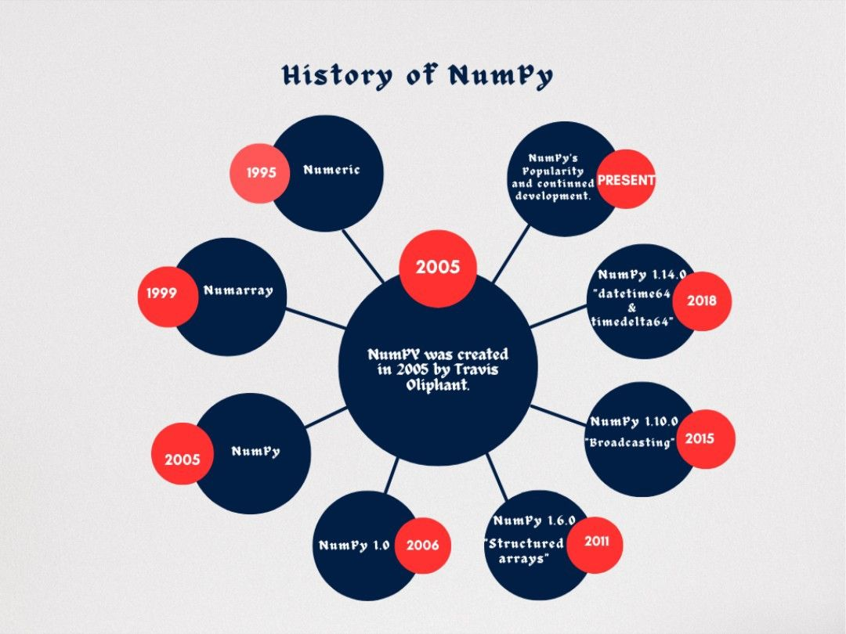

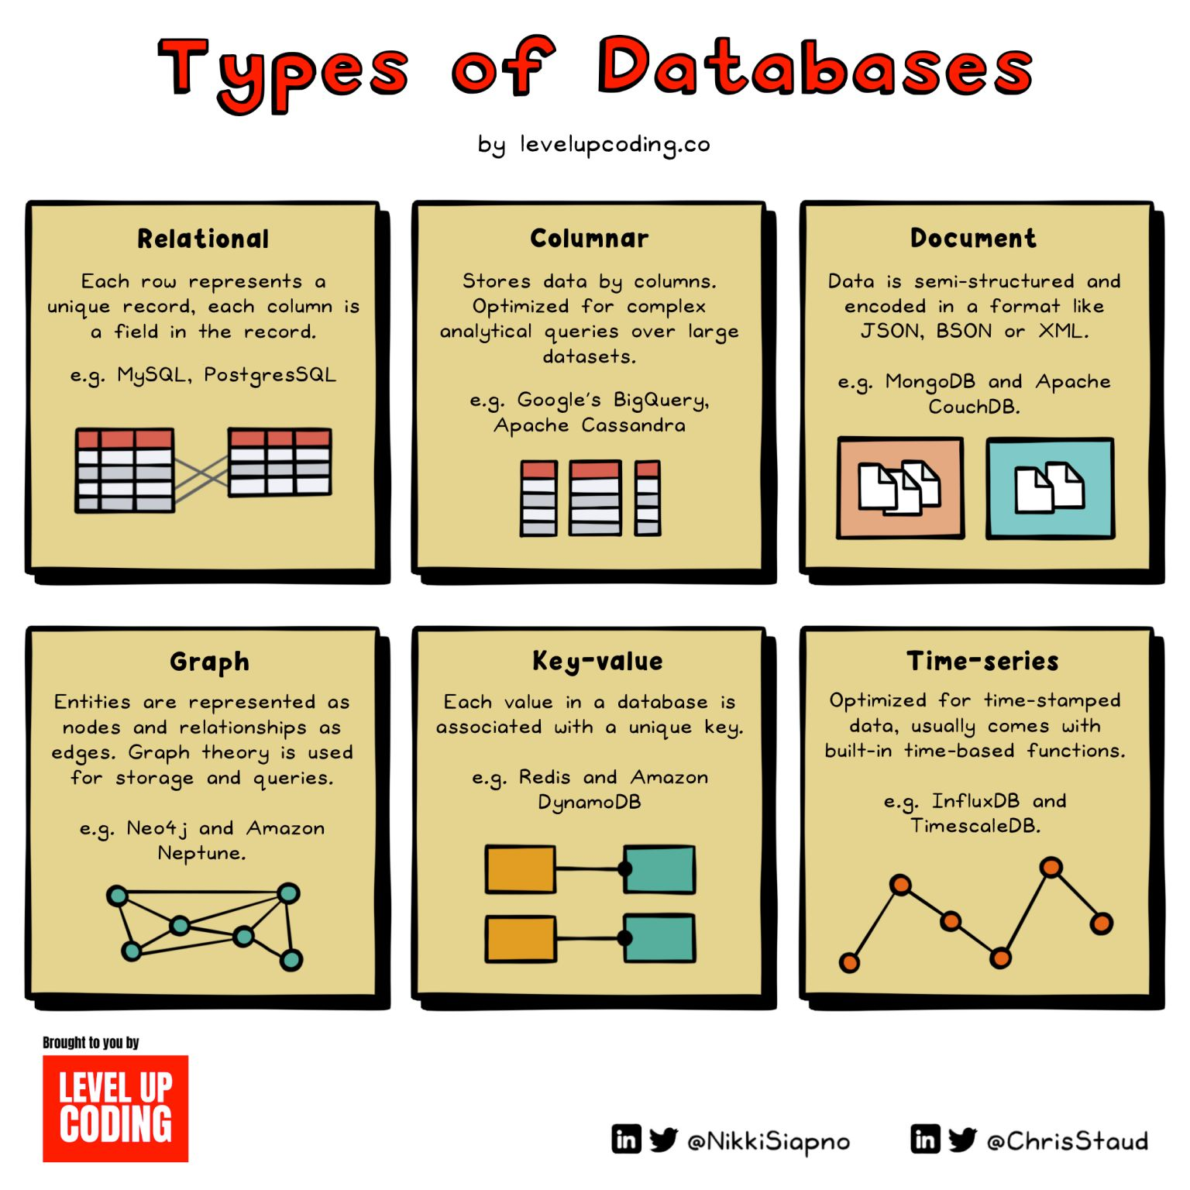

SQL is a structured query language used for managing and retrieving data from the database system.  
Whereas MySQL is a Relational database system that uses SQL to query data from the databases.  
  
✔️SQL supports user-defined functions and XML.Whereas MySQL does not support any user-defined function and XML.  
  
✔️In SQL, the server and database work independently Whereas MySQL servers do not work independently from databases and hence, blocks the time for the users to do anything else.   
  
✔️SQL servers are secured as no third party or outsiders are allowed to manipulate data.  
Whereas MySQL is susceptible to more security threats due to its open-source nature as it allows unauthorized users to access & manipulate data.



Hyperparameter optimization plays a crucial role in determining the performance of a machine learning model. They are one the 3 components of training.  
  
𝟛 ℂ𝕠𝕞𝕡𝕠𝕟𝕖𝕟𝕥𝕤 𝕠𝕗 𝕄𝕠𝕕𝕖𝕝:  
  
1️⃣ Training data:  
Training data is what the algorithm leverages (think: instructions to build a model) to identify patterns  
  
2️⃣ Parameters:  
Algorithm 'learns' by adjusting parameters, such as weights, based on training data to make accurate predictions, which are saved as part of the final model.  
  
3️⃣ Hyperparameters:  
Hyperparameters are variables that regulate the process of training and are constant during the training process.  
  
𝔻𝕚𝕗𝕗𝕖𝕣𝕖𝕟𝕥 𝕋𝕪𝕡𝕖𝕤 𝕠𝕗 𝕊𝕖𝕒𝕣𝕔𝕙:  
  
🔎Grid Search : Training models with every possible combination of the provided hyperparameter values a time-consuming process.  
  
🔎Random Search: Training models with randomly samples hyperparameter values from the defined distributions, a more effective search.  
  
🔎 Having Grid Search: Training models with all values, and then repeatedly "halving" the search space by only considering the parameter values that performed the best in the previous round.  
  
🔎 Bayesian Search: Starting with an initial guess of values, using performance of the model to the values. It's like how a detective might start with a list of suspects, then use new information to narrow down the list.  
  
I found these 𝟏𝟎 𝐩𝐲𝐭𝐡𝐨𝐧 𝐥𝐢𝐛𝐫𝐚𝐫𝐢𝐞𝐬 𝐟𝐨𝐫 𝐇𝐲𝐩𝐞𝐫𝐩𝐚𝐫𝐚𝐦𝐞𝐭𝐞𝐫 𝐎𝐩𝐭𝐢𝐦𝐢𝐳𝐚𝐭𝐢𝐨𝐧:  
  
📚 Optuna  
  
You can tune estimators of almost any ML, DL package/framework, including Sklearn, PyTorch, TensorFlow, Keras, XGBoost, LightGBM, CatBoost, etc with a real-time Web Dashboard called optuna-dashboard.  
  
📚Hyperopt  
  
Optimizing using Bayesian optimization, including conditional dimensions.  
  
📚 Scikit-learn  
  
different searches such as GridSearchCV or HalvingGridSearchCV.  
  
📚 Auto-Sklearn  
  
AutoML and a drop-in replacement for a scikit-learn estimator.  
  
📚 Hyperactive  
  
Very easy to learn but extremly versatile providing intelligent optimization.  
  
📚 Optunity  
  
Provides distinct approaches such plethora of score functions.  
  
📚 HyperparameterHunter  
  
Automatic save/learn from Experiments for persistent optimization  
  
📚 MLJAR  
  
AutoML creating Markdown reports from ML pipeline  
  
📚 KerasTuner  
  
with Bayesian Optimization, Hyperband, and Random Search algorithms built-in  
  
📚 Talos  
  
Hyperparameter Optimization for TensorFlow, Keras and PyTorch

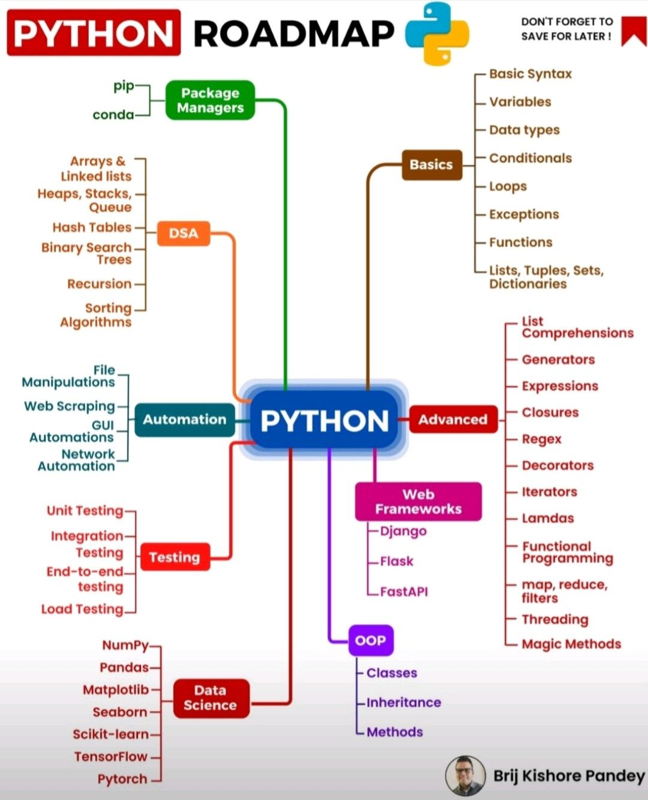

1. What is Scope Resolution in Python?  
   2. What are Python namespaces? Why are they used?  
   3. How is memory managed in Python?  
   4. How can you make a Python Script executable on Unix? Explain.  
   5. What are decorators in Python?  
   6. How do you copy an object in Python?  
   7. What is the difference between xrange and range in Python?  
   8. What is pickling and unpickling?  
   9. What is lambda and why is it used?  
   10. What are generators in Python?



Data ingestion: This involves gathering data from various sources, such as databases, files, APIs, or streaming services.  
  
🎯-Data preprocessing: This involves cleaning, validating, and transforming the raw data to ensure its quality and consistency.  
  
🎯-Data storage: This involves storing the processed data in a central repository or data warehouse, where it can be accessed and analyzed by various stakeholders.  
  
🎯-Data analysis: This involves performing various analyses on the data, such as descriptive statistics, predictive modeling, or machine learning algorithms, to extract insights and patterns.  
  
🎯-Data visualization: This involves presenting the analyzed data in a meaningful and actionable way, such as through charts, graphs, or dashboards.  
  
🎯-Data delivery: This involves delivering the analyzed data to end-users or downstream systems, such as business intelligence tools or operational applications.

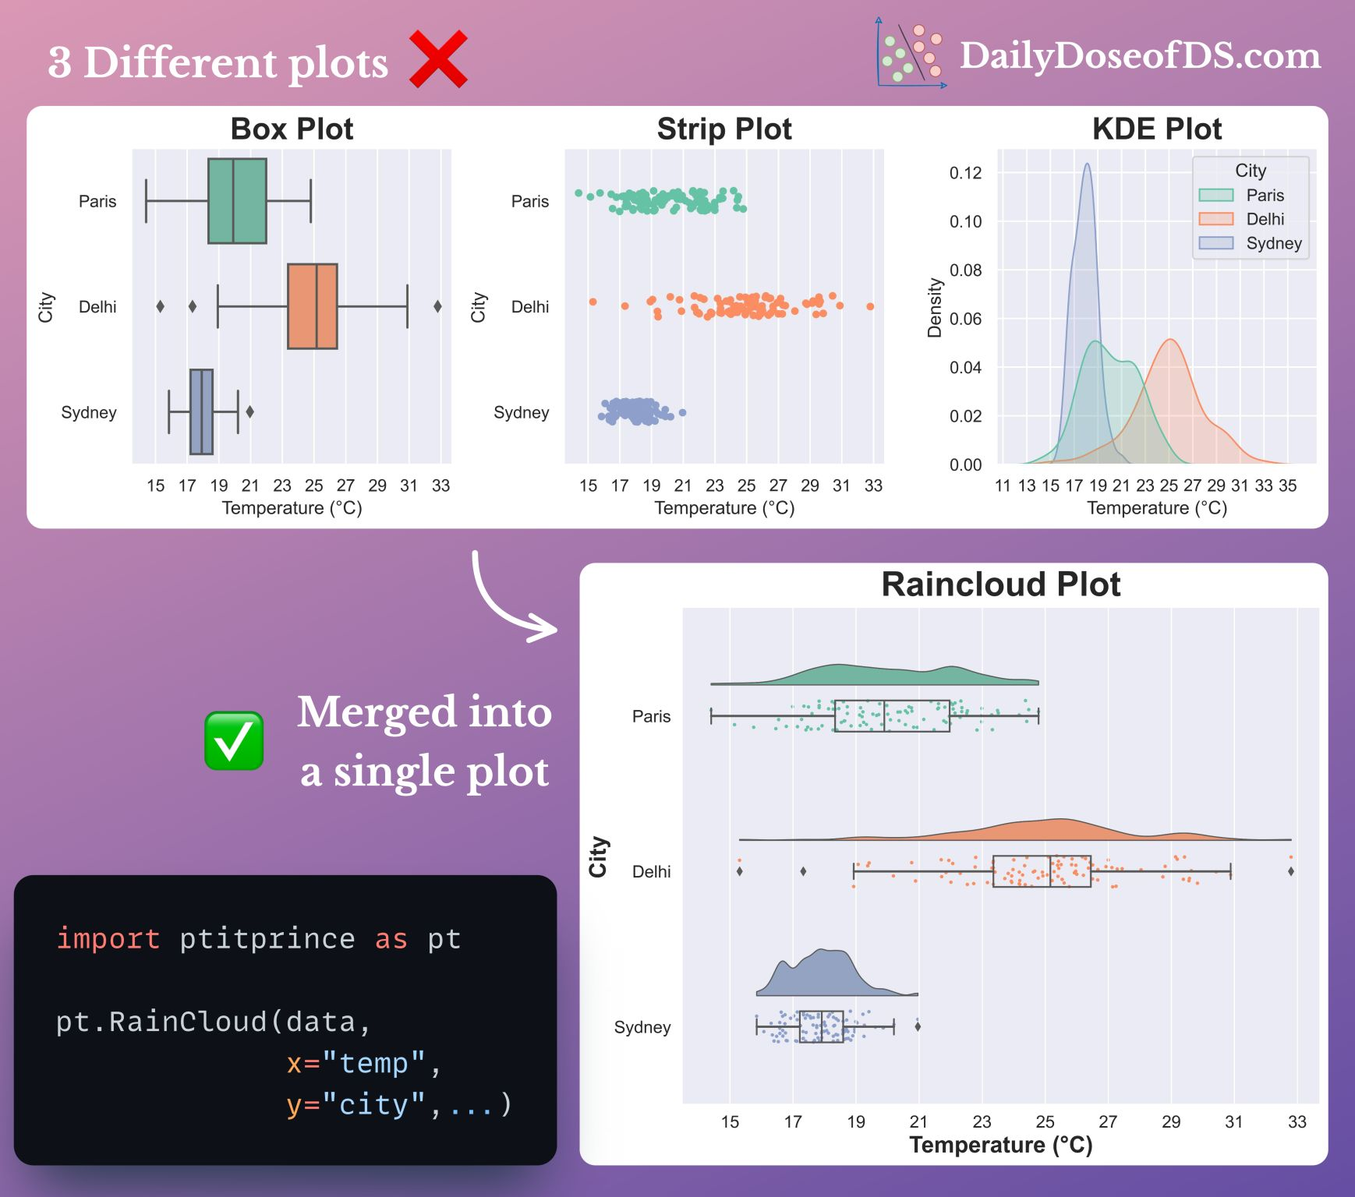

Below some popular and widely-used Python packages that can be installed using pip:  
  
1. numpy: Numerical computing library for multi-dimensional arrays and mathematical functions.  
  
2. pandas: Data manipulation and analysis library with powerful data structures and tools.  
  
3. matplotlib: Plotting library for creating static, animated, and interactive visualizations.  
  
4. scikit-learn: Machine learning library that provides a wide range of algorithms for classification, regression, clustering, and more.  
  
5. tensorflow: Deep learning framework for building and training neural networks.  
  
6. keras: High-level neural networks API that runs on top of TensorFlow or other deep learning backends.  
  
7. requests: Library for making HTTP requests, handling response data, and working with APIs.  
  
8. beautifulsoup4: HTML parsing library for web scraping and extracting data from HTML and XML documents.  
  
9. Django: High-level web framework for building robust and scalable web applications.  
  
10. Flask: Lightweight web framework for developing web applications with simplicity and flexibility.  
  
11. SQLAlchemy: SQL toolkit and Object-Relational Mapping (ORM) library for working with databases.  
  
12. seaborn: Statistical data visualization library built on top of matplotlib, providing beautiful and informative visualizations.  
  
13. nltk: Natural Language Toolkit for text processing and analysis, including tokenization, stemming, tagging, and more.  
  
14. pytorch: Deep learning framework with a focus on dynamic computation graphs and GPU acceleration.  
  
15. boto3: SDK for Amazon Web Services (AWS), providing easy access to AWS services and resources.  
  
16. scikit-image: Library for image processing and computer vision tasks, with a wide range of image manipulation and analysis functions.  
  
17. pytest: Testing framework for writing and executing unit tests in Python.  
  
18. opencv-python: Computer vision library with functions for image and video processing, object detection, and more.  
  
19. flask-restful: Extension for Flask that simplifies building RESTful APIs.  
  
20. networkx: Library for the creation, manipulation, and study of the structure, dynamics, and functions of complex networks.

Emphasize only the content  
Some CVs tend to overuse bold formatting, diminishing the impact of truly important information such as quantifiable achievements and outcomes. Ensure that you selectively emphasize only the elements that hold genuine significance.  
  
2. Maintain consistent font and font size  
Use the same font throughout your CV. While it is acceptable to use larger font sizes for headings, the font size for the main body of text should remain consistent across different sections.  
  
3. Include value-adding content exclusively:  
As candidates, we often feel compelled to include every single experience and accomplishment in our CVs, without considering its relevance from the recruiter's perspective. For example, merely stating that you "attended a conference" or were "part of an NGO's activity" does not provide sufficient value. Instead, focus on highlighting key learnings and the impact created. Avoid mentioning activities that lack significance or fail to contribute meaningfully to your profile.  
  
4. Establish a strategic flow:  
It is crucial to arrange your professional experience and academic qualifications in an order that reflects their relevance. Starting with academic experience may be more appropriate for fresh graduates, while experienced individuals should begin with their most recent professional experience. Since every company seeks distinct personality traits and skills, it is essential to customize your CV for each organization you apply to.  
  
Possessing the necessary qualities and skillset for a job is not enough if you fail to showcase them effectively. In a sea of thousands of CVs, only a select few are chosen for further consideration. What sets these CVs apart from the rest? Undoubtedly, something is outstanding about them.