# **Human body Measurement using computer vision**

**Aim :** The main aim of this code is, non-contact body measurement . This kind of system can be very useful in surveillance , physical healthcare , on-line business and virtual fittings .

**Approach :** The approach I have taken is to first locate the human , then locate the key-points in the human and then measure distance between some key points .

**Pre-requisite :**

Python 3.6

Cv2 3.4.2

Numpy 1.15.4

Matplotlib 2.2.2

Openpose

Gluoncv 0.3.0

Scipy 1.1.0

Imutils 0.5.1

Also downloaded some pretrained models from the following link :

<https://github.com/CMU-Perceptual-Computing-Lab/openpose/tree/master/models/pose>

**Steps :**

Upon trying various methods I finally achieved the results by following the below steps.

1. The first step is to instance segmentation . In this step I have used a pretrained COCO data trained on mask - R-CNN for instance segmentation.
2. The second step is to detect Key-points in the human body and to achieve this I have used a pretrained caffe model ( deep neural nets ), this gives us 18 key points in the human body .
3. The final step is to measure some body parts . For this we need to know at least one parameter i.e. either the height or width . Here our known parameter is the height(cm) and I have calculated the pixel height of the person by using Euclidean distance formula. This gave me the conversion of one pixel to cm , from this I have calculated the rest of the parameters like arm length , shoulder length etc. .

Below is the flow chart of the steps :

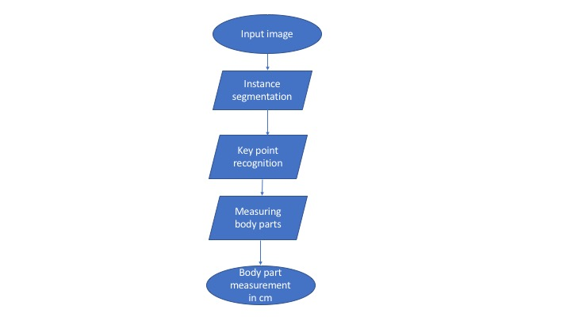

Fig 1