**SOCIAL WELFARE SITE**

Develop a Social welfare site, where most of the non-profit organizations are registered. There would be two types of registrations:

1. Volunteer registration
2. Donator registration

**Roles:**

Volunteer: Candidates interested in volunteering can register through this website and look up for events or organizations that they want to volunteer.

Event Manager: The manager of these organizations or events may approve their volunteering request based on the criteria of match.

Non-profit organizations: Various registered non-profit organizations would display their requirements on the site.

Donator: The donator can register to the website and lookup for non-profit organizations near his area of address or search and check the requirements of these organizations and donate stuffs accordingly.

UserRegistered Controller:

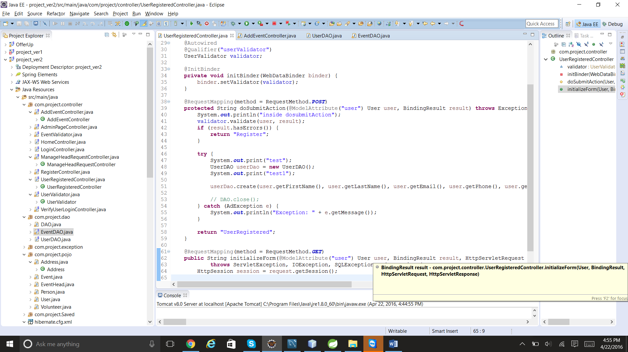

UserDAO:

