Exploratory Data Analysis (EDA) Summary
Report
Geldium Credit Card Delinquency Prediction | Prepared by: Apoorv Bajpai, AI Transformation Consultant, Tata iQ | For: Charithra, Senior Manager

1. Introduction
Geldium has seen a rise in credit card delinquency, with more customers missing payments beyond the 30-day threshold. Before any predictive model is built, this report checks whether the underlying customer data is reliable and usable.
Goals of this report: (1) assess the structure, completeness and consistency of the dataset; (2) treat missing and inconsistent values; (3) identify patterns, anomalies and risk indicators that should be considered in later stages of the project.

2. Dataset Overview
The dataset contains one row per credit card customer, with demographic, financial and 6-month payment history fields. The initial review found no duplicate records but did find missing values and inconsistent category labels, described below.
Key dataset attributes:
- Number of records: 500 customers, 19 columns (no duplicate rows, no duplicate Customer_IDs).
- Key variables: see table below.
- Data types: Numerical (Age, Income, Credit_Score, Credit_Utilization, Missed_Payments, Loan_Balance, Debt_to_Income_Ratio, Account_Tenure); Categorical (Employment_Status, Credit_Card_Type, Location, Month_1 to Month_6 with values On-time / Late / Missed); Binary target (Delinquent_Account); Identifier (Customer_ID).

Variable | Description / role
Delinquent_Account | Target. 1 = delinquent, 0 = not delinquent. 80 customers (16%) are delinquent, 420 (84%), so the dataset is imbalanced
Missed_Payments | Count of missed payments (payment history)
Month_1 to Month_6 | Monthly payment status: On-time, Late or Missed (payment history)
Credit_Utilization | Share of credit limit in use (0.05 to 1.03)
Debt_to_Income_Ratio, Loan_Balance | Debt burden indicators
Income, Employment_Status | Income level and employment stability
Credit_Score, Account_Tenure, Credit_Card_Type | Credit profile
Age, Location | Demographic fields. Used only for fairness monitoring, not as predictive features
Customer_ID | Identifier only. Excluded from analysis

Inconsistencies found: Employment_Status had the same category written several ways ("EMP", "Employed", "employed", "retired"). After standardization there are 4 categories: Employed (240), Unemployed (93), Retired (87), Self-Employed (80).

3. Missing Data Analysis
Identifying and addressing missing data is critical to ensuring model accuracy. Only three variables have missing values, and the share missing is low in each case.
Key missing data findings:
- Variables with missing values: Income (39 rows, 7.8%), Loan_Balance (29 rows, 5.8%), Credit_Score (2 rows, 0.4%). All other columns are complete.
- Missing data treatment: Median imputation for all three variables, plus a binary "_missing" flag column for each so the model can learn from missingness itself. No rows or columns were deleted, and no synthetic data was needed.

Variable | Missing | Delinquency rate in missing rows | Justification
Income | 39 (7.8%) | 12.8% (5 of 39) | Median used because income is spread widely and the median is not pulled by extreme values
Loan_Balance | 29 (5.8%) | 24.1% (7 of 29) | Median imputation plus flag. The higher rate in missing rows suggests missingness may carry signal, but the group is too small to conclude
Credit_Score | 2 (0.4%) | 0% (0 of 2) | Negligible share; median imputation has no material effect

Deletion was avoided because it would reduce an already small sample (only 80 delinquent cases). Synthetic data was considered but not used: with under 8% missing in any column, a supplementary synthetic approach (bootstrapping or Monte Carlo, validated against real distributions) is not justified. The missingness mechanism (MCAR, MAR or MNAR) was not formally tested and should be confirmed with Geldium.

4. Key Findings and Risk Indicators
The analysis compared delinquent and non-delinquent customers on each risk factor and checked correlations with the target.
Key findings:
- Correlations observed between key variables: Relationships between individual features and delinquency are very weak. The largest absolute correlation with Delinquent_Account is 0.045 (Income), and all others are below 0.04. Delinquent and non-delinquent customers have almost identical averages on utilization (0.51 vs 0.49), DTI (0.31 vs 0.30) and monthly missed payments (2.01 vs 2.02). Missed_Payments is slightly lower for delinquent customers (2.85 vs 2.99), the opposite of what is expected.
- Unexpected anomalies: see table below. The most important is that payment history fields contradict each other.

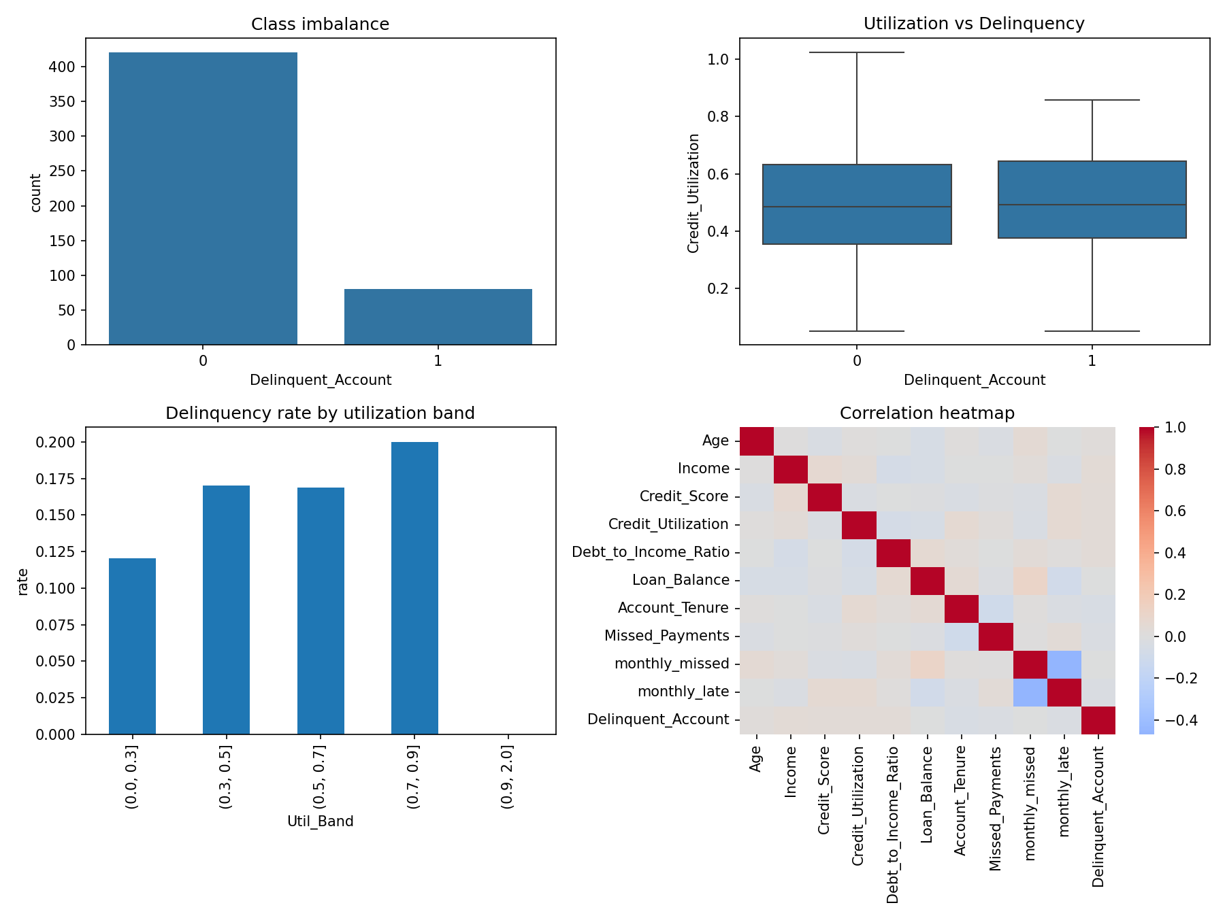
Figure 1: Class imbalance, utilization by delinquency status, delinquency rate by utilization band, and correlation heatmap.
Segments with a directional difference (indicative only, groups of 76 to 182 customers):
Factor | Delinquency rate | Note
Credit utilization | 12% (under 0.3), 17%, 17%, 20% (0.7 to 0.9) | Only clear upward trend. 0.9+ band has just 14 rows
Credit card type | Business 21.3%, Student 17.9%, Platinum 11.8% | Possible signal, needs testing
Employment status | Unemployed 19.4%, Retired 11.5% | Small gap
Age group (fairness check) | 45-60: 21.7%, 30-45: 12.3% | Monitor only, do not use as a feature
Location (fairness check) | Los Angeles 19.6%, New York 12.0% | Monitor only, do not use as a feature

Anomalies requiring further investigation:
Anomaly | Detail
Payment history contradiction | 77 customers have Missed_Payments = 0, yet 68 of them show at least one "Missed" month in Month_1 to Month_6
Delinquent but strong profile | 25 delinquent customers have a credit score above 700; 24 delinquent customers have 1 or fewer missed payments
Utilization above 100% | 4 customers (maximum 1.03). May be over-limit accounts or data errors
Implausible combinations | 12 customers under age 22 with income above 150,000; unemployed customers have a median income (about 106k) similar to employed customers (about 109k)
Zero tenure | 28 accounts with Account_Tenure = 0
Outliers (IQR method) | None found in any numerical column

Implication: the weak relationships and internal contradictions suggest the current data may limit how accurate a delinquency model can be. Findings from this sample should be treated as directional, not conclusive.

5. AI & GenAI Usage
Generative AI tools were used to summarize the dataset, suggest a missing-data strategy, generate the Python EDA code, and help detect patterns and anomalies. Imputation itself was executed in Python (pandas) using median values, not generated by the AI, and all treatment decisions were reviewed by the analyst.
Example AI prompts used:
- 'Summarize key patterns in the dataset and identify anomalies.'
- 'Identify missing values in this dataset and recommend the best imputation strategy based on industry best practices.'
- 'Write Python code to compare delinquent and non-delinquent customers on utilization, DTI and payment history, and check for logical contradictions.'
Data confidentiality: this is a simulated training dataset (placeholder IDs such as CUST0001, no real customer information). In a live engagement only aggregated, anonymized statistics (column names, data types, null counts, summary statistics) would be shared with GenAI tools, never raw customer records or identifiers. Age and Location were reviewed for fairness monitoring only.

6. Conclusion & Next Steps
The dataset is structurally sound (500 records, no duplicates) and missing data is limited (under 8% in any column) and has been treated. However, individual risk factors show little relationship with delinquency, delinquent customers are only 16% of records, and the payment history fields contradict each other. A model built on this data as-is would likely have limited predictive power.
Recommended next steps:
- Confirm with Geldium how Missed_Payments and Delinquent_Account are defined (for example, whether delinquency means 30+ days past due) and reconcile Missed_Payments with the monthly status columns.
- Investigate the flagged anomalies (utilization above 1.0, zero tenure, implausible age and income combinations) with the data owner.
- Address class imbalance in modeling (for example, class weights or stratified sampling) and use recall and precision, not accuracy alone.
- Build a simple, explainable baseline model (such as logistic regression) using payment history, utilization, DTI and credit profile features, with the missing flags included.
- Run fairness checks across age group and location before any deployment, and keep these fields out of the feature set.
- Request more data or additional signals (such as longer payment history or recent credit activity) if the baseline model performs poorly.

