“COMBINED CORNER AND EDGE DETECTOR”

ABSTRACT

The proposed work is done to achieve successful implementation of a “Combined edge and corner detector”. The core aim of this project is to provide an efficient methodology for detecting corners and edges in an image. In order to detect corners, we have chosen Harris Corner detection methodology which is based on the change of gradient of Intensity in different directions. For edge detection, Canny edge detection methodology is adopted which is based on the change of gradient of Intensity in a particular direction. For ensuring accurate results, we have implemented noise reduction on the input image before corner and edge detection is done. Noise reduction through Gaussian filter is done. Our project code is aimed to provide a working python code which could draw the detected edges as well corners in the input image. Image preprocessing (like conversion of color image to gray-scale) is done to convert the image into the format which is accepted by our algorithm to work. Thus, our project provides image with highlighted edges and corners.

4

1. INTRODUCTION

1.1 CONCEPT INTRODUCTION

For successful implementation of our project, the theoretical as well as mathematical knowledge in the context of image processing is required. The basic concept of our project is to calculate the difference of intensity of each image pixel and then, based on orientation of the gradients, we classify whether the detected pixel is a corner or edge or neither corner nor an edge. The main concept used here is that if the intensity of pixel changes, then we need to find the directions of change of intensity. If the change of intensity is detected in multiple directions, then it’s a corner, and if the intensity changes in a single direction, then there is an edge along the direction of change of intensity

1.2 SCOPE AND AIM

In the current world, one of the main aim of implementing image processing is feature detection. Images are the source of large amount of data. A single image may provide a large number of features which are of high interest for use in different purposes like research, forensics, medical research, etc. Therefore, our project is aimed to provide an efficient methodology of extracting features of an image. The features that our project extracts are corners and edges. Edge detection can be used to analyze the structural characteristics of the objects or entities of an image.

2. LITERATURE SURVEY

This project is implemented based on the work done by Chris Harris and Mike Stephens for edge and corner detection in an image. Their work is our motivation and the methodology proposed in their research paper is the driving force of this project. The research paper written by them was published in 1988 but it still serves as inspiration to several modern projects. Therefore our goal in this project is to extract the knowledge from the research paper and produce a working model of the theoretical and mathematics concepts explained in the paper regarding corner and edge detection.

5

3. OVERVIEW OF WORK

3.1 PROBLEM DESCRIPTION

This project report deals with the problem of detecting corners and edges with help of Harris Corner Detection algorithm and Canny Edge Detection algorithm. We are raising this topic edge and corner detection techniques help the modern technology like digit recognition, pattern recognition, face matching etc.

Edge detection is an important problem in image processing. Edge detection is a fundamental technique which is used for compressing the data content in the images to simplify the high level image processing and modern machine learning tasks; as edge contains sufficient information about the images and edges can help to segregate the shape of the objects. Similarly, the corner detection also helps in various advanced image processing problem.

Basic concept of both edge and corner detection revolves around the identification of various pixels in the digital image at which there is a sharp change in intensity. This detection is done by various mathematical models. The major difference between corner detection and edge detection is that a pixel is corner point when change in intensity is in muti-direction and it is edge point when change in intensity is only in one direction.

3.2 MATHEMATICAL MODEL

- Direction of edge is always perpendicular to direction of change in intensity.
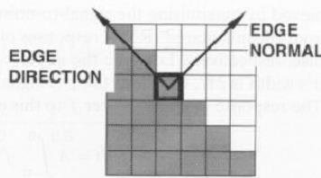

FIG.3.2.1

GRADIENT OF PIXELS:
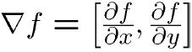

6

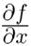
Here, change in intensity in x-direction. change in intensity in y-

direction.

ERROR FUNCTION:
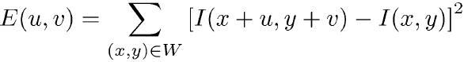

Here, 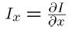

So, finally
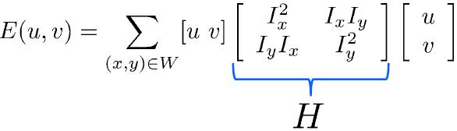

FIG. 3.2.2

HARRIS OPERATOR:
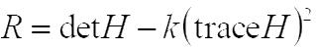

Here, k: empirical constant (0.04 – 0.06)

3.3 METHODOLOGY

- We select a window which is traversed over the image.

- The changes in the intensity values on shifting the window are observed and the gradient plots are generated.

- If there is an edge, there is change in intensity in a particular direction only.

- If there is a corner, significant changes are observed in all directions.

- The concepts of integration, matrices and determinants are used.

- To find the change in the intensity values on shifting the window, we find the value of e (u, v) where (u, v) is the shift of window and “e” is the error function.

- Now, we find the Eigen values of the matrix “H”. Then we find the points for which “Eigen value>threshold”.

- Finally we select those points where “eigen value is local maximum” as features of interest points.

7

3.3.1 METHODOLOGY FOR CANNY EDGE DETECTOR

- Apply Gaussian filter.

- Find magnitude and orientation of gradient.

- Non- maximum suppression (using two threshold values T1 and T2)

- Linking and thresholding (hysteresis thresholding). If T1<T2 use T2 for edge construction and T1 for edge Linking.

3.3.2 METHODOLOGY FOR HARRIS CORNER DETECTOR

1. Compute Gaussian derivatives at each pixel.

2. Compute second moment matrix ‘H’ in a Gaussian window around each pixel.

- Compute corner response function.

- Threshold ‘R.’

- Find local maxima of response function (non-maximum suppression).

8

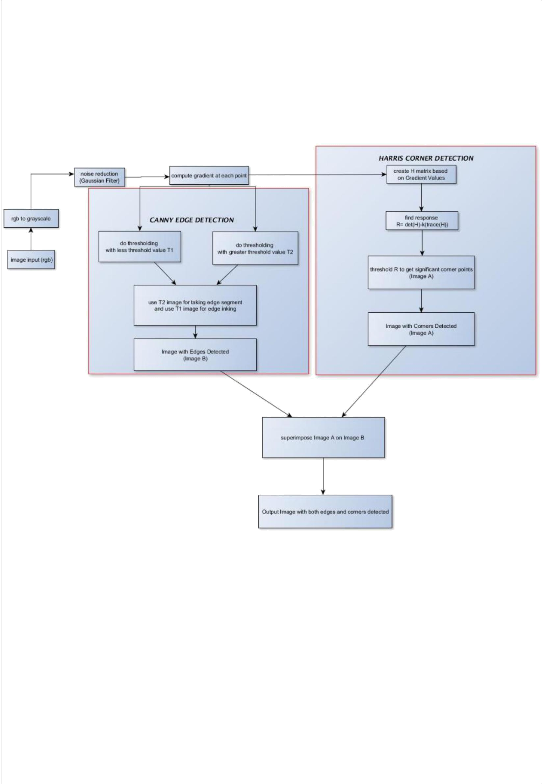

3.3.3 BLOCK DIAGRAM

FIG. 3.3

The Block Diagram is constructed based on the methodology described in section 3.3.1 and 3.3.2

9
4. IMPLEMENTATION

4.1 MODULE DESCRIPTION
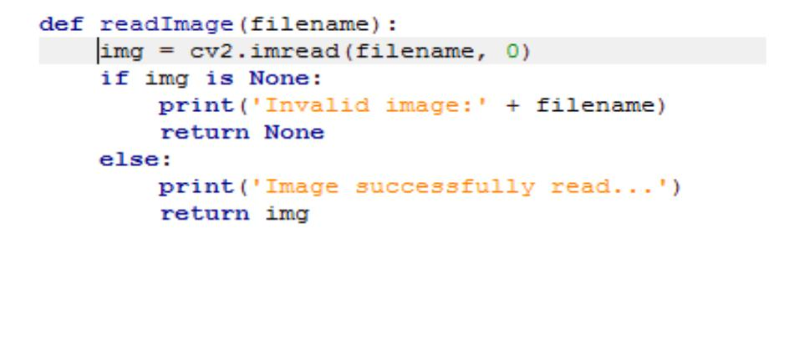

FIG 4.1.1

This function is meant for reading the image from the desktop. Here “cv2.imread (//filename of image)” helps to read the file from the system. If there is no image as per the direction then it shows “Invalid Image:” else “Image successfully read…”
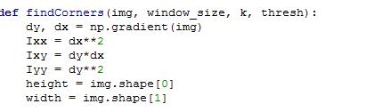

FIG 4.1.2

In this function “findCorners” we define certain attributes img, window_size, k and thresh. Here img is image matrix, window_size is size of window matrix, k is empirical constant and thresh is threshold.

Here, dy and dx are methods to find the gradient. Also, Ix is df/dx and Iy is df/dy. Also, height variable defines number of rows in the image matrix and width variable defines number of columns in image matrix.
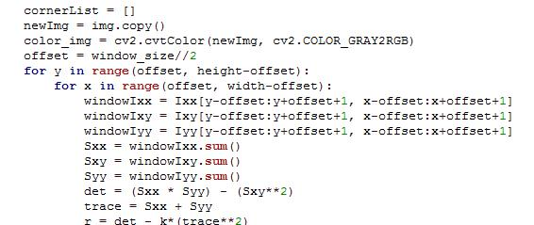

FIG 4.1.3

10

Now, in this module we develop H matrix and also finds the Harris Constant, where r = det – k*(trace**2).
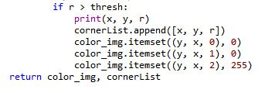

FIG 4.1.4

This part of the code deal with thresholding. Here, we don’t count the points whose intensity value is smaller than threshold value.
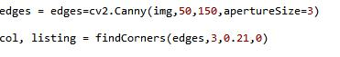

In this part of the code we call function for edge detection based on canny edge detection algorithm. Command ‘cv2.Canny(img, 50, 150, apertureSize=3) is used for this purpose. In this line img refers to matrix of pixels, aperture Size is size of window, 50 and 100 are the lower and higher value of the intensity range. Also, command col, listing = findCorners(egde,3,0,0.21,0) merge and shows both corners and edges in the same output for a picture.

4.2 SOURCE CODE

import cv2

import numpy as np

import sys

import getopt

import operator

import matplotlib.pyplot as plt

def readImage(filename):

img = cv2.imread(filename, 0)

if img is None:

11

print('Invalid image:' + filename)

return None

else:

print('Image successfully read...')

return img

def findCorners(img, window_size, k, thresh):

dy, dx = np.gradient(img)

Ixx = dx**2

Ixy = dy*dx

Iyy = dy**2

height = img.shape[0]

width = img.shape[1]

cornerList = []

newImg = img.copy()

color_img = cv2.cvtColor(newImg, cv2.COLOR_GRAY2RGB)

offset = window_size//2

for y in range(offset, height-offset):

for x in range(offset, width-offset):

windowIxx = Ixx[y-offset:y+offset+1, x-offset:x+offset+1]

windowIxy = Ixy[y-offset:y+offset+1, x-offset:x+offset+1]

windowIyy = Iyy[y-offset:y+offset+1, x-offset:x+offset+1]

Sxx = windowIxx.sum()

Sxy = windowIxy.sum()

12

Syy = windowIyy.sum()

det = (Sxx * Syy) - (Sxy**2)

trace = Sxx + Syy

r = det - k*(trace**2)

if r > thresh:

print(x, y, r)

cornerList.append([x, y, r])

color_img.itemset((y, x, 0), 0)

color_img.itemset((y, x, 1), 0)

color_img.itemset((y, x, 2), 255)

return color_img, cornerList

edges = edges=cv2.Canny(img,50,150,apertureSize=3)

col, listing = findCorners(edges,3,0.21,0)

cv2.imshow('k',col)

cv2.waitKey(0)

cv2.destroyAllWindows()

13

4.3 SNAPSHOTS

- TEST CASE 1- COMBINED EDGE AND CORNER DETECTION(CHESSBOARD)

INPUT IMAGE:- OUTPUT IMAGE:-

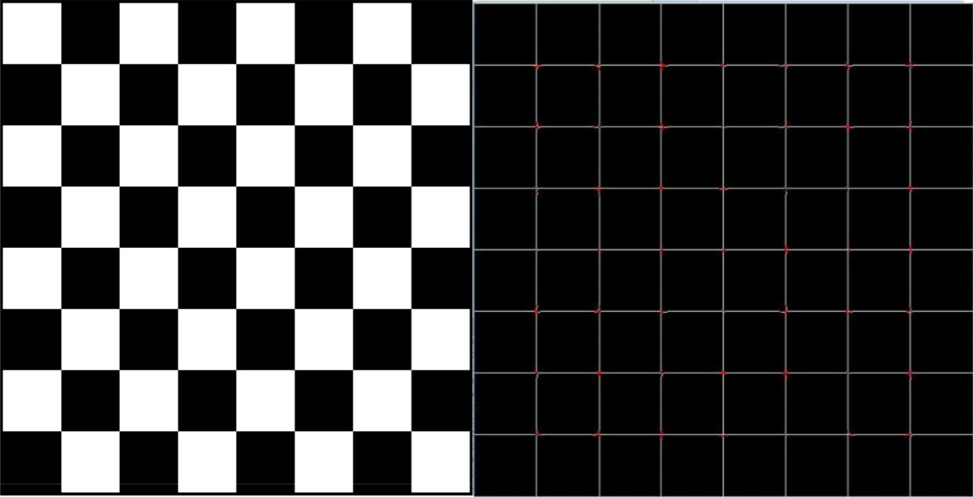

FIG 4.3.1

- TEST CASE 2- EDGE DETECTION INPUT IMAGE:-


Fig. 4.3.2 – original image.

14

OUTPUT IMAGES:-

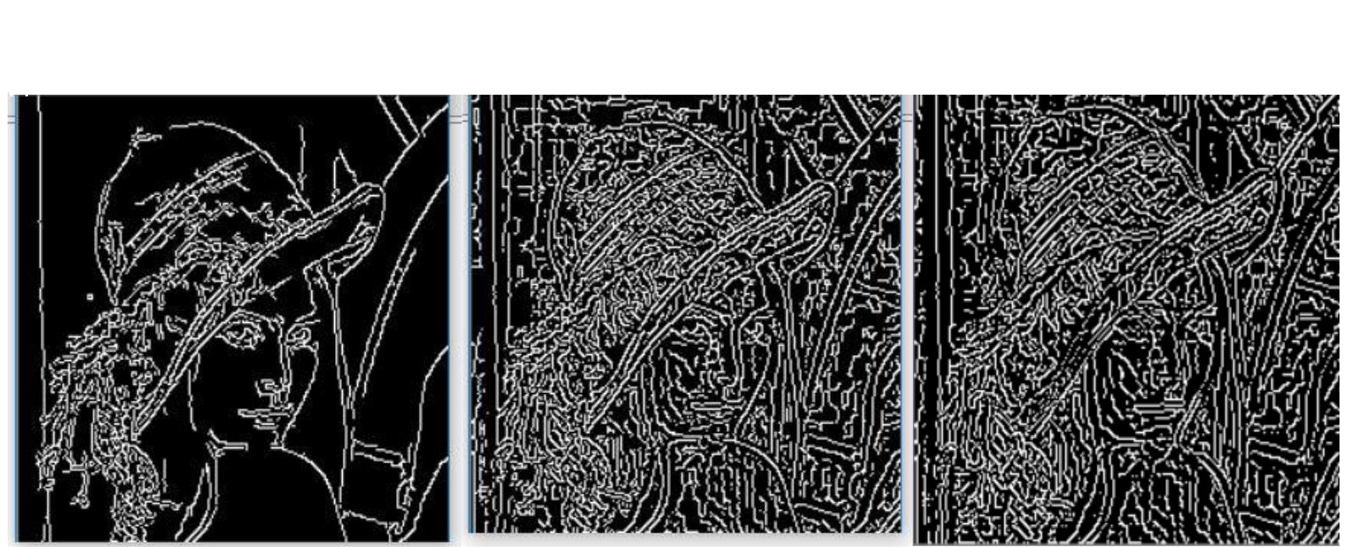

threshold1=50, thrershold2=150 | threshold1=50, thrershold2=150 | threshold1=50, thrershold2=150
aperturesize=3 | aperturesize=5 | aperturesize=7

Fig4.3.3-change in aperture size

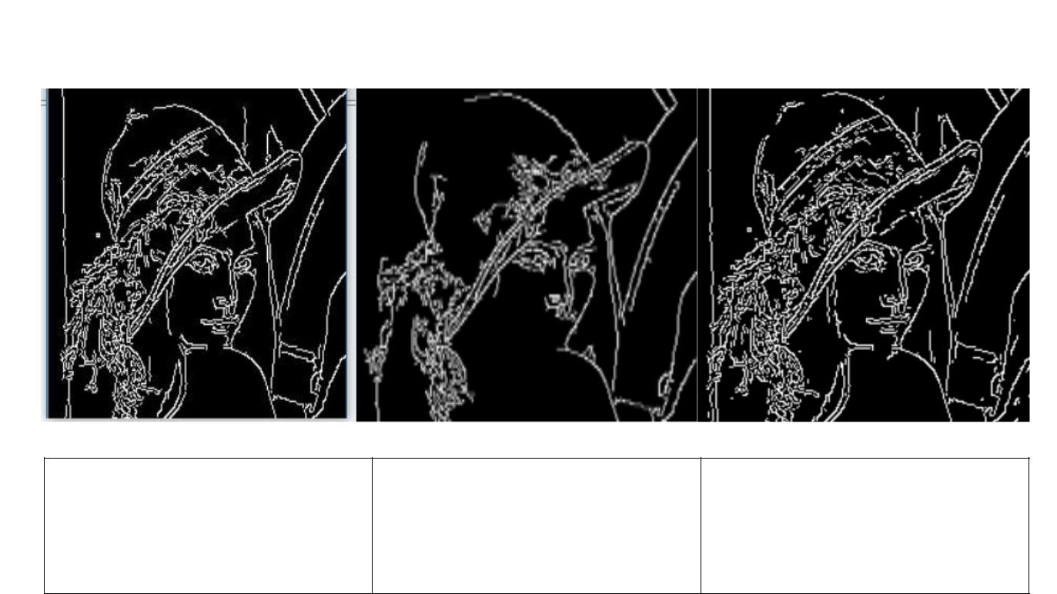

threshold1=50, thrershold2=150 threshold1=25, thrershold2=400 threshold1=70, thrershold2=100

aperturesize=3 aperturesize=3 aperturesize=3

Fig. 4.3.4-Change of threshold range.

15

- TEST CASE 3- CORNER DETECTION INPUT IMAGE:-

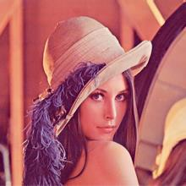

Fig. 4.3.5 – original image.

OUTPUT IMAGES:-

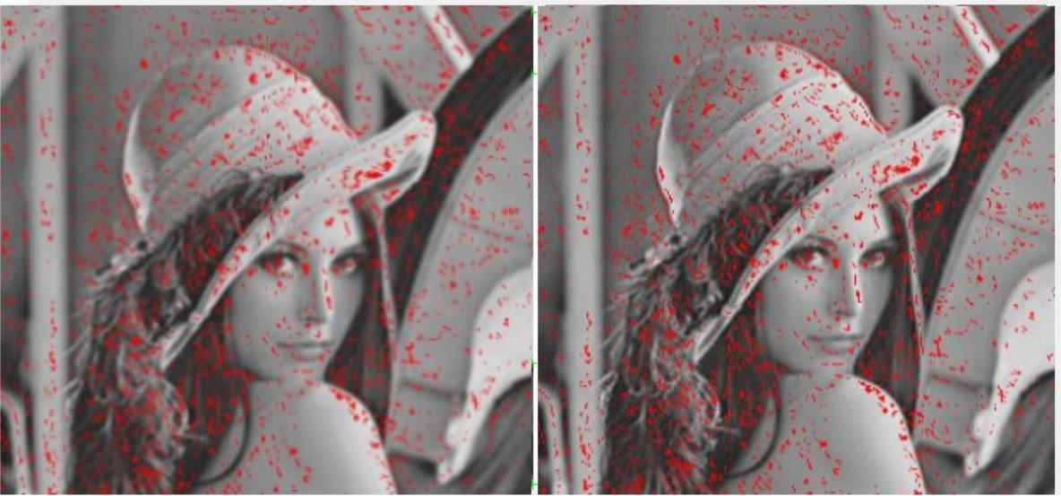

Threshold=75 | Threshold=20
Window_ size=3 | Window_ size=3

Fig.4.3.6 – change in threshold

16

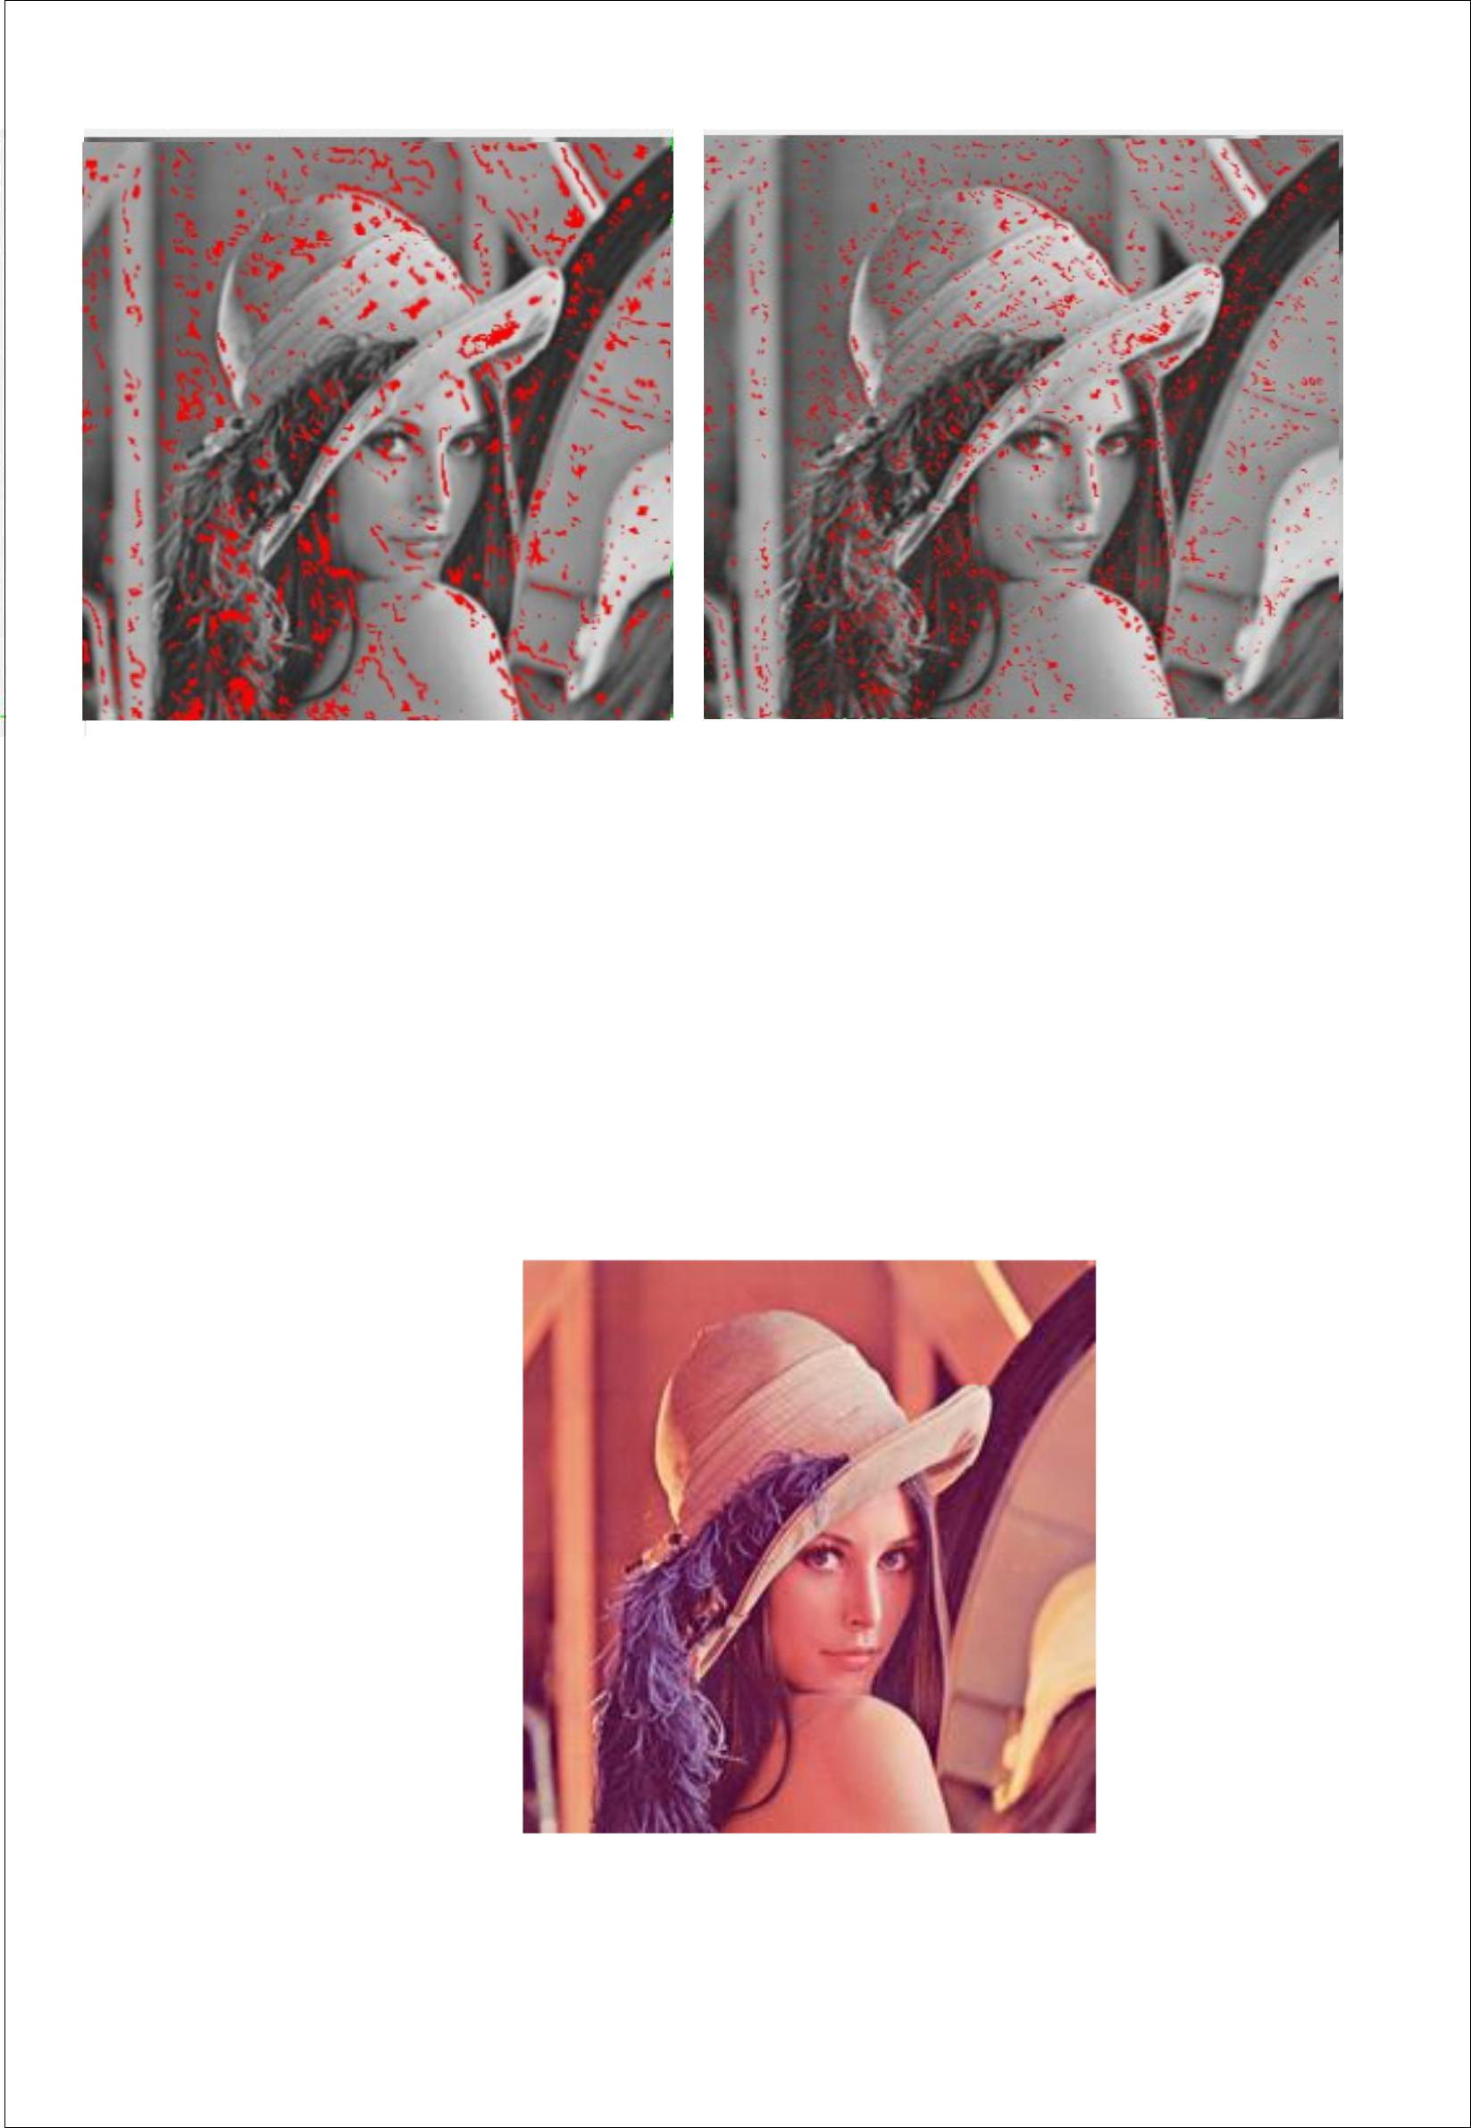

Threshold=100 | Threshold=100
Window_ size=4 | Window_ size=2

Fig.4.3.7 – change in window size

- TEST CASE 4 – COMBINED EDGE AND CORNER DETECTION (ANALYSIS).

INPUT IMAGE:-

Fig. 4.3.8 – Original Image

17
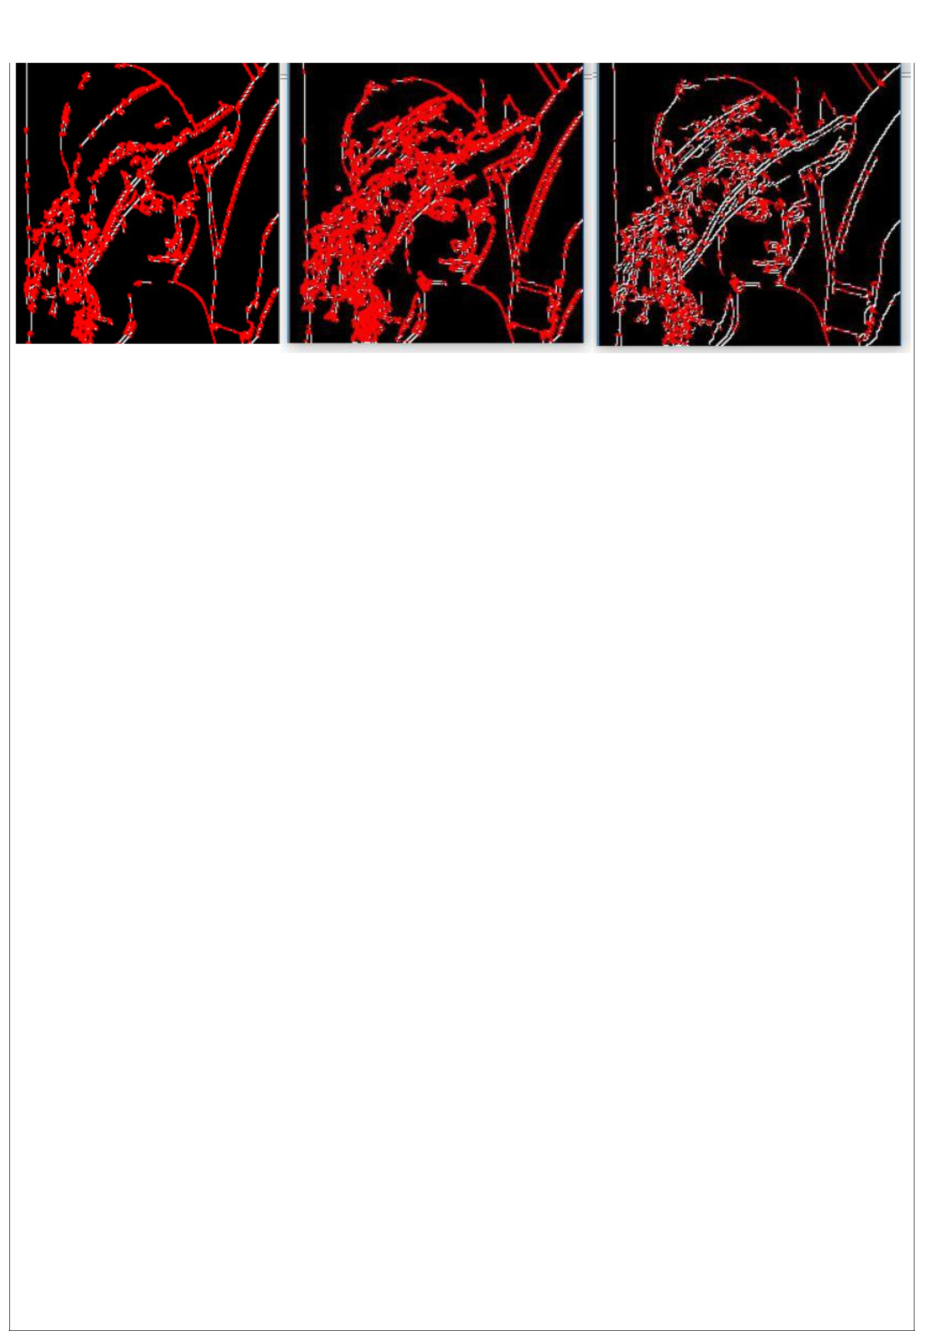

Window size=3 | Window size=4 | Window size=3
Harris constant value=0.15 | Harris constant value=0.15 | Harris constant value=0.15
Threshold=0 | Threshold=0 | Threshold=400

FIG 4.3.9

