



**Executive Summary:**

**Version 1.0**

This is a telegram bot. This bot will be similar to iCenter.co.

Revision History

|  |  |  |  |
| --- | --- | --- | --- |
| Doc. Version | Date | Author | Description of Revision |
| 1.0 | 03/10/2018 | CIS | Initial document & estimation |

TABLE OF CONTENT

1. Company Introduction
2. Project Briefing
3. Assumptions
4. Queries
5. Target Platform Baseline
6. Scope of work
7. Resource
8. Out of Scope
9. Prerequisite
10. Reporting tools
11. Project Monitoring
12. Service after Deployment
13. QA Notes
14. Terms & Policies

1. COMPANY INTRODUCTION

Established in 2003, Cyber Infrastructure Pvt. Ltd. (CIS) is a leading IT and consulting company in Central India. Since 2003, CIS has been providing highly optimized technology solutions and services for SMEs and large scale enterprises across the world. Our global delivery standards have received accolades in the form of prestigious quality certifications of CMMI Level 3 and ISO 9001:2015.

CIS has worked with 2100+ clients in more than 100 countries. Our expertise and experience ranges across a wide range of industry domains like education, finance, travel and hospitality, retail and e-commerce, manufacturing, gaming, media and entertainment, logistics, hi-tech, telecommunication, health care, and many more.

CIS offers comprehensive IT services such as custom application development, mobile application development, creative web design, Microsoft solutions, SAP solutions, open source development, Java development, Oracle development, big data solutions, digital experience solutions, CAD/CAM architectural services, testing automation, infrastructure automation and cloud, digital marketing, ITeS, etc.

**Our Partner**



**Key Highlights of CIS**

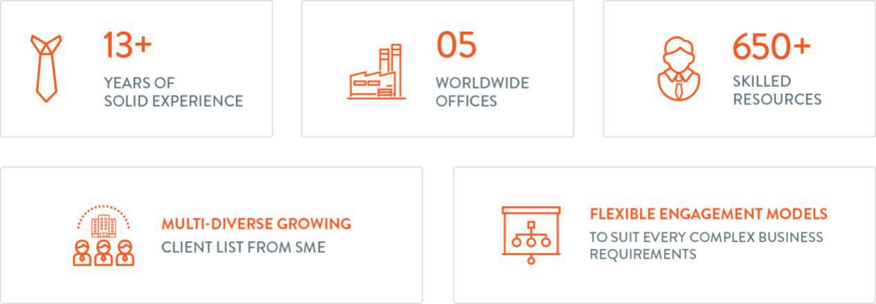

**Our Core Values**



2. PROJECT BRIEFING / EXECUTIVE SUMMARY OF THE PROJECT

We have to develop an audio management application.

3 ASSUMPTIONS FOR ESTIMATION

|  |  |
| --- | --- |
| S. No | Details |
| 1 | The above application estimation is for desktop application. |
| 2 | We are not going to write test cases for this application. |
| 3 | Please note that any point/feature which has not been mentioned in the document(scope of work) will be considered as new work/task and for that, time estimation will be provided. Also, above estimation will be valid for 45 days only. After that, we would review and re-estimate it if needed. |
| 4 | Please inform us in case, if we have forgot to mention any essential functionality that must be included while project development. |
| 5 | Please inform us in case, if we have mentioned any unnecessary modules that must be excluded while project development. |
| 6 | If you want to add any other feature/s, then please let us know. We will include it and will update the document. |
| 7 | Estimation time will only cover the creating desktop applications for both raspberry pi and your PCs. |
| 8 | Document / Deliverable: Defect Reports (All defects will be maintain through PMS or client required any specific tool, otherwise separate sheet will be maintain) |
| 9 | No any kind of automation.  No test cases and any other test documentation(Test Plan, Test Cases, Scenario, application flow ). If required then we need to estimated accordingly. Application will tested on 1 Language i.e English only. |

4. QUERIES FOR CLIENT(Answers may impact estimation time & cost)

|  |  |
| --- | --- |
| S. No | Details |
| 1 | NA |

5. TARGET PLATFORM

|  |  |  |  |  |
| --- | --- | --- | --- | --- |
| S.No | Platform | Operating System | Device/Make/Version | Included |
| 1 | Windows and raspberry pi | Windows and raspbian. |  |  |

6. SCOPE OF WORK

**6.1 Audio Management Application Development**

|  |  |  |  |
| --- | --- | --- | --- |
| S.No | Task | Sub Task | Remark |
| 1 | Analysis and Prepare Plan |  |  |
| 2 | File Transfer GUI application. | Start | This will be the start of the application. From here you will send the audio files you want to play on the multiple sound cards. |
| 3 | Play Audio |  | This will be the application available on the raspberry pi device. |
| 3.1 |  | Dashboard | This will be the GUI to interact with audio files to play.  Here You will open up all the files that you want to play, our application will merge those files in the background and play them on all the available sound cards. |

Note : its ballpark estimation as per the assumptions.

7. RESOURCES

|  |  |  |  |  |  |
| --- | --- | --- | --- | --- | --- |
| S.No | Skills/Technology | No. of Resources | Time Required (Hours) | Duration (Days) | Cost in USD |
| 1 | Python, PyQt. | 1 |  | 10 Days (Approx) | xx |
| 2 |  |  |  |  | xx |
| 3 |  |  |  |  | xx |
| 5 |  |  |  |  | xx |
| 6 |  |  |  |  | xx |

8. OUT OF SCOPE

|  |  |
| --- | --- |
| S. No | Details |
| 1 | Cloud based testing, white box testing, Test data, Performance testing and any kind of automation testing. |
| 2 | Any other test documentation.(Test cases, Test plan, Test strategy), User Documentation, |

9. PREREQUISITES

|  |  |
| --- | --- |
| S. No | Details |
| 1 |  |
|  |  |

10. REPORTING TOOLS

We will give you access of CIS PMS (Project Management System) to you and your in-house team, you will be able to get updates from CIS team on daily basis, can post your inputs, feedbacks, documents etc. and/ or add your own tickets, for CIS Team member to work on.

11. PROJECT MONITORING

Project will be monitored and managed by CIS Project Manager(s) and before any deployment it will be checked by CIS QA Team focusing on delivering a working, successful Product.

We will give you the access of development server/ Alpha Testing Server of CIS (max 1 CPU, 1 GB RAM, 300 MB SSD Space), so that you can check the project and daily work done by CIS team members. More Alpha server resource may cost additional, please check with your accounts manager at CIS.

12. SERVICE AFTER DEPLOYMENT

We will provide free bug fixing services for the work we have completed as per our Sales Agreement with you, excluding for:

* Issues in any pre-existing code, we did not work on, but may be impacted (Specially in case of maintenance projects).
* Any out of scope bug or change requests which are not covered in this document.

13. QA Notes

1.Estimation time will only cover the manual testing (End-to-End Testing).

2.Types of Testing performed: Smoke Testing, Integration Testing, Retesting and Regression Testing, Usability Testing.

3.Document / Deliverable: Defect Reports (All defects will be maintain through PMS or client required any specific tool,otherwise separate sheet will be maintain)

4.Web application should be test on latest browsers Chrome, Safari, Mozilla/IE any 3 browsers only, if any extra browser or version testing required then it would increased time line again.

5.No any kind of automation.

6.No test cases and any other test documentation(Test Plan, Test Cases, Scenario, application flow ). If required then we need to estimated accordingly.

7. We will tested on 1 Language i.e English only.

**Remarks:**

QA estimation is depend on mentioned requirements, if any requirement change at any point of time than QA estimation change accordingly.(Primarily, QA Estimation is based on current requirements)

14. TERMS & POLICIES

* We also work on 1st, 3rd & 5th Saturday of the month, so that you will have more interaction and more working hours with team members.
* We will give you services level agreement for the project on which we agreed on. Including all features and functionality with Payment Terms.
* We will provide you partial supervisor who ensures the quality & enterprises level standard solution. He/ She will monitor the project/work progress well.
* Team will have regular meeting with you on SKYPE/JOIN ME/GOTO MEETING OR ON CALL so that everyone should be on same page.
* Team will send you regular report through PMS so that you can check the work/task done each day.
* It is not a very deep drill down estimation, it may change during project execution, if so client will be informed and discussed. Appropriate cost will be paid by the client.