Injection-Molding Predictive Maintenance Digital Twin
Prototype Overview — what was built, how it works, and how to extend it

1. Goal
Decide when exactly to replace an injection-molding machine — neither too early (wasted residual life, lost capital) nor too late (catastrophic failure, zero resale value). The prototype predicts Remaining Useful Life (RUL) per component, converts that into a calendar replacement date and an urgency band, and surfaces it all in a live dashboard so an operator can plan interventions component-by-component.
The replacement decision is anchored on three health constants exposed via the API:
FAILURE_THRESHOLD = 0.20 # below this: imminent failure, do not run
OPTIMAL_REPLACE_LOW = 0.35 # sweet-spot lower bound
OPTIMAL_REPLACE_HIGH = 0.42 # sweet-spot upper bound — best resale window
Replace when median predicted health enters [0.35, 0.42]. Above 0.42 → keep running. Below 0.20 → already too late.

2. What was built
End-to-end working prototype, intentionally minimal stack:
- Physics-style cycle simulator with hidden component health (5 components) and injectable faults.
- DataSource abstraction — same interface for sim and real PLC. Swap one class to go live.
- Cycle-feature extractor (49 observable features per shot, no hidden state leakage).
- Per-component RUL: for each of the 5 components, three quantile regressors (p10/p50/p90). Plus a calibrated 3-class quality classifier (good / acceptable / waste).
- Urgency engine: converts each component's predicted RUL (cycles) into a calendar replacement date and an urgency band (critical / imminent / schedule / monitor), driven by a configurable cycles-per-day setting.
- aiohttp WebSocket server streaming live cycles + predictions; REST endpoints for fault injection, sim speed, and runtime settings (/api/settings).
- Modern React UI (Vite + React 18 + Tailwind + shadcn/ui + Recharts + lucide): radial component gauges, per-component detail dialogs, RUL band chart, quality card, live process charts, fault controls.
- Optional interactive 3-D digital twin of the machine (Three.js, Draco-compressed glb), feature-flagged on via VITE_ENABLE_3D.

2.1 Component map
src/simulator/ machine.py, profiles.py, degradation.py (FSM), faults.py
src/datasource/ simulator_source.py, plc_source.py (same interface)
src/ml/ features.py, splits.py, train_quality.py, train_rul.py,
predict.py, urgency.py
scripts/ generate_training_data.py, retrain_models.py,
capture_screenshots.py, build_overview_doc.py
run.py aiohttp server — WS stream, /api/fault, /api/speedup,
/api/settings, static frontend + /models + /draco
web/ Vite + React (TS strict). components/: ComponentGauge,
ComponentGrid, RULBand, QualityCard, ProcessCharts,
FaultButtons, Twin2D, Twin3D, ui/ (shadcn primitives)
web/public/ models/injection_machine.glb (Draco), draco/ (decoder)

3. The live demo
Healthy machine streaming live cycles: five radial gauges show per-component health and days-until-replacement, the RUL band sits far from the failure threshold, quality is GOOD.
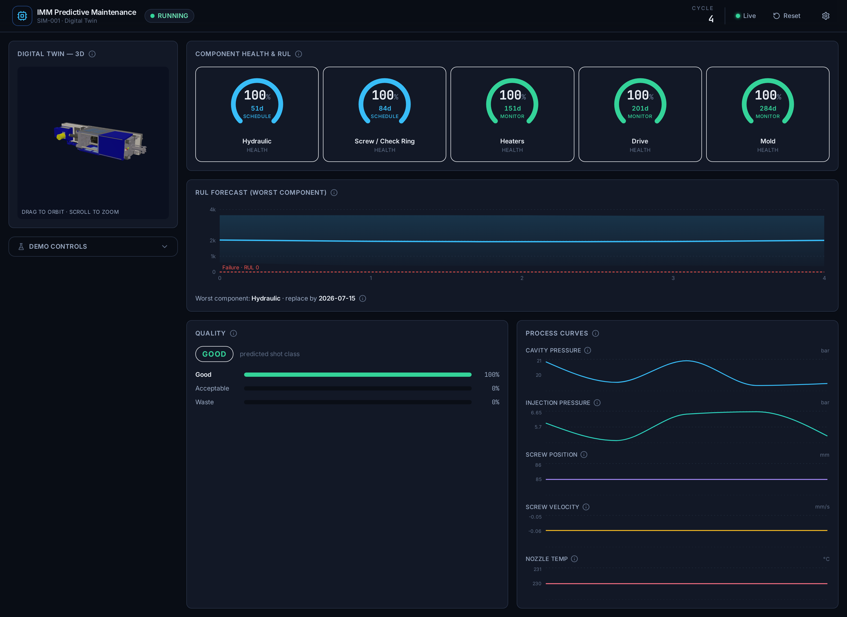
Figure: Full dashboard — live cycles, per-component gauges, RUL band, quality, process curves
After clicking a fault (e.g. Hydraulic Pump Wear): the affected component's gauge swings toward critical, health drops, the RUL band collapses toward the failure threshold, and quality degrades. This proves the simulator → features → ML → UI pipeline reacts end-to-end.
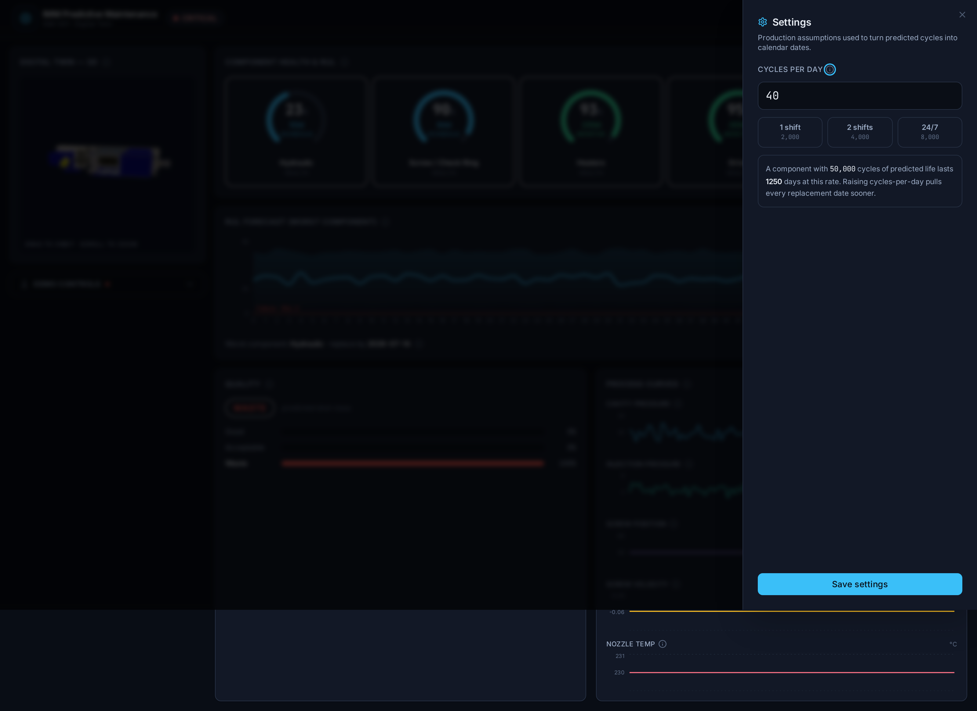
Figure: Fault injected — component health drops, RUL shrinks, quality degrades

4. How to read the UI

4.1 Component gauges (Component Health & RUL)
Five radial gauges, one per component (hydraulic, screw / check ring, heaters, drive, mold). The ring fill encodes health; the ring color encodes urgency band — red = critical (< 7 days), amber = imminent (7–30), cyan = schedule (30–90), green = monitor (> 90). Center text shows days until replacement. Click any gauge to open its detail dialog.

4.2 Component detail dialog
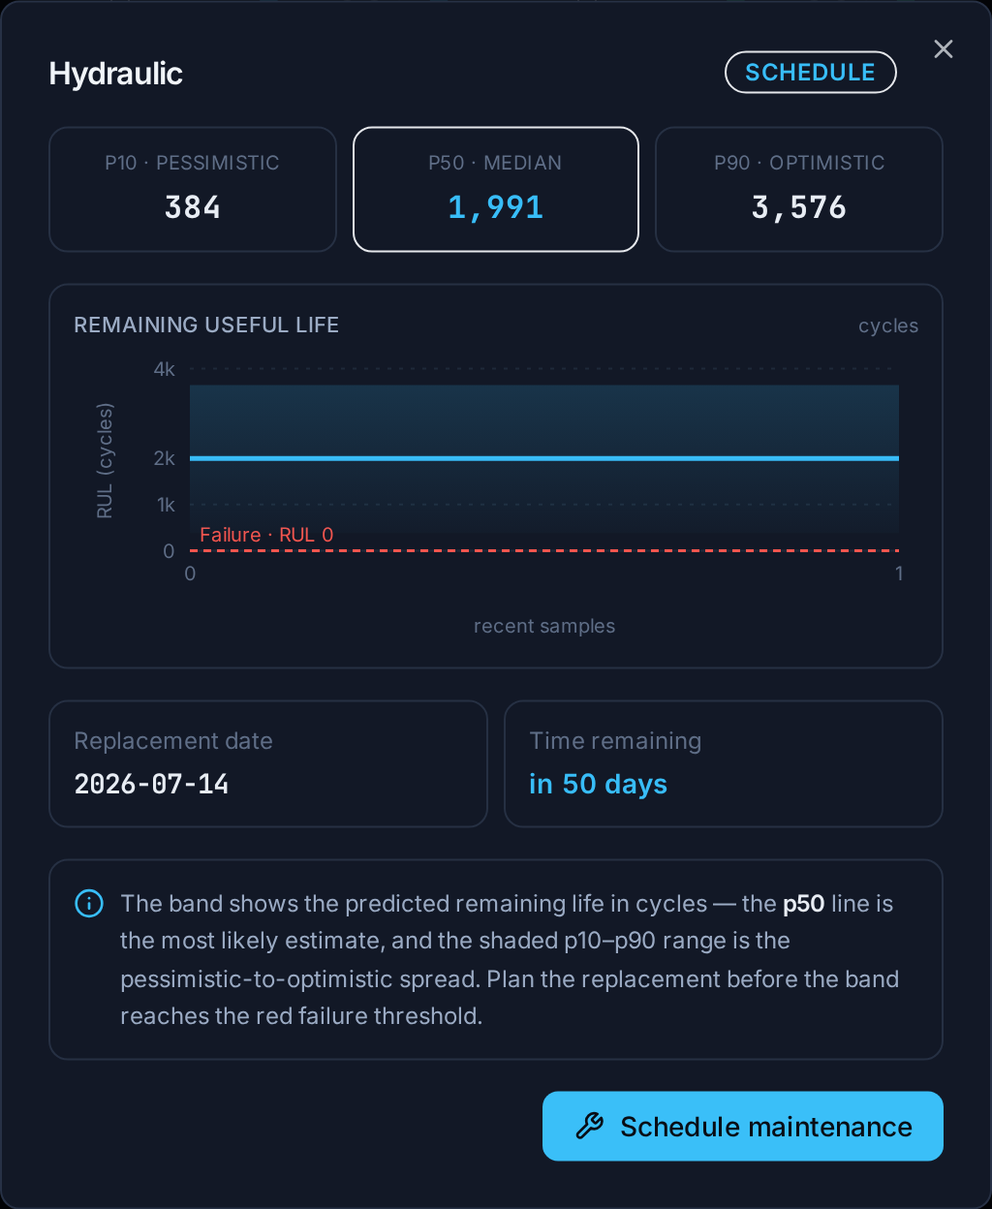
Figure: Per-component dialog — p10/p50/p90, RUL band, replacement date, urgency
The dialog shows that component's RUL quantiles (p10 / p50 / p90 in cycles), a component-scoped RUL band with the failure-threshold reference, the calendar replacement date, days remaining, and a (stub) Schedule-maintenance action.

4.3 RUL forecast band
Recharts area band for the worst component (lowest median RUL). Three quantiles from three models:
- p50 (line) — median estimate, the headline number.
- p10 / p90 (band) — pessimistic / optimistic bounds (10 % tails).
A failure-threshold reference line and the resale sweet-spot window are drawn for context. The footer names the worst component and its replace-by date.

4.4 Quality card
Calibrated 3-class prediction per shot: GOOD / ACCEPTABLE / WASTE with probability bars. Probabilities are calibrated (CalibratedClassifierCV) so they can be thresholded directly — e.g. alert when P(waste) > 0.3 for three consecutive shots.

4.5 Process charts
Live cavity-pressure, injection-pressure, screw-position / velocity, and nozzle-temperature traces from the most recent cycle (Recharts line charts). Models consume engineered cycle features, not the raw curves.

4.6 Fault buttons + controls
Click a fault button (Check Ring Wear, Heater Drift, Hydraulic Pump Wear) to inject that failure mode; the button turns red while active, click again to clear. The speed slider scales sim wall-clock for demos / fast degradation. The header shows machine id, cycle counter, and a green WebSocket-health dot.

4.7 Digital twin
Default build: a lightweight 2-D schematic twin. With the 3-D feature flag enabled, the same card becomes an interactive 3-D model of the machine (drag to orbit, scroll to zoom, idle auto-rotate). See section 6.
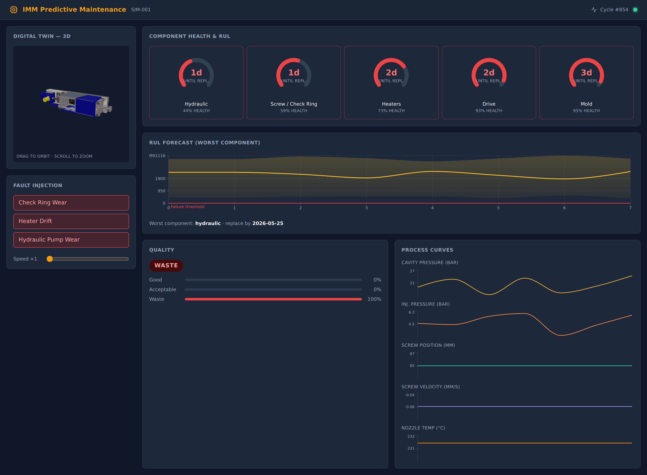
Figure: Dashboard with the interactive 3-D digital twin enabled (top-left card)

5. How it works under the hood

5.1 Simulator
Each cycle the machine produces cavity-pressure / velocity / screw-position curves. A hidden finite-state machine (degradation.py) advances each component's true health, accelerated by injected faults. The FSM state is private — used only to label training rows, never as a feature.

5.2 Feature extraction
features.py turns each raw cycle into 49 scalar features: peak pressures, areas under the curve, time-to-peak, slopes, ratios, temperature stats, etc. These are the only inputs to the models. An AST-level lint test forbids features.py from importing src.simulator.* — a hard guard against leaking hidden state into features.

5.3 Models (per-component RUL + quality)
- RUL: for EACH of the 5 components, 3 GradientBoostingRegressors with quantile loss (alpha = 0.1, 0.5, 0.9). Artifact shape: {components: {<comp>: {models, feature_cols, val_scores}}}.
- Quality: CalibratedClassifierCV(GradientBoostingClassifier) — 3 classes, calibrated probabilities.
- Validation: GroupKFold by machine_id — a machine's cycles are never split across train/val.
- Calibration gate: a held-out test asserts [p10, p90] coverage >= 70 % per component.
- No-leakage: neither head may use hidden FSM health nor the RUL target columns (rul_*_cycles) as features — enforced in both trainers.
Note on per-component val scores: because an un-faulted component's RUL is essentially (0.8 / base_wear) − elapsed_cycles, the per-component targets are affine-equivalent (same shape, different offset). Quantile pinball loss is invariant to that additive offset once learned, so the per-component pinball scores come out nearly identical — this is a property of the simulator's design, not a training bug; predicted RUL ranges still differ correctly per component.
Predictor (predict.py) loads the per-component artifact, returns rul_per_component (p10/p50/p90 + replacement_date + urgency for each component) plus a back-compat top-level rul block for the worst component. Quantile crossings from the independent heads are absorbed by sorting.

5.4 Replacement dates + urgency
urgency.py is pure functions:
cycles_to_date(cycles, cycles_per_day, now) -> date
classify(days) -> 'critical' (<7) | 'imminent' (7-30) | 'schedule' (30-90) | 'monitor' (>=90)
cycles_per_day is a runtime setting (default 40, adjustable live in the Settings drawer) read/updated via GET/POST /api/settings and echoed in every snapshot's config block; the predictor uses it to turn cycles into dates. It is kept low relative to the simulator's deliberately short component lifespans (~4k–13k cycles to the failure line) so a healthy machine reads schedule/monitor rather than critical.

5.5 Serving
run.py launches an aiohttp app. On each incoming cycle it extracts features, calls predict.predict(cycles_per_day=...), and broadcasts the snapshot over WebSocket to all browser clients. REST: /api/fault, /api/speedup, /api/settings. Static: the built frontend plus /models and /draco (needed by the 3-D twin). If model artifacts are missing the server still runs — the UI shows raw cycles with a per-cycle FSM fallback for RUL.

6. The 3-D digital twin
Optional, feature-flagged interactive 3-D model of the machine.
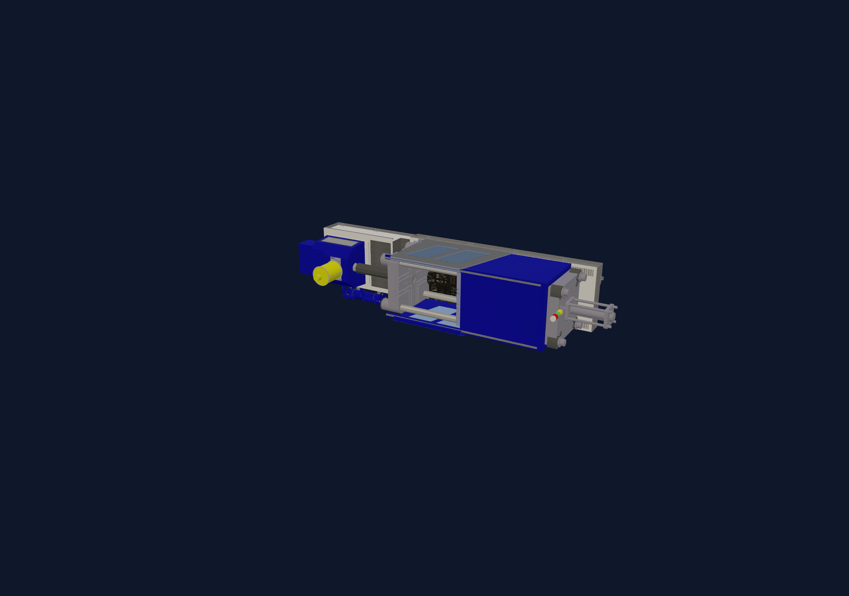
Figure: The Draco-compressed injection-machine model (350 KB)
- Source: Trimble 3D Warehouse model. Its General Model License permits embedding in a larger 'Combined Work' and format conversion, requires no attribution; only standalone redistribution is barred (N/A here). License analysis: docs/3D_LICENSE.md.
- Pipeline: .dae (8.7 MB) -> glb via trimesh -> gltf-transform optimize (dedup/join/weld/Draco/WebP) -> 350 KB (307 KB gzipped). Output is committed at web/public/models/injection_machine.glb.
- Twin3D.tsx: plain Three.js + GLTFLoader + DRACOLoader (decoder served from /draco/) + OrbitControls; bbox auto-fit, ResizeObserver, full dispose-on-unmount.
- Enable with VITE_ENABLE_3D=true at build/dev time; the Digital Twin card then renders Twin3D instead of the 2-D schematic. Off by default (no three.js model fetch).
- Live per-component binding is deferred: the model's nodes have only generic names (group_*, instance_*), so health is shown via the gauges, not bound to meshes. Binding would require re-authoring the model with semantic node names.

7. Reproducibility — cloning to a new machine (e.g. DGX)
What is tracked in the source tree and survives a clone:
- All code (src/, scripts/, run.py, tests/, web/src/).
- 3-D assets: web/public/models/injection_machine.glb and web/public/draco/* (NOT gitignored) — the twin works after clone with no re-conversion.
- The original 3-D source archive web/public/models/injection+machine.zip (re-conversion is reproducible).
- Dependency manifests: pyproject.toml (Python) and web/package.json + package-lock.json (JS, incl. three).
What is gitignored and must be regenerated after clone:
- Python venv (.venv/) and node_modules/ — reinstall (see section 8).
- Training data (data/, *.parquet) and ML artifacts (artifacts/, *.pkl) — regenerate via `make train`.
Notes:
- Project is not yet a git repo; when you git init + add, ensure the binary 3-D assets under web/public/ are committed (they are not ignored, so a normal `git add` includes them).
- Retraining is parallelized: train_rul/train_quality accept n_jobs (retrain_models.py uses 5/3). On a many-core box (DGX) the full retrain is comfortably fast.
- trimesh/pycollada (3-D conversion) and playwright (screenshots) are dev-only; not needed at runtime because the glb is already committed.

8. How to run it
python -m venv .venv && source .venv/bin/activate
pip install -e ".[dev]" # deps from pyproject.toml
python scripts/generate_training_data.py # synthetic cycles across machines
python scripts/retrain_models.py # writes artifacts/models/* (parallel)
# build the frontend:
cd web && npm install && npm run build && cd ..
# (3-D twin: VITE_ENABLE_3D=true npm run build)
python run.py # serves the app (default PORT 8000)
# open http://localhost:8000 — try fault buttons, watch RUL + quality react

9. Hard architectural rules (do not violate)
These constraints protect model integrity or keep the prototype shippable on a single laptop:
- Hidden component-health state is NEVER exposed to any model; models train only on observable signals.
- RUL target columns (rul_*_cycles) are never used as features (enforced in both trainers).
- RUL models use group-split-by-machine for validation — no cross-machine leakage.
- src/ml/features.py must not import from src/simulator/* — enforced by an AST lint test.
- Held-out [p10, p90] coverage must stay >= 70 % per component (calibration test).
Scope guardrails (deliberately out of scope): Docker/K8s, message brokers (MQTT/Kafka), TimescaleDB/MinIO/MLflow/Prefect, auth/JWT/RBAC, microservices, fleet view, RL, drift detection, and anything described as 'production-grade'. (Note: an optional decorative 3-D twin IS now included and license-cleared — see section 6.)

10. Glossary — plain English
Every technical term on the dashboard, translated. Each entry: one technical sentence, one plain sentence, and one factory-floor analogy.
RUL (Remaining Useful Life) — The number of production cycles a component is predicted to survive before its true health crosses the failure threshold.
In plain English: How much life the part has left, counted in shots.
On the factory floor: Like an oil-life gauge in a car — but counting molded parts instead of miles.

p10 / p50 / p90 quantile — Three points on the predicted RUL distribution: the model estimates a 10 %, 50 %, and 90 % chance the true RUL falls below each value.
In plain English: A pessimistic, a most-likely, and an optimistic estimate of remaining life.
On the factory floor: Like a forecast: 'most likely 50k more shots, but could be as few as 10k or as many as 90k.'

Calibration — Post-processing (CalibratedClassifierCV) that makes the model's reported probabilities match real-world frequencies, so a stated '70 %' really happens about 70 % of the time.
In plain English: Making the confidence numbers honest.
On the factory floor: If the card says '30 % chance of a bad part', roughly 3 of every 10 such shots really are bad.

GroupKFold — A cross-validation split that keeps all cycles from one machine entirely in either training or validation — never both.
In plain English: Testing the model on machines it has never seen, not just new shots from familiar machines.
On the factory floor: Proving the model works on a brand-new press, not only the few it learned on.

Urgency band — A bucket (critical / imminent / schedule / monitor) derived from days-until-replacement: <7, 7–30, 30–90, ≥90.
In plain English: A traffic-light label for how soon to act on a part.
On the factory floor: Red = order the part now; green = check again next month.

Replacement date — The calendar date the predicted p50 RUL runs out, computed as RUL cycles ÷ cycles-per-day.
In plain English: The day to put this part on the maintenance calendar.
On the factory floor: 'Replace the hydraulic pump by June 5' — something a scheduler can act on.

Failure threshold — The health value (0.20) below which a component is considered failed; the machine then latches into a FAILED state.
In plain English: The point where the part is too worn to trust.
On the factory floor: Like a brake-pad wear line — past it, stop the press.

Sweet spot — The resale-optimal health window [0.35, 0.42] where replacing recovers the most residual and resale value.
In plain English: The best time to replace — not too early, not too late.
On the factory floor: Trade the press while it still has resale value, before it becomes scrap.

Fault injection — A demo control that ramps extra wear pressure into a component's hidden FSM to simulate a developing fault.
In plain English: A test button that fakes a part going bad.
On the factory floor: Like a trainer tripping a sensor to check the alarm catches it — for demonstration only.

Digital twin — A live software model of the machine driven by the same data stream — here a 2-D schematic, or an optional interactive 3-D model.
In plain English: A virtual copy of the machine that mirrors its current condition.
On the factory floor: A dashboard stand-in of your press that lights up where it hurts.

Machine state — A ground-truth status (running / warning / critical / failed) derived from the worst component's true health — distinct from the ML-predicted urgency band.
In plain English: The overall traffic-light for the whole press, right now.
On the factory floor: Green = making good parts; red FAILED = stopped, reset to continue.

11. Reading the dashboard at a glance
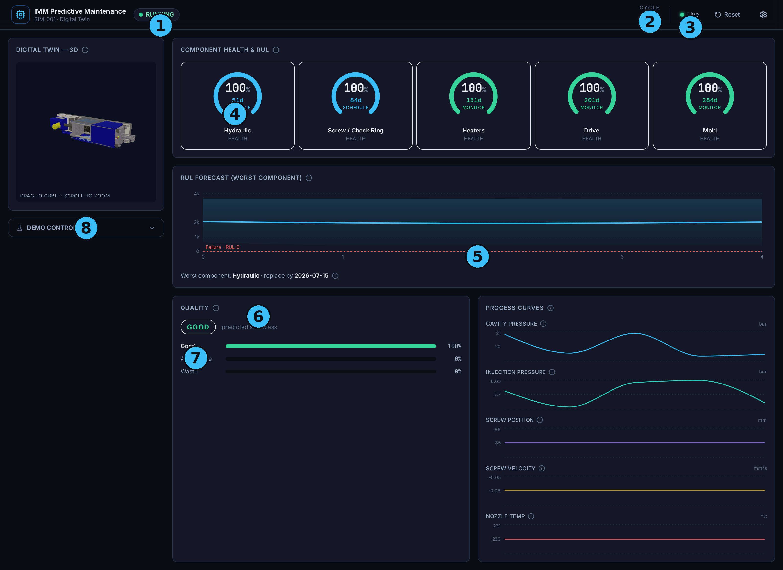
Figure: The dashboard with numbered callouts (see below)
- 1 Machine-state badge — the overall press status at a glance (Running/Warning/Critical/Failed).
- 2 Live cycle counter — shots produced this run; returns to 0 after a Reset.
- 3 Connection indicator — green 'Live' means the data stream is healthy.
- 4 Component gauges — health % (large), days-to-replace, and urgency for each of the five parts.
- 5 RUL forecast band — predicted remaining life (cycles) of the worst part, with the red failure line.
- 6 Worst-component footer — which part to act on first, and its replace-by date or status.
- 7 Quality card — the predicted class (good / acceptable / waste) of the most recent shot.
- 8 Reset · Settings · Demo controls — reset to pristine, set cycles-per-day, or inject test faults.
What should I do? — the decision in four bullets:
- All gauges green (Monitor) → keep running; check again next month.
- Any gauge amber or blue (Imminent / Schedule) → put that part on the maintenance calendar by its replace-by date.
- Any gauge red (Critical) or OVERDUE → order the part now and plan a stop.
- Banner reads FAILED → the press has stopped; replace the named part, then press Reset.

12. Visual design system
Dark-mode-only industrial palette, defined once as CSS variables in web/src/styles/tokens.css and mirrored into the shadcn theme.
Token | Swatch | Hex · purpose
--color-bg |  | #0a0e16 · app background
--color-surface |  | #121826 · cards / panels
--color-surface-elevated |  | #1b2433 · header, dialogs, hover
--color-border |  | #263043 · hairline borders
--color-text-primary |  | #e8edf4 · headings, key numbers
--color-text-secondary |  | #9babc4 · body, labels
--color-text-muted |  | #5f6e87 · captions, axis ticks
--color-accent |  | #38bdf8 · interactive chrome, focus
--color-success |  | #34d399 · healthy / good / monitor
--color-warning |  | #fbbf24 · attention / acceptable
--color-critical |  | #f4554e · urgent / waste
--color-failed |  | #8a7374 · STOPPED — distinct grey-red
Typography:
- Inter (variable, self-hosted via Fontsource) for all UI text.
- JetBrains Mono (variable) for every number — cycle counter, health %, RUL cycles, dates — with tabular figures so digits don't jitter.
- Type scale only: text-xs 12 / sm 14 / base 16 / lg 18 / xl 20 / 2xl 24 / 3xl 30 — no arbitrary sizes.
Spacing & hierarchy:
- 4 px spacing base; cards use a ~10 px corner radius and consistent internal padding.
- The most important thing (machine state, worst component) is largest and highest; less important panels are smaller and lower.
- Demo-only controls are collapsed and de-emphasized so a viewer never mistakes them for production features.

13. What happens when the machine fails
The simulator exposes a single top-level machine_state, derived from the worst component's true (hidden) health and anchored on the existing health constants:
- health > 0.42 → running
- 0.35 – 0.42 → warning (entering the resale sweet spot)
- 0.20 – 0.35 → critical (past the sweet spot, approaching failure)
- ≤ 0.20 → failed (latched)
The moment any component crosses 0.20 the machine latches into FAILED and stays there until Reset. While failed:
- Degradation freezes — health is pinned at its crossed value and never goes below 0.0.
- New cycles still stream, flagged failed=true in the snapshot.
- Quality is forced to WASTE (a serving-layer presentation override; the ML model is untouched).
The UI then shows a red banner naming the failed component and the cycle at which it crossed, a FAILED status badge, and a distinct 'stopped' gauge (lock icon, desaturated grey-red ring, struck-through label) — so it reads as stopped, not merely bad.
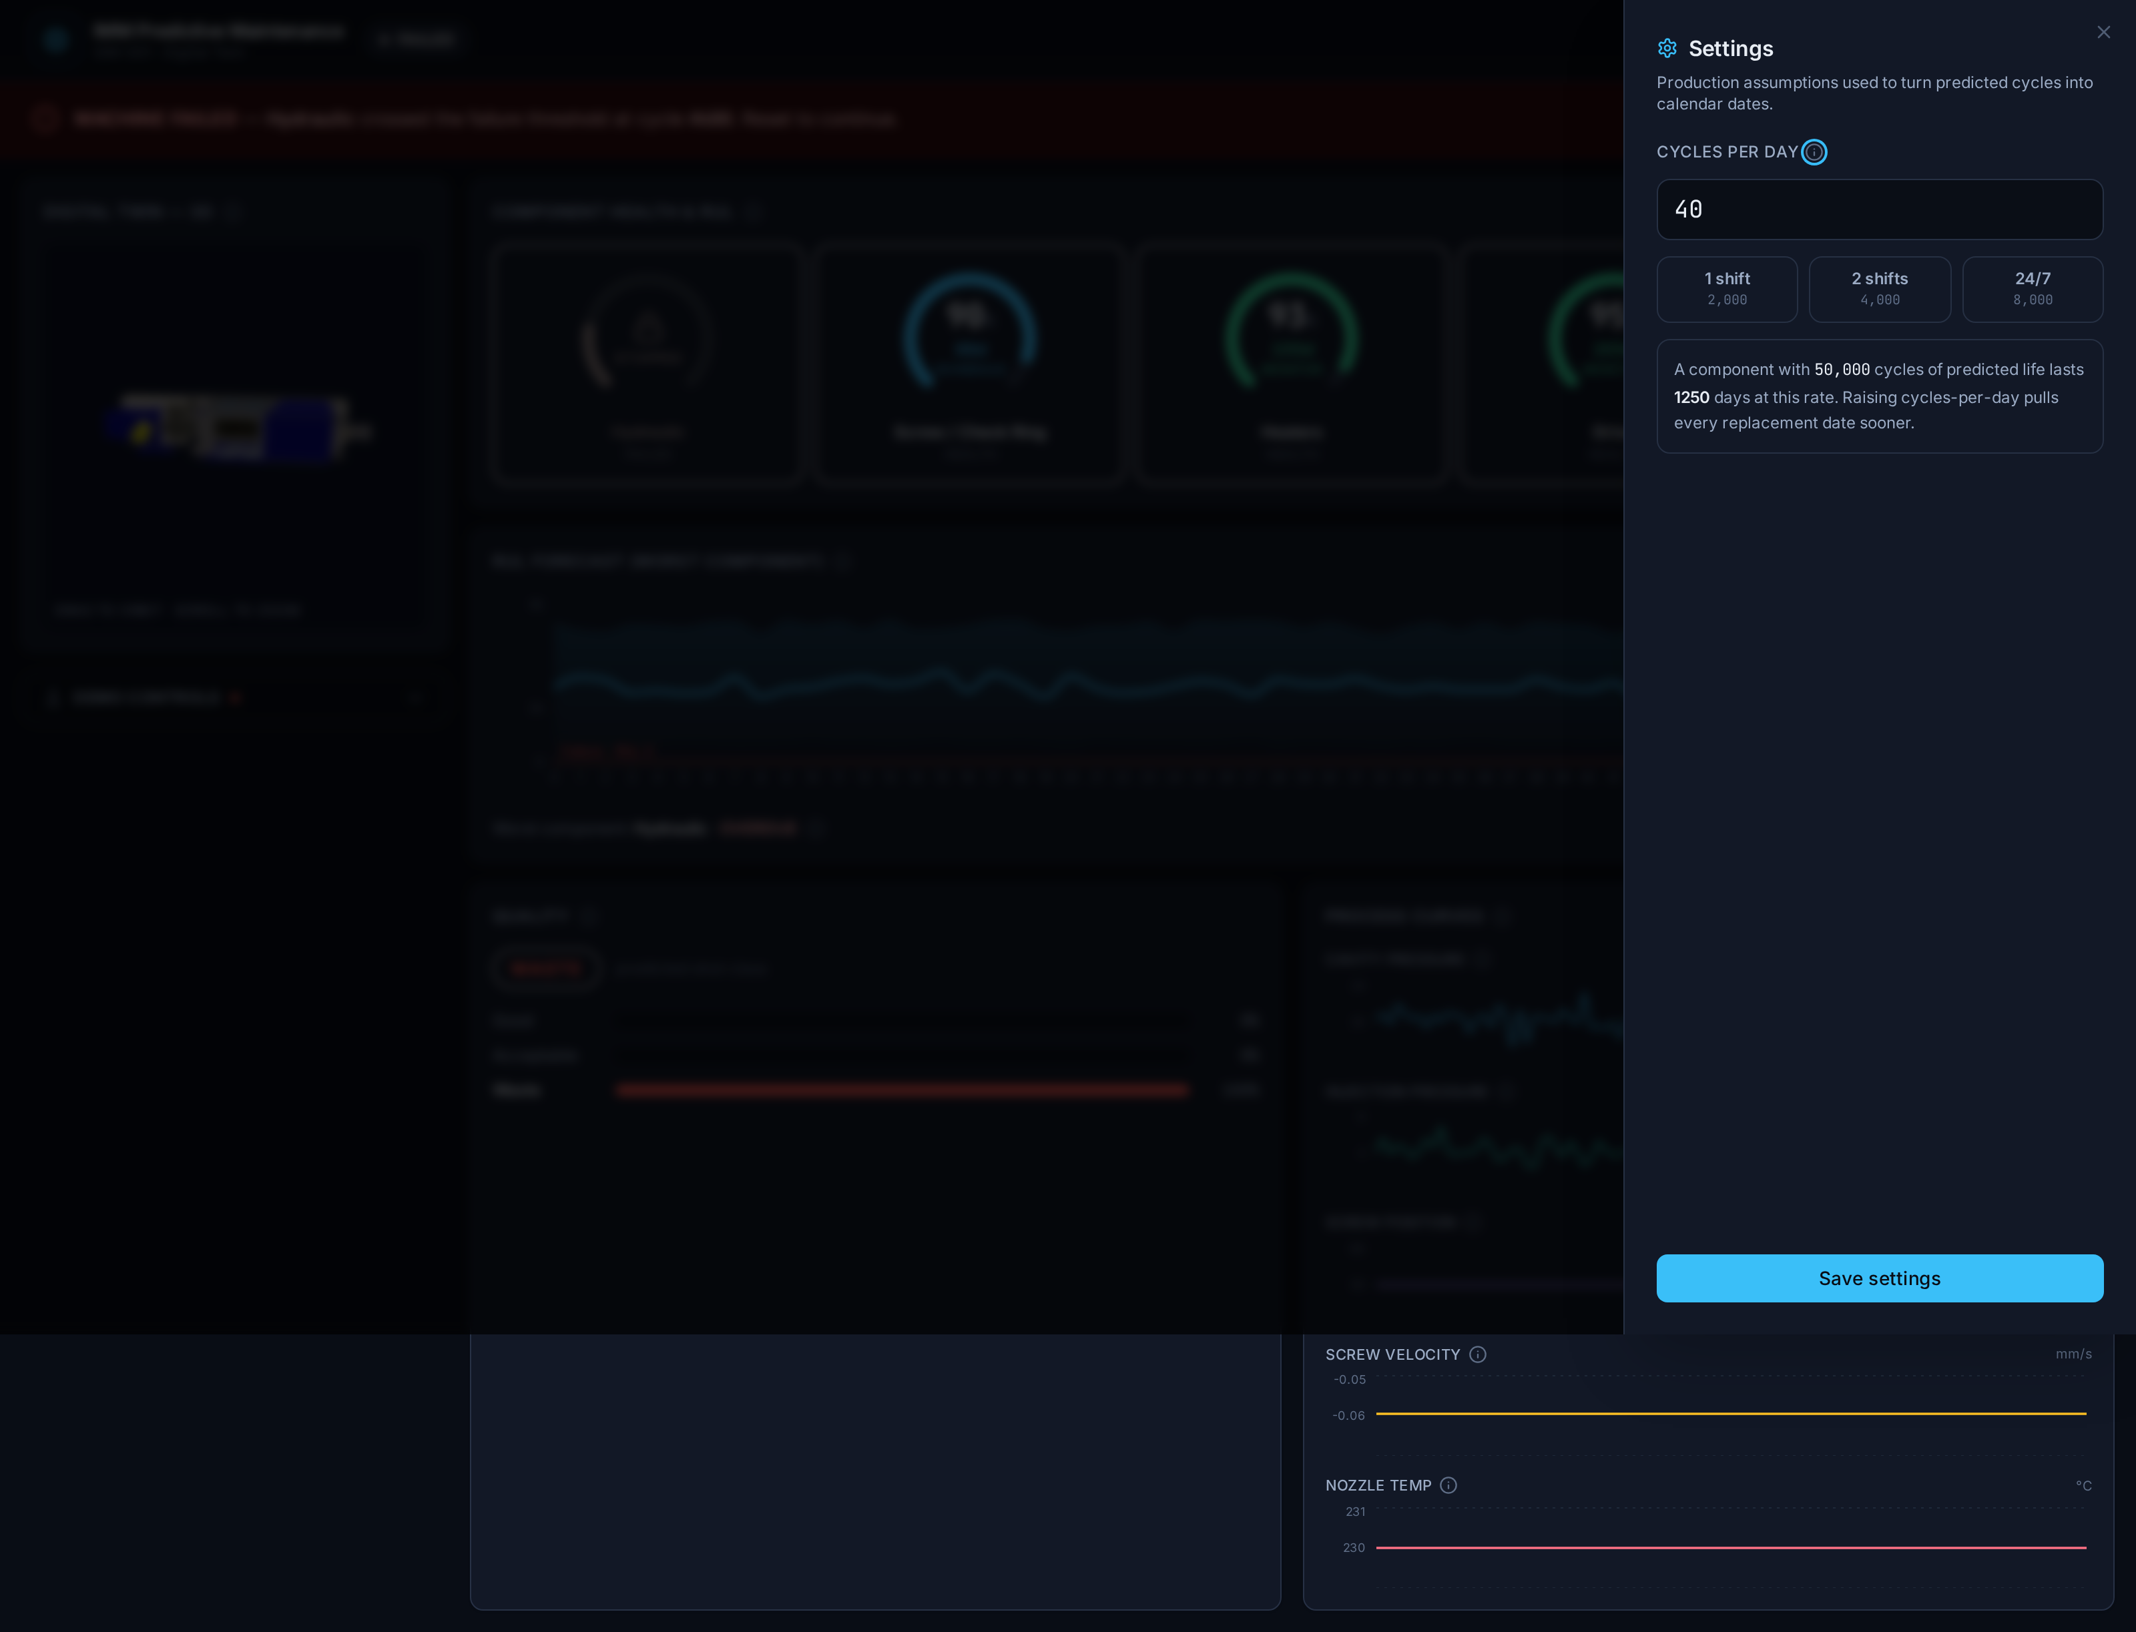
Figure: Failed state — banner, FAILED badge, STOPPED gauge, quality forced to WASTE
Note the distinction: machine_state is ground truth from the simulator's hidden health, whereas a gauge's urgency band is the ML model's days-based forecast. They answer different questions — 'what condition is the press in now?' versus 'how soon should I plan to replace this part?'

14. Replacement-date edge cases
Turning predicted cycles into calendar dates has three edge cases the UI handles explicitly so a date never looks broken:
- Normal: a real date plus a day count (e.g. 'replace by 2026-06-05 · in 12 days').
- Already due (days ≤ 0) or a failed component: shows OVERDUE with a distinct red style and no date — never 'replace on [yesterday]'.
- Far out (days > 365): shows '> 1 year' instead of a literal multi-year date, which would be technically correct but unhelpful.
Underpinning guarantees (unit-tested): the backend clamps predicted p50 RUL to ≥ 0 and never emits a past date. At 4000 cycles/day, a fresh component with a 50,000-cycle p50 RUL resolves to roughly 12.5 days out (2026-06-05, 12 whole days) — verified by tests/test_urgency.py. A failed component's part is treated as OVERDUE.

15. Demonstrating the prototype — the easy version
In one sentence: this dashboard watches an injection-molding machine and tells you, component by component, how much life is left and exactly when to replace each part — early enough to avoid a breakdown, late enough not to throw away good life.
Run it:
./demo.sh # build if needed, then open http://localhost:8000
./demo.sh --tunnel # same, plus a temporary public https link (Cloudflare)
You don't need to memorise anything: hover any label, gauge, chart, or the small ⓘ icons and the UI explains — in plain English — what it means and what to do.
A 60-second walkthrough:
- 1. Open the dashboard. The top badge reads RUNNING and the five gauges are green/cyan — a healthy machine. Each gauge: the big number is health, the ring colour is how urgently to replace, the small number is days left.
- 2. Hover a gauge — it states the reading and the recommended action ('plenty of life left', 'replace now', …). Hover any ⓘ to learn how to read that whole panel.
- 3. Open 'Demo controls' (left), click 'Hydraulic Pump Wear', and drag 'Speed' up. This simulates a failing hydraulic pump.
- 4. Watch the story unfold live: the Hydraulic gauge falls, the status badge moves RUNNING → WARNING → CRITICAL, the RUL forecast line drops toward the red failure line, the process curves get noisy, and quality slides toward WASTE.
- 5. Let it cross the line: a red 'MACHINE FAILED' banner names the part and the exact cycle, and that gauge shows a STOPPED lock.
- 6. Click 'Reset' — everything returns to 100% health and you can run the story again.
That arc — healthy → predicted decline → failure → reset — is the entire value proposition in about a minute.

16. Highlights — why it stands out
- Per-component remaining-life predictions with honest uncertainty (p10/p50/p90) and calibrated quality probabilities — not a single black-box number.
- Turns predictions into decisions: a calendar replacement date and a red/amber/cyan/green urgency band per component, plus a single 'worst component — act first' callout.
- Leakage-proof by construction: the machine's hidden health is never a model input (enforced by an AST lint test), validation never splits one machine across train/test (GroupKFold), and prediction-interval coverage is gate-tested at ≥ 70%.
- Live end-to-end: simulator → 49 engineered features → ML → dashboard over a WebSocket; inject a fault and the whole pipeline reacts within seconds.
- Swap-to-real ready: one DataSource interface means the same app runs on the simulator or a real PLC by changing a single class.
- Defined failure behaviour: the machine latches FAILED at the threshold, freezes, flags the cycle, and forces WASTE — with a one-click reset.
- Self-teaching UI: every control, gauge and chart explains itself on hover; designed empty/loading/offline states; accessible keyboard focus.
- Optional interactive 3-D twin, and a one-command demo that can publish a temporary public link via Cloudflare — clone, run, share.

17. Future work
- Bind live component health to the 3-D model's meshes (requires the model re-authored with semantic node names) so the twin itself lights up where it hurts.
- Connect a real machine through the PLC DataSource and validate predictions against real run-to-failure data.
- Drift / anomaly detection and alerting — e.g. notify when P(waste) > 0.3 for N consecutive shots.
- Cost-aware replacement policy: weigh residual life, downtime cost and resale value to recommend the optimal day, not just the urgency band.
- Fleet view across many machines, backed by a historian/database for trends and audit.
- Authentication and role-based access for a multi-user shop-floor deployment.
- Continuous retraining / online learning as real operating data accumulates.

