**🚀 Step 1: Requirement Finalization & MVP Scope**

Sab features ek saath banana practical nahi hai. Pehle ek **MVP (Minimum Viable Product)** banate hain:

1. User Management (Admin + Agent Login).
2. Basic Campaign Creation (upload CSV, assign to agents).
3. Dialer Engine (Preview + Progressive mode se start karein).
4. Call Handling (place call → receive → call status update).
5. Call Logs + Simple Report.

Predictive Dialer, AI-based routing, CRM integration etc. **Phase 2 & 3 me add karenge**.

**🛠 Step 2: Tech Stack Finalize**

Since aap Android Kotlin bola tha, aap **Agent Panel as Mobile App** bana sakte ho.  
Aur **Admin Panel Web-based** hoga.

* **Frontend (Admin Panel):** React.js / Angular
* **Agent Panel (Mobile):** Android Kotlin (Jetpack Compose)
* **Backend APIs:** Node.js (Express) ya Python Django/Flask
* **Database:** PostgreSQL (main DB) + Redis (caching for queues)
* **Telephony Engine:** Asterisk / FreeSWITCH (open-source) ya Twilio (managed)
* **Deployment:** AWS EC2 + RDS + S3 (storage)

**🧩 Step 3: System Architecture (High-Level Flow)**

Contacts (CSV/API Import) → Dialer Engine → Telephony (Asterisk/Twilio)

→ Agent Panel (Android app)

→ Admin Panel (Web dashboard)

→ CRM & Reports DB

* **Admin** creates campaigns, uploads leads.
* **Dialer Engine** auto dials numbers.
* **Telephony Server** (Asterisk/Twilio) handles call connection.
* **Agent App** (Kotlin) gets popup with customer details + notes option.
* **Backend API** stores call logs & reports.

**📦 Step 4: Project Modules Breakdown**

1. **Authentication & RBAC** (Admin/Agent/Manager roles).
2. **Campaign Module** (create, assign, manage leads).
3. **Dialer Engine** (start with Preview + Progressive).
4. **Agent App (Kotlin)**
   * Login
   * Call popup screen (details, notes, call status update)
   * Call actions (accept, transfer, end call)
5. **Reports & Logs** (basic CSV export initially).

**⚡ Step 5: Development Strategy**

🔹 **Phase 1 (4–6 weeks):**

* Setup backend (Auth, Campaign CRUD, Call API endpoints).
* Setup telephony server (Asterisk or Twilio sandbox).
* Build Android Agent app (login + call popup + basic call handling).
* Build Admin web dashboard (React).

🔹 **Phase 2 (6–8 weeks):**

* Add Predictive Dialing logic.
* Add call recordings (storage in S3 or local).
* CRM (lead management, tagging).
* Real-time dashboards.

🔹 **Phase 3 (6+ weeks):**

* Advanced analytics (AI-based dialing, productivity tracking).
* Multi-channel integrations (SMS, Email, WhatsApp).
* GDPR/CCPA compliance features.

**🧪 Step 6: Development Environment Setup**

* **Repo:** GitHub/GitLab monorepo (backend, frontend, mobile in separate folders).
* **CI/CD:** GitHub Actions / Jenkins.
* **Testing:** Postman for APIs, JUnit/Espresso for Android, Jest for React.

👉 Ab aap decide karo:  
Kya hum **Agent Panel Android App (Kotlin)** se start karein pehle (taaki calling + popup test ho jaye),  
ya **Backend + Telephony setup** pehle karein (taaki actual call flow implement ho)?

Meri suggestion: **Backend + Telephony setup se start karein**, kyunki bina call flow ke app sirf UI rahegi.

**⚖️ MySQL vs PostgreSQL**

**🔹 MySQL**

✅ Pros:

* Fast reads (high-performance SELECT queries).
* Easy to set up, well-documented, large community.
* Widely used in web apps, call-center CRMs.
* Good with horizontal scaling (read replicas).

❌ Cons:

* Limited support for complex queries (e.g., analytics, JSON handling).
* No full compliance with SQL standards.
* Fewer advanced features compared to Postgres.

**🔹 PostgreSQL**

✅ Pros:

* Fully **SQL-compliant**, supports advanced queries, JSONB (structured + unstructured data).
* Strong in **complex analytics & reporting** (important for dashboards & call analytics).
* Handles **concurrent connections** better → useful for high-volume dialing.
* Better data integrity (constraints, transactions, ACID compliance).

❌ Cons:

* Slightly more resource-heavy than MySQL.
* Learning curve is higher (for devs used to MySQL).

**📊 Dialer Project Ke Liye Recommendation**

Aapke project me:

* **High call logs (millions of records)**
* **Complex reports (agent performance, campaign analytics)**
* **Real-time dashboards**
* **Data integrity (DNC compliance, regulations)**

👉 **PostgreSQL is better choice**.  
Because:

* Advanced analytics queries kaam aayenge (average handling time, predictive dialing stats).
* JSONB support useful hoga agar aapko CRM-like features banana hai.
* Scales better for concurrency (jab 100s of agents parallel calls kar rahe honge).

**🚀 Final Suggestion**

* Start with **PostgreSQL** (primary DB).
* Use **Redis** for caching (real-time queue handling, agent availability).
* MySQL bhi chalega agar sirf basic call logs + reports rakhne hai, lekin future me analytics ke liye Postgres best hai. Aap **Authentication & RBAC (Role-Based Access Control)** se start karna chahte ho. Yehi sahi step hai, kyunki bina user/role management ke baaki modules banana mushkil hoga.
* **🔑 Authentication + RBAC Flow (Node.js + PostgreSQL)**
* **1. Tables Design**
* **Users**

|  |  |  |  |  |  |  |
| --- | --- | --- | --- | --- | --- | --- |
| Id(pk UUID) | Name | Email(Unique) | Password(hashed) | role (ENUM: 'admin', 'agent', 'manager') | created At | updated At |

(Foreign key **=** user.id)

**Sessions/tokens**

|  |  |  |  |
| --- | --- | --- | --- |
| Id | userId | refreshToken | expiresAt |

**roles** (optional if you want dynamic roles)

|  |  |  |
| --- | --- | --- |
| id (PK) | role_name (admin, agent, manager) | permissions (JSON) |

* **2. Auth Flow**
* **Register / Create User** (only Admin can create Agents/Managers).
* **Login**
* Verify email + password (bcrypt compare).
* Issue **JWT access token** + **refresh token**.
* **Middleware for RBAC**
* Check if token is valid.
* Check if user’s role has access to the route.
* **3. Example Node.js Structure**
* project/
* ├── src/
* │ ├── config/ # DB, JWT configs
* │ ├── models/ # Sequelize/Prisma models
* │ ├── routes/ # Express routes
* │ ├── controllers/ # Logic for auth, user mgmt
* │ ├── middlewares/ # Auth + Role checks
* │ └── utils/ # Helpers (hashing, tokens)
* └── package.json
* **5. Libraries to Use**
* **Express.js** – REST API
* **JWT (jsonwebtoken)** – Auth tokens
* **bcryptjs / argon2** – Password hashing
* **Sequelize / Prisma** – ORM for PostgreSQL
* **Helmet + CORS** – Security

**GDPR/CCPA compliance features** :-

* Auto Soft Dialer jaise project me compliance **must-have** hai, warna legal issues aa sakte hain. Chaliye main breakdown deta hoon:
* **🔒 GDPR / CCPA Compliance Features to Implement**
* **1. Consent & Opt-In**
* User ke data ko store/use karne se pehle explicit consent lena.
* Campaigns me **opt-in flag** rakhna (e.g., consent_given = true/false).
* Call recording ke liye **IVR message**: “This call may be recorded…”
* **2. Right to Access / Data Portability**
* Admin/Agent panel me option ho ki customer apna data request kare.
* Backend API → export data in **JSON/CSV**.
* **3. Right to be Forgotten (Deletion)**
* Customer request par **delete or anonymize** data.
* Database me **soft delete flag** use karo (e.g., is_deleted = true) ya PII fields blank kar do.
* **4. DNC (Do Not Call) List**
* Global & campaign-level **Do Not Call table** maintain karo.
* Dialer Engine check kare before dialing.
* **5. Data Security**
* **Encryption in transit:** TLS/SSL for API & WebSocket calls.
* **Encryption at rest:** Sensitive fields (phone, email, notes) encrypted in DB.
* Passwords → **bcrypt/argon2 hashing** only.
* **6. Role-Based Access Control**
* Agents ko sirf unke assigned leads dikhna chahiye.
* Admin/Manager ko reports + full access.
* Logs maintain karo for audit trail.
* **7. Data Retention Policy**
* Call recordings + logs automatically purge after X days (configurable).
* Admin panel me retention setting option hona chahiye.
* **8. Audit & Logging**
* Track who accessed/modified customer data.
* Store logs in append-only DB or external service (ELK stack / CloudWatch).
* **⚡ Implementation Strategy**
* **Backend:**
* Middleware for DNC compliance check.
* Encryption utils (e.g., crypto lib in Node.js).
* GDPR endpoints (/export-data, /delete-data).
* **Database (Postgres):**
* Table for dnc_numbers.
* consent field in leads table.
* Soft delete / anonymization strategy.
* **Frontend (Agent/Admin):**
* UI prompts for consent.
* GDPR/CCPA request buttons (Export/Delete).
* 👉 Yeh sab compliance features agar **Phase 1 ke MVP** me daaloge to project heavy ho jayega. Suggestion:
* **Phase 1:** DNC List + Consent Prompt + Encrypted storage.
* **Phase 2:** Right to be forgotten, data export, retention policy.
* Aap agar backend **Node.js** me start karte ho to future me **AI-based calling** integrate karna **easy aur scalable** hoga. Main breakdown deta hoon:
* **🤖 AI-based Calling me Node.js ka Role**
* **1. AI Dialing Logic**
* Predictive Dialing, Agent Availability Prediction, Call Scheduling → ye sab **algorithms** backend pe chalenge.
* Node.js async nature ke wajah se **real-time event handling** me best hai (e.g., call connected/disconnected events).
* **2. Integration with AI/ML Models**
* Core AI model (Python/TensorFlow/PyTorch) hota hai.
* Node.js backend **API gateway** ka kaam karega:
* Agent availability data → send to AI service.
* AI se prediction (next number, best time to call) → return to Dialer Engine.
* Matlab, Node.js + Python hybrid architecture banega.
* **3. Speech AI / Voice Bots**
* AI calling me **Speech-to-Text (STT)** + **Text-to-Speech (TTS)** use hota hai.
* Node.js ke paas official SDKs hain:
* Google Dialogflow
* OpenAI Realtime APIs
* Twilio Voice AI
* Matlab Node.js directly integrate kar lega.
* **4. Scalability**
* AI-based calling me **high concurrency** hota hai (100s/1000s calls).
* Node.js event-driven model = **lightweight + scalable**.
* Microservices architecture → ek service AI ko handle karegi, dusra Dialer Engine, dusra Analytics.
* **5. Future Proofing**
* Node.js ecosystem me already **WebRTC, SIP, Telephony, AI SDKs** available hain.
* Agar aap future me **Realtime Voice AI Bots** add karna chahte ho, Node.js easily integrate kar lega with Asterisk/FreeSWITCH/Twilio.
* **✅ Conclusion**
* **Yes**, Node.js backend future-proof hai.
* AI models mostly Python me banenge, lekin Node.js unhe APIs ke through consume karega.
* Aapko **hybrid approach** milegi:
* Node.js → Call Handling, Events, API Gateway
* Python → AI/ML Models (Predictive Dialing, Speech AI)

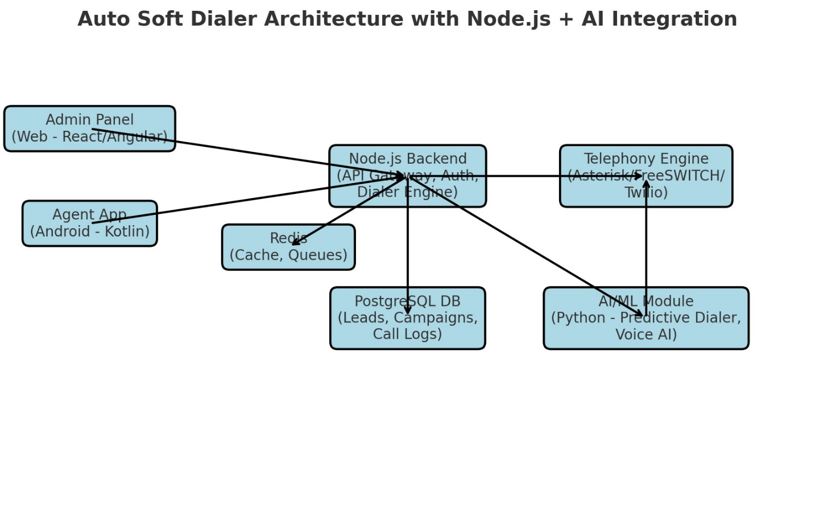

* **Auto Soft Dialer Architecture with Node.js + AI Integration**
* **Node.js Backend** → API Gateway, Auth, Dialer Engine.
* **PostgreSQL + Redis** → Data storage + real-time queues.
* **Telephony Engine (Asterisk/FreeSWITCH/Twilio)** → Handles calls.
* **AI/ML Module (Python)** → Predictive dialing, Voice AI, analytics.
* **Admin Panel (React/Angular)** → Campaign & reports.
* **Agent App (Android Kotlin)** → Call handling, notes.

AI module directly **connect karta hai Telephony Engine se bhi** (speech AI / predictive dialing) aur Node.js ke through bhi.

**📱 Android (Agent Panel) Responsibilities**

**1. Project Setup**

* Create **Android Studio Project** → *Empty Compose Activity*.
* Add dependencies:
  + **Retrofit + OkHttp** (API calls)
  + **Coroutines + Flow** (async tasks)
  + **Room DB** (local cache if needed)
  + **Jetpack Compose** (UI)
  + **Hilt/Dagger** (DI for scaling)

👉 Deliverable: Base Android project ready.

**2. Authentication (Login Screen)**

* UI: Email + Password fields.
* API Call: /auth/login → get JWT token.
* Store token in **EncryptedSharedPreferences** or **DataStore**.
* Redirect to Dashboard after login.

👉 Deliverable: Agent login flow ready.

**3. Dashboard (Assigned Leads)**

* UI: List of leads (name, phone, status).
* API Call: /campaign/:id/leads (from backend).
* Show each lead in a **Card** with a “Call” button.

👉 Deliverable: Agent can see assigned leads.

**4. Call Handling UI**

* When agent taps **Call**, app:
  + Sends API request → backend dials number via Telephony server.
  + Show **Call Popup Screen**:
    - Customer name + phone
    - Notes input
    - Call controls: Accept / End / Transfer
* End of call → Update backend (/call-log).

👉 Deliverable: Agent can place & end calls, and update notes.

**5. Call Status & Notifications**

* Integrate **Firebase Cloud Messaging (FCM)** → receive call status updates (connected, failed, missed).
* App should notify agent (e.g., “New lead assigned”, “Missed call alert”).

👉 Deliverable: Real-time call updates in app.

**6. Reports (Basic)**

* Agent can check:
  + Number of calls done today.
  + Success vs Missed vs Failed.
* API: /reports/agent/:id.

👉 Deliverable: Simple productivity report screen.

**🔥 Suggested First Step for You**

1. Setup **Login Screen** (Compose UI).
2. Use **Retrofit** to call backend login API.
3. On success → Save token → Open Dashboard screen.

**📱 Android Agent App – Structure & Documentation**

**1. Project Setup**

* **Language:** Kotlin
* **UI:** Jetpack Compose
* **Architecture:** MVVM (Model–View–ViewModel) + Clean Architecture
* **Dependency Injection:** Hilt (Google recommended)
* **Networking:** Retrofit + OkHttp
* **Async:** Kotlin Coroutines + Flow
* **Local Storage:** SharedPreference (for tokens, settings), Room (if offline storage needed)

**2. Folder Structure**

app/

├── data/

│ ├── model/ # Data classes (Lead, User, Campaign, CallLog)

│ ├── network/ # Retrofit API interfaces

│ ├── repository/ # Data handling logic

│

├── di/ # Hilt modules (Retrofit, Repository, etc.)

│

├── ui/

│ ├── auth/ # Login screen, ViewModel

│ ├── dashboard/ # Leads list

│ ├── call/ # Call popup, call handling UI

│ ├── reports/ # Agent productivity report

│ ├── components/ # Reusable Compose UI components

│

├── utils/ # Helpers (NetworkUtils, TokenManager)

│

├── MainActivity.kt

├── App.kt # Application class (Hilt entry point)

**3. Core Modules (Phase 1)**

**(a) Auth Module**

* **Screen:** Login
* **API:** POST /auth/login
* **Data:** User (id, name, role, token)
* **Flow:**
  + Enter email + password → API → Save JWT in SharedPrefernce → Navigate to Dashboard

**(b) Dashboard Module**

* **Screen:** Assigned Leads List
* **API:** GET /campaign/:id/leads
* **Data:** Lead (id, name, phone, status, notes)
* **Flow:**
  + Fetch leads from API → Show in list → “Call” button → Open Call Screen

**(c) Call Module**

* **Screen:** Call popup (customer details + controls)
* **APIs:**
  + POST /call/start (trigger backend dialer)
  + POST /call/end (update call log)
* **Flow:**
  + Press “Call” → API request → Backend connects call → Show status → End call updates backend

**(d) Reports Module**

* **Screen:** Agent stats (daily calls, success rate)
* **API:** GET /reports/agent/:id
* **Flow:**
  + Fetch stats → Show charts/cards

**4. Data Models (Sample)**

data class User(  
 val id: String,  
 val name: String,  
 val email: String,  
 val role: String,  
 val token: String  
)  
  
data class Lead(  
 val id: String,  
 val name: String,  
 val phone: String,  
 val status: String,  
 val campaignId: String  
)  
  
  
  
data class CallLog(  
 val id: String,  
 val leadId: String,  
 val agentId: String,  
 val status: String,  
 val duration: Int,  
 val timestamp: String  
)

**5. Networking (Retrofit Setup Example)**

interface APIService {  
 @POST("auth/login")  
 suspend fun login(@Body request: LoginRequest): Response<LoginResponse>  
  
 @GET("campaign/{id}/leads")  
 suspend fun getLeads(@Path("id") campaignId: String): Response<List<Lead>>  
  
 @POST("call/start")  
 suspend fun startCall(@Body callRequest: CallRequest): Response<CallResponse>  
  
 @POST("call/end")  
 suspend fun endCall(@Body callEndRequest: CallEndRequest): Response<BaseResponse>  
}

**6. Flow Diagram (Phase 1 MVP)**

Login → Dashboard (Leads List) → Call Popup (Start/End) → Reports

* Agent logs in → sees assigned leads → calls lead → updates call status → checks reports.

**7. Documentation Roadmap**

* **Phase 1:** Auth + Dashboard + Call (Preview Dialer)
* **Phase 2:** Advanced Call Features (Transfer, Auto Redial, Notes Sync)
* **Phase 3:** Notifications (FCM), Reports with charts
* **Phase 4:** AI integration (predictive dialing, speech AI support)

**Expected E-R Diagram**

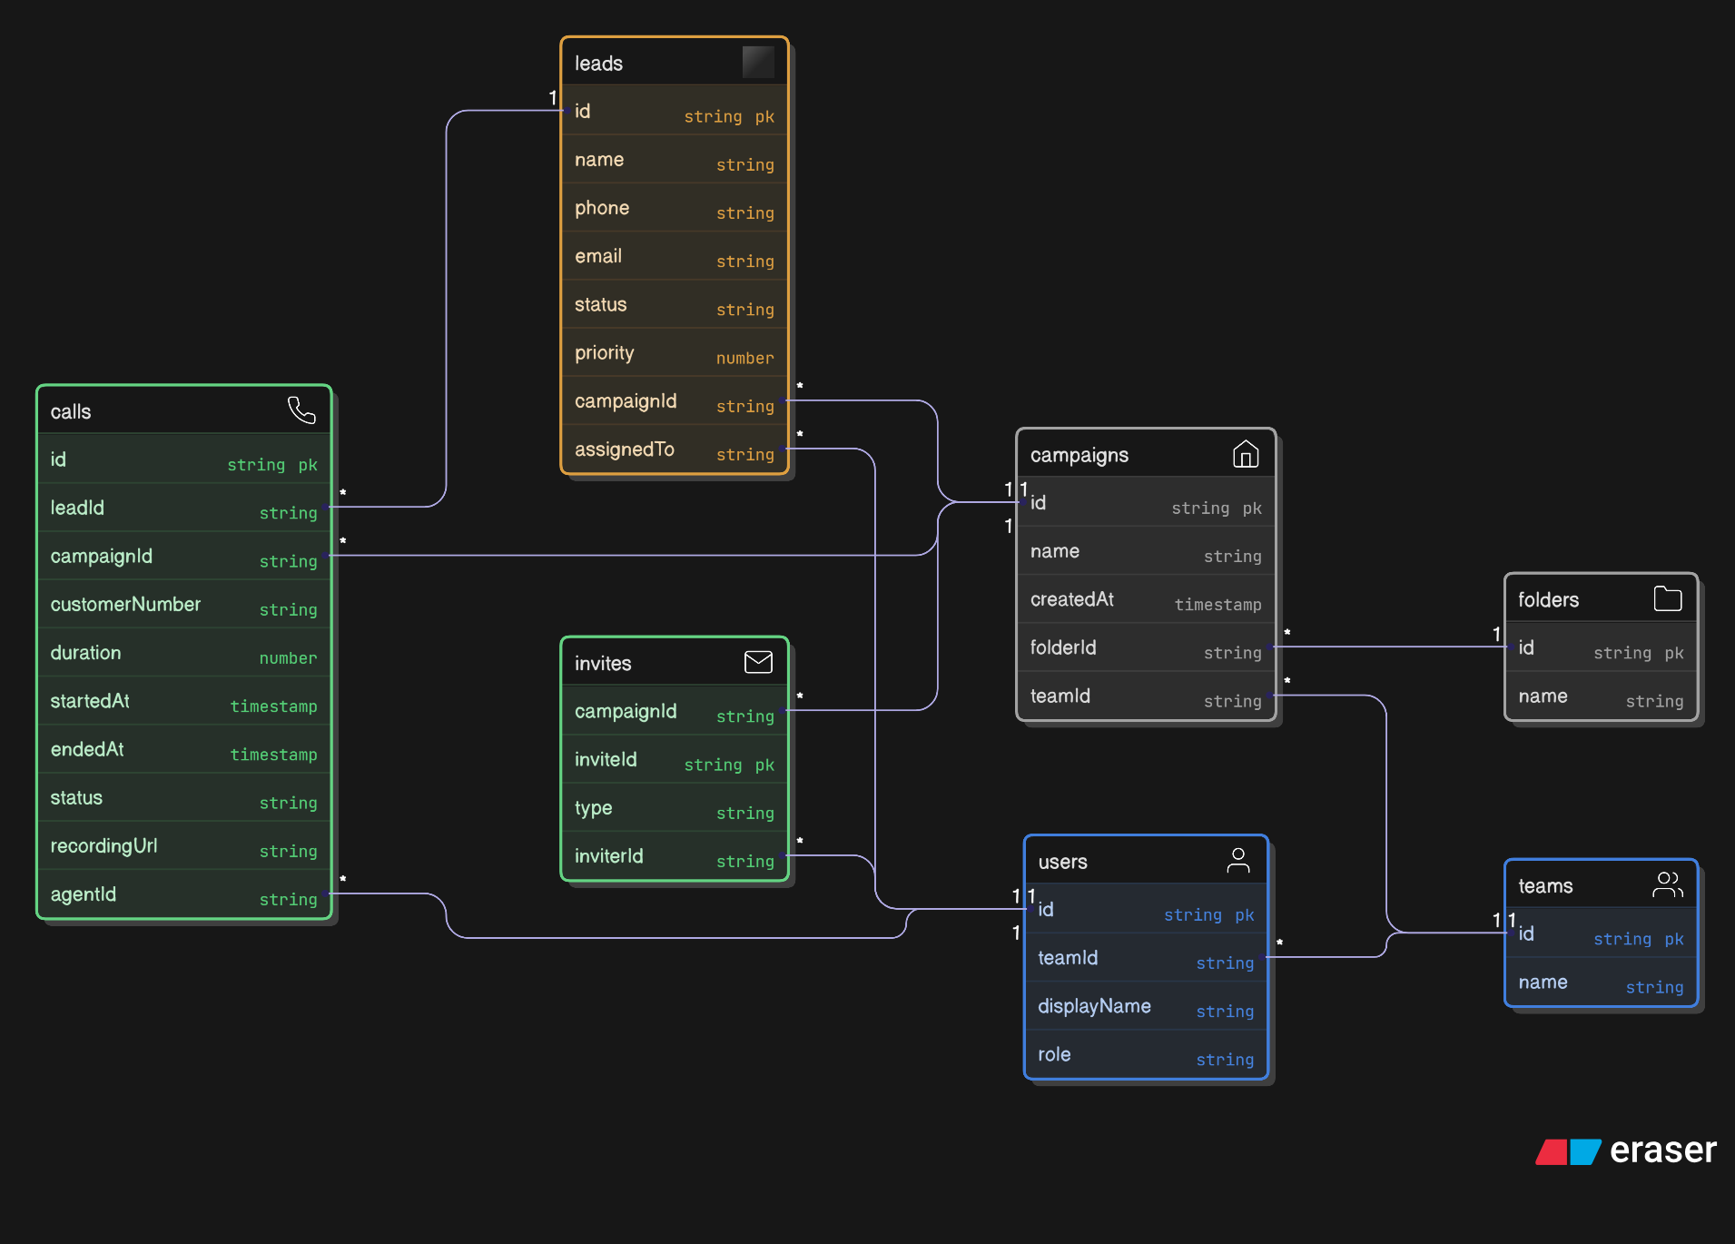

* **🚀 How to Start Android Project from Scratch**
* **1. Setup & Planning**
* Android Studio → *Empty Compose Activity*
* Minimum SDK: 23+ (Marshmallow, stable telephony APIs)
* Architecture: **MVVM + Clean Architecture**
* Dependencies:
* Jetpack Compose (UI)
* Retrofit + OkHttp (API calls)
* Coroutines + Flow (async ops)
* Hilt (DI)
* Room DB (local cache)
* Firebase Cloud Messaging (notifications)
* 📌 Deliverable: Project skeleton + GitHub repo setup.
* **2. Core Modules for Android (Agent App)**

**(A) Authentication & User Flow**

* Login (JWT token from backend)
* Role-based navigation (Admin/Agent)
* Secure token storage (DataStore / EncryptedSharedPreferences)

**(B) Campaign & Leads**

* Dashboard (assigned campaigns & leads list)
* Lead details (name, phone, status)
* Lead actions (Call, Reschedule, Add Notes)

**(C) Call Handling**

* Call screen (customer details, call timer, end/transfer)
* Call status update via API (answered, busy, failed)
* Call recording link (if backend supports)
* Notifications (new lead assigned, missed call alert)

**(D) Reports**

* Agent productivity (calls made, success ratio)
* Export/download summary.