Physics-Informed Diffusion Models for Spatio-Temporal Frame Prediction

First A. Author, Fellow, IEEE, Second B. Author, and Third C. Author Jr., Member, IEEE

Abstract—The applicability of deep generative models, though significant in creative tasks, has remained limited in scientific applications. To capture autocorrelations in spatio-temporal tasks, AI models require physical understanding. We present the Physics-Informed Spatio-Temporal Diffusion Model, a unified generative architecture for predicting images of spatio-temporal phenomena. The approach builds upon the standard latent diffusion architecture, switching to a simplified convolutional autoencoder for high-fidelity spatial latent representations and applying frame concatenation and cross-attention based spatio-temporal conditioning. Our primary contribution is the introduction of Physics-Informed Cyclical Sampling (PICS), an inference-time technique that iteratively injects physics correction during the diffusion process. PICS induces zero-shot conditioning from defined physical objectives, resulting in higher physical consistency in generations while avoiding computationally expensive retraining. Evaluated on climate data for future frame prediction of cloud sequences, the architecture substantially demonstrates the effectiveness of generative AI in scientific modeling, and how integrating deterministic physics-guidance provides significant improvements. This work extends the possibility of applying AI for rigorous scientific analysis in a generalized and physically consistent way, given known foundational dynamics.

Index Terms—Convolutional Autoencoder, Future Frame Prediction, Latent Diffusion Models, Physics-Informed Machine Learning, Physics-Informed Cyclical Sampling, Spatio-Temporal Modeling

I. INTRODUCTION
S
patio-Temporal modeling is a fundamental field of scientific computation that aims at studying evolution of physical systems. The study has to account for simultaneously the dependencies on spatial structures and the temporal dynamics known as autocorrelations. In fields such as meteorology, where data is present in form of high-dimensional multi-channel tensors, predicting the evolving state of each particle/pixel becomes highly challenging due to large scale of data (multi megapixel maps) and complexity of governing laws (high order partial-differential equations).
The existing approaches to predictive solutions in the field can be observed in three forms. Classically, statistical analysis based on autoregressive and interpolation methods have been mathematically robust and computationally efficient, but struggle to capture complex, nonlinear dependencies. Dynamic numerical simulation NWP systems, based on complex differential equations, strongly capture scientific accuracy and determinism but at the cost of immense supercomputing demands. Recently data-driven machine learning has emerged as a solution to sequential image/video predictions through recurrent, convolutional and transformer architectures. While these models excel at generalized representational capability that allows generating from diverse data, the same function restricts their applicability in scientific tasks due to over-smoothening.
Deep Generative Models, specifically Diffusion Models, have shown strong performance in image synthesis tasks, especially the latent-space forms in producing high-resolution generations preserving semantic and structural details at feasible computational costs. However, in their standard form, these generative AI methods while producing visually plausible future states remain limited for scientific applications due to the inherent stochasticity of the diffusion process sampling from probabilistic distributions. This results in diffusion models producing physically inconsistent predictions, disregarding deterministic evolution.
To address this challenge of computationally efficient, high-resolution and physically adherent spatio-temporal prediction, we architected the Physics-Informed Spatio-Temporal Diffusion Model. While we leverage the inherent capacity of diffusion models to map pure Gaussian noise to highly complex structural distributions, we introduce a unified, three-tier architecture specifically designed to regulate the generative process with deterministic physical constraints. This system deliberately isolates dimensionality reduction, probabilistic temporal forecasting, and physical consistency into distinct, optimized stages.
We perform latent encoding with a convolutional autoencoder to handle high-dimensional scientific data without losing critical fine-grained details, we utilize a custom convolutional autoencoder. Standard compression techniques like Variational Autoencoders (VAEs) or VQGANs rely on KL-divergence, which enforces probabilistic regularization but frequently induces blurring. Our implementation avoids KL-divergence entirely, optimizing instead for simplified pixel error (Mean Absolute Error, MAE) and perceptual objectives (LPIPS) to yield a highly accurate, deterministic latent space.
Further, a conditional latent diffusion model operates within this compressed spatial representation, a Latent Diffusion Model (LDM) is tasked with generating the future latent frame from pure noise. To ensure these predictions accurately reflect temporal evolution, the diffusion process is heavily conditioned on historical context using a combination of direct frame concatenation and cross-attention mechanisms.
Finally, we incorporate Physics-Informed Cyclical Sampling (PICS) to guide the stochastic generation with deterministic physical laws. Standard diffusion generates frames blindly based on learned distributions; PICS intervenes during this multi-step sampling process. It iteratively decodes intermediate diffusion steps to the pixel space, compares the evolving frame against an optical-flow derived advection prior, and computes the physical discrepancy. This negative error is then injected as a deterministic correction term back into the next step of the diffusion objective, actively steering the noise-denoising trajectory toward a physically coherent state.
In summary, this work bridges the gap between the representational power of deep generative models and the strict physical requirements of scientific computing. The primary contributions of this paper are:
  - A specialized, non-probabilistic convolutional autoencoder architecture that circumvents the blurring effects of traditional latent models, ensuring exact structural preservation for high-dimensional tensor data.
  - A robust, conditioned latent diffusion framework capable of high-resolution future state prediction that avoids the over-smoothing limitations of standard recurrent or transformer-based models.
  - The formulation of the PICS algorithm, a novel inference-time sampling technique that enforces physical priors (such as advection) directly into the diffusion generative process, enabling physically consistent, high-fidelity spatio-temporal forecasting.

II. Related Work and Background
Diffusion models have emerged as the fundamental paradigm for high-resolution image synthesis, especially their latent forms which optimize the generative process with autoencoding. On the other front Physics Informed Neural Networks (PINNs) are steering the use of AI in scientific discovery.

A. Diffusion Process
Denoising Diffusion Probabilistic Models (DDPM) define a class of generative models that formulate the synthesis of data as a parameterized Markov chain. The process consists of two fundamental phases: the forward diffusion process of adding Gaussian noise to the data according to a variance schedule and the reverse diffusion process that iteratively denoises the pure gaussian distribution towards the generation objective.
Mathematically the forward diffusion starts from a clean data sample $x_{0}$ (sampled from distribution $q\left(x_{0}\right)$) and progressively adds Gaussian noise over $T$ timesteps. The joint distribution for the sequence is defined as:
$$\begin{aligned}q\left(x_{1}:T | x_{0}\right)=\prod_{t=1}^{T}{q\left(x_{t} | x_{t-1}\right)}≈N\left(0,I\right)\#\left(1\right)\end{aligned}$$
A key property of this Markov chain is that we can sample the noisy state $x_{t}$ at any arbitrary timestep directly from the initial state $x_{0}$ using a variance schedule $β_{t}$ and its cumulative product ${\overline{α}}_{t}$:
$$\begin{aligned}q\left(x_{t} ∣ x_{0}\right)=N\left(x_{t};\sqrt{{\overline{α}}_{t}} x_{0},\left(1-{\overline{α}}_{t}\right)I\right)\#\left(2\right)\end{aligned}$$
$$\begin{aligned}x_{t}=\sqrt{{\overline{α}}_{t}}x_{0}+\sqrt{1-{\overline{α}}_{t}}\#\left(3\right)\end{aligned}$$
The Generative process occurs by reversing the noise addition process. Starting from pure noise $p\left(x_{T}\right)=x_{T}∼N\left(0,I\right)$, the model learns to sculpt a structured state. Since the true reverse distribution is intractable, a neural network $p_{θ}$ is trained to approximate the Gaussian transitions:
$$\begin{aligned}p_{θ}\left(x_{t-1} ∣ x_{t}\right)=N\left(x_{t-1};μ_{θ}\left(x_{t},t\right),Σ_{θ}\left(x_{t},t\right)\right)\#\left(4\right)\end{aligned}$$
$$\begin{aligned}x_{t-1}=μ_{θ}\left(x_{t},t\right)+\sqrt{Σ_{θ}\left(x_{t},t\right)} ϵ\#\left(5\right)\end{aligned}$$
$$\begin{aligned}p_{θ}\left(x_{0}\right)=\int{p\left(x_{T}\right)\prod_{t=1}^{T}{p_{θ}\left(x_{t-1} ∣ x_{t}\right)}} dx_{1:T}\#\left(6\right)\end{aligned}$$
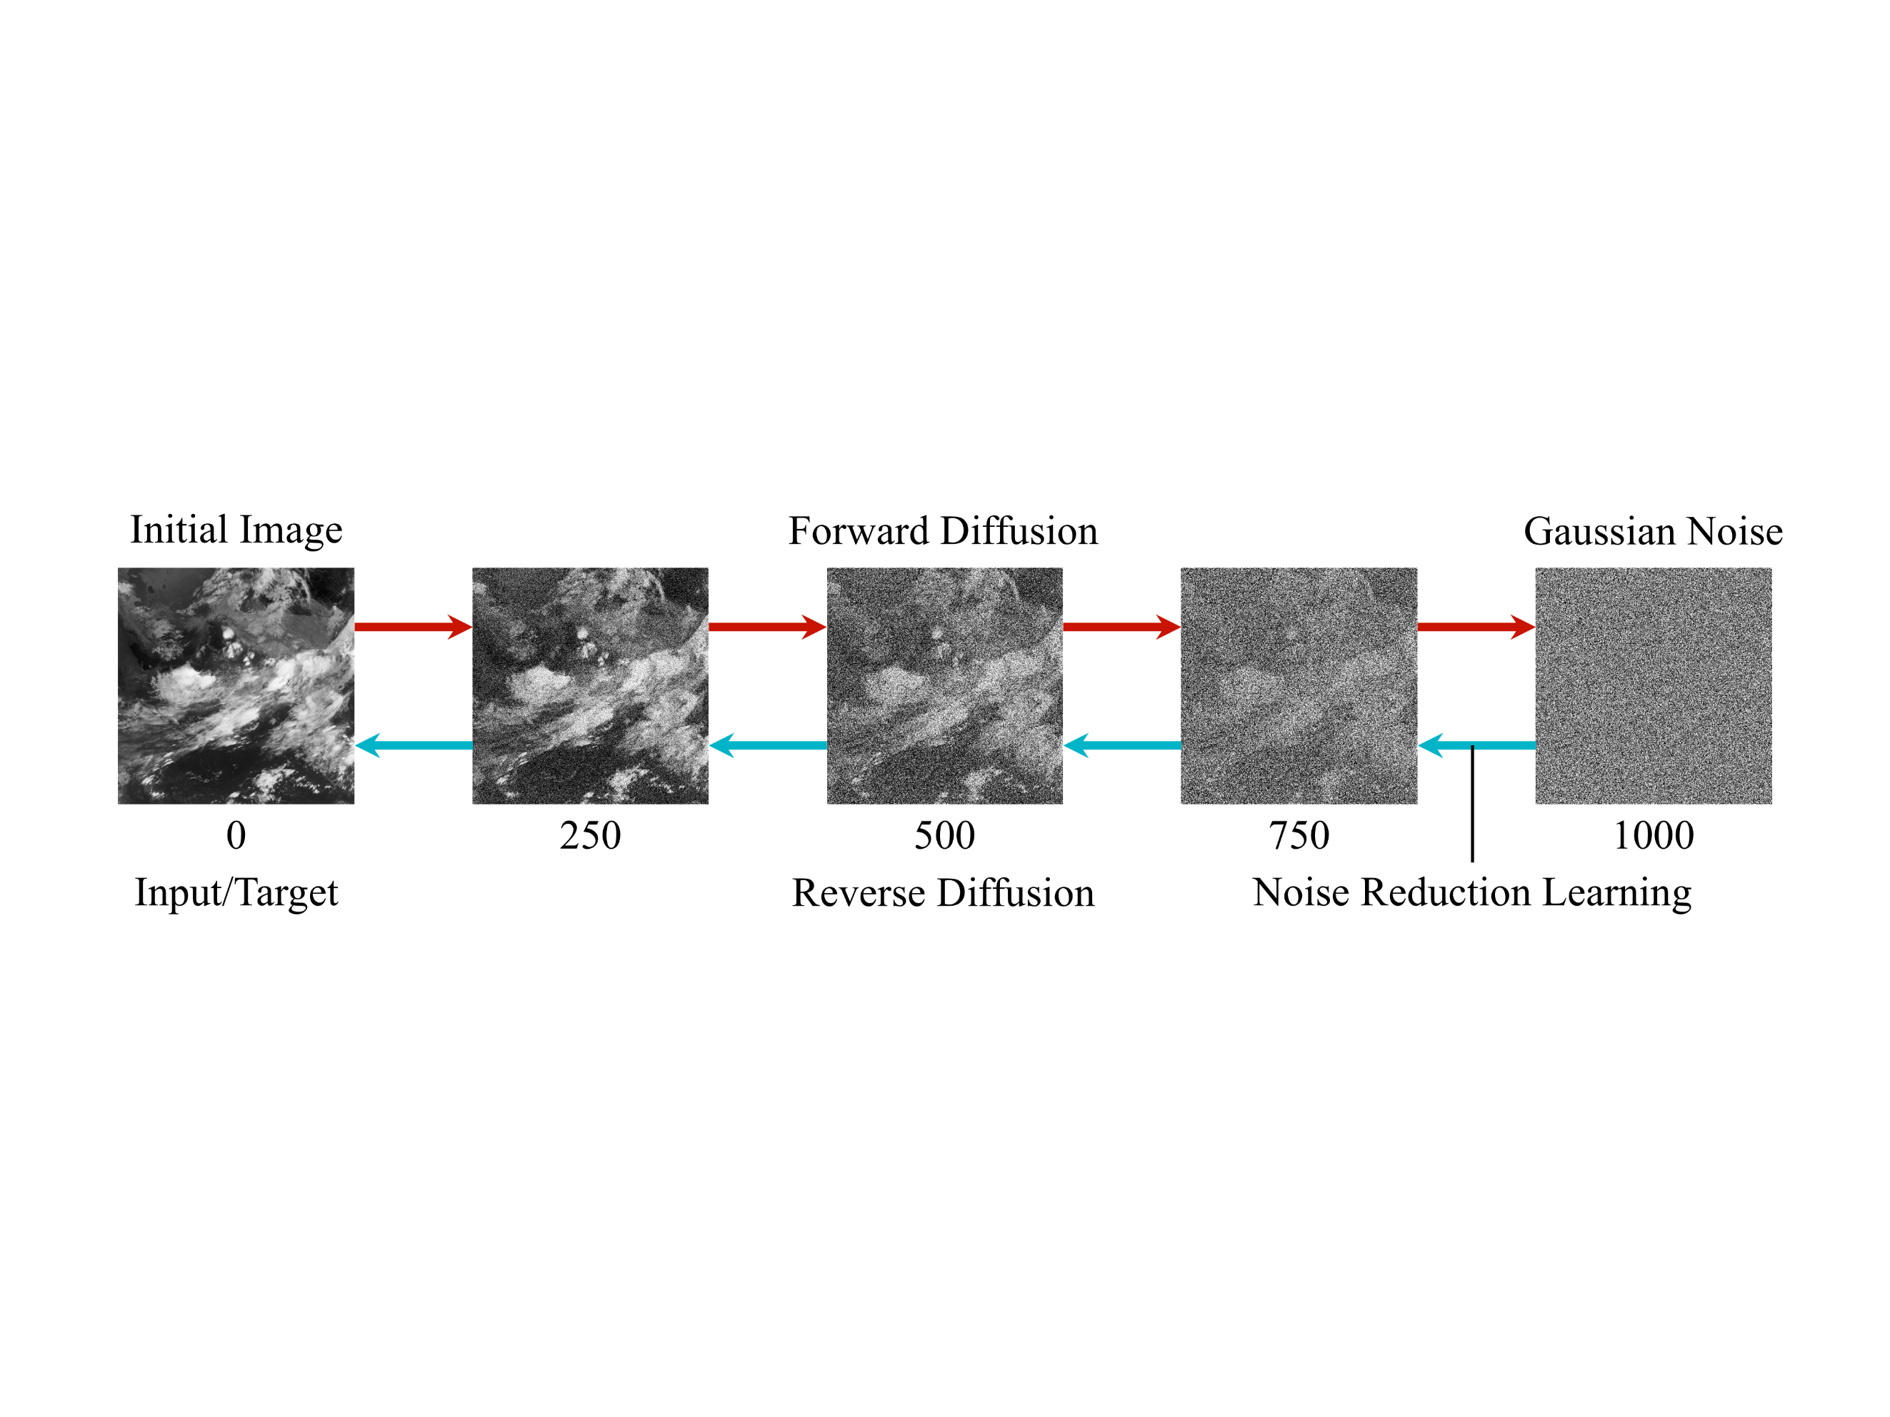 Fig. 1. Forward and reverse diffusion processes.

While standard DDPMs operate directly in the high-dimensional pixel space, the computational demands for processing high-resolution meteorological data make such an approach intractable. To resolve this, Latent Diffusion Models (LDM) leverage a perceptual compression framework consisting of an encoder $E$ and a decoder $D$. The encoder abstracts away high-frequency details to map the input $x$ into an efficient, low-dimensional latent space $z=E\left(x\right)$. By operating in this compressed manifold, the model can (i) focus on the critical semantic bits of the atmospheric data and (ii) train in a computationally efficient space.
The neural backbone $ϵ_{θ}$, typically a time-conditional U-Net, is trained to learn the reverse process within this latent manifold. The simplified training objective for the LDM is expressed as:
$$\begin{aligned}L_{LDM}≔E_{E\left(x\right),ϵ∼N\left(0,1\right),t}\left[{\left\|ϵ-ϵ_{θ}\left(z_{t},t\right)\right\|}_{2}^{2}\right]\#\left(7\right)\end{aligned}$$
During inference, a future latent state is sampled from the learned distribution $p\left(z\right)$ and subsequently decoded back into the full-resolution pixel space via a single pass through the decoder $D$.

B. The Autoencoder Dilemma
To handle the high dimensionality of meteorological data, generative frameworks typically rely on an autoencoding stage to map pixel-space inputs into a compressed latent manifold. However, the choice of compression architecture introduces a fundamental trade-off between structural sharpness and probabilistic regularity, known as the "Autoencoder Dilemma".
Variational Autoencoders (VAEs) and KLD Blur: Standard generative pipelines often utilize Variational Autoencoders (VAEs) to ensure a smooth latent space. Since the true posterior $p\left(z\right)$ is computationally intractable, VAEs optimize the Evidence Lower Bound (ELBO) defined as
$$\begin{aligned}L_{ELBO}=E_{q_{ϕ}\left(z | x\right)}\left[\log{p_{θ}\left(x | z\right)}\right]-D_{KL}\left(q_{ϕ}\left(z | x\right)∥p\left(z\right)\right)\#\left(8\right)\end{aligned}$$
The first term represents the reconstruction accuracy, while the second term is the Kullback-Leibler Divergence (KLD), which regularizes the approximate posterior $q_{ϕ}\left(z | x\right)$ toward a prior $p\left(z\right)$ (usually $N\left(0,I\right)$). Mathematically, the KLD is stated as:
$$\begin{aligned}D_{KL}\left(q\left(z ∣ x\right)∥p\left(z\right)\right)=\int_{-∞}^{∞}{q\left(z ∣ x\right)}\log\left(\frac{q\left(z ∣ x\right)}{p\left(z\right)}\right)dz\#\left(9\right)\end{aligned}$$
To allow for backpropagation through this stochastic process, the reparameterization trick is employed, defining $z = μ+ σ⊙ϵ$ where $ϵ∼N\left(0,I\right)$.
While this formulation provides a continuous latent manifold, it induces the "Regressive Mean" problem. The KL penalty penalizes outliers to fit the Gaussian prior, compelling the decoder to output a statistical average of all possible reconstructions. This results in "latent collapse," where high-frequency features are smoothed into indistinct, blurry ones.
To resolve the blurring endemic to VAEs, Vector Quantized Generative Adversarial Networks (VQGANs) utilize a discrete codebook $Z=\{e_{k}\}_{k=1}^{K}⊂R^{n_{z}}$ to represent latent features. Instead of a continuous distribution, the encoder output $\hat{z}=E\left(x\right)$ is mapped to its nearest neighbor in the codebook through a quantization function $q\left(⋅\right)$:
$$\begin{aligned}z_{q}=q\left(\hat{z}\right)≔\text{arg }{\text{min}}_{e_{k}∈Z}{\left\|\hat{z}-e_{k}\right\|}_{2}^{2}\#\left(10\right)\end{aligned}$$
While this prevents the regressive averaging of the KLD and yields sharper visual textures, it introduces artificial discretization. Because atmospheric fluid dynamics are fundamentally continuous, forcing smoothly evolving density gradients into fixed discrete steps creates quantization artifacts that are scientifically unreliable for fluid modelling.
In Section III, we detail our proposed Convolutional Autoencoder (CAE), which avoids these limitations by utilizing a deterministic, non-probabilistic mapping optimized for structural fidelity. By omitting both the Gaussian prior of VAEs and the discrete codebook of VQGANs, the CAE preserves the continuous physical gradients essential for accurate meteorological forecasting.

C. Physics Informed Neural Networks
Physics-Informed Neural Networks (PINNs) represent the dominant paradigm for grounding machine learning in classical mechanics by embedding physical laws directly into the neural network's optimization process. Unlike traditional black-box models, PINNs treat the governing Partial Differential Equations (PDEs) of a system, such as those describing the evolution of spatio-temporal quantities, as constraints. In this framework, a physical system for a spatio-temporal quantity $u\left(t,x\right)$ is modelled by a PDE of the form
$$\begin{aligned}\frac{∂u}{∂t}+N\left(u,∇u,∇^{2}u,…\right)=0\#\left(11\right)\end{aligned}$$
where $N$ is a nonlinear operator comprising a sum of successive spatial derivatives and differential terms. By incorporating these equations as the final layers of the network or as structural components of the loss function, PINNs ensure that the model's outputs remain consistent with established scientific principles. The optimization of these networks typically relies on a composite objective function that balances empirical data with virtual physical constraints:
$$\begin{aligned}L_{PINN}=w_{d}\sum_{\text{data}}{{\left.\left\|\hat{u}\left(x_{j}\right)-u\left(x_{j}\right)\right.\right\|}_{2}^{2}}+w_{p}\sum_{\text{physics}}{{\left.\left\|N\left(u\left(x_{j}\right),x_{j},t\right)\right.\right\|}_{2}^{2}}\#\left(12\right)\end{aligned}$$
In this formulation, $w_{d}$ and $w_{p}$ represent the relative weightages assigned to the data-driven and physics-driven "virtual" loss terms, respectively. The data loss ensures the model fits observed patterns, while the physics loss minimizes the residual of the governing PDE. This dual dependency makes PINNs particularly promising for identifying governing physical laws in scenarios where data is sparse, as the physical residual acts as a powerful regularizer that guides the model toward scientifically valid solutions.
However, despite their theoretical advantages, standard PINNs suffer from significant operational rigidity. Because they rely on "Training-Time Physics," the physical constraints are baked directly into the network weights during the optimization phase. Consequently, they are computationally expensive to train and wholly inflexible; if the governing physical equations need adjustment, the entire foundation model must be retrained from scratch. Taking inspiration from the rigor of PINNs while seeking to mitigate these limitations, our proposed architecture shifts toward an inference-time guidance paradigm. By introducing Physics-Informed Cyclical Sampling (PICS), we perform zero-shot physical correction during the generation process as discussed in Section III.

III. Architecture and Methodology
The Physics Informed Diffusion Model architecture follows a 3-phase sequential pipeline: raw satellite sequences are compressed into a latent manifold via a specialized Convolutional Autoencoder (CAE); a Conditional Latent Diffusion U-Net synthesizes the future latent state; and the Physics-Informed Cyclical Sampling (PICS) algorithm enforces fluid advection constraints during the inference.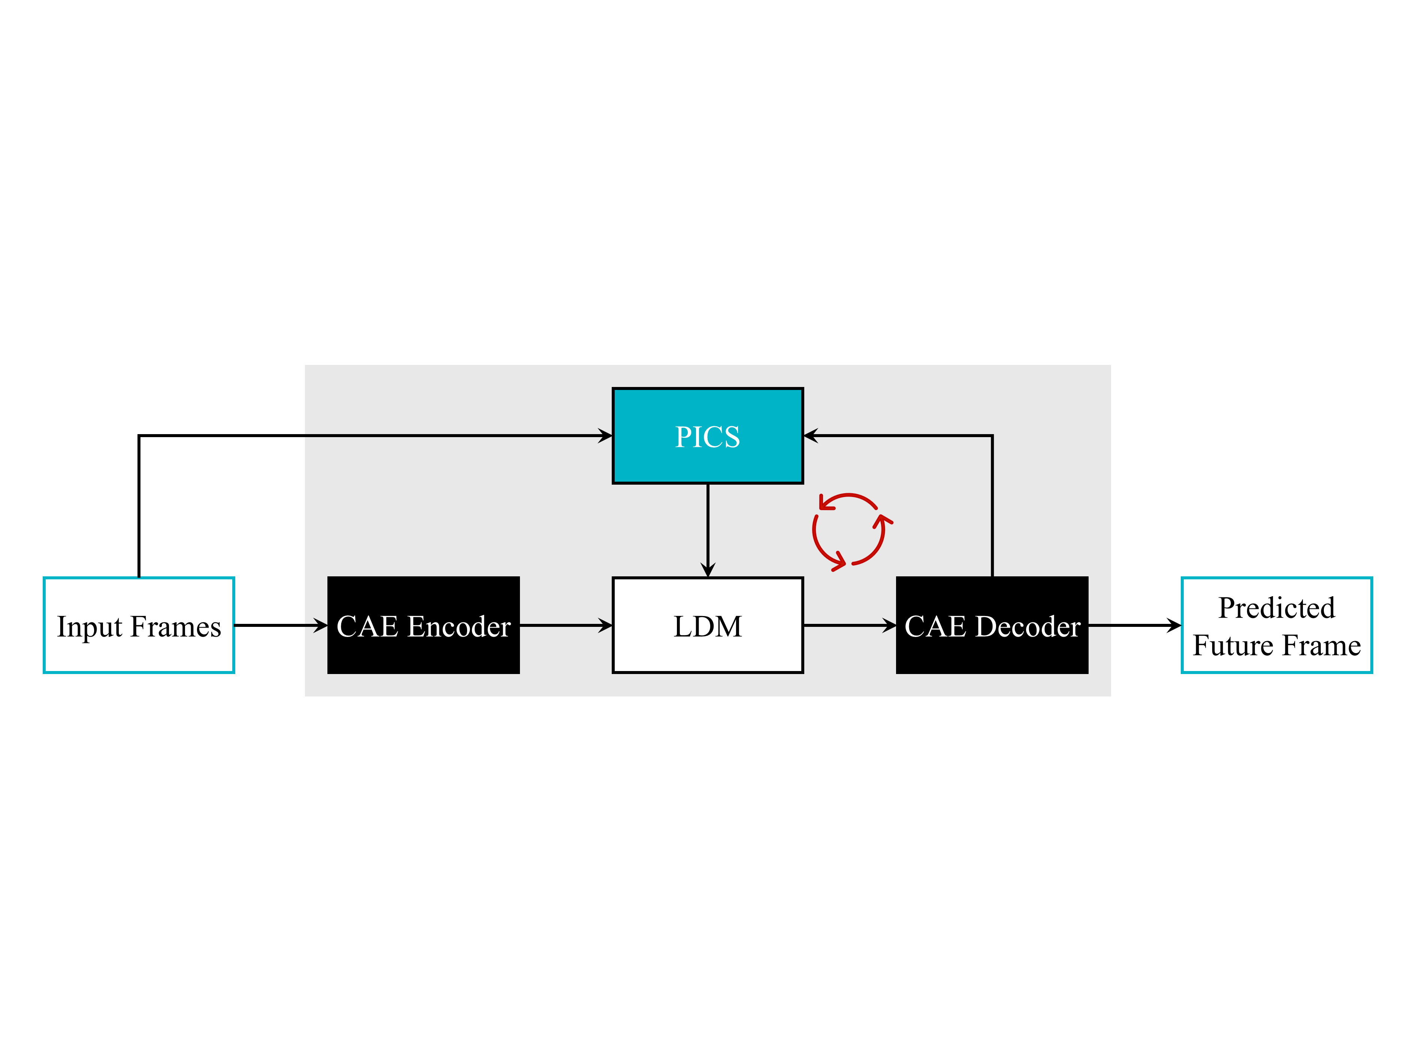 Fig. 2. Architecture pipeline overview.

A. Convolutional Autoencoder
The Convolutional Autoencoder (CAE) serves as the foundational neural translator of the architecture, tasked with mapping high-dimensional image tensors into a compact, continuous latent manifold. To preserve scientific accuracy, the CAE is designed as a near deterministic mapping function, deliberately omitting the probabilistic regularizers found in Variational Autoencoders (VAEs) to prevent the Regressive Mean and latent-collapse problems.
- Structural mechanics of CAE architecture
  - The architecture comprises of a near symmetrical arrangement of split Encoder $E$ and Decoder $D$. For Initial Feature Extraction, the encoder input layer utilizes a $7 ×7$ convolutional kernel with a stride of 1. This relatively large receptive field is a strategic choice intended to capture broad, large-scale spatial structures, such as massive cloud clusters, in the initial pass.
  - Residual Learning Blocks are used to propagate high-frequency satellite image textures through deep layers, we implement stacked Residual Blocks based on the identity mapping principle. These blocks, consisting of dual $3 ×3$ convolutions and skip connections, allow the network to learn residual functions $F\left(x\right)$ such that the output is $y=F\left(x\right)+x$, effectively mitigating the vanishing gradient problem and preserving fine-grained features.
  - As downsampling strategically avoids max-pooling, which performs non-learned downsampling by selecting local maxima and discarding other activations, instead the CAE employs strided $4×4$ convolutions (stride 2), enabling learned spatial aggregation and potentially better preservation of fine-grained structural information during resolution reduction.
  - At the latent bottleneck, the final encoding stage employs a $1×1$convolution to project feature maps into a compact 4-channel latent representation. A Tanh activation is applied to bound the latent values within $\left[-1,1\right]$, providing controlled scaling that can help stabilize training dynamics during subsequent diffusion processes.
- Dimensionality and Latent Representation
  - The CAE compresses an initial $512 ×512 ×1$ frame into a $64 ×64 ×4$ latent tensor. This 8-fold reduction per spatial dimension achieves a significant reduction in sequence length, which is critical for the downstream Latent Diffusion Model. 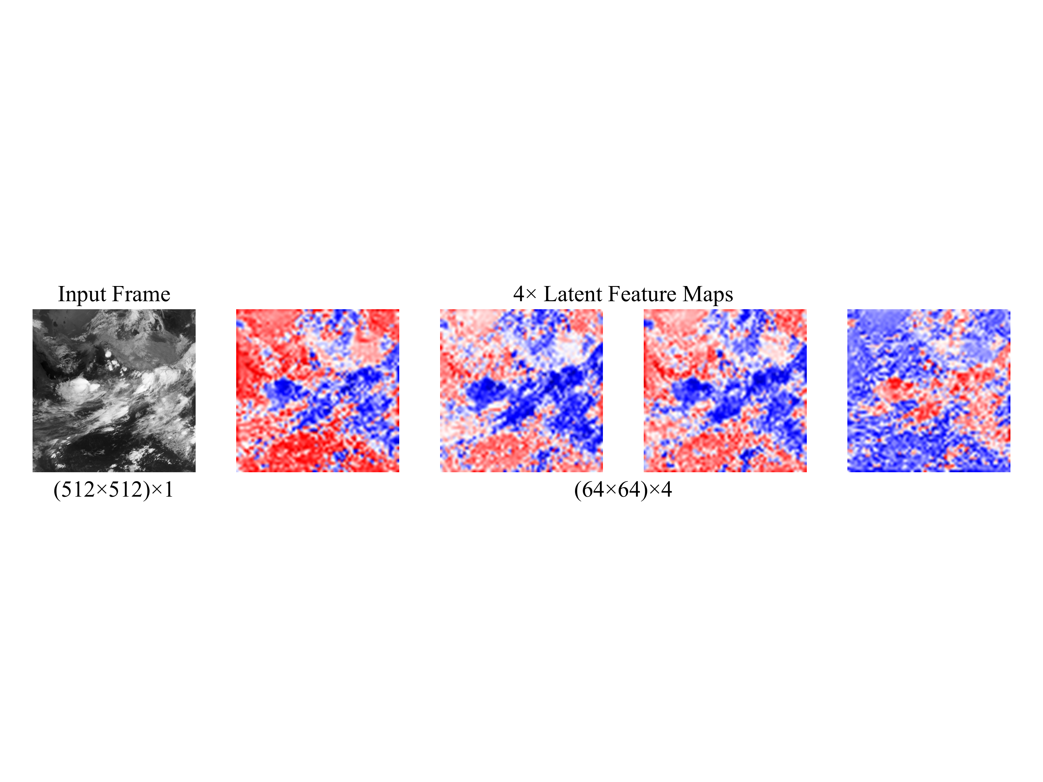 Fig. 3. Latent representation visualization.

With a 16 times reduction in raw data, the autoencoder reduces computation load on heavy mechanisms like attention, enabling rapid training and inference on consumer-grade hardware.
  - Visualization of the latent manifold indicates that the network effectively isolates distinct physical features across its 4 channels. For instance, high-frequency edges defining storm boundaries are captured in one channel, while broad thermal mass and density gradients are distributed across others, confirming that the latent space acts as a structured, physics-aware representation of the atmospheric state.
- Optimization Landscape and Hybrid Loss
  - To ensure that the latent mapping is both mathematically precise and structurally coherent, the network avoids the standard $L_{2}$ (Mean Squared Error) loss, which is mathematically prone to over-smoothing. Instead, we optimize a composite objective function:
$$L_{\text{CAE}}=α\underset{\text{MAE}}{\underbrace{\frac{1}{HW}\sum_{h,w}{\left|x_{hw}-{\hat{x}}_{hw}\right|}}}$$
$$\begin{aligned}+γ\underset{\text{LPIPS}}{\underbrace{\sum_{l}{\frac{1}{H_{l}W_{l}}}\sum_{h,w}{{\left\|\hat{f^{l}}{\left(x\right)}_{hw}-\hat{f^{l}}{\left(\hat{x}\right)}_{hw}\right\|}_{2,w_{l}}^{2}}}}\#\left(13\right)\end{aligned}$$
  - Mean Absolute Error (MAE) component (weighted by $α=0.8$) encourages pixel-level accuracy.
  - LPIPS (Learned Perceptual Image Patch Similarity): The second term (weighted by $γ=0.2$) calculates the distance between the original $\left(x\right)$ and reconstructed $\left(\hat{x}\right)$ frames within the feature space of a pre-trained deep network (VGG16 in our case). By minimizing this perceptual distance, the CAE prioritizes high-level textures and structural realism.
- Manifold Stability and Reconstruction Fidelity
  - By circumventing the KL-Divergence penalty, the CAE achieves a reconstruction MS-SSIM (Multi-Scale Structured Similarity Index Measure) of 98%, significantly exceeding the 85% fidelity typical of VAEs and 95% of VQGANs.
  - While the omission of a Gaussian prior can theoretically result in a "holed" or non-smooth latent manifold (still continuous), such artifacts were not observed in our results. We hypothesize that for satellite imagery, which possesses relatively uniform data distribution, the LPIPS metric provides sufficient structural regularization to maintain a continuous and stable latent space.
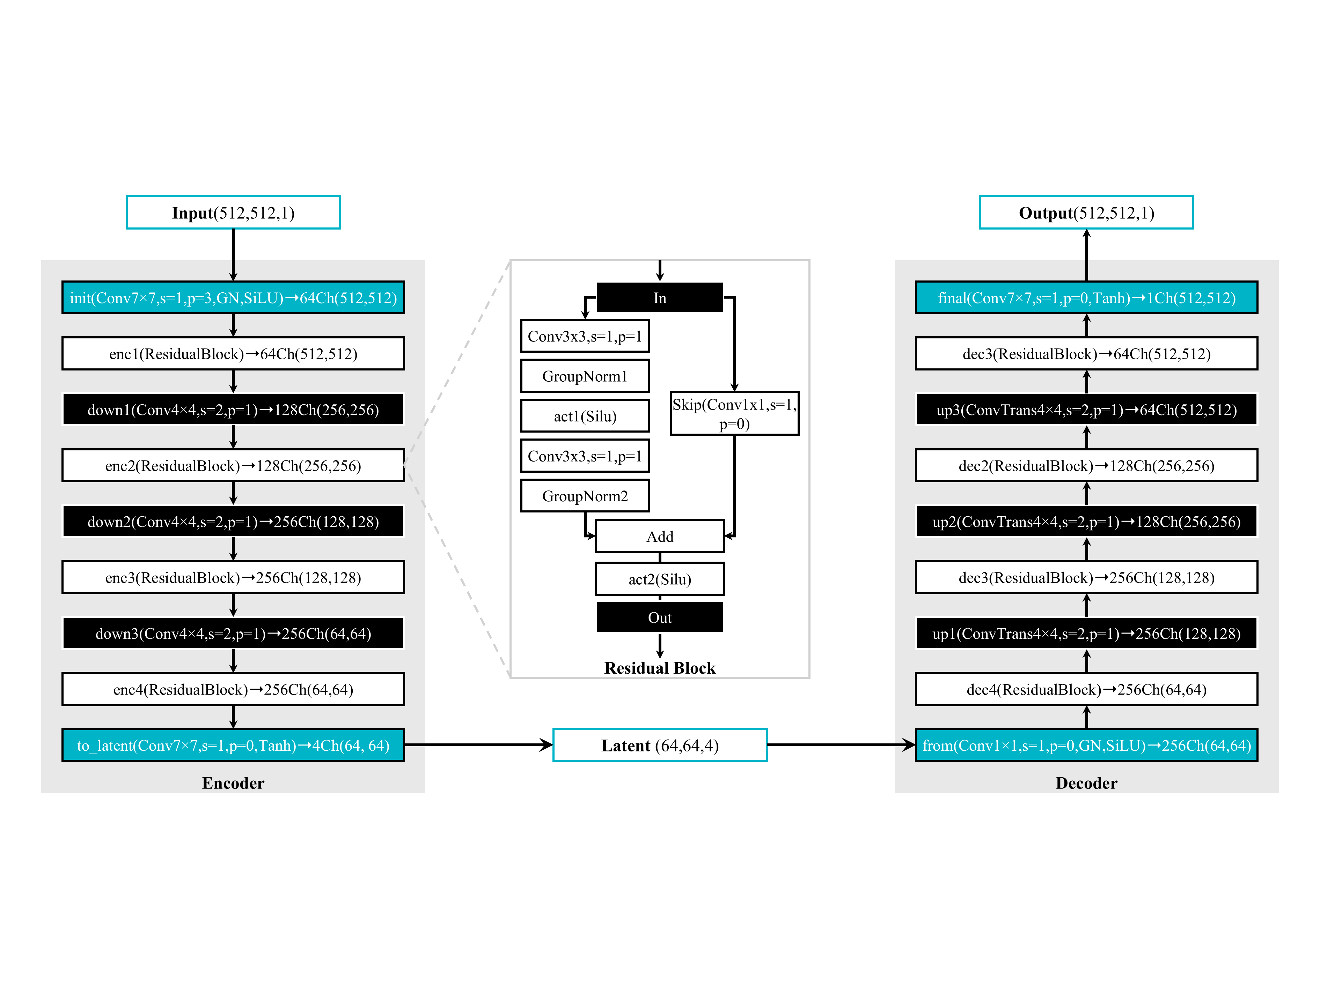
Fig. 4. CAE Architecture.

A. Latent Diffusion U-Net
Following the compression by the CAE encoder, latent frames are stored as tensors and forwarded to the LDM U-Net. This part of architecture learns to generate future latent from 1000 step denoising from pure Gaussian noise, simultaneously retrieving context for the future frame.
- Frame Concatenation and Noise Scheduling
  - The model is initialized with a $64 ×64 ×4$ ($H ×W ×C$) tensor of pure Gaussian noise, which represents the unknown future latent $z_{T}$. Historical context is provided by encoding the four preceding frames ($t-4$to $t-1$) into four separate latent tensors. These are concatenated along the channel dimension to form a $64 ×64 ×16$ context block. As shown in the architecture diagram, this block is merged with the current noise latent, resulting in a 20-channel input ($64 ×64 ×20$) for the initial U-Net layer.
  - A Cosine Beta Schedule is used for the forward diffusion process. It ensures a smooth transition between structured data and noise over 1000 steps by defining the cumulative alpha $\left({\overline{α}}_{t}\right)$ as
$$\begin{aligned}{\overline{α}}_{t}=\frac{f\left(t\right)}{f\left(0\right)}, f\left(t\right)=\cos^{2}\left(\frac{t/T+s}{1+s}⋅\frac{π}{2}\right)\#\left(14\right)\end{aligned}$$
where $s$ is a small offset (typically 0.008) to prevent $β_{t}$ from becoming too small at $t=0$.
- U-Net Architecture
  - The reverse denoising process is executed by a specialized U-Net backbone designed to process multi-scale spatial features while maintaining temporal synchronization. A hierarchical structure is employed with channel depths increasing from 256 at Level 1 to 1024 at the deepest stage. The Bottleneck (4th stage) reaches a spatial resolution of $8 ×8 ×1024$, integrating a sequence of Residual, Self-Attention, and Cross-Attention blocks to capture global atmospheric dependencies. Standard skip connections bridge the encoder and decoder paths to recover spatial information during reconstruction.
  - Temporal Embeddings are generated with a Multi-Layer Perceptron (MLP) consisting of Linear and SiLU layers with the current diffusion timestep $t$ is mapped into a 640-dimensional Time Vector (TimeVec). Within the U-Net layers, the TimeVec is injected into the residual blocks using Feature-wise Linear Modulation (FiLM). This modulates the feature map $F$ through learned scale $\left(γ\right)$ and shift $\left(β\right)$ parameters derived from the time embedding $\text{FiLM}\left(F_{i,c}\right)=γ_{c}\left(t\right)⋅F_{i,c}+β_{c}\left(t\right)$, After Group Normalization (GN), ensuring consistency of predicted noise with the current denoising stage.
  - To resolve the complex autocorrelations between historical patterns and future states, the architecture integrates both Self-Attention and Cross-Attention layers at lower spatial resolutions ($32 ×32$ and below). Self-Attention captures intra-frame spatial dependencies, querying how a cloud structure in one region relates to surrounding density zones. Cross-
Attention acts as a temporal bridge by querying the concatenated historical context $c$. Mathematically:
$$\begin{aligned}\text{Attention}\left(Q,K,V\right)=\text{softmax}\left(\frac{QK^{T}}{\sqrt{d_{k}}}\right)V\#\left(15\right)\end{aligned}$$
In these blocks, $K$ and $V$ are derived from the historical latents, aligning the generation with the chronological trajectory of preceding movement.
- Diffusion Objective and Reverse Sampling
The LDM is optimized using a Mean Squared Error (MSE) loss to predict the added noise $ϵ$:
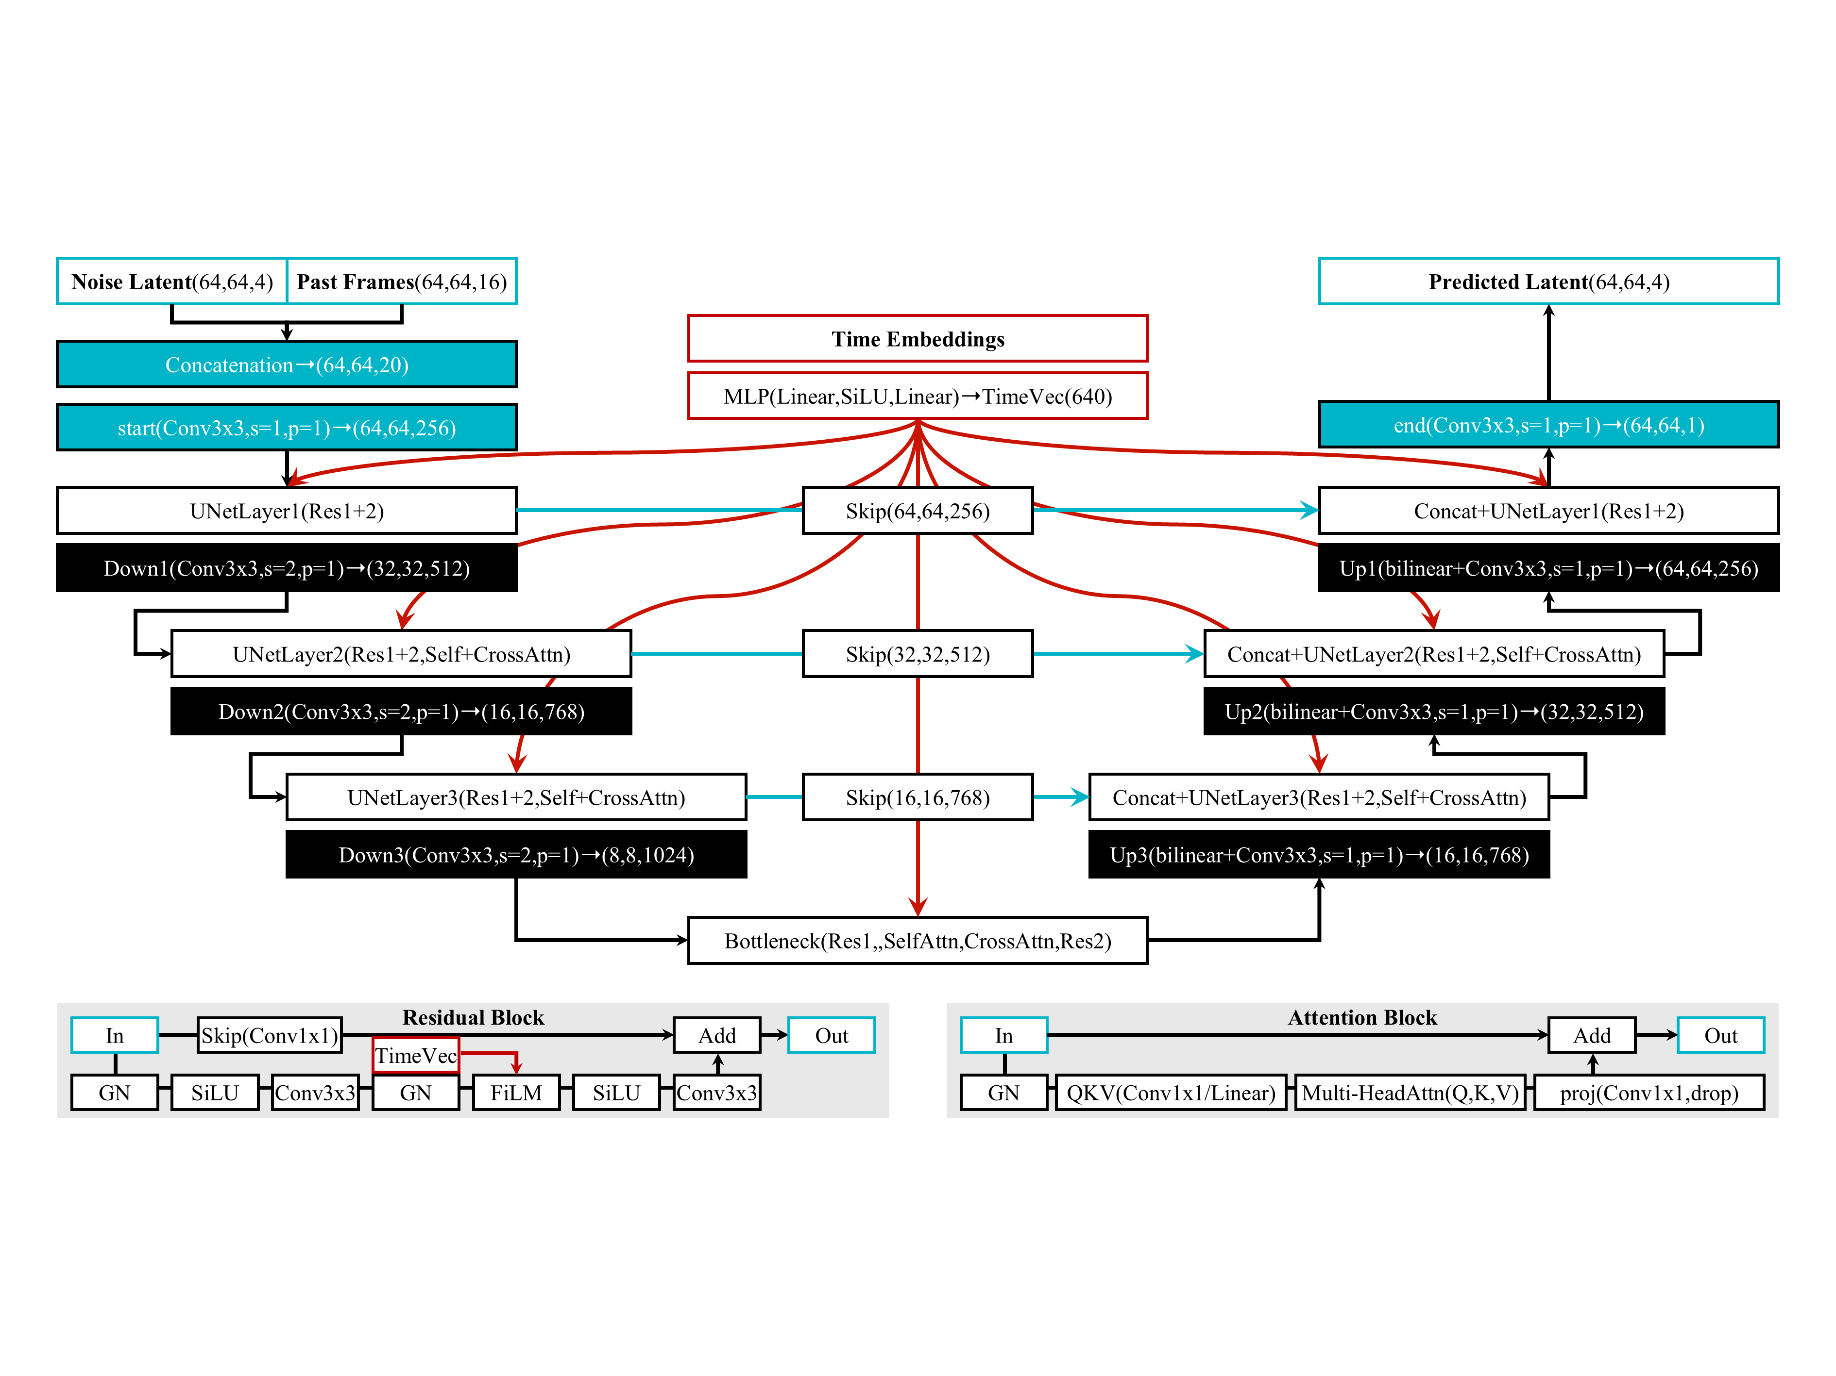
Fig. 5. LDM Architecture.

$$\begin{aligned}L_{\text{LDM}}=E_{z_{0},ϵ∼N\left(0,1\right),t}\left[{\left.\left\|ϵ-ϵ_{θ}\left(\sqrt{{\overline{α}}_{t}}z_{0}+\sqrt{1-{\overline{α}}_{t}}ϵ,t,c\right)\right.\right\|}^{2}\right]\#\left(16\right)\end{aligned}$$
- The reverse sampling equation recovers the state $z_{t-1}$ from $z_{t}$ iteratively:
$$\begin{aligned}z_{t-1}=\frac{1}{\sqrt{α_{t}}}\left(z_{t}-\frac{β_{t} }{\sqrt{1-{\overline{α}}_{t}}}ϵ_{θ}\left(z_{t},t,c\right)\right)\#\left(17\right)\end{aligned}$$
- This iterative formulation serves as the baseline for the generation process. As detailed in the following subsection, the Physics-Informed Cyclical Sampling (PICS) component injects deterministic physical corrections specifically at this stage.

C. Physics-Informed Cyclical Sampling
PICS is an inference-time optimization technique that enforces physical consistency of known stated objective. PICS allows zero-shot physics enforcement on a pre-trained generative model to be dynamically steered toward a scientifically valid generation.
- In atmospheric modeling, the transport of cloud density is primarily governed by higher degree non-linear Advection Equation. However, the Scalar form of the equation can act as a simplified substitute dictating the spatio-temporal state evolution.
$$\begin{aligned}\frac{∂I}{∂t}+v⋅∇I=0\#\left(18\right)\end{aligned}$$
- PICS utilizes Recurrent All-Pairs Field Transforms (RAFT) to extract an optical flow field ($F_{t-1→t}$) from the historical frames $I_{t-2}$ and $I_{t-1}$, serving as an intrinsic physical proxy for dynamic vector fields:
$$\begin{aligned}F_{t-1→t}=\text{RAFT}\left(I_{t-2},I_{t-1}\right)\#\left(19\right)\end{aligned}$$
This flow field is applied to the most recent frame $I_{t-1}$ via a spatial warping function to calculate the Physically Expected Frame ($\tilde{I}$), which serves as the deterministic prior for the generation process:
$$\begin{aligned}\tilde{I}\left(z,y\right)=\text{advect}\left(I_{t-1},F_{t-1→t}\right)\#\left(20\right)\end{aligned}$$
- A critical challenge in weather forecasting is that not all atmospheric changes are advective; processes like condensation and evaporation create regions where simple transport laws do not apply. To prevent the physics module from enforcing erroneous gradients in these zones, we introduce an Advection Mask ($M$):
$$\begin{aligned}M=\text{clip}\left(e^{-\frac{\left|\tilde{I}-I_{t-1}\right|}{E\left[\left|\tilde{I}-I_{t-1}\right|\right]+ϵ}}\right)\#\left(21\right)\end{aligned}$$
This mask attenuates the physical loss in regions where the historical movement is non-advective, focusing the guidance only on stable transport structures. During a selected sampling step $t$, the system decodes the current predicted latent ${\hat{z}}_{0}$ into pixel space ($\hat{I}=\text{decode}\left({\hat{z}}_{0}\right)$) and calculates the physics loss:
$$\begin{aligned}L_{PICS}=E\left[M⋅\left|\hat{I}-\tilde{I}\right|\right]\#\left(22\right)\end{aligned}$$
Early stages of diffusion are too chaotic, while final stages focus on micro-textures as the generation settles. Therefore, physical correction is applied non-uniformly across the diffusion timesteps using a Bell-Curve Schedule ($s\left(t\right)$) to target the mid-range "structural" phase of the denoising process:
$$\begin{aligned}s\left(t\right)=\max\left(s_{min}, s_{peak}⋅e^{-\frac{Δt^{2}}{2σ^{2}}}\right)\#\left(23\right)\end{aligned}$$
The raw physical gradient $∇_{t}=∇_{z_{t}}L_{PICS}$ is normalized by its standard deviation to prevent gradient explosion and scaled by $s\left(t\right)$:
$$\begin{aligned}{\tilde{∇}}_{t}=\frac{∇_{t}}{Std\left(∇_{t}\right)+ϵ}⋅s\left(t\right)⋅1_{t \left(mod i=0\right)}\#\left(24\right)\end{aligned}$$
This normalized gradient is then injected as a deterministic correction into the reverse sampling equation (17):
$$\begin{aligned}z_{t-1}=\frac{1}{\sqrt{α_{t}}}\left(z_{t}-\frac{β_{t}}{\sqrt{1-{\overline{α}}_{t}}}ϵ_{θ}\left(z_{t},t\right)\right)-{\tilde{∇}}_{t}\#\left(25\right)\end{aligned}$$
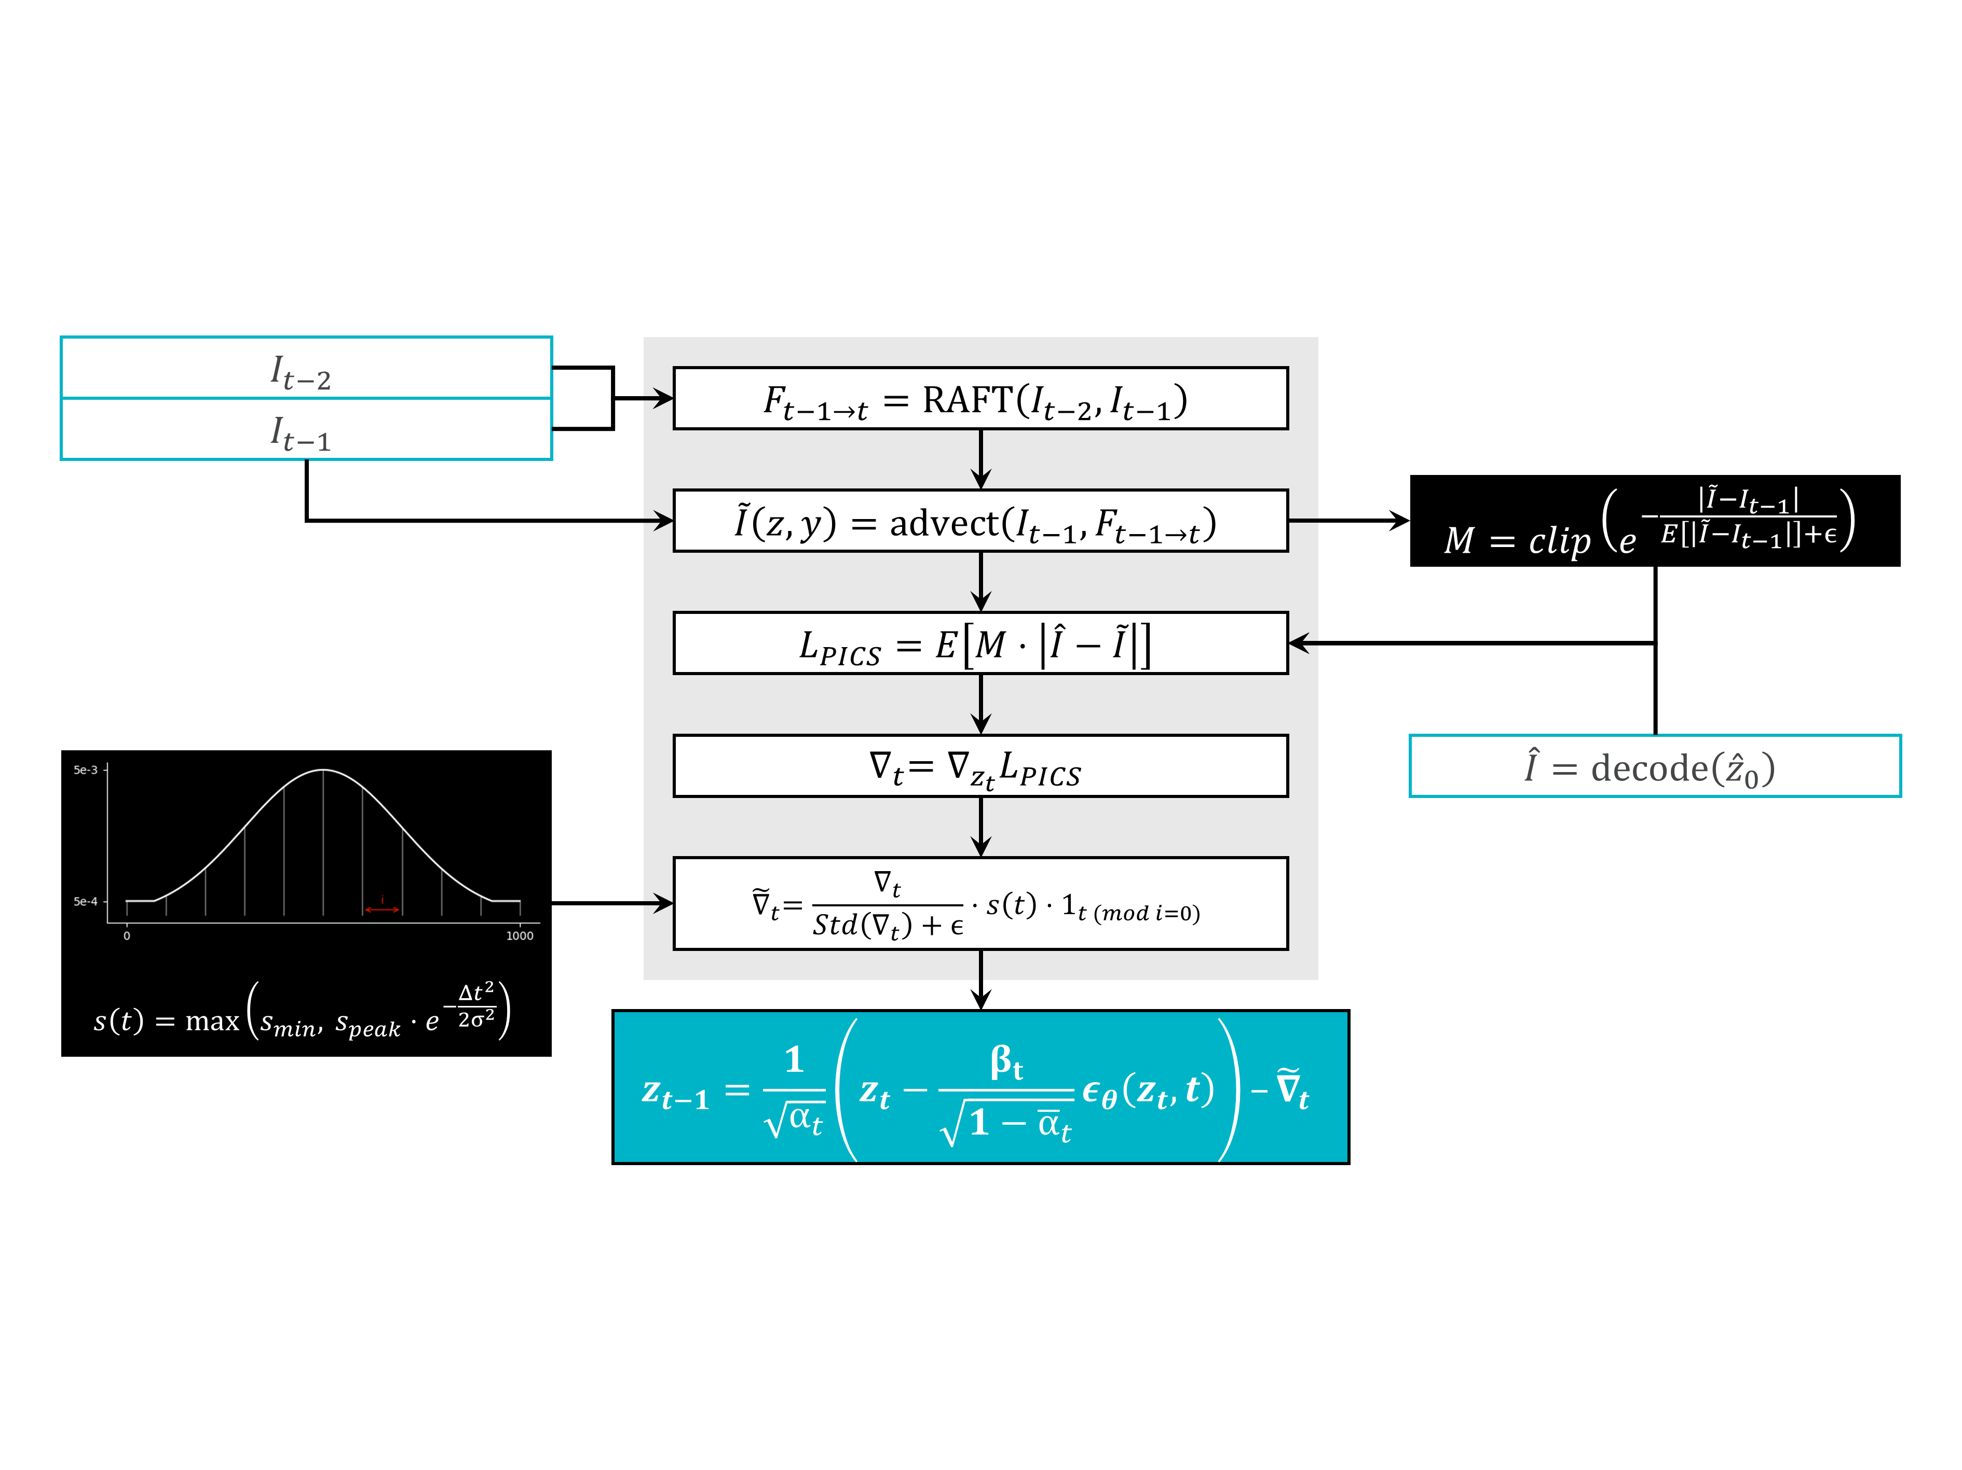Fig. 6. PICS algorithmic flow

IV. Experimentation
This section details the empirical framework utilized to train and validate the STPD model. The experimental design focuses on the decoupled optimization of the spatial and temporal components, ensuring that the generative capacity of the diffusion engine is grounded in a high-fidelity latent manifold before the application of physical constraints.

A. Data Acquisition and Preprocessing
The model was evaluated using two distinct meteorological sources to test both in-domain accuracy and zero-shot generalization capabilities.
  - INSAT-3DS TIR1 (Primary Dataset)
The training phase utilized Thermal Infrared (TIR1) band data from the INSAT-3DS satellite, sourced via ISRO-MOSDAC. This dataset captures brightness temperatures representing cloud-top altitudes and surface thermal distributions.
  - ERA5 Total Cloud Cover (Generalization Set)
To validate the model's adherence to universal physical laws, zero-shot testing was performed on ERA5 Total Cloud Cover (TCC) data from the ECMWF. This cross-domain evaluation ensures the PICS module recognizes advective patterns independently of the training pixel distribution.
Preprocessing Pipeline.
  - Spatial Resolution: Frames were center-cropped and resized to a consistent $512 ×512$ single-channel resolution.
  - Normalization: Pixel values were scaled from [0,255] to the range [-1,1] to match the Tanh activation at the CAE bottleneck and the Gaussian distribution of the diffusion noise.
  - Temporal Sequencing: Data was organized into sliding windows of 5 frames ($t-4$to $t-1$), with the first 4 acting as context and the $5^{th}$ as the ground truth target.

B. Implementation and Training Protocol
The STPD framework implements a Decoupled Training Strategy. This architectural decision was taken for computational efficiency; by training the CAE standalone, generating and storing latent tensors (.pt), the subsequent LDM can be trained on GPUs with significantly lesser load saved by avoiding simultaneous training of both stages.
  - Hardware Configuration of Training Environment
Model training was conducted on a cloud cluster utilizing Dual Nvidia Tesla T4 GPUs (32GB combined VRAM), allowing for the parallel processing of high-resolution tensors.
  - Convolutional Autoencoder (CAE) Training
Dataset size: 1500 samples
Training duration: 100 epochs
Convergence: ~40 epochs
Total time: ~5 hours (dual GPU)
Hyperparameters: Optimizer = Adam, learning rate = $2×{10}^{-4}$, batch size = 15 (per GPU).
Loss Function
$$L_{CAE}=α⋅∥x-\hat{x}∥_{1}+β⋅\text{LPIPS}(x,\hat{x})$$
Rationale
L1 (MAE): preserves sharp boundaries $α=0.2$
LPIPS: enforces structural realism $β=0.8$
Reconstruction Performance
MAE: 0.021 | MS-SSIM: 0.98 | LPIPS: 0.16
  - Latent Diffusion Model (LDM) Training
Training steps: 25,000
Convergence: ~10,000 steps
Total time: ~6 hours
Hyperparameters: Cosine Beta Schedule timesteps $T=1000$, learning rate = $1×{10}^{-4}$, batch size = 16
Loss Function
$$L_{\text{LDM}}=E\left[{\left.\left\|ϵ-ϵ_{θ}\left(z_{t},t,c\right)\right.\right\|}^{2}\right]$$
Conditioning: 4+1 Frame concatenation, Self + Cross Attention ($32×32$ and below)
Pixel-space Prediction Performance (64x64 pixels)
MSE: 0.001 | MAE: 0.025 | SSIM: 0.965 | MS-SSIM: 0.994 | LPIPS: 0.037

C. Inference Configuration
  - Inference Environment: To demonstrate the efficiency of the PICS module, inference is performed on a local Nvidia RTX 4070 Laptop GPU (8GB VRAM). A single frame generation, including 100 physics-informed cyclical steps, is completed in approximately 40 seconds.
  - PICS guidance parameters
Guidance Interval ($i$) inject gradient every $i$=10 steps ($t ∈\{1000, 990, …, 10\}$) for low inference latency.
Bell-Curve Parameters, scale $s\left(t\right)$ peak at $t=500$, max value $s_{peak}=0.005$, width $σ= 200$
Advection Prior: RAFT-Large Optical flow model,

D. Evaluation Metrics
The predictive performance was measured using five core metrics to capture both statistical accuracy and structural realism:
  - MSE & MAE: pixel-level accuracy.
  - SSIM & MS-SSIM: structural similarity.
  - LPIPS: perceptual realism and distribution distance

V. Observations

A. Evaluation Results
TABLE I
INSAT3DS Reconstruction Results
Metric | Value
MAE ↓ | 0.0211
MS-SSIM ↑ | 0.9857
LPIPS ↓ | 0.1648

TABLE II
INSAT3DS Prediction Results
Metric | Standard | PICS | Improvement
MSE | 0.0034 | 0.0032 | ↓ 5.9%
MAE | 0.0400 | 0.0372 | ↓ 7.0%
SSIM | 0.7120 | 0.7190 | ↑ 1.0%
MS-SSIM | 0.8969 | 0.9018 | ↑ 0.5%
LPIPS | 0.3919 | 0.3820 | ↓ 2.5%

TABLE III
ERA5 Prediction Results
Metric | Standard | PICS | Improvement
MSE | 0.0204 | 0.0162 | ↓ 20.5%
MAE | 0.0837 | 0.0707 | ↓ 15.5%
SSIM | 0.6138 | 0.6727 | ↑ 9.5%
MS-SSIM | 0.8217 | 0.8601 | ↑ 4.7%
LPIPS | 0.2220 | 0.1957 | ↓ 11.8%

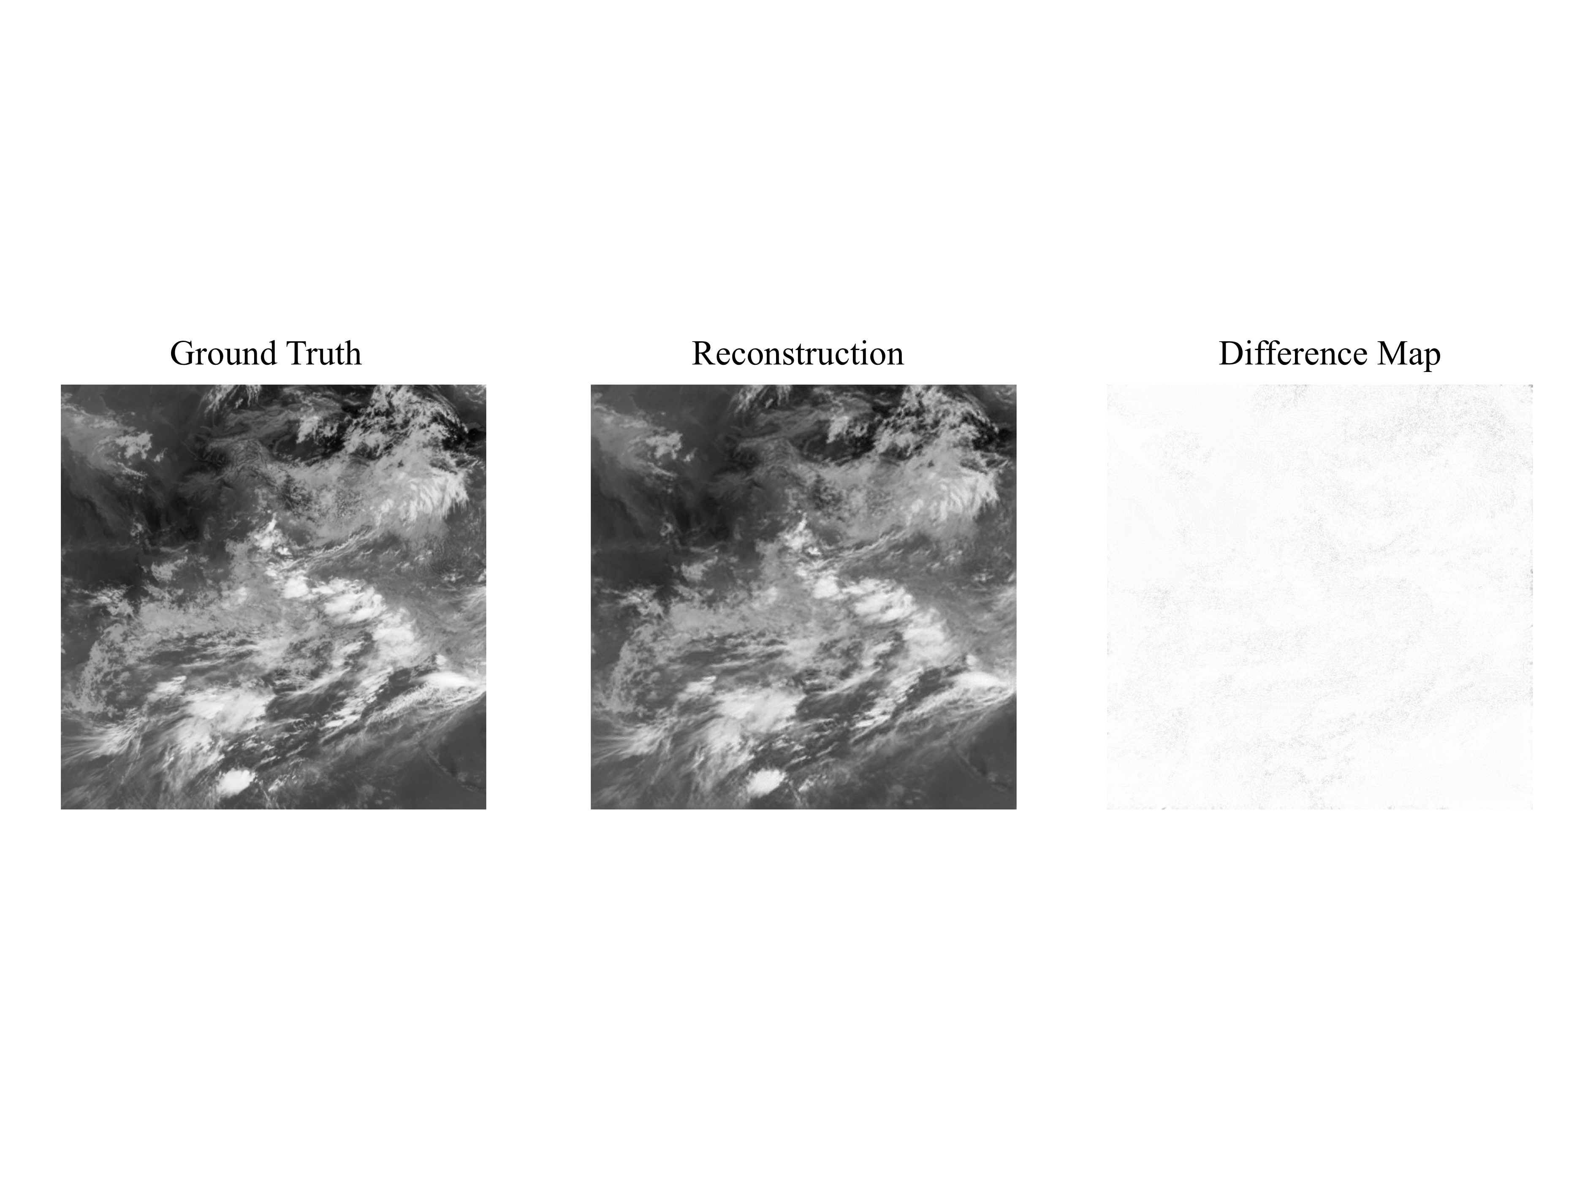
Fig. 7. INSAT3DS CAE Reconstruction
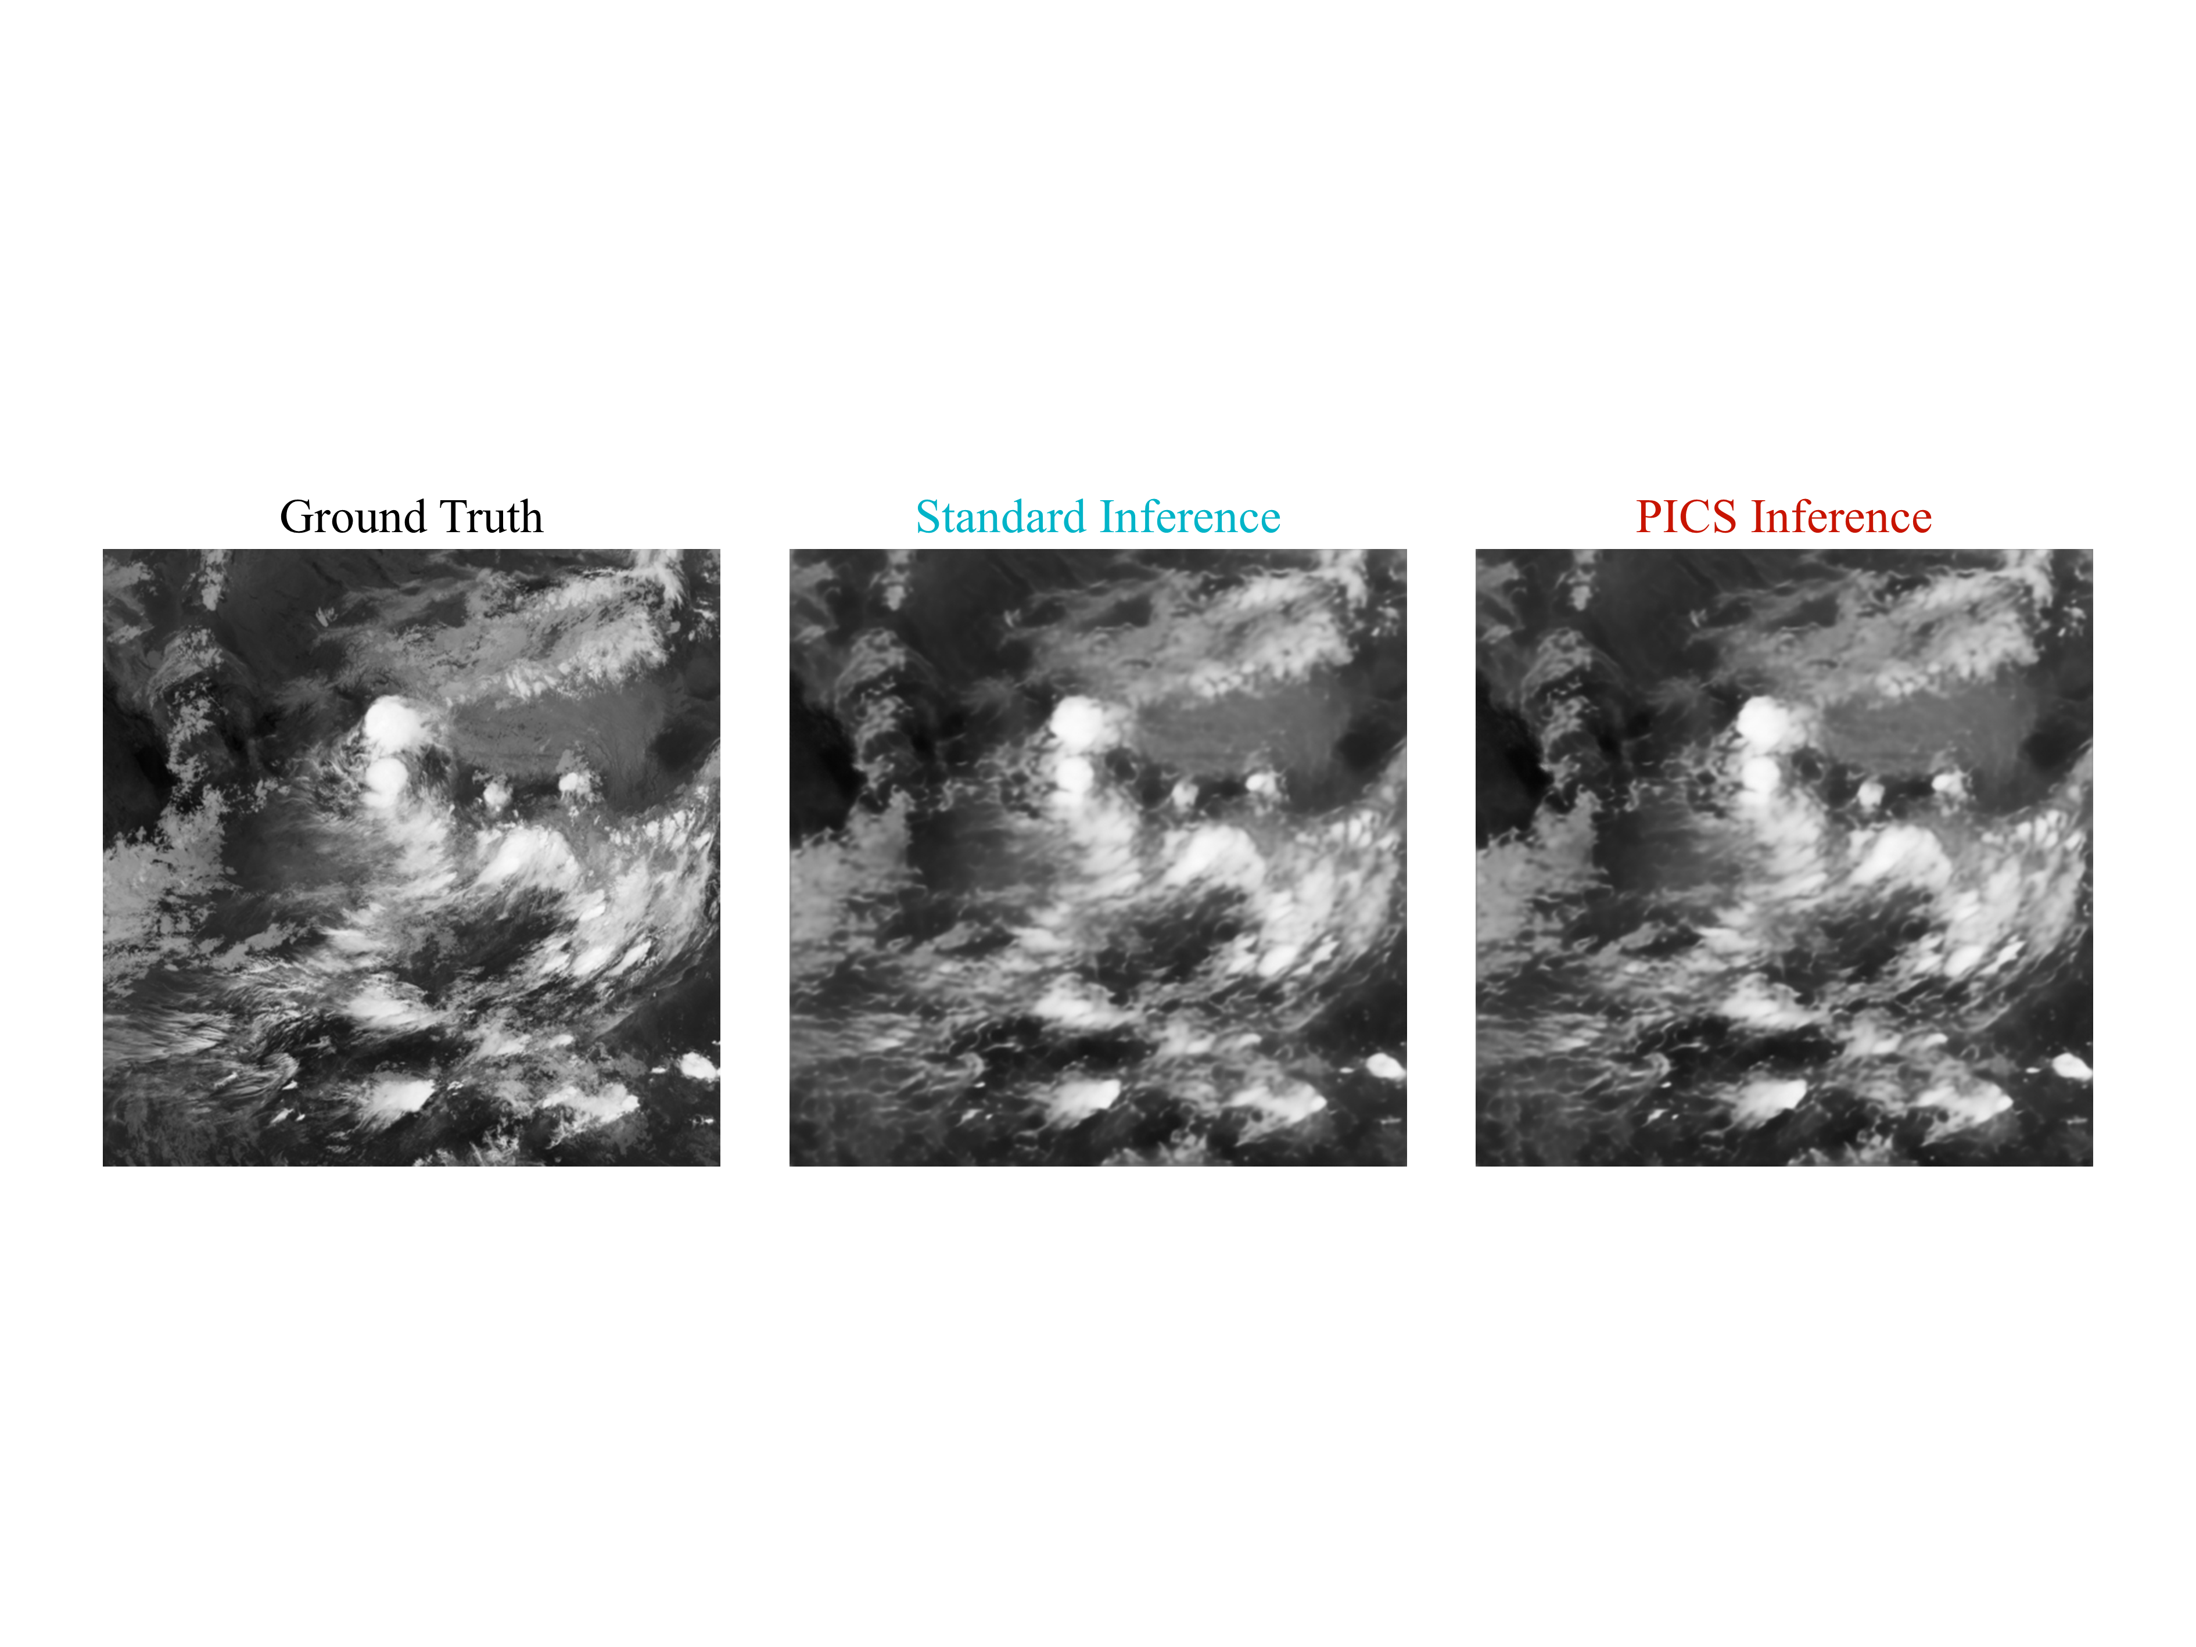Fig. 8. INSAT3DS Complete Frame Prediction
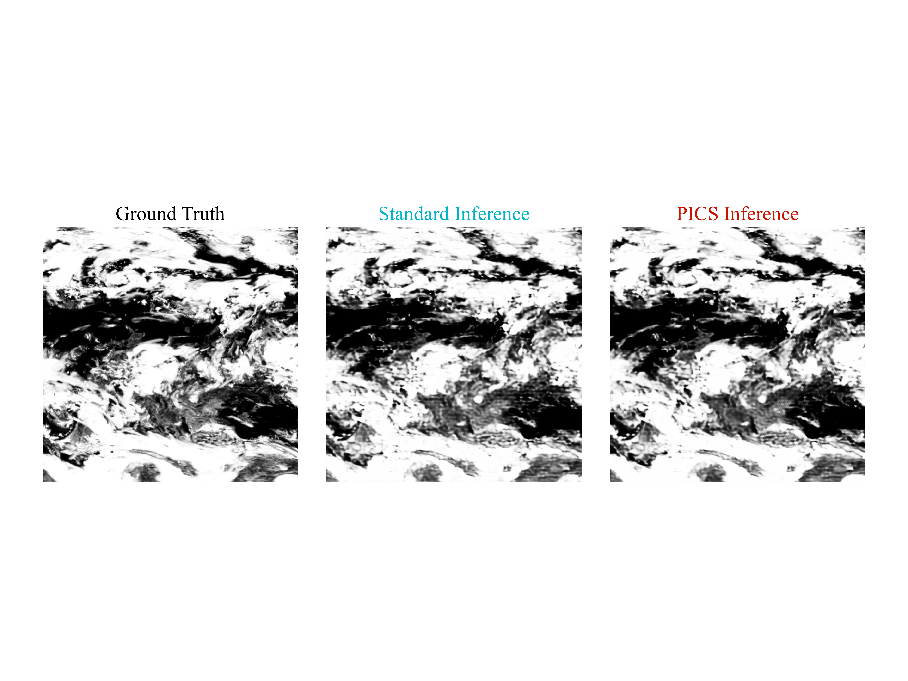Fig. 9. ERA5 Complete Frame Prediction

B. Discussion
The development and validation of the STPD framework revealed several fundamental insights regarding the intersection of generative AI and scientific computing. While the three-tier architecture achieves state-of-the-art results in meteorological forecasting, the following observations delineate the current technical boundaries and the inherent friction between stochastic synthesis and physical determinism.
  - Limitations of Latent Representation in Scientific Contexts Despite the superior reconstruction performance of the custom CAE, the transition into a latent manifold introduces a "Representational Gap" that pure image-quality metrics fail to capture.
  - Non-Invertibility and Information Loss: The mapping $x→z→\hat{x}$ is mathematically lossy. While an MS-SSIM of 98% indicates high structural similarity, the irreversible degradation of pixel-level intensity values means that specific radiometric signatures critical for quantitative analysis are altered during the encoding-decoding cycle.
  - Structural vs. Physical Fidelity: We observe that high perceptual scores do not inherently guarantee scientific fidelity. Latent spaces are not explicitly constrained to preserve physical invariants, such as mass or energy conservation laws. Consequently, a great visual reconstruction may still harbor latent inconsistencies that propagate through the diffusion process.
  - The Encoding Paradigm Dilemma: Our observations confirm that existing paradigms are deficient for encoding continuous physical fields. VAEs introduce excessive blurring due to the ELBO/KL-divergence penalty, while VQGANs impose artificial discretization that breaks the continuity of fluid gradients. While the CAE mitigates these, it lacks guarantees for dynamical consistency, which remains an open area for research.
  - Stochastic Indeterminacy in Diffusion Models
Diffusion models are fundamentally stochastic generative processes. During the reverse sampling chain, each prediction is conditioned on a random noise initialization $ϵ∼N\left(0,I\right)$.
  - Prediction Variance: Even with identical historical conditioning, the inherent indeterminism of the diffusion process can lead to varying outputs across different runs. While PICS acts as a deterministic "guidance" mechanism, the baseline model's reliance on stochastic sampling limits the strict physical reproducibility required for operational weather forecasting.
  - The Challenge of Physics Selection: "How" vs. "What". A pivotal observation of this study is that the difficulty in physics-informed machine learning is not the mathematical application of a constraint (the "How"), but the selection of the appropriate governing law for the specific data modality (the "What").
  - Formulation Sensitivity: Empirical experiments with alternative physics-inspired constraints—such as simple frame averaging, spatial gradients, and higher-order operators like divergence and curl—yielded only marginal improvements in predictive accuracy.
  - Multi-Modal Mismatch: Integrating physical laws requires careful alignment between disparate variables. For instance, cloud density is a scalar field, whereas the wind field that drives it is a vector field. Enforcing wind-based constraints on scalar density maps requires a deep understanding of the governing dynamics; improper variable selection or transformation can actually degrade model performance.
  - Effectiveness of Advection-Based Guidance: The PICS formulation’s success stems from using RAFT-derived optical flow as a viable proxy for the underlying wind velocity. This advection-based alignment corresponds most closely with observable atmospheric cloud transport, providing consistent improvements across both TIR1 and ERA5 datasets.
These observations highlight that while physics-guided diffusion represents a paradigm shift in structural realism and dynamical consistency, the broader task of learning physically faithful latent representations and selecting optimal governing constraints for multi-modal scientific data remains an active frontier.
V. Conclusion
The Physics-Informed Diffusion Model represents a successful integration of high-resolution generative AI with deterministic physical constraints for Spatio-Temporal modelling. The Convolutional Autoencoder (CAE) preserves high-fidelity information while conditional latent diffusion model acts as promising generative core. The innovation of this work is the Physics-Informed Cyclical Sampling (PICS) technique. This innovation demonstrates that a pre-trained generative model can be effectively guided toward physical consistency during the inference phase, eliminating the need for rigid and expensive retraining cycles.
However, significant challenges remain. While the model excels at capturing macroscopic motion, achieving full physical adherence remains a limitation and matter of study. Furthermore, the autoencoding gap is a critical bottleneck; developing a truly lossless, invertible encoding paradigm for continuous physical fields is essential to prevent information degradation in scientific representations.
Future work will prioritize scaling to multi-frame generation and exploring Diffusion Transformers (DiT) and Flow-matching architecture. Key objectives include developing invertible, spatio-temporal autoencoders to ensure scientific fidelity and investigating training-time physics integration through ControlNet or PINN layers. Learning and integration of accurate multi-modal dynamics remains prime aim of study.

Acknowledgment
References
- J. Song, C. Meng, and S. Ermon, “Denoising Diffusion Implicit Models,” in Proceedings of the International Conference on Learning Representations (ICLR), 2021.
- J. Ho, A. Jain, and P. Abbeel, “Denoising Diffusion Probabilistic Models,” in Advances in Neural Information Processing Systems (NeurIPS), vol. 33, 2020, pp. 6840–6851.
- L. Yang, L. Zhang, Y. Liu, Z. Jiang, and Y. He, “Video Diffusion Models with Local-Global Context Guidance,” in Proceedings of the International Joint Conference on Artificial Intelligence (IJCAI), 2023, pp. 1639–1647.
- Z. Zhang, J. Hu, W. Cheng, D. Paudel, and J. Yang, “ExtDM: Distribution Extrapolation Diffusion Model for Video Prediction,” in Proceedings of the IEEE/CVF Conference on Computer Vision and Pattern Recognition (CVPR), 2024, pp. 8950–8960.
- S. Yu, W. Nie, D.-P. Kingma, B. Li, J. Sinha, and A. Anandkumar, “Efficient Video Diffusion Models via Content-Frame Motion-Latent Decomposition,” in Proceedings of the International Conference on Learning Representations (ICLR), 2024.
- A. Blattmann, R. Rombach, H. Ling, T. Dockhorn, S. Kim, S. Fidler, and K. Kreis, “Align Your Latents: High-Resolution Video Synthesis with Latent Diffusion Models,” in Proceedings of the IEEE/CVF Conference on Computer Vision and Pattern Recognition (CVPR), 2023, pp. 22563–22575.
- T. Höppe, A. Mehrjou, S. Bauer, D. Nielsen, and A. Dittadi, “Diffusion Models for Video Prediction and Infilling,” IEEE Transactions on Machine Learning Research (TMLR), 2022.
- I. Voleti, A. Jolicoeur-Martineau, and C. Pal, “MCVD: Masked Conditional Video Diffusion for Prediction, Generation, and Interpolation,” in Advances in Neural Information Processing Systems (NeurIPS), vol. 35, 2022, pp. 23371–23385.
- R. Esser, S. A. Rombach, P. Ommer, and L. Rombach, “High-Resolution Image Synthesis with Latent Diffusion Models,” arXiv preprint arXiv:2112.10752, 2021.
- J. Lugmayr, M. Danelljan, A. Van Gool, and R. Timofte, “RePaint: Inpainting Using Denoising Diffusion Probabilistic Models,” in Proceedings of the IEEE/CVF Conference on Computer Vision and Pattern Recognition (CVPR), 2022.
- A. Ramesh et al., “Hierarchical Text-Conditional Image Generation with CLIP Latents,” arXiv preprint arXiv:2204.06125, 2022.
- A. Radford et al., “Learning Transferable Visual Models from Natural Language Supervision,” in Proceedings of the International Conference on Machine Learning (ICML), 2021, pp. 8748–8763.
- R. Zhang, P. Isola, A. A. Efros, E. Shechtman, and O. Wang, “The Unreasonable Effectiveness of Deep Features as a Perceptual Metric,” in Proceedings of the IEEE Conference on Computer Vision and Pattern Recognition (CVPR), 2018, pp. 586–595.
- D. P. Kingma and J. Ba, “Adam: A Method for Stochastic Optimization,” arXiv preprint arXiv:1412.6980, 2014.
- K. He, X. Zhang, S. Ren, and J. Sun, “Deep Residual Learning for Image Recognition,” in Proceedings of the IEEE Conference on Computer Vision and Pattern Recognition (CVPR), 2016, pp. 770–778.
- K. Simonyan and A. Zisserman, “Very Deep Convolutional Networks for Large-Scale Image Recognition,” in International Conference on Learning Representations (ICLR), 2015.

This paragraph of the first footnote will contain the date on which you submitted your paper for review, which is populated by IEEE. It is IEEE style to display support information, including sponsor and financial support acknowledgment, here and not in an acknowledgment section at the end of the article. For example, “This work was supported in part by the U.S. Department of Commerce under Grant 123456.” The name of the corresponding author appears after the financial information, e.g. (Corresponding author: Second B. Author). Here you may also indicate if authors contributed equally or if there are co-first authors. The next few paragraphs should contain the authors’ current affiliations, including current address and e-mail. For example, First A. Author is with the National Institute of Standards and Technology, Boulder, CO 80305 USA (e-mail: author@ boulder.nist.gov). Second B. Author Jr. was with Rice University, Houston, TX 77005 USA. He is now with the Department of Physics, Colorado State University, Fort Collins, CO 80523 USA (e-mail: author@lamar.colostate.edu). Third C. Author is with the Electrical Engineering Department, University of Colorado, Boulder, CO 80309 USA, on leave from the National Research Institute for Metals, Tsukuba 305-0047, Japan (e-mail: author@nrim.go.jp). Mentions of supplemental materials and animal/human rights statements can be included here. Color versions of one or more of the figures in this article are available online at http://ieeexplore.ieee.org

