# General – Last Updated 19Dec21

* Refer > AWS_Menus.xlsx
* <https://docs.aws.amazon.com/>

## Software /Tools

|  |  |
| --- | --- |
|  |  |
| RDP Tool | <https://mobaxterm.mobatek.net/download.html> |
| CLI | <https://docs.aws.amazon.com/cli/latest/userguide/getting-started-install.html>  aws --version |
| Visual Studio | <https://code.visualstudio.com/download> |
|  |  |

## URLs

|  |  |
| --- | --- |
| https://aws.amazon.com/about-aws/global-infrastructure/regions_az/ | Region details |
|  |  |

# Compute

## AmazonEC2

* User data is data that is supplied by the user at instance launch in the form of a script.
* User data is limited to 16KB.
* Instance user data is available at <http://169.254.169.254/latest/user-data>.
* Instance metadata is data about your instance that you can use to configure or manage the running instance.
* Instance metadata is available at http://169.254.169.254/latest/meta-data/ (the trailing “/” is required)
* Keywords – Instance, Placement Group, Auto Scaling, IAM, AMI, encryption, Tag, Key Pair,

## AWSApp Runner

## AWSBatch

## AWSElastic Beanstalk

## AmazonEC2 Image Builder

## AWSEnd-of-Support Migration Program (EMP) for Windows Server

## AWSLambda

## AmazonLightsail

## AWSOutposts

## AWSParallelCluster

## AWSServerless Application Model (AWS SAM)

## AWSServerless Application Repository

## AWSWavelength

# Containers

## AmazonECR

## AmazonECS

## AmazonEKS

## AWSApp2Container

## AWSApp Runner

## Red Hat OpenShift Service on AWS

## a

# Storage

## Types

### BlockStorage

* Files will be broken to blocks and store
* Interface are used to store or retrieve is iSCSI, FC
* 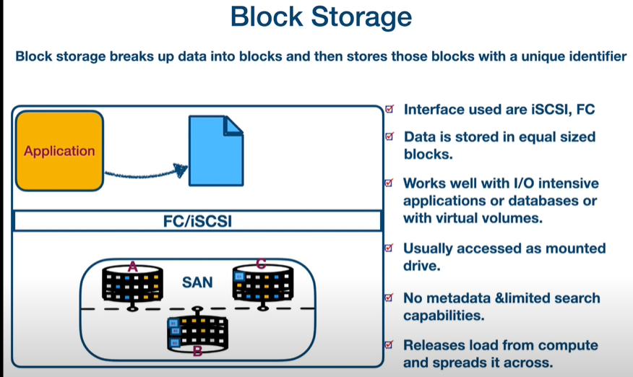

### File Storage

* A
* 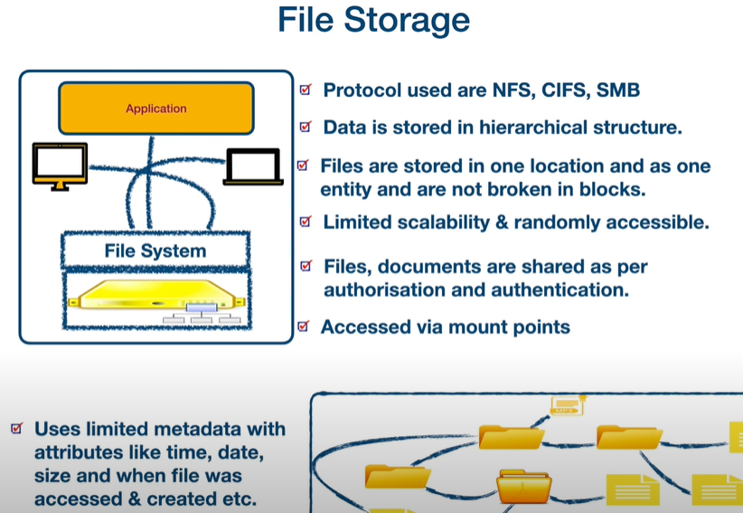

### ObjectStorage

* A
* 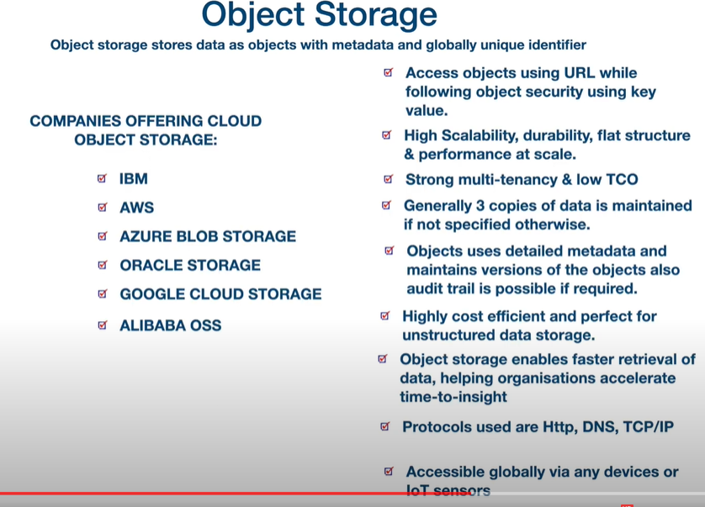

## Amazon S3 – Obj Storage

## AWS Backup

## Amazon EBS – Block Storage

## Amazon EFS – File Storage

## AWS Elastic Disaster Recovery

## Amazon FSx

## Amazon S3 Glacier

## AWS Snow Family

## AWS Storage Gateway

# Database

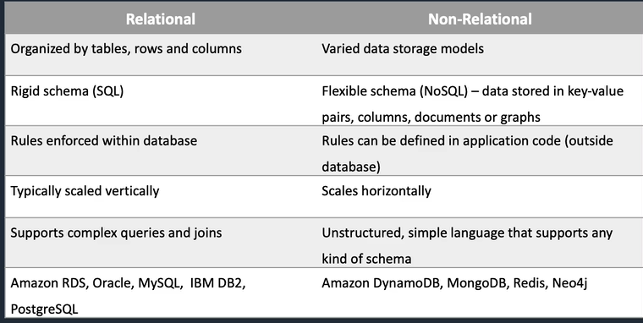

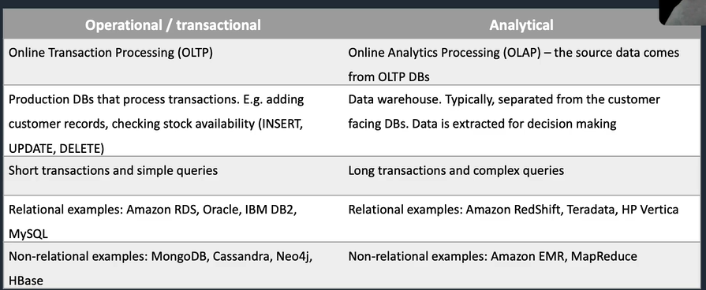

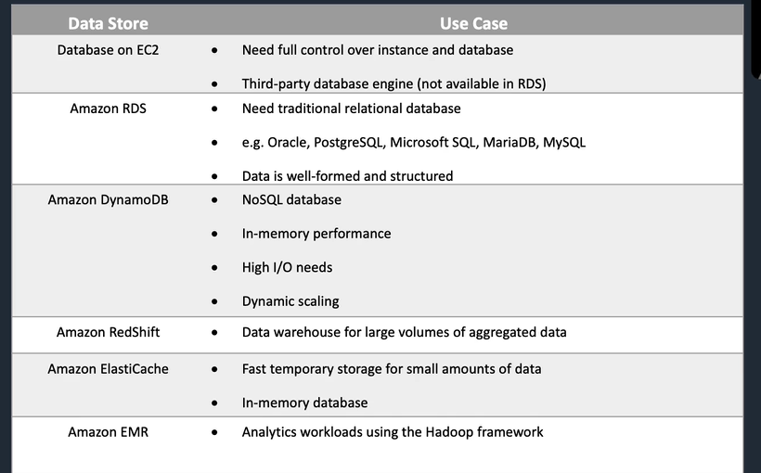

## AmazonAurora

## AmazonDocumentDB

## AmazonDynamoDB

* Amazon DynamoDB is a fully managed NoSQL database service that provides fast and predictable performance with seamless scalability.
* Read Methods
  + Eventually consistent reads (Default)
  + Strongly consistent reads:

## AmazonElastiCache

* Best for scenarios where the DB load is based on Online Analytics Processing (OLAP) transactions
* Fully managed implementations of two popular in-memory data stores – Redis and Memcach
* ElastiCache is a web service that makes it easy to deploy and run Memcached or Redis protocol-compliant server nodes in the cloud
* Elasticache can be used for storing session state.

### Memcach

* Not persistent

### Redis

* Data is persistent.
* Supports master/slave replication

## AmazonKeyspaces (for Apache Cassandra)

## AmazonMemoryDB for Redis

## AmazonNeptune

## AmazonQLDB

## AmazonRDS

* OLTP type of DB
* Automated backups and patching applied in customer-defined maintenance windows
* RDS is a managed service and you do not have access to the underlying EC2 instance (no root access).
* Database instances are accessed via endpoints. Endpoints can be retrieved via the DB instance description in the AWS Management Console, DescribeDBInstances API or describe-db-instances command.

### Amazon Aurora

### MySQL

### MariaDB

### Oracle

### SQL Server

### PostgreSQL

## AmazonRedshift - OLAP

## AmazonTimestream

## a

# Security, Identity, & Compliance

## AWSIdentity & Access Management (IAM)

## AWSArtifact

## AWSAudit Manager

## AmazonCognito

## AmazonDetective

## AWSDirectory Service

## AWSFirewall Manager

## AmazonCloud Directory

## AmazonGuardDuty

## AmazonInspector

## AmazonMacie

## AWSNetwork Firewall

## AWSResource Access Manager (AWS RAM)

## AWSSecrets Manager

## AWSSecurity Hub

## AWSShield

* AWS Shield Standard – Free and enabled by default
* AWS Shield Advanced – 3K pm
  + Application Layer 7 will be monitored

## AWSSingle Sign-On

## AWSWAF

* Web Application Firewall

# Cryptography & PKI

## AWSCryptographic Services Overview

## AWSPKI Services Overview

## AWSCloudHSM

## AWSKey Management Service (AWS KMS)

## AWSCrypto Tools

## AWSCertificate Manager

## AWSCertificate Manager Private Certificate Authority

## AWSSigner

## a

# Machine Learning

## AmazonSageMaker

## AmazonAugmented AI (A2I)

## AmazonCodeGuru

## AmazonComprehend

## AmazonComprehend Medical

## AmazonDevOps Guru

## AmazonElastic Inference

## AmazonForecast

## AmazonFraud Detector

## AmazonHealthLake

## AmazonKendra

## AmazonLex

## AmazonLookout for Equipment

## AmazonLookout for Metrics

## AmazonLookout for Vision

## AmazonMonitron

## AWSPanorama

## AmazonPersonalize

## AmazonPolly

## AmazonRekognition

## AmazonTextract

## AmazonTranslate

## AmazonTranscribe

## AWSDeep Learning AMIs

## AWSDeep Learning Containers

## AWSDeepComposer

## AWSDeepLens

## AWSDeepRacer

## Apache MXNet on AWS

## AmazonMachine Learning

## a

# Management & Governance

## AWSAccount Management

## AWSAppConfig

## Auto Scaling

* [https://aws.amazon.com/autoscaling/faqs/#](https://aws.amazon.com/autoscaling/faqs/)
* <https://docs.aws.amazon.com/autoscaling/ec2/userguide/as-scaling-simple-step.html>
* Related Items
  + Load Balancer / Auto Scaling Group /
* Step Scaling
* Simple Scaling

### Benefits of AWS Auto Scaling

* Setup scaling quickly
* Make smart scaling decisions
* Automatically maintain performance
* Anticipate costs and avoid overspending

### Ways of Auto Scaling

#### Amazon EC2 Auto Scaling

* AWS Auto Scaling monitors your applications and automatically adjusts capacity to maintain steady, predictable performance at the lowest possible cost.
* EC2 Auto Scaling can also detect when an instance is unhealthy, terminate it, and launch an instance to replace it. When you use EC2 Auto Scaling, your applications gain better fault tolerance, availability, and cost management.
* EC2 Auto Scaling launches and terminates instances dynamically
* Scaling is horizontal (scales out)
* Provides elasticity and scalability
* Responds to EC2 status checks and CloudWatch metrics
* Can scale based on demand (performance) or on a schedule
* Scaling policies define how to respond to changes in demand
* Auto Scaling groups define collections of EC2 instances that are scaled and managed together

#### Application Auto Scaling API

* To scale a resource other than EC2, you can use this,
* Application Auto Scaling can scale Amazon ECS services, Amazon EC2 Spot fleets, Amazon EMR clusters, Amazon AppStream 2.0 fleets, provisioned read and write capacity for Amazon DynamoDB tables and global secondary indexes, Amazon Aurora Replicas, and Amazon SageMaker endpoint variants
* zOthers
* Minimum size, desired capacity, maximum size, scale out as needed.
* Launch Template

### Type of Auto scaling

#### Horizontal Scaling (Scaling Out - IN)

* Adding servers sidewise

#### Vertical Scaling (Scaling Up - Down)

* Server upgraded with RAM and Peripherals in existing servers
* Scaling Up or Down = managing resources to the same instance

### Auto Scaling Group

* Either EC2 Status Checks or Amazon CloudWatch sends the matrics to Auto Scaling Group. Based on the policy, may EC2 removed or added new instances.

#### Configure the Auto Scaling Group

##### Launch Template

##### Launch Config

* Zothers

### Auto Scaling Settings

* Cooldowns
* Termination Policy
* Termination Protection
* Standby State
* Lifecycle Hooks

### In Console

* EC2 – Auto Scaling
  + Launch Configurations
  + Auto Scaling Groups
    - Create Auto Scaling group
      * Step 1 Choose launch template or configuration
      * Step 2 Choose instance launch options
      * Step 3 (optional) Configure advanced options
      * Step 4 (optional) Configure group size and scaling policies
      * Step 5 (optional) Add notifications
      * Step 6 (optional) Add tags
      * Step 7 Review
  + FYI – Launch Template > Auto Scaling >Target Group > Load Balancer (>=mapped with)

## AWSBackint Agent for SAP HANA

## AWSChatbot

## AWSCloudFormation

* CloudFormation helps users to deploy resources in a consistent and orderly way. By ensuring the CloudFormation templates are created and administered with the right security configurations for your resources, you can then repeatedly deploy resources with secure settings and reduce the risk of human error

## AWSCloudTrail

## AmazonCloudWatch

## AWSCommand Line Interface (AWS CLI)

## AWSCompute Optimizer

## AWSConfig

## AWSConsole Mobile Application

## AWSControl Tower

## Amazon Data Lifecycle Manager

## AWSHealth

## AWSLaunch Wizard

## AWSLicense Manager

## AmazonManaged Grafana

## AmazonManaged Service for Prometheus

## AWSManagement Console

## AWSOpsWorks

## AWSOrganizations

## AWSProton

## AWSResilience Hub

## AWSResource Groups

## AWSService Catalog

## Service Quotas

## AWSSystems Manager

## Tag Editor

## AWSTools for PowerShell

## AWSTrusted Advisor

## AWSWell-Architected Tool

# Developer Tools

## AWSCloud9

## AWSCloud Control API

## AWSCloudShell

## AWSCodeArtifact

## AWSCodeBuild

## AWSCodeCommit

## AWSCodeDeploy

## AWSCodePipeline

## AWSCodeStar

## AWSFault Injection Simulator

## AWSMicroservice Extractor for .NET

## Porting Assistant for .NET

## AWSTools & SDKs

## AWSX-Ray

## a

# Migration & Transfer

* AWS Application Discovery Service
* AWS Migration Hub – for monitoring migration services
* VPN or Direct Connect or Internet for transfer
* Onsite Servers – AWS Server Migration Service – EC2 Instances
* Onsite DB – AWS Database Migration Service – Amazon RDS
* NAS/File Server – AWS Data Sync – EFS or S3

## AWS Application Discovery Service

|  |  |  |
| --- | --- | --- |
|  | **Discovery Connector** | **Discovery Agent** |
| Agent | Agentless | Agent based. Agent to be installed |
| Supported Servers | VMware | VMware, Physical |
| Deployment | Per vCenter | Per Server |
| Collected data | Static configuration data | Static configuration data |
| Collected data | VM utilization metrics | Time Series Performance info (export) Network Inbound/outbound (export) Running processes (export) |
| Supported OS | Any OS running in VMware vCenter (v5.5,v6, & v6.5 | Amazon Linux, Ubuntu, RHEL, CentOS,SUSE, Windows Server |

## AWSApplication Migration Service

## AWSDatabase Migration Service

## AWSDataSync

## AWSMainframe Modernization (Preview)

## AWSMigration Hub

## AWSSchema Conversion Tool

## AWSServer Migration Service

## AWSSnow Family

## AWSTransfer Family

## A

# Networking & Content Delivery

## AmazonAPI Gateway

## AWSApp Mesh

## AWSCloud Map

## AmazonCloudFront

## AWSDirect Connect

* AD Connector for Security
  + Small – 500 Users
  + Large – 5000 Users

## Elastic Load Balancing

## Load Balancer

<https://docs.aws.amazon.com/elasticloadbalancing/index.html>

* Console – EC2 – Load Balancing
* Used to route the request to EC2, IP, Containers, Lambda EndPoint
* SLA for Load Balancing is 99.99%
* Server Name Indication (SNI) not supported in Network LB and Classic Load Balancer
* Session Stickiness
  + If one user connects one server then the load balancer routes the same server for that user until the session ends
* Connection Draining
  + Load balancer will stop new requests to that particular server and process only existing connection requests. (like before close the shop, no new customer will allow but existing customer can do their shopping)
* Access Logs
  + Not enabled by default
  + Time, IP, latencies, request path, server responses are logged

### Type of Load Balancers

#### Application Load Balancer

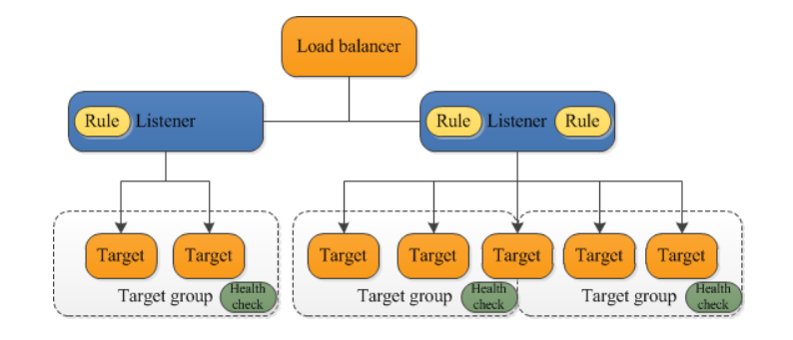

* OS Layer 7 – HTTP and HTTPS based traffic
* Load balancing can be done based on Application, IP, Cookies, Geo-Location, host based
* Minimum two subnets required
* Health check feasible

#### Network Load Balancer

* Layer 4 – Port based (LDP, UDP and TLS)
* Label Distribution Protocol (LDP)
* Mainly used to load balance within your VPC
* Cross Zone load balance

#### Gateway Load Balancer

#### Classic Load Balancer (Previous generation > removed)

* Intended for applications that were built within the EC2-Classic Network
* EC2-Classic retiring
  + On October 30, 2021 we will disable EC2-Classic in Regions for AWS accounts that have no active EC2-Classic resources in the Region
  + On August 15, 2022 we expect all migrations to be complete, with no remaining EC2-Classic resources present in any AWS account

### Target Groups

* Choose EC2 – Load Balancing – Target Group

#### Available Targets

##### Instances

* Protocols – HTTP, HTTPS, TCP, TLS,UDP, TCP_UDP, GENEVE

##### IP Addresses

* Protocols – HTTP, HTTPS, TCP, TLS,UDP, TCP_UDP, GENEVE

##### Lambda Functions

* No Protocols

##### Application Load Balancers

* Only Port 80 is available

### Elastic Load Balancer

* ELB can balance traffic only in one region ???

### Scaling Options

* Manual Scaling
* Scale based on schedule – using scheduled plan
* Scale based on Demand
* Scale to maintain minimum resource count
* Predictive Scaling – based on the historical data AWS decide

## AWSGlobal Accelerator

## AmazonRoute 53

## AmazonVPC

## AWSVPN

# Media Services

## AWSCloud Digital Interface SDK

## AmazonElastic Transcoder

## AWSElemental MediaConnect

## AWSElemental MediaConvert

## AWSElemental MediaLive

## AWSElemental MediaPackage

## AWSElemental MediaStore

## AWSElemental MediaTailor

## AWSElemental On-Premises

## AmazonInteractive Video Service

## AmazonNimble Studioa

# Internet of Things (IoT)

## AWSIoT Core

## FreeRTOS

## AWSIoT Analytics

## AWSIoT Device Defender

## AWSIoT Device Management

## AWSIoT Events

## AWSIoT ExpressLink (Preview)

## AWSIoT FleetWise (Preview)

## AWSIoT Greengrass

## AWSIoT RoboRunner (Preview)

## AWSIoT SiteWise

## AWSIoT Things Graph

## AWSIoT TwinMaker (Preview)

## AWSIoT 1-Click

## a

# Front-End Web & Mobile

## AWSAmplify

## Amplify Android (AWS Mobile SDK for Android)

## Amplify iOS (AWS Mobile SDK for iOS)

## AWSAppSync

## AWSDevice Farm

## AmazonLocation Service

## AWSMobile SDK for Unity

## AWSMobile SDK for Xamarin

## AmazonPinpoint

## #AmazonSNS – See in Application Integration

# End User Computing

## AmazonWorkSpaces

## AmazonWorkSpaces Web

## AmazonAppStream 2.0

## AmazonWorkLink

## AmazonWAM

## NICE DCV

## a

# Analytics

## AmazonAppFlow

## AmazonAthena

## AmazonCloudSearch

## AWSData Exchange

## AWSData Pipeline

## AmazonOpenSearch Service

## AmazonEMR

## AmazonFinSpace

## AWSGlue

## AmazonKinesis

## AWSLake Formation

## AmazonMSK

## AmazonQuickSight

## AmazonRedshift

## a

# Application Integration

## AmazonAppFlow

## AmazonEventBridge

## AmazonManaged Workflows for Apache Airflow

## AmazonMQ

## AmazonSNS

* send notifications from the cloud.
* used for building and integrating loosely-coupled, distributed applications
* push-based delivery (no polling).
* Data Type is JSON
* Supports event notification, monitoring applications, workflow systems, time-sensitive information updates, mobile applications, and any other application that generates or consumes notifications

## AmazonSQS

## AWSStep Functions

## AmazonSWF

## a

# Business Applications

## Alexa for Business

## AmazonChime

## AmazonConnect

## AmazonHoneycode

## AmazonPinpoint

## AmazonSimple Email Service (Amazon SES)

## AmazonWorkDocs

## AmazonWorkMail

## a

# Customer Enablement Services

## AWSManaged Services

## AWSProfessional Services

## AWSSupport

## AWSTraining and Certification

## AWSIQ

## a

# Satellite

## AWSGround Stationa

# Robotics

## AWSRoboMakera

# Quantum Computing

## AmazonBraketq

# Blockchain

## AmazonManaged Blockchain

# AR & VR

## AmazonSumerian

# Game Development

## AmazonGameLift

## AmazonLumberyard

## q

# General Reference

## AWSService Endpoints

## AWSSecurity Credentials

## Service Quotas

## Tagging AWS Resources

## AWSGlossarya

# Cloud Financial Management

## AWSApplication Cost Profiler

## AWSBilling & Cost Management

### Pricing Model

#### On-Demand

* No interruption – small project
* Good for dev/test.

#### Reserved

* Steady state – business critical
* Capacity is reserved for a term of 1 or 3 years.
* EC2 has three RI types: Standard, Convertible, and Scheduled

##### Standard

##### convertible

#### Scheduled Reserved

* AWS deprecated in 2021 – but questions may be exists

#### Spot Instances

* Can withstand interruption –
* You can use the RequestSpotFleet API operation to launch thousands of Spot Instances and diversify resources automatically.
* Spot Instances receive a two-minute interruption notice when these instances are about to be reclaimed by EC2, because EC2 needs the capacity back

#### Dedicated Instances

* Dedicated hardware, per-instance billing

#### Dedicated Hosts

* We have own licensing

## AWSPricing Calculator

## Savings Plans

## a

# AWS Management Console

## Getting Started with the Console

## AWSConsole Mobile Application

## a

# SDKs & Toolkits

## AWSCloud Development Kit (AWS CDK)

## AWSCode Examples Repository

## AWSCommand Line Interface (AWS CLI)

## AmazonCorretto

## AWSCrypto Tools

## AWSServerless Application Model (AWS SAM)

## AWSSDK for C++

## AWSSDK for Go

## AWSSDK for Java

## AWSSDK for JavaScript

## AWSSDK for Kotlin

## AWSSDK for .NET

## AWSSDK for PHP

## AWSSDK for Python (Boto3)

## AWSSDK for Ruby

## AWSSDK for Rust

## AWSSDK for Swift

## AWSToolkit for Eclipse

## AWSToolkit for JetBrains

## AWSToolkit for Visual Studio

## AWSToolkit for Visual Studio Code

## AWSTools for PowerShell

## AWSToolkit for Azure DevOps

## AWSSDKs and Tools Reference Guidea

# Additional Resources

## AWSSecurity Documentation

## Alexa Top Sites

## Alexa Web Information Service

## AWSSupport

## AWSBlockchain Templates

## AWSGeneral Reference

## AWSCode Examples Repository

## AWSGovCloud (US)

## AWSMarketplace

## AWSPrescriptive Guidance

## AWSQuick Starts

## AWSSolutions

## AmazonSilk

# AWS – Others

* If you do not want to manage EC2 instances you must use the AWS Fargate launch type which is a serverless infrastructure managed by AWS.

## IAM

## Placement Group

### Cluster – within a AZ

* Packs instances close together inside an Availability Zone. This strategy enables workloads to achieve the low-latency network performance necessary for tightly-coupled node-to-node communication that is typical of HPC applications

### Spread

* strictly places a small group of instances across distinct underlying hardware to reduce correlated failures

### Partition

* Spreads your instances across logical partitions such that groups of instances in one partition do not share the underlying hardware with groups of instances in different partitions. This strategy is typically used by large distributed and replicated workloads, such as Hadoop, Cassandra, and Kafka

### s

# Out of AWS - Others

## Open Systems Interconnection (OSI) model – 7 Layers

### Layer 1 – Physical Layer

### Layer2 – Data Link

### Layer 3 Network

### Layer 4 Transport

### Layer 5 Session

### Layer 6 Presentation

### Layer 7 Application

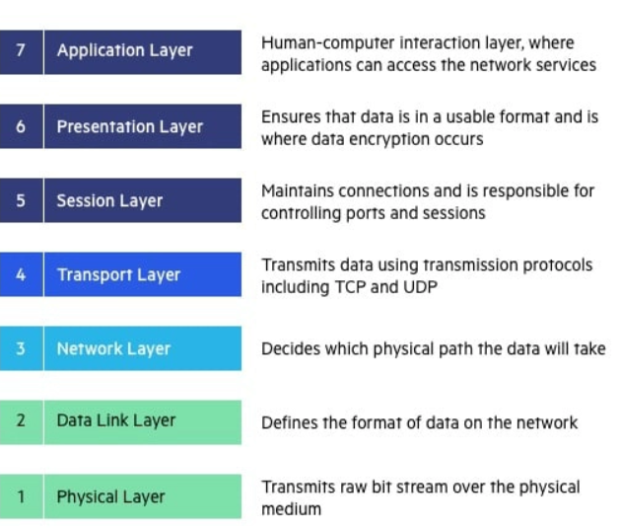

## Protocol and Port

|  |  |  |
| --- | --- | --- |
| **Port** | **Service name** | **Transport protocol** |
| 20, 21 | File Transfer Protocol (FTP) | TCP |
| 22 | Secure Shell (SSH) | TCP and UDP |
| 23 | Telnet | TCP |
| 25 | Simple Mail Transfer Protocol (SMTP) | TCP |
| 50, 51 | IPSec |  |
| 53 | Domain Name System (DNS) | TCP and UDP |
| 67, 68 | Dynamic Host Configuration Protocol (DHCP) | UDP |
| 69 | Trivial File Transfer Protocol (TFTP) | UDP |
| 80 | HyperText Transfer Protocol (HTTP) | TCP |
| 110 | Post Office Protocol (POP3) | TCP |
| 119 | Network News Transport Protocol (NNTP) | TCP |
| 123 | Network Time Protocol (NTP) | UDP |
| 135-139 | NetBIOS | TCP and UDP |
| 143 | Internet Message Access Protocol (IMAP4) | TCP and UDP |
| 161, 162 | Simple Network Management Protocol (SNMP) | TCP and UDP |
| 389 | Lightweight Directory Access Protocol | TCP and UDP |
| 443 | HTTP with Secure Sockets Layer (SSL) | TCP and UDP |
| 1433 | SQL Server |  |
| 989, 990 | FTP over SSL/TLS (implicit mode) | TCP |
| 3389 | Remote Desktop Protocol | TCP and UDP |