# GitHub Repository

* GitHub is a web-based cloud service to host your source code(Git repositories). It is a centralized system.
* Git doesn’t require GitHub but GitHub requires Git.

## Create account in GitHub

## Create New Repository in Github

Create New Repo -> Repositories -> NEW

To access the code, we need Personal Access Tokens Settings -> Developer Settings -> Personal access tokens-> Generate new token

Copy the token since it cannot be viewed once we navigate the page

Windows Control Panel-> Credential Manager ->windows credential ->Add windows credential -> github.com -> Username -> pwd: Token.

# Git

* Version control tool (software) to track the changes in the source code.
* Git doesn’t require GitHub but GitHub requires Git.

## Install Git (GitBash)

https://git-scm.com/download/win

## git clone

Goto folder in windows explorer – Rt Click – Git Bash Here

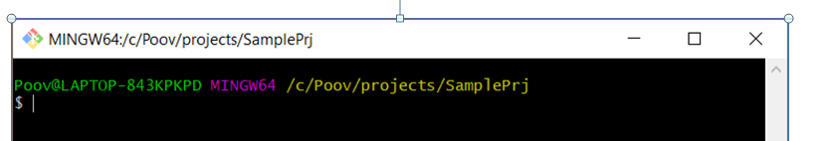

Check global and local userid and email id already set. If not set that

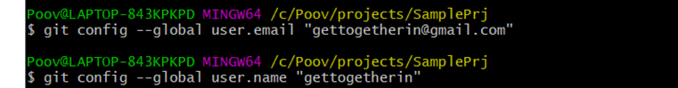

Clone the project by using github URL

git clone <https://github.com/C121B4/WAT_IT_Documents.git>



Asking to login in the website – once login your github account it will clone in your local repository

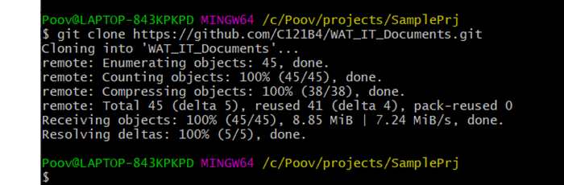

## git status

* to check for any untracked files

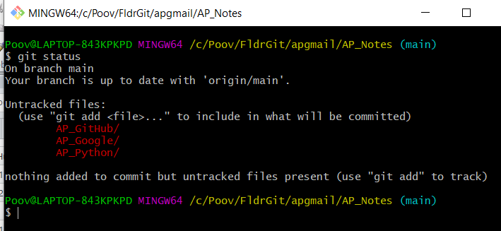

## git add .

* adds the untracked files

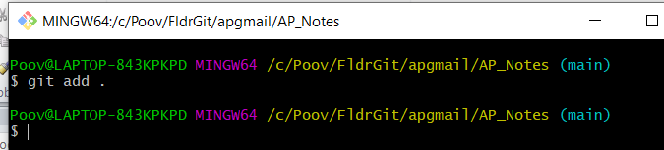

git status to know the status

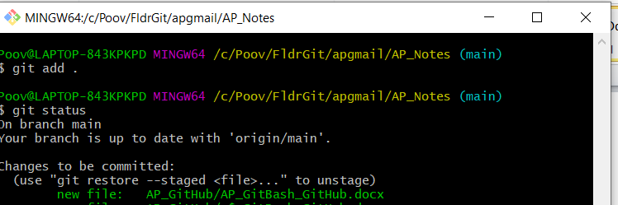

## git commit -m "message“

* creates a copy that needs to be updated in repository
* 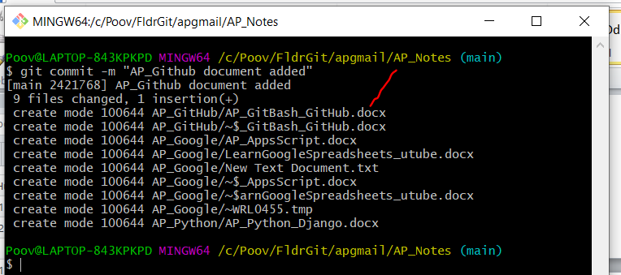

## git push

* pushes the code changes into the repository
* 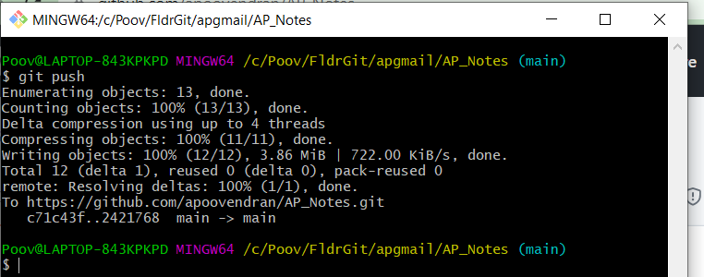
* In the github URL

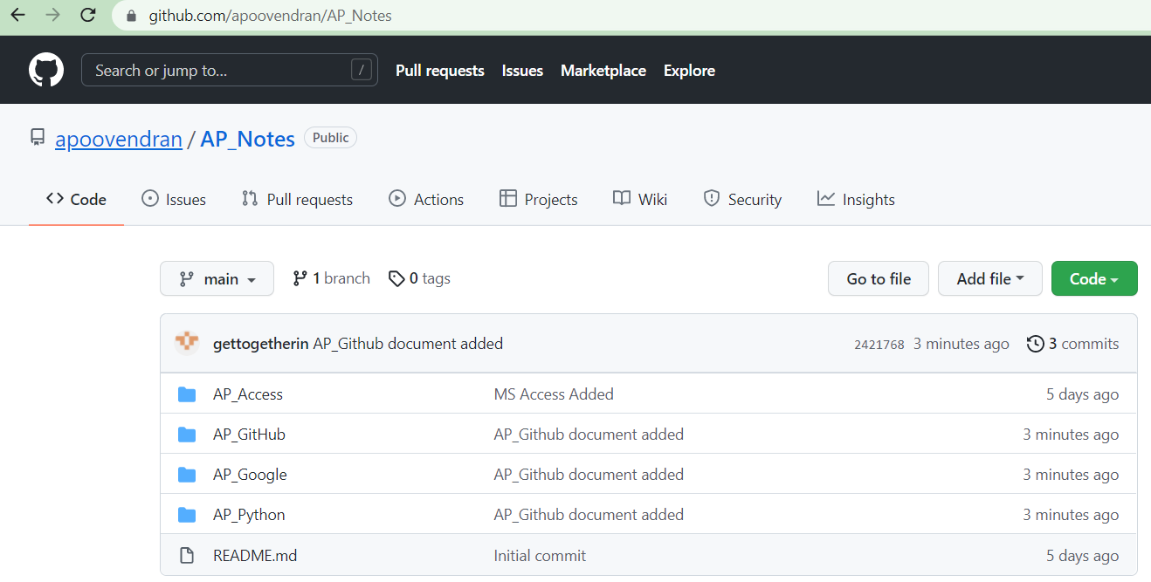

## Handling with Branches

* In case of merge conflicts, need to resolve conflicts and then merge.
* For review purposes we usually create a pull request in github after pushing the code into the repository, review the code and then merge the branches

### git branch

### git checkout -b "newdevbranch"

* creates a new branch in local repository

### git pull

* gets the latest version code from GitHub

### To merge new branch to Master

#### git checkout master

* switches to existing branch

#### git merge newdevbranch