# Google Sheet Scripts Playlist - getto@gmail - SamplePrj

## App Script Editor Tutorial - Google Sheets - Excel VBA Equivalent - Read & Write to Ranges & Cells 29:48

Gsheet – Extension Menu – Apps Script

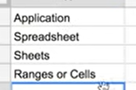

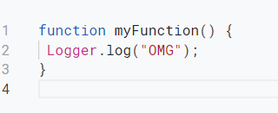

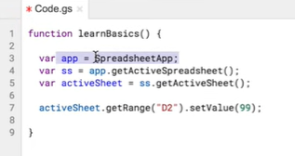

getrange works for range and cell

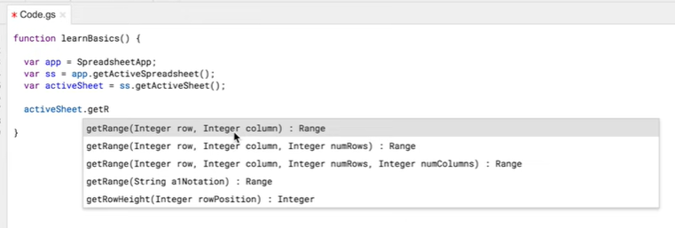







Reading data





## App Script Tutorial - Google Sheets - For Loops, Looping Through Cells, Variables, Comments - Part 2 24:17”

??? how gsheet knows starting function?

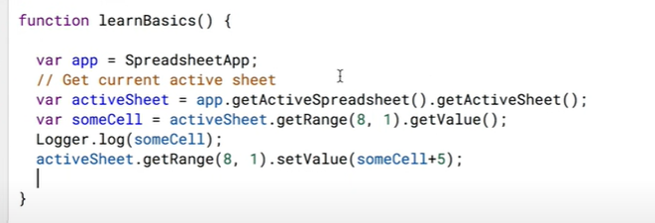

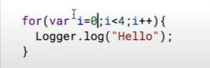



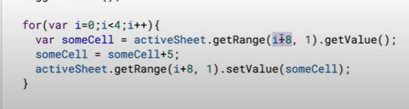

## Google Sheets Scripts Tutorial - Get & Set Cell Value in Other Sheets - Part 3 10:05

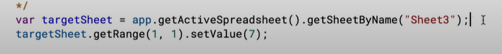

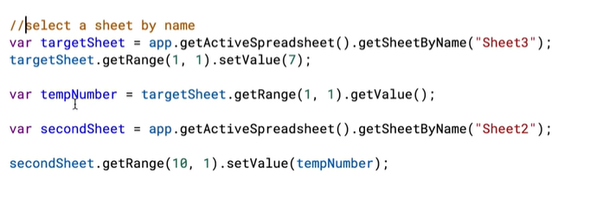

## Google Sheets Apps Script Tutorial - Clear Contents - Part 4 5:49

clear = clear the data and format

clearcontent = clears only content – format will be reamins

clearformat = clear only format

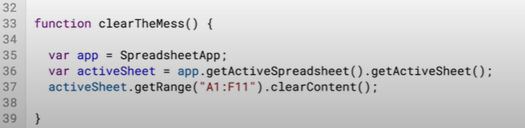

we can choose which function to be run

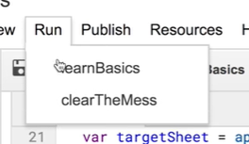

## Google Sheets - Create Custom Functions (UDF) using Apps Script with AutoComplete Tutorial - Part 5 11:40

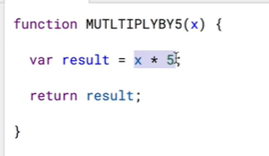

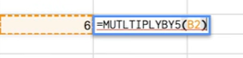

the below /** will enable the autocomplete in gsheet

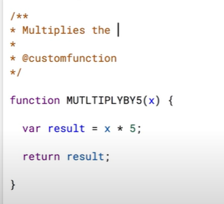

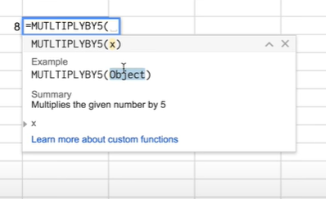

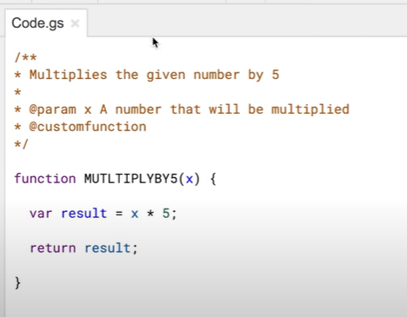

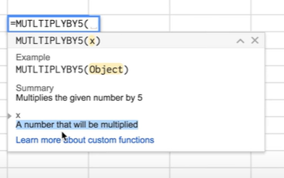

## Google Sheets Apps Script - If, Then, Else If, Else JavaScript Statements Tutorial - Part 6 17:43

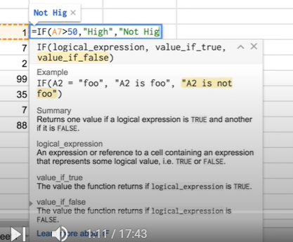

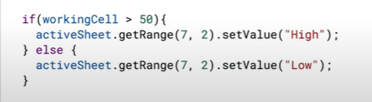

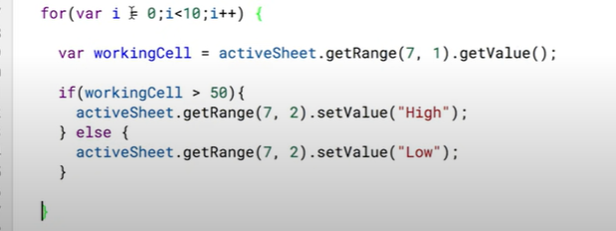

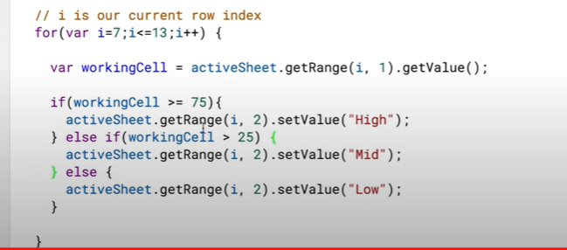

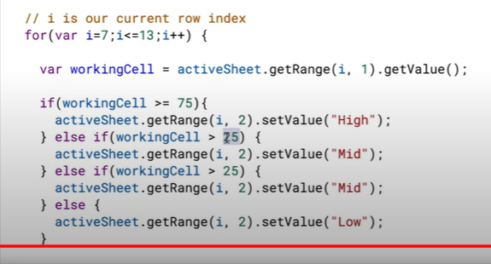

## Google Sheets Apps Script - Read Range to a JavaScript Array & Write to a Range Tutorial - Part 7 10:21

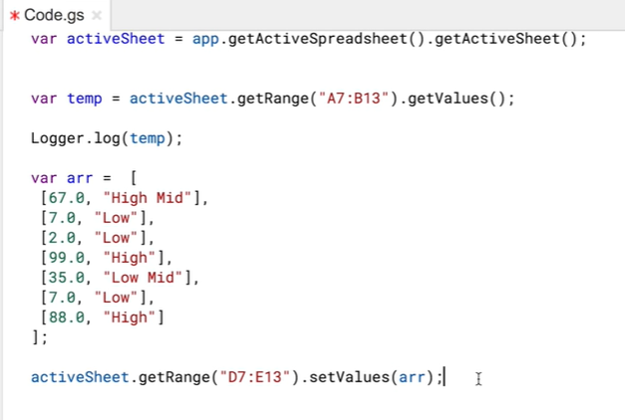

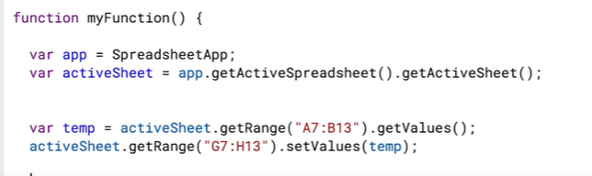

/*

multi line comments here

*/

## Google Sheets - Apps Script New Authorization Steps 2017 Tutorial - Part 8 2:46

## Google Sheets - Apps Script Fill Down Formula (Set a Fromula & Copy Down AutoFill) Tutorial - Part 9 11:52

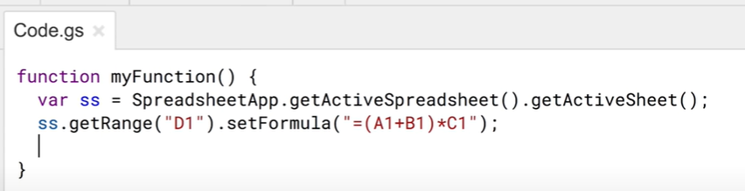

Copy formula

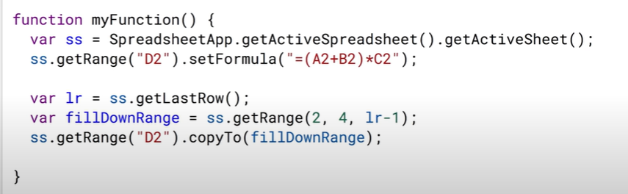

## Google Sheets - Apps Script Google Calendar API Integration Tutorial - Get Events - Part 10 30:52

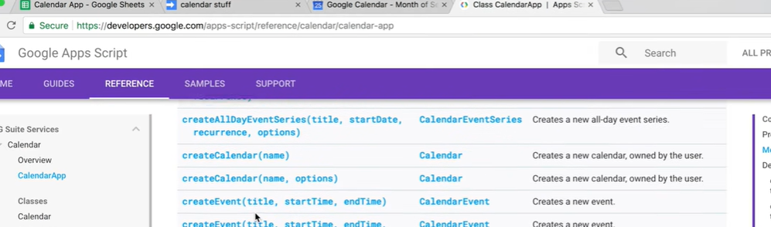

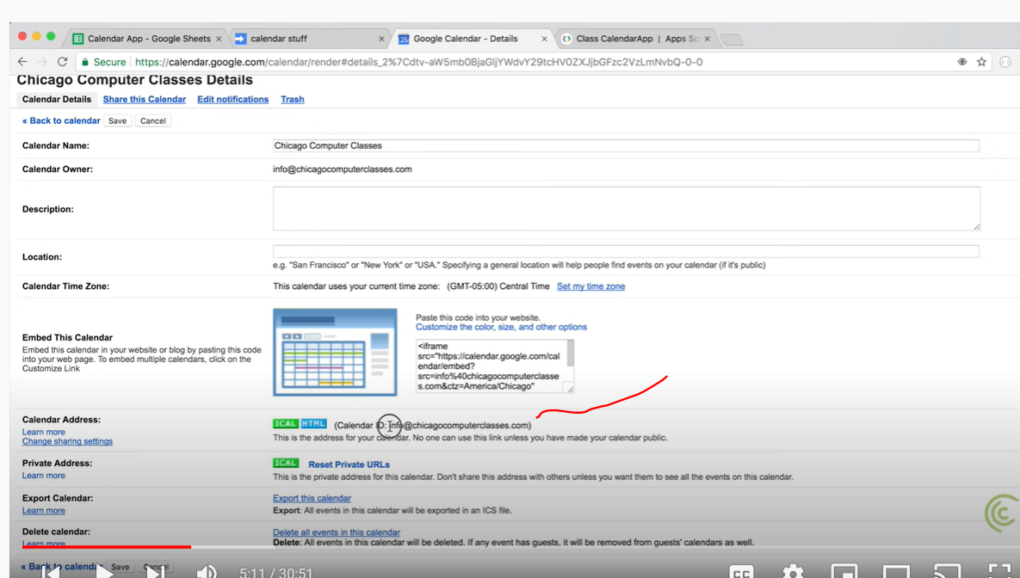

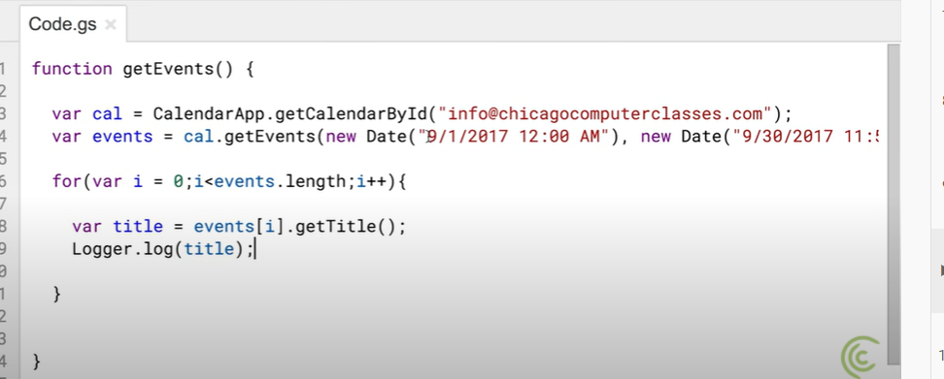

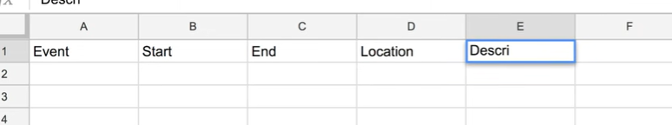

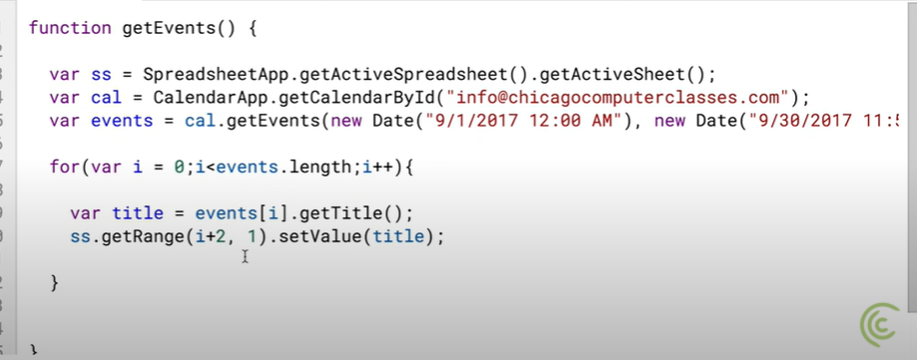

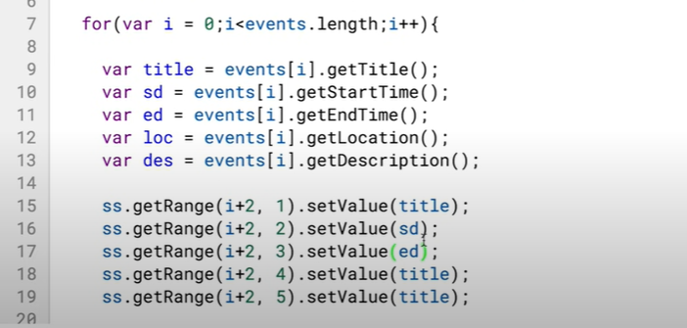

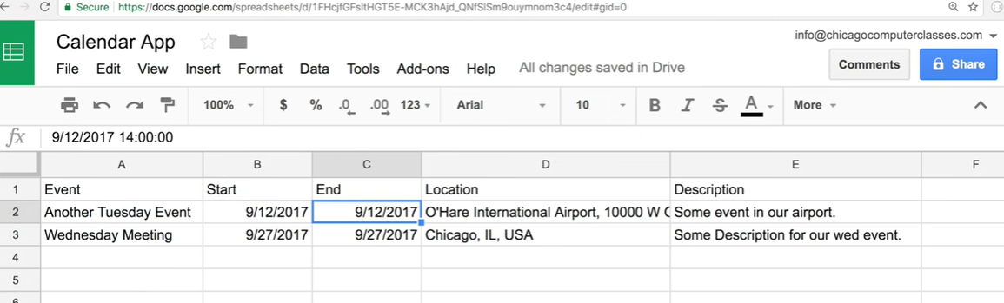

## Google Sheets - Add (Import) Events in Bulk to Google Calendar Using Apps Script Tutorial - Part 11 19:25

## Google Sheets - Send Emails Using Apps Script JavaScript MailApp Tutorial - Part 12 36:10

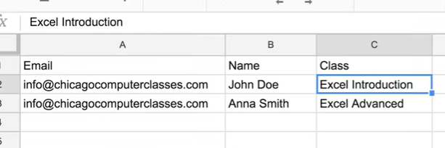

email tempalte

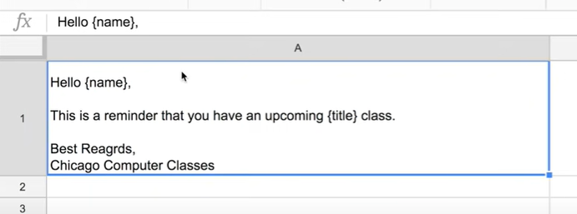

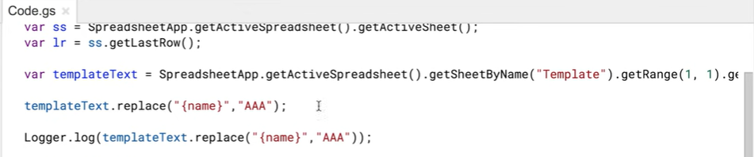





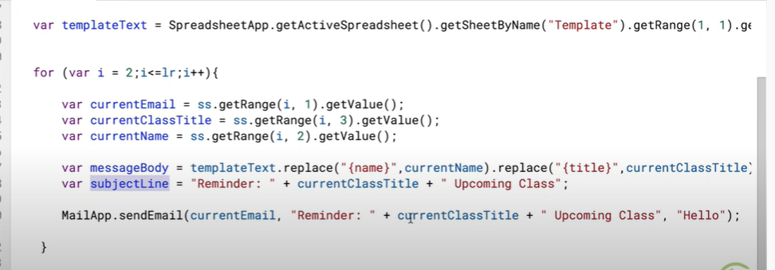

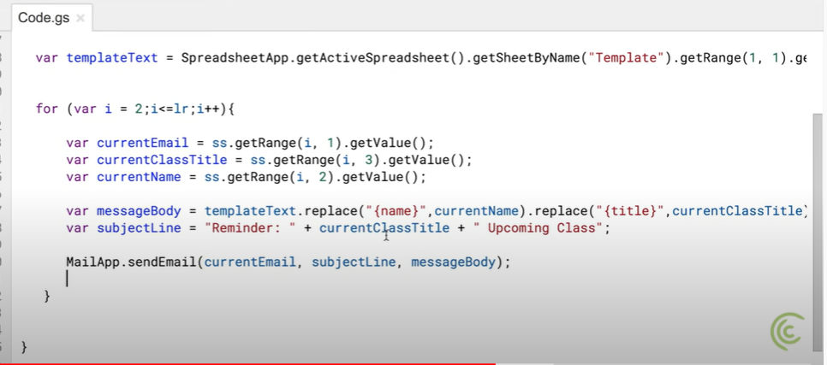

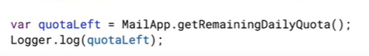

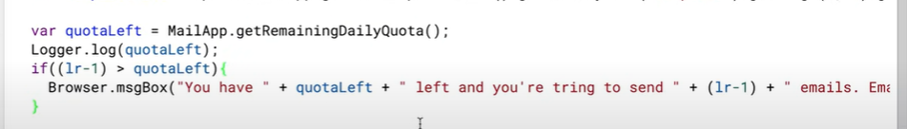

## *JavaScript Objects - Iterate Through Object Keys and Values - Google Sheets Apps Script - Part 13 35:10

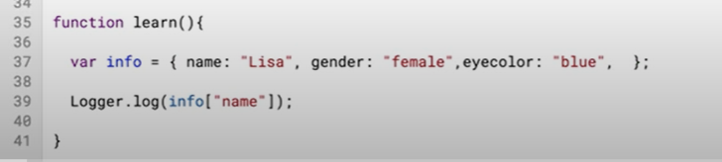

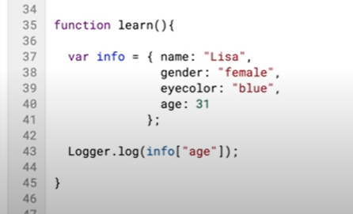

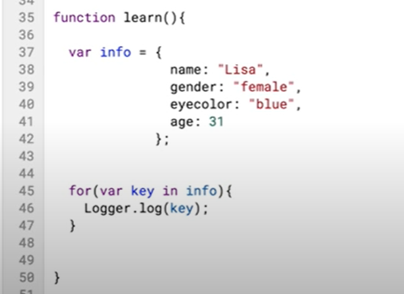

now key and val both will be logged

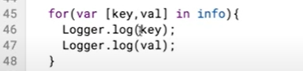

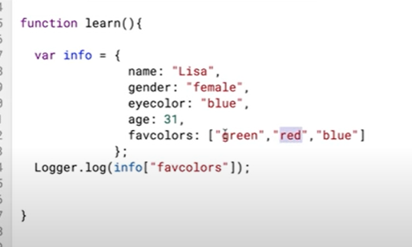

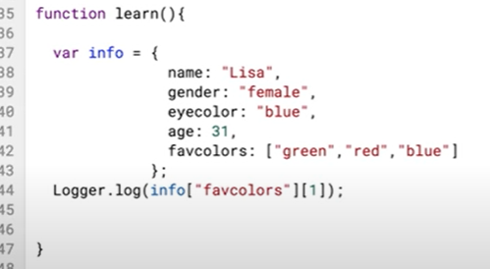

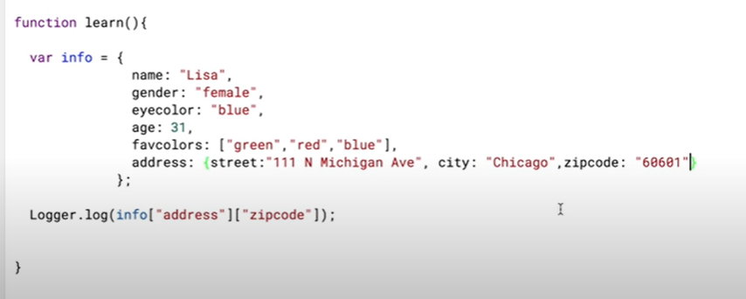

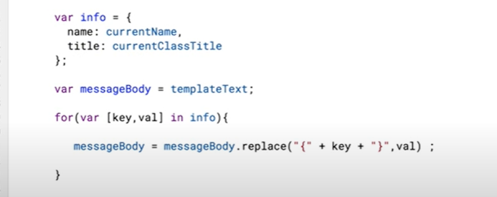

## Google Maps Distance & Duration Calculator - Google Sheets, Build Apps Script Function - Part 14 42:34 - skipped

## Google Apps Script - Google Drive Tutorial, Files, Folders, Copy Files, DriveApp, Iterator - Part 15 29:31

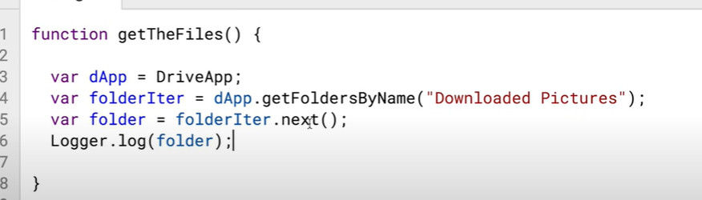

Learn Google Spreadsheets

16

18:48

NOW PLAYING

Match Function with Google Sheets Apps Script -JavaScript IndexOf Method Tutorial - Part 16

Learn Google Spreadsheets

17

40:47

NOW PLAYING

Google Sheets - Combine All Sheets into One When Column Order Doesn't Match - Apps Script - Part 17

Learn Google Spreadsheets

18

19:33

NOW PLAYING

Google Sheets - Dependent Dropdown List for Entire Column - App Scipt, Run On User Input - Part 1

Learn Google Spreadsheets

19

24:14

NOW PLAYING

Google Sheets - Dependent Dropdown List for Entire Column - Apps Scipt, Match Alternative - Part 2

Learn Google Spreadsheets

20

21:53

NOW PLAYING

Google Sheets - Crosstab to List or Flat File Data Table, UnPivot - Apps Script Tutorial

Learn Google Spreadsheets

21

20:52

NOW PLAYING

Google Sheets - Macro Recorder Tutorial - How to Record an Apps Script

Learn Google Spreadsheets

# 

# Requirement

* Title request by providing Journal
* Title Suggeests
* Title Approve

# Code

## code.gs

function doGet(request) {

  return HtmlService.createTemplateFromFile('Index').evaluate();

}

function include(filename){

  return HtmlService.createHtmlOutputFromFile(filename).getContent();

}

function processForm(formObject){

  var url="https://docs.google.com/spreadsheets/d/1oP_OxQ_bpKZf7EQl3jyECDxz_hf1B2MPRtvmhx0rmiU/edit#gid=0";

  var ss= SpreadsheetApp.openByUrl(url);

  var ws=ss.getSheetByName("Data");

  //var ui = SpreadsheetApp.getUi();

  ws.appendRow([

    formObject.journalname,

    Session.getActiveUser().getEmail(),

    Utilities.formatDate(new Date(), "GMT+1", "dd-MMM-yy"),

    getNextId()

  ]);

  //ui.alert('Submitted');

}

function getNextIdOld() {

  var titleDate = Utilities.formatDate(new Date(), "GMT+1", "yyMM");

  var CurID = 20;

  CurID++;

  //var CurID = text("00000000",20);

  CurID = titleDate+CurID;

  return CurID;

}

function getNextId() {

  const ss = SpreadsheetApp.getActiveSpreadsheet(); // <<< current spreadsheet

  const s1 = ss.getSheetByName("Data");

  const s2 = ss.getSheetByName("CurrentID");

  const data = s1.getDataRange("d19").getValues();

  var titleDate = Utilities.formatDate(new Date(), "GMT+1", "yyMM");

  var CurID = 20;

  CurID++;

  //var CurID = text("00000000",20);

  CurID = titleDate+data;

  return CurID;

}

## Index.html

<!DOCTYPE html>

<html>

  <head>

    <link rel="stylesheet" href="https://cdn.jsdelivr.net/npm/bootstrap@4.5.3/dist/css/bootstrap.min.css"

 integrity="sha384-TX8t27EcRE3e/ihU7zmQxVncDAy5uIKz4rEkgIXeMed4M0jlfIDPvg6uqKI2xXr2"

crossorigin="anonymous">

  <?!= include('JavaScript'); ?>

  </head>

  <body>

    <div class="container">

            <div class="row">

                <div class="col-6">

                    <form id="myForm" onsubmit="handleFormSubmit(this)">

                        <p class="h4 mb-4 text-center">Title Details</p>

                        <div class="form-row">

                            <div class="form-group col-md-6">

                                <label for="journal_name">Journal Name</label>

                                <input type="text" class="form-control" id="journal_name" name="journalname" placeholder="Journal Name">

                            </div>

                        </div>

                        <button type="submit" class="btn btn-primary btn-block">Submit</button>

                    </form>

                    <div id="output"></div>

                </div>

            </div>

        </div>

  </body>

</html>

## Javascript.html

<script>

  function preventFormSubmit(){

    var forms=document.querySelectorAll('form');

    for (var i=0;i<forms.length;i++){

      forms[i].addEventListener('submit',function(event){

        event.preventDefault();

      });

    }

  }

window.addEventListener('load',preventFormSubmit);

function handleFormSubmit(formObject){

  google.script.run.processForm(formObject);

  document.getElementById("myForm").reset();

}

</script>

## gs