Lab – Intents

# Objectives:

Familiarize yourself with Android Intents. You will create Intents and then use them to activate Activities.

# The Intent class

In this lab, you will use both explicit and implicit Intents to activate Activities. In one case, you will start an Activity using the startActivity() method. In another case, you will start an Activity by using startActivityForResult(). See <http://developer.android.com/training/basics/intents/> for more information.

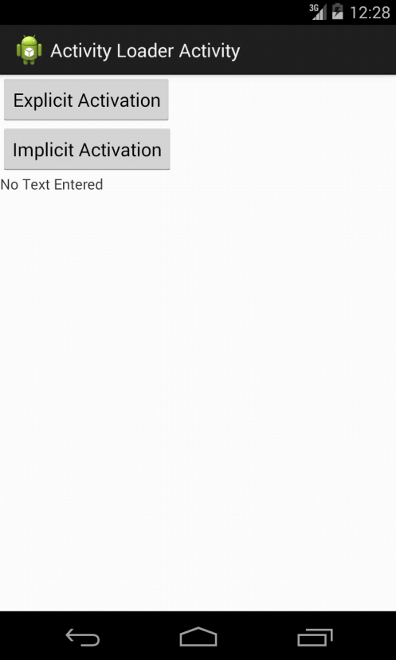The main Activity for this application is called ActivityLoaderActivity. It should display two Buttons, one labeled “Explicit Activation” and one labeled “Implicit Activation.” It should also display one TextView, initially displaying the words, “No Text Entered”.

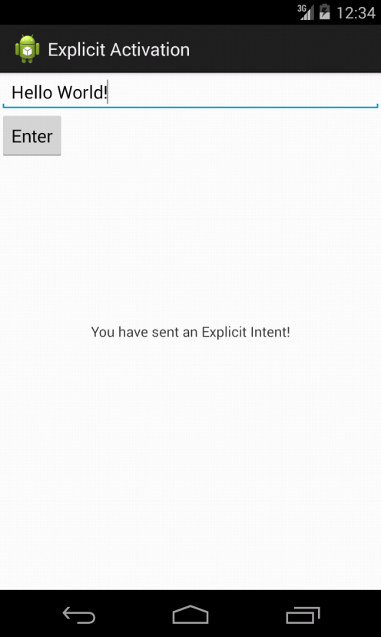The application should behave as follows. When the user clicks the “Explicit Activation” Button, the ActivityLoaderActivity should launch a new Activity called ExplicitlyLoadedActivity. This activity should display a user interface containing an EditText and a Button. An EditText object allows a user to enter text.

When the user clicks the “Enter” Button, this Activity should finish, returning the current contents of the EditText object (seen above as ‘Hello World!) back to the ActivityLoaderActivity. Once the ActivityLoaderActivity is again visible, any text that was returned from the ExplicitlyLoadedActivity should appear in the ActivityLoaderActivity’s TextView object, as shown below.

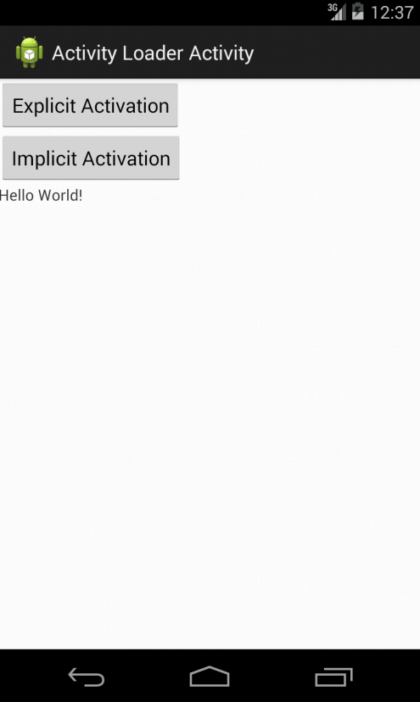

When the user clicks on the “Implicit Activation” Button, the ActivityLoaderActivity will create an implicit Intent, and then use it to implicitly activate a separate application to view the URL, “http://www.google.com”. Because multiple applications may be able to handle this Intent, ActivityLoaderActivity will create and display an App Chooser (one example is shown below, but yours may have a slightly different layout), allowing the user to select the specific application to handle the Intent. For this assignment, the Chooser should display two choices: Android’s built-in Browser and a separate application you’ve created called MyBrowser. To create an App Chooser, start by creating an initial Intent to view a webpage, (as part of this process you'll need to use the Uri class’ parse() method). Then, create a second Intent, based on the first one, by calling the Intent class’ createChooser() method. Finally, start a new Activity using this second Intent. See http://developer.android.com/training/basics/intents/sending.html for more information about creating chooser Intents.

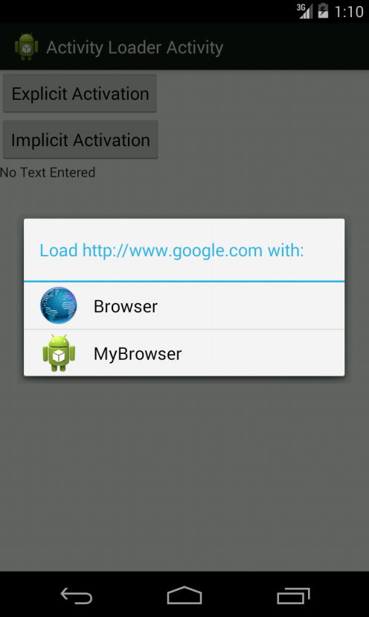

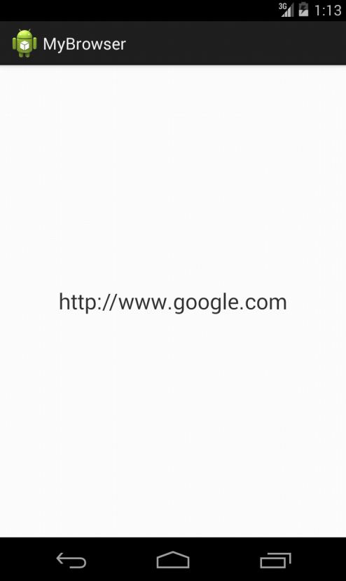If the user selects the Android Browser from this chooser dialog, then that application will open and display the webpage at the given URL. If the user instead selects the MyBrowser application, then that application will open and simply display the text of the URL in a TextView.

See the screencast in the download package to see the app in action.

## Implementation Notes:

Import the two projects Lab3a_IntentsLab and Lab3a_MyBrowser. For the Lab3a_IntentsLab project, perform the following steps.

1. In ActivityLoaderActivity.java, implement launching the ExplicitlyLoadedActivity and returning the text result to the ActivityLoaderActivity.
   1. When the user clicks the “Explicit Activation” Button create an explicit Intent for launching the ExplicitlyLoadedActivity.
   2. In the ActivityLoaderActivity onActivityResult() will eventually be called. In that method you should use Intent.getStringExtra() to read it back out. See http://developer.android.com/training/basics/intents/result.html for more information.
2. In ExplicitlyLoadedActivity.java, finish the Activity and return any user-entered text when the user clicks the Enter Button.
   1. To return the text, you can use the Intent.putExtra() method to store the text in an Intent to be returned to the ActivityLoaderActivity. What key will you use when storing the text? You will pass this Intent to the setResult() method, add an appropriate result code, and then call finish().
3. In ActivityLoaderActivity, implement launching an unknown Activity to view a URL.
   1. When the “Implicit Activation” Button is clicked you should create an implicit Intent indicating that you want to a view a URL. The application should use an app chooser to display Activities that are capable of viewing URLs. See http://developer.android.com/training/basics/intents/sending.html for more information.

For the Lab3b_MyBrowser project, do the following.

1. Implement and deploy the Lab3a_MyBrowser application.
   1. In Lab3a_MyBrowser’s AndroidManifest.xml file, add the appropriate Intent Filter to MyBrowserActivity so that Android will know that this Activity can view web pages. To indicate that the Activity can handle this type of Intent, you will need to add an <intent-filter> to the <activity> in Lab3b_MyBrowser’s AndroidManifest.xml file. Be sure to add the correct <action>, <category>, and <data> elements to an <intent-filter> element.

As explained above, you can find the skeleton code in the Lab's download package. Below are the list of classes and methods you need to implement. You can find them in the code by looking for comments with the String TODO:

1. In ActivityLoaderActivity.java implement the following methods.

**private void** startExplicitActivation(): create an intent and start the ExplicitlyLoadedActivity.

**private** **void** startImplicitActivation(): create an Implicit Intent and use the Intent.createChooser() method to select an application for viewing a web page. What action string should you use? Activate the user-selected Activity using this Implicit Intent.

**protected** **void** onActivityResult(**int** requestCode, **int** resultCode, Intent data): get the data that is returned from the ExplicitlyLoadedActivity Activity and display it in the mUserTextView. How do you find and access that TextView?

1. In ExplicitlyLoadedActivity.java implement the following method.

**private** **void** enterClicked(): get user-entered text from the EditText, store it in an Intent, and return it to the ActivityLoaderActivity.

1. In Lab3a_MyBrowser’s AndroidManifest.xml file, add the necessary intent filter tags. You'll need to define the right <action>, <category> and <data> elements. What values should be used for these? Remember that how you express certain values in Java can be different than how you express them in xml.

# Testing

The test cases for this Lab are in the Lab3a_IntentsLabTest. Import this project into your IDE. You can run the test cases either all at once, by right clicking the project folder and then selecting Run As>Android Junit Test, or one at a time, by right clicking on an individual test case class and then continuing as before. The test classes are Robotium test cases, but be aware that the test cases have been tested only for the standard AVD described below.

As you implement various steps of the Lab, run the test cases every so often to see if you are making progress toward completion of the Lab.

**Warnings:**

1. These test cases have been tested on a Galaxy Nexus AVD emulator with API level 18. To limit configuration problems, you should test you app against a similar AVD. Also, when testing, make sure that your device is in Portrait mode with the screen unlocked when the test cases start running.
2. The ImplicitTest test case requires that you've installed both the Lab3a_IntentsLab and the Lab3a_MyBrowser applications. Remember - If you change Lab3a_MyBrowser, you'll need to reinstall it.
3. The ImplicitTest test case causes the Lab3a_MyBrowser application to start. Due to Android security policies, Robotium test cases cannot test across multiple applications. So when a test case starts up Lab3a_MyBrowser, it can't interact with Lab3a_IntentsLab after that. What this means for you, is that after running ImplicitTest, you must manually exit Lab3a_MyBrowser (for example, by hitting the back button). If you don't and then try to run another test case, Eclipse gets completely stuck.
4. Spelling counts. Pay attention to how to specify data values in your xml files. Leave out or misspell a single letter and Android won't understand what you really meant.

As you implement various steps of the lab, run the test cases every so often to see if you are making progress toward completion of the lab.

Once you’ve passed all the test cases, follow the instructions on the Assignment page to submit your work to the Coursera system for grading.

# Submission

To submit your work you will need to copy files from your Lab3a_IntentsLabs project and Lab3a_MyBrowser project, put them in designated directories, and compress them as a single zip file. Then you will submit this zip file to the Coursera system. The automatic grading system will test your submission and give you feedback. This process may take some time, especially if many students are submitting at the same time. To make sure your submission is correctly graded, pay attention to the following aspects:

1. Your project files must be compressed in a zip file named IntentsLabSubmit.zip.
2. The zip file should have the following directory structure:  
   IntentsLabSubmit/  
    - IntentsLab/  
    - ActivityLoaderActivity.java  
    - ExplicitlyLoadedActivity.java  
    - MyBrowser/  
    - AndroidManifest.xml
3. Each new submission will overwrite any previous submissions.