Politicians often make the reference that crime was lower when their political party was in office. But how often is that true and are there genuine differences in the scale and shape of the distributions of crime between political parties. To study this crime data was extracted from the Chicago Police Department's CLEAR (Citizen Law Enforcement Analysis and Reporting) system. For the purpose of this project crime data was subsetted to only reflect monthly counts of homicide from year 2001-2020, this yielded 215 data points. Data from the National Governors Association was used to determine which years held democratic versus replican politicians for the governor of Illinois, this yielded 68 data points for republican governors and 147 for democrats. The goal of this project is to determine if there are group level differences in monthly counts of homicide between political parties.

This analysis was completed using R, code can be found on Github (<https://github.com/aporter1350/nonparametrics>). Estimations of the density function for monthly count of homicide for each political party are shown in Figure 1, smoothing parameter h was chosen using the Sheather-Jones method for both. The values of h used were fairly different for the two groups, with SJ = 7.25 for the republican group and SJ = 4.73 for the democrat group. The sample means and standard deviations for monthly homicide were also slightly different between groups for republicans and for democrats. To test the hypothesis that the density functions of homicide rates are the same in the two groups a density comparison method was used, smoothing parameter was selected by taking the geometric mean of hSJ for the two groups ( ). Using the standard .05 criteria for significance, the p-value of 0 observed here indicates that we reject the hypothesis for density function to be the same. This indicates there is a difference in the distribution of homicides per month for republican and democrat governors in Chicago (Figure 2.). To see if the two density functions have the same shape but at different parameters of scale data was standardized using the mean and standard deviation and applied to the same test for significance. The geometric mean became a lot smaller , and the test reveals that there is no evidence to reject the hypothesis (p=.34) and so concludes that there is no difference in shapes of the distribution of homicides per month and political parties as shown in Figure 3.

To conclude the data would suggest that there are differences in the distribution of homicide counts per month when comparing democrat and republican governors in the city of Chicago. While the current understanding of why high rates of crime occur in the city of Chicago remains elusive this at least provides a glossy overview of how the distributions of crime change with politics. There may be other factors that influence rates of crime, the general example being the changes in seasons, as higher temperatures occur, the rates of crime generally change (Figure 4.) with higher temperatures reflecting higher rates of crime. As well as other societal factors such as unemployment and laws governing the use of firearms.

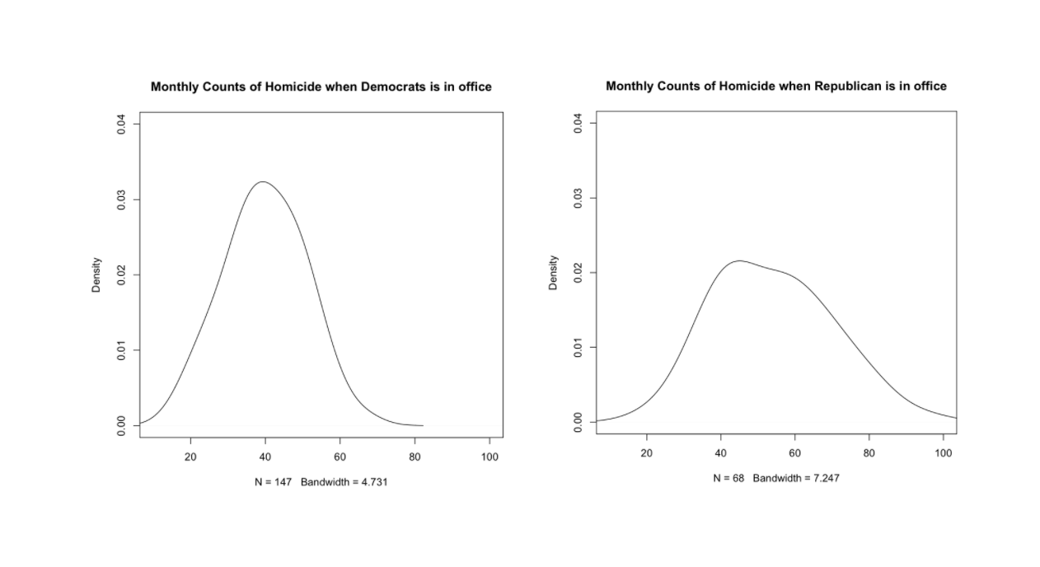

Figure 1. Kernel Estimates of the Density of Monthly Counts of Homicides for Democrats and Republicans in Chicago.

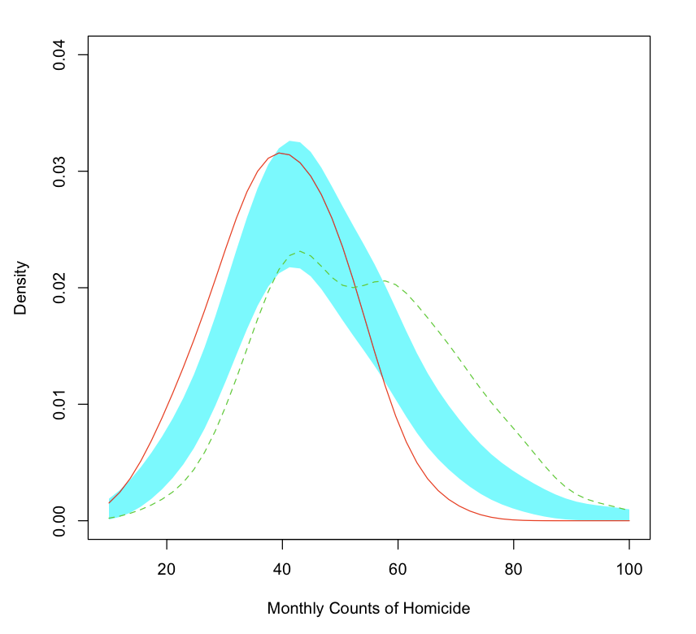

Figure 2. Hypothesis Test of Density Functions of Monthly Counts of Homicide

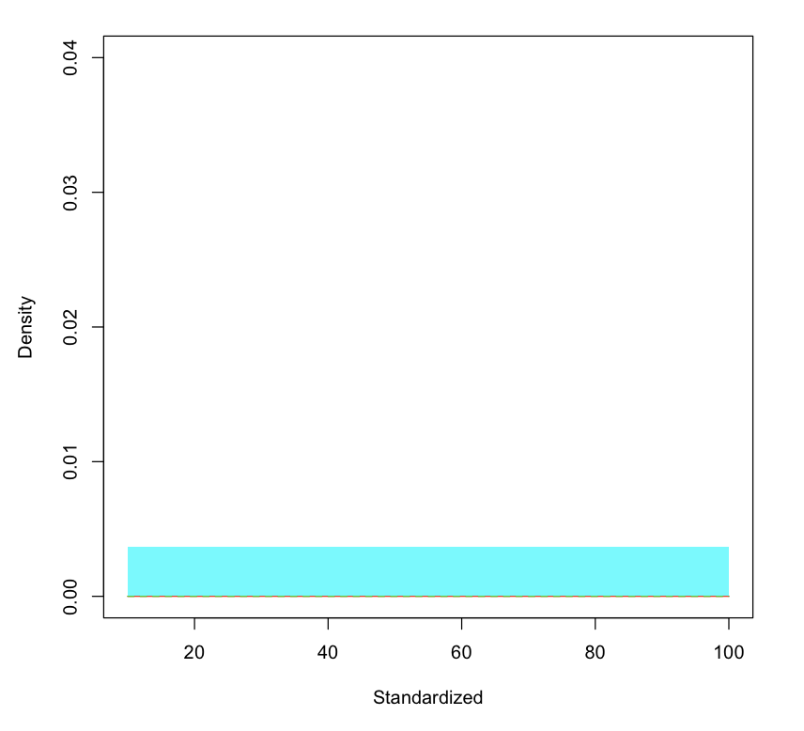

Figure 3. Testing the Densities of Standardized Monthly Counts of Homicide between Political Parties

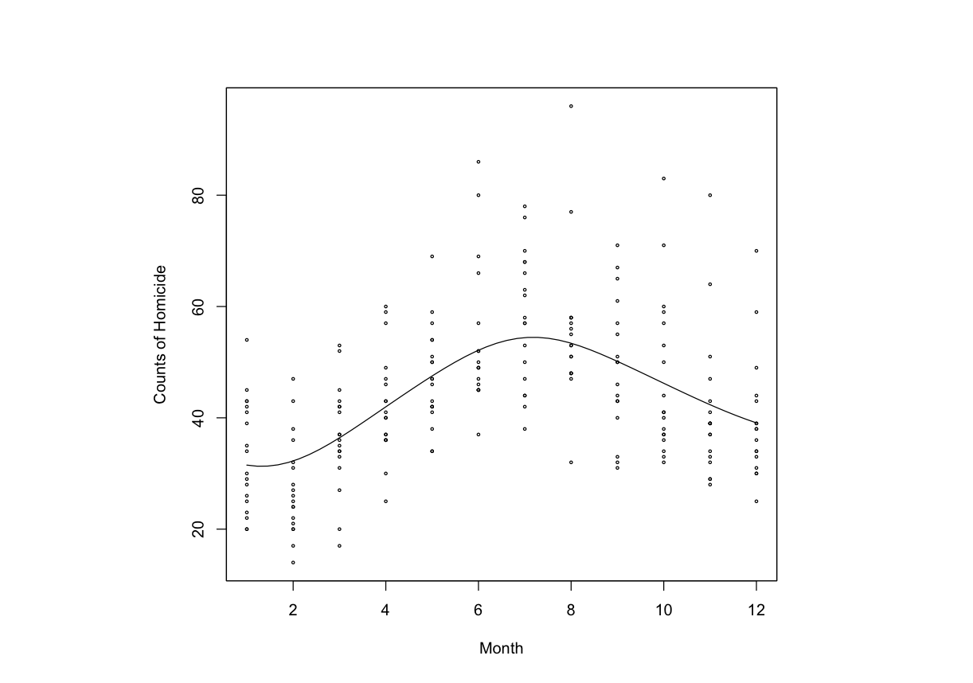

Figure 4. Kernel Estimates Counts of Homicide For Each Month Independent of Year