E-APOSTILLE
(Convention de La Haye du 5 octobre 1961)
(Also valid for the countries that are not in reciprocal arrangement with Bangladesh under the Apostille Convention of 1961, subject to proper legalisation)

Issuing Authority

Country: BANGLADESH
The public document
- has been signed by: Md Faruk
- acting in the capacity of: Deputy Police Commissioner

- bears the seal/stamp of: Dhaka Metropolitan Police, Dhaka

Certified

at Dhaka, Bangladesh
- the 21-Apr-2026

by Md. Rashid Abid , Assistant Secretary , Ministry Of Foreign Affairs

- No 1776851400

Seal/stamp 10. Signature

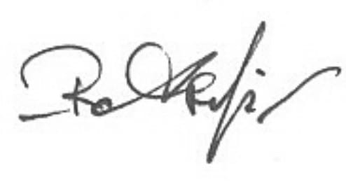
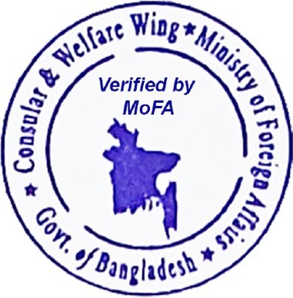

Digitally signed by Md. Rashid Abid Date: 2026-04-21
Time:23:51:51 +06:00

Reason: Document verification Location: Dhaka, BD

- To see the Apostille documents, please scan the QR code
- For verification of the e-Apostille, please visit: https://mofa-servicedirectory.apostille.mygov.bd

