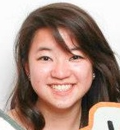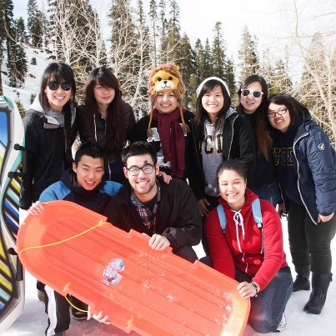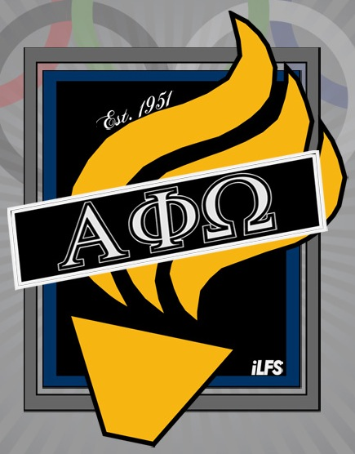

**Rush Week!**

2/25/13-3/1/13

Monday: Info Night 7:30pm  
Tuesday: Ice Cream Social 7:00pm  
Wednesday: Service Night 7:00pm  
Thursday: Bowling Night 8:45pm  
Friday: Initiation 5:30pm

Winter Retreat

* When: President’s day weekend 2/15/12-2/18/13
* Day 1: Arrived late and hung out for the rest of the night.
* Day 2: Ate breakfast and played board games. Some people went sledding.
* Day 3: Woke up late, went to Reno and Circus Circus. Had a buffet, and then hung out some more with movies and board games.
* Last day: drove home.
* Trang had a fun experience and would definitely go again. It was well planned out and would not change a thing.
* Harty term, 2nd year Nutritional Science major
* If she were an animal, she would be a hybrid of a leopard and a lion.
* She wants to visit all seven continents before she dies.
* Guilty pleasure: chocolate
* Favorite part of APO: people (Especially Sam Khuu)
* Likes chocolate covered nuts
* Favorite color is down-low teal
* Favorite food: noodles

Interview by Trang Ngo

### Fellowship Spotlight!

Samantha Fang

### Meet an Active!

1. **Service**

Rush Flyering all throughout now until initiation!

1. **Membership**

3/16/13

Sectionals at Mu Zeta

a. Day $35

b. Day with Banquet $45

2/21/13

Study Session at Fountain Circle

1. **Corresponding Secretaries**

02/23/13

[UC Merced] Alpha Eta Gamma’s 1st Birthday

1. **Fellowship**

2/22/13

* Actives Lock In at Avalon Lounge

2/23/13

* Boiling Crab
* Woodland Taco Run Part 2

### Important Dates