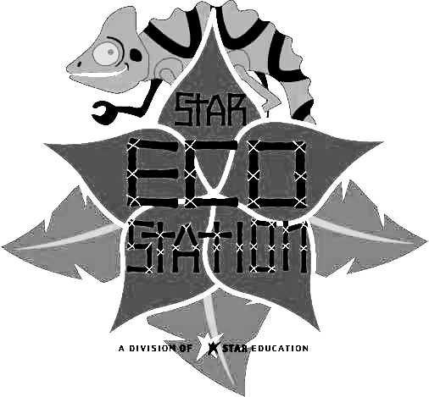
Star Eco Station
10101 W. Jefferson Blvd. Culver City, CA 90232

Phone: 310-842-8060 FAX: 310-842-8245
Special Events Volunteer

______________________________________________________ ___________________
Name of Volunteer Date
Birth date: ________/________/________ Sex: M_______ F________

__________________________________________________________________________________________
Home Address City Zip Code

____________________________________________________________________________________________
Home Phone # Alternate # Email Address
Parent/Guardian

___________________________________________________________________________________________
Name Alternate # Work #

Emergency Contact
Name: ____________________________________________________________ Relation: ____________________________
Address: ___________________________________________________ Phone #: ____________________________
EMERGENICES
In case of an emergency, STAR Eco Station will make every effort to contact the guardian of the minor involved, before any treatment is begun. However, in the event we are unable to make contact with the parents/guardians, we require this medical release to be signed by all the participants in the program.
I HEREBY AUTHORIZE THE PHYSICIAN OR HOSPITAL SELECTED BY THE STAR ECO STATION TO HOSPITALIZE SECURE TREATMENT FOR, AND TO ORDER INJECTION, ANESTHESIA, OR SURGERY OF MY CHILD.
It is further understood that the undersigned will assume full responsibility for any such treatment, including the payment of all costs, and will hold the STAR Eco Station, its representatives, and staff, harmless therefrom.
Name of Insurance: __________________________________________ Policy #__________________________
Parent/Guardian’s Name (PRINT):______________________________________________________________
Parent/Guardian’s Signature: ________________________________________ Date: ___________________
Minor’s Medical Information: (physical, dietary, allergies, etc.)
____________________________________________________________________________________________________

1. Are you …?
A. volunteering for a school/program credit? Yes No
If yes, which school/program? ___________________________________________ Current grade: __________
B. volunteering for Court mandated community service? Yes No
If yes, why? _________________________________________________________________________________
C. volunteering for ______________________________________________________________________________
2. Who referred you, or, how did you find out about the STAR Eco Station? _______________________________________
3. Do you have any medical/physical issues that could affect your performance?
No Yes (explain) _____________________________________________________________________________
Note: Peanut products are used on the STAR Eco Station premise. Continued on back

Star Eco Station

RELEASE, WAIVER, AND ASSUMPTION OF RISK
AGREEMENT FOR VOLUNTEERS

This is a legally binding release, waiver and assumption of risk agreement made by me __________________________ (hereafter, “I” or “Volunteer”) to STAR Education and the STAR Eco Station (hereafter, collectively “STAR”). I wish to volunteer my services to STAR and I hereby agree as follows:

- I acknowledge and understand that, as part of my participation with STAR and in STAR-related events, there are dangers, hazards and inherent risks to which I may be exposed, including the risk of serious physical injury, temporary or permanent disability, and death, as well as economic and property loss, arising from the actions, inactions or negligence of me or others or from the condition of the premises. I also acknowledge and understand that there may be other dangers, hazards or risks not presently known or reasonably foreseeable, and that participation may include travel to and from the event.
- I further acknowledge and understand that there may be photography conducted at STAR and STAR-related events and I hereby consent and agree that any and all such photographs containing my image may be used by STAR for promotional purposes.
- In consideration of the opportunity to volunteer my services to STAR, I agree to assume all risks, dangers, and hazards arising from such volunteer services and that such assumption shall be binding upon my heirs, designees and assigns.
- I agree that, in connection with my volunteer activities, I will adhere to all of the policies and procedures of STAR and all laws and regulations of the jurisdiction in which I am located including, but not limited to, the State of California.
- I hereby release, indemnify and agree to hold harmless STAR, its officers, trustees, employees, volunteers, assigns, successors and/or agents, from and against any and all liability, actions, debts, claims and demands of any kind whatsoever including, but not limited to, any claim for negligent acts or omissions and any present or future claim, loss or liability for injury to person or property that I may suffer, or for which I may be liable to another, arising out of my volunteer activities for STAR.
- I hereby waive all rights under California Civil Code Section 1542, or similar law of any other jurisdiction, which reads as follows: “A general release does not extend to claims which the creditor does not know or suspect to exist in his favor at the time of executing the release, which if known by him must have materially affected his settlement with the debtor.”
- I hereby agree to pay for any damages to any property or other damage caused by me, either negligently, willfully or otherwise, during my volunteer activities.
- I acknowledge that, prior to signing this release, waiver and assumption of risk, I have had an adequate opportunity to read it, and any questions I had were directed to STAR and have been answered to my satisfaction.

Signature of Volunteer: ________________________ Date: ______________________

Printed Name: _______________________________

If volunteer is under 18 years of age:
I am the parent or legal guardian of the Volunteer. I have read and understand the foregoing release, waiver and assumption of risk. I hereby consent to Volunteer’s participation with STAR and in STAR events; I am and will be legally responsible for the obligations and actions of Volunteer as set forth above; and I agree to be bound by the terms of this release, waiver, and assumption of risk.

Signature of Parent/Guardian: _______________________ Date: __________________

Printed Name: ________________________________
-------------------------------------------------For Office Use Only------------------------------------------------------------
1st event:
Comments:

