**Robowar**

**Weight Category – 8Kgs**

Date:- 24-02-2023

**Team Information**

Team name: Rob­_OG`s

Team leader`s name: Rakshit Garg

Contact details of team leader:

Contact no.: 9354484405

Email ID: rakshitgarg1712@gmail.com

Number of members in the team: 6

**MEMBERS:**

|  |  |  |  |  |
| --- | --- | --- | --- | --- |
| S.No | Name | Tech ID | Email ID | Contact No. |
| 1 | Vinayak Singhal | 25255 | vinayaksinghal10@gmail.com | 9625942216 |
| 2 | Nishant Kaushik | 25852 | kaushik8929@gmail.com | 7988365704 |
| 3 | Vishal Kumar | 25331 | kumarvishal90593@gmail.com | 8527857803 |
| 4 | Rachit Batra | 26306 | 21001013091@jcboseust.ac.in | 9350098383 |
| 5 | Vivek Priya | 24023 | vivekgautamtet@gmail.com | 9289391800 |

**Introduction**

Robots: Man's other best friend. We build because we can. With this moto our Team ROB_OG`s from Mechnext: The Mechatronics Society of J.C Bose University of Science and Technology, Faridabad has designed our bot MX SHAURYA. A rough and tough bot designed to eliminate all opponents from the game.

This bot is programmed to be merciless. With its dimensions of 30x15x10 cm and weight under 8kg. The bot is specially designed to compete in the robowar of IIT KANPUR's event TECHKRITI.

Our bots use powerful motors for quick responses and operate wirelessly to avoid problems. It employs a transmitter and receiver to provide seamless responses.

Our bot has a weapon that is in the form of a roller and rotates at 11000 RPM, giving it an advantage.

We don't lose, but when we do, we work hard to be better than the last time. We learn from our mistakes as well as our competitors.

We've come to gain some valuable experience and to put what we've learned over the last few months to the test. We gave it our all to create SHAURYA.

**Component Details**

1. Transmitter & Receiver
2. Drive Motors
3. Weapon Motor
4. Nylon Wheels
5. ESCs
6. Battery
7. Chassis Material - MS
8. Wire
9. Bearings
10. Shafts & Axles
11. Screws & Fasteners
12. Body Material - Aluminum

**Component Specifications**

|  |  |  |  |  |
| --- | --- | --- | --- | --- |
| S.No. | Components | Specification | Weight | Dimensions |
| 1 | Brushless Motor | 24V 450 KV | 100 gm | 2.8*2.8*4.6 cm |
| 2 | RS775 Motors | 24V 1000 RPM | 300 gm | 6.7*1.8*4.3 cm |
| 3 | Lipo Battery | 24V 6S | 620 gm | 5.1*4.4*13.7 cm |
| 4 | BLDC ESC | 24V 40 A | 25 gm | 4.5*2.4*0.9 cm |
| 5 | Powermax ESC | 60-D 3S-6S | 35 gm | 0.7*0.3*0.1 cm |
| 6 | Bearings | Ball & Taper-Roller | 10 gm | 2.2*0.7*0.7 cm |

**Construction**

* After overcoming all of the obstacles, we designed our bot to be able to withstand harsh conditions during the war. Drum bot is preferred because it has a wide drum with protruding, spinning teeth or blades mounted on a horizontal axis across the front of the robot. The front of the drum, like the vertical spinner, spins upward to lift the opponent on contact.
* The drum robot is made up of a chassis, a drum, wheels, locomotion motors, a switch box (remote), a belt, bearings, a solid rod that serves as the shaft for the drum, and gears. The drum robot's main assembly begins with the chassis. The chassis is made of aluminium and MS, which is about 5mm thick, is designed to have side supports that are screwed to the chassis using an Allen key set.
* These side supports have holes in them to hold the drum shaft. This drum is cylindrical and has two projections (blades) on either side to effectively hit the opponent's robot. The drum shaft is supported between two side supports by bearings on both sides. A brushless motor with a speed range of 9000-11000 RPM drives the drum mounted.
* We built the frame out of MS (mild steel) plate. Mild steel is derived from carbon steel with a low-carbon alloy. Mild steel has a low chromium and molybdenum content and a high carbon content. Mild steel has several advantages, including low cost, ease of welding, and machinability. These plates have high strength, tensile strength, yield strength, mechanical strength, ductility, hardness, and toughness.
* Aluminium 6061-T6 is also used as armour plates to protect our bot from our adversary's bot.
* We used brushed motors for the drive electronics, with a motor speed of 800-1000 RPM and a voltage of 24 V. We're using an ESC Powermax 60-D 3S-6S that can handle high amps like 60A. Its input voltage ranges from 6V to 28V.
* For weapon motor electronics, we used a brushless motor with a speed range of 9000-11000 RPM and a voltage of 24 V. We're using a BLDC ESC that can run on 30-40A. The input voltage is 24 V.
* We are using a power transfer mechanism for the drive motors. The simplest way to transfer power to the wheels is to have a wheel that mounts directly to the output shaft from the gearbox.
* Belt drive - Timing belts and pulleys are widely used to power featherweight spinning weapons. A pulley with teeth on the motor and a smooth surface on the weapon is a popular choice because the smooth surface allows for 'slip' on impact. Because the weapon can stop dead and the motor can continue to move, the motor's life is extended.
* We are using natural rubber wheels with dimensions of 4*1.5 inch.
* Bearings are used to improve the stability of wheels and weapon motors. Ball bearings are used in wheels, while taper roller bearings are used in drum spinners.
* We are using a 4500 mAH 6cell LIPO battery to power our bot.
* Fly sky FS-I6 2.4Gz 6 channel PPM RC transmitter and FS-iA6B receiver were used for wireless communication.

**Working Principle**

* Drivetrain (Wheel)

Brushed motors are used in the bot's drivetrain to control its movement. Our bot is designed using brushed RS775 motors.

This configuration will allow for a low-cost, efficient drive system. Because of the nature of the combat bot, using easily replaceable and less expensive parts is a high priority in the design process. The drives system was designed for ease of assembly by allowing bolt together parts that can be easily disassembled and reassembled. Each drivetrain assembly is designed to be symmetric, so parts do not need to be specified between left and right. The following components comprise the drivetrain assembly:

* + Brushed motor
  + Hardware
  + Side plate (frame)
  + Wheel hub
  + Bearings
  + Wheel
* Weapon Powertrain

We used a belt drive system to design the weapon power transmission. The timing belt assembly provides a lightweight option for transferring power from the drive motor to the weapon pulley. A belt also allows for slippage for high contact forces from the weapon while providing a high output force to the weapon. The timing belt assembly is composed of the following parts:

* + Brushless motor
  + Drive Pulley
  + Timing Belt
* Controls and electronics

We used a transmitter/receiver (remote controller), batteries, and a motor driver. The motor driver is used to control two brushed motors that power the robot's drivetrain. For our design, our robot control will be tank-style, which means that the motor controller will need to mix forward, backward, left, and right input controls to send the output controls to the two drive motors. The following are the control components:

* + Transmitter & Receiver
  + Motor controller
  + Battery

**References**

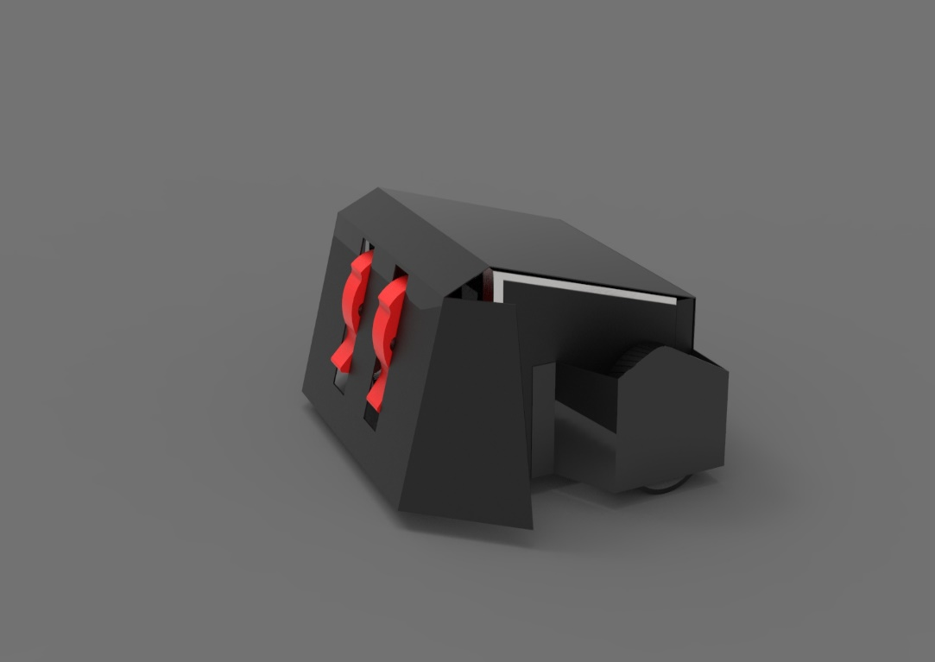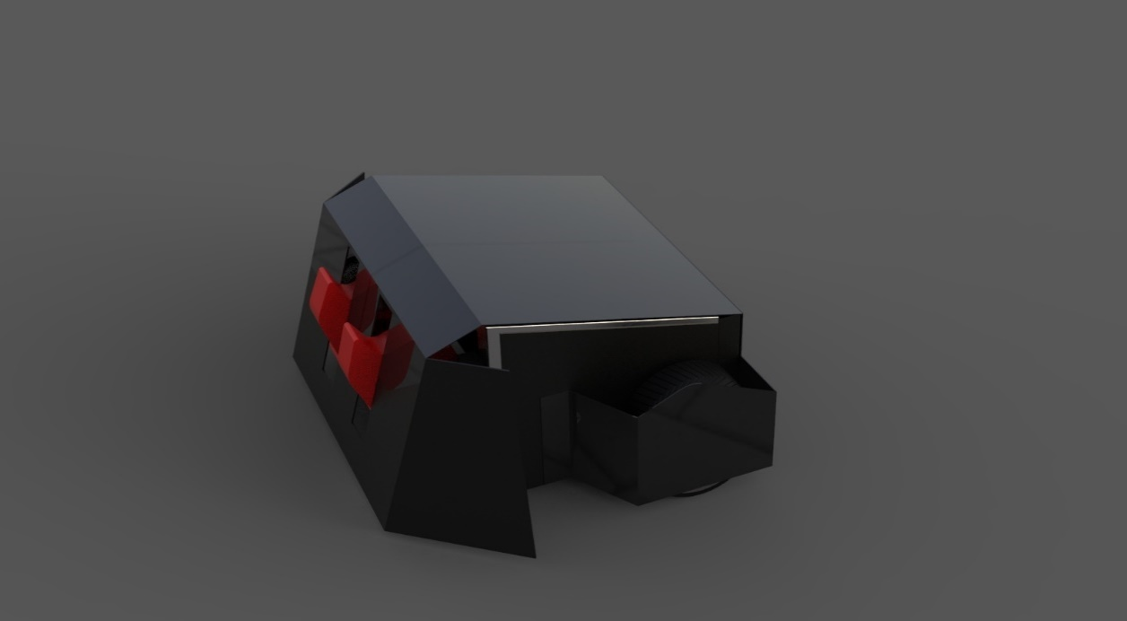

**The Hexahoop**

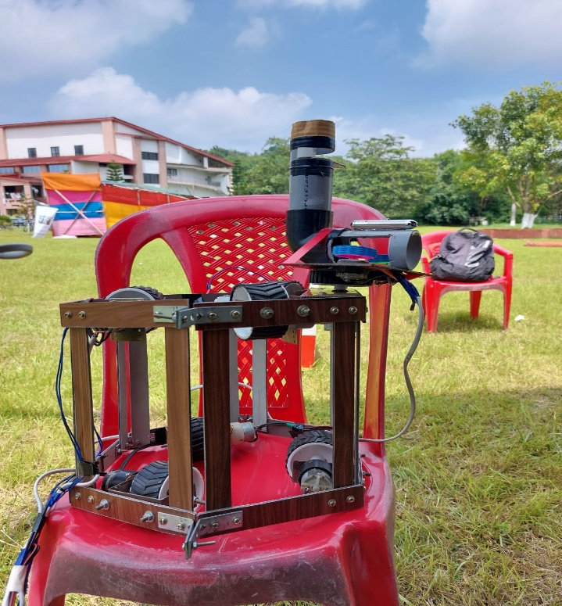

* The Techniche Escalade is a well-known IIT Guwahati event. The competition is divided into two rounds. first is PreLims, in which teams are given a unique problem statement and must solve it in the best way possible in order to move on to the mains round. The mains round is held on the premises of IIT Guwahati, where the selected teams compete. At each stage, the problem statement becomes more difficult.
* We passed the PreLims round, in which 150 teams from across India competed. Only 25 teams were chosen for the next round. We finished in the top ten teams in the Mains Round.
* We created a very stable bot with a distinctive look.
* On the occasion of the 55th Engineer's Day, we were awarded first place by J.C.Bose University of Science and Technology, YMCA for our innovation.
* Our Hexahoop has numerous real-world applications, including use as a Gas Pipeline Leakage Detector in industries.