**Warm-up**: Discovery of the topic

**expected outcome 1**: understand & describe how a website works

**expected outcome 2**: Give a presentation of a website or mobile app

Where is the information I need? & 

Work with partners! Name items and comment on the extracts below using the following terms!

At the top

On the right

In the middle

Above

Next to

Below

between

On the left

At the bottom

In the upper part

In the lower part

Pic 1

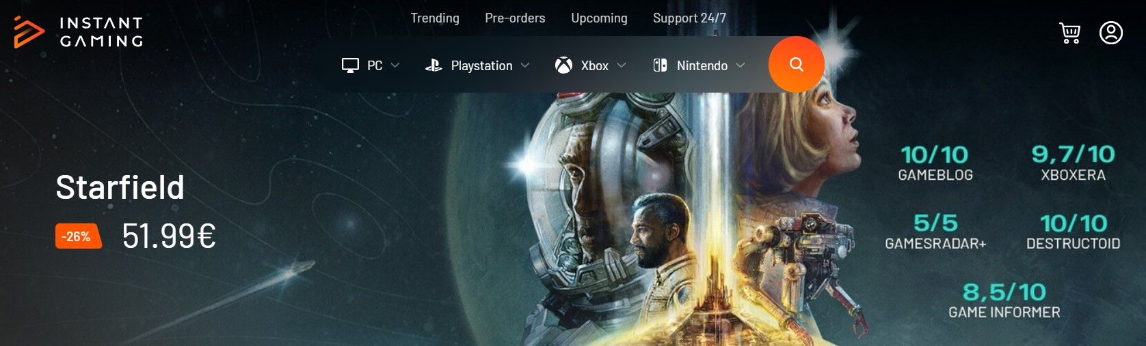

*Source :* [*https://www.instant-gaming.com/en/*](https://www.instant-gaming.com/en/)

Pic 2

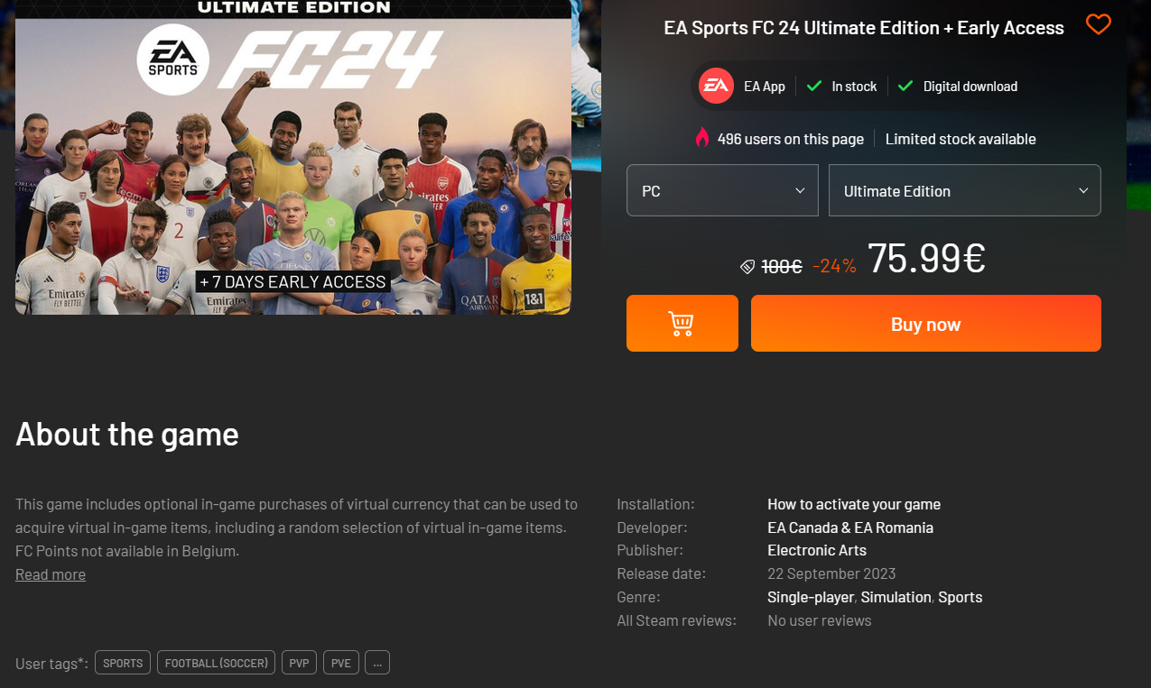

*Source :* [*https://www.instant-gaming.com/en/*](https://www.instant-gaming.com/en/)

Pic 3

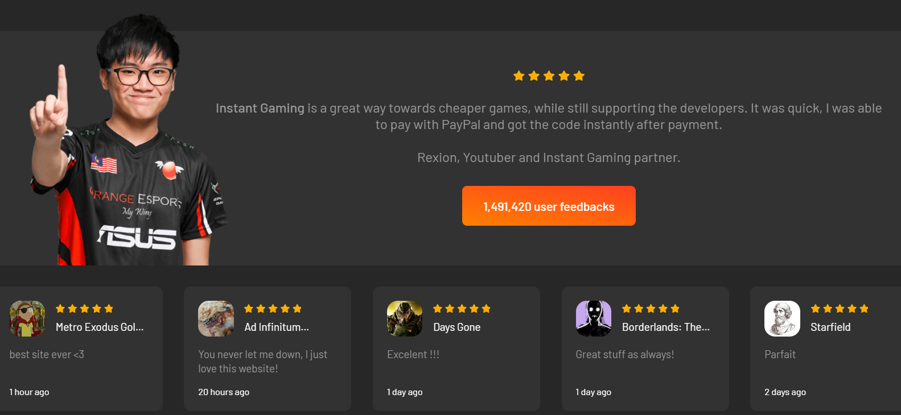

*Source :* [*https://www.instant-gaming.com/en/*](https://www.instant-gaming.com/en/)

Pic 4



*Source :* [*https://www.instant-gaming.com/en/*](https://www.instant-gaming.com/en/)*◦◦*

 Now Present your website, web app or mobile app of your choice & describe it to the class! 3 mn max

Introduce yourself

Introduce the website or app

The target

The layout & The main features (where things are located)

The buttons, menus, links, info, etc…. Focus on A more detailed description of a relevant feature!