FOUNDING BLUEPRINT · THE COMPLETE OPERATING & LEARNING MODEL
The Itqan Way
From Vision to a Working School
A new Islamic secondary school (Stages 4–6), Sydney — a model in which knowledge, action and faith are one journey, not three subjects. The named model, what learning looks like in practice per year level, how industry plugs in, the technology, the staffing and real NSW salaries, the pathways, and the foundation & risk plan.
Prepared for Dr Khaled Altarawneh · Head of School (Founding Appointment) candidacy
How to read the numbers in this document
Four kinds of figure appear, and they are flagged so the Board can trust them: NESA facts (registration mechanics, mandatory hours, requirements); NSW salary figures (NSW Department of Education teacher and leadership scale effective 9 October 2025, plus independent-sector loadings — real, current rates); established practice (patterns proven in named schools); and planning assumptions (staffing counts, ratios, time allocations and enrolment sizing — explicitly labelled). No invented dollar figures are presented as fact.

Part 1 · The model and its names

1.1 One journey — faith at the centre, not on the side
Most schools teach the mind in one room, character in another, and faith in a third. The Itqan Way refuses that split. Everything turns on a single principle — Itqan: excellence and perfection in whatever your hands turn to, performed as worship. From that centre, three things that are usually separated become one act:
The faculty | The Islamic frame | In our school
Mind | ‘Ilm — beneficial knowledge | The wellspring (Manhal)
Hands | ‘Amal — righteous action | Real projects in the real world (’Amal Projects + Kitab Maftuh)
Heart | Iman & Akhlaq — faith & character | Formed in the doing — evidenced in the Athar portfolio
The tradition does the connecting work for us: knowledge (‘ilm) is incomplete until it becomes action (‘amal); action is only worthy when done with excellence (Itqan / Ihsan); and the purpose of reading the world (Iqra — ‘read the signs’) is to flourish and serve. That is also, almost exactly, the project-based-learning sequence — learn → apply → reflect → contribute. Faith and pedagogy are saying the same thing, so a child practises faith-as-excellence in real contexts hundreds of times before they graduate. That habit, formed young, is what produces leaders who are capable and grounded.

1.2 Three design tests
Every decision — every node, project, hire, policy — must pass three tests: Ihsan (does it serve the learner and community with excellence, as a trust before the Divine?); Authentic mastery (does the learner genuinely understand and can they apply it, evidenced not assumed?); and NESA assurance (can we evidence that it meets or exceeds the mandatory outcome for the RoSA/HSC and inspection?).

1.3 A named architecture — explicit, faith-rooted, built to inspire
A founding school needs a language of its own. Each name is chosen so it carries its Islamic meaning and its exact pedagogical job at once — nothing decorative, everything translatable.
In the school | Name | Meaning · what it does · comparator
The whole model | The Itqan Way | Itqan = mastery/perfection of one’s work as worship. The philosophy: do everything beautifully.
The wellspring | Manhal | ‘The Tree of Knowledge.’ The self-paced, mastery-gated curriculum map. Mirrors the CSU topic tree.
The platform | Manara | ‘The lighthouse / minaret’ — the guiding light. The digital home of the tree, portfolio and dashboards.
The projects | ’Amal Projects | ‘Amal = righteous action. Knowledge turned into deeds — one real interdisciplinary project a term. Mirrors Gold-Standard PBL.
The real-world layer | Kitab Maftuh | ‘The Open Book’ — the world and the city as an open book of God’s signs. Studios, mosques, councils, workplaces as real learning sites. Mirrors Big Picture’s ‘Leaving to Learn.’
The portfolio | Athar | ‘The lasting trace one leaves.’ The curated, defended body of evidence. Mirrors the Mastery Transcript / Portfolio of Learning.
Public exhibitions | Majlis | ‘The gathering.’ Termly public showcase to family, mentors and community. Mirrors Exhibitions of Learning.
The home-group | Usrah | ‘The learning family.’ The small belonging-group, 2+ years with one coach. Mirrors Big Picture’s Advisory.
The coach | Murabbi / Murabbiyah | ‘One who nurtures the whole person’ (from Tarbiyah). Owns each student’s plan, portfolio and wellbeing.
Subject experts | Mu’allim / Mu’allimah | ‘The teacher.’ Authors tree nodes, leads knowledge sprints (the Domain Guides).
The three stages | Talab · Tafaqquh · Riyadah | Seek (Talab — talab al-‘ilm) → Deepen (Tafaqquh — deep understanding) → Lead (Riyadah — pioneering leadership & enterprise).
A respectful note: these terms are drawn from the Islamic tradition and should be reviewed with the school’s scholars and community before adoption — that care is itself adab.

1.4 This is proven practice — comparable schools
School / network | Where & scale | What it proves
Charles Sturt Engineering | Australia — MIT-recognised | On-demand topic tree + project challenges + workplace learning + competency gating works (your direct experience).
Big Picture Learning Australia | 40+ AU campuses, 15+ years (incl. NSW: Sydney Secondary College Leichhardt, Five Islands) | Advisory + internships + personalised plans + portfolios + exhibitions, at scale in the NSW public system.
Templestowe College | Victoria — ~1,000 students | Student-empowered, flexible-hours, mixed-cohort PBL revived a near-closed school; among Australia’s most innovative.
High Tech High / XP / School 21 | USA & UK | Rigorous interdisciplinary PBL, oracy and public exhibitions sustain inside national curricula/exams.
Mastery Transcript Consortium | USA, many schools | Universities accept competency/portfolio transcripts alongside grades.
The Big Picture Australia precedent matters most: this kind of model is already registered and operating inside the NSW system. We combine that proven practice with CSU’s knowledge-tree rigour and an explicit Islamic foundation.

1.5 The hard constraints (NESA), in brief
Registration before opening (a 12-month provisional licence on ‘capacity to comply’); applications due 31 March of the year before opening; nine Part-B requirements (B1 Proprietors/Principals · B2 Management & operation · B3 Staff · B4 Curriculum · B5 Premises · B6 Facilities · B7 Enrolment & attendance · B8 Safe & supportive environment · B9 Discipline); Part C for RoSA/HSC accreditation; mandatory hours (400 each of English, Mathematics, Science across Years 7–10, 100 of a language, plus PDHPE and the rest); all teaching by NESA-accredited teachers; a first-year inspection (Strand A welfare, Strand B teaching). NESA does not prescribe class sizes or staffing ratios — it requires accredited teachers covering the mandatory curriculum and safe supervision. That is the legal space in which this model’s flexibility lives.

Part 2 · What learning looks like in practice, per stage

2.1 The weekly architecture and the modality mix
The week is built from blocks, not 40-minute single-subject periods. Manhal carries most content acquisition (asynchronous, on-demand, self-paced); the human time is reserved for what a video cannot do: knowledge sprints (scheduled, face-to-face, Guide-led explicit teaching); ’Amal Project studios (collaborative project work); self-paced Manhal time (independent mastery, coach circulating); Usrah (daily home-family with the Murabbi); and Kitab Maftuh (off-site real-world learning). Students attend a structured, supervised week (NESA B7); the flexibility is in how the time is used, not whether they come.

2.2 Time per week, per stage (planning model)
Indicative split of a ~27-hour student week. The mix shifts from high structure toward independence as self-regulation matures; all hours map to NESA indicative outcome hours across the year.
Element | Talab · Seek (Y7–8) | Tafaqquh · Deepen (Y9–10) | Riyadah · Lead (Y11–12)
Knowledge sprints (F2F, Guide-led) | 8 hr | 6 hr | 6 hr (HSC-focused)
Self-paced Manhal time | 5 hr | 7 hr | 8 hr
’Amal Project studio | 7 hr | 7 hr | 5 hr (capstone)
Usrah + coaching | 3 hr | 2.5 hr | 2 hr
Kitab Maftuh (off-site / internship) | 2 hr (visits) | 4 hr (mentorship) | 6 hr (internship, ~1 day)
Spiritual life, wellbeing, physical, creative | 2 hr | 0.5 hr | — (embedded)
Planning assumption — ratios and hours are a starting model, tuned against NESA indicative hours and the timetable.

2.3 Talab · Seek (Year 7–8) — a day in the life
Highest structure, mostly face-to-face. Aisha (Year 7) begins each day in her Usrah with her Murabbi — a spiritual anchor, intention-setting, and a look at today’s plan. Mid-morning is a knowledge sprint: a Guide teaches ratio and proportion, because her current ’Amal Project (a fair water-sharing roster for the school garden) needs it. She then spends a self-paced block in Manhal mastering two nodes, her coach checking each gate. After prayer and lunch, the project studio; the day ends with a reflection logged to her Athar portfolio. Once a fortnight the class visits a community partner — the gentle start of Kitab Maftuh.

2.4 Tafaqquh · Deepen (Year 9–10) — a day in the life
More independence, deeper discipline, first real mentorships. Yusuf (Year 10) runs more of his own week. Two mornings he is off-site at a council sustainability office, working on his ’Amal Project (“The Cool Courtyard”, §2.7). On campus he pulls heat-transfer and water-cycle nodes from Manhal exactly when his calculations need them, books a tutorial with the science Guide, and joins a sprint on technical-report writing. His Murabbi meets him fortnightly for a deeper one-to-one. His evidence — the dataset, the model, the client feedback, the reflection on adab with a real client — builds toward his RoSA.

2.5 Riyadah · Lead (Year 11–12) — a day in the life
Highest flexibility, with the HSC held firmly in view. Mariam (Year 12) spends about a day a week in a genuine internship (the Learning-Through-Internship model), and much of her on-campus time in self-paced Manhal work and HSC sprints. Her capstone — a Riyadah project of real consequence — is supervised by both a Guide and an industry mentor. She still sits her HSC examinations (non-negotiable for Board Developed Courses), and graduates with an Athar portfolio and a real professional reference — a young leader, ready to serve.

2.6 The Manhal in practice
Each node is the atomic unit: a learning intention; the NESA outcome code(s) it delivers; a visible Bloom badge (Remember → Understand → Apply → Analyse → Evaluate → Create); prerequisites (the upstream links); multi-modal on-demand resources; a mastery check that gates it; and the projects it feeds. A student navigates it like a map: see what is mastered, in progress and next; pull what a project needs; advance on demonstrated mastery, not the clock. Because every mandatory outcome is tagged to a node and a portfolio evidence point, an automated coverage audit guarantees no gaps against a traditional curriculum — with a stronger audit trail.

2.7 An ’Amal Project, fully mapped (worked example)
Tafaqquh-stage (Year 9) ’Amal Project: “The Cool Courtyard” · one term
Design a passive-cooling, water-wise courtyard and an ablution-water re-use concept for a partner mosque, presented to the mosque committee and a council officer. Every phase shows the nodes pulled, when, prerequisites (P) and co-requisites (C), the artefact, the Bloom level and the NESA areas evidenced.

Phase / weeks | Manhal nodes (P=prereq, C=co-req) | Artefact (evidence) | Bloom | NESA areas
Empathise & Define (1–2) | P: client brief; sustainability; urban-heat. C: interviewing | Brief & needs analysis | Understand/Analyse | English; Geography
Investigate (2–4) | P: measurement; area; scale drawing; data. C: spreadsheets & stats | Site dataset + scaled plan | Apply/Analyse | Maths; Science
Knowledge sprint (4–6) | P: heat transfer; water cycle; evaporative cooling. C: rates & ratios | Thermal & water calcs + diagrams | Apply/Analyse | Science; Maths
Ideate & prototype (6–8) | P: design thinking; materials; intro CAD. C: costing | CAD + physical model; costed proposal | Create/Evaluate | Design & Tech; Maths
Communicate (8–9) | P: report structure; oracy; data viz. C: critique | Technical report + client pitch | Create/Evaluate | English
Majlis & reflect (10) | (synthesis) | Public exhibition + reflective entry | Evaluate/Create | Cross-KLA; values; portfolio

2.8 Assessment, the Athar portfolio and the exam question
- Mastery is shown many ways — product, Majlis exhibition, portfolio defence/viva, observation, structured tasks — across defined mastery levels.
- Stages 4–5 (RoSA): no formal exams required. The RoSA rests on satisfactory completion and grades against syllabus standards; the school chooses the method, and the Athar portfolio is the evidence.
- Stage 6 (HSC): external examinations are mandatory for Board Developed Courses. The model wraps the HSC inside Riyadah projects, but students still sit the exams — state this plainly; knowing the regulator’s hard line builds trust.

2.9 Coaching and mentoring requirements, per stage
Stage | Murabbi ratio* | Coaching cadence | Mentoring
Talab · Seek (Y7–8) | ~1 : 15 | Daily Usrah + weekly 1:1 | Guest practitioners; class site visits
Tafaqquh · Deepen (Y9–10) | ~1 : 16–18 | Daily Usrah + fortnightly deep 1:1 | First project mentor (feedback across a project; ~monthly)
Riyadah · Lead (Y11–12) | ~1 : 18 | Daily Usrah + fortnightly 1:1 + capstone supervision | Sustained internship host (weekly during placement) + academic mentor for HSC & capstone
*Ratios are planning assumptions in the range Big Picture advisories use (≈15–20:1); to be confirmed against the staffing budget.

Part 3 · Industry & community as a working process
Kitab Maftuh is an operating system, not a hope. Industry and community involvement is tiered by stage, screened, scheduled and evidenced — and the accredited teacher always owns the learning.

3.1 Who, what, when, why — by stage
Stage | Who | What they do | When / how often
Talab · Seek (Y7–8) | Guest practitioners; community partners | Talk to a class; host a short site visit; pose a real problem for a project | A few times a term
Tafaqquh · Deepen (Y9–10) | Project mentors (industry & community) | Co-set a brief; give feedback at milestones; host half-day visits | Across a project — roughly monthly
Riyadah · Lead (Y11–12) | Internship hosts; capstone supervisors | Provide real workplace tasks; supervise an internship; co-judge the capstone | Weekly during placement (~1 day)
Why it matters: authentic ilm naafiʼ (beneficial knowledge), genuine employability, real references and networks, and the lived experience that turns content into capability — and character.

3.2 The operational machinery — what makes it work
- Curate the network. The Partnerships Lead builds a host/mentor database with signed MOUs (mosques, councils, businesses, universities, creative practitioners).
- Screen and induct. Every adult in student contact holds a Working With Children Check and completes a duty-of-care and child-protection induction (NESA B8). A mentor handbook sets expectations.
- Match and schedule. A platform (ImBlaze-style) matches students to opportunities by interest and project, and schedules them into the week.
- Govern safety off-site. Risk assessments, transport and supervision protocols, insurance and emergency procedures for every external placement.
- Evidence and sign off. Industry feedback maps to outcomes via a shared rubric and is logged to the Athar portfolio; the accredited Guide signs off the learning. Mentors enrich; they are not the teacher of record.

Part 4 · The technology, in practice

4.1 The Manara platform stack
Layer | Function | Real options
Delivery LMS | Hosts node resources, comms | Canvas, Moodle (+ add-ons)
Competency / outcomes | Outcome map; gates nodes on mastery | Canvas Outcomes + Mastery Paths; Moodle Competency Frameworks
Adaptive / knowledge-graph | Manhal itself — prerequisites, on-demand pathing | Realizeit (the CSU engine); knowledge-graph tools
Learning Record Store (xAPI) | Captures every learning event, in and out of school | Any xAPI-conformant LRS
Portfolio / credential | The Athar portfolio & transcript | Portfolio tools; Mastery-Transcript model
Real-world / mentor | Curates internships safely | ImBlaze-style platform
Analytics / early-warning | Coverage audit, mastery dashboards, at-risk flags | Built on LRS + LMS data

4.2 What Manara looks like to each person
- Student: “my tree” (mastered / in progress / next), my current ’Amal Project, my Athar portfolio, my coverage map, and my next sprint or booked tutorial.
- Murabbi (coach): the whole Usrah at a glance — each student’s pace, flags, plan and portfolio completeness.
- Parent: their child’s coverage against the mandatory map in plain language, mastery progress, and Majlis invitations — transparency that builds confidence in a non-traditional model.
- Leadership / NESA inspector: school-wide coverage assurance, standard-of-teaching evidence, attendance, and the full audit trail — the cleanest inspection artefact a school can offer.

4.3 Build vs buy, and the ‘no-gaps’ guarantee
Recommended posture: start with a configured mainstream LMS + competency layer + an LRS for the opening stage (lowest risk, registrable, affordable, within your expertise); add an adaptive engine once the model is proven and the tree is mature. The no-gaps guarantee is a process: a coverage matrix lists every mandatory outcome; the stage’s tree is not ‘ready’ until each maps to a node and a portfolio evidence point; an automated audit re-checks per student each term. Build the data model right; buy sophistication later.

Part 5 · Staffing and salaries (grounded in NSW rates)

5.1 Real NSW salary benchmarks (effective 9 October 2025)
Current NSW Department of Education rates — the public-school scale is the benchmark; independent schools (via the IEU/AIS multi-enterprise agreement) commonly sit around 5–10% higher, with an Accomplished Teacher allowance of $5,203 (from 1 Feb 2026) and leadership allowances on top.
Role / level | NSW benchmark salary | Basis
Graduate teacher (Step 1) | $90,177 | NSW DoE classroom scale
Top of classroom scale (Step 7) | $129,536 | NSW DoE classroom scale
Highly Accomplished / Lead Teacher | ~$137,861 | NSW DoE
Assistant Principal / Head Teacher | $149,059 | NSW DoE leadership
Deputy Principal | $174,034 | NSW DoE leadership
Principal | $229,435 | NSW DoE leadership
Executive Principal | $245,989 | NSW DoE leadership

5.2 The staffing & salary plan, by phase
Role types mostly exist from Year 1 (lean, often part-time); what scales is the number of Domain Guides and Murabbi coaches as cohorts grow, plus HSC subject specialists added as the cohort reaches Stage 6. Salaries are benchmarked to the NSW rates above; FTE counts are planning assumptions on the enrolment basis stated.
Role | Salary benchmark | Yr1 (Y7 only) | Full (Y7–12)
Head of School | $210k–$250k (Principal–Exec Principal band) | 1 | 1
Director, Registration & Compliance | ~$150k–$175k (Asst/Deputy Principal) | 1 | 1
Director of Learning Architecture | ~$150k–$175k | 1 | 1
Competency Architects | ~$130k–$150k (top scale + allowance) | 1–2 (build) | 2–3
Domain Guides (Mu’allim) — accredited | $90k–$130k + allowances | 3–4 | 20–26 (incl. HSC specialists)
Learning Coaches (Murabbi) | teacher scale + coordination allowance | (Guides double) | 8–12
Islamic Studies & Spiritual Formation (Imam) | teacher scale + leadership allowance | 1 | 2–3
Wellbeing & Inclusion Lead | ~$130k–$150k (or P/T + external psych) | 0.5–1 | 2
Learning Technologist (Manara) | ~$90k–$120k (planning assumption) | 0.5–1 | 1–2
Business Manager / Operations | ~$120k–$160k (planning assumption) | 1 | 1–2
Partnerships & Community Lead | ~$100k–$130k (planning assumption) | 0.5–1 | 1–2
Experts-in-Residence | sessional / honoraria / volunteer | via partners | via partners
Indicative total FTE | — | ~10–13 | ~45–55 (≈600 students)
Enrolment basis (planning assumption): Year 1 opens with a single Year 7 cohort (≈40–60 students); the full school reaches ≈600 across Y7–12. NESA sets no fixed staff ratio — the floor is that every mandatory KLA, and every HSC Board Developed Course offered, is taught by an accredited teacher with safe supervision.

5.3 The phased org chart
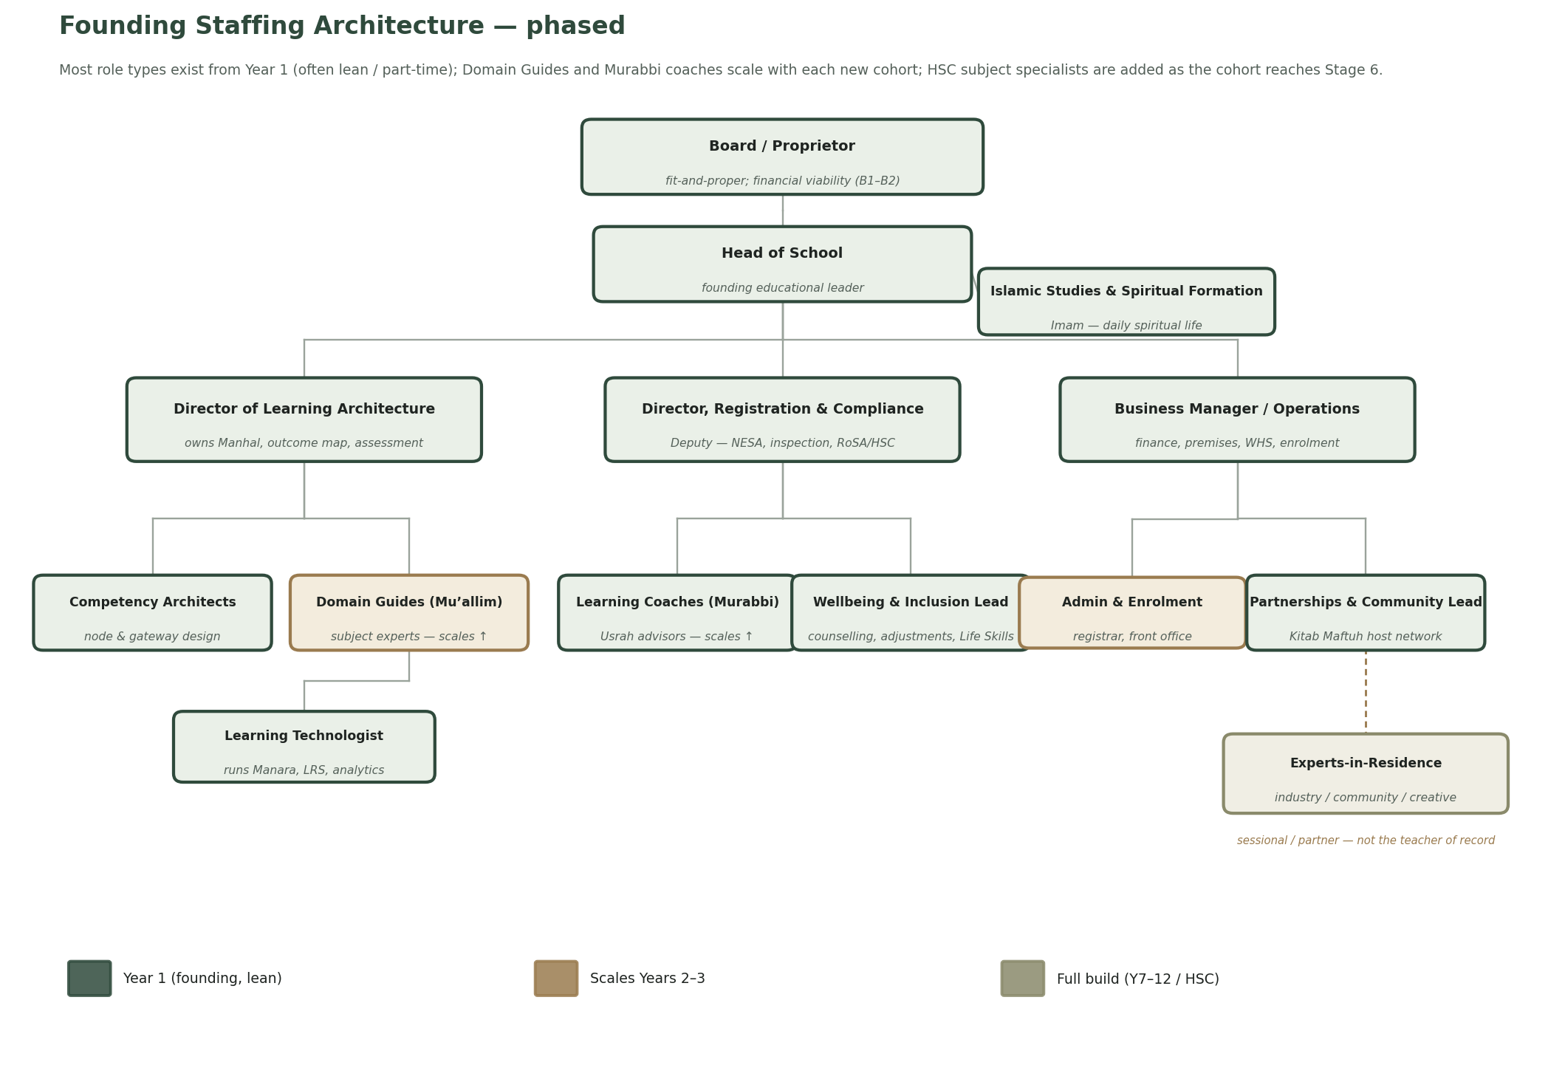
Founding staffing architecture, colour-coded by when each role joins. Guides and Murabbi coaches scale with cohorts; HSC specialists are added by ~Year 4–5.

5.4 The Head-of-School salary, benchmarked
The advertised band ($210,000–$250,000) is well-founded: it sits between the NSW Principal rate ($229,435) and Executive Principal rate ($245,989). A $250,000 expectation is therefore defensible as a top-of-band, founding-leader figure aligned to a substantial NSW principalship — not aspirational.

Part 6 · Pathways to university and the workforce

6.1 How learning and excellence are demonstrated
Five evidence streams, layered: mastery levels recorded in Manhal; public Majlis exhibitions; the Athar portfolio; HSC results; and a graduate-attribute profile (Scholar, Maker, Steward, Communicator, Self-directed learner, Person of character). Excellence is visible, defended and externally witnessed — not reduced to a single number.

6.2 The university pathway
Students sit the HSC and receive an ATAR — the conventional gate is fully preserved. On top of it they carry an Athar portfolio of authentic work. With universities increasingly offering early-entry and portfolio-based admission, a graduate who can evidence real capability is advantaged, not disadvantaged. The model widens the door rather than narrowing it.

6.3 The workforce & vocational pathway
Internships through Kitab Maftuh produce real references, networks and work samples; VET (Board Endorsed / Content Endorsed) courses can be embedded where relevant; and the portfolio is itself a record of applied competence. A graduate leaves employable, not merely examined.

6.4 The graduate — the ‘deep generalist’
The brief asks for graduates who combine academic excellence, spiritual depth, creative problem-solving and moral conviction. The model manufactures that profile by design: rigorous knowledge (Manhal), applied in consequence (’Amal + Kitab Maftuh), formed in character (Tarbiyah / Adab), and evidenced in a body of work (Athar). A young leader who is excellent and grounded — the operational definition of the school’s vision.

Part 7 · Foundation roadmap & risk

7.1 Phases and gateways
Phase | Focus | Exit gateway
0 — Feasibility | Entity, board, financial model, site search, EOI to NESA | Funded mandate + viable site line-of-sight
1 — Design & evidence | Manhal build, platform, policy suite, NESA briefing | Registration application ready
2 — Build & approve | Submit (31 Mar), recruit team, fit-out, enrolment | Provisional registration granted
3 — Launch & prove | Open Term 1, operate, renew | Pass first-year inspection (Term 2)

7.2 Master schedule (Gantt)
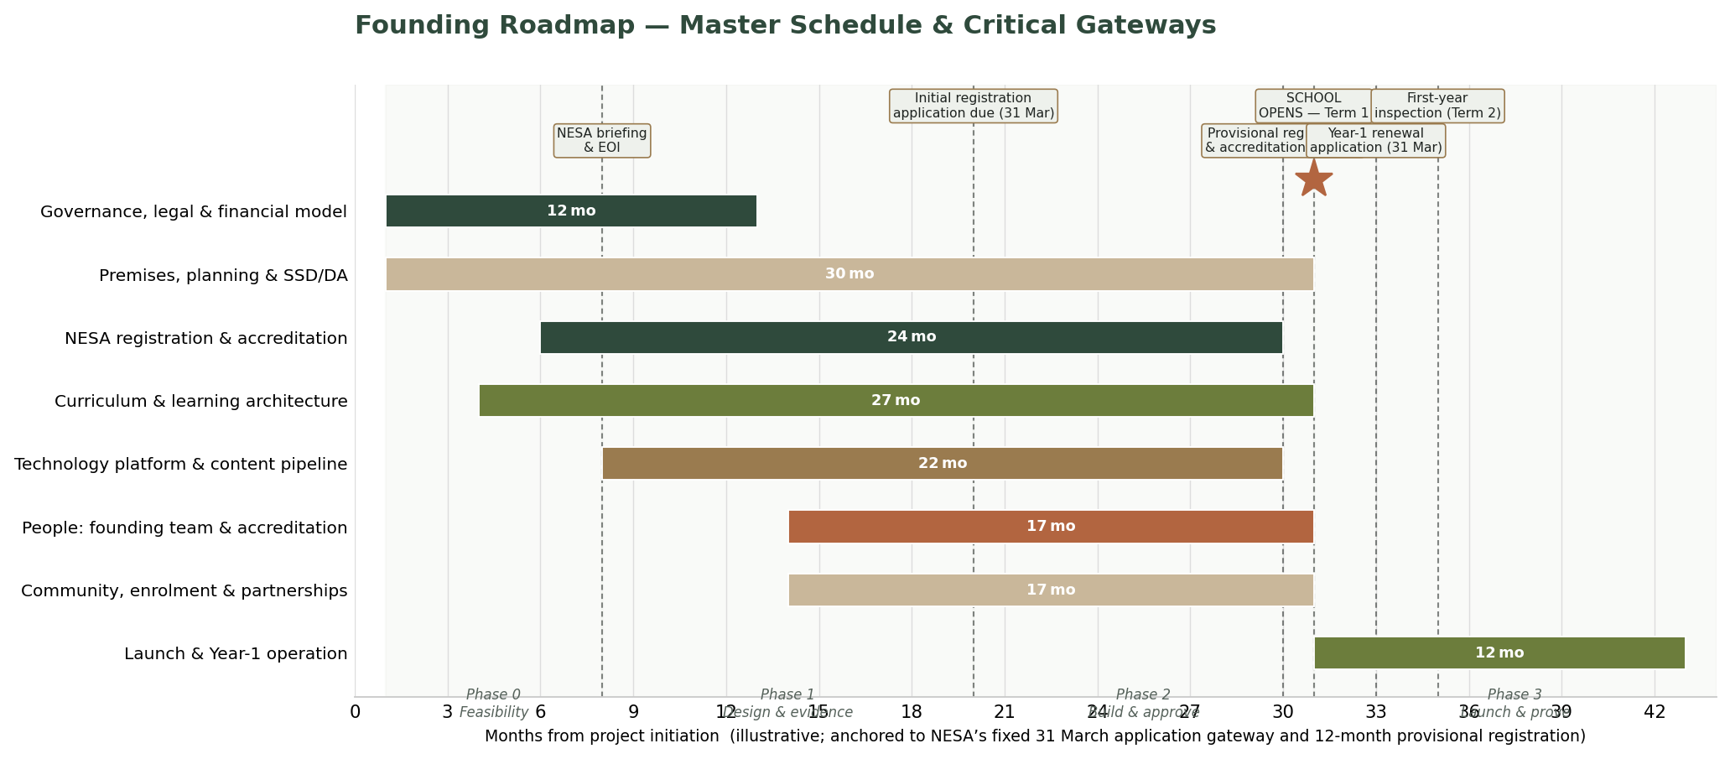
Three items bind everything: the immovable 31 March application date (~9–10 months before a January open); premises/planning (a State Significant Development can take ~24 months); and the opening-stage Manhal, which must be coverage-complete before opening.

7.3 Risk register (pre-mitigation)
ID | Risk | L×I | Mitigation
R1 | NESA registration/accreditation delayed or refused | Likely × Critical | Engage NESA early; build evidence from Phase 1; single-stage launch defers accreditation
R2 | Premises / planning delay or no site | Possible × Critical | Start in Phase 0; interim leased premises; planning advisers
R3 | Manhal not coverage-complete at opening | Possible × Severe | Coverage audit; single-stage scope; AI-assisted authoring + QA; buffer
R4 | Cannot recruit aligned, accredited educators | Likely × Severe | Early recruitment; grow-your-own PD; hire for character then train; partner sessionals
R5 | Financial viability shortfall (B2.5) | Unlikely × Critical | Conservative enrolment; staged scaling; sponsor runway; sensitivity testing
R6 | Family reluctance; soft enrolment | Possible × Major | Transparent evidence; clear HSC pathway messaging
R7 | Model-fidelity drift to conventional teaching | Likely × Major | Fidelity rubric; PD; hire for alignment; measure it
R8 | Tech stack fails to assure coverage | Unlikely × Severe | Proven mainstream LMS first; pilot before launch
R9 | Inspection finds welfare/curriculum gaps | Possible × Severe | Strand A & B readiness from day one; mock inspection
R11 | Teacher accreditation not complete in time | Likely × Moderate | Track in recruitment; support staff through NESA early
R12 | Insufficient/unsafe internship supply | Possible × Moderate | Build host network early; WWCC + duty-of-care; vet every site
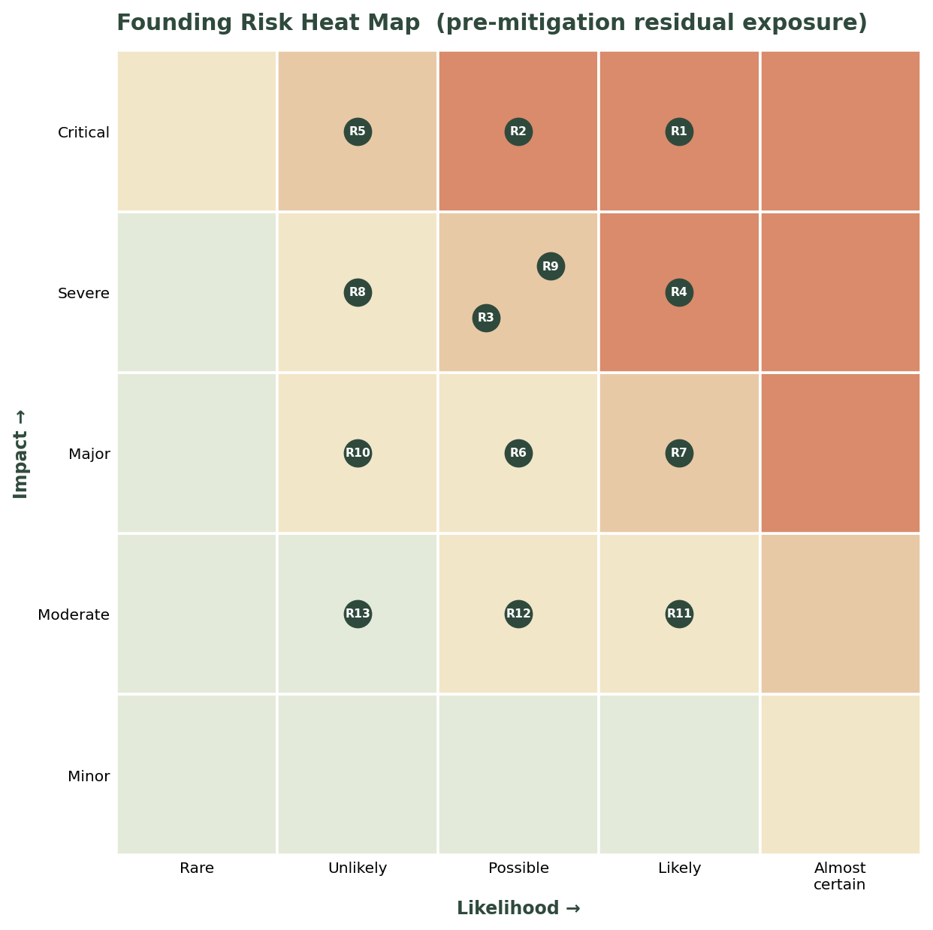

7.4 Scaling logic — the single-stage launch
The move that de-risks everything
Open with Year 7 only, then add one year-level a year. It shrinks the Year-1 Manhal to a single stage, needs a smaller team and less capital, and defers HSC accreditation (no senior students for ~4–5 years) so registration is secured first and accreditation added as the cohort reaches Tafaqquh and Riyadah. A terrifying ‘open a whole school’ problem becomes a manageable ‘open one year group well’ problem.

Part 8 · Compliance, deployment & sources

Appendix A — NESA compliance crosswalk
Req. | Requirement | Owner & key evidence
B1 | Proprietors & Principals | Board — fit-and-proper persons; Principal suitability
B2 | Management & operation | Board — governance, conflict-of-interest, audited financial viability
B3 | Staff | Compliance — NESA-accredited teachers; induction/mentoring/PD
B4 | Curriculum | Learning Architecture — syllabus-based programs; coverage audit
B5/B6 | Premises & facilities | Business Manager — compliant, fit-for-purpose, safe spaces
B7 | Enrolment & attendance | Operations — policies and records (flexible time, attended week)
B8 | Safe & supportive environment | Designated officer — child protection, welfare (Strand A)
B9 | Discipline | HoS — fair discipline policy
C1/C2 | RoSA & HSC curriculum | Compliance — mandatory courses/hours; HSC Board Developed Courses & external exams
C3 | Quality of educational program | HoS — standard of teaching & quality of learning (Strand B)

Appendix B — Using this with the Board
- Open with the connecting idea and the named model — faith at the centre, Mind/Hands/Heart as one journey; it shows a systems thinker with a brand.
- Show the worked ’Amal Project, the org chart and the Gantt — concreteness is what separates you.
- Lead the risk conversation with the single-stage launch — the answer that makes the whole thing safe to back.
- Anchor salary to the NSW principal benchmark — confident, evidence-based, not aspirational.

Appendix C — Sources & assumptions
Grounded in current NESA guidance (registration process; Sept-2023 Non-government Schools Manual Part B/C; mandatory curriculum & hours; teacher-accreditation requirements; ACE Rules); the NSW Department of Education salary scale effective 9 October 2025 and IEU/AIS independent-sector loadings; the published Charles Sturt Engineering model; Big Picture Learning (Australia: 40+ campuses, incl. NSW; and internationally) and the Mastery Transcript Consortium; Templestowe College, High Tech High, XP and School 21; and established frameworks (Gold-Standard PBL, Stanford design thinking, Bloom’s and SOLO taxonomies, UDL). Names are proposals for review with the school’s scholars and community. Ratios, FTE counts, time allocations and enrolment sizing are planning assumptions. Verify all specific NESA and salary figures against the live sources before relying on them in writing.
Confidential preparation document · a candidate’s proposed architecture, not an official school plan.

