### **Experiment -1**

**Aim:- Write a program to draw a dot, line, triangle, rectangle and circle using functions of graphics.h header file.**

**Program:-**

#include<iostream.h>

#include<conio.h>

#include<graphics.h>

void main(){

int gd=DETECT,gm;

clrscr();

initgraph(&gd,&gm,"c:\\turboc3\\BGI");

settextstyle(2,0,4);

putpixel(50,60,WHITE);

outtextxy(30,65,"Pixel");

line(100,60,200,60);

outtextxy(110,65,"Line");

circle(300,60,40);

outtextxy(290,100,"Circle");

rectangle(100,100,200,200);

outtextxy(120,210,"Rectangle");

line(250,100,250,250);

line(250,100,350,250);

line(250,250,350,250);

outtextxy(270,260,"Triangle");

getch();

closegraph();

}

**Output:-**

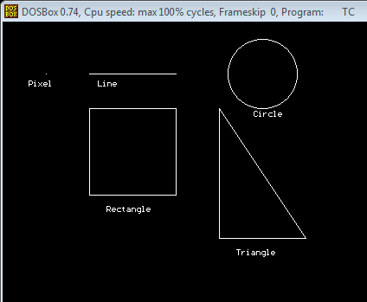

### **Experiment -2**

**AIM:- Write a program to display Shapes like(like hut,star,car,etc)using graphical primitives.**

**Program:**