***Experiment 4***

**Aims : Use of Linux file related commands like ls, grep, cat, etc.**

**Requirements : Ubuntu , Terminal**

**Introduction**

1. **ls -a :** list all files including hidden file starting with '.'

**Syntax:** ls -a

**Example:**

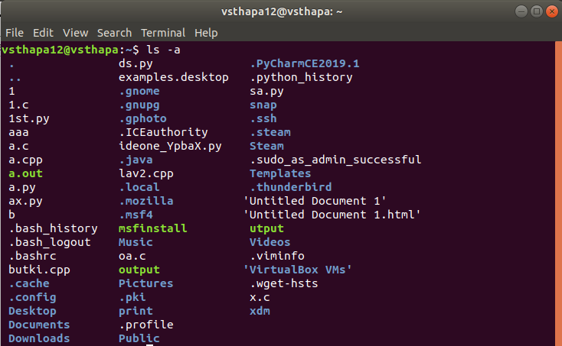

1. **ls -f :**add one char of */=>@| to enteries

**Syntax : ls -f**

**Example:**

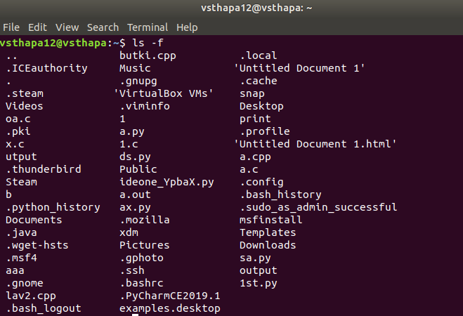

1. **ls -r :** list in reverse order

**Syntax : ls -r**

**Example :**

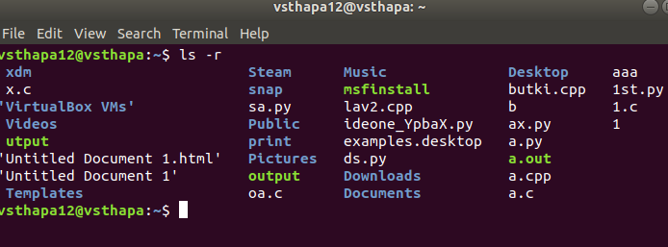

1. **cat :** its allows us to create single or multiple files, view contain of file, concatenate files and redirect output in terminal or files

**Syntax : cat file1_name file2_name**

**Example:**

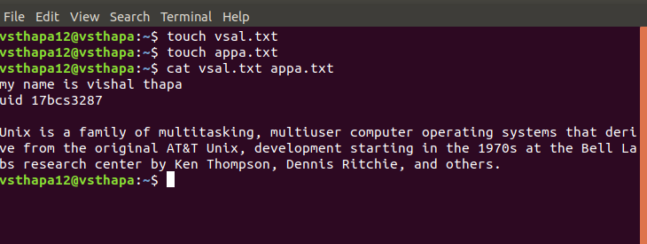

1. **sort :**sorts the contents of a text file, line by line

**Syntax : sort file_name**

**Example:**

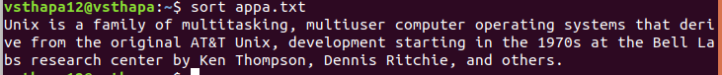

1. **tac :** it is used to concatenate and print files in reverse

**Syntax : tac file1_name file2_name**

**Example :**

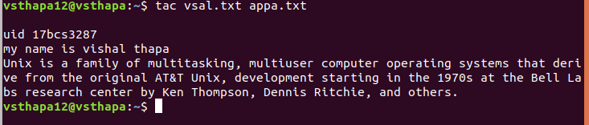

1. **head :** The head command reads the first ten lines of a any given file name and print from top to bottom

**Syntax : head file_name**

**Example:**

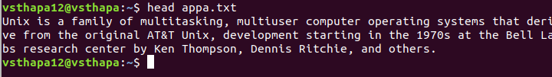

1. **tail :** The tail command reads the first ten lines of a any given file name and print from bottom to top

**Syntax : tail file_name**

**Example:**

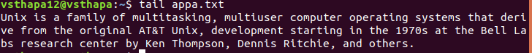

1. **wc (-l, -c, -w) :**The **wc** command in UNIX is a command line utility for printing newline(**-l**), word(**-w**) and byte counts (**-c**) for files

**Synatx: wc -l file_name**

**wc -w file_name**

**wc -c file_name**

**Example:**

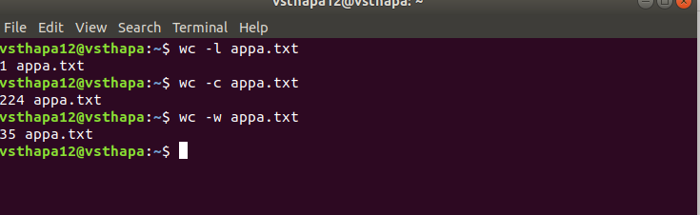

**10. grep :** this command is used processes text line by line and prints any lines which match a specified pattern.

**Syntax: grep “the text need to search “ file_name**

**Example:**

